|  |  |
| --- | --- |
| **Ex. No: 7** | Routing Implementation using ExpressJS |
| **2.10.2023** |

**Aim:**

To implement the routing feature(s) using the ExpressJS.

**Program:**

Server.js

const express = require('express');

const path = require('path');

const app = express();

// Define a route for the root path

app.get('/', (req, res) => {

const indexPath = path.join(__dirname, 'index.html');

res.sendFile(indexPath);

});

// Define a route for the /about path

app.get('/about', (req, res) => {

const aboutPath = path.join(__dirname, 'about.html');

res.sendFile(aboutPath);

});

// Define a route for serving images

app.get('/image', (req, res) => {

const imagePath = path.join(__dirname, 'images', 'bs.jpg');

res.sendFile(imagePath);

});

const PORT = 3000;

app.listen(PORT, () => {

console.log(`Server is running on http://localhost:${PORT}`);

});

Index.html

<!DOCTYPE html>

<html lang="en">

<head>

<meta charset="UTF-8">

<meta name="viewport" content="width=device-width, initial-scale=1.0">

<title>Home</title>

<link rel="stylesheet" href="style.css">

</head>

<body>

<h1>Welcome to the Home Page</h1>

<p>This is the home page of our website.</p>

<script src="script.js"></script>

</body>

</html>

About.html

<!DOCTYPE html>

<html lang="en">

<head>

<meta charset="UTF-8">

<meta name="viewport" content="width=device-width, initial-scale=1.0">

<title>About</title>

<link rel="stylesheet" href="style.css">

</head>

<body>

<h1>About Us</h1>

<p>This is the about page of our website.</p>

<script src="script.js"></script>

</body>

</html>

**Output:**

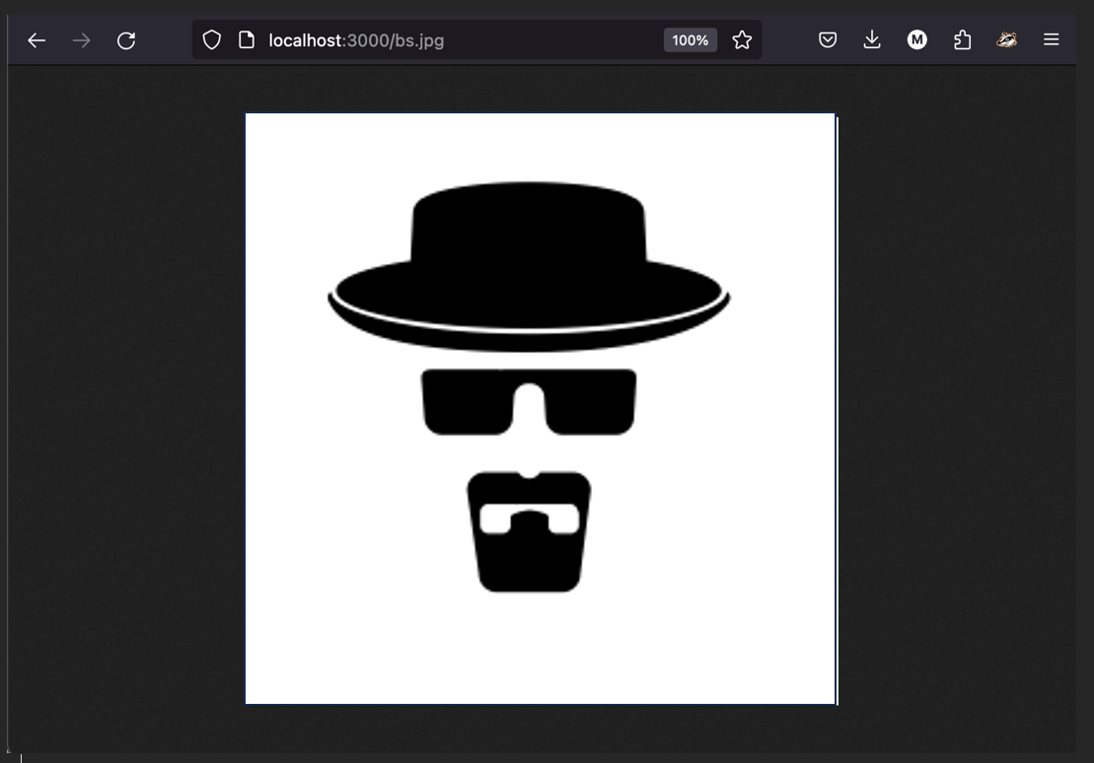

**Result:**

Successfully implemented the routing feature(s) using the ExpressJS.