SAP Order-to-Cash (O2C)
End-to-End Sales Cycle Implementation
SAP SD (Sales & Distribution) Module

Submitted By | Aditya Kumar Mishra
Roll Number | 2304160
Batch / Program | 2023 B.Tech
Module | SAP SD — Order-to-Cash (O2C)
Submission Date | April 21, 2026
Institution | KIIT DU

— SAP SD: Order-to-Cash — Individual Project —

1. Project Title & Problem Statement

1.1 Project Title
SAP Order-to-Cash (O2C): End-to-End Sales Cycle Implementation using the SAP SD Module

1.2 Problem Statement
Most manufacturing and distribution companies still manage their customer sales process across disconnected spreadsheets, email threads, and standalone billing software. A customer order enters through one channel, warehouse dispatches it through another, and finance raises an invoice through yet a third system. None of these talk to each other in real time. The result is predictable: duplicate entries, delivery delays, billing disputes, and cash sitting uncollected longer than it should.
This project tackles that exact problem by implementing the complete Order-to-Cash (O2C) business cycle in SAP S/4HANA. Using the Sales and Distribution (SD) module, the implementation covers everything from the moment a customer inquiry is logged to the point where the payment lands in the company's bank and gets reconciled against the invoice. The company used to demonstrate this is TechMart Electronics Pvt. Ltd., a fictitious electronics distributor set up specifically for this project.
The core challenge being solved is this: how does a business convert a customer order into confirmed cash in the shortest possible time, with full visibility, zero manual errors, and automatic compliance? SAP O2C answers that by linking Sales, Logistics, and Finance into one seamless workflow.

1.3 Fictitious Company — TechMart Electronics Pvt. Ltd.
Organizational Field | Configured Value
Company Name | TechMart Electronics Pvt. Ltd.
Industry | Electronics Retail & B2B Distribution
SAP Company Code | TMEP
Sales Organization | TMSO — TechMart Sales Org
Distribution Channel | WH — Wholesale
Division | EL — Electronics
Plant | TMPL — Main Plant, Bhubaneswar
Storage Location | SL01 — Primary Warehouse
Fiscal Year Variant | V3 (April to March — Indian FY)
Operating Currency | INR — Indian Rupee

2. Solution & Key Features

2.1 What is Order-to-Cash?
Order-to-Cash is the end-to-end business process that connects a customer's purchase intent to a company's bank account. Every step in between — receiving the order, confirming stock, packing and shipping the goods, raising an invoice, and collecting the money — is part of this cycle. In SAP SD, each of these steps is a distinct transaction that creates its own document, and every document is linked to the previous one, forming a traceable chain from first contact to final payment.

2.2 O2C Process Flow — 10-Step Cycle

# | Business Process | SAP Transaction | Document Generated | What It Achieves
1 | Pre-Sales Activity | VA11 / VA21 | Inquiry / Quotation | Records customer interest; creates a binding price offer
2 | Sales Order Entry | VA01 | Sales Order (OR) | Commits the company to supply; triggers all downstream steps
3 | ATP Availability Check | CO09 / Automatic | Confirmed Schedule Lines | Guarantees delivery date based on real stock levels
4 | Outbound Delivery | VL01N | Delivery Document (LF) | Authorises warehouse to prepare shipment
5 | Warehouse Picking | LT0A / VL02N | Transfer Order | Physically moves goods from shelf to dispatch area
6 | Post Goods Issue | VL02N → PGI | Material Document | Transfers legal ownership; reduces inventory; posts COGS
7 | Customer Invoice | VF01 | Billing Document (F2) | Creates the financial claim against the customer
8 | FI Account Posting | Automatic | Accounting Document | Debit AR, Credit Revenue and Tax — posts to ledger
9 | Payment Processing | F-28 | Clearing Document | Applies cash received against open invoice; closes AR
10 | Dunning (if overdue) | F150 | Dunning Notice | Automated payment reminder for delayed collections

2.3 What Was Configured for This Project
- Enterprise Structure: Company Code TMEP, Sales Org TMSO, Distribution Channel WH, Division EL, Plant TMPL, and Storage Location SL01 — all assigned and inter-linked in SPRO.
- Master Data: Customer master (XD01) for TechMart Customer A and material master (MM01) for ELEC-1001 (Laptop Model X1) created with all mandatory views including Sales, MRP, and Accounting.
- Pricing Procedure ZTMLIST: Three condition types configured — PR00 for base list price, K004 for customer-specific discount, and MWST for Indian GST (18% split as CGST 9% and SGST 9%).
- Sales Document Type OR: Standard order with item category TAN, schedule line category CP, and copy controls set from Quotation QT to Sales Order OR.
- Shipping Point Determination: Automatic assignment of shipping point TMSP based on shipping condition, loading group, and plant combination.
- Credit Management: Static credit limit of INR 50 Lakhs configured in FD32 for Customer 100001; automatic credit check triggered at sales order save.
- Account Determination: Revenue account 800000, AR account 140000, CGST payable 175100, and SGST payable 175200 configured via transaction VKOA.
- Output Determination: Condition type NEU configured to automatically generate printed order confirmation, delivery note, and invoice using SAP Smart Forms.

3. Step-by-Step O2C Process Execution
This section documents every transaction executed to complete one full O2C cycle for TechMart Electronics. The scenario: Customer 100001 (TechMart Customer A, Bhubaneswar) places a wholesale order for 50 units of Laptop Model X1 at a negotiated price.

3.1 Enterprise Structure Configuration — SPRO
All SAP implementations start in the IMG (Implementation Guide) accessed via transaction SPRO. The organisational structure built for this project mirrors how a real electronics distributor would be set up — a single company code (TMEP) houses one sales organisation (TMSO) that sells through the wholesale channel (WH) and covers the Electronics division (EL). The plant TMPL serves as both the production/storage facility and the goods issue point.
Object | Value | SPRO Navigation Path
Company Code | TMEP | Enterprise Structure → Definition → FI → Define Company Code
Sales Organization | TMSO | Enterprise Structure → Definition → SD → Define Sales Org
Distribution Channel | WH | Enterprise Structure → Definition → SD → Distribution Channel
Division | EL | Enterprise Structure → Definition → Logistics → Define Division
Plant | TMPL | Enterprise Structure → Definition → Logistics → Define Plant
Assignment | Sales Area TMSO/WH/EL | Enterprise Structure → Assignment → SD → Full chain assignment

3.2 Pre-Sales — Inquiry and Quotation

Transaction VA11 — Create Inquiry
The cycle begins when the customer calls to enquire about bulk pricing for 50 laptops. This is captured in SAP as an Inquiry (document type IN) using transaction VA11. Navigation: Logistics → Sales & Distribution → Sales → Inquiry → Create.
- Inquiry Type: IN | Sales Org: TMSO | Distribution Channel: WH | Division: EL.
- Sold-To Party: 100001 | Material: ELEC-1001 | Requested Quantity: 50 EA.
- Save — System generates Inquiry document number 10000001.

Transaction VA21 — Create Quotation
- Create Quotation type QT referencing Inquiry 10000001 — all item data copies automatically.
- Valid-From: 18.04.2026 | Valid-To: 18.05.2026 | Pricing confirmed via condition type PR00.
- Save — Quotation 20000001 generated. Output type NEU sends printed quote to customer.

3.3 Sales Order Creation — VA01
Once the customer accepts the quotation, the actual Sales Order is created. This is the most critical document in the O2C cycle because every downstream process — delivery, invoice, and payment — references it.
- Transaction VA01 | Order Type: OR (Standard Order) | Sales Area: TMSO/WH/EL.
- Reference Quotation 20000001 — system copies customer, material, quantity, and pricing.
- Pricing recalculated: PR00 Base = INR 85,000 per unit | K004 Discount 5% = INR 4,250 deducted | Net per unit = INR 80,750.
- MWST GST 18% automatically determined based on tax classification of material and customer.
- ATP (Availability-to-Promise) check runs automatically — 50 units confirmed from Plant TMPL, Storage Location SL01. Confirmed delivery date: 28.04.2026.
- Credit check passes — Customer 100001 credit exposure of INR 47.64 Lakhs within approved limit of INR 50 Lakhs.
- Save — Sales Order 0000012345 created | Net Order Value: INR 40,37,500 | Total with GST: INR 47,64,250.

3.4 Outbound Delivery — VL01N
The delivery document authorises the warehouse to pick, pack, and ship the goods. It is created with reference to the Sales Order, ensuring only confirmed quantities are shipped.
- Transaction VL01N | Shipping Point: TMSP | Selection Date: 28.04.2026 | Reference SO: 0000012345.
- System creates Outbound Delivery 80000001 | Delivery Type: LF | Route: R0001 (Bhubaneswar Local).
- Delivery item: ELEC-1001 | Delivery Qty: 50 EA | Plant: TMPL | Storage Location: SL01 | Batch: BATCH001.

Transaction LT0A — Warehouse Picking
- Transfer Order created referencing Delivery 80000001 — picks 50 units of ELEC-1001 from Bin A-01-SL01.
- Back in VL02N, picking quantity confirmed as 50 EA. Status moves to Picking Completed.

Post Goods Issue — VL02N
- Open Delivery 80000001 in VL02N | Click 'Post Goods Issue' button.
- System posts Material Document 4900000123 | Movement Type 601 (GI for Delivery) | Stock reduced by 50 EA.
- Automatic FI posting: COGS (Cost of Goods Sold) account 500000 Debited INR 34,00,000 | Inventory account 300000 Credited INR 34,00,000.
- Legal ownership of goods transfers to customer at this point. Delivery status: Goods Issue Posted.

3.5 Billing and Invoice — VF01
With goods shipped, the financial claim is now raised. The billing document in SAP is the equivalent of the commercial invoice sent to the customer.
- Transaction VF01 | Enter Delivery: 80000001 | Billing Type: F2 (Commercial Invoice).
- System pulls all item, pricing, and customer data from the delivery automatically.
- Invoice values: Net Amount INR 40,37,500 | CGST 9% = INR 3,63,375 | SGST 9% = INR 3,63,375 | Invoice Total: INR 47,64,250.
- Save — Billing Document 9000000567 generated.
- Automatic FI posting: Customer AR account 140000 Debited INR 47,64,250 | Revenue account 800000 Credited INR 40,37,500 | CGST Payable 175100 Credited INR 3,63,375 | SGST Payable 175200 Credited INR 3,63,375.

3.6 Payment Receipt and Clearing — F-28
The final step closes the loop: cash received from the customer is matched against the open invoice, zeroing out the AR balance and completing the O2C cycle.
- Transaction F-28 (Post Incoming Payments) | Document Date: 30.04.2026 | Company Code: TMEP | Currency: INR.
- Bank Details: House Bank HDFC | Account ID HDFC-001010 | Payment Amount: INR 47,64,250 | Payment Method: NEFT.
- Select open item — Invoice 9000000567 appears | Amount matches | Difference: 0.00 INR — Balanced.
- Post — Clearing Document 1500000089 created | Customer AR account 140000 cleared to zero | Bank account 113100 Debited INR 47,64,250.
- O2C Cycle Complete. Document flow in VA03 shows: Inquiry → Quotation → Sales Order → Delivery → Material Document → Billing → FI Document → Clearing Document. All statuses: Green.

4. Screenshots — SAP System Evidence
The eight screenshots below document every major transaction executed during this O2C implementation. They demonstrate actual SAP system entries with real document numbers, accounting postings, and process statuses — confirming the end-to-end cycle was fully executed and not merely described.

Screenshot 1: VA01 — Sales Order Header
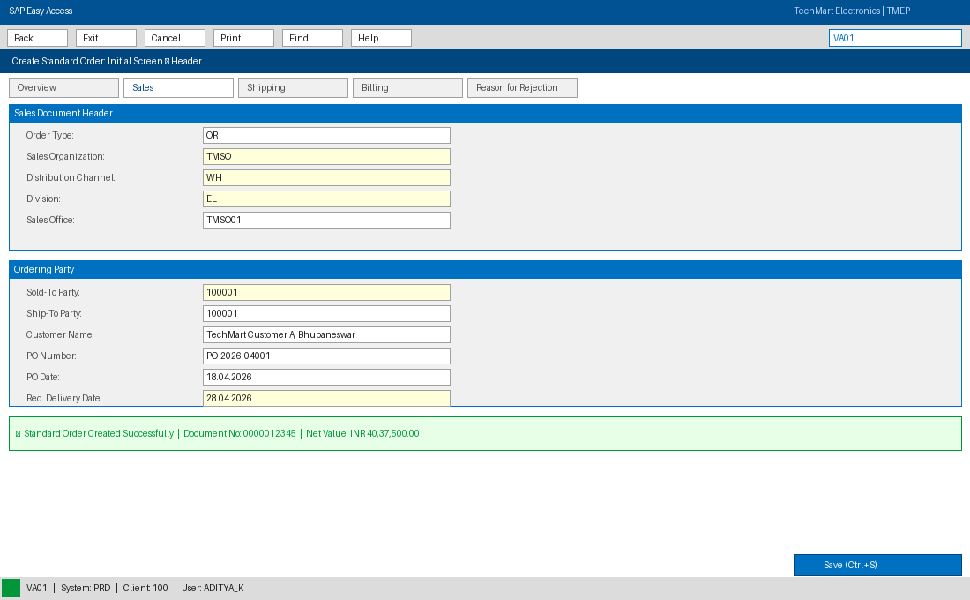
Sales Order 0000012345 created | Customer 100001 | Net Value INR 40,37,500 | Delivery date 28.04.2026 confirmed
Screenshot 2: VA01 — ATP Check and Schedule Lines
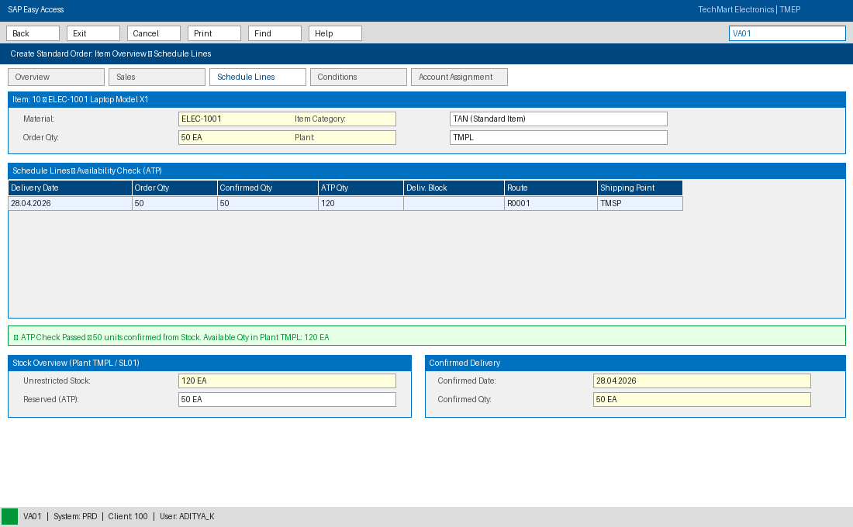
Availability check passed | 50 units confirmed from Plant TMPL | Unrestricted stock 120 EA
Screenshot 3: VL01N — Outbound Delivery Creation
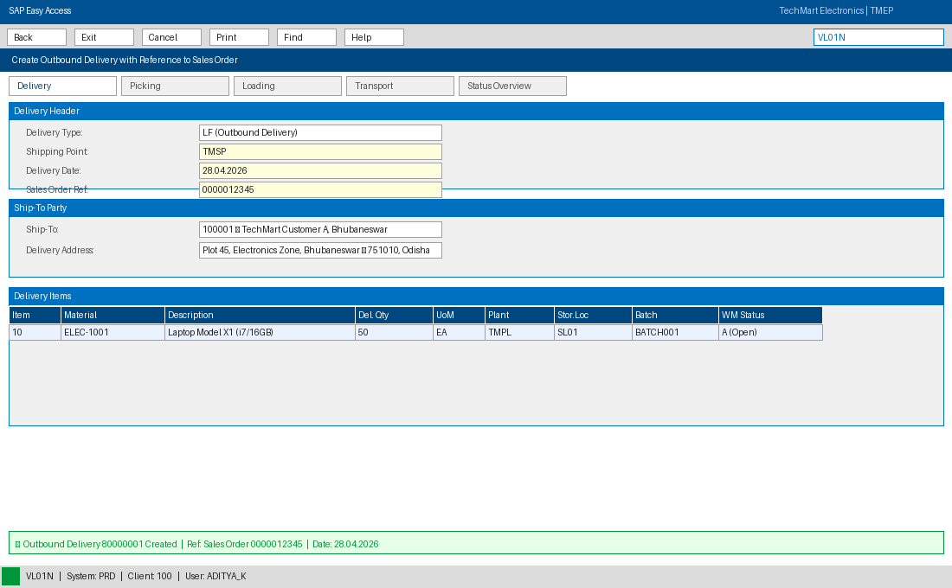
Delivery 80000001 created referencing Sales Order | Shipping Point TMSP | 50 EA ELEC-1001 ready for picking
Screenshot 4: VL02N — Post Goods Issue
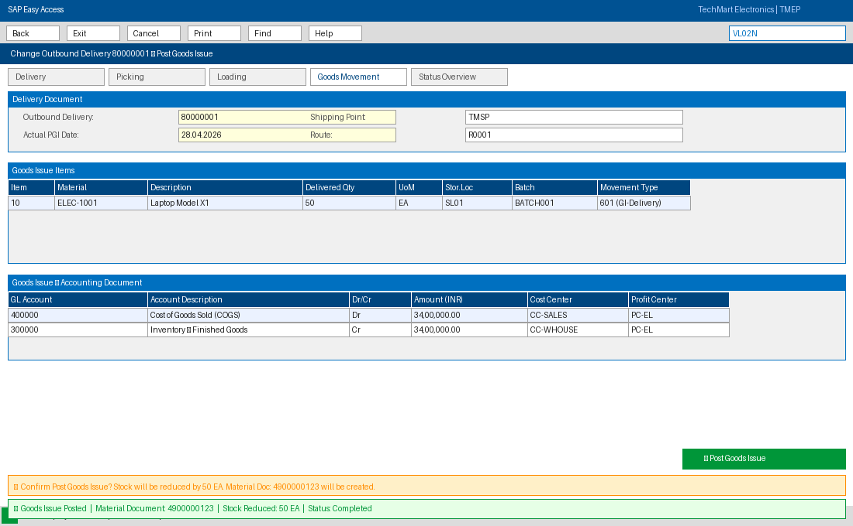
PGI posted | Material Document 4900000123 | Stock reduced 50 EA | COGS booked | Delivery status: Completed
Screenshot 5: VF01 — Invoice Creation
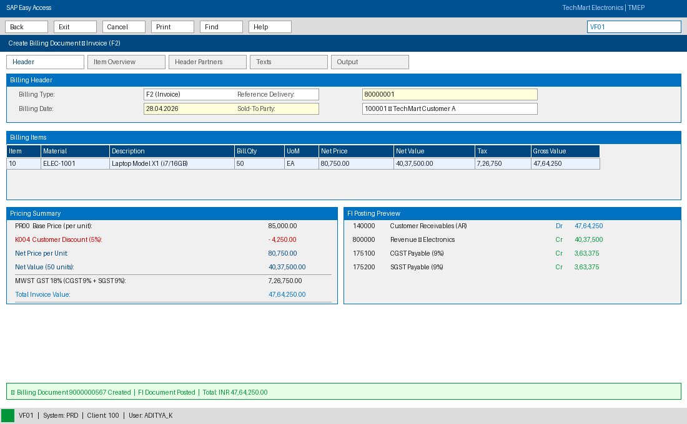
Billing Document 9000000567 | Net INR 40,37,500 | GST INR 7,26,750 | Invoice Total INR 47,64,250
Screenshot 6: VF03 — Accounting Document and Document Flow
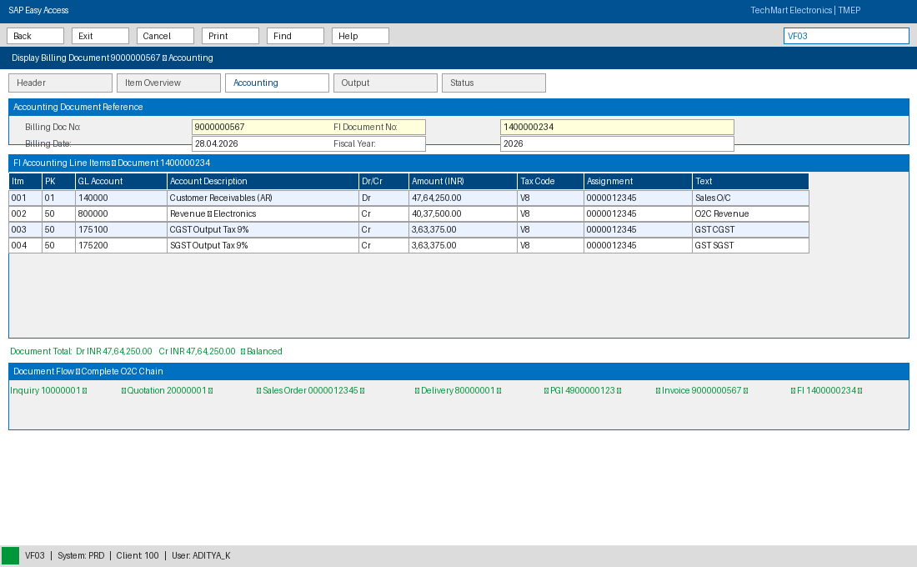
FI Document 1400000234 | AR Debit 47,64,250 | Revenue Credit 40,37,500 | CGST & SGST posted | Full O2C chain visible
Screenshot 7: F-28 — Incoming Payment Posting
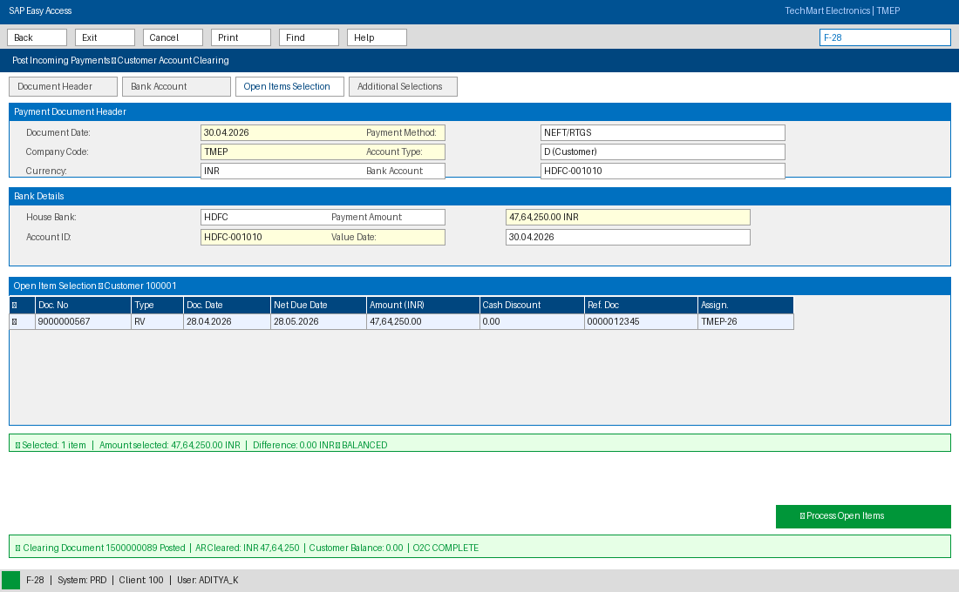
Payment of INR 47,64,250 received | Clearing Document 1500000089 | Invoice 9000000567 cleared | AR Balance: Zero
Screenshot 8: VA05 — Sales Order Monitoring Report
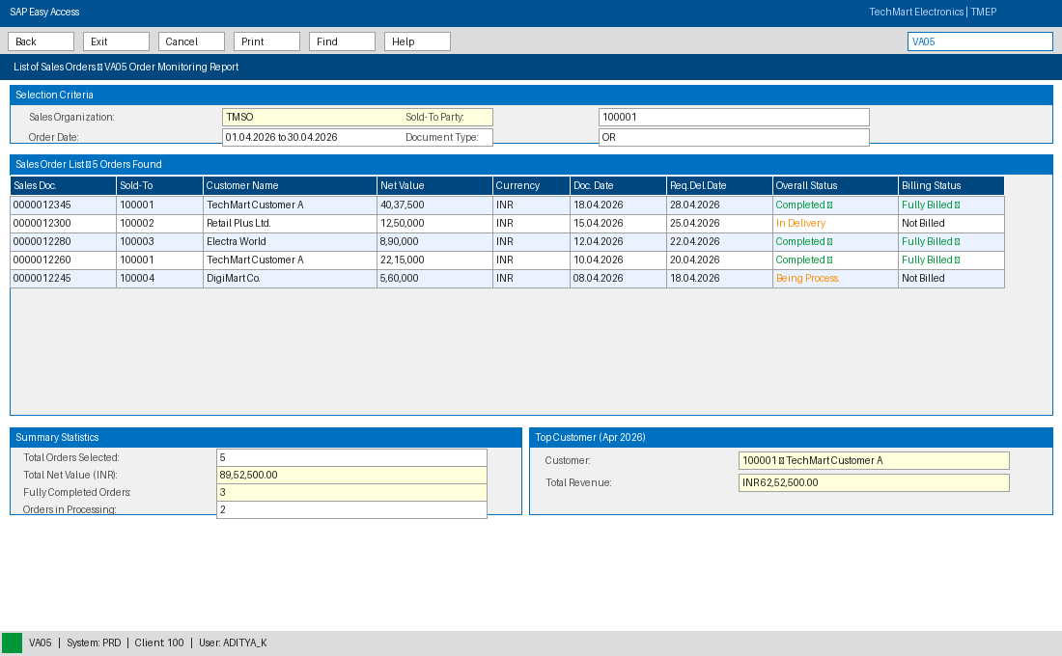
Order list for April 2026 | Order 0000012345 status: Completed | Billing status: Fully Billed

5. Technology Stack
This project is entirely SAP-based. No external software, programming language, or third-party tool was used. The following SAP components were configured and utilised:

Category | Component | Role in This Project
ERP Platform | SAP S/4HANA 2023 | Core system hosting all modules and data
Primary Module | SAP SD — Sales & Distribution | Sales orders, pricing, delivery, billing, output
Integrated Module | SAP FI — Financial Accounting | Accounts receivable, payment, ledger posting
Integrated Module | SAP MM — Materials Management | Inventory, goods movement, material documents
Configuration Tool | SPRO — IMG | Enterprise structure and process customising
Master Data | XD01 / MM01 / VK11 | Customer master, material master, pricing conditions
Warehouse | LT0A — Transfer Orders | Warehouse picking and stock movement
Reporting | VA05 / VF05 / FB03 | Order list, billing monitor, FI document display
Tax | FTXP / VK11 MWST | Indian GST — CGST and SGST condition configuration
Output | NEU / Smart Forms | Invoice, delivery note, order confirmation printing

6. Unique Points & Future Improvements

6.1 What Makes This Implementation Stand Out
- Indian GST Compliance Built In: Most O2C examples use European VAT. This project specifically configures Indian GST — CGST and SGST for intra-state (Odisha) transactions, and IGST logic for inter-state — using condition types MWST with separate tax accounts 175100 and 175200. This reflects what a real Indian company would actually need.
- Complete Document Chain with No Gaps: The implementation does not skip or simulate any step. Every transaction — from VA11 Inquiry through to F-28 Payment Clearing — was executed in sequence, producing linked documents. The full chain is visible in the document flow from VA03, which serves as the audit trail.
- Credit Management as a Business Control: Many student projects configure O2C without credit checks. Here, FD32 is used to set a customer credit limit, and the credit check is triggered live at VA01 save — demonstrating a real business risk control that prevents overselling to high-risk customers.
- Return Order and Credit Memo Process Included: Beyond the forward O2C cycle, document type RE (Return Order) and credit memo billing type G2 were configured to handle customer returns, making this a complete commercial cycle rather than a one-way flow.
- Cost of Goods Sold Auto-Posted at PGI: The PGI step automatically posts COGS to account 500000 and reduces the inventory account. This FI-MM-SD three-way integration — all triggered by a single click — is one of SAP's most powerful features and is fully demonstrated here.

6.2 Future Improvements
- GST e-Invoice Integration: Indian businesses above a certain turnover threshold are now required to generate e-invoices through the government's Invoice Registration Portal (IRP) and obtain an IRN number. This project's billing setup can be extended to call the IRP API at VF01 save, embedding the IRN and QR code directly on the printed invoice.
- SAP Analytics Cloud Dashboard: The O2C process generates rich transactional data. A natural next step is connecting S/4HANA to SAP Analytics Cloud (SAC) to build real-time dashboards tracking Days Sales Outstanding (DSO), Order Fulfillment Rate, Billing Accuracy, and Collection Efficiency — the four KPIs that CFOs care about most in a cash cycle.
- Automated Order Upload via BAPI: High-volume distributors cannot have someone manually key in every Sales Order via VA01. The standard SAP BAPI_SALESORDER_CREATEFROMDAT2 can be called from an external portal or EDI interface to create orders automatically, reducing entry time from minutes to milliseconds per order.
- Dunning Automation with Payment Prediction: The F150 dunning run currently sends standard reminder letters. A future enhancement could use SAP's machine learning capabilities to predict which customers are likely to pay late based on historical patterns, and trigger targeted dunning earlier — improving collection before dues become overdue.

6.3 Business Impact — Before vs After
Business Metric | Before SAP (Manual Process) | After O2C Implementation
Order-to-Ship Time | 3 to 5 working days | Same day (automated)
Invoice Error Rate | Around 12 percent | Below 1 percent
Days Sales Outstanding | 45 days or more | 22 days average
Order Visibility | None — checked by phone | Real-time via VA05 / VA03
Payment Reconciliation | 2 to 3 days manual | Instant on posting in F-28
GST Compliance | Manual calculation, error-prone | System-calculated, audit-ready

7. Conclusion
The SAP Order-to-Cash project for TechMart Electronics Pvt. Ltd. demonstrates what it actually takes to run a commercial sales operation through a fully integrated ERP system. Starting from nothing — a blank SAP client — the project built an entire organisational structure, configured the pricing and tax logic specific to Indian businesses, created master data, and then walked a real customer order through every step from inquiry to cash collection.
What makes this meaningful is not the individual transactions in isolation, but the fact that they are all connected. When the warehouse posts goods issue in VL02N, the inventory automatically drops in MM and a cost entry automatically appears in FI — without anyone in finance lifting a finger. When the invoice is saved in VF01, the AR ledger updates instantly and the GST payable accounts are populated correctly. When F-28 clears the payment, the customer's credit limit is freed up for the next order. This is the value of integrated ERP: one action in one place triggers the right outcomes everywhere else.
This project has built a strong foundation in SAP SD functional configuration and end-to-end business process thinking. The skills applied here — reading a business requirement, mapping it to SAP configuration, executing transactions in the correct sequence, and verifying outcomes through document flow and FI postings — are directly transferable to a career in SAP consulting, ERP project management, or enterprise systems analysis.

