
PROJECT REPORT
Real-Time Object Tracking
Colour, Histogram and Optical-Flow based Tracking using OpenCV
Course: Computer Vision
Slot: F11 + F12
Submitted To: Dr. Neha Rathore
Submitted By: Aditya Chahar
Reg No: 24BAI10371

Index / Table of Contents
S. No. | Section | Description
1 | Introduction | Background, motivation and overview of the project.
2 | Problem Statement | The tracking problem the project sets out to solve.
3 | Objectives | Measurable goals defined for the project.
4 | Functional Requirements | The three functional modules and their capabilities.
5 | Non-Functional Requirements | Performance, usability, portability, reliability and related qualities.
6 | System Architecture | Layered architecture and the responsibility of each layer.
7 | Design Diagrams | Use case, workflow, sequence, component and technique-taxonomy diagrams.
8 | Design Decisions & Rationale | Key technical choices, alternatives and justification.
9 | Implementation Details | Repository structure, algorithms, parameters, setup and behaviour.
10 | Testing Approach | Manual test procedure and expected results.
11 | Challenges Faced | Technical difficulties identified and their resolution or status.
12 | Learnings & Key Takeaways | Skills and insights gained from building the project.
13 | Future Enhancements | Planned improvements.
14 | References | Papers, libraries and documentation consulted.
SECTION - 1

1. Introduction
Overview:
Object tracking is the task of locating a moving object in every frame of a video and following it over time. It sits at the centre of many computer vision applications, including surveillance, traffic monitoring, human-computer interaction, sports analytics and robotics. Modern systems often rely on deep neural networks, but these need training data, heavy computation and usually a GPU. Classical computer vision techniques solve a useful subset of the problem with a fraction of the cost, and they are also the best way to understand what tracking actually involves.
This project implements and compares six classical tracking techniques in Python using OpenCV, all running on a live webcam stream from the command line. Two of them detect an object by its colour in HSV space (a plain colour filter and a contour-based tracker that also draws a movement trail). Two follow an object using the back-projection of its hue histogram, with MeanShift and with CamShift, which adapts its window to the size and orientation of the object. The last two are based on optical flow: Lucas-Kanade tracks a set of sparse feature points, and Farneback estimates a motion vector for every pixel.
Each technique is implemented as its own self-contained script, so a reader can run it, read it and modify its parameters independently of the others. Together they show how the same goal, following something across frames, can be reached through colour, probability distributions and motion.
Key Characteristics:
- Classical, training-free approach - no dataset, model file or GPU is needed. Everything is built from OpenCV and NumPy functions.
- Real-time operation - every script processes the webcam stream frame by frame and displays the annotated result immediately.
- Multiple techniques side by side - colour thresholding, contours, MeanShift, CamShift, sparse optical flow and dense optical flow cover the main families of classical tracking.
- Command-line execution - each program starts with one command and stops when the user presses q.
- Tunable parameters - colour ranges, tracking windows and optical-flow settings are named variables at the top of each script.
SECTION - 2

2. Problem Statement
Problem Statement:
Design and implement a set of real-time object tracking programs that take a live video stream from a camera, locate a moving object or region of interest in every frame using classical computer vision methods, and display the result visually with a bounding shape, a trail or a motion map. The programs must run from the command line, must not depend on any trained model, and should cover colour-based, histogram-based and optical-flow-based tracking so that their behaviour can be compared.
Scope of the Project:
- In scope: live webcam capture, HSV colour segmentation, contour analysis with image moments, MeanShift and CamShift tracking from a hue histogram, Lucas-Kanade sparse optical flow, Farneback dense optical flow, on-screen visualisation and keyboard exit.
- Out of scope: tracking several objects with identity assignment, deep-learning detectors and trackers (for example YOLO or DeepSORT), automatic object selection, re-identification after long occlusion, recording of results to disk, and any graphical user interface beyond the OpenCV display window.
Target Users:
- Students learning the fundamentals of video analysis and object tracking.
- Developers who need a light, dependency-free tracker for a controlled scene, for example a coloured marker in front of a camera.
- Anyone comparing how colour, histogram and motion cues behave on the same live input.
SECTION - 3

3. Objectives
Objectives:
1. To capture a live video stream from a webcam and process it frame by frame in real time.
2. To detect objects by colour by converting frames from BGR to HSV and applying a configurable range filter.
3. To locate the largest coloured blob using contours, compute its enclosing circle and centroid with image moments, and draw a movement trail that is cleared when the object disappears.
4. To track a region using the back-projection of its hue histogram with MeanShift, and to extend it to CamShift so that the tracking window adapts to size and rotation.
5. To track a set of Shi-Tomasi feature points with the Lucas-Kanade pyramidal optical-flow algorithm and draw their trajectories.
6. To compute Farneback dense optical flow and visualise motion direction and speed for every pixel as a colour image.
7. To keep every program runnable from the command line with a single command and a simple exit key.
8. To document the setup, parameters, known limitations and observed behaviour of every technique so that the project can be reproduced by someone with no prior context.
SECTION - 4

4. Functional Requirements
Major Functional Modules:
The project is organised into three functional modules. Each module groups scripts that use the same kind of cue for tracking, and every script is independent, so a module can be run or modified without touching the others.
Module 1 - Colour-based Detection and Contour Tracking
ID | Requirement | Description
FR-1.1 | Frame capture | Frames are read from the default webcam (device 0) in a continuous loop until the user quits.
FR-1.2 | HSV colour filter | Each frame is converted from BGR to HSV and pixels inside a configurable [H,S,V] range are kept using cv2.inRange (trackColor.py).
FR-1.3 | Filtered views | The original frame, the binary mask and the masked colour image are displayed in three windows.
FR-1.4 | Largest-blob detection | Contours are extracted from the mask and the contour with the largest area is treated as the object (trackObject.py).
FR-1.5 | Centroid and enclosing circle | The centroid is computed from image moments (m10/m00, m01/m00) and the minimum enclosing circle is drawn; blobs with radius of 25 pixels or less are ignored as noise.
FR-1.6 | Movement trail | Successive centroids are stored and joined by lines; the trail is cleared after 10 consecutive frames without a valid object.

Module 2 - Histogram Back-projection Tracking (MeanShift and CamShift)
ID | Requirement | Description
FR-2.1 | Initial window | A starting window (240, 100, 400, 160) selects the region whose colour histogram defines the target.
FR-2.2 | Hue histogram model | The hue channel of the region is masked with an HSV range, histogrammed with 180 bins and normalised to 0-255.
FR-2.3 | Back-projection | For every frame, cv2.calcBackProject converts the frame into a probability image of belonging to the target histogram.
FR-2.4 | MeanShift tracking | cv2.meanShift moves the window towards the densest region of the probability image; the window is drawn as a rectangle (meanshiftOT.py).
FR-2.5 | CamShift tracking | cv2.CamShift additionally adapts the window size and orientation; the result is drawn as a rotated box using cv2.boxPoints and cv2.polylines (camshiftOT.py).
FR-2.6 | Termination criteria | The window search stops after at most 10 iterations or when the centre moves by less than 1 pixel.

Module 3 - Optical-Flow Based Motion Tracking
ID | Requirement | Description
FR-3.1 | Corner detection | Up to 100 strong corners are detected in the first frame with cv2.goodFeaturesToTrack (quality level 0.3, minimum distance 7, block size 7).
FR-3.2 | Lucas-Kanade tracking | Corners are followed between frames with cv2.calcOpticalFlowPyrLK using a 15x15 window and 2 pyramid levels; only successfully tracked points are kept.
FR-3.3 | Trajectory drawing | A coloured line is drawn between the old and new position of each point on a persistent canvas, and the current position is drawn as a filled circle (kanadeOpticalFlowOT.py).
FR-3.4 | Dense flow | cv2.calcOpticalFlowFarneback computes a flow vector for every pixel between consecutive greyscale frames (denseOpticalFlow.py).
FR-3.5 | Flow visualisation | Flow vectors are converted to polar form; direction is mapped to hue and speed to brightness, and the result is shown as a colour image.

Input / Output Structure:
Program | Input | Output
trackColor.py | Webcam frames, HSV range | Three windows: original, binary mask, colour-filtered image
trackObject.py | Webcam frames, HSV range | Frame with enclosing circle, centroid dot and movement trail
meanshiftOT.py | Webcam frames, start window, HSV range | Frame with tracking rectangle
camshiftOT.py | Webcam frames, start window, HSV range | Frame with rotated tracking box
kanadeOpticalFlowOT.py | Webcam frames | Frame with feature points and coloured trails
denseOpticalFlow.py | Webcam frames | Colour-coded dense motion image
SECTION - 5

5. Non-Functional Requirements
Quality Attributes:
ID | Attribute | Requirement and Design Response
NFR-1 | Performance | Each frame is processed with a small number of OpenCV calls and displayed with cv2.waitKey(1), so the programs are designed to run in real time on an ordinary laptop CPU. Dense optical flow is the most expensive step; the other techniques are lighter.
NFR-2 | Usability | Every program starts with one command and stops with the q key. A short comment above each OpenCV call explains what it does.
NFR-3 | Portability | Only Python, OpenCV and NumPy are required, all of which run on Windows, Linux and macOS. No GPU, model file or dataset is needed.
NFR-4 | Maintainability | Each technique lives in its own short script. Colour ranges, the tracking window, corner-detection settings and flow parameters are named variables at the top, so behaviour can be tuned without changing the loop logic.
NFR-5 | Configurability | The HSV range (color_range), the initial window (track) and the parameter dictionaries params_kanade and params_corner can be edited to adapt a program to a different object or scene.
NFR-6 | Reliability | The MeanShift and CamShift loops check whether a frame was read and exit cleanly if not. Some other scripts do not yet perform this check; this is listed as a known limitation and as future work.
NFR-7 | Privacy | All processing is local. Frames are only held in memory for display; nothing is stored to disk or sent over a network.
NFR-8 | Resource use | Memory use is limited to a few frame-sized arrays per program. The Lucas-Kanade canvas and the trail list are the only structures that grow, and the trail list is reset when the object disappears.
SECTION - 6

6. System Architecture
Architectural Overview:
The project follows a simple four-layer pipeline. Data flows upward from the camera to the display, and each layer only depends on the one below it. Keeping the layers separate makes it easy to swap the input (for example a video file instead of a webcam) or add a new tracking technique without changing the rest.
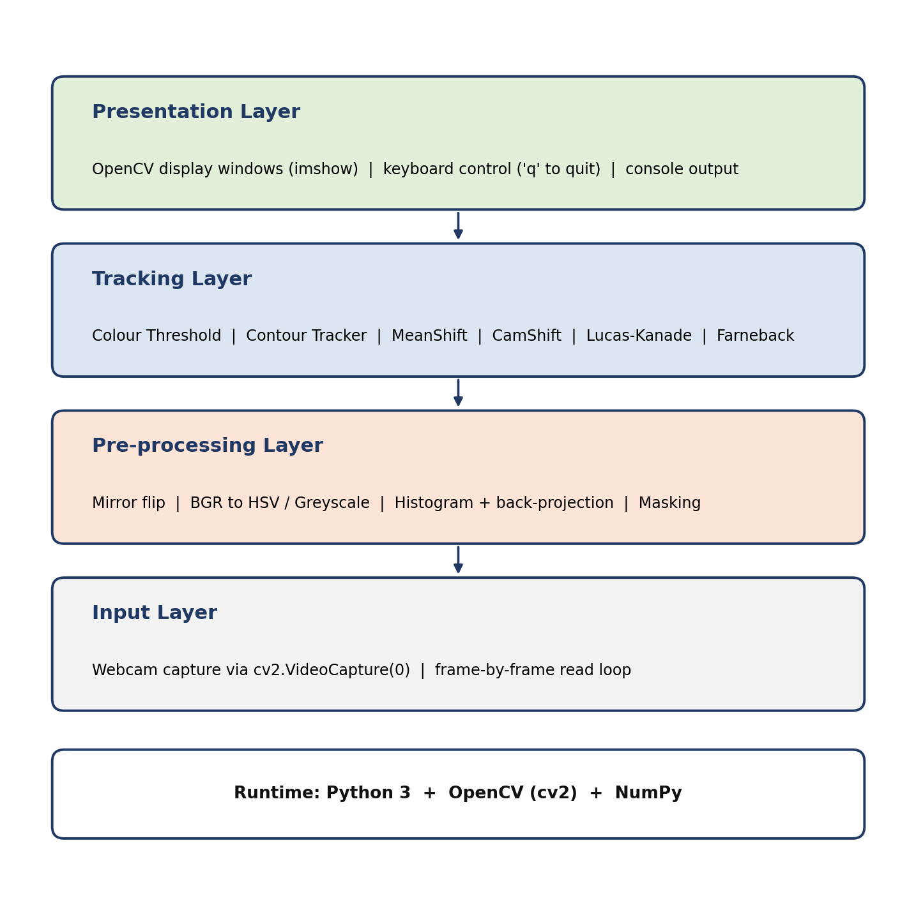
Fig 6.1 - Layered architecture of the object tracking system
Input Layer
Frames are acquired from the webcam with cv2.VideoCapture(0) inside a continuous read loop. Every frame is a NumPy array in BGR order. The captured frame is mirror-flipped with cv2.flip so that movement on screen matches the user's movement.
Pre-processing Layer
This layer prepares each frame for the tracker: conversion from BGR to HSV for the colour-based and histogram-based methods, conversion to greyscale for optical flow, thresholding with cv2.inRange to build a mask, and calcHist / calcBackProject to convert a hue histogram into a probability image.
Tracking Layer
This layer holds the six tracking techniques: colour threshold, contour tracker with moments, MeanShift, CamShift, Lucas-Kanade sparse flow and Farneback dense flow. Each takes the pre-processed frame and returns the updated object position, the set of point positions or the flow field.
Presentation Layer
Results are drawn directly onto the frame (rectangles, circles, rotated boxes, lines, points) or shown as a separate image (mask, flow map) and displayed with cv2.imshow. The q key ends the loop, releases the camera and closes all windows.
SECTION - 7

7. Design Diagrams

7.1 Use Case Diagram:
The user is the only actor. After starting a program the user watches the tracking result and quits with the q key.
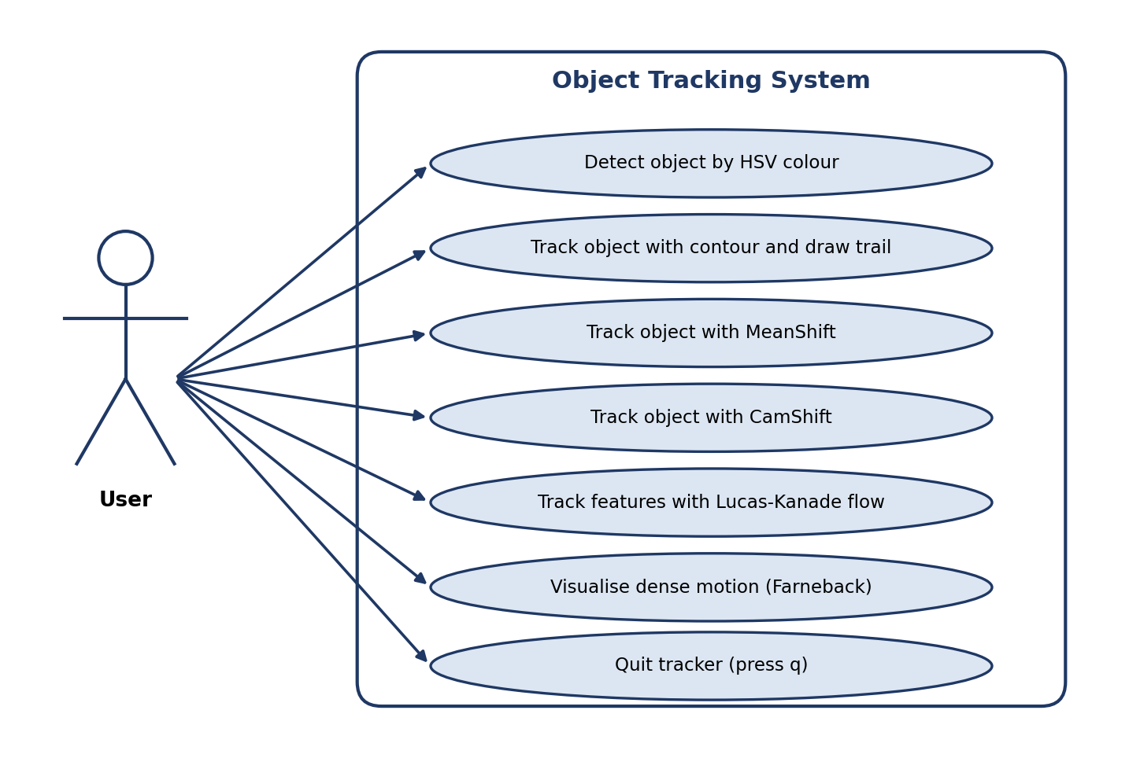
Fig 7.1 - Use case diagram of the object tracking system

7.2 Process Flow / Workflow Diagram:
All six programs share the same outer loop: read a frame, flip it, pre-process it, apply the tracker, draw the result and display it. The loop ends when q is pressed.
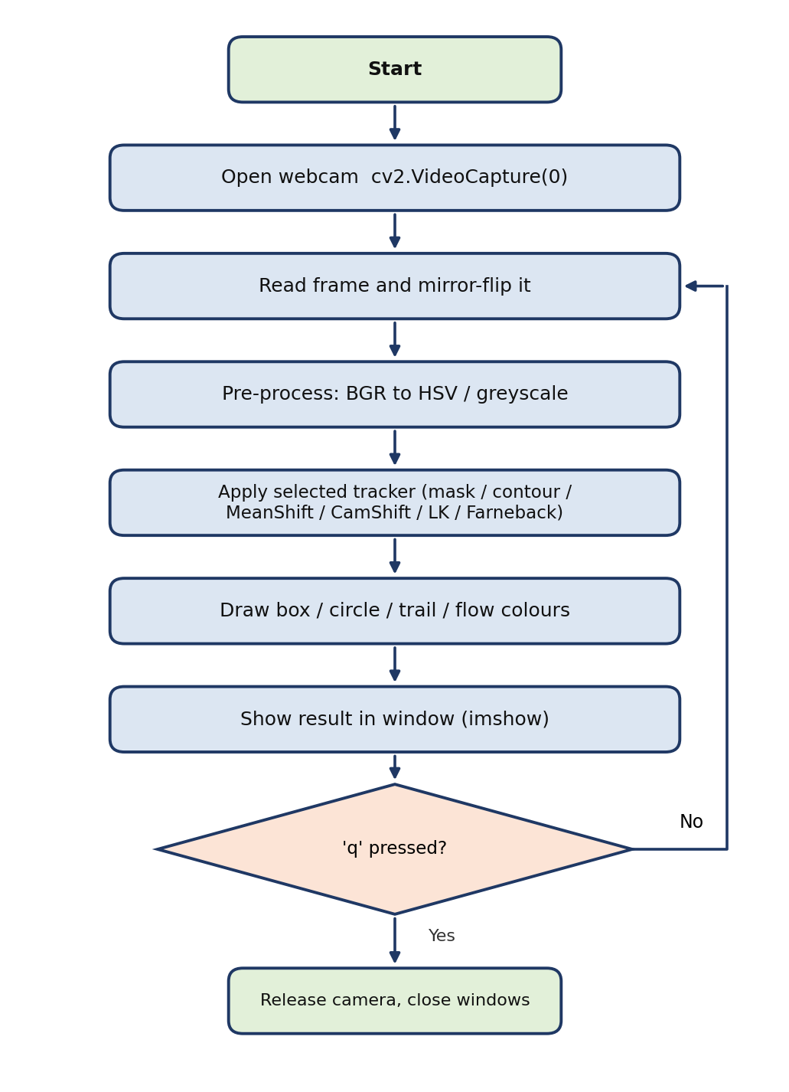
Fig 7.2 - End-to-end tracking workflow

7.3 Sequence Diagram:
The sequence shows the interaction between the user, the Python script, OpenCV and the webcam for one run of a program.
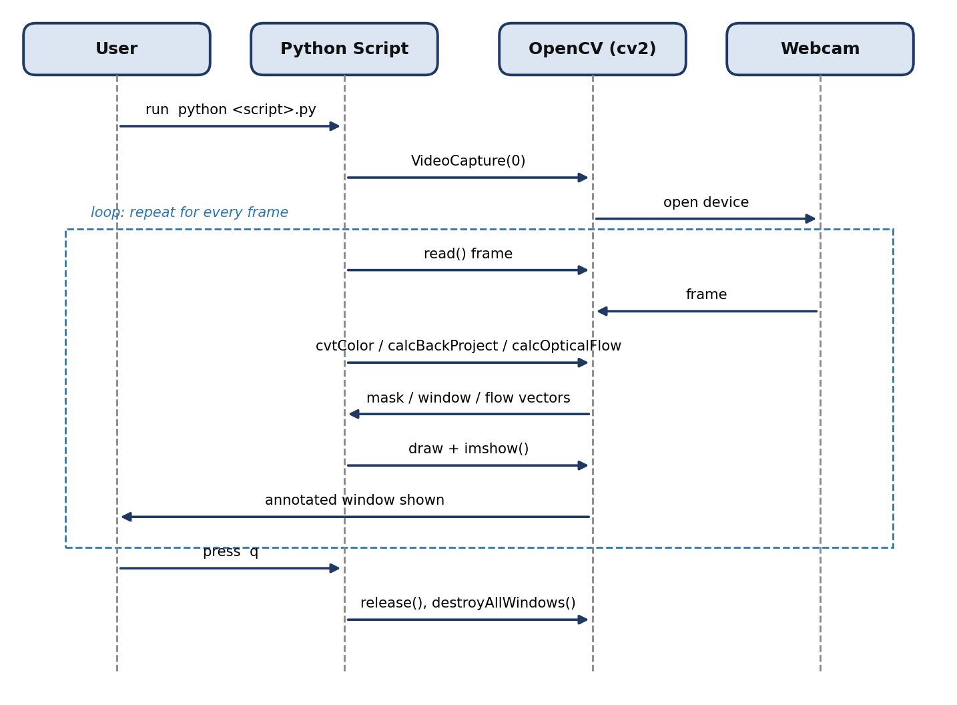
Fig 7.3 - Sequence diagram for a tracking session

7.4 Component / Module Diagram:
The project consists of six independent scripts. Each one takes the same camera frames as input and relies on a different set of OpenCV functions.
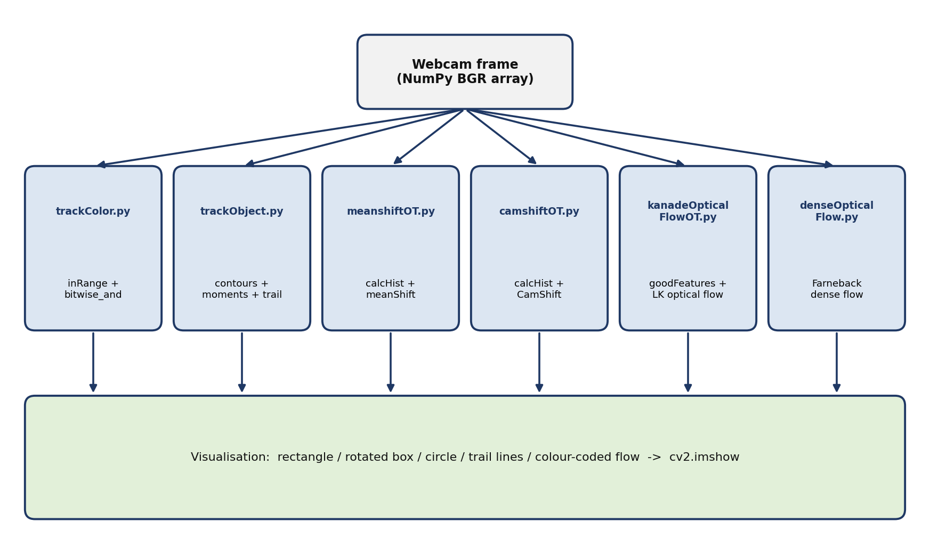
Fig 7.4 - Component and module structure

7.5 Technique Taxonomy Diagram:
Because the project has no database, the entity-relationship diagram of a typical application is replaced by a taxonomy that groups the scripts by the kind of cue they use to follow the object.
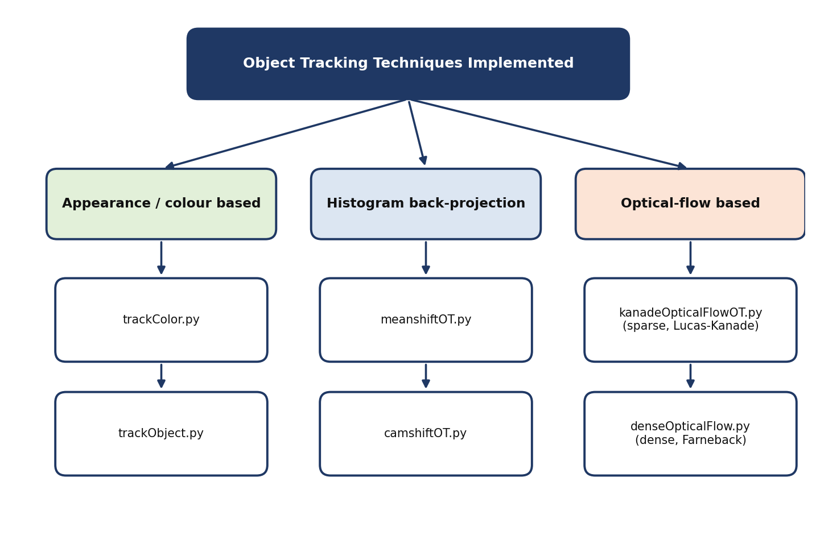
Fig 7.5 - Taxonomy of the tracking techniques implemented
SECTION - 8

8. Design Decisions & Rationale
Key Decisions:
Decision | Alternatives Considered | Rationale
Classical computer vision with OpenCV | Deep-learning detectors and trackers (YOLO, DeepSORT, Siamese trackers) | The course focuses on the fundamentals of tracking. Classical methods need no training data or GPU, run in real time on a laptop and make every step of the algorithm visible and explainable.
HSV colour space for segmentation | Thresholding directly in BGR | In HSV the colour (hue) is separated from brightness (value), so a colour range stays valid when the lighting changes slightly. In BGR all three channels move together with the light.
Largest contour with a minimum radius of 25 px | Using every contour; using the mask centroid directly | Small blobs are usually noise. Taking only the largest contour and ignoring anything with a radius of 25 pixels or less avoids jumping to tiny false detections.
Centroid from image moments | Centre of the bounding box | Moments give the centre of mass of the blob, which is more stable than the bounding-box centre when the contour changes shape.
Trail cleared after 10 empty frames | Never clearing; clearing on the first missed frame | A short tolerance keeps the trail through brief detection dropouts, while clearing after 10 frames prevents an old trail from staying on screen once the object has really gone.
Hue histogram with back-projection | Template matching; tracking on raw pixel values | A histogram describes the colour distribution of an object without depending on its exact pixel layout, so it stays valid when the object rotates or changes shape a little.
MeanShift and CamShift both implemented | Only one of the two | MeanShift uses a fixed-size window and is simple and fast. CamShift adapts the window size and orientation, which suits objects that move towards or away from the camera. Implementing both makes the difference visible.
Lucas-Kanade on Shi-Tomasi corners | Tracking every pixel; tracking a hand-picked point | Optical flow works best on well-textured points. Corners are the points that can be tracked most reliably, and following only up to 100 of them is cheap.
Farneback for dense flow | Horn-Schunck; deep-learning flow networks | Farneback is available directly in OpenCV, needs no training and gives a motion vector for every pixel, which makes it a good complement to the sparse method.
Mapping flow direction to hue and speed to brightness | Drawing arrows for every pixel | A colour image shows the whole motion field at once and is easier to read than thousands of arrows.
One self-contained script per technique | One large program with a mode switch | Every technique can be read, run and modified on its own, which is better for learning and for evaluation.
Mirror-flipped frames | Showing the raw camera image | A mirrored view feels natural, because moving the object to the right also moves it to the right on screen.
SECTION - 9

9. Implementation Details
Technology Stack:
Layer | Technology
Language | Python 3.8 or newer
Computer vision | OpenCV (opencv-python)
Numerical computing | NumPy
Input | Webcam through cv2.VideoCapture(0)
Output | OpenCV windows (cv2.imshow)
Environment | Python virtual environment with pip

Repository Structure:
object-tracking/
├── trackColor.py HSV colour thresholding
├── trackObject.py contour + moments tracking with trail
├── meanshiftOT.py MeanShift tracking
├── camshiftOT.py CamShift tracking
├── kanadeOpticalFlowOT.py Lucas-Kanade sparse optical flow
├── denseOpticalFlow.py Farneback dense optical flow
├── requirements.txt
├── README.md
└── Project_Report.docx

Core Implementation Logic:
Colour Detection and Contour Tracking
1. A frame is read from the webcam, mirror-flipped and converted from BGR to HSV.
2. cv2.inRange keeps the pixels inside color_range and produces a binary mask. In trackColor.py the mask is combined with the frame using cv2.bitwise_and.
3. In trackObject.py, cv2.findContours extracts the contours of the mask and the contour with the largest area is selected.
4. cv2.minEnclosingCircle gives the circle around the blob and cv2.moments gives its centroid (m10/m00, m01/m00).
5. If the radius is greater than 25 pixels the circle and centroid are drawn and the centroid is appended to a list of points; consecutive points are joined by lines to form the trail.
6. If no valid object is found for 10 frames, the list of points is cleared.
MeanShift and CamShift
1. The first frame is read and the initial window is cropped from it.
2. The crop is converted to HSV, masked with cv2.inRange, and its hue histogram (180 bins) is computed with cv2.calcHist and normalised to the range 0-255.
3. For every new frame, cv2.calcBackProject projects the histogram onto the hue channel to produce a probability image.
4. cv2.meanShift (or cv2.CamShift) iteratively moves the window towards the region of highest probability, with at most 10 iterations and a movement threshold of 1 pixel.
5. MeanShift draws the resulting window as a rectangle. CamShift returns a rotated rectangle, which is converted to four corner points with cv2.boxPoints and drawn with cv2.polylines.
Lucas-Kanade Sparse Optical Flow
1. Strong corners are detected in the first greyscale frame with cv2.goodFeaturesToTrack.
2. For every new frame, cv2.calcOpticalFlowPyrLK estimates where each corner has moved, and a status array marks the points that were tracked successfully.
3. The successfully tracked old and new positions are paired. A coloured line joins each pair on a persistent canvas and a filled circle marks the new position.
4. The canvas is added to the current frame with cv2.add, and the new positions become the points to track in the next iteration.
Farneback Dense Optical Flow
1. The previous and current greyscale frames are passed to cv2.calcOpticalFlowFarneback, which returns a two-channel array with the horizontal and vertical motion of every pixel.
2. cv2.cartToPolar converts the vectors to magnitude (speed) and angle (direction).
3. The angle is stored in the hue channel, the speed normalised to 0-255 in the value channel and saturation is fixed at 255. The image is converted from HSV to BGR and displayed.

Key Parameters:
Program | Parameter | Value
trackObject.py | color_range | [[0,0,0],[179,50,100]] - dark, low-saturation objects
trackObject.py | Minimum radius / trail reset | 25 px / 10 frames without a detection
meanshiftOT.py | color_range / start window | [[0,0,128],[0,0,255]] / (240, 100, 400, 160)
camshiftOT.py | color_range / start window | [[0,0,0],[0,0,0]] (placeholder, to be set) / (240, 100, 400, 160)
MeanShift, CamShift | Termination criteria | 10 iterations or 1 pixel movement
kanadeOpticalFlowOT.py | Corner detection | maxCorners 100, qualityLevel 0.3, minDistance 7, blockSize 7
kanadeOpticalFlowOT.py | Lucas-Kanade | winSize (15,15), maxLevel 2, criteria 10 iterations / 0.03
denseOpticalFlow.py | Farneback | pyr_scale 0.5, levels 3, winsize 15, iterations 3, poly_n 5, poly_sigma 1.2, flags 0

Setup and Execution:
1. Clone the repository and change into its directory.
2. Create a virtual environment with python -m venv venv and activate it (source venv/bin/activate on Linux or macOS, venv\Scripts\activate on Windows).
3. Install the dependencies with pip install -r requirements.txt (opencv-python and numpy).
4. Confirm the installation with python -c "import cv2, numpy; print(cv2.__version__)".
5. Connect a webcam and run any program, for example python trackObject.py. The programs are: trackColor.py, trackObject.py, meanshiftOT.py, camshiftOT.py, kanadeOpticalFlowOT.py and denseOpticalFlow.py.
6. For the colour-based programs, edit color_range to match the object being tracked. For MeanShift and CamShift, hold the object inside the start window when the program starts.
7. Press q in the video window to quit. To use a video file instead of a webcam, replace cv2.VideoCapture(0) with cv2.VideoCapture("video.mp4").

Observed Behaviour:
The table below describes how each program behaves according to its implementation. Screenshots taken during a run can be added under it.
Program | Behaviour
trackColor.py | Only pixels inside the HSV range remain visible in the filtered window and appear white in the mask. The result depends directly on how well the range matches the object.
trackObject.py | The largest dark blob is enclosed by a red circle with a green centroid dot, and a green trail follows its movement. Small blobs are ignored. When the object leaves the view for 10 frames the trail disappears.
meanshiftOT.py | The rectangle stays at a fixed size and follows the region with the densest match to the stored hue histogram. It works best when the object's colour is distinct from the background.
camshiftOT.py | The tracking box can change size and rotate, so it fits an object that turns or moves closer to the camera, provided a valid colour range has been set.
kanadeOpticalFlowOT.py | Coloured trails follow the feature points as they move. Points on textured, moving objects are tracked; points are lost when they leave the frame or are occluded.
denseOpticalFlow.py | Moving regions appear in colour, with hue showing direction and brightness showing speed. Static regions remain dark.

SECTION - 10

10. Testing Approach
Strategy:
The programs are interactive and depend on a live camera, so testing is manual and is carried out by running each program and observing the result. Each test below states the procedure and the expected result, and can be repeated on any machine with a webcam.
Test Coverage:
Type | Target | Procedure and Expected Result
Functional | Camera capture | Run any program. The video window opens and shows a mirrored live image; pressing q closes it and releases the camera.
Functional | trackColor.py | Hold an object inside the configured colour range. It appears in the filtered window and in the mask; objects outside the range do not.
Functional | trackObject.py | Move an object of the configured colour across the view. A circle and centroid follow it and a trail is drawn behind it.
Boundary | trackObject.py noise filter | Show a very small object. No circle is drawn because its radius is 25 pixels or less.
Boundary | trackObject.py trail reset | Remove the object from view and wait 10 frames. The trail disappears.
Functional | meanshiftOT.py / camshiftOT.py | Place the object in the start window and move it slowly. The rectangle (MeanShift) or rotated box (CamShift) follows it.
Functional | CamShift adaptation | Move the object closer to and further from the camera and rotate it. The CamShift box changes size and orientation; the MeanShift rectangle keeps its size.
Functional | kanadeOpticalFlowOT.py | Move a textured object. Coloured trails follow the tracked corners.
Functional | denseOpticalFlow.py | Wave a hand in different directions. Moving areas change colour with direction; a still scene stays dark.
Robustness | Lighting and background | Change the lighting and add a similarly coloured object to the background. Observe how tracking degrades; this documents the limits of the colour-based methods.
Compatibility | OpenCV / NumPy versions | Run the programs on the installed versions and check the compatibility notes in the README for any required changes.
SECTION - 11

11. Challenges Faced
Challenges and Resolutions:
1. Choosing the colour range. HSV tracking only works when color_range matches the object. The ranges are exposed as named variables at the top of each script so they can be adjusted, and the README explains how to find them. The colour ranges in the scripts differ per program and the CamShift range is a placeholder that has to be set before use.
2. Hue histograms and grey or white objects. A hue histogram carries no useful information for objects with very low saturation, because their hue is not meaningful. The MeanShift script masks with a low-saturation, high-brightness range to select bright pixels, but a saturation-aware or value-aware histogram would be more robust for such objects.
3. Consistent start window. The start window is used as (x, y, width, height) by the tracker but is also used to crop the first frame with row and column indexing. The two uses do not describe the same area, so the histogram region and the tracking window differ. This was identified as an inconsistency and is listed in the README with the fix.
4. Filtering out false detections. In the contour tracker, small noisy blobs caused the circle to jump. A minimum radius of 25 pixels and the choice of the largest contour reduced false detections.
5. Trail management. The trail had to stay continuous during brief dropouts and be removed once the object left the scene. A counter that clears the trail after 10 frames without a detection solves both.
6. Losing points in Lucas-Kanade tracking. Feature points are lost when they leave the frame or are occluded, and the programme keeps only the points that were tracked successfully. If every point is lost, the next iteration cannot continue, so re-detecting corners is documented as an improvement.
7. Colour wrap-around in dense flow visualisation. OpenCV stores hue in the range 0-179, and the angle scaling used produces values beyond this range, which makes colours wrap. The correct scaling of the angle is documented in the README.
8. Library version differences. cv2.findContours returns two values in OpenCV 4 and three in OpenCV 3, np.int0 was removed in NumPy 2.0, and newer OpenCV releases reject floating-point drawing coordinates. These differences are documented in the README with the corresponding fixes, and requirements.txt pins NumPy below 2.0.
9. Lighting sensitivity. Colour-based methods are affected by changes in lighting and by similarly coloured background objects. This is an inherent limitation of colour cues and is why optical-flow methods, which rely on motion, were included for comparison.
SECTION - 12

12. Learnings & Key Takeaways
Key Takeaways:
- Colour segmentation in HSV is much more stable than in BGR, but it still depends entirely on choosing the right range and on constant lighting.
- Back-projection turns a histogram into a probability image, and MeanShift and CamShift then reduce tracking to finding the peak of that image. CamShift's added ability to adapt the window makes it the better choice when the object changes scale or orientation.
- Sparse optical flow follows individual points cheaply but loses them over time, while dense optical flow describes all motion in the scene at a higher computational cost. Each suits different problems.
- A method should be chosen for the cue that is reliable in the scene: colour when the object has a distinct colour, motion when the camera is still and the object moves.
- Small details such as the return signature of a function, the value range of the hue channel or the coordinate convention of a window can silently break a computer vision program. Reading the OpenCV documentation for each function is essential.
- Keeping each technique in its own script makes experimentation simple, because parameters can be changed and the effect observed immediately.
- Documenting the setup and limitations clearly is part of the work: a project is only useful if someone else can run it and know where it fails.
SECTION - 13

13. Future Enhancements
Planned Work:
1. Apply the compatibility fixes listed in the README (findContours return value, NumPy integer type, integer drawing coordinates, hue scaling and consistent start window) so that all six programs run unchanged on current OpenCV and NumPy releases.
2. Add a check on the result of capture.read() in every script, and support a command-line argument for a video file so that programs can run without a webcam.
3. Let the user select the object with the mouse (cv2.selectROI) and compute the colour range automatically from the selected region instead of editing the code.
4. Use a hue-saturation histogram, and re-detect Lucas-Kanade corners when too few points remain.
5. Add a Kalman filter to smooth the trajectory and predict the position during short occlusions.
6. Save the annotated output to a video file and log the tracked positions to a CSV file for later analysis.
7. Measure and compare frame rate and accuracy of the six techniques on recorded videos.
8. Support multiple objects with identity assignment, and try modern trackers such as the ones provided in OpenCV's tracking module or deep-learning based trackers for comparison.
9. Combine techniques, for example using optical flow to detect motion and CamShift to follow the detected region.
SECTION - 14

14. References
References:
1. OpenCV Documentation - https://docs.opencv.org/
2. NumPy Documentation - https://numpy.org/doc/
3. Python Documentation - https://docs.python.org/3/
4. Bradski, G., The OpenCV Library, Dr. Dobb's Journal of Software Tools, 2000.
5. Comaniciu, D. and Meer, P., Mean Shift: A Robust Approach Toward Feature Space Analysis, IEEE Transactions on Pattern Analysis and Machine Intelligence, 24(5), 2002.
6. Bradski, G. R., Computer Vision Face Tracking for Use in a Perceptual User Interface, Intel Technology Journal, Q2 1998.
7. Lucas, B. D. and Kanade, T., An Iterative Image Registration Technique with an Application to Stereo Vision, Proceedings of IJCAI, 1981.
8. Shi, J. and Tomasi, C., Good Features to Track, IEEE Conference on Computer Vision and Pattern Recognition, 1994.
9. Farneback, G., Two-Frame Motion Estimation Based on Polynomial Expansion, Scandinavian Conference on Image Analysis, 2003.
10. Project repository - README.md and source files, Real-Time Object Tracking.

