Research and Implementation Report
An Agentic AI and IoT-Based Intelligent Soil Monitoring and Precision Management System for Mango Orchards

1. Summary
This report documents the design, implementation and simulated evaluation of an agentic irrigation-management system for mango orchards. The software package accompanying it contains ESP32 firmware, an MQTT/HTTP backend, a DQN-based decision agent with a deterministic safety guard, a web dashboard, a soil-water simulator and a test suite of 21 automated tests.
In simulation on 30 unseen random weather years, the agentic policy kept the root zone inside its stage-specific target band on 61.8% of days, against 54.3% for a conventional threshold rule, 21.4% with no irrigation and 18.1% for a fixed calendar schedule. It reduced days below the target band from 8.2% (threshold rule) to 0.3%, at the price of about 52 mm more irrigation water per year (683 mm against 631 mm). The fixed schedule used more than twice as much water as any adaptive policy and lost about 1,040 mm a year to deep drainage.
These numbers come from a simulator with assumed soil constants and target bands. They show that the approach is sound under those assumptions, not that it will give the same gains in a particular orchard. Section 8 lists what must be done before field use.

2. Background and literature

2.1 Why stage-aware irrigation matters for mango
Guidance from mango-growing regions agrees on the broad pattern. The Northern Territory Department of Agriculture advises that irrigation is highly recommended from flowering until late fruit maturity, that it normally stops a few weeks before harvest and does not restart until flowering in the next season, and that the actual rate should be set for each site using soil-moisture monitoring (tensiometers, neutron probes or capacitance sensors). The Queensland Water for Profit benchmark lists the same phases: withholding water in the pre-flowering dormancy period to improve flowering, avoiding stress during flowering, fruit set and fruit development, reducing irrigation one to two weeks before harvest, and restarting irrigation immediately after harvest.
Field trials support deficit strategies rather than constant wetting. An Indian Council of Agricultural Research study on the hybrid Amrapali compared deficit drip irrigation levels with mulching, and Hahn and Garcia (2022) found that reduced deficit irrigation gave yield similar to daily irrigation in a high-density orchard while improving water-use efficiency. The practical lesson for a controller is that the target moisture changes with the season, and that a policy which simply keeps soil wet all year wastes water and may harm flowering.

2.2 Sensing and decision methods
Soil-moisture sensing in mango orchards is usually done with capacitance probes or tensiometers placed in the root zone, often combined with plant-based sensors such as dendrometers. Capacitance probes are cheap and suit a low-cost IoT node, but they need soil-specific calibration. On the decision side, reinforcement learning has been applied to irrigation because the problem is sequential, weather is uncertain and the cost of mistakes is delayed. The DQN of Mnih et al. (2015) and its Double-DQN refinement by van Hasselt et al. (2016) are standard value-based methods. The agentic pattern of reasoning, acting through tools and observing results is described in general form by Yao et al. (2023); here the pattern is applied conservatively, with learned and language-model components restricted to proposing and explaining while a fixed rule set holds the final say over the valve.

2.3 Gap addressed
- Monitoring-only systems display data but do not decide or explain.
- Simulation-only learners rarely describe a deployment path or protect against hardware faults.
- Few systems encode mango's stage-dependent water requirement, including the deliberate dry period before flowering.

3. System architecture
Layer | Components | Role
Field node | ESP32, capacitive soil probe, DHT22, relay and solenoid valve | Sample every 15 min, publish JSON, close the valve on a local timer even if offline
Transport | MQTT (Mosquitto) and HTTP | Telemetry in, valve commands out
Backend | FastAPI, SQLite | Validation, storage, scheduling, REST API, optional API key
Agent | DQN planner, safety guard, advisories, optional LLM explainer | Perceive, propose, check, act, remember
Interface | Web dashboard | Live chart, decision log, alerts, manual valve, weather input
Simulator | Soil-water balance and weather generator | Training and offline evaluation

3.1 Agent loop
- Perceive: take the median soil moisture over the last 24 hours, mean temperature and humidity, weather input, calendar-derived growth stage and days since the last irrigation.
- Reason: the DQN scores four actions (0, 6, 12 or 20 mm) and proposes the best.
- Guard: the proposal is reviewed. Irrigation is blocked if rain is falling or forecast, if the soil is already above the band, or during the pre-flowering dry phase unless the soil is close to wilting. Events are capped at 20 mm and a rolling 7-day budget of 60 mm applies. If the sensor is missing, implausible or stuck, no irrigation is issued and an alert is raised. Near the wilting point outside pre-flowering, the guard forces an emergency 12 mm.
- Act: millimetres are converted to valve minutes using the drip application rate and sent over MQTT or returned in the HTTP reply.
- Remember and explain: the decision, reasons, alerts and a plain-language note are stored. If an Anthropic API key is configured, a language model rewrites the note for the farmer; if the call fails, a template note is used. The language model never changes the amount.

4. Methodology

4.1 Soil-water model
The root zone is modelled as a single layer 500 mm deep, so 1 mm of water changes volumetric water content (VWC) by 0.2 percentage points. Each day: store = previous store + rain + irrigation - actual evapotranspiration - drainage. Reference evapotranspiration follows a Hargreaves-type temperature formulation (Allen et al., 1998 describe the underlying FAO approach), scaled by a stage-specific crop coefficient (0.70 to 1.00) and reduced when the soil is dry. Half of any water above field capacity (32% VWC) drains each day; anything above saturation (42%) is lost at once. The wilting point is 12%.

4.2 Target bands
Stage (months, N. India) | Band (VWC %) | Reasoning
Pre-flowering (Oct-Jan) | 12 - 20 | Deliberate mild dryness before flowering
Flowering (Feb-Mar) | 22 - 30 | Avoid stress during flowering and fruit set
Fruit development (Apr-May) | 24 - 32 | Highest demand, protect fruit growth
Pre-harvest (Jun) | 19 - 26 | Reduced irrigation ahead of harvest
Post-harvest (Jul-Sep) | 22 - 30 | Restart growth after harvest, mostly rain-fed
The bands are defaults chosen to follow the qualitative guidance in Section 2.1. They are not measured values for any variety or soil, and they are the first thing to calibrate locally.

4.3 DQN formulation
- State (12 values): scaled soil moisture, one-hot stage, temperature, humidity, rain today, forecast rain, days since irrigation, reference evapotranspiration.
- Actions: 0, 6, 12 or 20 mm of irrigation per day.
- Reward: +1 inside the band; a distance penalty outside it (steeper for dryness); 0.03 per mm of water; extra penalties for irrigating soil that is already too wet, for irrigating ahead of forecast rain of 8 mm or more, and for drainage loss.
- Network: two hidden layers of 64 units, Double-DQN targets, Huber loss, Adam, replay buffer of 30,000, target sync every 400 updates, discount 0.97, 700 training episodes on different synthetic years.

4.4 Policies compared
- No irrigation: rain only.
- Fixed schedule: 12 mm every third day all year.
- Threshold rule: irrigate toward the middle of the stage band whenever soil moisture falls below its lower bound.
- DQN: the learned policy on its own.
- Agentic (DQN + guard): the deployed configuration.

5. Implementation

5.1 Repository layout
Path | Content
mangoagent/ | config, weather, env (simulator), dqn, policies, guard, agent, llm_advisor
backend/ | FastAPI app, SQLite layer, MQTT bridge, optional Open-Meteo weather
firmware/esp32_node/ | Arduino sketch for the field node
dashboard/index.html | Single-page dashboard served by the backend
scripts/ | train_dqn.py, evaluate.py, simulate_node.py
tests/ | 21 pytest tests (core logic and API)
deploy/, docker-compose.yml | Mosquitto, Dockerfile, compose file
results/ | Trained weights, summary tables and figures

5.2 Hardware list (per node)
Item | Notes
ESP32 dev board | Use ADC1 pins; ADC2 is unavailable while Wi-Fi is active
Capacitive soil-moisture sensor v1.2 | Two-point calibration in your own soil is essential
DHT22 | Air temperature and humidity
Relay module and 12 V solenoid valve | Fail-safe: valve closed at boot; firmware caps any command at 240 minutes
Li-ion cell, 1:2 divider, small solar panel | Battery voltage is reported and alerted below 3.4 V
Weatherproof enclosure | Seal cable glands; keep the probe electronics above the soil line

5.3 What was and was not tested
- Tested: simulator, DQN training, guard, agent, database and REST API (21 automated tests), plus a 150-day end-to-end run in which a simulated node posted data to a live server and received agent decisions.
- Not tested: the ESP32 firmware on real hardware, the MQTT path against a real broker, the optional language-model explainer and the Open-Meteo feed, because these need physical devices, network services or API keys that were not available.

6. Results
Each policy was run on the same 30 weather years that were never used for training. Values are means over those years.
Policy | In band % | Below band % | Above band % | Water mm/yr | Drainage mm/yr | Events
No irrigation | 21.4 | 44.1 | 34.4 | 0 | 272 | 0
Fixed schedule | 18.1 | 8.8 | 73.1 | 1460 | 1042 | 122
Threshold rule | 54.3 | 8.2 | 37.5 | 631 | 312 | 32
DQN | 61.6 | 0.2 | 38.2 | 703 | 323 | 73
Agentic (DQN + guard) | 61.8 | 0.3 | 37.9 | 683 | 307 | 70
Table 1. Simulated annual performance (mean of 30 unseen years).
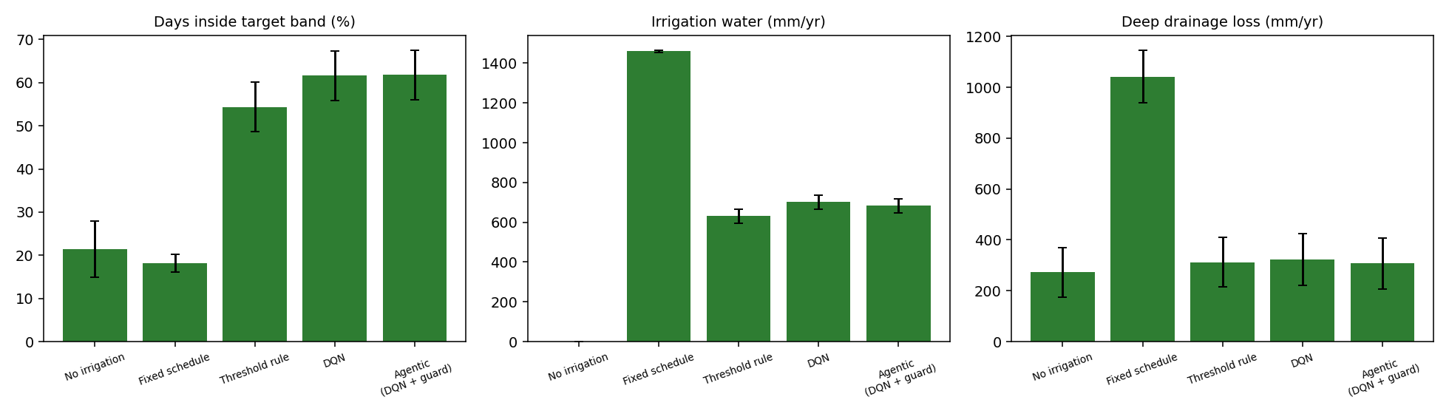
Figure 1. Target-band attainment, irrigation water and drainage loss by policy (error bars: standard deviation).
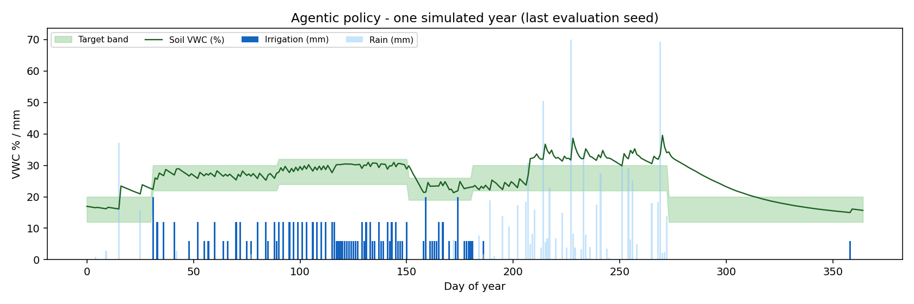
Figure 2. One simulated year under the agentic policy. Soil moisture stays near the stage band; irrigation is absent in the dry pre-flowering phase.
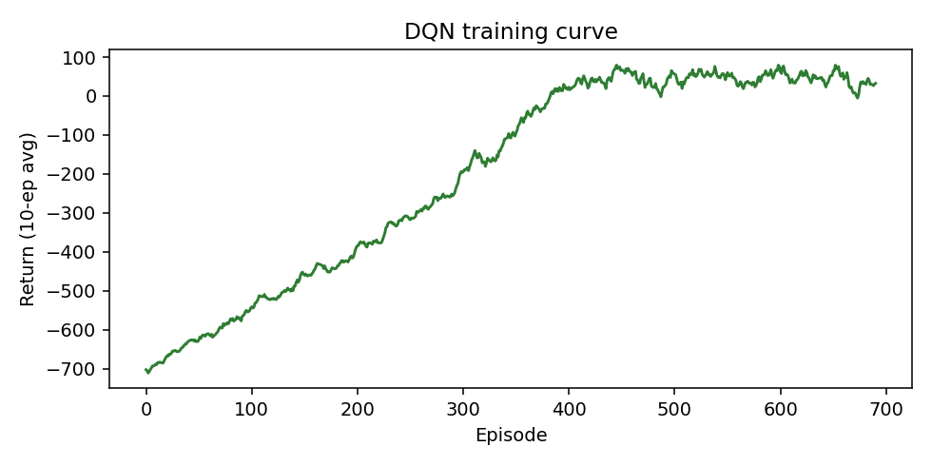
Figure 3. DQN training curve (10-episode moving average).

7. Analysis
- Adaptive beats calendar. The fixed schedule spent 1,460 mm and still spent 73% of days above the band, because it ignores rain and growth stage. Its drainage loss of about 1,040 mm is the clearest sign of waste.
- The learned policy trades a little water for much less stress. Compared with the threshold rule, the agentic policy gives roughly 7.5 more days per hundred inside the band and nearly removes days below it (8.2% to 0.3%), but uses about 8% more water. Whether that trade is worth making depends on water cost and on how much a day of stress costs the crop, which this study does not measure.
- The guard changed little in simulation, and that is fine. DQN alone and DQN with the guard are almost identical, because the reward already penalises the behaviours the guard blocks. The guard's value is in situations the simulator does not contain: a failed probe, a stuck value, a forecast the learner misread. Those cases are covered by unit tests rather than by the yearly averages.
- Above-band days are mostly rain. Roughly 38% of days sit above the band even for good policies, largely during the monsoon when no controller can remove water. This figure should not be read as controller error. Better drainage design, mulching or raised beds would be the lever, not a smarter valve.
- Variation between years is large. Standard deviations of 5 to 6 percentage points show that single-year comparisons can mislead; trials should span more than one season.

8. Limitations and validation plan
- Soil constants, band limits and crop coefficients are assumed, not measured. Calibrate field capacity, wilting point and bands with soil tests and an agronomist, and compare against a tensiometer or neutron-probe reference.
- The simulator uses one soil layer and synthetic weather. Re-train on real historical weather for your site, and consider a multi-layer root-zone model for deep-rooted trees.
- The learner knows nothing about yield or fruit quality. A trial should include blocks run by the agent and by the grower's usual practice, with yield, fruit size and water use recorded.
- Sensor drift and salinity affect capacitive probes. Re-calibrate each season and cross-check with a manual reading.
- Disease advisories are simple temperature and humidity heuristics and should be checked with local plant-protection guidance.
- Secure the system before field use: set API_KEY, enable MQTT authentication and TLS, and run behind HTTPS.
- Keep a manual override. The dashboard supports it, and the firmware's local timer closes the valve even if the network drops.

9. Running the system
- Install dependencies: pip install -r requirements-dev.txt
- Run tests: python -m pytest -q
- Retrain (optional): python scripts/train_dqn.py --episodes 700, then python scripts/evaluate.py
- Start the server: uvicorn backend.app:app --port 8000, and open http://localhost:8000
- Try it without hardware: python scripts/simulate_node.py --days 60
- With hardware: edit Wi-Fi, broker, zone and calibration values in the .ino file, flash the ESP32, and start the stack with docker compose up --build

References
Allen, R. G., Pereira, L. S., Raes, D., and Smith, M. (1998). Crop evapotranspiration: guidelines for computing crop water requirements. FAO Irrigation and Drainage Paper 56. Food and Agriculture Organization of the United Nations.
Hahn, F., and Garcia, J. A. (2022). Mango stem response under different irrigation regimes. International Journal of Fruit Science, 22(1), 35-56. https://doi.org/10.1080/15538362.2021.1970080
Indian Council of Agricultural Research. Effect of deficit drip irrigation and mulching on mango hybrid 'Amrapali'. JISCAR (ICAR e-Pubs). https://epubs.icar.org.in/index.php/JISCAR/article/download/79587/33352/202120
Mnih, V., et al. (2015). Human-level control through deep reinforcement learning. Nature, 518, 529-533.
Northern Territory Department of Agriculture and Fisheries. Mango irrigation management guidelines. https://daf.nt.gov.au/__data/assets/pdf_file/0004/232969/587.pdf
van Hasselt, H., Guez, A., and Silver, D. (2016). Deep reinforcement learning with double Q-learning. Proceedings of the AAAI Conference on Artificial Intelligence.
Water for Profit. Benchmark: irrigating mangoes in north Queensland. https://www.industry.mangoes.net.au/cmsb/uploads/wfp-benchmark-irrigating-mangoes-in-north-queensland.pdf
Yao, S., et al. (2023). ReAct: synergizing reasoning and acting in language models. International Conference on Learning Representations.

