Account Confirmation - Demo
Case C17 | Synthetic demo evidence only
The supporting evidence is embedded as an image below.
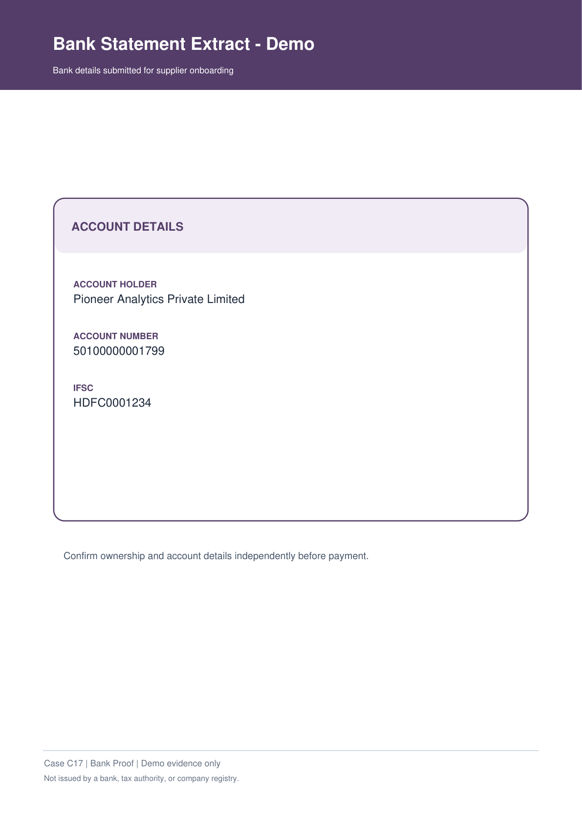
Not issued by a bank, tax authority, or company registry.

