JSS MAHAVIDYAPEETA JSS SCIENCE AND TECHNOLOGICAL UNIVERSITY JSS Technical Institution Campus Mysore – 570006.



A MINI PROJECT REPORT
ON

“DISCOVERING FREQUENTLY PURCHASED ITEMS IN A FRENCH STORE USING APRIORI ALGORITHM”

Submitted in partial fulfillment of curriculum prescribed for the Data Warehouse and Data Mining course

Submitted by

Katkam Aditya 01JST16CS039

Under The Guidance
Of

Dr. Trisiladevi C. Nagavi
Assistant Professor
Dept. of CS & E
JSS STU Mysore

DEPARTMENT OF COMPUTER SCIENCE & ENGINEERING

JSS MAHAVIDYAPEETA
JSS SCIENCE AND TECHNOLOGICAL UNIVERSITY
JSS Technical Institution Campus Mysore – 570006.

CERTIFICATE

This is to certify that the work entitled “DISCOVERING FREQUENTLY PURCHASED ITEMS IN A FRENCH STORE USING APRIORI ALGORITHM” is a bonafied work carried out by Katkam Aditya in partial fulfillment of the award of the degree of Bachelor of Engineering in Computer Science and Engineering of JSS Science and Technology, Mysuru during the year 2020. It is certified that all corrections / suggestions indicated during CIE have been incorporated in the report. The mini project report has been approved as it satisfies the academic requirements in respect of mini project work prescribed for the Data Warehosue and Data Mining (CS610) course.

Course In Charge And Guide

Dr. Trisiladevi C. Nagavi
Assistant Professor
Dept. of CS & E
JSS STU
Mysore

Date : 10 / 05 / 2020

Place: Mysuru

DECLARATION

I here by declare that the project report entitled “DISCOVERING FREQUENTLY PURCHASED ITEMS IN A FRENCH STORE USING APRIORI ALGORITHM” submitted by us to the JSS Science and Technological University, in partial fulfillment of the requirement for the award of the degree of B.E in computer science department is a record of bonfide project work carried out by me under the guidance of DR. Trisiladevi C. Nagavi. I further declare that the work reported in this project has not been submitted and will not be submitted, either in part or in full, for the award of any other degree or diploma in this institute or any other institute or university.

ABSTRACT

In today’s world, computer technologies have advanced a lot. One of its greatest gifts to the world is Artificial Intelligence. Natural Language Processing (NLP) and Machine Learning (ML) are two of its subdomains. In this paper, modified versions of two common NLP and ML algorithms have been used to classify food reviews and provide suitable recommendations from them. Currently, reviews can be classified into positive and negative reviews, but it becomes difficult when one review says positive about item A and negative about item B. Moreover, the current Apriori algorithm doesn’t consider the feedbacks from customers (reviews). Modified classifier algorithm and consequently, Apriori algorithm has been used to classify each statement part by part and provide recommendations, not just on previous purchases but also using the reviews about above-mentioned purchases. The algorithms can be used for purposes other than retrieving frequently purchased items also – wherever purchases and reviews are involved. For e.g., e-commerce companies can use the algorithms to predict and recommend suitable items a user may be interested in.

ACKNOWLEDGEMENT

I would like to express my special thanks of gratitude to our guide DR. Trisiladevi C. Nagavi, who gave us the golden opportunity to do this project of “DISCOVERING FREQUENTLY PURCHASED ITEMS IN A FRENCH STORE USING APRIORI ALGORITHM”, and who also helped us in completing our project. We came to know about so many new things we are really thankful to them and also like to thank our friends who helped us in finalizing this project within the limited time frame.

INTRODUCTION

In today‟s fast paced world people like to have everything at their fingertips. This has created a surge in the food industry too. In the last couple of years, we have seen a major outburst in the domain of online grocery delivery business. Some big players like BigBasket, Grofers and the likes are constantly grinding to provide better services to their customers. Pre-processing involves techniques to transform raw data into more understandable format. Data gathered from real world instances is usually incomplete, noisy and inconsistent. Incomplete data lacks attribute values, lacks certain attributes of interest, thereby containing only aggregate module. Noisy data comprises of errors and outliers.

Aim of the problem statement

- DISCOVERING FREQUENTLY PURCHASED ITEMS IN A FRENCH STORE USING APRIORI ALGORITHM

Applications

- Makes the ordering process easier.
- Efficient customer and order management.
- Monitor your expenses incurred in real time.
- Free and cheap marketing.
- Better customers data.
- The convenience of mobile ordering.
- Stay ahead of the competition.
- Grow your bottom line

TOOLS
- Apyori Pacakge
- Mysql

IMPLEMENTATION
Methodology

The development of this research work is mainly based on the implementation of the
Apriori algorithm for the extraction of association rules to develop a system that allows the elaboration of combos and provide suggestions of items according to the preferences of the customer.

Association rules

Association rules are used to discover facts that occur in common within a given set of data. This information can be used as a basis to make decisions about marketing activities an association rule is defined as: Let I = {i1, i2, ..., in} be a set of n binary attributes called items. Let D = {t1,t2,...,tn} be a set of transactions called the database. Each transaction in D has a unique transaction ID and contains a subset of the items in I. A rule is defined as implication of the form X->Y where X, Y belongs to I and intersection of X and Y is null.
The set of items (for short itemsets) X and Y are called antecedent (left-hand-side or LHS) and consequent (right-hand-side or RHS) of the rule respectively. To limit the number of rules obtained, metrics are used to measure the importance or interest of a rule, these being the following:
Support.
The support supp(X) of an itemset X is defined as the proportion of transactions in the dataset which contains the itemset.

Given a rule “If A => B”, the support of this rule is defined as the number of times or the
(relative) frequency with which A and B appear together in a transaction database. Supportcan be defined for individual items, however, it can also be defined for the rule. A first criterion that can be imposed to limit the number of rules is that they comply with minimal support.

Confidence. The confidence of a rule is defined:

Apriori algorithm

Apriori is an algorithm proposed by R. Agrawal and R. Srikant (1994) to mine sets of
frequent elements for Boolean association rules. The name of the algorithm is based on the fact that the algorithm uses prior knowledge of the frequent properties of the set of elements. Apriori employs an iterative approach known as a level search, where k-sets of elements are used to explore (k + 1) – itemset. First, the set of frequent 1-itemset is found by scanning the database to accumulate the count of each element and collecting the elements that satisfy the minimum support. The resulting set is denoted by L1. Next, L1 is used to find L2, which is used to find L3, and so on, until more frequent k-itemsets are found. The finding of each Lk requires a complete analysis of the database. To improve the efficiency of the generation of sets of frequent elements at level, an important property called Apriori property is used to reduce the search space. The Apriori property is based on the fact that if a set of elements does not satisfy the minimum support threshold (min_supp), then it is not frequent, that is, P(I) < min_supp. If an element A is added to the set of elements, then the resulting element (that is, IՈA) cannot happen more often than I. Therefore, IՈA is also not frequent, that is, P(IՈA) < min_sup. This property belongs to a special category of properties called antimonotonicity in the sense that, if a set cannot pass a test, all its supersets will also fail the same test.

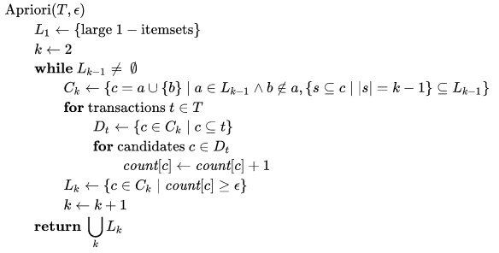
Figure: Psuedo code for Apriori algorithm

SOURCE CODE FOR APRIORI ALORITHM:

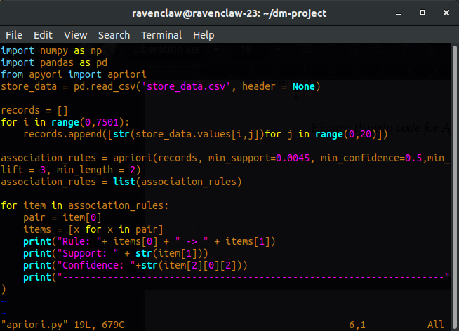

We will use the Apriori algorithm to find rules that describe associations between different products given 7500 transactions over the course of a week at a French retail store. Another interesting point is that we do not need to write the script to calculate support, confidence, and lift for all the possible combination of items. We will use an off-the-shelf library “apyori” where all of the code has already been implemented.

The Apriori library we are going to use requires our dataset to be in the form of a list of lists, where the whole dataset is a big list and each transaction in the dataset is an inner list within the outer big list. Currently we have data in the form of a pandas dataframe. To convert our pandas dataframe into a list of lists, execute the following script

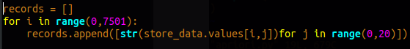

The apriori class requires some parameter values to work. The first parameter is the list of list that you want to extract rules from. The second parameter is the “min_support” parameter. This parameter is used to select the items with support values greater than the value specified by the parameter. Next, the “min_confidence” parameter filters those rules that have confidence greater than the confidence threshold specified by the parameter. Finally, “the min_length” parameter specifies the minimum number of items that you want in your rules.

Let's suppose that we want rules for only those items that are purchased at least 5 times a day, or 7 x 5 = 35 times in one week, since our dataset is for a one-week time period. The support for those items can be calculated as 35/7500 = 0.0045. The minimum confidence for the rules is 20% or 0.2. Similarly, we specify the value for min_length as 2 since we want at least two products in our rules.

In the second line here we convert the rules found by the apriori class into a list since it is easier to view the results in this form.

For instance from the first item, we can see that light cream and chicken are commonly bought together. This makes sense since people who purchase light cream are careful about what they eat hence they are more likely to buy chicken i.e. white meat instead of red meat i.e. beef. Or this could mean that light cream is commonly used in recipes for chicken.
The support value for the first rule is 0.0045. This number is calculated by dividing the number of transactions containing light cream divided by total number of transactions. The confidence level for the rule is 0.2905 which shows that out of all the transactions that contain light cream, 29.05% of the transactions also contain chicken. It tells us that chicken is 4 times more likely to be bought by the customers who buy light cream compared to the default likelihood of the sale of chicken.
The following script displays the rule, the support, the confidence, and lift for each rule in a more clear way:
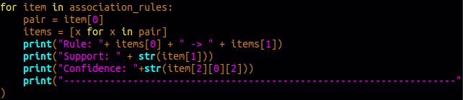
OUTPUT
- With confidence = 0.2 (or 20%) and support = 0.0045
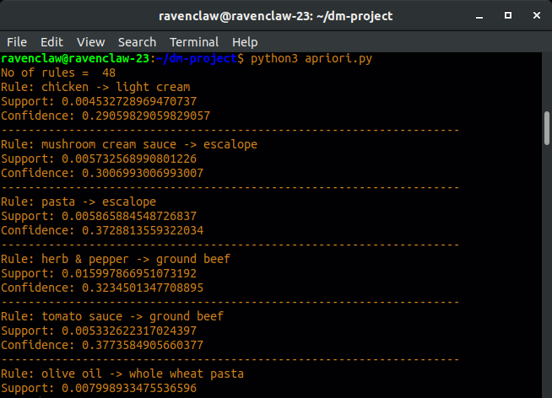
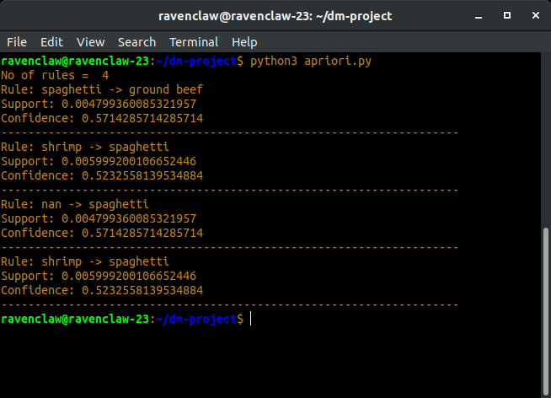
- With confidence = 0.5 (or 50%) and support = 0.0045

Conclusion
Association rule mining algorithms such as Apriori are very useful for finding simple associations between our data items. They are easy to implement and have high explain-ability. However for more advanced insights, such those used by Google or Amazon etc., more complex algorithms, such as recommender systems, are used. However, you can probably see that this method is a very simple way to get basic associations if that's all your use-case needs.

References
Website links
- www.google.com
- www.stackabuse.com
- https://drive.google.com/file/d/1y5DYn0dGoSbC22xowBq2d4po6h1JxcTQ/view?usp=sharing (dataset)

