**ROBO SOCCE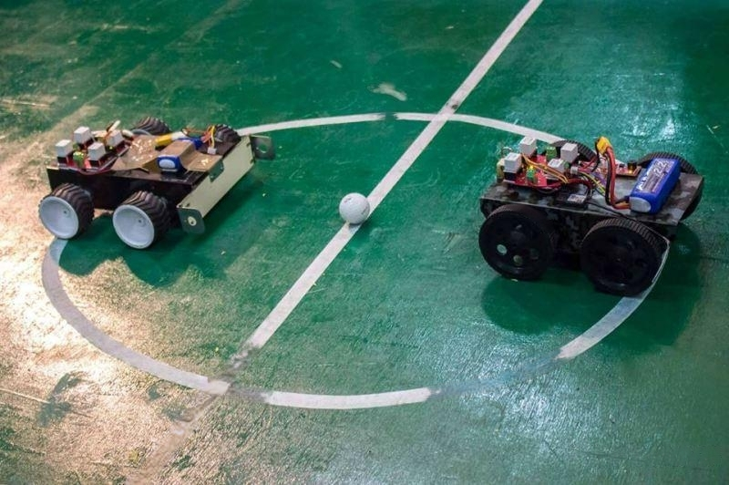R**

## DESCRIPTION:

It’s football time and no-one plays soccer better than the engineers, in their own sophisticated way we hail this event **ROBO SOCCER**. All you soccer fans hold your breath, as we present to you soccer with an entirely new dimension. So, if you are up for the challenge get your manual soccer playing bots ready in order to compete on the biggest stage and bring out the hidden RONALDO, MESSI in you…its time you to stop watching soccer on screens. Participate and have lots of fun it’s going to be thrilling for sure…...enjoy the event!

Organized by **TEAM TECHNOCRACY** in collaboration with **ROBOTIX club** under the banner of ‘Tech Fest “**AAVARTAN’23**”.

**Event:**

The objective is to design a manual robot and which can compete on an arena specially designed for robotic soccer match. The event is aimed at testing the Flipping, Kicking, maneuvering skills and the control of the robot. The event mainly consists of **ROUNDS 1, 2 and 3.**

**ROUND 1 (Elimination):**

* 5 balls are placed at specified locations on the arena.
* Time limit is 3 minutes.
* Participants can drive, push or hit the ball into any of the goal posts.
* Points = number of goals.
* If the ball is hit out of the arena, then it will not be placed back.

**ROUND 2:**

* This is a knock out round (one on one).
* Different color same size balls for different teams are placed in their half arena.
* •The ball of one arena has to be goaled into opposite arena goal post. White color ball is common to both of the teams placed in the center.
* There will be a match of 2 minutes.
* Points = number of goals.
* Fouls will also be accounted to choose the winner. (Touching other team’s ball is a foul). white ball should be goaled after completion of his color balls.
* Driving the ball intentionally towards the opponent leads to foul.
* Penalty shots will be provided in case of tie

## ROUND 3:

* Only one ball will be placed at the center, robots are initially placed at their respective goal posts.
* Time limit is 3 minutes.
* Participants should hit the ball into the opponent’s goal to score points.
* Each participant can make as many as goals in the limited time.
* Obstacles are placed on both halves of the arena; points will be deducted if the robot touches the obstacles…
* Robot gets negative points each time it touches the obstacle and border of the arena
* Judging criteria for final winner will be based on number of goals scored and time taken by the participants.

ROBOT SPECIFICATIONS:

* The robot should fit inside a box of 30cm*30cm*30cm.
* Robot should not exceed 3 kg.
* The robot can be wired, wireless or autonomous.
* The robot should be self-powered with supply not exceeding 12V(on board power supply)
* Power supply (only DC) should be on board. Participants cannot draw power from outside

# RULES AND REGULATIONS:

* Team can have maximum number of four members.
* Anyone can control the robot and player can be exchanged in the middle of match.
* A robot can push or hit the ball. It cannot withhold or grab the ball.
* Human interference (e.g., touching the robot) during the game is allowed but at most 3 free touches and after that penalty will be entertained.
* Decision of the Judges and Event Organizers shall be treated as final and binding on all and cannot be contested. The event coordinator is the match referee. He takes all the decisions and participants have to abide by it.
* No more AC/DC power supply will be provided at the sight of play.
* Coordinators reserve the right to ask for the explanation of the robot. The coordinator can change the rules of the game depending on the situation.
* Rules & Regulations may change without prior notice, by the Event organizers.
* Positions of balls and obstacles in the arena will be decided by the organizers on the particular day of event.

# Contact:

# HARSH-8529322799

# ANJALI-9987394775

# EKANT-8319379484