LIBRARY MANAGEMENT SYSTEM
DBMS MINI PROJECT REPORT
Name: Aditya Kumar
Roll No.: 2419157
Branch: CSE (A)

1. Introduction
This project is a simple Library Management System developed using MySQL. It stores basic information about students and books and keeps a record of books issued to students. The project helped me practise creating tables, inserting records and retrieving information through SQL queries.

2. Problem Statement
Managing library records manually in registers can take time. It can also be difficult to find a book, check its availability or know which student has borrowed it. This project uses a database to keep these records organised and makes it easier to view and update them.

3. Objectives
- Create a database named LibraryDB.
- Store student and book details in separate tables.
- Maintain records of issued and returned books.
- Display books that are currently available.
- Use SQL queries to find related information.
- Practise primary keys, foreign keys, JOIN and GROUP BY.

4. Software and Technology Used
Tool / Technology | Purpose
MySQL | To create the database, tables and run SQL queries.
MySQL Workbench | To write SQL commands and view query results.

5. Database Design
I created three tables for this project: Students, Books and Book_Issue. Each table stores a different type of information.
Table Name | Main Fields | Purpose
Students | student_id, student_name, email, department | Stores student details.
Books | book_id, book_name, author, category, total_copies, available_copies | Stores book details and copy availability.
Book_Issue | issue_id, student_id, book_id, issue_date, return_date, status | Stores book issue and return details.

The student_id field in Book_Issue refers to Students.student_id, and book_id refers to Books.book_id. These foreign key relationships connect an issue record with the correct student and book.

6. Sample Records
For checking the queries, I inserted 5 student records, 10 book records and 4 book issue records. The names and other details used in the database are sample data.
Table | Number of Records
Students | 5
Books | 10
Book_Issue | 4

7. SQL Commands and Concepts Used
- CREATE DATABASE and USE – create LibraryDB and select it for the queries.
- CREATE TABLE – create the Students, Books and Book_Issue tables.
- PRIMARY KEY – give each record a unique ID.
- FOREIGN KEY – connect issue records with students and books.
- INSERT INTO – add sample records to the tables.
- SELECT and WHERE – display records and filter available books.
- JOIN – show student names and book names together with issue details.
- GROUP BY and COUNT() – count the number of books in each category.
- UPDATE – change student information and update a book issue record.
- DELETE – a sample DELETE statement is included as a comment in the SQL file.

8. Important SQL Queries
Display all students:
SELECT * FROM Students;

Display all books:
SELECT * FROM Books;

Display available books:
SELECT * FROM Books
WHERE available_copies > 0;

Display all book issue records:
SELECT * FROM Book_Issue;

Display books issued to students:
SELECT Students.student_name, Books.book_name,
Book_Issue.issue_date, Book_Issue.status
FROM Book_Issue
JOIN Students ON Book_Issue.student_id = Students.student_id
JOIN Books ON Book_Issue.book_id = Books.book_id;

Count books by category:
SELECT category, COUNT(*) AS total_books
FROM Books
GROUP BY category;

9. How the Database Can Be Connected to a Website
A website can connect to this database through a backend application. For example, a website made with HTML, CSS and JavaScript can send a request to a Node.js and Express backend. The backend can use a MySQL connection library to run queries and send the result back to the website. In this way, a user can search for books or check issue details through a web page.

10. Distributed Database for Multiple Campuses
If a college has more than one campus, each campus can maintain its own book and issue records. A central database or a synchronisation system can share common information between campuses. This can help students and staff check book availability across different campus libraries. Proper access control and regular backups would also be needed.

11. Testing and Screenshots
I executed the SQL queries in MySQL Workbench and checked the result grids. The following screenshots show the outputs obtained from the database.
Screenshot 1 – Student Records
SELECT * FROM Students;
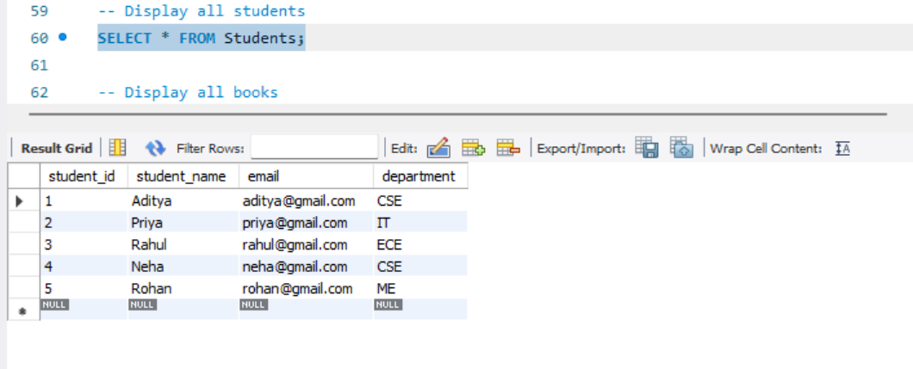
Screenshot 2 – Book Records
SELECT * FROM Books;
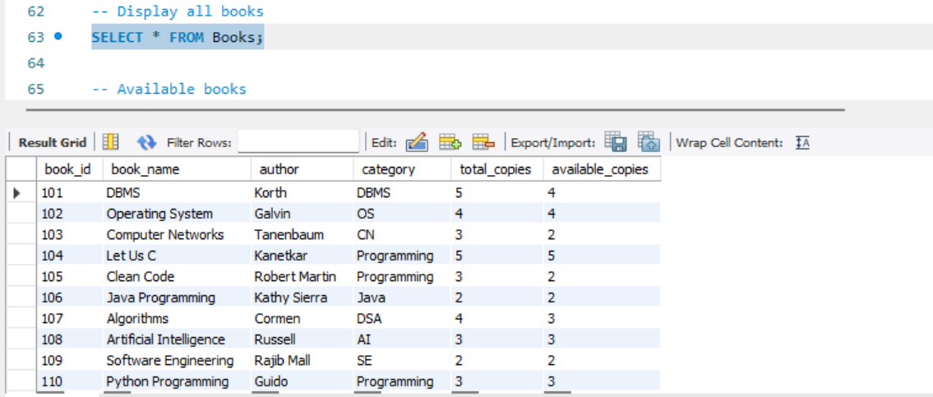
Screenshot 3 – Available Books
SELECT * FROM Books WHERE available_copies > 0;
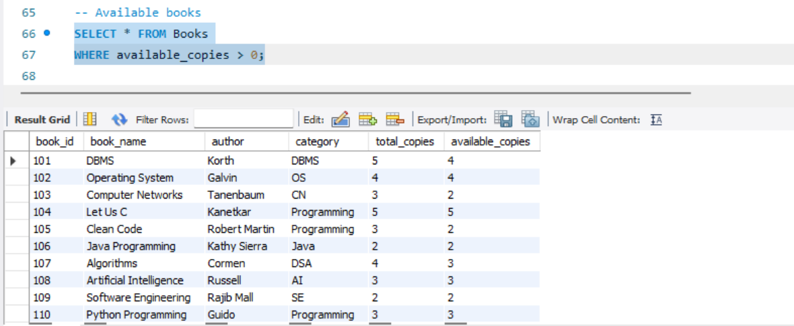
Screenshot 4 – Book Issue Records
SELECT * FROM Book_Issue;
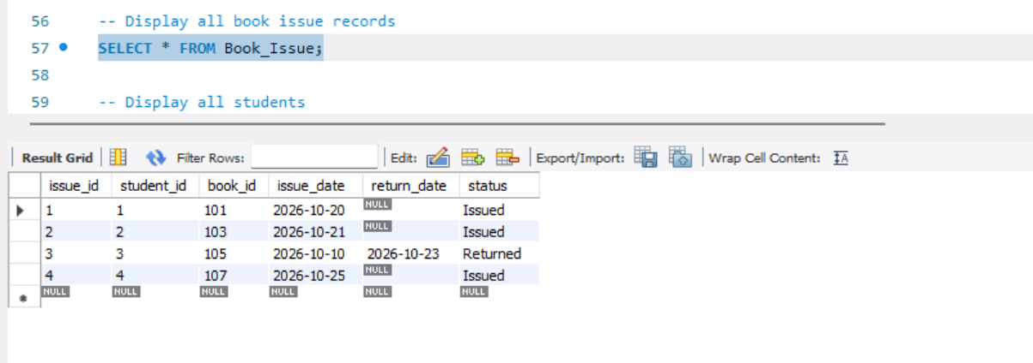
Screenshot 5 – Books Issued to Students (JOIN)
SELECT Students.student_name, Books.book_name, Book_Issue.issue_date, Book_Issue.status
FROM Book_Issue JOIN Students ON Book_Issue.student_id = Students.student_id
JOIN Books ON Book_Issue.book_id = Books.book_id;
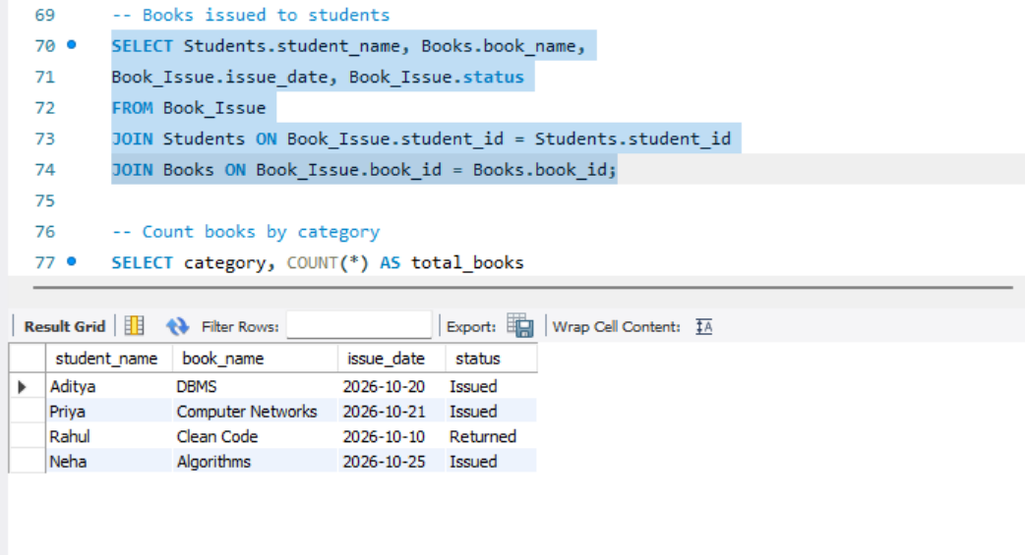
Screenshot 6 – Book Count by Category (GROUP BY)
SELECT category, COUNT(*) AS total_books
FROM Books
GROUP BY category;
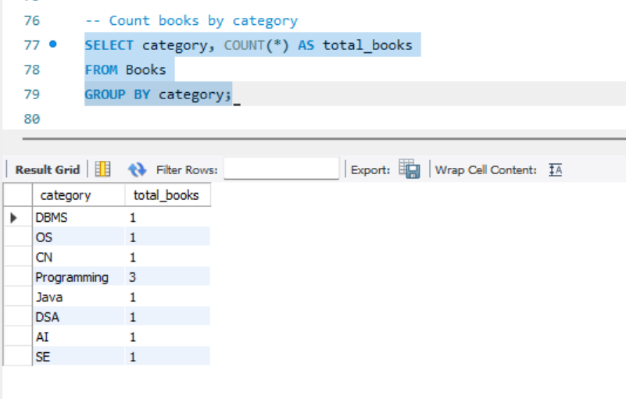

12. Conclusion
By completing this project, I learned how to create a database in MySQL and organise information into related tables. I also practised inserting, displaying and updating records and using JOIN and GROUP BY queries. This mini project gave me a basic understanding of how a database can be used in a library management system.

