Department of Computer Technology

Vision of the Department
To be a preferred hub for nurturing computer engineering aspirants through innovative, ethical, value-based technical education, impactful research, and industry collaboration, to become successful professionals contributing for the betterment of society.

Mission of the Department
To nurture computer engineering professionals by offering:
- Dynamic learning environment that encourages problem-solving using emerging technology
- National Education Policy aligned evidence-based technical education, fostering innovation, research, and industry–institute collaboration
- Holistic, ethical and sustainable development for lifelong success.

Session 2025-2026

Vision: To become a skilled and responsible engineer who uses technology to solve real-world problems and contribute positively to society. | Mission: To gain strong technical knowledge, practical skills, and ethical values through continuous learning, hands-on practice, and collaboration, in order to achieve my professional goals.

Program Educational Objectives of the program (PEO): (broad statements that describe the professional and career accomplishments)

PEO1 | Preparation | P: Preparation | Pep-CL abbreviation pronounce as Pep-si-lL easy to recall
PEO2 | Core Competence | E: Environment (Learning Environment)
PEO3 | Breadth | P: Professionalism
PEO4 | Professionalism | C: Core Competence
PEO5 | Learning Environment | L: Breadth (Learning in diverse areas)

Program Outcomes (PO): (statements that describe what a student should be able to do and know by the end of a program)

Keywords of POs:
Engineering knowledge, Problem analysis, Design/development of solutions, Conduct Investigations of Complex Problems, Engineering Tool Usage, The Engineer and The World, Ethics, Individual and Collaborative Team work, Communication, Project Management and Finance, Life-Long Learning

PSO Keywords: Cutting edge technologies, Research


“I am an engineer, and I can apply engineering knowledge to analyze, investigate, and design solutions for complex problems using appropriate tools, while following ethical practices, working collaboratively, and continuously improving my skills throughout my life” to contribute to the development of cutting-edge technologies and Research.
Integrity: I will strictly follow the Laboratory Code of Conduct and maintain honesty, discipline, and ethical behavior while performing all laboratory work

Aditya Patil

Name and Signature of Student and Date
(Signature and Date in Handwritten)

Department of Computer Technology

Vision of the Department
To be a preferred hub for nurturing computer engineering aspirants through innovative, ethical, value-based technical education, impactful research, and industry collaboration, to become successful professionals contributing for the betterment of society.

Mission of the Department
To nurture computer engineering professionals by offering:
- Dynamic learning environment that encourages problem-solving using emerging technology
- National Education Policy aligned evidence-based technical education, fostering innovation, research, and industry–institute collaboration
- Holistic, ethical and sustainable development for lifelong success.

Sr. No  . | COs | POs |  |  |  |  |  |  |  |  |  |  |  | PSOs
 |  | Course Outcomes | 1 | 2 | 3 | 4 | 5 | 6 | 7 | 8 | 9 | 10 | 11 | PSO 1 | PSO 2
1 | CO1 | Demonstrate the ability to execute Linux process management, memory management, and shell  commands to manage system resources efficiently. | 3 | 3 | 3 | - |  | - | - | - | - | - | 3 | 3
2 | CO2 | Develop programs utilizing system calls, thread programming, and page  replacement algorithms to  simulate and analyze operating system functionalities. | 3 | 3 | 3 | - | - | - | - | - | - | - | 3 | 3
3 | CO3 | Design and implement process scheduling, memory allocation, and deadlock detection algorithms to address  real-world operating system challenges. | 3 | 3 | 3 | - |  | - | - | - | - | - | 3 | 3
 |  | Avg |  | 3 | 3 | - |  | - | - | - | - | - | 3 | 3

Department of Computer Technology

Vision of the Department
To be a preferred hub for nurturing computer engineering aspirants through innovative, ethical, value-based technical education, impactful research, and industry collaboration, to become successful professionals contributing for the betterment of society.

Mission of the Department
To nurture computer engineering professionals by offering:
- Dynamic learning environment that encourages problem-solving using emerging technology
- National Education Policy aligned evidence-based technical education, fostering innovation, research, and industry–institute collaboration
- Holistic, ethical and sustainable development for lifelong success.

Session | 2025-26 (EVEN) |  | Course Name | Operating Systems Lab
Semester | 4 |  | Course Code | 23CT1402
Roll No | 38 |  | Name of Student | Aditya Patil
Practical Number |  | 06
Course Outcome |  | 1. Demonstrate the ability to execute Linux process  management, memory management. (CO2)
Aim |  | Write a simulator program for the given CPU scheduling algorithms. Pre-emptive CPU Scheduling Algorithm. (SJF, Priority, Round Robin)
Problem Definition |  | To create a C program that simulates pre-emptive CPU scheduling algorithms including Shortest Job First (SJF), Priority Scheduling, and Round Robin. The program schedules processes based on given inputs and evaluates performance using waiting time and turnaround time.
Theory  (100 words) |  | Brief Explanation Pre-emptive CPU scheduling is a technique in which the operating system can interrupt a currently running process and allocate the CPU to another process based on specific scheduling conditions. This method helps in improving system responsiveness and ensures better utilization of CPU resources.  In this simulator program, different pre-emptive CPU scheduling algorithms such as Shortest Job First (SJF), Priority Scheduling, and Round Robin are implemented. Each algorithm schedules processes in a different way based on factors like burst time, priority level, or time quantum.  The program takes process information such as process ID, arrival time, burst time, and priority as input. After scheduling the processes, it calculates important performance measures such as waiting time and turnaround time to evaluate the efficiency of the scheduling algorithms

Department of Computer Technology

Vision of the Department
To be a preferred hub for nurturing computer engineering aspirants through innovative, ethical, value-based technical education, impactful research, and industry collaboration, to become successful professionals contributing for the betterment of society.

Mission of the Department
To nurture computer engineering professionals by offering:
- Dynamic learning environment that encourages problem-solving using emerging technology
- National Education Policy aligned evidence-based technical education, fostering innovation, research, and industry–institute collaboration
- Holistic, ethical and sustainable development for lifelong success.

Procedure and Execution  (100 Words) | Steps for Implementation:  1. Pre-emptive Shortest Job First (SJF)  - Start the program and enter the number of processes.  - Input arrival time and burst time for each process.  - Initialize remaining time equal to burst time.  - Set the current time to zero.  - At each time unit, select the process with the smallest remaining time among arrived processes.  - Execute the selected process for one unit of time.  - Reduce its remaining time.  - If remaining time becomes zero, mark the process as completed.  - Calculate waiting time and turnaround time.  - Display the results and average waiting and turnaround time.  2. Pre-emptive Priority Scheduling  - Start the program and enter the number of processes.  - Input arrival time, burst time, and priority for each process.  - Initialize remaining time equal to burst time.  - Set current time to zero.  - Select the process with the highest priority among arrived processes.  - Execute the process for one time unit.  - Decrease the remaining time after execution.  - If the process completes, calculate waiting time and turnaround time.  - Repeat until all processes finish execution.  - Display the average waiting time and turnaround time.  3. Round Robin Scheduling  - Start the program and enter the number of processes.  - Input arrival time and burst time for each process.  - Enter the time quantum.  - Initialize remaining time equal to burst time.  - Execute processes in cyclic order.  - Allocate CPU for the given time quantum to each process.  - Reduce the remaining time after execution.  - If a process completes, calculate waiting time and turnaround time.  - Continue until all processes are completed.  - Display average waiting time and turnaround time.

Department of Computer Technology

Vision of the Department
To be a preferred hub for nurturing computer engineering aspirants through innovative, ethical, value-based technical education, impactful research, and industry collaboration, to become successful professionals contributing for the betterment of society.

Mission of the Department
To nurture computer engineering professionals by offering:
- Dynamic learning environment that encourages problem-solving using emerging technology
- National Education Policy aligned evidence-based technical education, fostering innovation, research, and industry–institute collaboration
- Holistic, ethical and sustainable development for lifelong success.
Code :

- Pre-emptive SJF (Shortest Remaining Time First )
#include<stdio.h>
int main()
{
int n,i;
printf("Enter number of processes: ");
scanf("%d",&n);
int at[10],bt[10],rt[10],wt[10],tat[10],ct[10];
for(i=0;i<n;i++)
{
printf("\nEnter details of Process P%d\n",i+1);

printf("Arrival Time: ");
scanf("%d",&at[i]);

printf("Burst Time: ");
scanf("%d",&bt[i]);
rt[i]=bt[i];
printf("Process P%d initialized with Burst Time = %d\n",i+1,rt[i]);
}
printf("\n\nPID\tAT\tBT\n");
For(int j = 0 ; j< n ; j++){
printf("P%d\t%d\t%d\t%d\n",i+1,at[j],bt[j]);
}
int time=0,complete=0,smallest;
rt[9]=9999;

printf("\n--- CPU Scheduling Started ---\n");

while(complete!=n)
{
smallest=9;

for(i=0;i<n;i++)
{
if(at[i]<=time && rt[i]<rt[smallest] && rt[i]>0)
smallest=i;
}

printf("\nCurrent Time: %d",time);
printf("\nProcess P%d is executing",smallest+1);

rt[smallest]--;
time++;

if(rt[smallest]==0)
{
complete++;
ct[smallest]=time;
tat[smallest]=ct[smallest]-at[smallest];
wt[smallest]=tat[smallest]-bt[smallest];

printf("\nProcess P%d completed at time %d\n",smallest+1,time);
}
}

float avgwt=0,avgtat=0;

printf("\n\nPID\tAT\tBT\tWT\tTAT\n");

for(i=0;i<n;i++)
{
printf("P%d\t%d\t%d\t%d\t%d\n",i+1,at[i],bt[i],wt[i],tat[i]);
avgwt+=wt[i];
avgtat+=tat[i];
}

printf("\nAverage Waiting Time = %.2f",avgwt/n);
printf("\nAverage Turnaround Time = %.2f\n",avgtat/n);

return 0;
}

Department of Computer Technology

Vision of the Department
To be a preferred hub for nurturing computer engineering aspirants through innovative, ethical, value-based technical education, impactful research, and industry collaboration, to become successful professionals contributing for the betterment of society.

Mission of the Department
To nurture computer engineering professionals by offering:
- Dynamic learning environment that encourages problem-solving using emerging technology
- National Education Policy aligned evidence-based technical education, fostering innovation, research, and industry–institute collaboration
- Holistic, ethical and sustainable development for lifelong success.
for(i=0;i<n;i++)
{
if(at[i]<=time && rt[i]<rt[smallest] && rt[i]>0)
smallest=i;
}

printf("\nCurrent Time: %d",time);
printf("\nProcess P%d is executing",smallest+1);

rt[smallest]--;
time++;
if(rt[smallest]==0)
{
complete++;
ct[smallest]=time;
tat[smallest]=ct[smallest]-at[smallest];
wt[smallest]=tat[smallest]-bt[smallest];

printf("\nProcess P%d completed at time %d\n",smallest+1,time);
}
}
float avgwt=0,avgtat=0;
printf("\n\nPID\tAT\tBT\tWT\tTAT\n");
for(i=0;i<n;i++)
{
printf("P%d\t%d\t%d\t%d\t%d\n",i+1,at[i],bt[i],wt[i],tat[i]);
avgwt+=wt[i];
avgtat+=tat[i];
}

printf("\nAverage Waiting Time = %.2f",avgwt/n);
printf("\nAverage Turnaround Time = %.2f\n",avgtat/n);

return 0;
}

Department of Computer Technology

Vision of the Department
To be a preferred hub for nurturing computer engineering aspirants through innovative, ethical, value-based technical education, impactful research, and industry collaboration, to become successful professionals contributing for the betterment of society.

Mission of the Department
To nurture computer engineering professionals by offering:
- Dynamic learning environment that encourages problem-solving using emerging technology
- National Education Policy aligned evidence-based technical education, fostering innovation, research, and industry–institute collaboration
- Holistic, ethical and sustainable development for lifelong success.

B) Pre-emptive Priority Scheduling
#include<stdio.h>

int main()
{
int n,i,time=0,highest;
int at[10],bt[10],rt[10],pr[10];
int wt[10],tat[10],ct[10];
int count=0;

printf("Enter number of processes: ");
scanf("%d",&n);

for(i=0;i<n;i++)
{
printf("\nEnter Arrival Time, Burst Time and Priority of P%d: ",i+1);
scanf("%d%d%d",&at[i],&bt[i],&pr[i]);

rt[i]=bt[i];
printf("Process P%d initialized\n",i+1);
}

printf("\n--- Input Process Table ---\n");
printf("PID\tAT\tBT\tPR\n");
for(i=0;i<n;i++)
{
printf("P%d\t%d\t%d\t%d\n",i+1,at[i],bt[i],pr[i]);
}

pr[9]=9999;

printf("\n--- Scheduling Simulation ---\n");

while(count!=n)
{
highest=9;

for(i=0;i<n;i++)
{
if(at[i]<=time && pr[i]<pr[highest] && rt[i]>0)
highest=i;
}

printf("Current Time: %d -> Process P%d executing\n",time,highest+1);

rt[highest]--;
time++;

if(rt[highest]==0)
{
count++;
ct[highest]=time;
tat[highest]=ct[highest]-at[highest];
wt[highest]=tat[highest]-bt[highest];

printf("Process P%d completed at time %d\n",highest+1,time);
}
}

float avgwt=0,avgtat=0;

printf("\n--- Result Table ---\n");
printf("PID\tBT\tWT\tTAT\n");

for(i=0;i<n;i++)
{
printf("P%d\t%d\t%d\t%d\n",i+1,bt[i],wt[i],tat[i]);
avgwt+=wt[i];
avgtat+=tat[i];
}

printf("\nAverage Waiting Time = %.2f",avgwt/n);
printf("\nAverage Turnaround Time = %.2f\n",avgtat/n);

return 0;
}

C ) Round Robin Scheduling

#include<stdio.h>

int main()
{
int n,i,time=0,remain,flag=0,ts;
int at[10],bt[10],rt[10];
int wt[10]={0},tat[10]={0},ct[10]={0};
float avgwt=0,avgtat=0;

printf("Enter number of processes: ");
scanf("%d",&n);

remain=n;

for(i=0;i<n;i++)
{
printf("\nEnter Arrival Time and Burst Time for Process P%d: ",i+1);
scanf("%d%d",&at[i],&bt[i]);
rt[i]=bt[i];

printf("Process P%d initialized\n",i+1);
}

printf("\nEnter Time Quantum: ");
scanf("%d",&ts);

printf("\n--- Input Process Table ---\n");
printf("PID\tAT\tBT\n");
for(i=0;i<n;i++)
{
printf("P%d\t%d\t%d\n",i+1,at[i],bt[i]);
}

printf("\n--- Round Robin Scheduling Simulation ---\n");

for(time=0,i=0;remain!=0;)
{
if(rt[i]<=ts && rt[i]>0)
{
printf("Current Time: %d -> Process P%d executing\n",time,i+1);

time+=rt[i];
rt[i]=0;
flag=1;
}
else if(rt[i]>0)
{
printf("Current Time: %d -> Process P%d executing\n",time,i+1);

rt[i]-=ts;
time+=ts;
}

if(rt[i]==0 && flag==1)
{
remain--;
ct[i]=time;
tat[i]=ct[i]-at[i];
wt[i]=tat[i]-bt[i];

printf("Process P%d completed at time %d\n",i+1,time);

avgwt+=wt[i];
avgtat+=tat[i];
flag=0;
}

if(i==n-1)
i=0;
else if(at[i+1]<=time)
i++;
else
i=0;
}

printf("\n--- Result Table ---\n");
printf("PID\tBT\tWT\tTAT\n");

for(i=0;i<n;i++)
{
printf("P%d\t%d\t%d\t%d\n",i+1,bt[i],wt[i],tat[i]);
}

printf("\nAverage Waiting Time = %.2f",avgwt/n);
printf("\nAverage Turnaround Time = %.2f\n",avgtat/n);

return 0;
}
Output : | - Pre-emptive SJF (Shortest Remaining Time First )  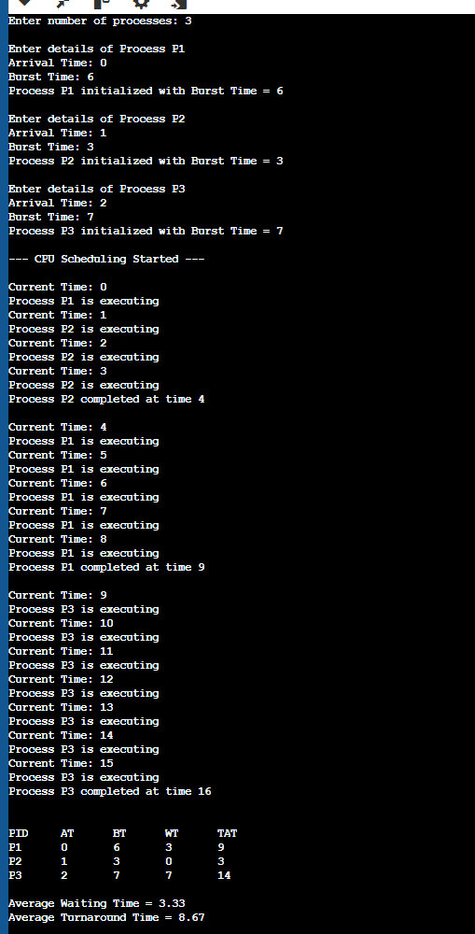  - ) Pre-emptive Priority Scheduling  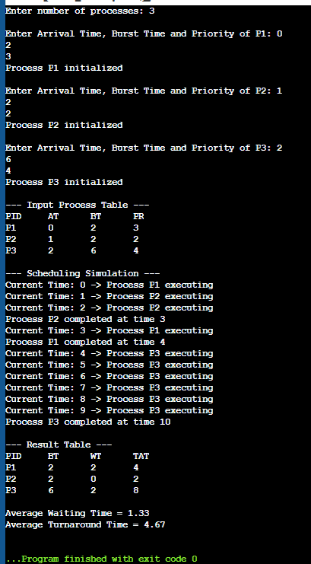  - ) Round Robin Scheduling  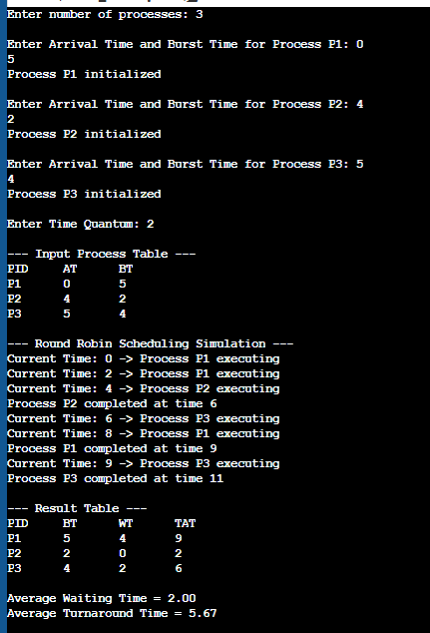
Output Analysis | The program simulates three pre-emptive CPU scheduling algorithms: Shortest Job First (SJF), Priority Scheduling, and Round Robin. After entering the process details such as arrival time, burst time, priority, and time quantum (for Round Robin), the scheduler selects processes according to the respective algorithm rules.  The program calculates Waiting Time (WT) and Turnaround Time (TAT) for each process and displays them in a result table. It also computes the average waiting time and average turnaround time for all processes.  From the output, we can observe how different scheduling algorithms affect process execution order and overall CPU performance. The comparison of average waiting and turnaround times helps evaluate the efficiency of each scheduling method.
Link of student Github profile where lab assignment has been uploaded
Conclusion | The simulation of pre-emptive CPU scheduling algorithms such as Shortest Job First (SJF), Priority Scheduling, and Round Robin was successfully implemented. The program schedules processes based on their burst time, priority, or time quantum. It calculates important parameters like Waiting Time (WT) and Turnaround Time (TAT) for each process. From the results, it can be observed that different scheduling algorithms produce different execution orders and performance outcomes. This experiment helps in understanding how CPU scheduling techniques improve process management and CPU utilization in an operating system.
Plagiarism Report (Similarity index <  12%) | 8%
Date | 10/03/26

