Department of Computer Technology

Vision of the Department
To be a preferred hub for nurturing computer engineering aspirants through innovative, ethical, value-based technical education, impactful research, and industry collaboration, to become successful professionals contributing for the betterment of society.

Mission of the Department
To nurture computer engineering professionals by offering:
- Dynamic learning environment that encourages problem-solving using emerging technology
- National Education Policy aligned evidence-based technical education, fostering innovation, research, and industry–institute collaboration
- Holistic, ethical and sustainable development for lifelong success.

Session 2025-2026

Vision: To become a skilled and responsible engineer who uses technology to solve real-world problems and contribute positively to society. | Mission: To gain strong technical knowledge, practical skills, and ethical values through continuous learning, hands-on practice, and collaboration, in order to achieve my professional goals.

Program Educational Objectives of the program (PEO): (broad statements that describe the professional and career accomplishments)

PEO1 | Preparation | P: Preparation | Pep-CL abbreviation pronounce as Pep-si-lL easy to recall
PEO2 | Core Competence | E: Environment (Learning Environment)
PEO3 | Breadth | P: Professionalism
PEO4 | Professionalism | C: Core Competence
PEO5 | Learning Environment | L: Breadth (Learning in diverse areas)

Program Outcomes (PO): (statements that describe what a student should be able to do and know by the end of a program)

Keywords of POs:
Engineering knowledge, Problem analysis, Design/development of solutions, Conduct Investigations of Complex Problems, Engineering Tool Usage, The Engineer and The World, Ethics, Individual and Collaborative Team work, Communication, Project Management and Finance, Life-Long Learning

PSO Keywords: Cutting edge technologies, Research


“I am an engineer, and I can apply engineering knowledge to analyze, investigate, and design solutions for complex problems using appropriate tools, while following ethical practices, working collaboratively, and continuously improving my skills throughout my life” to contribute to the development of cutting-edge technologies and Research.
Integrity: I will strictly follow the Laboratory Code of Conduct and maintain honesty, discipline, and ethical behavior while performing all laboratory work

Aditya Patil

Name and Signature of Student and Date
(Signature and Date in Handwritten)

Department of Computer Technology

Vision of the Department
To be a preferred hub for nurturing computer engineering aspirants through innovative, ethical, value-based technical education, impactful research, and industry collaboration, to become successful professionals contributing for the betterment of society.

Mission of the Department
To nurture computer engineering professionals by offering:
- Dynamic learning environment that encourages problem-solving using emerging technology
- National Education Policy aligned evidence-based technical education, fostering innovation, research, and industry–institute collaboration
- Holistic, ethical and sustainable development for lifelong success.

Sr. No  . | COs | POs |  |  |  |  |  |  |  |  |  |  |  | PSOs
 |  | Course Outcomes | 1 | 2 | 3 | 4 | 5 | 6 | 7 | 8 | 9 | 10 | 11 | PSO 1 | PSO 2
1 | CO1 | Demonstrate the ability to execute Linux process management, memory management, and shell  commands to manage system resources efficiently. | 3 | 3 | 3 | - |  | - | - | - | - | - | 3 | 3
2 | CO2 | Develop programs utilizing system calls, thread programming, and page  replacement algorithms to  simulate and analyze operating system functionalities. | 3 | 3 | 3 | - | - | - | - | - | - | - | 3 | 3
3 | CO3 | Design and implement process scheduling, memory allocation, and deadlock detection algorithms to address  real-world operating system challenges. | 3 | 3 | 3 | - |  | - | - | - | - | - | 3 | 3
 |  | Avg |  | 3 | 3 | - |  | - | - | - | - | - | 3 | 3

Department of Computer Technology

Vision of the Department
To be a preferred hub for nurturing computer engineering aspirants through innovative, ethical, value-based technical education, impactful research, and industry collaboration, to become successful professionals contributing for the betterment of society.

Mission of the Department
To nurture computer engineering professionals by offering:
- Dynamic learning environment that encourages problem-solving using emerging technology
- National Education Policy aligned evidence-based technical education, fostering innovation, research, and industry–institute collaboration
- Holistic, ethical and sustainable development for lifelong success.

Session | 2025-26 (EVEN) |  | Course Name | Operating Systems Lab
Semester | 4 |  | Course Code | 23CT1402
Roll No | 38 |  | Name of Student | Aditya Patil
Practical Number |  | 05
Aim |  | Write a simulator program for the given CPU scheduling algorithms. Non Pre-emptive  CPU Scheduling Algorithm. (FCFS, SJF)
Problem Definition |  | To develop a simulator program in C for Non-Preemptive CPU Scheduling algorithms such as First Come First Serve (FCFS) and Shortest Job First (SJF). The program should take process details as input and calculate waiting time, turnaround time, average times, and execution order to analyze CPU scheduling performance.
Theory  (100 words) |  | Brief Explanation CPU scheduling is a process used by the operating system to decide which process should use the CPU at a particular time. In Non-Preemptive Scheduling, once a process starts execution, it continues until it finishes and the CPU cannot be taken away from it.  First Come First Serve (FCFS) scheduling executes processes in the order of their arrival. The process that arrives first gets the CPU first. It is simple but may cause long waiting time for short processes.  Shortest Job First (SJF) scheduling selects the process with the smallest burst time for execution. It reduces the average waiting time compared to FCFS but requires knowledge of burst time beforehand.

Department of Computer Technology

Vision of the Department
To be a preferred hub for nurturing computer engineering aspirants through innovative, ethical, value-based technical education, impactful research, and industry collaboration, to become successful professionals contributing for the betterment of society.

Mission of the Department
To nurture computer engineering professionals by offering:
- Dynamic learning environment that encourages problem-solving using emerging technology
- National Education Policy aligned evidence-based technical education, fostering innovation, research, and industry–institute collaboration
- Holistic, ethical and sustainable development for lifelong success.

Procedure and Execution  (100 Words) | Steps of Implementation for FCFS  - Start the program and include the header file stdio.h.  - Declare variables and arrays for arrival time (AT), burst time (BT), completion time (CT), turnaround time (TAT), and waiting time (WT).  - Input the number of processes from the user.  - Accept arrival time and burst time for each process.  - In FCFS scheduling, execute processes in the order of their arrival.  - Calculate Completion Time (CT) for each process.  - Calculate Turnaround Time (TAT = CT − AT).  - Calculate Waiting Time (WT = TAT − BT).  - Compute Average WT and Average TAT.  - Display the results in a table format.  Steps of Implementation for Non-Preemptive SJF  - Start the program and include the header file stdio.h.  - Declare variables and arrays for AT, BT, CT, TAT, WT, and a visited array.  - Input the number of processes and their arrival and burst times.  - Initialize time and completed process counter.  - Find the process with the shortest burst time among the available processes.  - Execute that process completely (non-preemptive).  - Update Completion Time (CT).  - Calculate Turnaround Time (TAT = CT − AT) and Waiting Time (WT = TAT − BT).  - Repeat until all processes are completed.  - Calculate Average WT and Average TAT and display the result table.

Department of Computer Technology

Vision of the Department
To be a preferred hub for nurturing computer engineering aspirants through innovative, ethical, value-based technical education, impactful research, and industry collaboration, to become successful professionals contributing for the betterment of society.

Mission of the Department
To nurture computer engineering professionals by offering:
- Dynamic learning environment that encourages problem-solving using emerging technology
- National Education Policy aligned evidence-based technical education, fostering innovation, research, and industry–institute collaboration
- Holistic, ethical and sustainable development for lifelong success.

Code : | #include <stdio.h>  void fcfs(int n, int at[], int bt[])  {  int ct[20], tat[20], wt[20];  int time = 0;  float avg_wt = 0, avg_tat = 0;  for(int i = 0; i < n; i++)  {  if(time < at[i])  time = at[i];  time += bt[i];  ct[i] = time;  tat[i] = ct[i] - at[i];  wt[i] = tat[i] - bt[i];  avg_wt += wt[i];  avg_tat += tat[i];  }  printf("\n----- FCFS Scheduling -----\n");  printf("PID\tAT\tBT\tCT\tTAT\tWT\n");  for(int i = 0; i < n; i++)  {  printf("%d\t%d\t%d\t%d\t%d\t%d\n",  i+1, at[i], bt[i], ct[i], tat[i], wt[i]);  }  printf("\nAverage Waiting Time = %.2f", avg_wt/n);  printf("\nAverage Turnaround Time = %.2f\n", avg_tat/n);  }  void sjf(int n, int at[], int bt[])  {  int ct[20], tat[20], wt[20];  int visited[20] = {0};  int completed = 0, time = 0;  float avg_wt = 0, avg_tat = 0;  while(completed < n)  {  int idx = -1;  int min = 9999;  for(int i = 0; i < n; i++)  {  if(at[i] <= time && visited[i] == 0 && bt[i] < min)  {  min = bt[i];  idx = i;  }  }  if(idx != -1)  {  time += bt[idx];  ct[idx] = time;  tat[idx] = ct[idx] - at[idx];  wt[idx] = tat[idx] - bt[idx];  avg_wt += wt[idx];  avg_tat += tat[idx];  visited[idx] = 1;  completed++;  }  else  {  time++;  }  }  printf("\n----- Non Preemptive SJF -----\n");  printf("PID\tAT\tBT\tCT\tTAT\tWT\n");  for(int i = 0; i < n; i++)  {  printf("%d\t%d\t%d\t%d\t%d\t%d\n",  i+1, at[i], bt[i], ct[i], tat[i], wt[i]);  }  printf("\nAverage Waiting Time = %.2f", avg_wt/n);  printf("\nAverage Turnaround Time = %.2f\n", avg_tat/n);  }  int main()  {  int n, choice;  int at[20], bt[20];  printf("Enter number of processes: ");  scanf("%d", &n);  for(int i = 0; i < n; i++)  {  printf("\nProcess %d\n", i+1);  printf("Arrival Time: ");  scanf("%d", &at[i]);  printf("Burst Time: ");  scanf("%d", &bt[i]);  }  while(1)  {  printf("\n===== CPU Scheduling Simulator =====\n");  printf("1. FCFS\n");  printf("2. Non Preemptive SJF\n");  printf("3. Exit\n");  printf("Enter choice: ");  scanf("%d", &choice);  switch(choice)  {  case 1:  fcfs(n, at, bt);  break;  case 2:  sjf(n, at, bt);  break;  case 3:  return 0;  default:  printf("Invalid choice\n");  }  }  }
Output : | 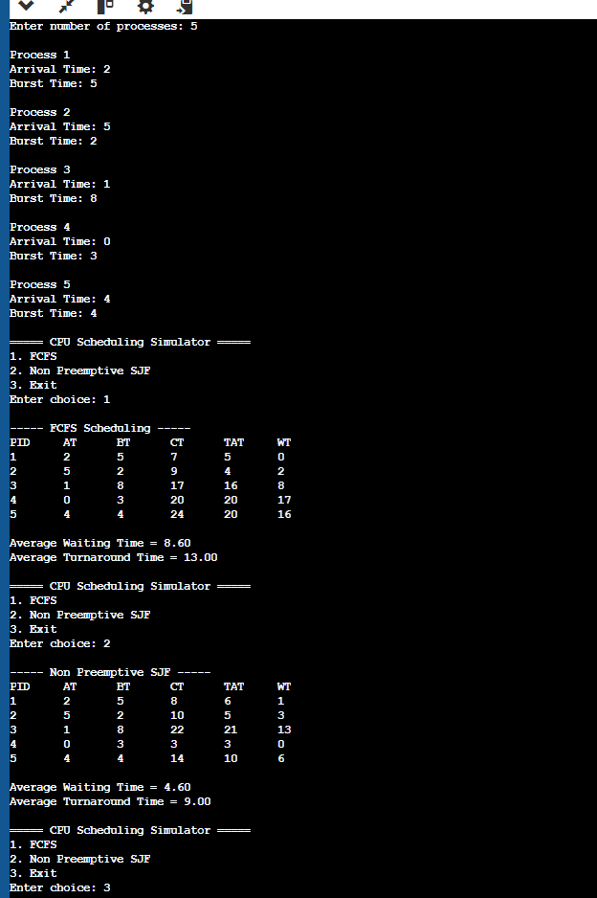
Output Analysis | From the output, we can observe the Completion Time (CT), Turnaround Time (TAT), and Waiting Time (WT) of each process for both FCFS and Non-Preemptive SJF scheduling algorithms.  In FCFS, processes are executed in the order of arrival, which is simple but may increase waiting time for shorter processes.  In SJF, the process with the smallest burst time is executed first, which usually reduces the average waiting time and turnaround time compared to FCFS.  By comparing the average values, we can evaluate which scheduling algorithm performs more efficiently for the given processes.
Link of student Github profile where lab assignment has been uploaded
Conclusion | From this program, we studied the working of Non-Preemptive CPU Scheduling algorithms such as FCFS and SJF. The simulator calculates completion time, waiting time, and turnaround time for each process. By comparing the results, we observe that SJF generally gives lower average waiting time and turnaround time than FCFS. However, FCFS is simpler to implement, while SJF requires knowledge of burst time in advance. This program helps in understanding how different scheduling algorithms affect CPU performance and process execution efficiency.
Plagiarism Report (Similarity index <
12%)
Date | 10/03/26

