Department of Computer Technology

Vision of the Department
To be a preferred hub for nurturing computer engineering aspirants through innovative, ethical, value-based technical education, impactful research, and industry collaboration, to become successful professionals contributing for the betterment of society.

Mission of the Department
To nurture computer engineering professionals by offering:
- Dynamic learning environment that encourages problem-solving using emerging technology
- National Education Policy aligned evidence-based technical education, fostering innovation, research, and industry–institute collaboration
- Holistic, ethical and sustainable development for lifelong success.

Session 2025-2026

Vision: To become a skilled and responsible engineer who uses technology to solve real-world problems and contribute positively to society. | Mission: To gain strong technical knowledge, practical skills, and ethical values through continuous learning, hands-on practice, and collaboration, in order to achieve my professional goals.

Program Educational Objectives of the program (PEO): (broad statements that describe the professional and career accomplishments)

PEO1 | Preparation | P: Preparation | Pep-CL abbreviation pronounce as Pep-si-lL easy to recall
PEO2 | Core Competence | E: Environment (Learning Environment)
PEO3 | Breadth | P: Professionalism
PEO4 | Professionalism | C: Core Competence
PEO5 | Learning Environment | L: Breadth (Learning in diverse areas)

Program Outcomes (PO): (statements that describe what a student should be able to do and know by the end of a program)

Keywords of POs:
Engineering knowledge, Problem analysis, Design/development of solutions, Conduct Investigations of Complex Problems, Engineering Tool Usage, The Engineer and The World, Ethics, Individual and Collaborative Team work, Communication, Project Management and Finance, Life-Long Learning

PSO Keywords: Cutting edge technologies, Research


“I am an engineer, and I can apply engineering knowledge to analyze, investigate, and design solutions for complex problems using appropriate tools, while following ethical practices, working collaboratively, and continuously improving my skills throughout my life” to contribute to the development of cutting-edge technologies and Research.
Integrity: I will strictly follow the Laboratory Code of Conduct and maintain honesty, discipline, and ethical behavior while performing all laboratory work

Aditya Patil

Name and Signature of Student and Date
(Signature and Date in Handwritten)

Department of Computer Technology

Vision of the Department
To be a preferred hub for nurturing computer engineering aspirants through innovative, ethical, value-based technical education, impactful research, and industry collaboration, to become successful professionals contributing for the betterment of society.

Mission of the Department
To nurture computer engineering professionals by offering:
- Dynamic learning environment that encourages problem-solving using emerging technology
- National Education Policy aligned evidence-based technical education, fostering innovation, research, and industry–institute collaboration
- Holistic, ethical and sustainable development for lifelong success.

Sr. No  . | COs | POs |  |  |  |  |  |  |  |  |  |  |  | PSOs
 |  | Course Outcomes | 1 | 2 | 3 | 4 | 5 | 6 | 7 | 8 | 9 | 10 | 11 | PSO 1 | PSO 2
1 | CO1 | Demonstrate the ability to execute Linux process management, memory management, and shell  commands to manage system resources efficiently. | 3 | 3 | 3 | - |  | - | - | - | - | - | 3 | 3
2 | CO2 | Develop programs utilizing system calls, thread programming, and page  replacement algorithms to  simulate and analyze operating system functionalities. | 3 | 3 | 3 | - | - | - | - | - | - | - | 3 | 3
3 | CO3 | Design and implement process scheduling, memory allocation, and deadlock detection algorithms to address  real-world operating system challenges. | 3 | 3 | 3 | - |  | - | - | - | - | - | 3 | 3
 |  | Avg |  | 3 | 3 | - |  | - | - | - | - | - | 3 | 3

Department of Computer Technology

Vision of the Department
To be a preferred hub for nurturing computer engineering aspirants through innovative, ethical, value-based technical education, impactful research, and industry collaboration, to become successful professionals contributing for the betterment of society.

Mission of the Department
To nurture computer engineering professionals by offering:
- Dynamic learning environment that encourages problem-solving using emerging technology
- National Education Policy aligned evidence-based technical education, fostering innovation, research, and industry–institute collaboration
- Holistic, ethical and sustainable development for lifelong success.

Session | 2025-26 (EVEN) |  | Course Name | Operating Systems Lab
Semester | 4 |  | Course Code | 23CT1402
Roll No | 38 |  | Name of Student | Aditya Patil
Practical Number |  | 04
Course Outcome |  | - Understand Computer System Configuration and Simulate system resources efficiently using Linux Commands (CO1)  - Analyse operating system functionalities utilizing system calls, thread programming and process scheduling algorithms (CO2)  - Apply Synchronization primitives to implement a Deadlock-free solution(CO3)  - Simulate Disk scheduling, Memory allocation, File allocation, page replacement algorithms (CO4)
Aim |  | Implement Process and thread (Life cycle of process):  - Process creation and Termination  - Thread creation and Termination.
Problem Definition |  | Write a C program to Implement process and thread lifecycle
Theory  (100 words) |  | Brief Explanation :  In an operating system, a process is a program in execution and it goes through several stages known as the process life cycle such as new, ready, running, waiting, and terminated. Processes can create other processes using system calls like fork(). The newly created process is called a child process, while the original process is called the parent process. Process termination occurs when a process finishes its execution using exit() or when the parent process waits for the child using wait().  A thread is the smallest unit of CPU execution within a process. Multiple threads can exist inside a single process and share the same memory space. Threads are created using the POSIX thread library (pthread) with functions like pthread_create() and terminated using pthread_exit() or when the thread function finishes execution.

Department of Computer Technology

Vision of the Department
To be a preferred hub for nurturing computer engineering aspirants through innovative, ethical, value-based technical education, impactful research, and industry collaboration, to become successful professionals contributing for the betterment of society.

Mission of the Department
To nurture computer engineering professionals by offering:
- Dynamic learning environment that encourages problem-solving using emerging technology
- National Education Policy aligned evidence-based technical education, fostering innovation, research, and industry–institute collaboration
- Holistic, ethical and sustainable development for lifelong success.

Procedure  And  Execution  (100 Words) | Steps for Implementation:  • Include required header files: stdio.h, unistd.h, sys/wait.h, pthread.h, stdlib.h  • Start main() function  • Declare variables (pid_t for process, pthread_t for threads)  • Use fork() to create a child process (where required)  • Check fork() result (pid < 0, pid == 0, pid > 0)  • In child process, print PID and execute required task  • Create thread(s) using pthread_create() (where needed)  • Define thread function to print message and call pthread_exit()  • Use pthread_join() to wait for thread completion  • In parent process, use wait() to wait for child  • Print termination messages  • End program using return 0 or exit()

Department of Computer Technology

Vision of the Department
To be a preferred hub for nurturing computer engineering aspirants through innovative, ethical, value-based technical education, impactful research, and industry collaboration, to become successful professionals contributing for the betterment of society.

Mission of the Department
To nurture computer engineering professionals by offering:
- Dynamic learning environment that encourages problem-solving using emerging technology
- National Education Policy aligned evidence-based technical education, fostering innovation, research, and industry–institute collaboration
- Holistic, ethical and sustainable development for lifelong success.
Code :
1)
#include <stdio.h>
#include <unistd.h>
#include <sys/wait.h>
#include <stdlib.h>

int main()
{
pid_t pid;

printf("Parent process started. PID = %d\n", getpid());

pid = fork();

if (pid < 0)
{
printf("Fork failed!\n");
exit(1);
}
else if (pid == 0)
{
printf("Child process running.\n");
printf("Child PID = %d, Parent PID = %d\n", getpid(), getppid());
printf("Child process terminating...\n");
exit(0);
}
else
{
wait(NULL);
printf("Parent process resumed.\n");
printf("Parent process terminating...\n");
}

return 0;
}

Department of Computer Technology

Vision of the Department
To be a preferred hub for nurturing computer engineering aspirants through innovative, ethical, value-based technical education, impactful research, and industry collaboration, to become successful professionals contributing for the betterment of society.

Mission of the Department
To nurture computer engineering professionals by offering:
- Dynamic learning environment that encourages problem-solving using emerging technology
- National Education Policy aligned evidence-based technical education, fostering innovation, research, and industry–institute collaboration
- Holistic, ethical and sustainable development for lifelong success.
2)
#include <stdio.h>
#include <unistd.h>
#include <sys/wait.h>
#include <stdlib.h>

int main()
{
pid_t pid;

pid = fork();

if (pid < 0)
{
printf("Fork failed!\n");
exit(1);
}
else if (pid == 0)
{
printf("Child Process:\n");
printf("Hello! My PID is %d\n", getpid());
printf("Child process: I'm performing a task.\n");
printf("Child process: Waiting for 2 seconds...\n");
sleep(2);
printf("Child process: Task finished, terminating.\n");
exit(0);
}
else{
printf("Parent Process:\n");
printf("Hello! My PID is %d and my child is %d\n", getpid(), pid);
printf("Parent process: Waiting for my child to complete...\n");
wait(NULL);
printf("Parent process: Child is done. I am now terminating.\n");
}
return 0;
}

Department of Computer Technology

Vision of the Department
To be a preferred hub for nurturing computer engineering aspirants through innovative, ethical, value-based technical education, impactful research, and industry collaboration, to become successful professionals contributing for the betterment of society.

Mission of the Department
To nurture computer engineering professionals by offering:
- Dynamic learning environment that encourages problem-solving using emerging technology
- National Education Policy aligned evidence-based technical education, fostering innovation, research, and industry–institute collaboration
- Holistic, ethical and sustainable development for lifelong success.

3)
#include <stdio.h>
#include <pthread.h>
#include <stdlib.h>

void* thread_function(void* arg)
{
printf("Thread is running...\n");
printf("Thread ID = %lu\n", pthread_self());
printf("Thread is terminating...\n");
pthread_exit(NULL);
}

int main()
{
pthread_t tid;

if (pthread_create(&tid, NULL, thread_function, NULL) != 0)
{
printf("Thread creation failed!\n");
exit(1);
}

printf("Main thread waiting for child thread to finish...\n");

pthread_join(tid, NULL);

printf("Child thread has finished execution.\n");
printf("Main thread terminating...\n");

return 0;
}
4)
#include <stdio.h>
#include <pthread.h>
#include <stdlib.h>

void* thread1_func(void* arg)
{
printf("Thread 1 is running...\n");
printf("Thread 1 ID = %lu\n", pthread_self());
printf("Thread 1 terminating...\n");
pthread_exit(NULL);
}

void* thread2_func(void* arg)
{
printf("Thread 2 is running...\n");
printf("Thread 2 ID = %lu\n", pthread_self());
printf("Thread 2 terminating...\n");
pthread_exit(NULL);
}

int main()
{
pthread_t t1, t2;

if (pthread_create(&t1, NULL, thread1_func, NULL) != 0)
{
printf("Thread 1 creation failed!\n");
exit(1);
}

if (pthread_create(&t2, NULL, thread2_func, NULL) != 0)
{
printf("Thread 2 creation failed!\n");
exit(1);
}

printf("Main thread waiting for threads to finish...\n");

pthread_join(t1, NULL);
pthread_join(t2, NULL);

printf("Both threads have finished execution.\n");
printf("Main thread terminating...\n");

return 0;
}
5)
#include <stdio.h>
#include <unistd.h>
#include <sys/wait.h>
#include <pthread.h>
#include <stdlib.h>

void* thread_func(void* arg)
{
printf("Thread in child process is running...\n");
printf("Thread ID = %lu\n", pthread_self());
printf("Thread terminating...\n");
pthread_exit(NULL);
}

int main()
{
pid_t pid;

pid = fork();

if (pid < 0)
{
printf("Fork failed!\n");
exit(1);
}
else if (pid == 0)
{
pthread_t tid;

printf("Child process started. PID = %d\n", getpid());

if (pthread_create(&tid, NULL, thread_func, NULL) != 0)
{
printf("Thread creation failed!\n");
exit(1);
}

pthread_join(tid, NULL);

printf("Child process terminating...\n");
exit(0);
}
else
{
printf("Parent process waiting for child...\n");

wait(NULL);

printf("Child finished execution.\n");
printf("Parent process terminating...\n");
}

return 0;
}
Output : | 1)  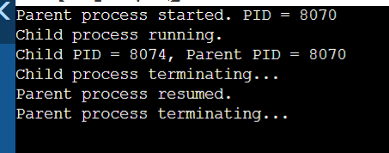  2)  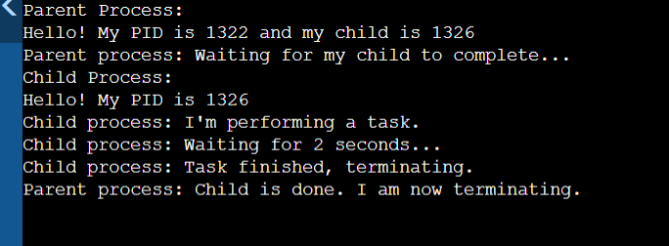  3)  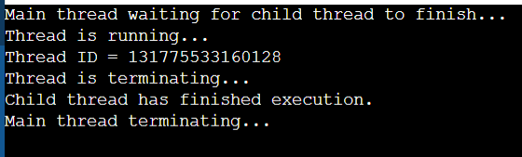  4)  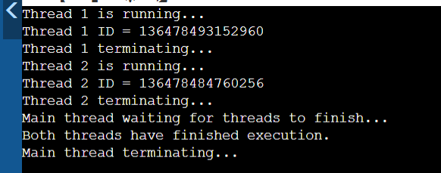  5)  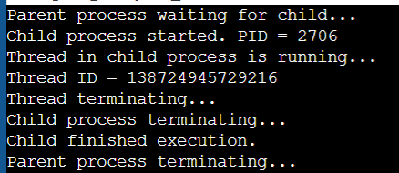
Output Analysis | When the program is executed, the operating system first creates the parent process. Using the fork() system call, the parent process creates a child process. After the child process is created, both the parent and child processes run independently. The child process prints its process ID using getpid() and the parent process ID using getppid(). After completing its execution, the child process terminates and the parent process waits for the child using the wait() system call before continuing its execution.  In the thread program, the main program creates a new thread using pthread_create(). The created thread starts executing the specified thread function and prints its thread ID using pthread_self(). Once the thread completes its task, it terminates using pthread_exit(). The main thread waits for the created thread to finish using pthread_join() before the program ends.  Thus, the output confirms the successful creation, execution, and termination of both processes and threads, demonstrating their life cycle in the operating system.
Link of student Github profile where lab assignment has been uploaded | https://github.com/Aditya-patil481/Operating-system-practical-
Conclusion | Thus, the experiment was successfully performed to demonstrate the life cycle of processes and threads. The program illustrated how a parent process creates a child process using the fork() system call and how the process terminates after execution. Similarly, thread creation and termination were implemented using the POSIX thread library functions such as pthread_create() and pthread_exit(). This experiment helps in understanding how operating systems manage multiple processes and threads efficiently for concurrent execution.
Plagiarism Report (Similarity index <  12%) | 10%
Date | 18/03/26

