III. PROPOSED METHODOLOGY
This study proposes a noise-aware fine-tuning framework for BirdNET-based avian species classification, specifically designed to improve recognition accuracy on the Indian Bird Call dataset (IBC53) comprising 30 species. The proposed pipeline integrates domain-specific audio preprocessing with transfer learning on the BirdNET deep learning backbone. The framework consists of four principal stages: (1) audio segmentation, (2) energy-based noise detection, (3) noise-augmented dataset construction, and (4) BirdNET fine-tuning with multi-configuration evaluation. The overall architecture of the proposed methodology is depicted in Fig. 1.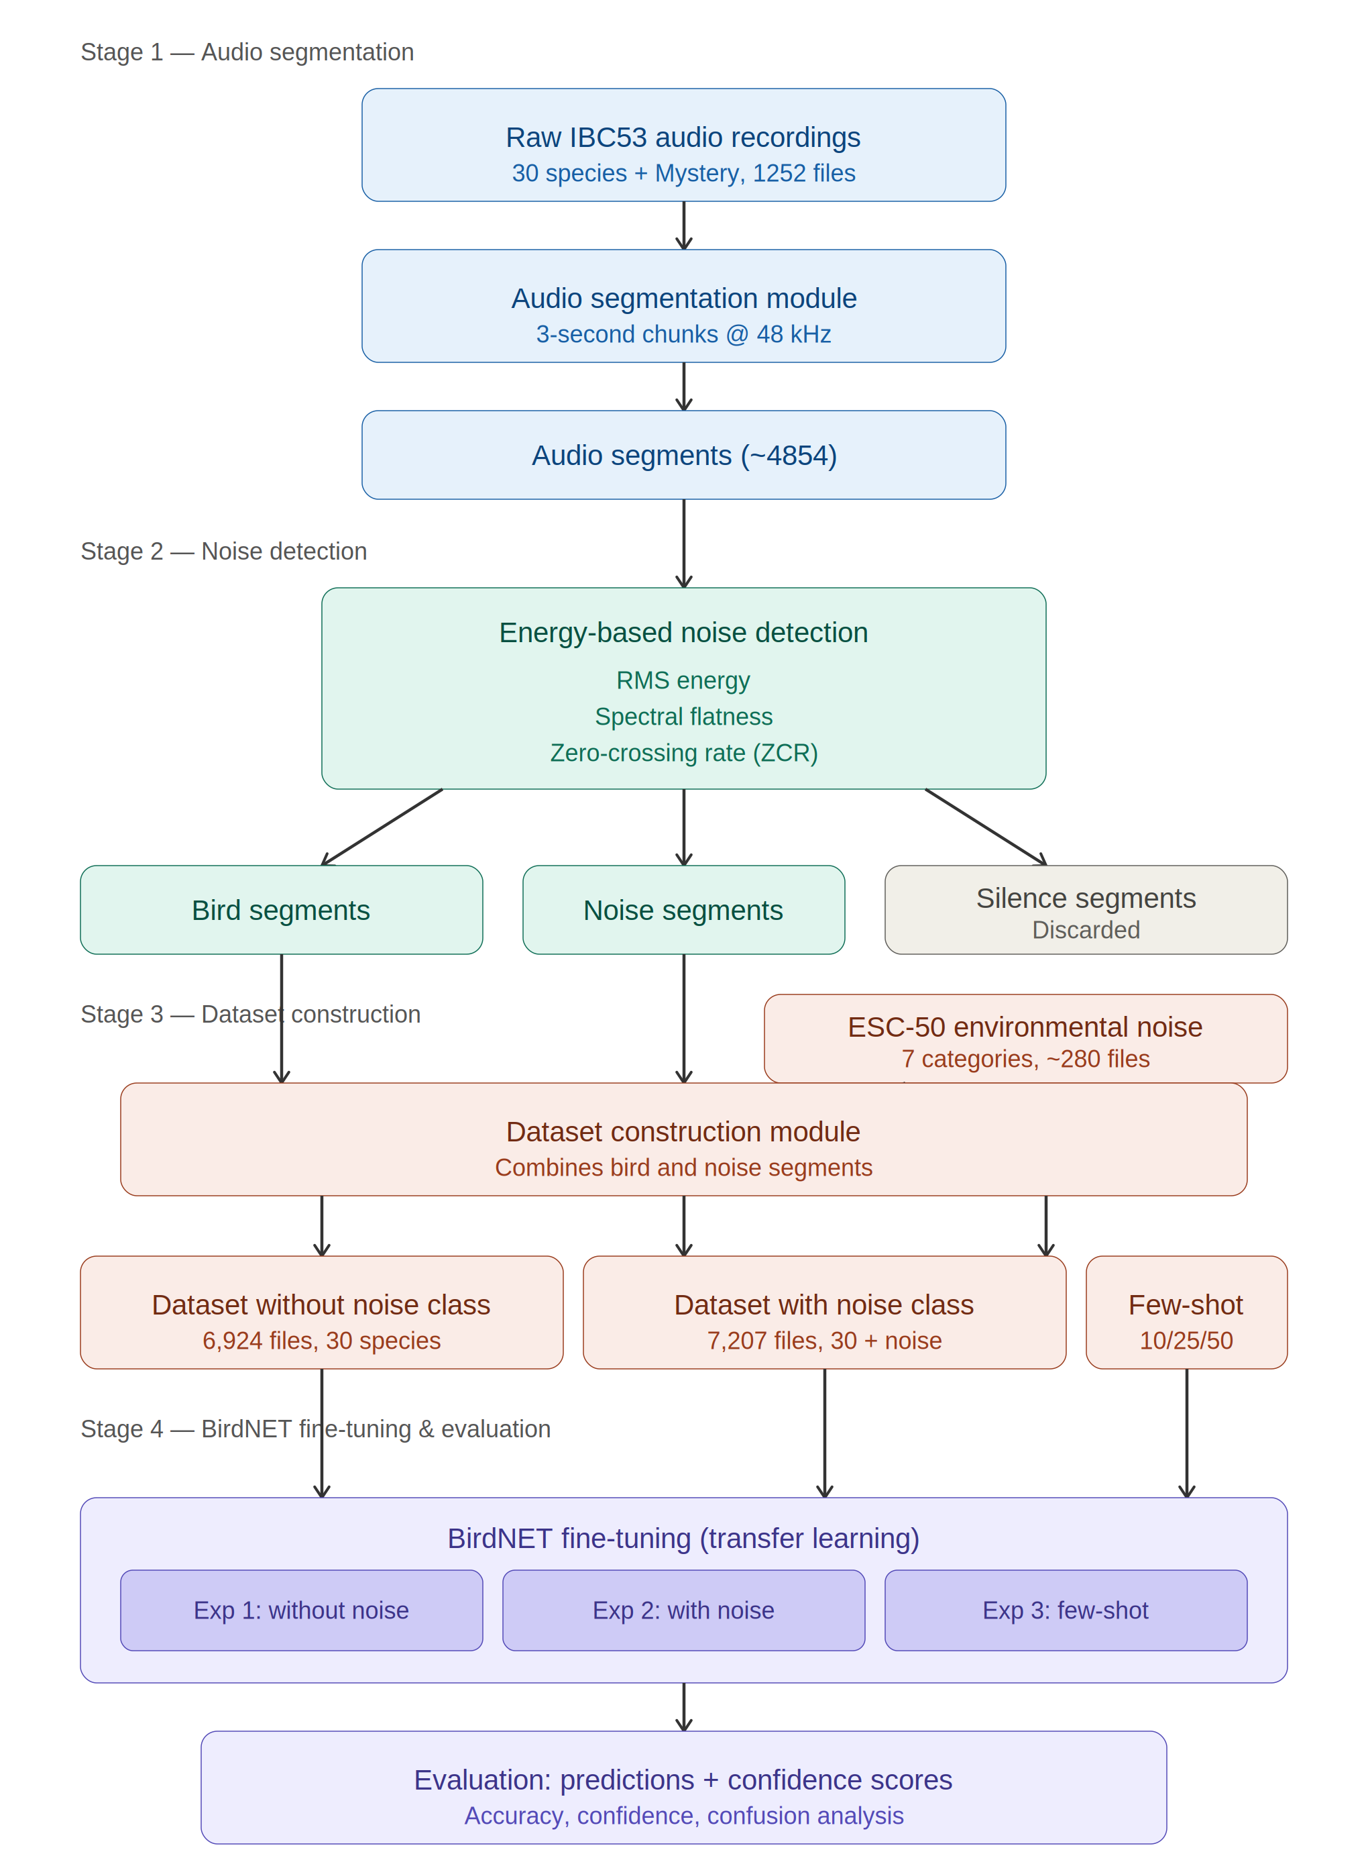
Fig. 1. Architecture of the proposed noise-aware BirdNET fine-tuning framework showing the four-stage pipeline: audio segmentation, energy-based noise detection, dataset construction with ESC-50 noise integration, and BirdNET fine-tuning with multi-experiment evaluation.

A. Audio Segmentation
The initial step in the proposed pipeline involves tackling the problem of handling varying lengths of field recordings in order to generate consistent input samples that can be used by the classifier based on deep learning models. The audio recordings obtained from the IBC53 dataset, consisting of a total of 1,252 recordings from 30 Indian bird species and another 443 mystery recordings without labels, are divided into samples of equal length of 3 seconds.
The process of segmentation makes use of a simple non-overlapping sliding window technique. First, the waveform in each audio recording is resampled to a rate of 48 kHz since this is the input size accepted by BirdNET. The resampled waveform is subsequently divided into sequential 3-second samples. Any waveform less than 3 seconds in length at the end of a recording is zero-padded in order to maintain dimensional consistency. With this process, the original 1,252 recordings are converted to approximately 4,854 samples. If we let x(t) represent the audio recording waveform of duration T seconds, the segmentation operator S produces N segments of length L = 3, where N = ceil(T / L), such that each segment The formula for s_i can be expressed as:
s_i = x(t), t=[3(i-1), 3i] where i=1, 2, ..., N (1)
In cases where the duration of the last frame is less than three seconds, zero padding is used so that the length of all the frames becomes 144,000.
B. Noise Detection Based on Energy
A field recording will have a mix of target bird vocalization, environmental noise, and silence in every recording. Training the classifier on these segments will result in label noise and reduce classifier performance. This challenge will be addressed in the second phase through the implementation of an energy-based noise detection module where each of the 3 seconds segments will be categorized as follows: Bird vocalization, environmental noise, or silence.
Each of the 3-second segments will be classified based on three acoustic features calculated from both time domain and frequency domain:
1) RMS Energy: RMS Energy calculates the average energy in the audio signal. A segment is said to be silence if its RMS energy level is below the threshold value of theta_RMS = 0.01 since it does not have enough energy content. The RMS energy calculation formula for a sample s_i of length L is given by:RMS(s_i) = sqrt((1/L) * sum(s_i[n]^2)), n = 0, 1, ..., L-1 (2)
2) Spectral Flatness: The spectral flatness feature characterizes how evenly distributed the power spectrum is. A high spectral flatness corresponds to a uniformly distributed power spectrum, resembling the spectrum of a noise-like signal (white noise). Conversely, low spectral flatness values correspond to spectra that have distinct peaks, which is a feature typical for tonal signals like bird calls. The spectral flatness can be calculated as the ratio of the geometric mean of the power spectral density to its arithmetic mean. The noise segments are identified using segments that have spectral flatness above the threshold theta_SF = 0.5.
SF(s_i) = (prod(P(k))^(1/K)) / ((1/K) * sum(P(k))), k = 0, ..., K-1 (3)
where P(k) is the power spectral density of the kth frequency bin, and K is the total number of frequency bins.
3) Zero-Crossing Rate (ZCR): This measure refers to the rate at which the signal crosses the zero axis in its amplitude domain. As noise signals are aperiodic and unpredictable, their ZCR values are generally higher than those of bird songs. Segments that have spectral flatness greater than theta_SF and ZCR greater than theta_ZCR = 0.1 are considered noise.
The combined decision rule for segment classification is formulated as follows: a segment is labeled as silence if RMS(s_i) < theta_RMS; as noise if SF(s_i) > theta_SF AND ZCR(s_i) > theta_ZCR; and as bird vocalization otherwise. Table I summarizes the threshold parameters used in the noise detection module.
TABLE I. Threshold Parameters for Energy-Based Noise Detection
Parameter | Symbol | Value | Purpose
RMS Threshold | theta_RMS | 0.01 | Silence detection
Spectral Flatness Threshold | theta_SF | 0.5 | Noise candidate detection
Zero-Crossing Rate Threshold | theta_ZCR | 0.1 | Noise confirmation

C. Training Data Set Creation with Noise Augmentation
The final stage involves the generation of training data sets that will be used in fine-tuning BirdNET. This is an important addition to the paper, whereby special care has been taken to include noise samples in the training data set to allow the model to learn noise suppression when making predictions.
The bird call samples filtered in Stage 2 are sorted into separate directories for each type of bird according to the expected training data set format for BirdNET, where the subdirectories are named by the scientific name of the bird (e.g., Pnoepyga_pusilla, Pellorneum_ruficeps). This gives a data set of 6,924 samples for 30 bird species classes.
To create the noise-augmented dataset, environmental noise samples are taken from the ESC-50 [ref] dataset. Noise classes that are applicable to field recording scenarios are chosen, specifically: rain, wind, thunderstorm, insects, water drops, crackling fire, and engine idling. In total, 283 noise samples are obtained and stored in a special noise folder. During training, BirdNET sees this folder as a NON_EVENT_CLASS which means that the noise samples do not have a dedicated output label but rather help to train BirdNET to ignore non-bird sound snippets. The noise-augmented dataset includes 7,207 audio files (6,924 birds + 283 noises).
Besides, few-shot samples are taken from the whole dataset in order to evaluate data efficiency. In particular, for each of 30 species and noise class, samples of 10, 25, and 50 samples are taken randomly and without replacement leading to the creation of 3 few-shot datasets including 583, 1033, and 1783 samples respectively.
TABLE II. Dataset Configurations for Experimental Evaluation
Dataset | Bird Files | Noise Files | Total | Classes
Without Noise (Exp 1) | 6,924 | 0 | 6,924 | 30
With Noise (Exp 2) | 6,924 | 283 | 7,207 | 30 + noise
Few-Shot 10 (Exp 3a) | 300 | 283 | 583 | 30 + noise
Few-Shot 25 (Exp 3b) | 750 | 283 | 1,033 | 30 + noise
Few-Shot 50 (Exp 3c) | 1,500 | 283 | 1,783 | 30 + noise

D. Fine-Tuning and Evaluating the BirdNET Model
In the fourth step, which will be the last step of our proposed pipeline, we will fine-tune the pre-trained BirdNET model using our datasets. BirdNET is an AI system built on deep CNN with pre-training on more than 6,000 species of birds worldwide by applying the EfficientNet architecture. The BirdNET has robust general purpose audio feature extraction capabilities that can be used after fine-tuning it to extract features for Indian bird species.
While fine-tuning, we freeze the pre-trained feature extractor part and add a new classification head to train the BirdNET on our target dataset. This new classification head learns how to classify feature embeddings into 30 species classes. Training is done for 50 epochs with the help of the BirdNET's own training API. We select the best performing model using the Area under Precision Recall curve, which is ideal for imbalanced multi-class audio classification problems.
The fine-tuned models are exported in the TensorFlow Lite (.tflite) format. The size of each of the trained models is around 25.1 MB. This will allow deploying our model on limited-resource devices to use them in the field.
Four different experiments are run to test the effect of noise-aware fine-tuning and amount of training data:
1) Experiment 1 (Baseline Fine-Tuning): The model is fine-tuned using 6,924 bird clips from 30 classes of birds, but no noise. Experiment 1 provides the basis to compare how much noise-aware training increases classification accuracy.
2) Experiment 2 (Noise-Aware Fine-Tuning): In this experiment, the model is fine-tuned using 7,207 clips and the new noise class (ESC-50). This is the main experiment we perform to find out if noise-aware fine-tuning makes the model better.
3) Experiment 3 (Sensitivity to Few-Shot Datasets): Three separate sub-experiments were performed by fine-tuning the model on 10, 25, and 50 samples from each class.
E. Evaluation Metrics
All experiments are evaluated using the entire test set IBC53 consisting of 1,252 audio clips belonging to 30 different species and 443 mystery/unlabeled audio files. The following evaluation metrics are calculated to measure the model’s performance thoroughly:
1) Overall Accuracy: The ratio between correct classification of species and total number of classifications made across all test files and all species.
2) Species-specific Accuracy: Individual accuracy per species across the 30 different species used, providing information on per-species performance and potential inter-species confusion.
3) Confidence Distributions: Analysis of prediction confidence scores in terms of their means, medians, and frequency above certain threshold levels (0.5, 0.7, and 0.9). High confidence implies better-calibrated models.
4) Confusion Analysis: Calculation of the most common classification error pairs to evaluate the role played by inter-species acoustical similarity.
5) Fine-Tuning Metrics: AUPRC, AUROC, and training loss values are tracked during the fine-tuning process to study model convergence behavior.
The evaluation process allows for a direct comparison among all experiment conditions and provides the independent contribution of noise-awareness and amount of training data on species classification in Indian birds.

