# LifeDash AI CRM - HCP Interaction Module Implementation Plan

## 1. Concept Overview
LifeDash is an AI-first CRM designed for Life Sciences sales representatives. It focuses on reducing administrative burden by allowing reps to log interactions naturally through voice-to-text or chat, while maintaining high-quality, structured data for medical compliance and sales tracking.

## 2. Technical Stack
- **Frontend**: React (Vite), Redux Toolkit, CSS Variables (Inter Font).
- **Backend**: FastAPI (Python 3.10+).
- **AI Agent**: LangGraph for stateful multi-step interactions.
- **LLM**: Groq (gemma2-9b-it for fast extraction, llama-3.3-70b-versatile for complex reasoning).
- **Database**: PostgreSQL (SQLAlchemy ORM).
- **Styling**: Modern, premium UI with glassmorphism and life-science themed accents.

## 3. LangGraph Agent Architecture
The agent acts as a "Medical CRM Concierge". It manages the state of the conversation, ensuring all required fields for a medical interaction are captured before finalizing the log.

### Agent Tools
1. **log_interaction (Required)**:
- **Function**: Structures raw text into HCP ID, Product, Key Messaging, Sentiment, and Compliance Flags.
- **Process**: LLM extraction -> Validation -> Database Write.
2. **edit_interaction (Required)**:
- **Function**: Retrieves an existing interaction and applies targeted updates (e.g., "Change the follow-up date to next Friday").
3. **search_hcp_profile**:
- **Function**: Provides context on the HCP's specialty, hospital affiliation, and previous sentiment towards products.
4. **schedule_follow_up**:
- **Function**: Creates tasks in the CRM calendar based on the "Next Steps" identified in an interaction.
5. **get_product_knowledge**:
- **Function**: Real-time retrieval of clinical trial results or product FAQs to help the rep answer HCP questions accurately.

### State Diagram (LangGraph)
```mermaid
graph TD
A[Input: Text/Voice/Form] --> B{Route Input}
B -->|Log New| C[Extraction Node]
B -->|Update| D[Edit Node]
B -->|Query| E[HCP Profile Node]
C --> F[Confirm/Review State]
F -->|Approved| G[Tool: log_interaction]
D --> H[Tool: edit_interaction]
G --> I[Finalize & Suggest Next Steps]
H --> I
```
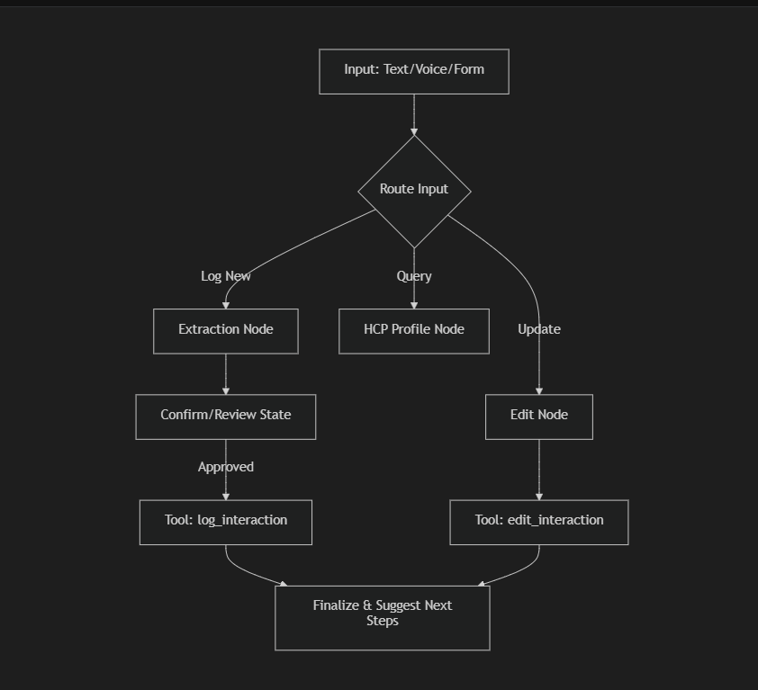

## 4. UI/UX Design (Log Interaction Screen)
- **Hybrid Interface**: A split view or toggle between a "Clean Form" and a "Conversational Chat".
- **Real-time Feedback**: As the user types in chat, form fields highlight or auto-populate.
- **Micro-animations**: Subtle pulses when AI is processing or extracting entities.
- **Color Palette**: Clinical White, Deep Med-Tech Blue (#004A99), and Soft Sage (#E8F5E9) for success states.

## 5. Development Milestones
1. **Phase 1**: Setup React + Redux and design the Premium HCP Dashboard.
2. **Phase 2**: Implement the FastAPI backend with LangGraph stubs.
3. **Phase 3**: Integrate Groq LLM for entity extraction and conversational logging.
4. **Phase 4**: Connect PostgreSQL and persistence layers.
5. **Phase 5**: Final Polish & Interaction animations.

