**Assignment**

**Spring Framework**

Date-03/03/2021

Q1)Write a program to demonstrate Tightly Coupled code

Answer-

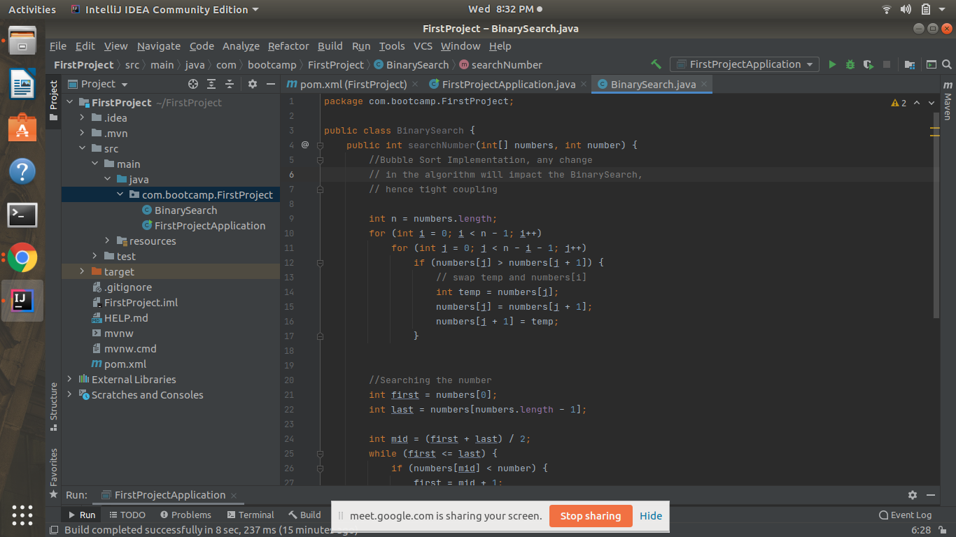

Q2) Write a program to demonstrate Loosely Coupled code.

Answer-We create a seperate class of bubble sort and create it’s method in BinarySearch to avoid tight coupling.

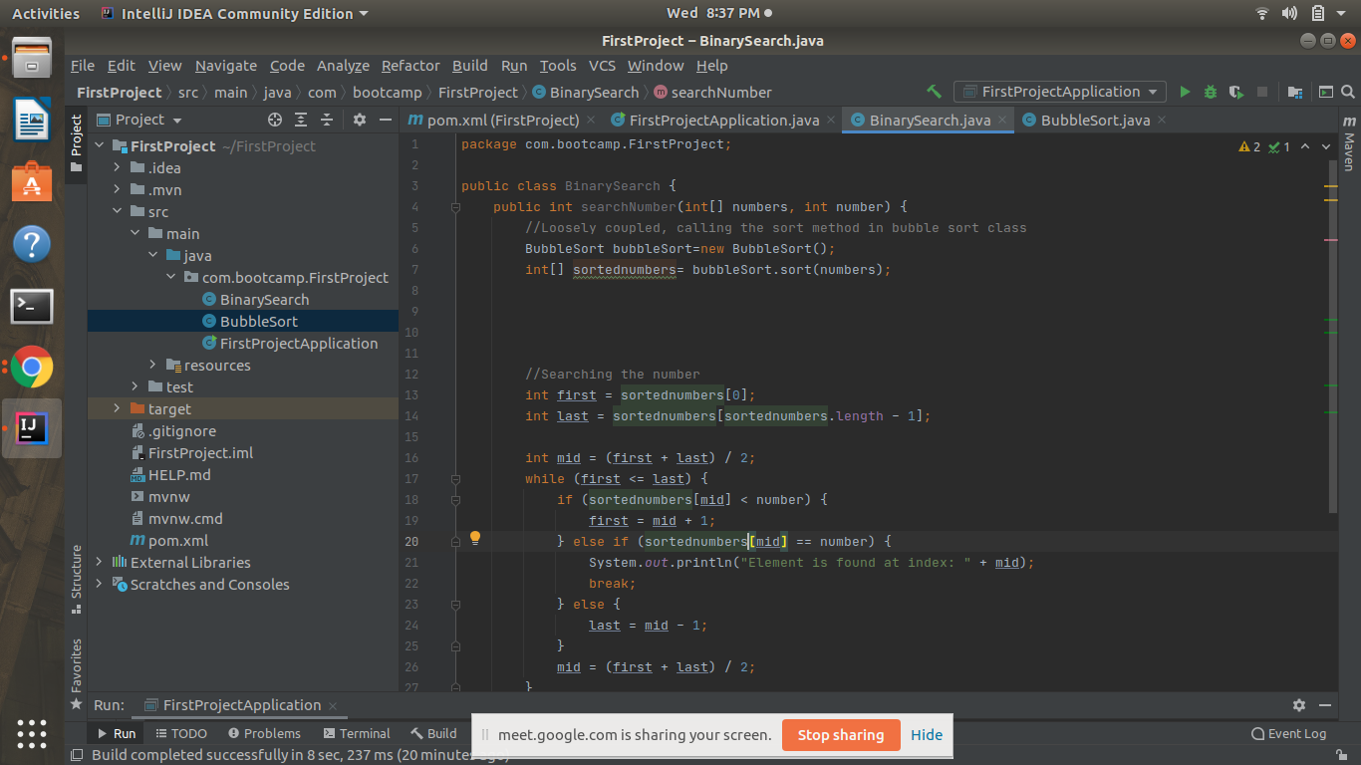

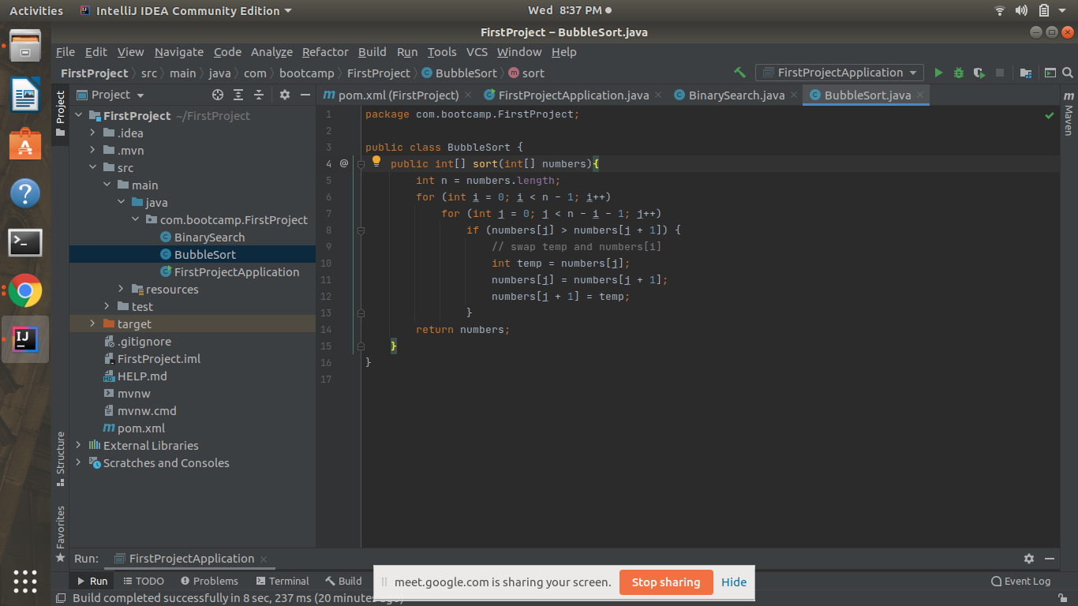

Q3)Use @Compenent and @Autowired annotations to in Loosely Coupled code for dependency management.

Answer-

Main class

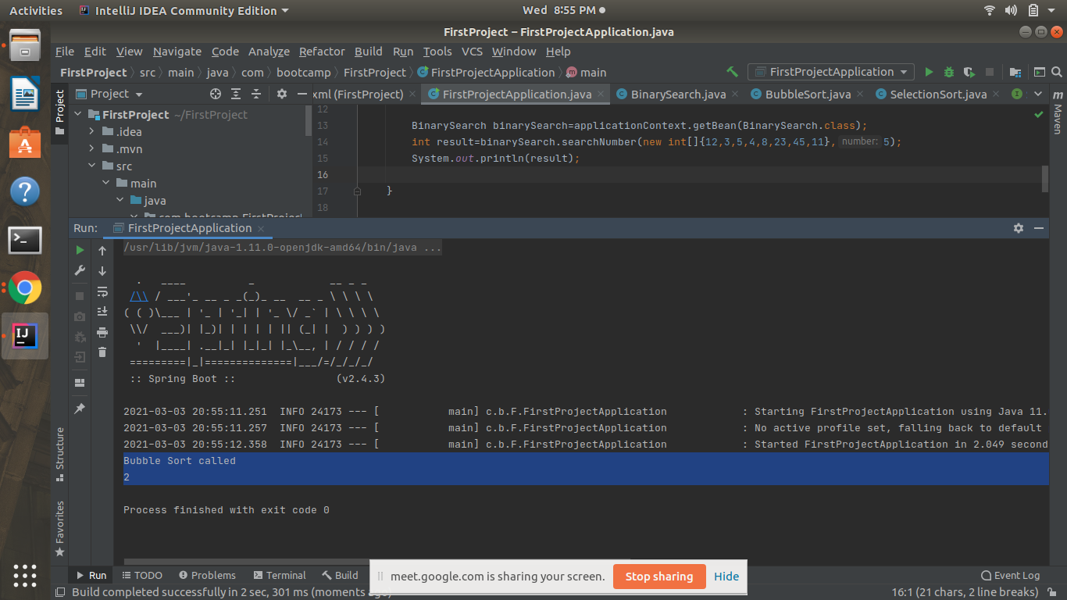

We have created an interface and autowired it as the dependency of a BinarySearch class which is a component.

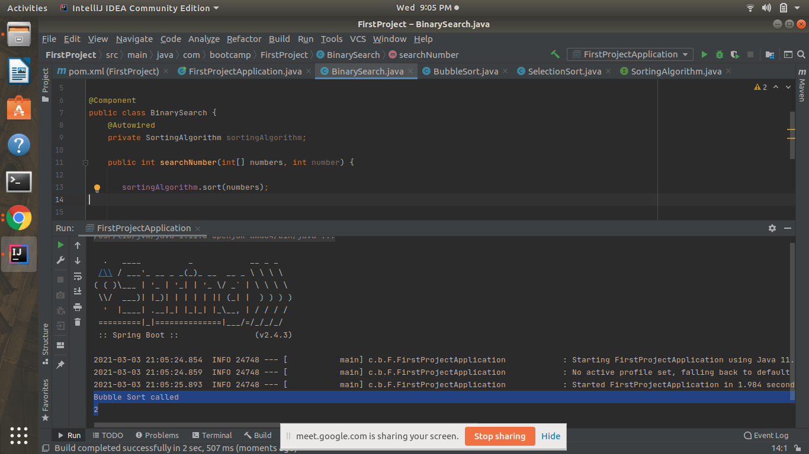

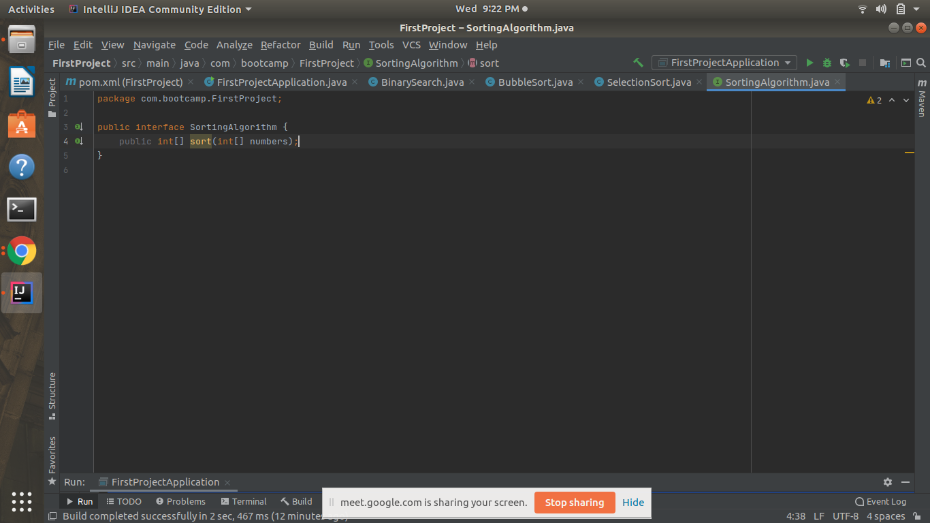

BubbleSort implements SortingAlgorithm interface and is itself a component that will be called as a dependency of BinarySearch

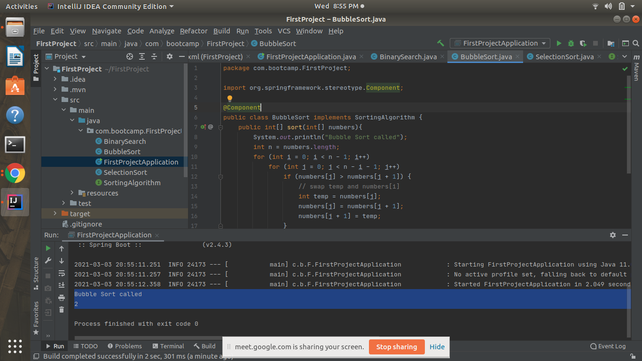

Q4)Get a Spring Bean from application context and display its properties.

Answer-

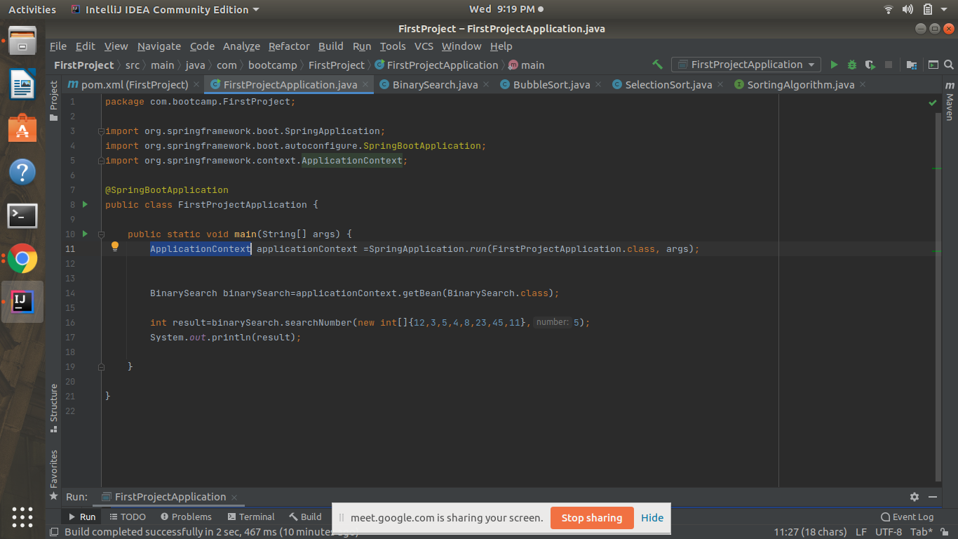

Q5) Demonstrate how you will resolve ambiguity while autowiring bean (Hint : @Primary)

Answer-We will write @Primary annotation under the component we want to call to remove ambiguity, this will give that component priority over other components.

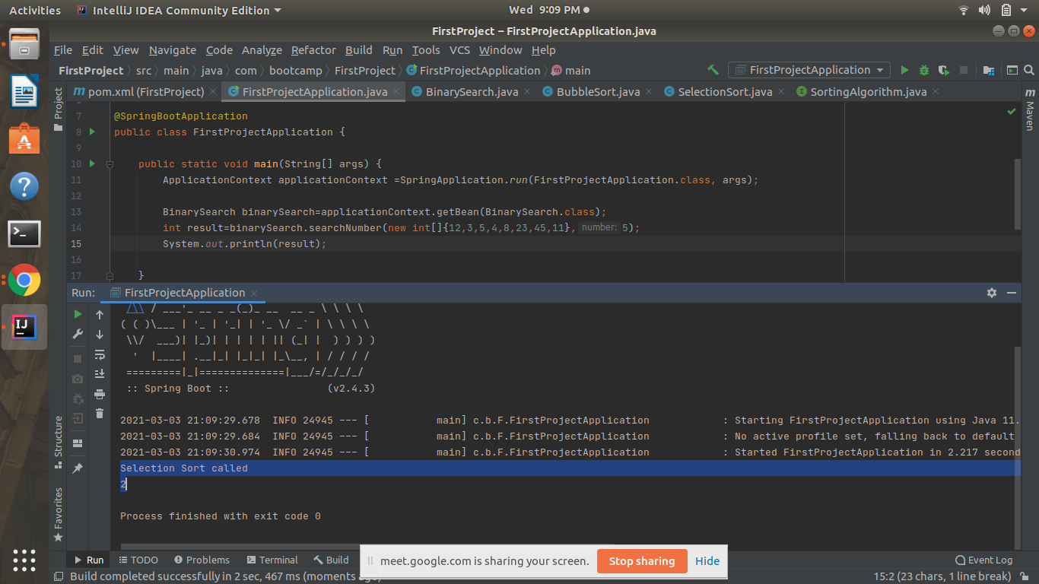

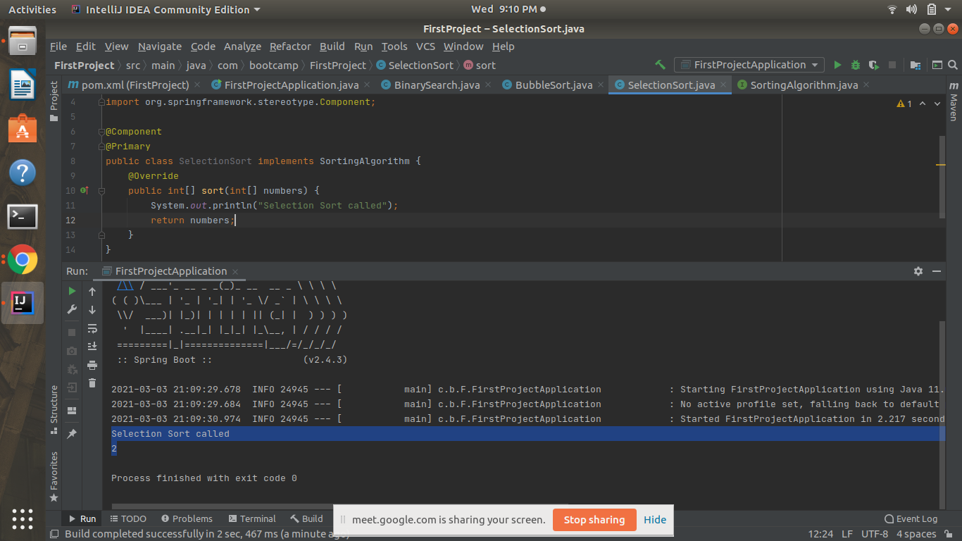

Q6)Perform Constructor Injection in a Spring Bean

Answer-



