**Assignment**

**Spring Security oauth2**

Doc -><https://docs.google.com/document/d/1uMMB-FryB49Wl2Ufmam2ZaNGcBtEa3ir1TbwUfogQDw/edit>

Q1)Implement oauth 2 using spring security and authenticate a user which is saved in database using spring data jpa.

* 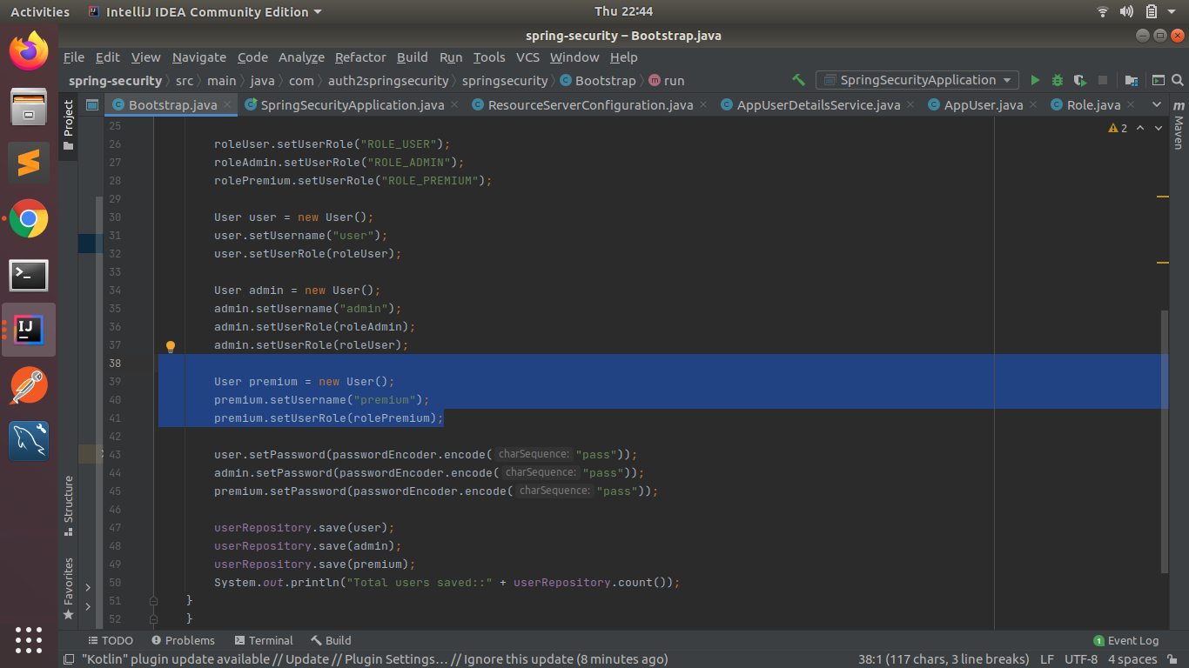

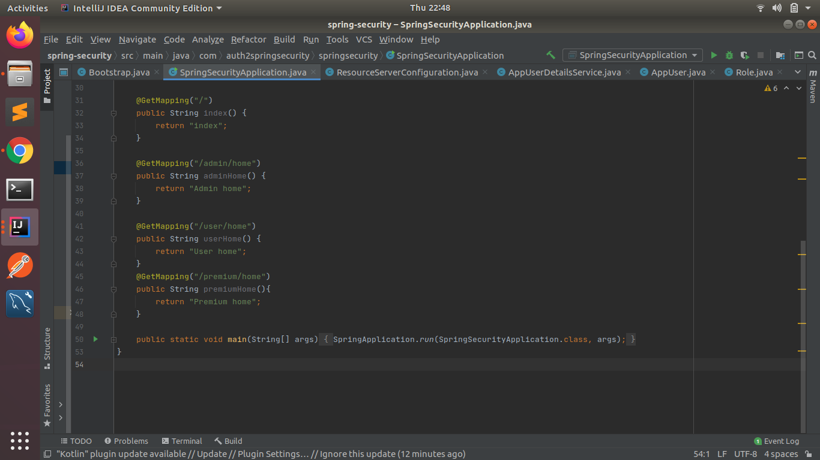

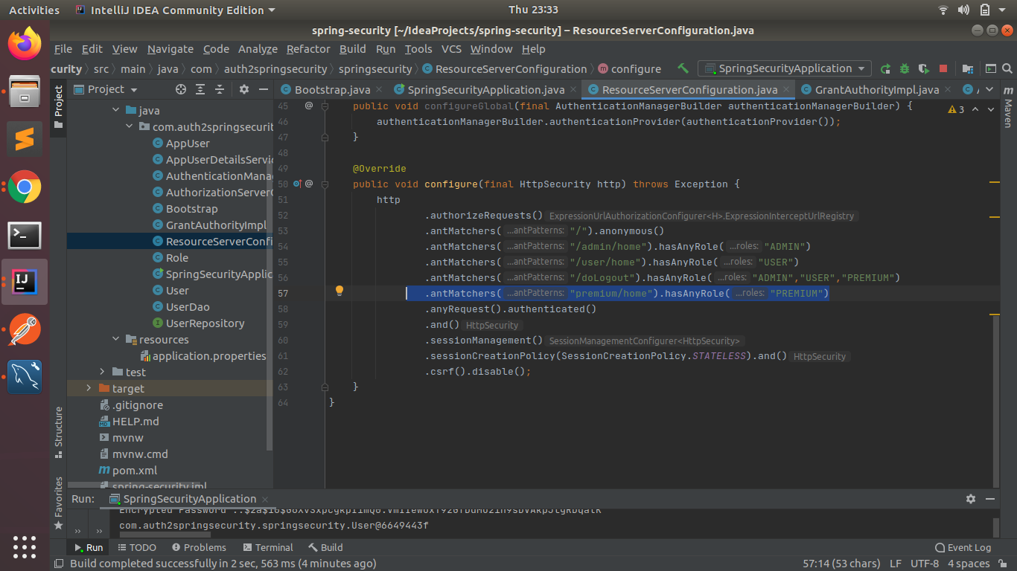

**Premium user is saved in Database.**

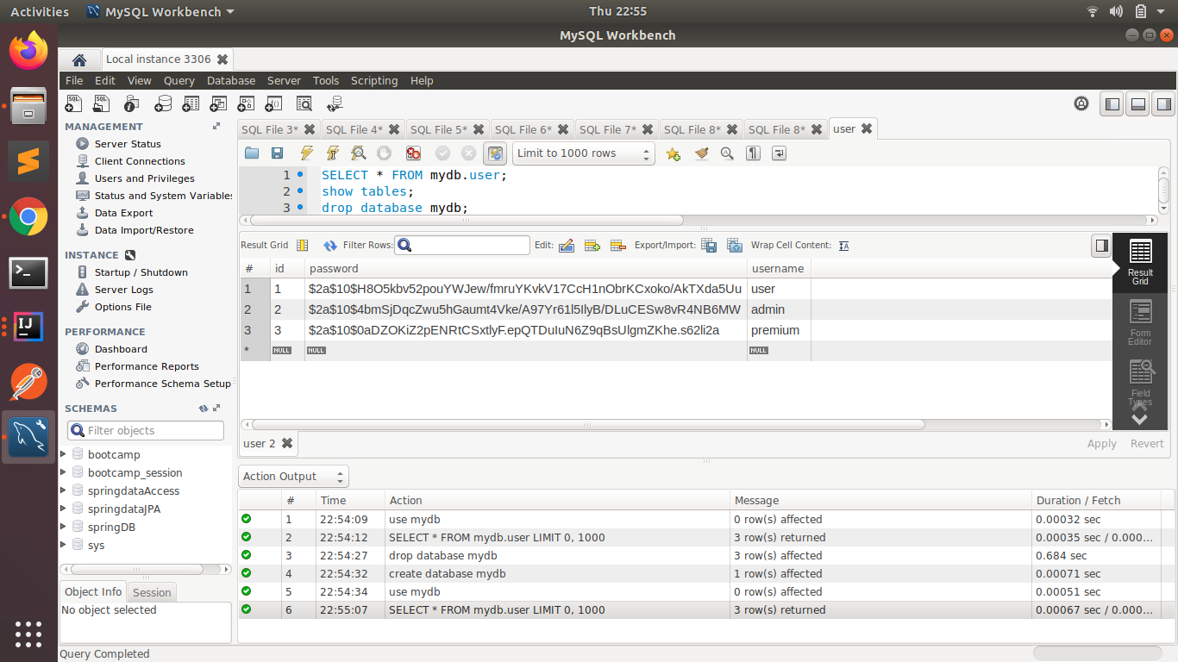

**Getting token for Premium user.**

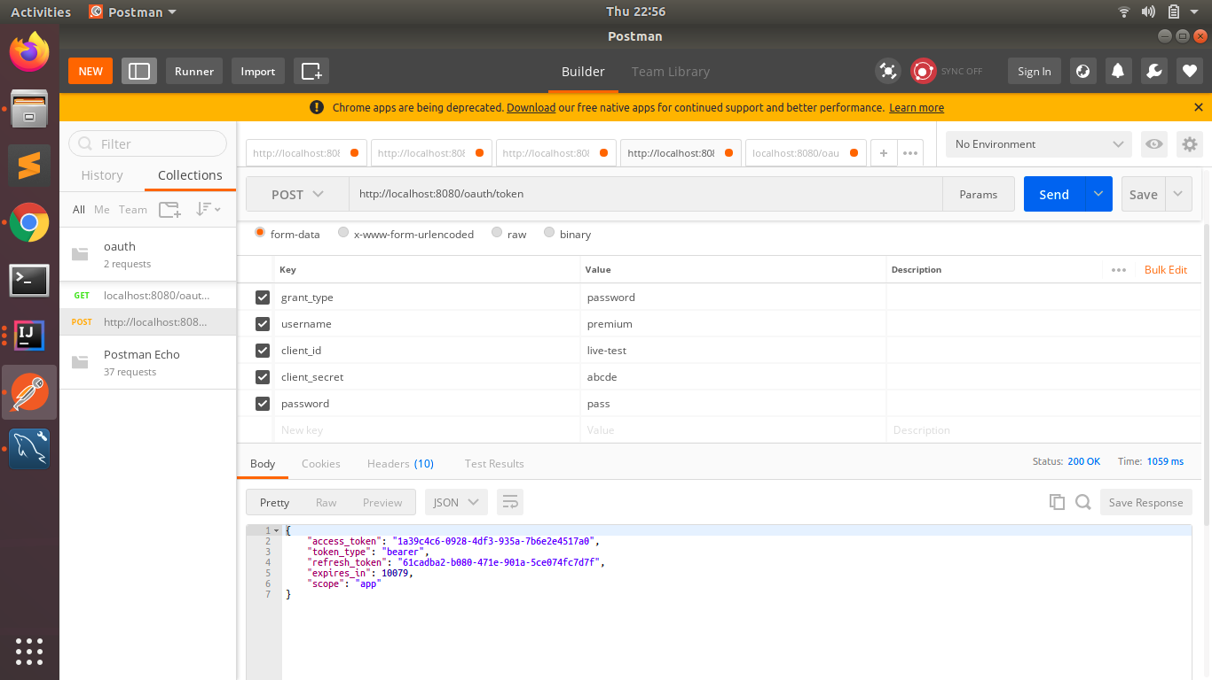

**After authentication that the user is saved in the database, it is accessing premium user’s URI.**

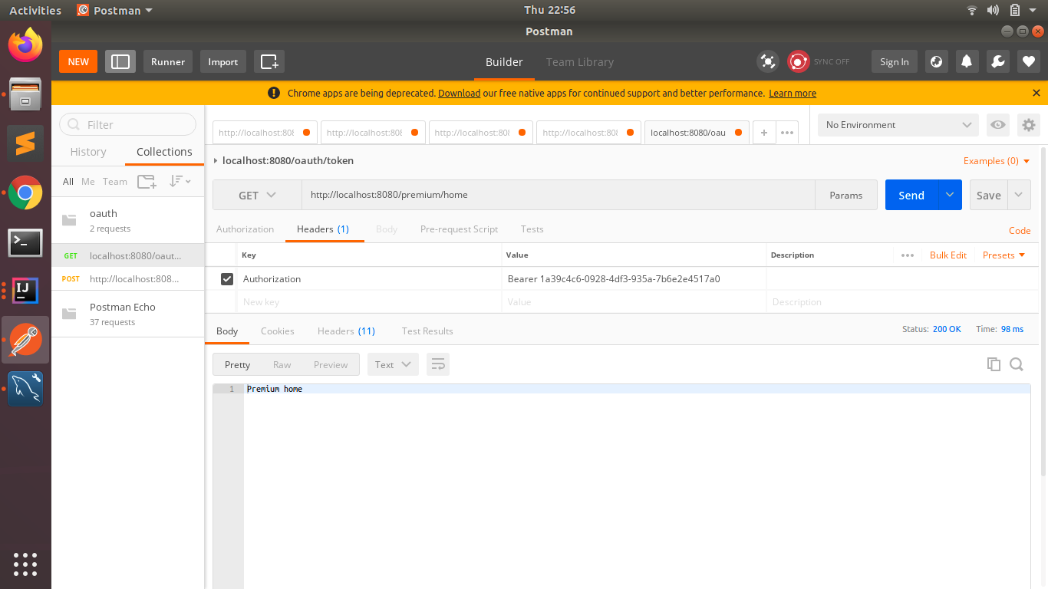

Q2)Grant different Roles to different users and make sure that only authorized users of a given type can access the resource.

**Admin can also be user, so it has both roles( ADMIN, USER).**

* 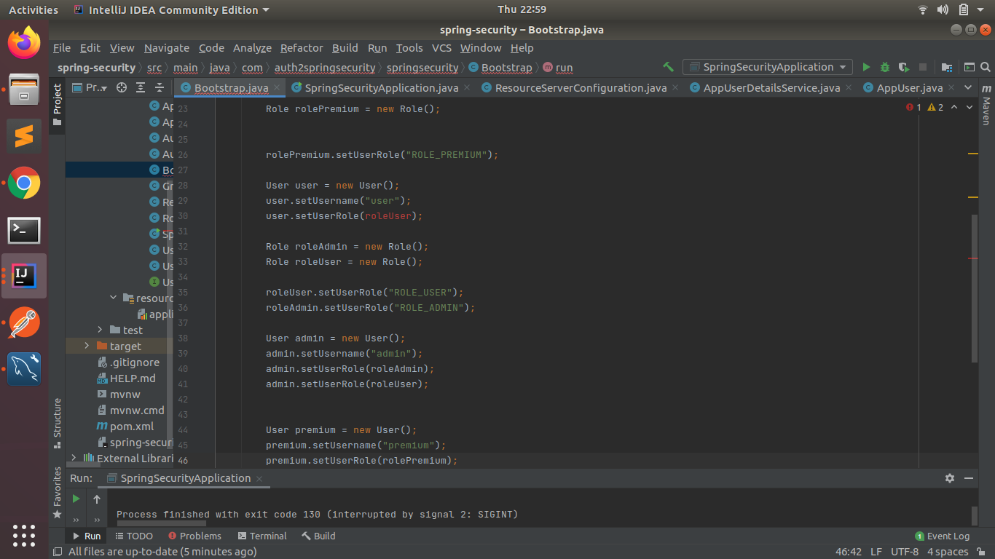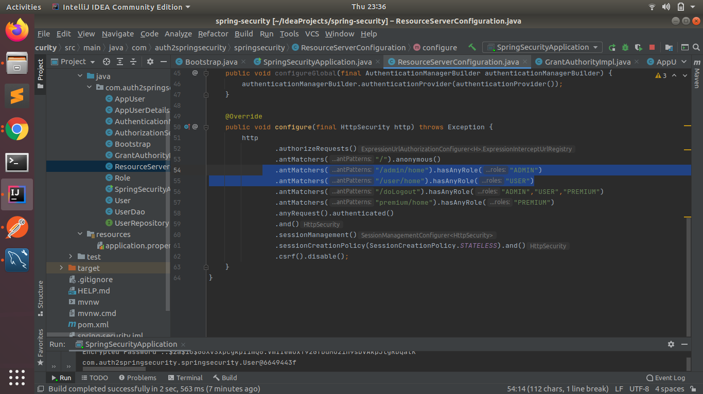

**Here we are taking token for admin**

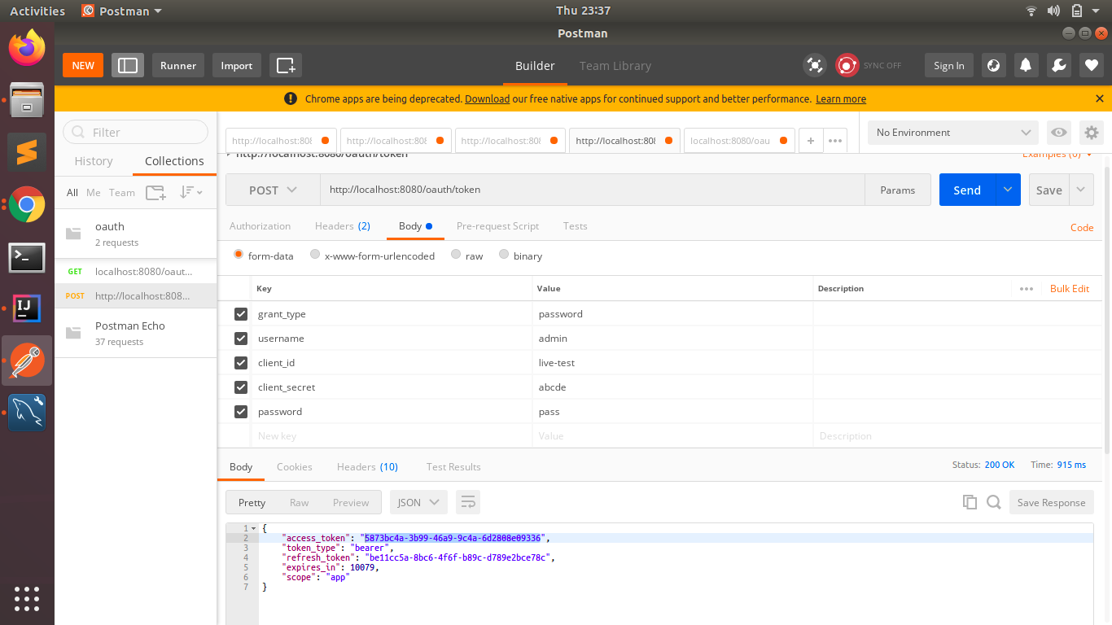

**Here we are accessing user Uri with Admin’s token.**

