Secure File Vault
Project Report

INDUSTRIAL TRAINING (ECS-591)
Degree
BACHELOR OF TECHNOLOGY (IBM)

PROJECT GUIDE:  MR. AMIT KUMAR | SUBMITTED BY:  ADITYA KUMAR (TCA2357004)



FACULTY OF ENGINEERING & COMPUTING SCIENCES
TEERTHANKER MAHAVEER UNIVERSITY, MORADABAD

ACKNOWLEDGEMENT
I would like to express my profound gratitude to all those who supported, guided, and encouraged me throughout the development of my project titled “Secure File Vault.” This project has been an enriching experience, allowing me to deeply explore various aspects of data security, encryption, authentication systems, and database-driven application design.
First and foremost, I extend my heartfelt thanks to my respected faculty members and mentors, whose consistent guidance and constructive feedback have played a crucial role in shaping this work. Their expertise in areas such as cryptography, database management, and software development helped me refine my understanding of secure system design. Their encouragement motivated me to integrate essential security features such as AES encryption using PBKDF2-derived keys, SHA-256 integrity checks, activity logging, and secure user authentication mechanisms within the application.
I am especially grateful to the academic environment that encouraged hands-on development and experimentation with modern technologies. Working with powerful tools and frameworks like Python 3, Tkinter for GUI design, MongoDB for database management, PyMongo, and the Cryptography library allowed me to gain real-world experience in building a robust security-focused desktop application. With these technologies, I was able to design a system capable of supporting critical functionalities such as file encryption/decryption, tamper detection, password recovery, environment-variable–based configuration, and auto-logout features for enhanced safety.
I also wish to acknowledge the immense contribution of the global open-source community. The documentation and resources available for technologies like MongoDB Atlas, Python-dotenv, Pymongo, and the Cryptography module significantly simplified the integration and implementation processes. Their continuous efforts toward developing open-source tools have been indispensable to the successful creation of this project.
I am deeply thankful to my classmates and peers, who provided suggestions, shared their insights, and assisted me in testing various modules of the application. Their feedback helped me improve the overall stability, usability, and performance of the Secure File Vault system. Collaborating with them enabled a more comprehensive understanding of practical challenges related to data encryption, user accessibility, and secure file handling workflows.
Finally, I owe my deepest gratitude to my family for their unwavering support, patience, and motivation throughout this project. Their belief in my abilities has always been a source of inspiration and strength.
This project has been a significant milestone in my academic journey, allowing me to combine theoretical knowledge with real-world application in the domain of cybersecurity and secure software development. I am grateful to everyone who contributed directly or indirectly to the successful completion of this project.

Aditya Kumar TCA2309129
Place: Moradabad
Date: 10/11/2025

DECLARATION

We hereby declare that this Project Report titled “Secure File Vault” submitted by me and approved by our project guide, the College of Computing Sciences and Information Technology (CCSIT), Teerthanker Mahaveer University, Moradabad, is a bonafide work undertaken by me and it is not submitted to any other University or Institution for the award of any degree diploma / certificate or published any time before.

Submitted By:

Aditya Kumar B.Tech (IBM)
Enrollment No. : TCA2357004

Project Guide:

Name: Mr. Amit Kumar
Designation: Assistant Professor

Brief About the Company

Codec Technologies Pvt. Ltd. is a distinguished and forward-thinking IT training, software development, and technology consulting organization committed to empowering students, professionals, and enterprises with industry-relevant skills and advanced digital solutions. Over the years, the company has built a strong reputation for delivering high-quality technical training, practical mentorship, and robust software engineering practices. With a continuously evolving curriculum and a learner-centric approach, Codec Technologies consistently contributes to developing future-ready IT professionals.
The organization operates with a clear vision to bridge the gap between academic theory and real-world industry expectations. While many students possess foundational knowledge, they often lack exposure to practical development tools, modern frameworks, and professional workflows. Codec Technologies addresses this challenge by combining structured classroom learning with hands-on training, real-time project execution, and continuous expert mentorship. This integrated model helps students strengthen their conceptual understanding while gaining the confidence to solve real-world technical problems.
Codec Technologies offers a comprehensive range of training programs in various cutting-edge domains such as full-stack development, Python programming, data science, artificial intelligence, machine learning, cybersecurity, ethical hacking, DevOps, cloud computing (AWS & Azure), mobile app development, and automation frameworks. Each program is designed by industry professionals to meet global IT standards and corporate workforce requirements.
The organization is equipped with advanced computer labs, modern hardware infrastructure, professional development tools, and licensed software environments, providing learners with an industry-standard workspace. This environment enables students to write, test, debug, and deploy real applications, closely mirroring workflows followed in top software development companies. It fosters creativity, analytical thinking, innovation, and problem-solving skills—essential traits for a successful IT career.
One of the remarkable strengths of Codec Technologies is its active involvement in live software development projects across multiple industries, including business management, finance, education, healthcare, retail, logistics, and e-commerce. These projects include enterprise dashboards, automation tools, CRM platforms, analytics systems, billing modules, inventory solutions, and secure data management applications. By working on such projects, students gain real-world experience in every phase of the Software Development Life Cycle (SDLC)—from requirement gathering and analysis to system design, coding, testing, deployment, and post-deployment maintenance.
The organization’s internship program—through which my project, Secure File Vault, was successfully developed—is especially impactful. During the internship, students handle industry-like responsibilities including module development, encryption implementation, secure coding practices, database operations, GUI design, debugging, documentation, and feature testing. They also work with essential development tools such as Git for version control, Python frameworks, MongoDB databases, and cryptographic libraries, gaining practical exposure under the guidance of experienced trainers and software developers. This hands-on experience transforms learners from academic students into confident contributors capable of solving real-world challenges.
Beyond technical skills, Codec Technologies conducts a wide range of professional development activities such as seminars, workshops, hackathons, coding bootcamps, expert talks, and peer-learning sessions. These activities help learners stay updated with emerging technologies, build collaborative skills, and develop an innovative mindset. Additionally, mock interviews, resume-building guidance, and career counseling sessions help students prepare for placement opportunities and professional growth.
Through its continuous commitment to quality education, innovation, and student success, Codec Technologies Pvt. Ltd. has established itself as a leading organization in technical training and software development. The professional exposure, mentorship, and hands-on experience gained during the internship played a crucial role in the successful completion of my project, Secure File Vault, and greatly contributed to my overall technical and professional development.

Table of Contents
1 SECURE FILE VAULT-A SECURE FILE STORAGE,ENCRYPTION & USER DATA PROTECTION Error! Bookmark not defined.
2 Problem Statement 8
3 Project Description 9
3.1 Scope of the Work 9
3.2 Project Modules 11
3.3 Context Diagram (High Level) 15
4 Implementation Methodology 17
5 TECHNOLOGIES TO BE USED 19
5.1 Software Platform 19
5.2 Hardware Platform 21
5.3 Tools, if any 21
6 Advantages of this Project 23
7 Assumptions, if any 29
8 Future Scope and further enhancement of the Project 31
9 Definitions, Acronyms, and Abbreviations 34
10 .Conclusion 35
11 .References 38

Appendix
A: Data Flow Diagram (DFD)
B: Entity Relationship Diagram (ERD)
C: Use Case Diagram (UCD)
D: Code
E: Screen Shots

- Secure File Vault – A Secure File Storage, Encryption & User Data Protection System
In today’s digital age, data security has become one of the most critical concerns for individuals, organizations, and businesses across the world. With the rapid expansion of digital communication, cloud storage, and online transactions, protecting sensitive information from unauthorized access, theft, or manipulation has become more challenging than ever before. The increasing number of cyber threats, malware attacks, identity thefts, and data breaches highlights the urgent need for secure and reliable methods of storing and managing confidential files. To address these challenges, the Secure File Vault system has been designed and developed as a robust solution for safeguarding user data through advanced cryptographic techniques and intelligent security features.
Secure File Vault is a user-friendly desktop application that allows individuals to securely store, encrypt, decrypt, and manage their files in a protected digital environment. The system combines strong encryption mechanisms, secure password management, file integrity verification, and user activity logging to create a comprehensive security platform. It functions as a personal vault where users can confidentially store important documents, images, or data files without worrying about unauthorized access or tampering. Built using Python, Tkinter GUI, MongoDB, and cryptographic algorithms, the application delivers a reliable and efficient method of securing digital information.
The project focuses on implementing AES (Advanced Encryption Standard) using PBKDF2-derived keys to ensure that all stored files remain unreadable without the correct password. Additionally, SHA-256 hashing is integrated to verify file integrity and detect any form of modification. The system also includes essential features such as user authentication, password recovery via hobby-based security, activity logging, and automatic logout after inactivity, making it a complete and practical solution for everyday data security needs.
The primary objective of the Secure File Vault is to offer users a secure, accessible, and easy-to-use platform that protects their data from unauthorized access. It is particularly useful for professionals, students, and individuals who handle sensitive documents and require a reliable means of securing personal information. The graphical user interface ensures a smooth user experience, while the backend ensures that all operations are performed securely and efficiently.
This project not only enhances digital security awareness but also demonstrates the practical application of cryptographic principles, secure authentication practices, and database-driven system design. By developing Secure File Vault, I gained valuable experience in building a security-focused software application that addresses real-world challenges in data protection. The project represents a meaningful step toward understanding and contributing to the broader field of cybersecurity and secure information systems.

Problem Statement
In today’s digitally driven world, data has become one of the most valuable assets for individuals, businesses, and organizations. People store a wide range of sensitive information on their personal computers and digital devices—such as identity documents, financial records, professional files, passwords, personal photographs, academic data, and confidential business materials. While this shift toward digital storage has increased convenience and accessibility, it has also exposed users to a wide range of security threats. Cyber-attacks, unauthorized access, data breaches, ransomware infections, malicious software, and internal misuse have become increasingly common, placing sensitive data at significant risk.
Despite the growing need for data protection, many individuals still rely on basic file storage methods such as unprotected folders, unsecured cloud drives, or systems without proper access control. These methods fail to offer robust protection against unauthorized access or file tampering. Even users who attempt to secure their data with passwords or simple encryption tools often lack a comprehensive solution that includes strong cryptographic protection, secure authentication, activity logging, data integrity verification, and an intuitive interface. As a result, sensitive files remain vulnerable to theft, manipulation, or accidental exposure.
Another major challenge is the absence of file integrity checks. In many existing systems, users cannot verify whether a file has been altered or corrupted after being stored. This creates opportunities for attackers to silently modify data without detection. Additionally, most common file managers do not provide user activity logs, making it impossible to track login attempts, file access, or system interactions—features that are essential in any secure environment.
Users also frequently encounter difficulties with password recovery, especially when systems do not provide a safe, non-invasive recovery mechanism. Forgetting a password can result in permanent loss of access, while insecure recovery methods can compromise the entire system.
Furthermore, many applications lack automatic logout features, which increases the risk of unauthorized access if users accidentally leave their device unattended. This is particularly concerning in shared or workplace environments where multiple users may have physical access to the same system.

Given these limitations, there is an urgent need for a secure, reliable, and user-friendly file protection system that integrates modern cryptographic techniques with essential security features. Such a system must:
- Encrypt and decrypt files using strong encryption algorithms like AES.
- Derive secure keys using PBKDF2 to prevent brute-force attacks.
- Provide user authentication and secure login mechanisms.
- Offer safe password recovery methods without compromising security.
- Verify file integrity using SHA-256 hashing to detect tampering.
- Maintain detailed activity logs for tracking user actions.
- Automatically log out users after a period of inactivity.
- Use a database system like MongoDB to store metadata securely.
- Present a simple, intuitive GUI through Tkinter for ease of use.
Secure File Vault aims to address all these challenges by providing a comprehensive solution that ensures the confidentiality, integrity, and availability of stored files. By combining encryption, hashing, authentication, secure recovery options, and activity monitoring, the system protects users from modern cybersecurity risks while offering a seamless user experience.
Thus, the fundamental problem this project solves is the lack of a dedicated, robust, and accessible file protection system capable of safeguarding sensitive user data through advanced security mechanisms, ensuring that confidentiality is maintained and unauthorized access is effectively prevented.

.

3 Project Description

Scope of the Work
The scope of the Secure File Vault project encompasses the complete design, development, implementation, and testing of a robust digital security system dedicated to protecting user files through encryption, secure authentication, and integrity verification mechanisms. Clearly defining the scope ensures a structured approach to development, sets proper expectations for system functionality, and establishes boundaries for the features included in this version of the application. The Secure File Vault is designed to function as a comprehensive solution for individuals and professionals who require a safe, dependable, and user-friendly environment for the storage and protection of confidential information.
Within the defined scope, the project includes the development of a fully functional user authentication module. This module ensures that only authorized users can access the vault. It includes registration, login, encrypted password storage using PBKDF2 hashing, and a hobby-based password recovery option that allows users to regain access without compromising security. The authentication system forms the first layer of protection and prevents unauthorized entry into the secure environment.
Another major component included in the scope is the file encryption and decryption module, which serves as the core functionality of the Secure File Vault. Users will be able to add any type of file to the system, and the application will encrypt these files using AES (Advanced Encryption Standard) before saving them. The encryption key is derived from the user’s password, ensuring that no one—not even the system developers—can access the stored data without the correct credentials. Similarly, users can securely decrypt their files whenever needed through a controlled process that validates the user’s password before performing the operation.
The scope also includes a file integrity verification feature, which uses SHA-256 hashing to detect whether a file has been altered or tampered with since it was first encrypted. This is crucial for identifying unauthorized modifications, corruption, or malicious interference. By comparing stored hash values with freshly computed hashes, the system can inform users about the status of their files and safeguard against silent data manipulation.
Another in-scope component is the activity logging module. This module records all significant operations performed by the user, including login attempts, file uploads, encryption actions, decryption actions, integrity checks, password recovery attempts, and logout events. The activity logs serve as a transparency and accountability tool, allowing users to monitor how their vault is being accessed and ensuring that no suspicious activities go unnoticed. This feature enhances the system’s overall trustworthiness and professionalism.
Additionally, the scope includes the implementation of an automatic logout mechanism, ensuring that the system locks itself after a period of user inactivity. This prevents unauthorized access in cases where the user may leave the application open unintentionally. Automatic session timeout is essential for environments where multiple individuals may share the same device or workspace.
The Secure File Vault will also implement a complete MongoDB-based database system to store encrypted file metadata, user credentials, logs, and configuration settings. The scope covers establishing a structured database schema, securing stored data, and ensuring reliable communication between the application and the database. Both local MongoDB instances and cloud-based MongoDB Atlas are supported, although cloud synchronization itself is not part of this version's enhancements.
The project scope further includes the development of an intuitive Tkinter-based graphical user interface (GUI). This interface will allow users to visually interact with the system through menus, buttons, and dialogs. The GUI will support navigation to file management, encryption, decryption, logs viewing, and other essential functions. The focus is on providing a smooth, accessible user experience, even for individuals with limited technical expertise.
Furthermore, the scope includes supporting features such as deleting files from the vault, viewing stored file details, managing user session preferences, and accessing system notifications. These functionalities contribute to making the Secure File Vault a complete and user-centric security application.
While the system is feature-rich, several elements are explicitly out of scope for this version. The current scope does not include multi-user role-based access, cloud file synchronization, AI-based threat detection, biometric authentication, remote access capabilities, or mobile application integration. Advanced enterprise-level features such as distributed storage, multi-device syncing, intrusion detection, or ransomware shielding are also outside the boundaries of this development cycle.
By defining these boundaries, the Secure File Vault project remains focused on its primary goal: to offer a powerful, secure, and efficient platform that encrypts and protects sensitive user files. The application concentrates on solving real-world data security challenges while providing a reliable, structured, and practical solution for end users. Future upgrades may expand the system’s scope, but within the current phase, all foundational elements necessary for secure file management and protection are confidently delivered.

Project Modules

The Secure File Vault system is divided into several structured, interconnected modules that collectively form a comprehensive security application capable of encrypting, decrypting, storing, and verifying files in a protected environment. Each module is designed with clear responsibilities and functions to ensure ease of use, system reliability, data protection, and smooth workflow navigation. The modular architecture enhances system maintainability, scalability, and flexibility, enabling future upgrades without affecting core functionalities. The key modules of the system are detailed below.

1. User Authentication Module
The User Authentication Module serves as the first and most essential layer of system security. It ensures that only authorized users can access the Secure File Vault application. This module includes user registration and login functionalities supported by PBKDF2 password hashing to protect stored credentials. During login, the system validates user-entered credentials against securely hashed values in the database. The module also includes a hobby-based password recovery system, allowing users to reset their password safely without exposing sensitive data. The authentication module maintains system integrity by preventing unauthorized access and securing the vault environment.

2. File Encryption Module
The File Encryption Module is the core component of the Secure File Vault system. This module enables users to upload and encrypt files using AES (Advanced Encryption Standard), one of the most secure symmetric encryption algorithms. Encryption keys are derived from the user’s password using PBKDF2, ensuring that only the rightful owner can access the encrypted file. The encrypted files are stored in a secure format within the system, ensuring confidentiality even if unauthorized individuals gain access to the storage location. This module ensures complete data protection and prevents misuse in case of external breaches.

3. File Decryption Module
Complementing the encryption module, the File Decryption Module allows authorized users to securely retrieve and decrypt previously encrypted files. Before decryption, the system validates the user’s password to derive the correct cryptographic key. If the user fails authentication, the file remains inaccessible and fully protected. The module ensures that users can seamlessly recover their data without compromising security protocols. This bidirectional encryption–decryption architecture enhances system reliability and maintains a consistent user experience.

4. File Integrity Verification Module
The File Integrity Module plays a crucial role in detecting tampering, corruption, or unauthorized modification of stored files. Using SHA-256 hashing, the system stores unique hash signatures for each encrypted file. Whenever a user initiates a file verification process, the system recalculates the hash and compares it with the original stored value. If both values match, the file is confirmed to be intact; otherwise, the system alerts the user about potential modifications. This module ensures trustworthiness, transparency, and authenticity of all stored files.

5. Secure File Management Module
This module provides users with tools to manage their encrypted files within the vault. Users can add new files, delete existing files, view file metadata, track file status, and organize stored content. The module interacts seamlessly with encryption, decryption, and integrity verification components to maintain an efficient, secure, and well-structured file repository. All operations performed within this module are monitored and logged for accountability.

6. Activity Logging Module
The Activity Logging Module enhances system transparency by recording all significant operations performed by the user. This includes login attempts, file uploads, encryption actions, decryption actions, integrity checks, password resets, and logout events. The logs allow users to review system usage patterns and detect any suspicious or unexpected activities. By maintaining a detailed history of actions, this module increases accountability and strengthens overall system security.

7. Automatic Logout & Session Management Module
To prevent unauthorized system access due to prolonged inactivity, the Secure File Vault includes an Automatic Logout Module. This module tracks user activity and automatically locks the system after a defined period of inactivity. When triggered, the user is required to re-authenticate before continuing their session. This ensures that the vault remains secure even in shared or public environments and reduces the risk of unauthorized access.

8. Database Management Module (MongoDB)
The Database Management Module handles all communication between the application and the MongoDB database. It stores user credentials, encrypted file metadata, hash values, activity logs, and system configurations. MongoDB’s NoSQL structure provides flexibility for storing diverse file attributes without rigid schema constraints. The module ensures data consistency, fast retrieval, secure storage, and smooth backend operations throughout the system’s lifecycle.

9. Graphical User Interface (GUI) Module
Developed using Tkinter, the GUI Module provides an intuitive, visually structured interface that allows users to access all system functions easily. It includes menus, forms, buttons, dialogs, and interactive elements that help users navigate through encryption, decryption, file verification, log viewing, and other operations. The GUI is designed to be simple, accessible, and user-friendly for both technical and non-technical users.

10. System Configuration & Preferences Module
This module allows users to configure basic system settings, adjust preferences, and customize elements such as file directories or interface behaviour. Alongside user convenience, it ensures that system configurations are securely stored and retrieved as needed.

Module Integration Summary
The collective operation of these modules ensures that the Secure File Vault functions as a cohesive, secure, and efficient system. The modular architecture supports clean separation of responsibilities, enhances performance, and ensures that changes in one module do not disrupt the rest of the system. The integration between encryption, authentication, logging, verification, and GUI components forms a highly secure environment suitable for protecting sensitive digital files.

Context Diagram (High Level)

The Level-0 Context Diagram for the Secure File Vault system represents the highest-level overview of how the application interacts with all external entities and the information that flows into and out of the system. At this level, the entire software is treated as a single, unified process without revealing its internal components or submodules. The purpose of the high-level context diagram is to clearly define the system’s boundaries, identify external actors, and illustrate how user inputs are processed into meaningful outputs. This helps establish a clear understanding of how the Secure File Vault functions within its environment and what essential interactions occur during normal system operation.
In this system, the primary external entity is the User, who communicates directly with the Secure File Vault application. The user provides several types of inputs required for the proper functioning of the system. These inputs include authentication credentials such as username, password, and recovery hobby details during registration and login. Once the user is authenticated, additional inputs are provided such as selecting files for encryption, uploading files to the vault, entering the correct password for decryption, and initiating file integrity checks. The user may also provide commands to delete stored files, view activity logs, manage preferences, or log out of the system. Each of these interactions initiates a corresponding internal process within the vault application.
When the system receives user commands, it processes these inputs and produces a variety of outputs. One of the major outputs generated by the system is the creation of encrypted files, which are stored securely within the vault’s internal directory or metadata database. Whenever a file is encrypted, the system also generates a unique hash value using SHA-256, which is another important output that helps track file integrity. The system produces decrypted files as outputs whenever the correct password is provided and validation is successful. The application also generates integrity verification results, indicating whether a stored file has remained unchanged or has been tampered with. Additionally, the system produces activity logs, displaying user actions such as login attempts, file encryption, decryption, deletions, verification events, and logout activities.
Another essential external entity involved in the system is the MongoDB database, which acts as the central data repository for the Secure File Vault. Although the database is not a human user, it interacts with the system as an external data store. The application sends structured data to the database, including encrypted file metadata, password hashes, activity logs, user profiles, and recovery details. In return, the system retrieves stored information whenever required—for example, to validate user credentials during login, fetch metadata for decrypting files, or display logged activity. The database plays a vital role in maintaining data consistency, ensuring secure storage, and supporting efficient retrieval operations throughout the lifecycle of the application.
The system also generates several types of alerts and notifications as outputs. These include incorrect password notifications, failed login attempt warnings, file integrity mismatch alerts, and inactivity timeout notifications. Such outputs help ensure that the user is always aware of critical security events. Automatic logout is another significant system output that occurs when the user remains inactive beyond a predefined time limit. This strengthens the security boundary of the vault and prevents unauthorized access in shared environments.
From a high-level perspective, the Secure File Vault receives a wide variety of inputs from the user—credentials, file selections, commands for encryption, decryption, verification, log viewing, and settings adjustments. These inputs are processed internally through cryptographic algorithms, data validation procedures, integrity-checking mechanisms, and system logging components. The corresponding outputs include encrypted files, decrypted files, activity logs, verification results, authentication responses, and security notifications.
Overall, the Level-0 Context Diagram of the Secure File Vault system demonstrates how the application interacts with two primary external entities: the User and the MongoDB Database. It clarifies the boundary of the system by showing that the vault receives authentication data, file inputs, operational commands, and configuration settings from the user; processes them through internal workflows; and returns outputs such as secured files, verification reports, logs, and status notifications. This high-level overview establishes the functional environment of the application and sets the foundation for deeper design details provided in subsequent documentation sections.

4. Implementation Methodology

The implementation methodology of the Secure File Vault system describes the complete, structured process followed to transform user requirements into a fully functional, secure, and reliable software application. This methodology outlines the sequence of phases used during development, including requirement analysis, architectural design, module development, cryptographic integration, database structuring, testing, and final deployment. The purpose of this methodology is to ensure that the system is built in a disciplined manner that promotes accuracy, security, maintainability, and scalability. The Secure File Vault implementation follows a systematic software engineering approach to guarantee that every functional and non-functional requirement is addressed effectively.
The process begins with the requirement analysis phase, where user needs and system expectations were studied in depth. This stage included understanding the core problems users face with traditional file storage, such as lack of encryption, risk of unauthorized access, and absence of file integrity checks. The requirement analysis identified essential features such as user authentication, file encryption, decryption, integrity verification, activity logging, secure password recovery, and automatic logout. These requirements were then documented and refined to form a clear development blueprint.
Once the requirements were finalized, the next stage involved system design and modelling. During this phase, multiple diagrams and design tools were used to visualize how the Secure File Vault would operate. A high-level context diagram was created to illustrate interactions between the user, the system, and the database. Data Flow Diagrams (DFDs) were prepared to break down internal processes such as authentication, file encryption, file verification, and logging. The Entity–Relationship Diagram (ERD) was developed to define how MongoDB collections store user credentials, encrypted file metadata, hash values, logs, and recovery information. Use case diagrams and flowcharts were used to model user interactions, helping establish clear workflows for tasks such as encryption, login, decryption, and file checking.
After the design phase, the project proceeded to the development phase, where each module of the Secure File Vault was implemented using Python. Development followed a modular architecture so that individual components—such as the authentication module, encryption module, verification module, and GUI—were built independently and then integrated together. The graphical user interface was developed using Tkinter, ensuring a clean and user-friendly experience. Special attention was given to usability so that even non-technical users could navigate the system easily.
Parallel to GUI development, the encryption and security mechanisms were implemented. AES encryption was used to secure files, with encryption keys derived from the user’s password using PBKDF2, a strong key derivation algorithm that prevents brute-force attacks. SHA-256 hashing was implemented to generate file integrity signatures. These cryptographic processes form the backbone of the Secure File Vault and ensure that user data remains protected at all times. Additionally, the password storage mechanism was implemented using hashing and salting techniques, ensuring that no plaintext passwords are ever saved.
The backend development involved constructing the communication layer with MongoDB. Using PyMongo, a series of operations were developed to store and retrieve encrypted file metadata, activity logs, user credentials, configuration details, and stored hash values. The database structure was designed to support efficient storage, retrieval, and security. The automatic logout feature was implemented using an idle timer to enhance overall system safety. These backend operations ensured accuracy, consistency, and secure handling of sensitive user information throughout the system.
Once development was complete, the system entered the testing phase, where all modules were thoroughly evaluated to ensure they performed correctly and securely. Functional testing was conducted to validate essential features such as user authentication, file encryption, file decryption, integrity verification, password recovery, activity logging, and auto logout. Integration testing was performed to ensure that modules interacted smoothly—for example, verifying that encryption data was saved properly in the database and that the GUI accurately reflected all actions. Boundary testing was conducted for input fields such as usernames, passwords, file paths, and metadata lengths. Negative testing ensured that the system properly handled incorrect passwords, invalid files, unauthorized access attempts, and unexpected user behaviours.
A Defect Log was maintained throughout testing to record any issues encountered during execution. Each defect entry included the defect description, module involved, severity level, steps to reproduce, and final resolution status. Maintaining the defect log helped ensure transparency and consistency in the debugging process, allowing the development team to correct errors efficiently before final deployment.
After resolving all major defects, the system proceeded to the deployment phase, where the Secure File Vault was packaged for real-world usage. The final application was bundled into a Python-executable format that can run on any compatible system without requiring advanced configuration. Users can install and run the system easily, create accounts, store files, and experience secure file protection.
Finally, the maintenance phase ensures that the system continues to function smoothly after deployment. This phase involves updating dependencies, improving system performance, fixing newly discovered issues, enhancing security protocols, and adding new features when required. Maintenance ensures that the Secure File Vault remains reliable, secure, and adaptable to evolving technological environments.
In summary, the implementation methodology of the Secure File Vault follows a well-organized, multi-phase process involving requirement analysis, system design, modular development, cryptographic integration, backend structuring, user interface development, rigorous testing, deployment, and continuous maintenance. This structured approach ensures that the final system is secure, robust, user-friendly, and capable of meeting real-world data protection needs effectively.

5. TECHNOLOGIES TO BE USED

a. Software Platform
Front-end
The Secure File Vault system is developed using a combination of modern, robust, and reliable software technologies chosen specifically to support secure file storage, advanced encryption, efficient data handling, and a user-friendly interface. Each software component plays a crucial role in ensuring that the system delivers high performance, strong security, and smooth user interaction. The software platform integrates GUI development, cryptographic operations, database management, and backend processing into one cohesive application environment.

Front-End (User Interface Layer)
The front-end of the Secure File Vault system is developed entirely using Tkinter, the default GUI toolkit that comes bundled with Python. Tkinter was selected for its simplicity, lightweight structure, and ability to create clean, responsive desktop interfaces without external dependencies. The toolkit provides essential widgets such as buttons, labels, frames, forms, dialog boxes, and interactive components that form the foundation of the application’s user interface.
To enhance the visual appeal and improve user experience, the front-end design follows a structured layout, ensuring clarity and ease of navigation across all modules such as login, registration, file operations, activity logs, and settings. Tkinter’s flexibility allows the application to maintain consistency across different screens while providing an intuitive user experience for both technical and non-technical users.
In addition to Tkinter, the system integrates Message Box components, file dialogs, and tree view tables, which allow users to browse files, view encrypted file lists, and interact seamlessly with system functionalities. The goal of the front-end platform is to create a secure and user-centric interface that simplifies the process of encrypting, decrypting, and managing sensitive files.

Back-End (Logic & Security Layer)
The back-end of the Secure File Vault system is powered by Python, a versatile and powerful programming language widely used for developing security-centric applications. Python serves as the backbone of all file encryption, decryption, hashing, authentication, and database operations in the project. Its strong library ecosystem, readability, and reliability make it ideal for implementing secure algorithms and efficient processing workflows.
To provide strong security features, the system uses the following critical Python libraries:
Cryptography Library (Fernet / AES / PBKDF2)
The encryption and decryption mechanisms are implemented using the cryptography package. It utilizes:
- AES (Advanced Encryption Standard) for encrypting user files
- PBKDF2 (Password-Based Key Derivation Function) for deriving encryption keys from user passwords
- Secure random salts and tokens for strengthening cryptographic operations
This ensures that all encrypted files remain inaccessible without the correct authentication and derived key.
SHA-256 Hashing (Integrity Verification)
The system uses Python’s hashlib module to generate SHA-256 hashes of encrypted files. These hashes are stored and later compared during integrity checks to detect tampering, corruption, or unauthorized modifications.
Activity Logging & System Operations
Python’s built-in libraries are used to track all user actions, timestamps, and operational logs. These logs are stored securely in the database and displayed through the GUI when required.

Database Platform (MongoDB)
The system uses MongoDB, a modern NoSQL database, to store essential metadata such as:
- User credentials (stored as hashed values)
- Encrypted file metadata
- File hash signatures
- Activity logs
- Password recovery details
- Application configurations
MongoDB provides high flexibility and scalability due to its document-based structure, making it ideal for storing variable-length records such as file details and logs. The connection between Python and MongoDB is enabled using the PyMongo driver, which supports fast read/write operations, indexing, and secure data transactions.
Whether running locally or through MongoDB Atlas, the database ensures efficient storage, retrieval, and organization of sensitive vault data.

Supporting Software Tools and Libraries
To complete the system architecture, several additional tools are used:
- dotenv: For securely managing environment variables like database URIs
- OS & Pathlib modules: For handling file paths and secure system-level operations
- Time & DateTime modules: For generating timestamps for logs and automatic logout
- JSON library: For lightweight data formatting (if needed for internal operations)
All supporting software tools are integrated smoothly into the application to strengthen reliability and maintainability.

Hardware Platform
The hardware platform required to operate the Secure File Vault system is designed to be simple, practical, and easily accessible for users across diverse environments. Since the application is developed as a lightweight desktop system with efficient memory usage and minimal graphical requirements, it can be installed and executed on most modern computing devices without the need for specialized hardware. The goal is to ensure that the system provides stable performance, smooth encryption operations, and reliable data management even on basic machines commonly available to students, professionals, and small organizations.
At the core of the hardware requirements is the processor, which plays a crucial role in executing cryptographic algorithms and handling encryption–decryption operations. A minimum of Intel Core i3 or an equivalent processor is recommended to ensure that the system performs efficiently while processing file encryption, hashing computations, and database operations. Although the application can run on lower-end processors, using an i3 or higher helps maintain smooth performance, reduces delays during file handling, and improves overall responsiveness. For larger datasets or heavier workloads—such as encrypting large files or managing extensive logs—a more powerful processor like Intel Core i5, Ryzen 5, or higher is advisable.
Memory (RAM) is another key factor that determines the system’s ability to handle simultaneous operations without performance drops. The minimum recommended RAM for the Secure File Vault system is 4 GB, which is sufficient for running the application alongside other basic programs. However, for enhanced performance—especially when processing multiple files, performing batch operations, or handling large datasets—8 GB RAM is recommended. Adequate memory ensures that encryption, hashing, and GUI rendering occur smoothly without causing system lag or application freezing.
In terms of storage, the system requires minimal disk space for installation, encrypted file storage, logs, and metadata. A minimum of 2 GB of free disk space is recommended to support application files, Python libraries, encrypted file storage, and database files generated by MongoDB. The actual storage requirement may vary depending on the number and size of encrypted files stored by the user. Since encrypted files typically retain their original size, users working with large multimedia files may require additional disk space. Using SSD storage is beneficial for faster read/write operations, but it is not mandatory; traditional HDDs are fully sufficient for running the system.
The display resolution also plays a role in ensuring proper visibility of the GUI components. A minimum screen resolution of 1366 × 768 is recommended to ensure that all interface elements—including buttons, tables, dialogs, and message boxes—are displayed correctly without clipping. Higher resolutions such as 1920 × 1080 (Full HD) provide better clarity and improved user experience, especially during log viewing and handling multiple system windows. The system can be run on standard monitors, laptops, or desktop workstations.
The Secure File Vault system occasionally requires peripheral devices, especially when managing or transferring files. A standard keyboard and mouse setup is essential for smooth navigation and file selection. For users who wish to back up encrypted files or logs externally, USB drives or external hard disks may also be used. Although not a mandatory hardware requirement, an Uninterruptible Power Supply (UPS) is recommended—particularly in environments where power fluctuations are common—to prevent data corruption during sensitive operations such as encryption or database writing.
Additionally, it is assumed that the system runs on a stable, updated operating system environment, such as Windows 10/11, macOS, or a Linux distribution. A stable OS ensures proper interaction between Python, MongoDB, and GUI components. Maintaining an updated environment also reduces compatibility issues and helps the Secure File Vault run efficiently over longer periods.
Overall, the hardware platform for the Secure File Vault system is intentionally designed to be accessible, cost-effective, and compatible with widely available computing devices. The application performs efficiently without requiring high-end hardware, ensuring that users from academic, professional, or personal backgrounds can adopt the system without additional investment. The lightweight nature of the application, combined with optimized encryption processes, ensures that the system remains reliable, responsive, and suitable for real-world usage across a variety of hardware setups.

6. Tools

The development of the Secure File Vault system required the use of several essential tools that supported the implementation of encryption algorithms, database operations, graphical interface design, environment configuration, and overall system development. These tools were chosen based on their reliability, compatibility with Python, and ability to enhance productivity while ensuring system security and stability. Each tool played a significant role in simplifying development processes, testing functionalities, and maintaining secure communication between system components. The major tools used in the project are described below:

1. Python 3 Interpreter

The Python interpreter served as the central execution environment for developing and running the Secure File Vault application. All system modules—including encryption, authentication, hashing, GUI management, and database operations—were written in Python. The interpreter enabled easy debugging, modular development, and smooth execution of cryptographic instructions. Python’s extensive standard library and compatibility with external packages made it an ideal tool for developing a security-focused application.

2. PyCharm / VS Code (Integrated Development Environment)

An IDE such as PyCharm or Visual Studio Code (VS Code) was used to write, structure, and debug the source code. These tools provided intelligent code suggestions, syntax highlighting, environment management, error detection, version control integration, and code formatting features. The use of a professional IDE ensured clean, maintainable, and well-organized code throughout the development process. The debugging tools built into the IDE were especially helpful during module testing and error resolution.

3. MongoDB Compass

MongoDB Compass was used as a graphical interface for interacting with the MongoDB database. It allowed easy visualization of stored data such as user credentials, encrypted file metadata, activity logs, hash values, and recovery details. The tool supported operations like inserting, updating, deleting, and querying documents, which made database testing and debugging significantly easier. It also provided schema insights and performance monitoring features that simplified backend validation.

4. MongoDB Atlas / Local MongoDB Server

MongoDB Atlas or the local MongoDB server environment was used to host the database backend. The tool supported secure storage of critical information, flexible document structures, and efficient data management using NoSQL technology. The database server ensured reliable performance for storing and retrieving credentials, metadata, and system logs.

5. PyMongo Library

The PyMongo package enabled seamless communication between the Python application and the MongoDB database. As an essential tool, it provided functions for inserting, reading, updating, and deleting database documents. PyMongo’s stability and speed made it indispensable for backend development and data handling throughout the Secure File Vault system.

6. Cryptography Library (Fernet / AES / PBKDF2)

The cryptography library served as the primary tool for implementing secure encryption and key derivation within the system. Using AES encryption, PBKDF2 key derivation, and secure hashing, this library ensured that all protected files remained confidential and inaccessible without proper authentication. Its built-in functions simplified complex cryptographic operations, making it an essential component of the project.

7. Hashlib (SHA-256 Hashing Tool)

Python’s built-in hashlib module acted as a tool for generating SHA-256 hash signatures used in file integrity verification. This helped detect tampering or unauthorized modification of stored files. The reliability of hashlib ensured consistent and secure hash computation throughout the system.

8. Tkinter GUI Toolkit

Tkinter served as the primary tool for building the graphical user interface of the Secure File Vault system. It provided ready-to-use widgets for labels, buttons, frames, dialogs, and file explorers. The toolkit made it easy to create a clean and user-friendly interface that supported all system functionalities such as login, encryption, decryption, and log viewing.

9. Dotenv (Environment Management Tool)

The python-dotenv tool was used for securely loading environment variables such as the MongoDB connection string. This helped prevent sensitive information from being hard-coded into the source files, thereby improving overall system security and enabling smooth deployment across different environments.

10. File Dialogs & OS Utilities

Tools such as tkinter.filedialog, os module, and pathlib were used extensively for browsing files, retrieving file paths, managing directories, and performing system-level operations. These utilities simplified file handling processes and ensured platform-independent behaviour across different operating systems.

11. Git & GitHub (Version Control Tools)

During development, Git served as the version control tool for tracking code changes, managing revisions, and maintaining backups of the project. GitHub was used to store the repository online, providing a secure space for collaboration, remote access, and version management.

7. Advantages of this Project

The Secure File Vault system offers a wide range of advantages that make it an effective, practical, and highly reliable solution for protecting sensitive digital information. With the growing dependency on digital storage, users increasingly require strong security mechanisms to safeguard their files from unauthorized access, manipulation, and cyber threats. The software has been specifically designed to address these challenges by integrating advanced encryption, integrity verification, secure authentication, and user-friendly management features into a single comprehensive platform. The major advantages of the Secure File Vault system are described below:

1. Strong AES-Based File Encryption
One of the primary advantages of the Secure File Vault is the use of Advanced Encryption Standard (AES) for encrypting files. AES is globally recognized as one of the strongest symmetric encryption algorithms, ensuring that files remain protected even if attackers gain access to the storage location. Encrypted files cannot be opened or understood without the correct key, making this system extremely secure for personal, academic, and organizational use.

2. Password-Derived Keys for Maximum Security
The system uses PBKDF2 (Password-Based Key Derivation Function) to generate cryptographically strong keys from user passwords. This approach adds multiple layers of security such as salting and iterations, making brute-force and dictionary attacks significantly more difficult. This ensures that only the rightful user can decrypt the stored files.

3. Secure User Authentication Mechanism
The Secure File Vault provides a robust authentication system that includes secure login, password hashing, and a hobby-based password recovery option. Passwords are stored in hashed form using PBKDF2, preventing credential leakage even if the database is compromised. The authentication process prevents unauthorized individuals from accessing private data.

4. File Integrity Verification Using SHA-256
The system integrates SHA-256 hashing to verify the integrity of stored files. This ensures that users can easily detect any changes, tampering, or corruption. If a file has been modified by an external entity, the mismatch in hash values alerts the user, thus providing an additional layer of protection against unauthorized manipulation.

5. Comprehensive Activity Logging for Transparency
All significant user actions, including login attempts, encryption, decryption, file deletion, password recovery, and integrity checks, are logged and stored securely in the database. These activity logs provide transparency, help users track unusual behavior, and enhance system accountability. The log viewer allows users to analyze past actions with timestamps.

6. Automatic Logout for Enhanced Session Security
To prevent unauthorized access when the system is left unattended, the Secure File Vault includes an automatic logout feature that activates after a predefined period of inactivity. This is particularly beneficial in shared environments or workplaces, where physical access to the system may be compromised.

7. User-Friendly Graphical Interface
The software comes with a clean, intuitive Tkinter-based GUI that allows users to navigate through encryption, decryption, verification, and log analysis modules with ease. The graphical interface eliminates the need for command-line usage, making the system suitable even for users with limited technical knowledge.

8. No Special Hardware Requirements
The Secure File Vault is lightweight and does not require high-end hardware or specialized equipment. It runs smoothly on standard personal computers and laptops, making it accessible to students, professionals, and small-scale organizations without requiring additional investment.

9. Flexible NoSQL Database Support (MongoDB)
The use of MongoDB ensures fast and efficient storage of user credentials, encrypted file metadata, hash values, and logs. As a NoSQL database, it provides scalability and flexibility, enabling the system to adapt to various data storage requirements without strict schema constraints.

10. Strong Protection Against Unauthorized Access & Data Theft
With its combined features of encryption, authentication, activity logging, and integrity checks, the Secure File Vault significantly reduces the risk of unauthorized access, data breaches, and file theft. Even if system files are accessed forcibly, the encrypted contents remain unreadable.

11. Reliable Password Recovery Mechanism
Instead of insecure email-based recovery systems, the Secure File Vault uses a secure hobby-based recovery option, ensuring that users can regain access without exposing confidential data. This makes the system practical for offline use as well.

12. Easy Maintenance and Upgradability
The modular structure of the software ensures that each component (authentication, encryption, logging, integrity verification, GUI) can be independently updated, extended, or enhanced without affecting the entire application. This makes long-term maintenance simple and efficient.

13. Enhances User Awareness of Digital Security
By interacting with features like encryption, hashing, recovery, and logs, users naturally become more aware of secure file-handling practices. This promotes cybersecurity awareness, which is increasingly important in the digital age.

14. Practical for Real-World Usage
The Secure File Vault can be used not only by students but also by business professionals, researchers, freelancers, and anyone who handles confidential information. Its versatility makes it suitable for personal data protection as well as organizational file security

8. Assumptions
While developing the Secure File Vault system, several assumptions were made to ensure smooth execution of the application, consistent performance, and proper interaction between software components. These assumptions help define the operating conditions under which the system is expected to function effectively. They also establish reasonable expectations regarding user behavior, system environment, and hardware or software prerequisites. The primary assumptions made during the design and development of the Secure File Vault are listed below:

1. Stable Operating System Environment
It is assumed that the Secure File Vault will be run on a stable and updated operating system such as Windows, Linux, or macOS. A stable OS ensures smooth execution of Python scripts, GUI rendering, and MongoDB connectivity without unexpected crashes or compatibility issues.

2. Python and Required Libraries are Properly Installed
The system assumes that Python 3 and all necessary libraries such as Tkinter, cryptography, hashlib, PyMongo, datetime, dotenv, and other dependencies are correctly installed in the user’s environment. Missing libraries or incompatible versions may result in errors during execution.

3. MongoDB Server is Running and Accessible
It is assumed that the MongoDB database—either local or cloud (Atlas)—is running properly and is accessible to the application at all times. The connection string provided in the .env file must be valid for successful storage and retrieval of user credentials, file metadata, and logs.

4. User Provides Valid & Proper Input
The system assumes that users will provide valid and appropriate input while using the application. Examples include entering a unique username, using strong passwords, selecting legitimate files for encryption or decryption, and providing correct hobby-based recovery information.

5. User Has Basic Computer Knowledge
It is assumed that users possess basic computing knowledge such as navigating directories, selecting files, understanding password fields, and interacting with GUI elements. The system interface is designed to be simple, but still requires minimal familiarity with computer operations.

6. Sufficient Storage Space is Available
The system assumes that users have sufficient disk space on their computer to store encrypted files, decrypted files, database documents, and system logs. File encryption does not reduce file size; therefore, adequate space is required for larger files.

7. User Passwords Are Kept Private
It is assumed that users will follow general security practices and keep their passwords confidential. Since the encryption key is derived from the user’s password, sharing or forgetting it may affect secure access to encrypted files.

8. System Will Not Be Interrupted During Encryption/Decryption
The system assumes that the user’s device will not shut down, lose power, or enter sleep mode during ongoing encryption or decryption operations. Such interruptions may result in incomplete encryption or corrupted files.

9. No Malicious Intent from Authenticated Users
The system assumes that authenticated users will interact with the vault responsibly. Since the system grants full access to the vault once logged in, malicious use by a legitimate user is beyond the scope of the project.

10. Application Runs on a Single-User Local Machine
The Secure File Vault is designed with the assumption that it will be used by a single user on a personal machine. Multi-user role-based access or network-based simultaneous access is outside the scope of this version.

11. Users Understand That Forgotten Passwords Cannot Recover Encrypted Files
Although the system provides a hobby-based password recovery option, if a user forgets both the password and recovery information, the encrypted files cannot be unlocked due to the security model. This assumption is crucial for maintaining strong encryption standards.

12. Users Will Follow Proper Shutdown Procedures
It is assumed that users will close the application properly rather than force-stopping it, ensuring that logs, metadata, and sessions are securely stored in the database.

9. Future Scope and further enhancement of the Project

Although the Secure File Vault system provides a robust and comprehensive platform for file encryption, secure storage, authentication, and integrity verification, there are several advanced features and improvements that can be incorporated in future versions to further enhance functionality, usability, and security. Modern cybersecurity requirements continue to evolve rapidly, and future enhancements will ensure that the system remains adaptable, scalable, and capable of addressing emerging threats. The following future enhancements are proposed:

1. Cloud Integration for Remote Access
A major future enhancement is the integration of encrypted cloud storage, allowing users to securely upload and access their encrypted files from any location. This will enable remote backups, multi-device access, and enhanced availability without compromising security.

2. Multi-User Role Management
Future versions can incorporate different user roles such as Admin, Standard User, and Guest. Role-based access control would allow organizations to manage access levels, add multiple employees, assign permissions, and track activities in a more structured way.

3. Biometric Authentication
Integrating modern biometric authentication methods—such as fingerprint scanning, facial recognition, or voice recognition—can greatly increase user convenience and security. Biometrics would help prevent unauthorized access even in cases where passwords are compromised.

4. AI-Based Threat Detection
Artificial intelligence can be used to analyze user behavior, detect unusual file activity, predict potential security breaches, and automatically alert the user. Anomaly detection algorithms can identify suspicious patterns and help prevent unauthorized system manipulation.

5. Mobile Application Version
Developing a mobile application for Android and iOS would expand the usability of the Secure File Vault, allowing users to encrypt, store, and access files directly from their smartphones. This enhancement would significantly increase accessibility and convenience.

6. Two-Factor Authentication (2FA)
Adding SMS, email, or app-based OTP verification can strengthen authentication security. Two-Factor Authentication ensures that even if a password is compromised, unauthorized individuals cannot access the vault.

7. Encrypted File Sharing System
A secure file-sharing module can be added to allow users to send encrypted files to trusted recipients. The system would generate temporary secure keys or shareable encrypted links with expiration time settings.

8. Automatic Backup and Syncing
Future versions may include automated encrypted backup features to external storage, cloud drives, or internal secure partitions. Syncing and backup automation ensures that users never lose their data due to accidental deletion or hardware failure.

9. Ransomware Protection and Monitoring
A real-time monitoring feature can be added to detect ransomware-like activity such as mass file modifications or unauthorized encryption attempts. The system can immediately lock the vault and alert the user.

10. Detailed Analytics Dashboard
A dashboard containing charts, statistics, and insights about file operations, access patterns, and system usage can be introduced. This enhancement helps users analyze their data management habits and system interactions.

11. Secure Key Backup and Recovery System
A future improvement could include encrypted key escrow or split-key recovery mechanisms, allowing users to recover lost decryption keys without compromising system security.

12. Enhanced File Organization System
Categorization, tagging, search filters, and folder-based structuring can be added to improve file management within the vault, making it easier to handle large collections of sensitive documents.

13. Multi-Platform Installer and Auto-Update Feature
Future versions may include automated software updates and cross-platform installers for Windows, Linux, and macOS. Auto-update functionality ensures that users always receive the latest security patches and improvements.

10. Definitions, Acronyms, and Abbreviations

This section provides definitions and abbreviations of important technical terms used throughout the Secure File Vault project. These definitions help establish clarity, improve understanding, and ensure consistent usage of concepts related to encryption, authentication, database operations, and software development

Abbreviation | Description
AES | A widely used symmetric encryption algorithm that encrypts data using the same key for both encryption and decryption. AES is known for its strength, speed, and reliability in securing sensitive information.
PBKDF2 | A cryptographic algorithm used to derive secure encryption keys from user passwords. It applies multiple iterations and a unique salt value to make brute-force attacks extremely difficult.
Hashing | A hashing algorithm that generates a fixed 256-bit hash value from any input data. It is used in Secure File Vault to verify file integrity and detect tampering.
Encryption | The process of transforming readable data into an unreadable format using cryptographic algorithms, ensuring that only authorized users can access the original information.
Decryption | The reverse process of encryption. It converts the unreadable encrypted data back into its original form using the correct key or password.
MongoDB | A NoSQL database used to store user credentials, encrypted file metadata, hash values, and activity logs in the Secure File Vault system. It stores data in a flexible JSON-like document format.
PyMongo | The Python library used to interact with MongoDB. It enables the system to perform database operations such as insert, update, delete, and retrieve.
GUI | A visual interface that allows users to interact with the software using buttons, menus, dialogs, and other graphical elements instead of command-line instructions.
Tkinter | Python’s built-in GUI toolkit used to design the interface for the Secure File Vault application. It provides widgets like labels, frames, buttons, text boxes, and dialogs.
Integrity Verification | A mechanism used to ensure that stored files have not been tampered with. In this project, SHA-256 hashing is used to detect any changes to encrypted files.
Activity Logging | The process of recording important user actions such as login attempts, file uploads, encryption operations, decryption attempts, and logout events.
MongoDB | A NoSQL document-oriented database used to store all application data including items, invoices, and user settings.
Key Derivation | A method used to generate cryptographic keys from passwords. PBKDF2 performs thousands of iterations to increase key strength and prevent brute-force attacks.
Cryptography | The practice of securing communication and data through mathematical algorithms. It includes encryption, hashing, key generation, and digital signatures.
.env File | A file used to store sensitive configuration data such as database connection strings. It prevents hard-coding sensitive information directly into the program.
Fernet | A cryptographic system built on AES and HMAC, ensuring that encrypted data cannot be manipulated or read without the correct key.
Auto-Logout / Session Timeout | A security feature that logs out the user automatically after a period of inactivity to prevent unauthorized access.
Key Salt | A random value added to a password during hashing or key derivation to protect against dictionary and rainbow-table attacks.
Metadata | Data that provides information about other data. In Secure File Vault, metadata includes file names, sizes, encryption timestamps, hash values, and log entries.

11. Conclusion
The development of the Secure File Vault system has been a significant step toward understanding the practical implementation of modern cybersecurity concepts and their importance in safeguarding digital information. As data continues to grow in value and sensitivity, ensuring its protection from unauthorized access, tampering, and cyber threats has become a major concern in both personal and professional environments. This project successfully addresses these concerns by providing a secure, efficient, and user-friendly solution for encrypting, managing, and verifying the integrity of confidential files through advanced cryptographic techniques.
Throughout the development process, strong emphasis was placed on designing a system that combines functionality, reliability, and security. By implementing AES-based encryption, PBKDF2-derived key generation, SHA-256 integrity verification, secure authentication, and activity logging, the Secure File Vault ensures that users have complete control over their sensitive data. The graphical interface built using Tkinter provides a smooth and intuitive experience, making the system accessible even to users with minimal technical background. Furthermore, the use of MongoDB as the backend database ensures flexible data storage, fast retrieval, and consistent system performance across all modules.
The project allowed for the practical application of theoretical knowledge acquired during academic study, enabling a deeper understanding of cybersecurity principles such as symmetric encryption, hashing, authentication mechanisms, secure storage, and session management. The modular architecture of the system ensures that each component operates independently while still contributing to the overall functionality. This approach not only simplifies debugging and maintenance but also creates a strong foundation for future enhancements and scalability.
Additionally, the project has provided valuable hands-on experience in software engineering practices, including requirement analysis, system design, implementation, testing, and documentation. It has strengthened skills in Python development, GUI design, cryptographic operations, database integration, and security-based problem-solving. The knowledge gained through this project will be highly beneficial for future academic and professional endeavours in the fields of cybersecurity, software development, and secure system architecture.
In conclusion, the Secure File Vault achieves its objective of providing a robust platform for secure file management and demonstrates the feasibility of creating a strong encryption-based system using Python and modern technologies. While the current version delivers essential security features, the system also has significant potential for future improvements, such as biometric authentication, cloud synchronization, mobile integration, and AI-driven threat detection. With continuous enhancements, the Secure File Vault can evolve into a comprehensive, industry-grade security application suitable for both personal and enterprise-level use.
Looking toward the future, the system holds significant potential for expansion through cloud integration, mobile applications, barcode support, AI-based forecasting, multi-branch synchronization, and advanced financial reporting tools. These enhancements would not only increase functionality but also broaden the system’s applicability to larger industries and diverse business models. With technology evolving rapidly, the Master Stroke system is positioned as a strong foundation that can grow into a comprehensive enterprise solution, offering even more robust digital tools and intelligent automation features.
In conclusion, the Master Stroke project demonstrates the transformative power of digital solutions in business operations. It achieves all defined objectives by delivering a practical, efficient, and scalable management system that modernizes inventory practices, simplifies billing, enhances data reliability, and supports strategic decision-making. The project’s recommendations are both feasible and beneficial, taking into account the human, financial, managerial, and technical implications of deploying such a system. By embracing Master Stroke, businesses can move toward greater efficiency, accuracy, transparency, and professionalism—ultimately strengthening their place in an increasingly competitive marketplace. The system not only solves immediate operational challenges but also lays the groundwork for future innovation, growth, and long-term digital evolution.

12. References

During the development of the Secure File Vault system, various learning resources, documentation platforms, and technical materials were consulted to ensure accurate implementation of encryption algorithms, database operations, GUI design, and Python-based development practices. The following references helped in understanding industry-standard tools, cryptographic methods, and secure coding practices:

Books & Academic Resources
- William Stallings, Cryptography and Network Security: Principles and Practice, Pearson Education.
- Behrouz A. Forouzan, Computer Networks, McGraw Hill Publications.
- Charles Pfleeger & Shari Lawrence Pfleeger, Security in Computing, Pearson.
- Mark Lutz, Learning Python, O’Reilly Media.

Online Documentation & Official Guides
- Python Official Documentation – https://docs.python.org/
- Tkinter GUI Documentation – https://docs.python.org/3/library/tkinter.html
- Cryptography Library Documentation – https://cryptography.io/
- Hashlib (SHA-256) Documentation – https://docs.python.org/3/library/hashlib.html
- MongoDB Official Documentation – https://www.mongodb.com/docs/
- PyMongo Documentation – https://pymongo.readthedocs.io/
- dotenv (Environment Variables) Documentation – https://pypi.org/project/python-dotenv/

Technical Tutorials & Learning Platforms
- Tutorials Point – Python Programming, Cryptography Tutorials
- GeeksforGeeks – Articles on AES Encryption, Hashing, Python Modules
- W3Schools – MongoDB Basics and Python Integration
- Medium & Dev.to – Articles on Secure File Handling & Data Encryption

Research Papers & Security Articles
- National Institute of Standards and Technology (NIST), AES Encryption Standard Specification.
- Research publications on PBKDF2 key derivation methods and cryptographic security models.
- Articles on secure password storage, hashing techniques, and database security best practices.

Software Tools & Libraries Used
- Python 3 Interpreter
- Tkinter GUI Toolkit
- Cryptography Package (Fernet / AES / PBKDF2)
- Hashlib (SHA-256)
- MongoDB & MongoDB Compass
- PyMongo Driver
- VS Code / PyCharm IDE
- Git & GitHub

Annexure A
Data Flow Diagram (DFD)

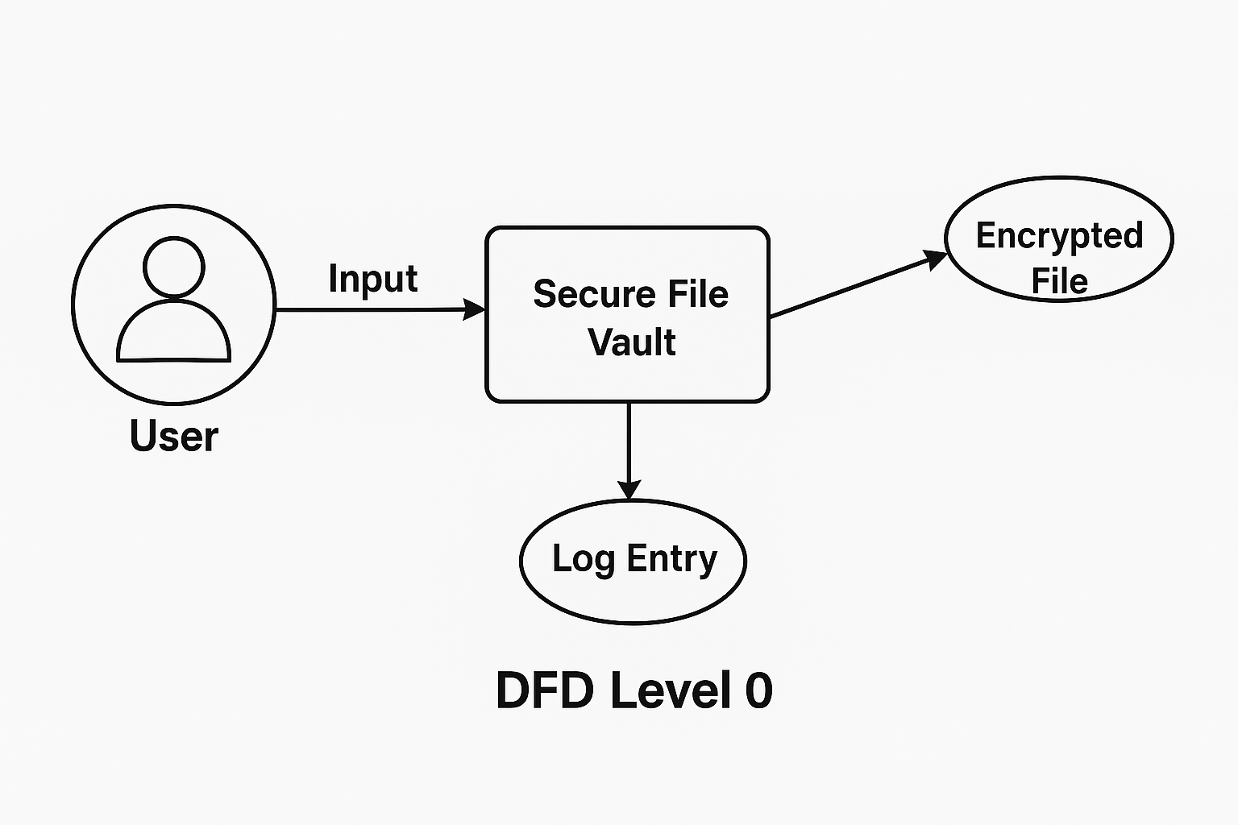

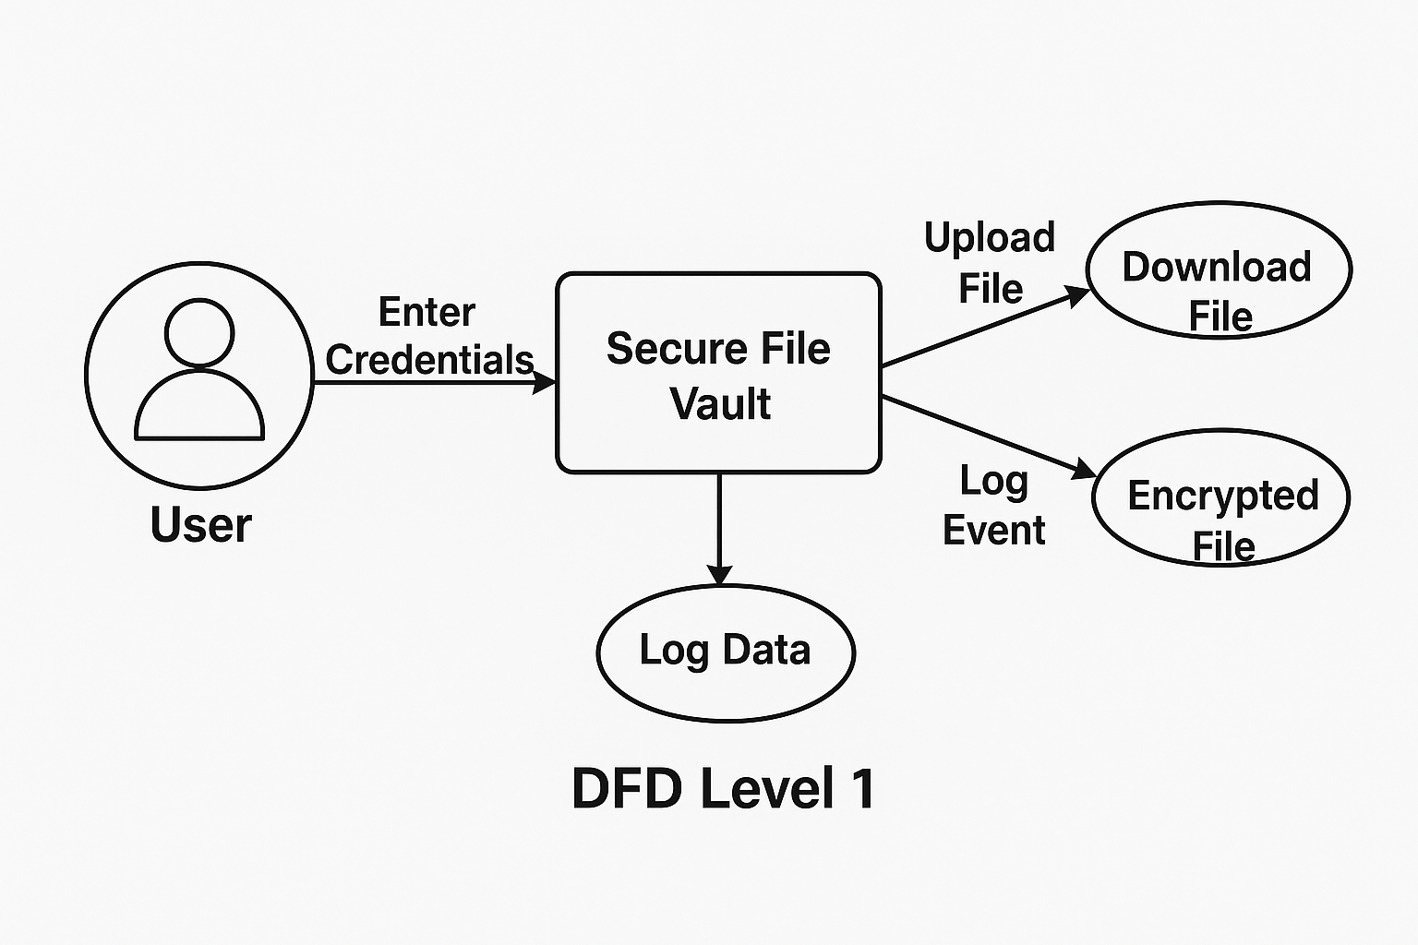

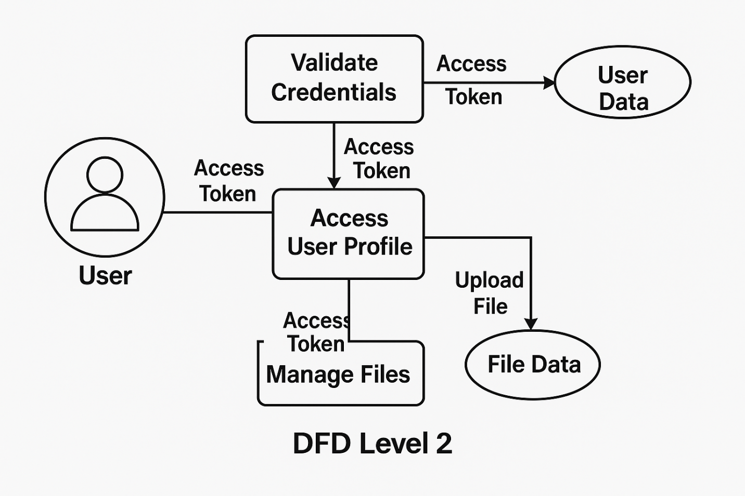

Annexure B
Entity-Relationship Diagram (ERD)

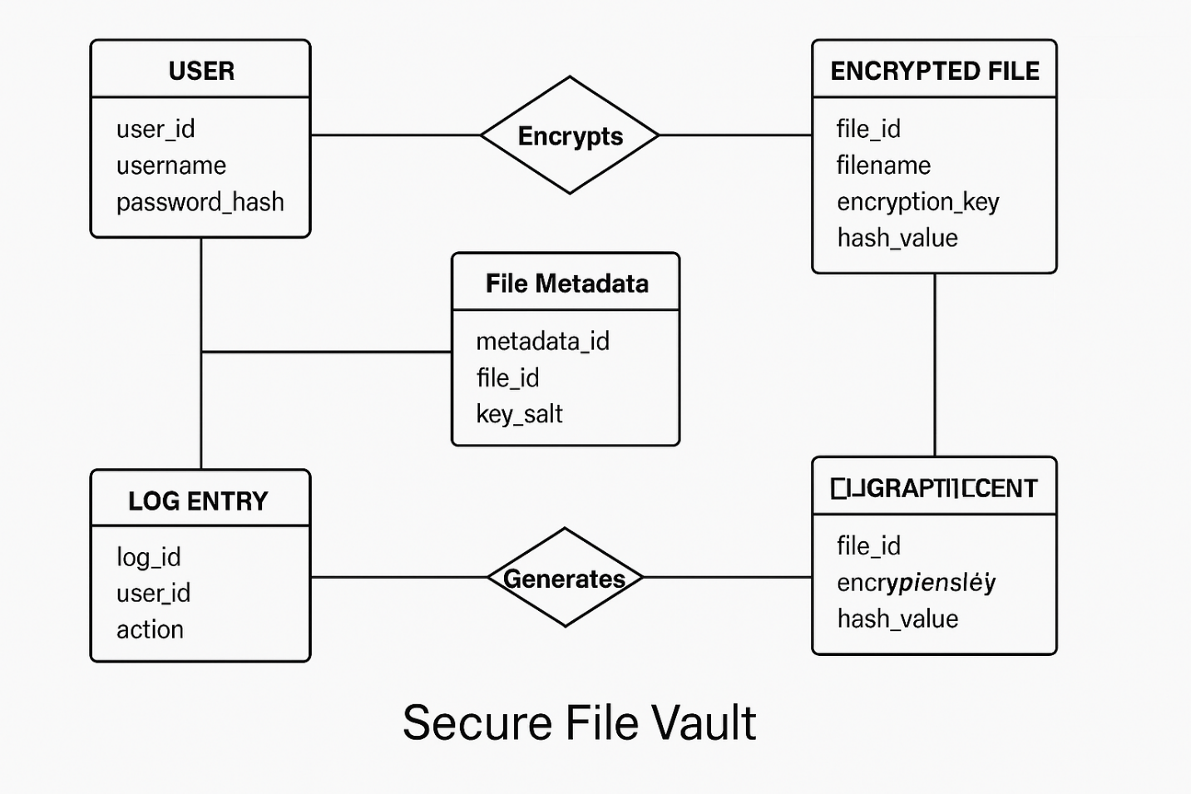

Annexure C
Use-Case Diagram (UCD)

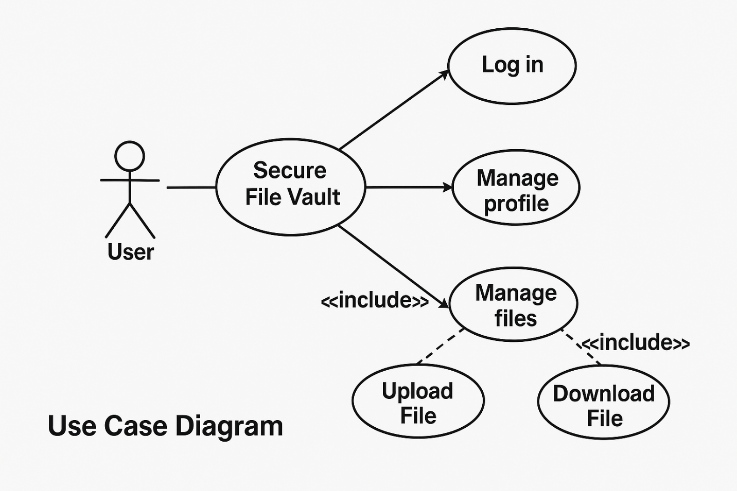

Annexure D
Code
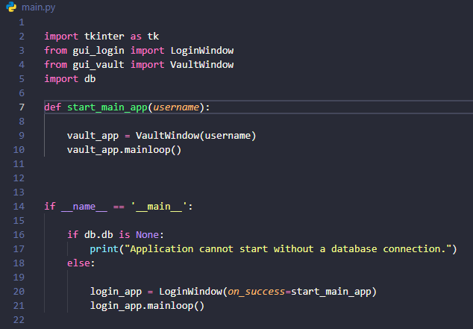

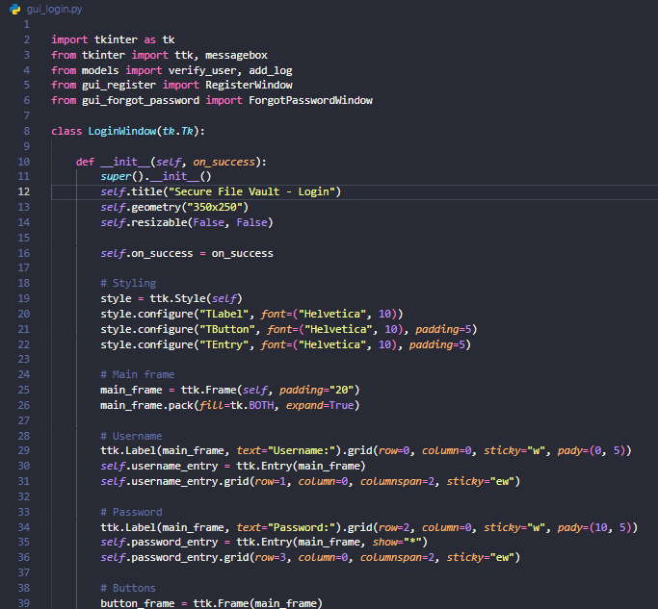

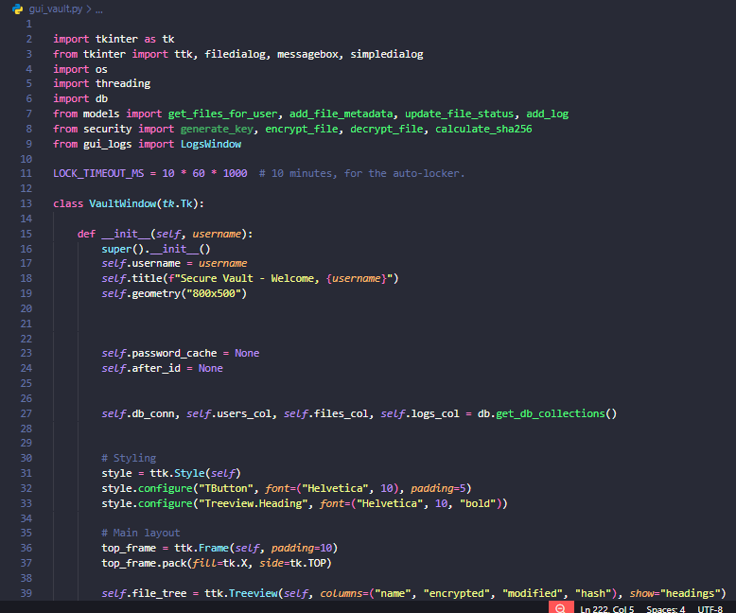

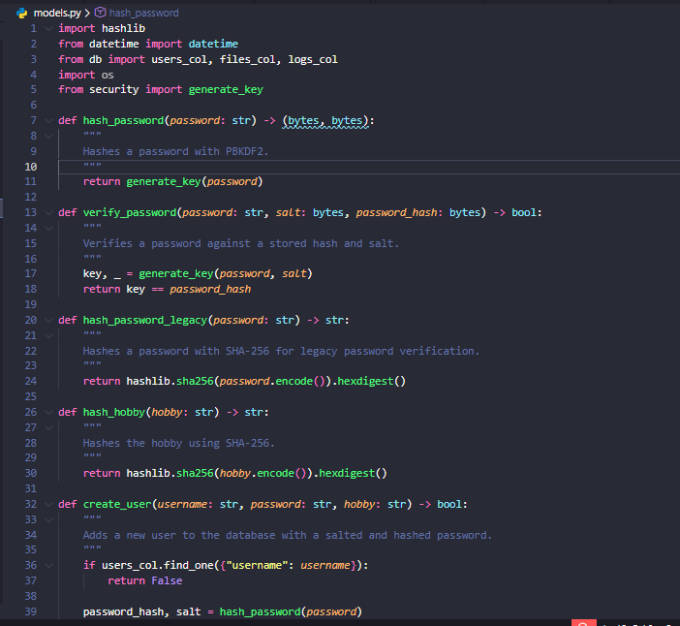

Annexure E

Screen Shots
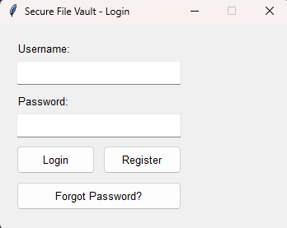
Login Page:

Home Page:

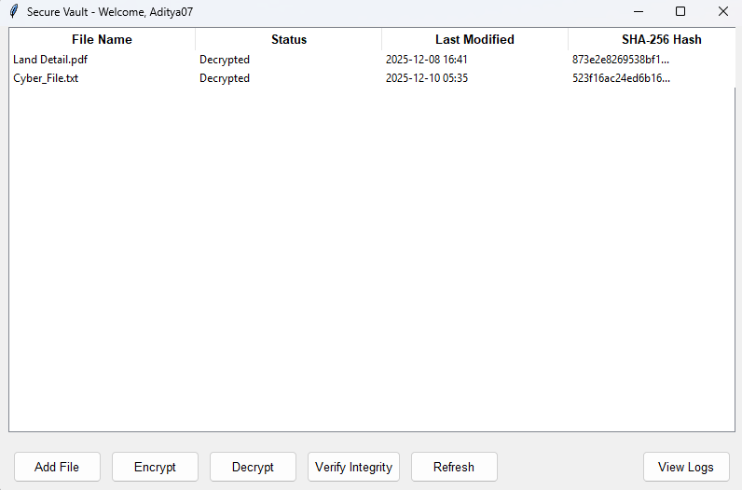
Screen Shots of Working:
