**Project 1**

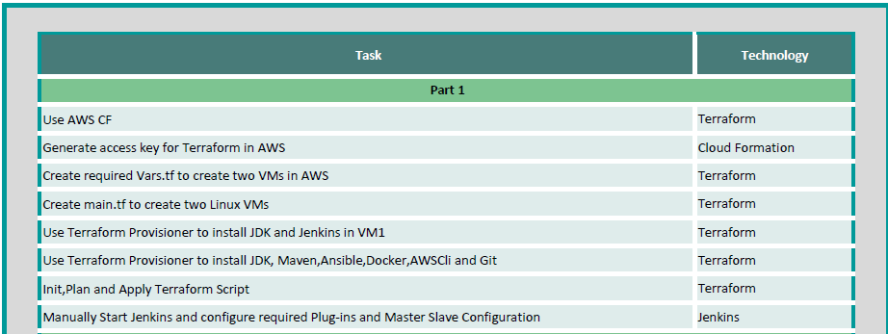

Created access key



Created 2 terraform files to created 2 VM’s one for Jenkins and another for Ansible with provisioners.



Created 2 folders Jenkins and ansible and placed the above files in their respective directories

Ran terraform init, plan and apply on the respective folder to create 2 VM’s with name Jenkins_instance and ansible_instance with elastic public ip’s as shown below

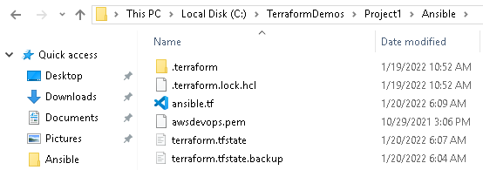

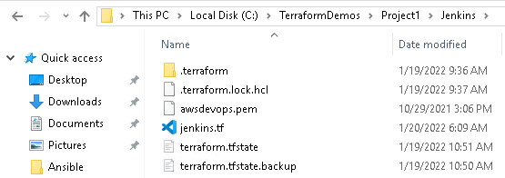



Login in to Jenkins’s server and verify java and Jenkins are installed.

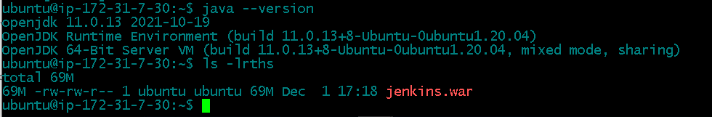

Login to Ansible server and verify java, maven, ansible, docker, AWS CLI and GIT

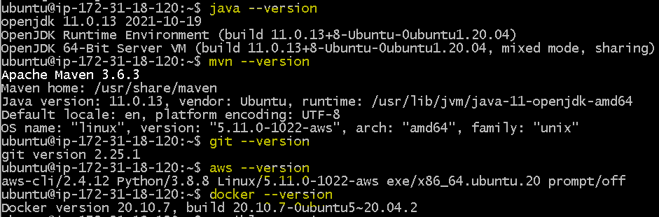

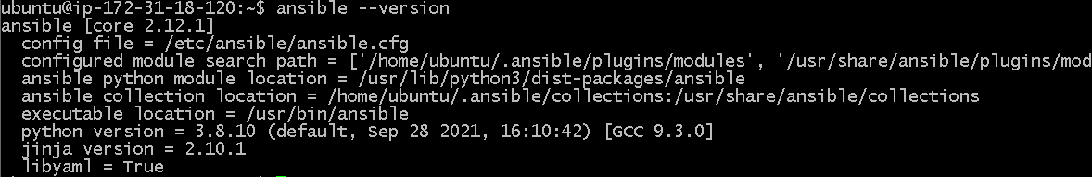

Now run aws configure to setup aws console authentication on Ansible server

Now generate public and private keys using ssh-keygen command on both servers

Now on Jenkins and ansible switch to use root and add the “ubuntu ALL=(ALL:ALL) ALL” line to /etc/sudoers file on both servers

Now on ansible node server create Jenkins folder as shown below

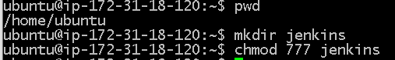

Now on ansible node server add public key of ubuntu user from Jenkins server and ansible server to the file “/home/ubuntu/.ssh/authorized_keys”

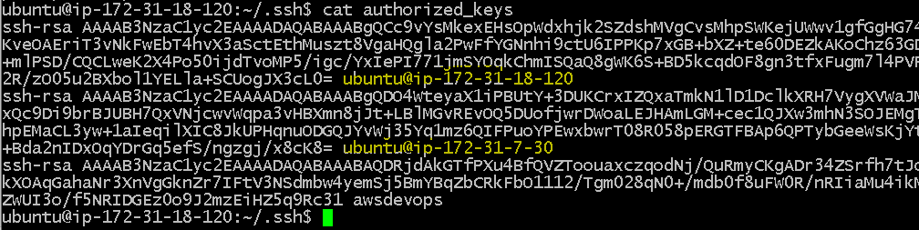

Now on Jenkins server run the below command to start Jenkins



Get the admin password for initial set up from nohup file

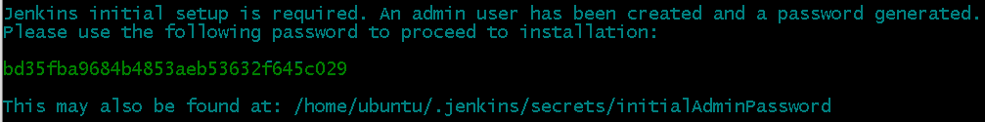

bd35fba9684b4853aeb53632f645c029

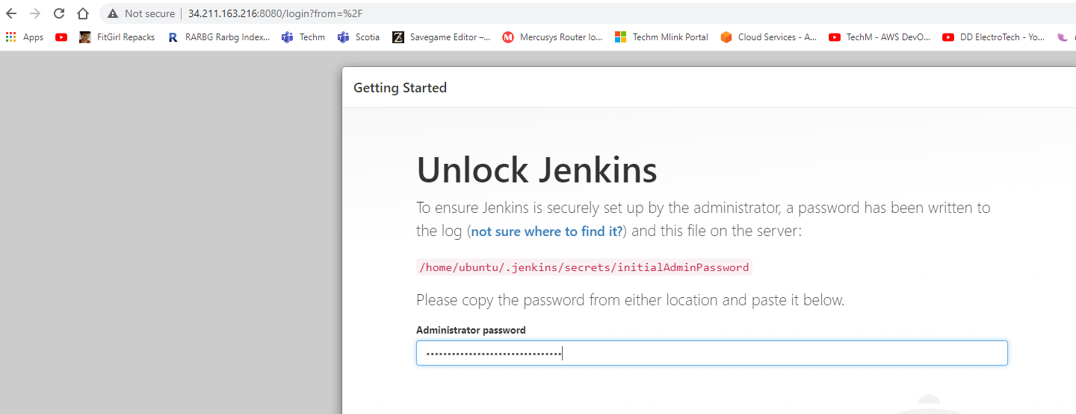

Install suggested plugins and in next screen create admin credentials and remember them,

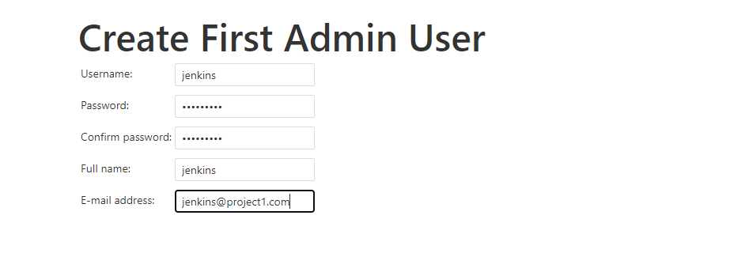

Username : jenkins

Password : Twenty@20

Save and continue and u will get the below screen

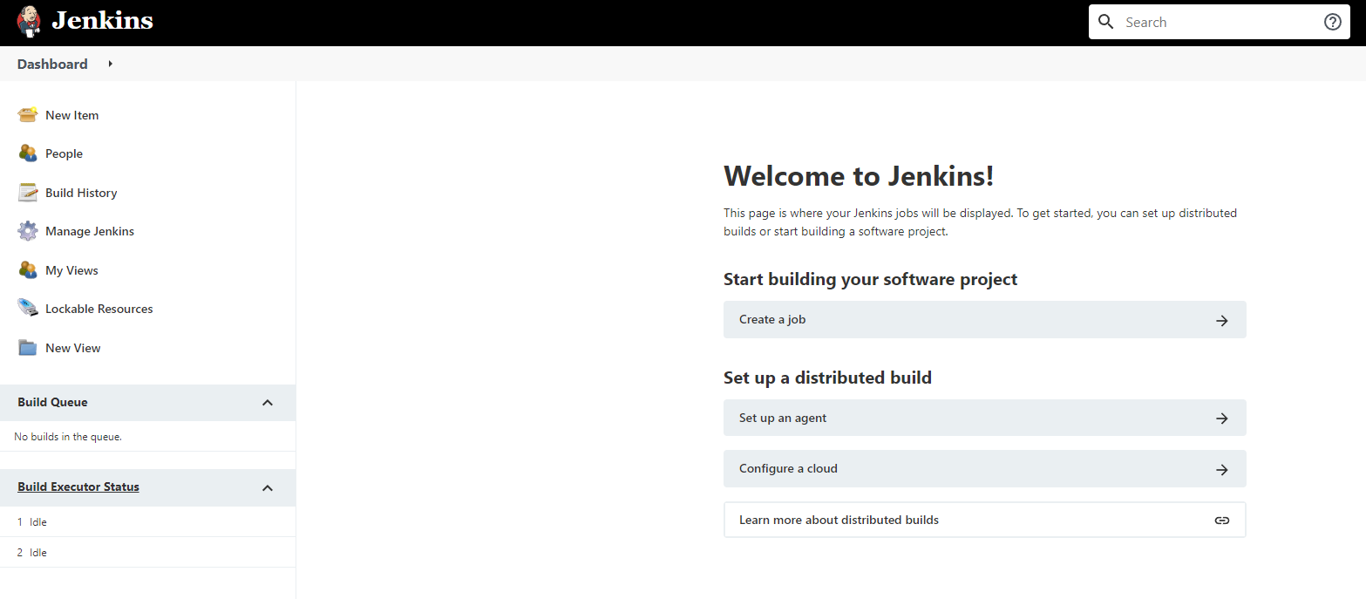

Go to Manage Jenkins -> Manage nodes and clouds -> New node

Select name and enable permanent.

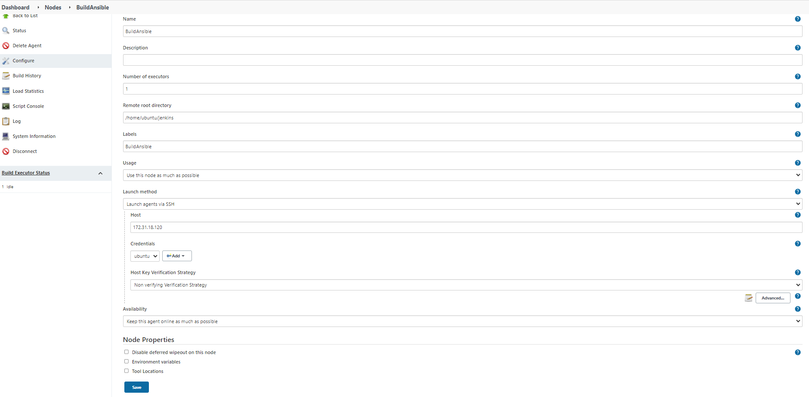

Enter Remote root directory, Labels and select Launch method as Launch agent via SSH.

Enter the private ip of ansible node as host.

Add credentials with kind as SSH username with private key and enter user name as ubuntu and enter private key of ubuntu user in Ansible node instance

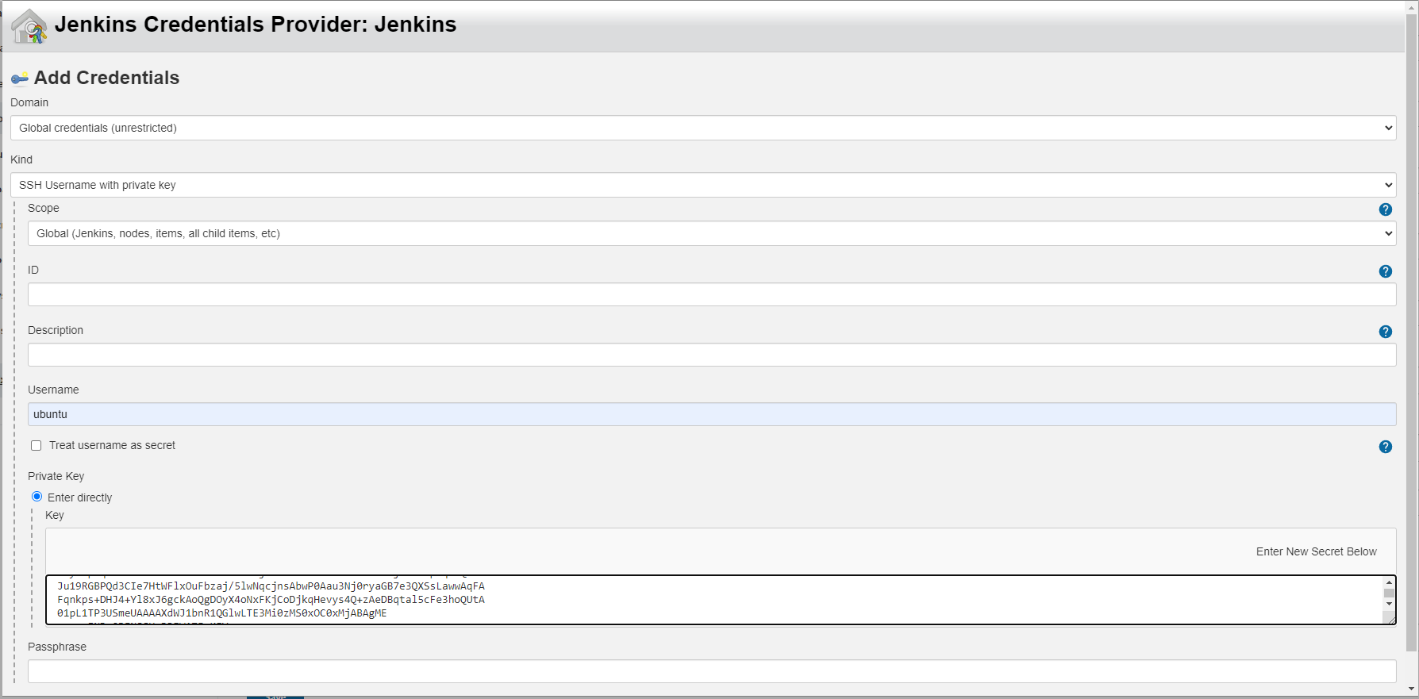

After the setup you can see the node is online as shown below





Make sure that build in node usage is changed to below.

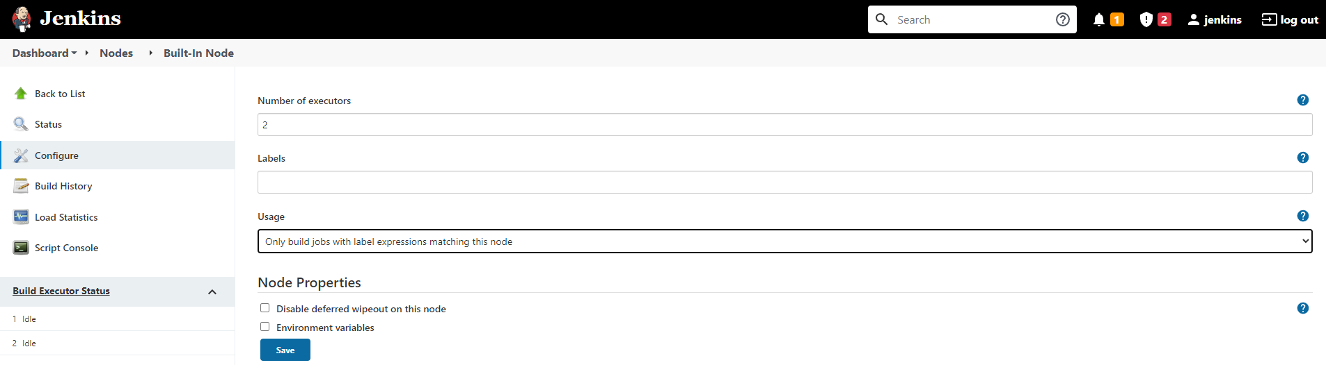

From Manage Plugins screen install required plugins as below

Git Hub Integration

Maven Integration

Docker

CloudBees Docker Build and Publish

Ansible

Terraform

AWS plugins

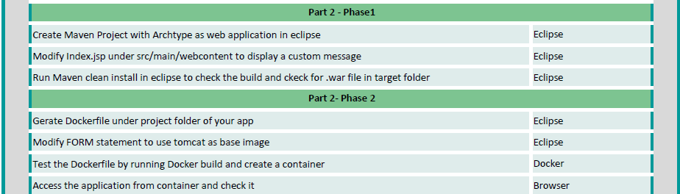

Using eclipse create new Maven project with archtype as web application.

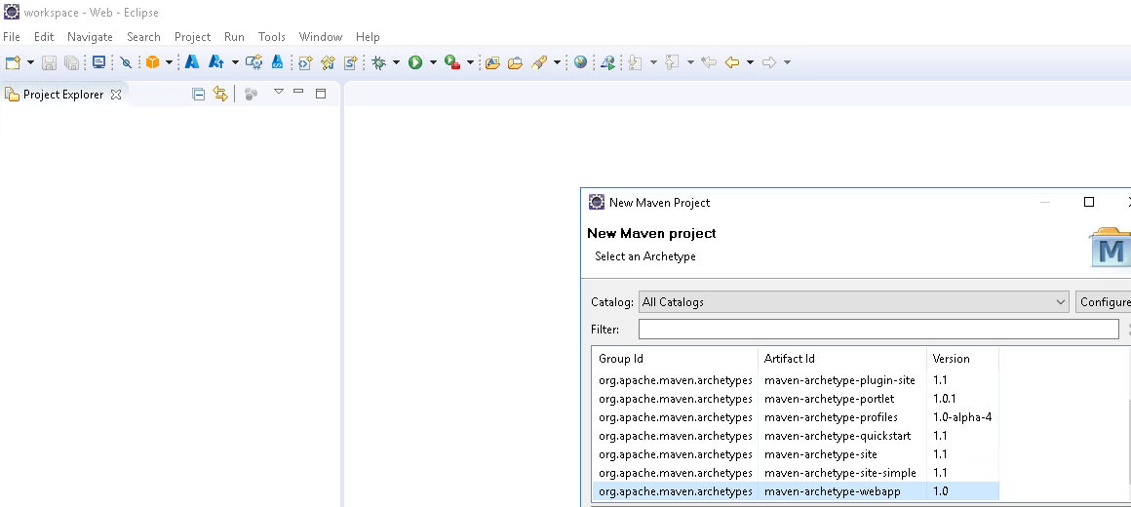

Modified the index.jsp as shown below and save the changes

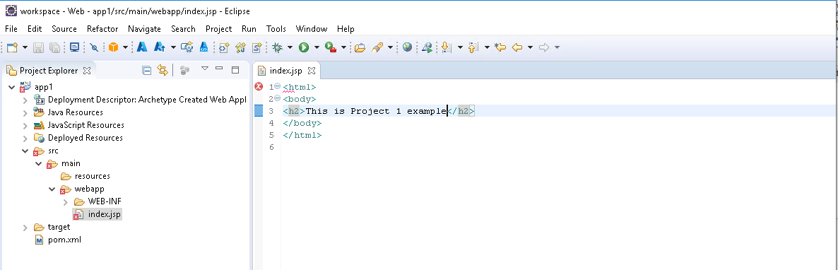

Create the Dockerfile as shown below

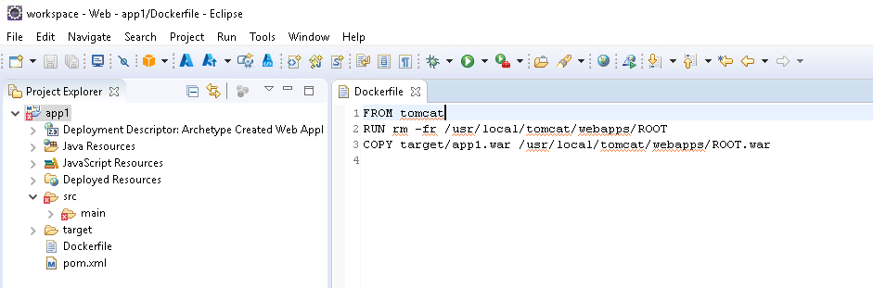

Right click on app1 project Runas -> Maven install to generate app1.war in target folder

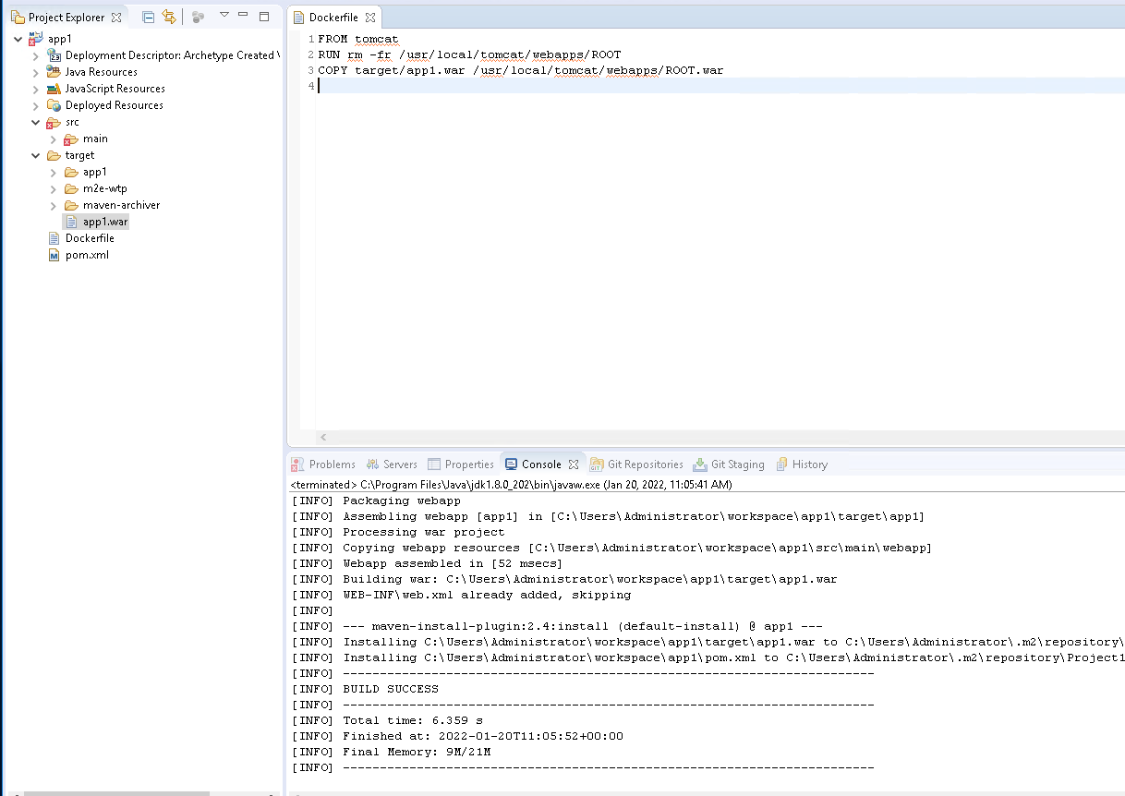

To Test the docker file

Now right click on app1 project -> show in -> system explorer

And compress the app1 folder to zip as shown below

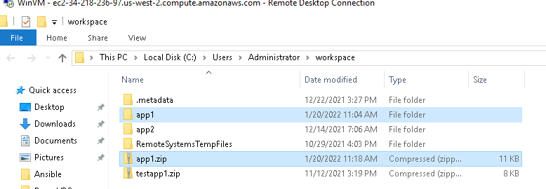

Now use winscp and copy app1.zip to ansible instance, as shown below

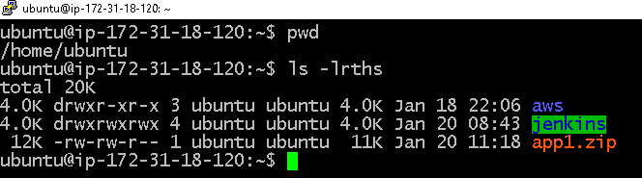

Unzip the app1.zip and open app1 folder to see docker and project files

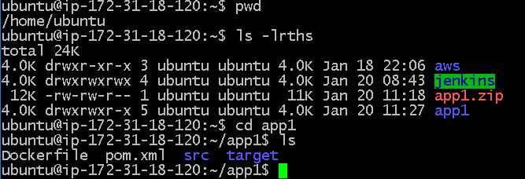

Now run sudo docker build -t myapp1 . to build docker image

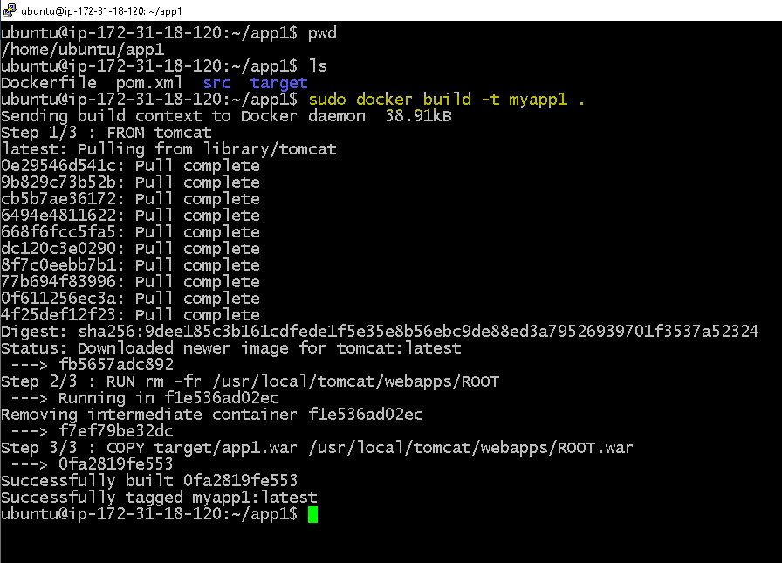

Create a container from myapp1 image as below.

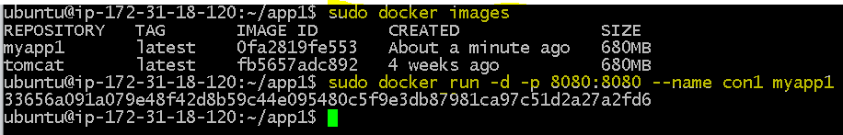

Now use ansible instance ip address with 8080 port to check the page.



Once the test is successful, remove the container and image as below.

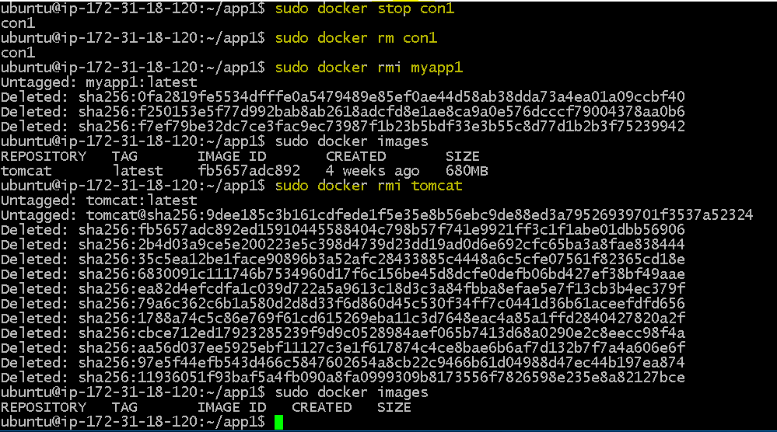

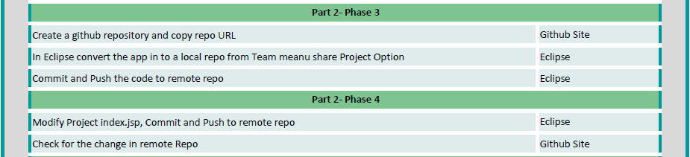

Created new git repo name Project1

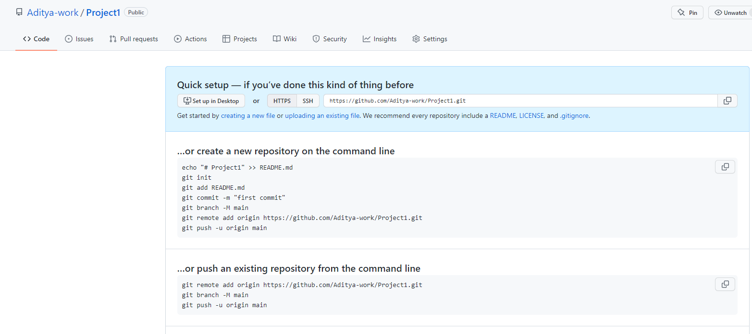

In eclipse right click on app1 -> Team -> Share Project and create local copy.

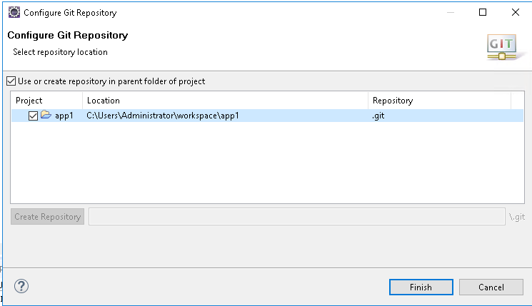

Now commit and push the changes.

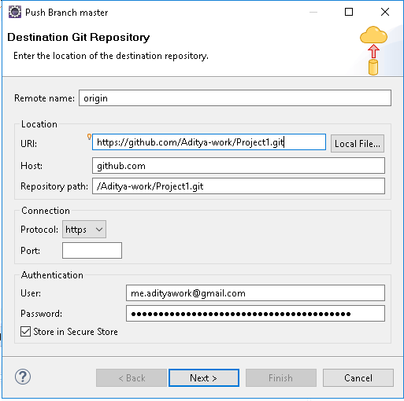

Verify the git hub Project1 repository to verify

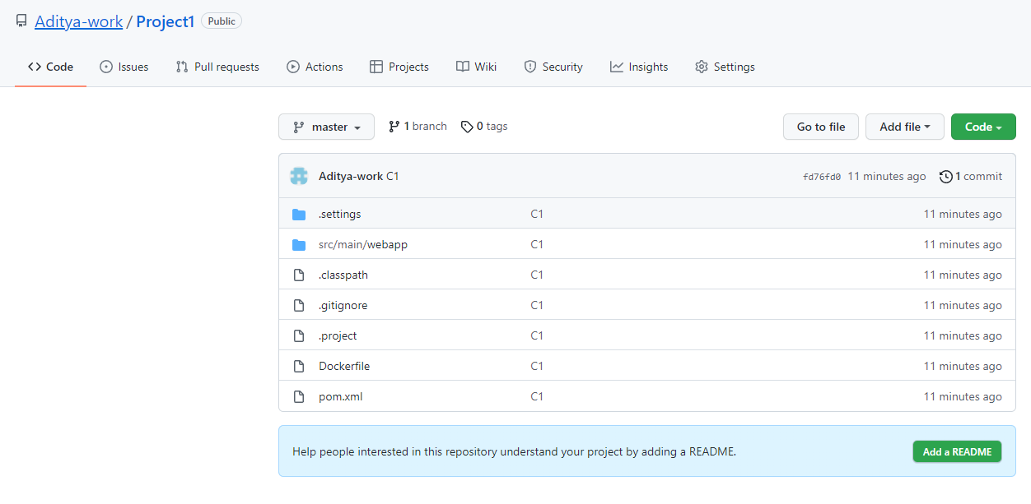

Modify the below index.jsp file and commit C2 and push and verify the git repository

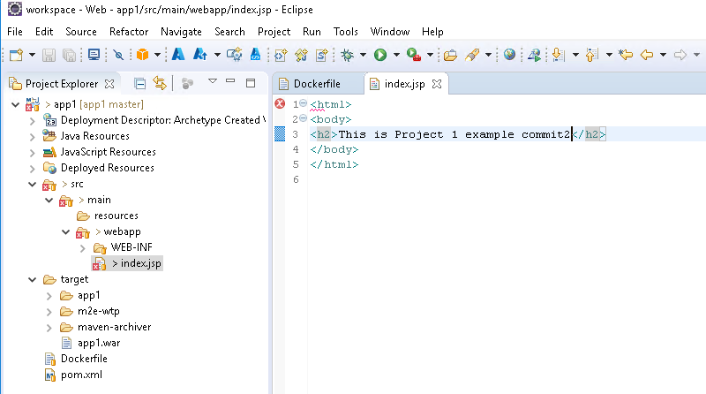

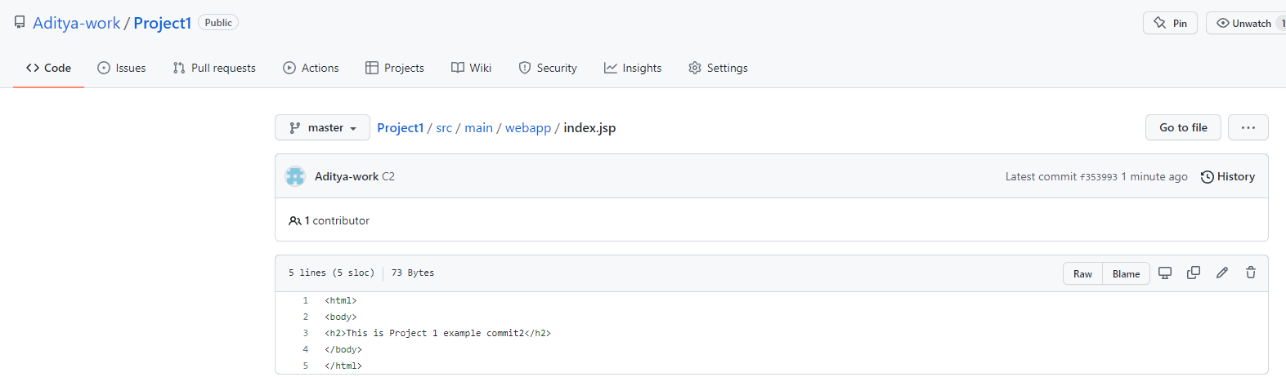

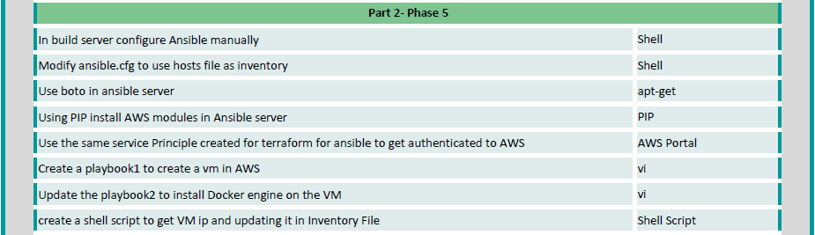

Ansible already installed using terraform earlier. You can verify using ansible –version command.

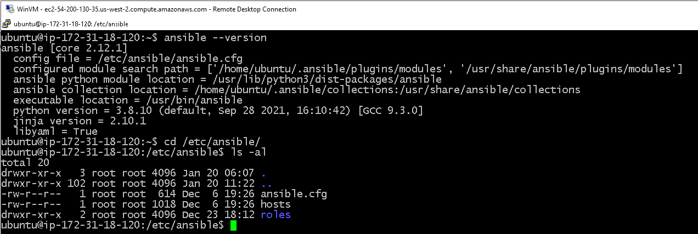

Change the owner ship of ansible folder from root to ubuntu as shown below.

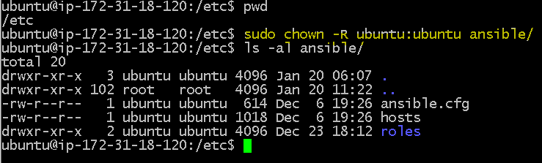

Make sure that. ansible folder in home dir has ownership to ubuntu

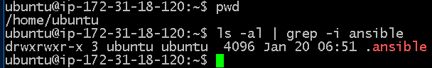

In /etc/ansible/ansible.cfg enable inventory and set deprecation_warnings as false





Now run the below commands

sudo apt install python3-pip

pip install boto3

now open /etc/ansible/ansible.cfg file and add enable plugin line as shown below.

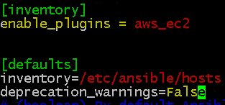

Now create the below aws_ec2.yaml file with your AWS credentials and run

ansible --list-hosts -i aws_ec2.yaml all

to check if it can list instances of EC2 or not

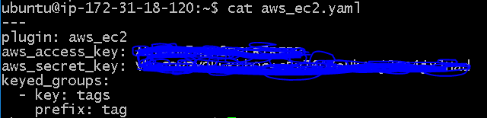

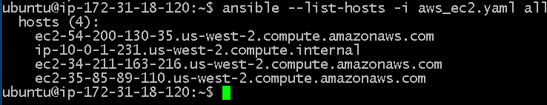

Copy you pem file to ansible master server as shown below and give permissions as 600

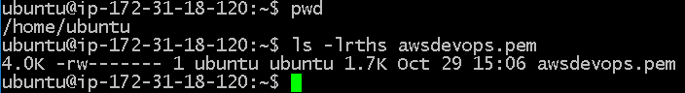

Now create playbook1 which creates EC2 instance and adds the EC2 instance private ip to hosts files



Now create ~/.ssh/config file with the below lines

vi ~/.ssh/config

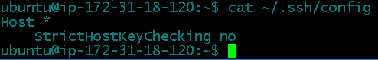

Give permissions to file as 400

sudo chmod 400 ~/.ssh/config

now create a playbook2.yml to install docker in EC2 instance created from playbook1.yml



Playbook1.yml already has lines to copy private ip of newly created EC2 instance to inventory file

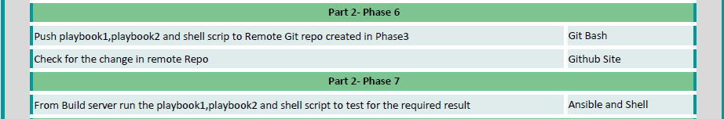

Uploaded both playbooks in github Project1 repository

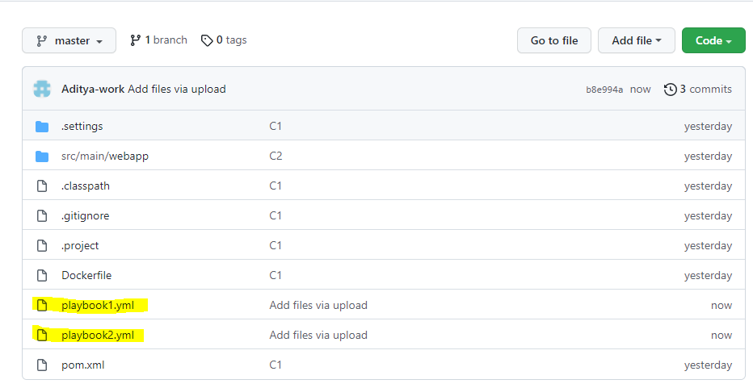

Manually ran playbook1 and playbook2 and the test was successful.

Playbook1 created new EC2 instance and added new EC2 private key to hosts file in Ansible Built server

Playbook2 successfully installed Docker on newly created EC2 instance

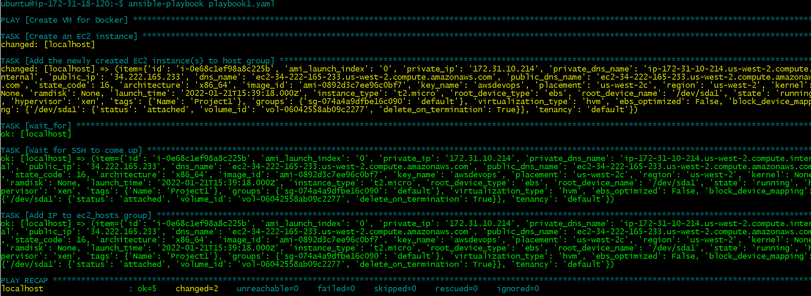



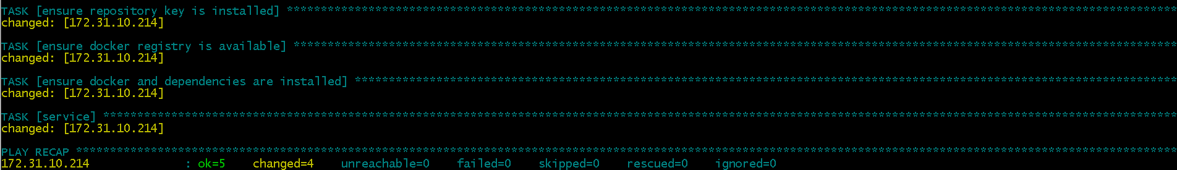



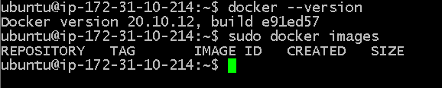

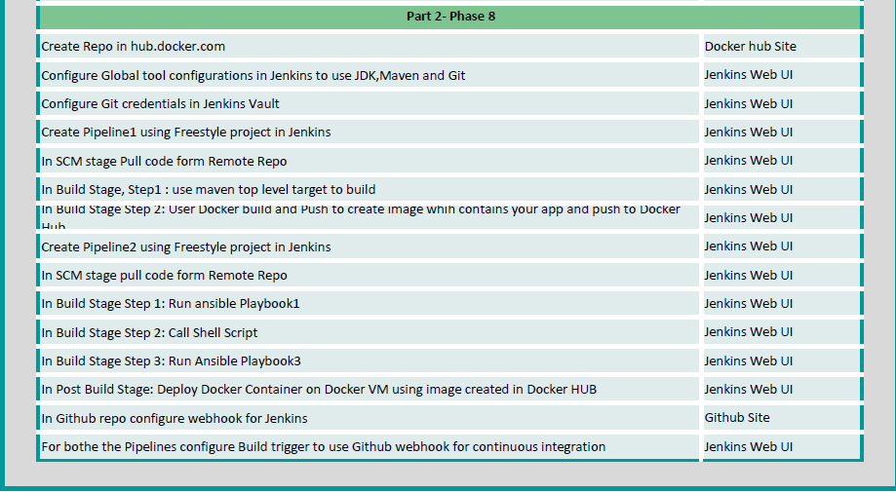

Create new repo in Docker as project1

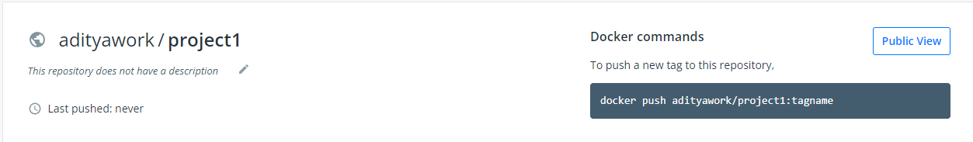

Add JDK, Maven and GIT(automatically detected) in Jenkins global configuration

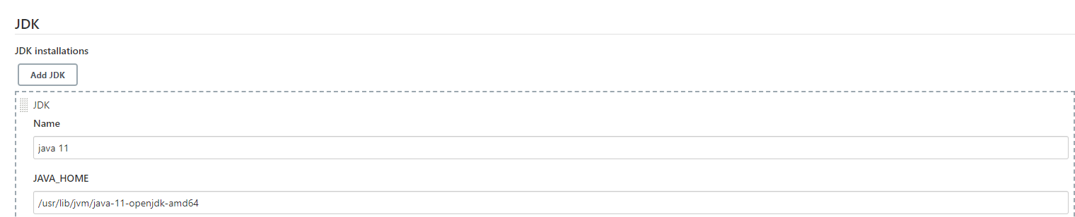

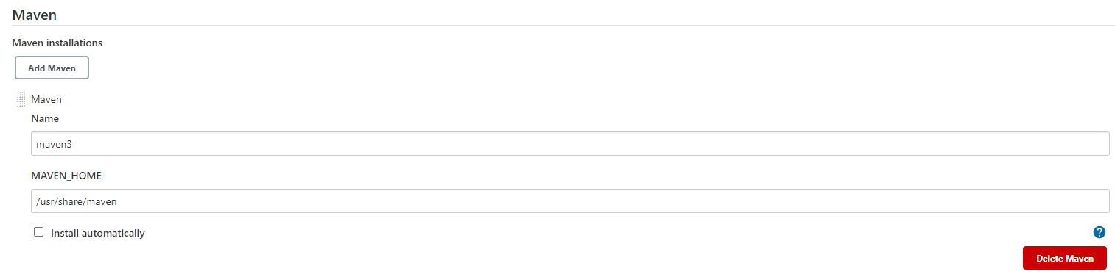

Created new pipeline with name Build

And select SCM as git and added credentials

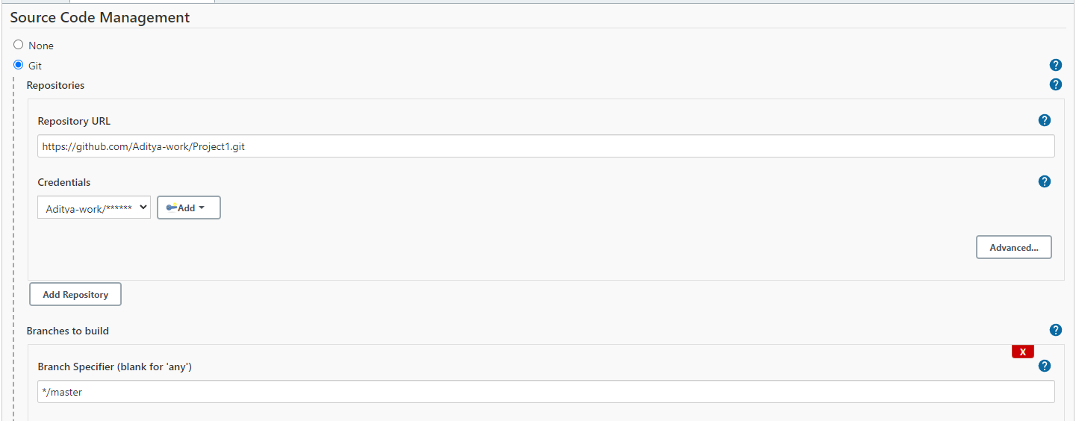

Select build as top level maven targets and fill out the details as below

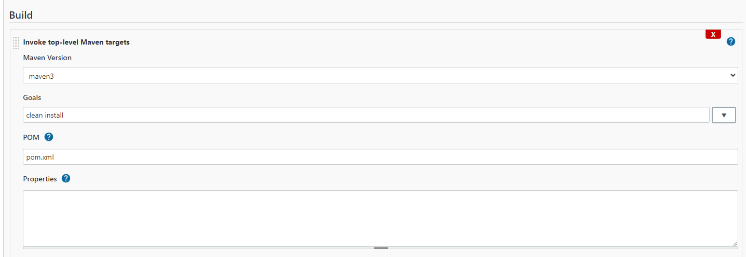

Add execute shell build step as below as the permission for group keeps on changing after server reboot

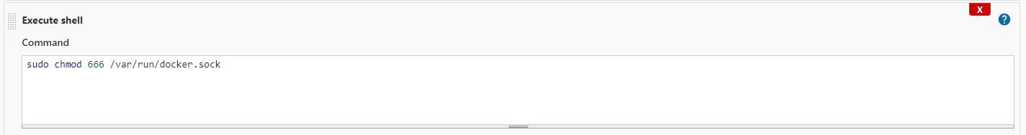

Add one more build step and select Docker Build and Publish

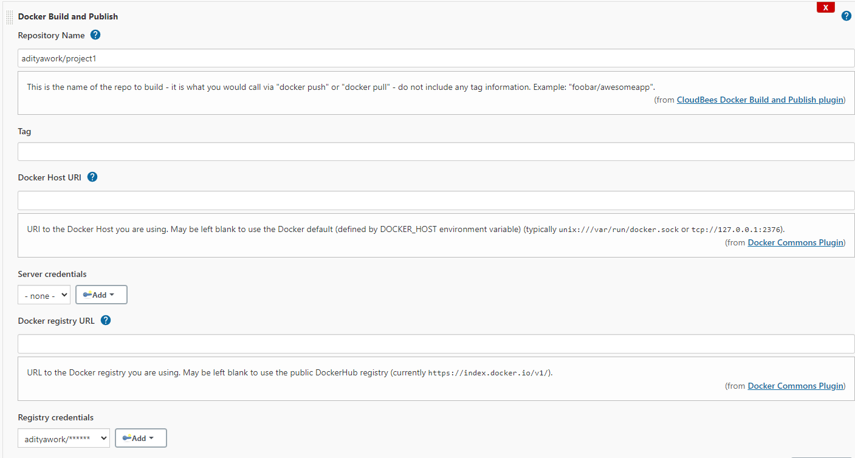

On Ansible server run the below commands one more time.

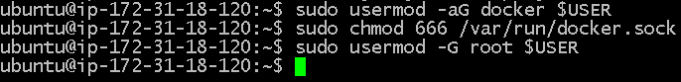

Now run the Build pipeline and check the status

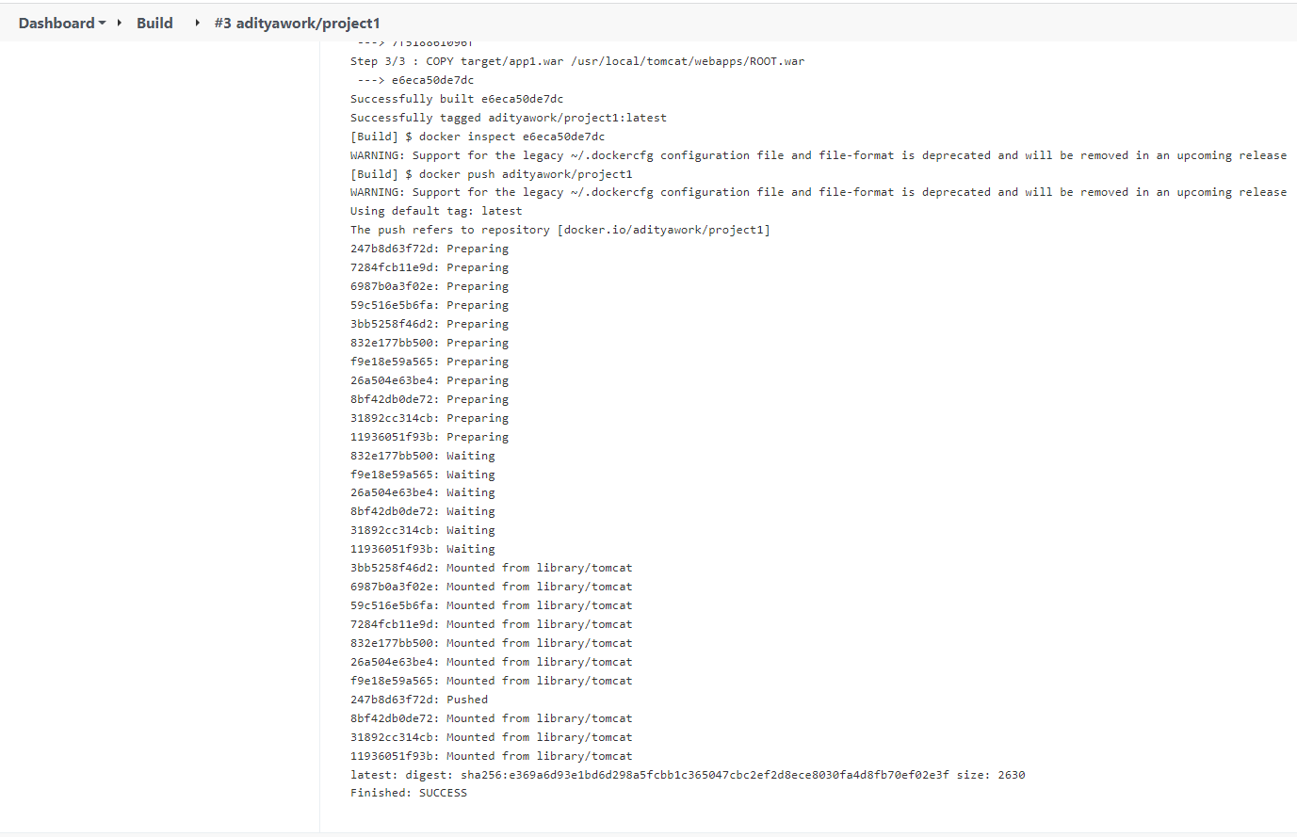

Build was successful and the image is pushed to Docker repo successfully

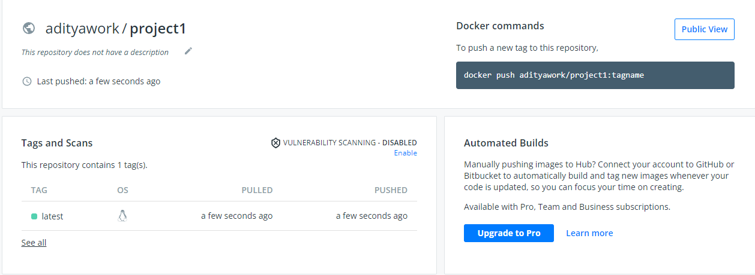

Now update playbook2.yml in the git hubrepo with the below content.



The above playbook contains instructions to install docker, supporting packages and also will pull the image from Dcoker repo and will create a container in new EC2 instance

Now Create new pipeline with name Deploy

Configure SCM

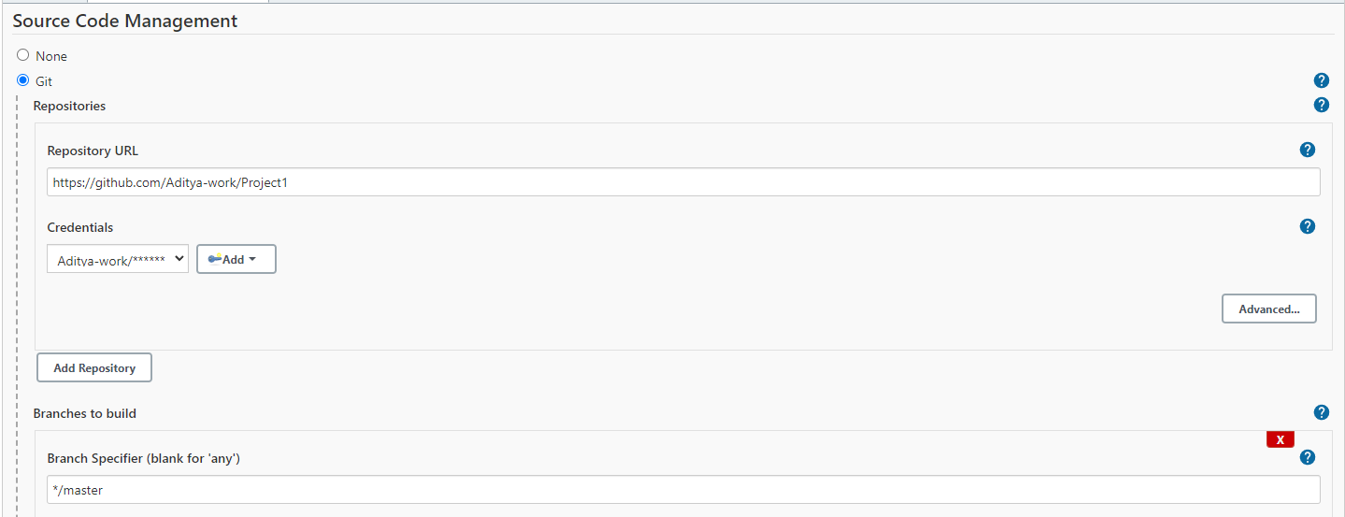

Select Build trigger to start after Deploy Pipeline automatically after Build pipeline is done successfully

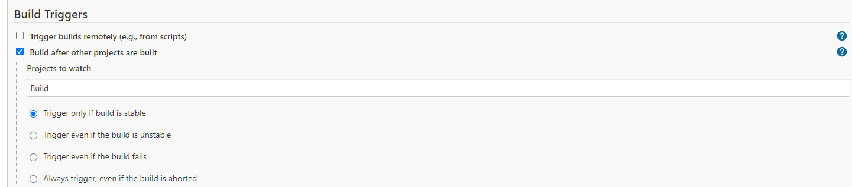

Create 2 builds to invoke playbook1 and playbook2 as shown below

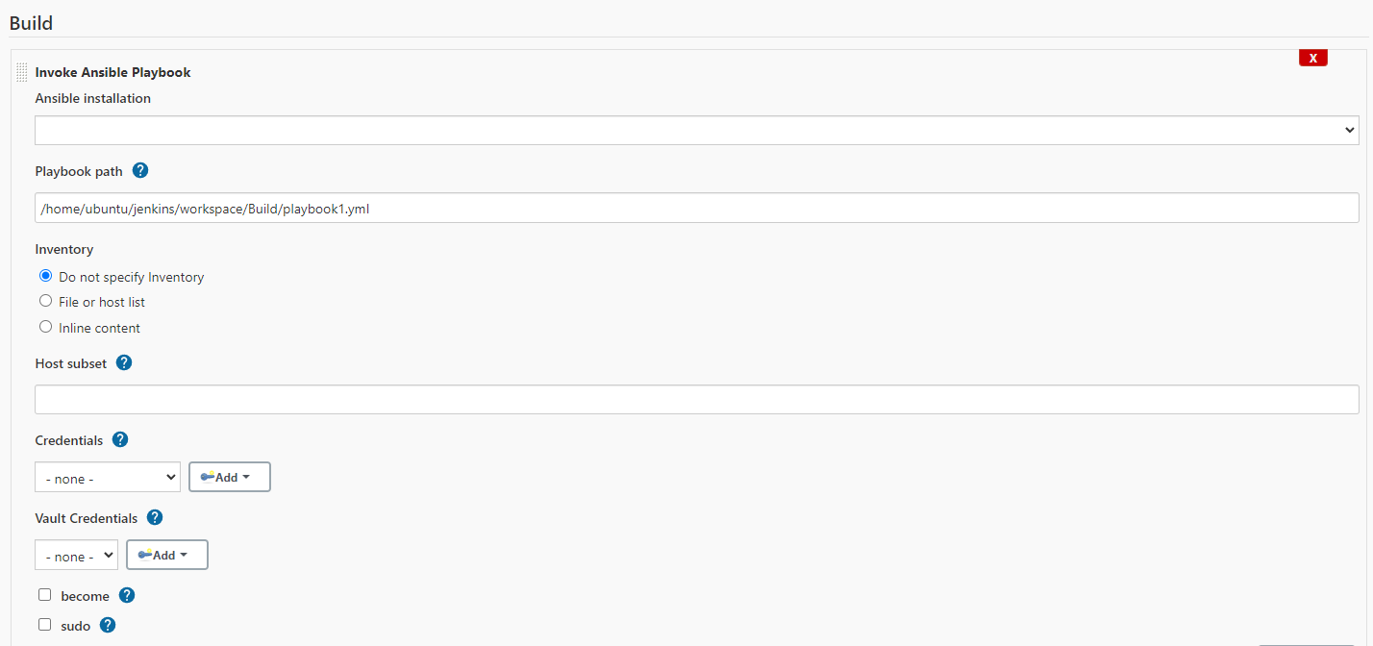

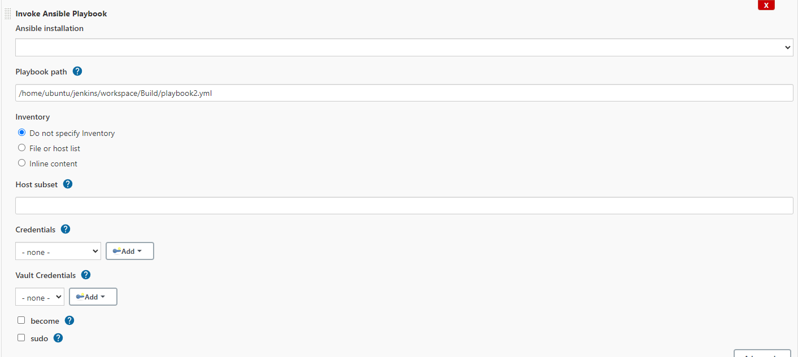

Now go to Github Project1 repo setting and configure the webhooks as shown below.

Payload URL is Jenkins URL/github-webhook/

NOTE:- Here elastic ip for Jenkins server will be useful. If we use dynamic public ip the URL will keep on changing causing webhook issues

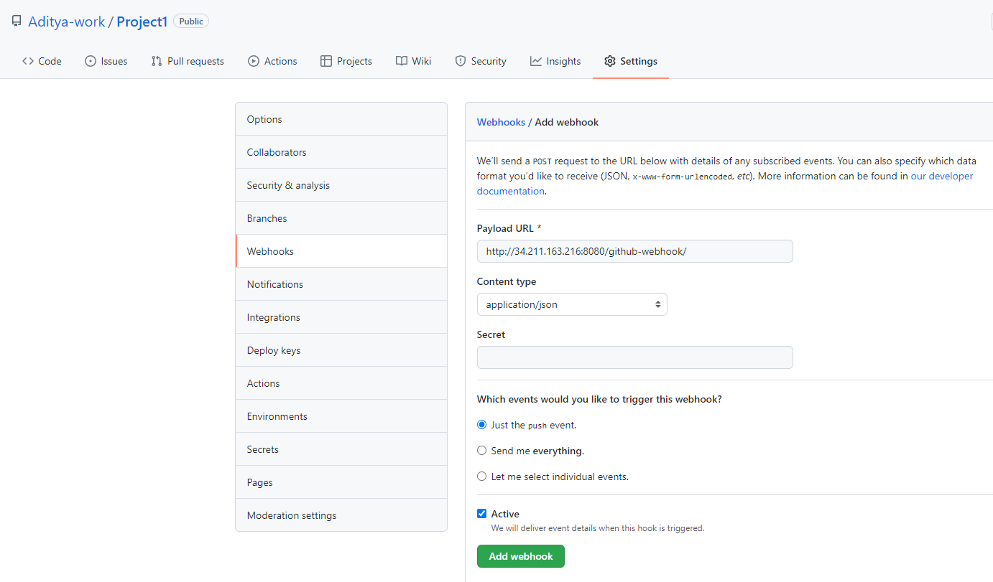

Now add the webhook

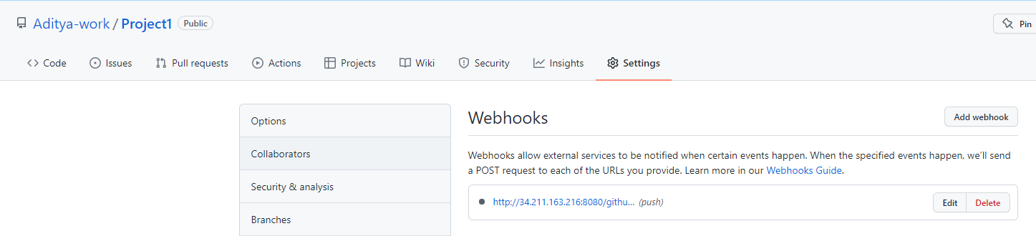

Now go to Build Pipeline and enable GitHub hook trigger

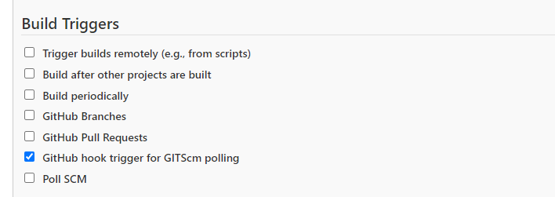

**TESTING**

Jenkins and Ansible should be running



Start Jenkins server, check the node and open pipelines

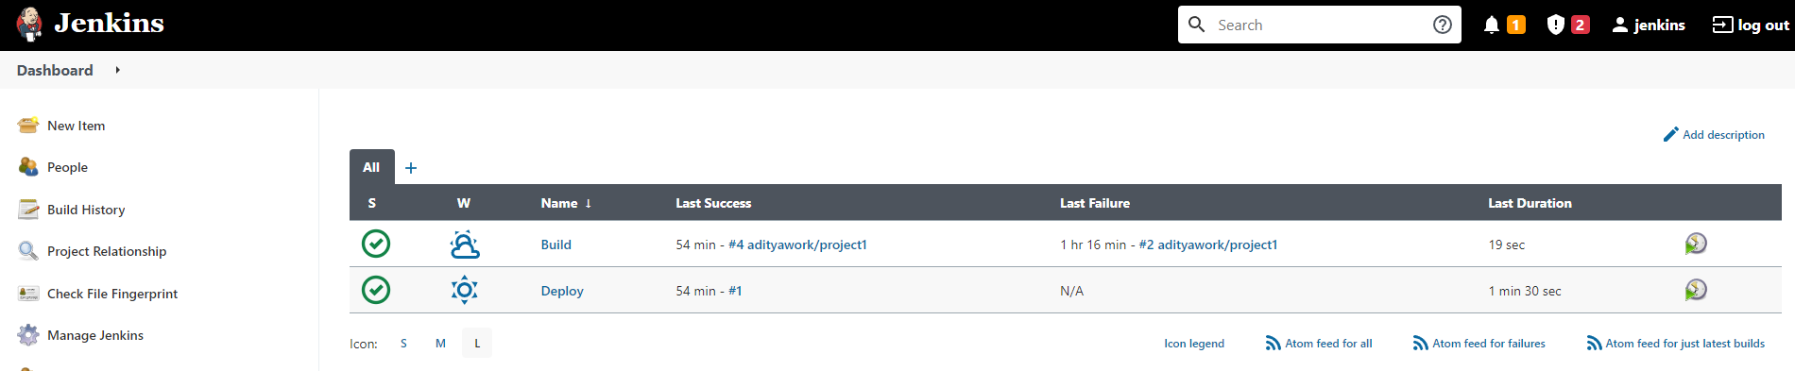



Now make a change in GIT repository to index.jsp and commit the changes

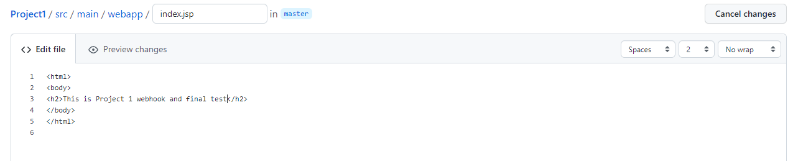

Once the commit is done, Build pipeline is triggered automatically on jenkins

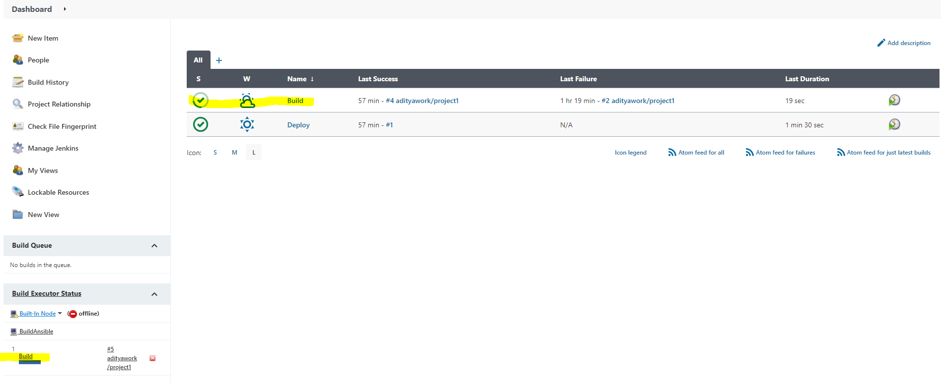

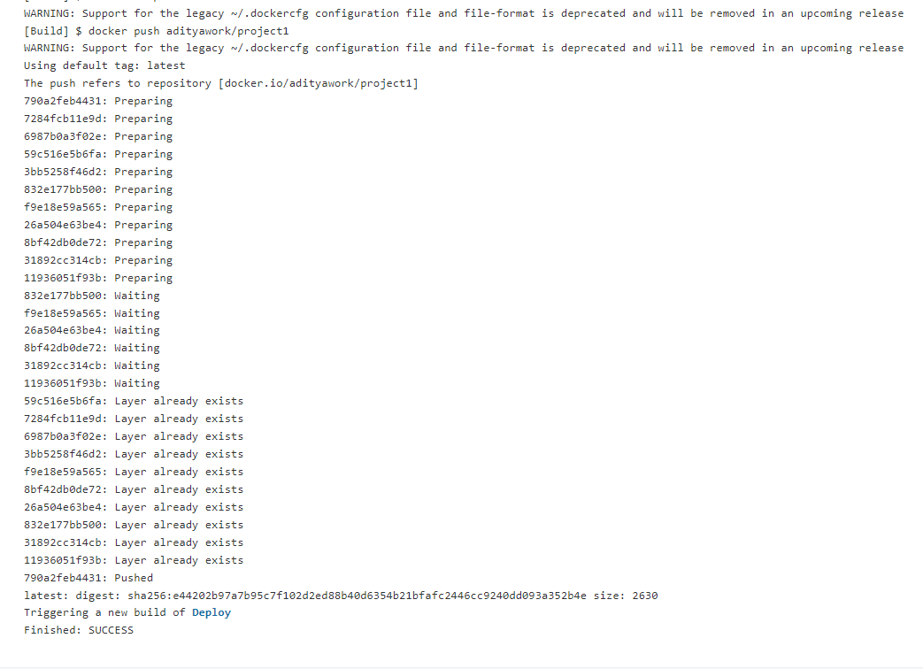

Build pipeline triggers Deploy pipeline as shown below

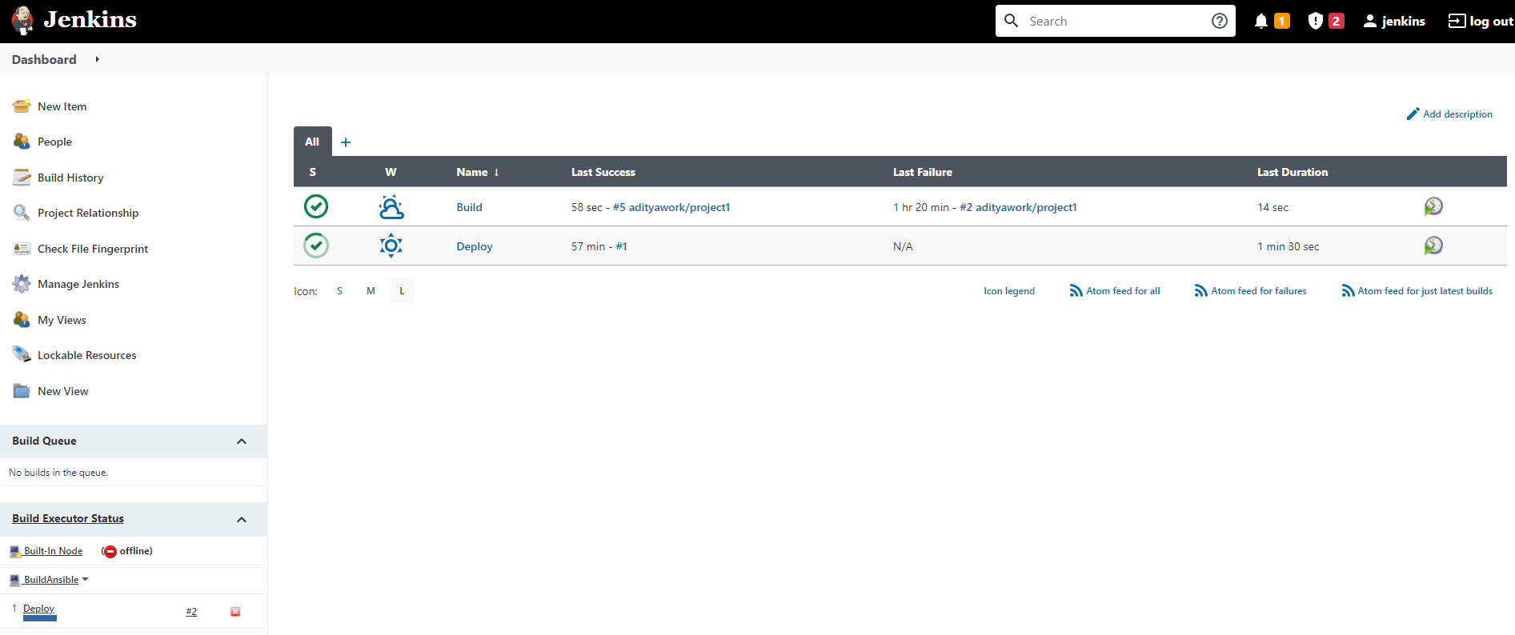

Deploy pipeline ran successfully

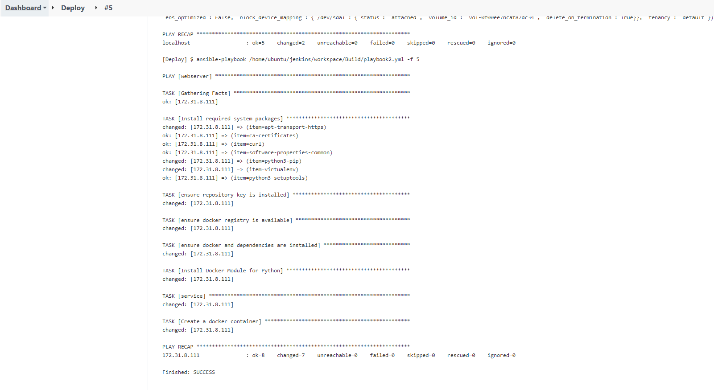

EC2 instance created



Able to open the page using public ip.

