Skewness analysis:
Before:
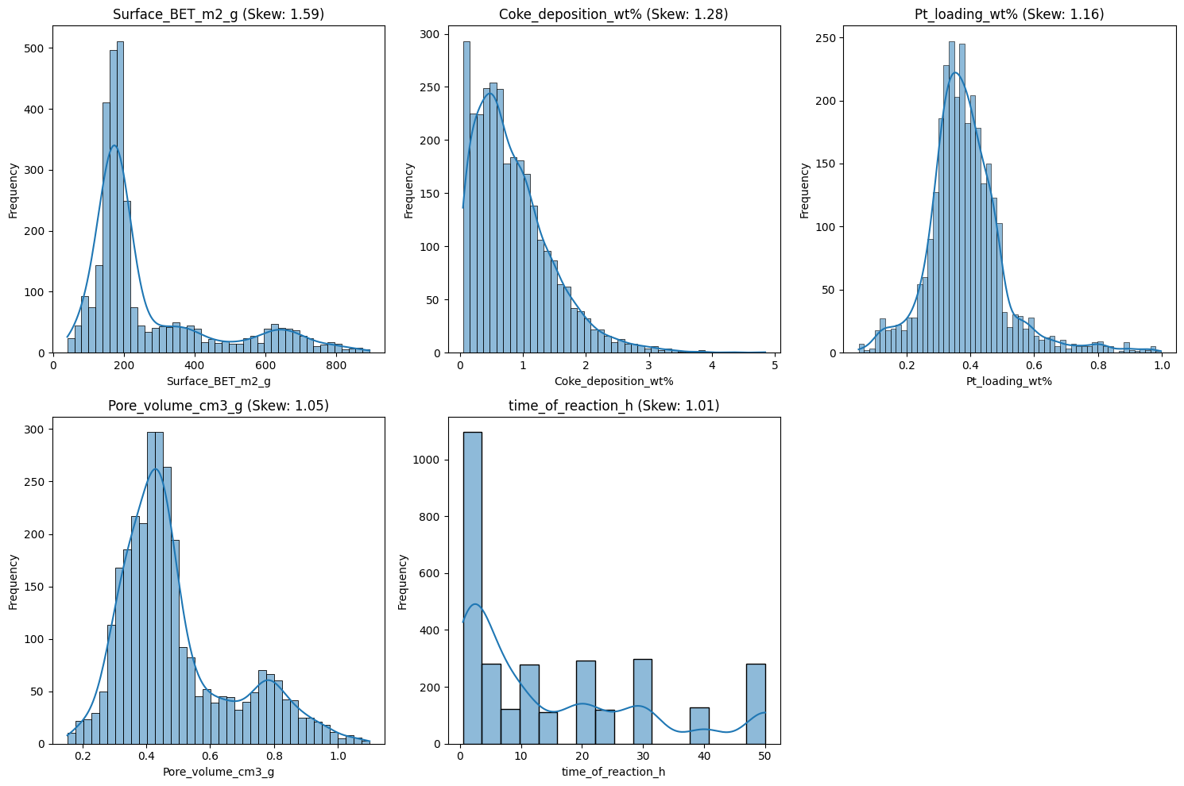

After skewness:
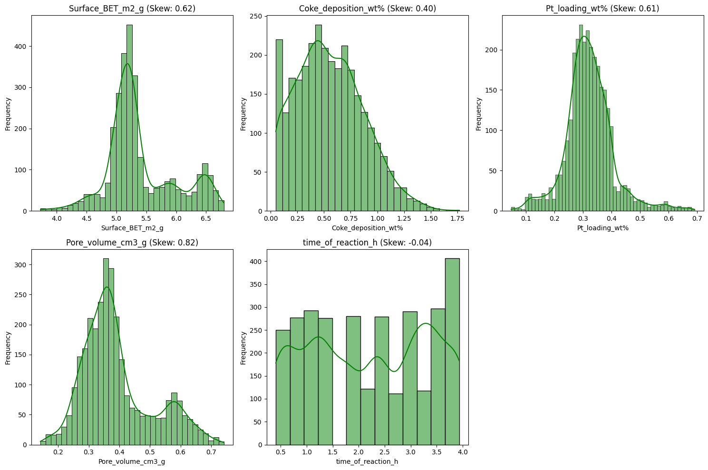
Histogram:
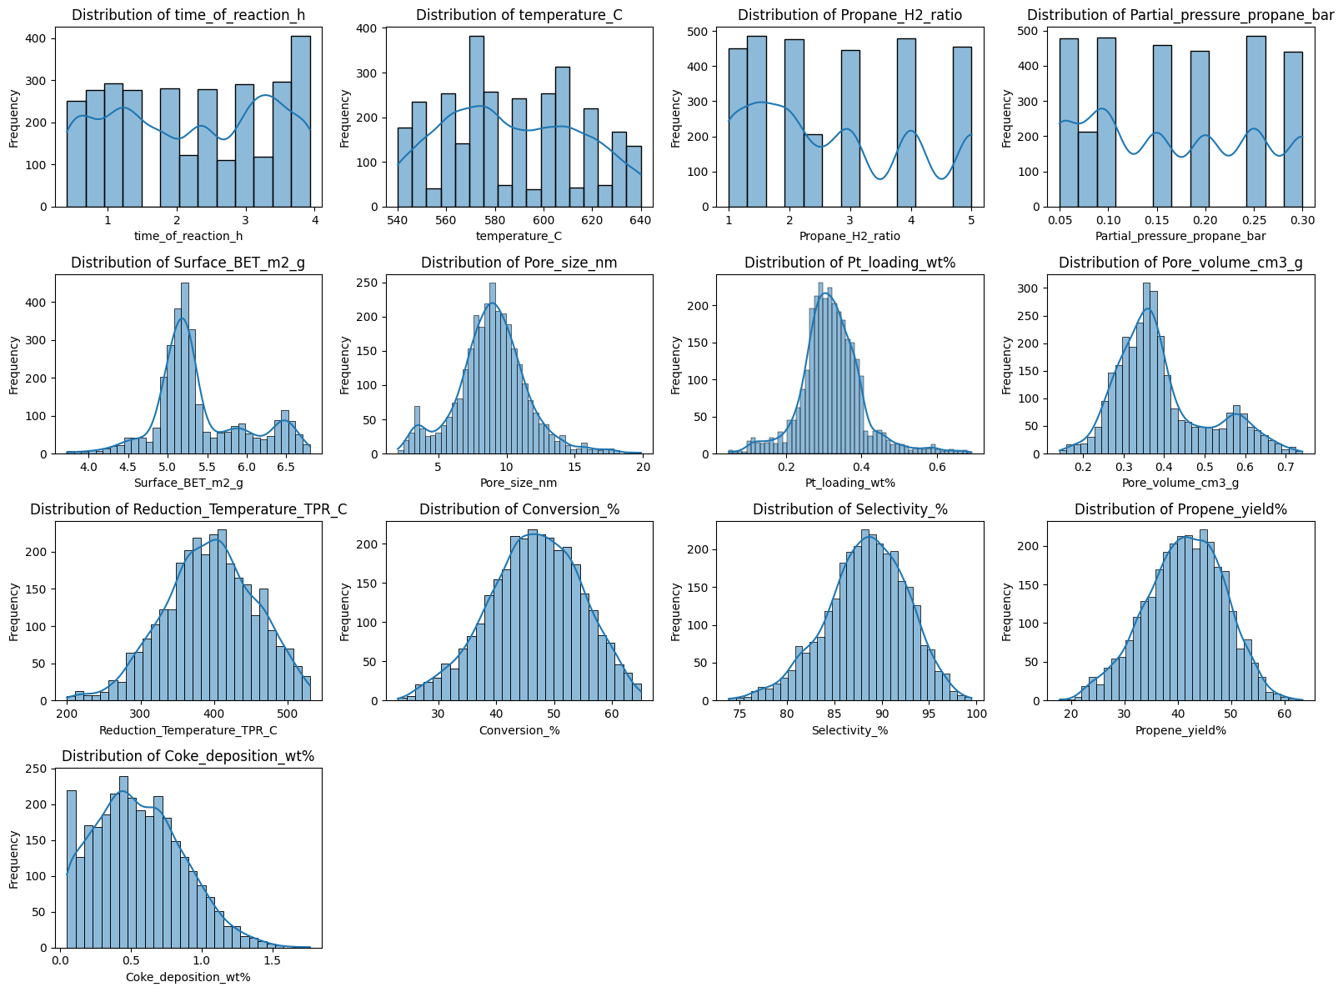
Important parameter and output 2D scatter point dataset:
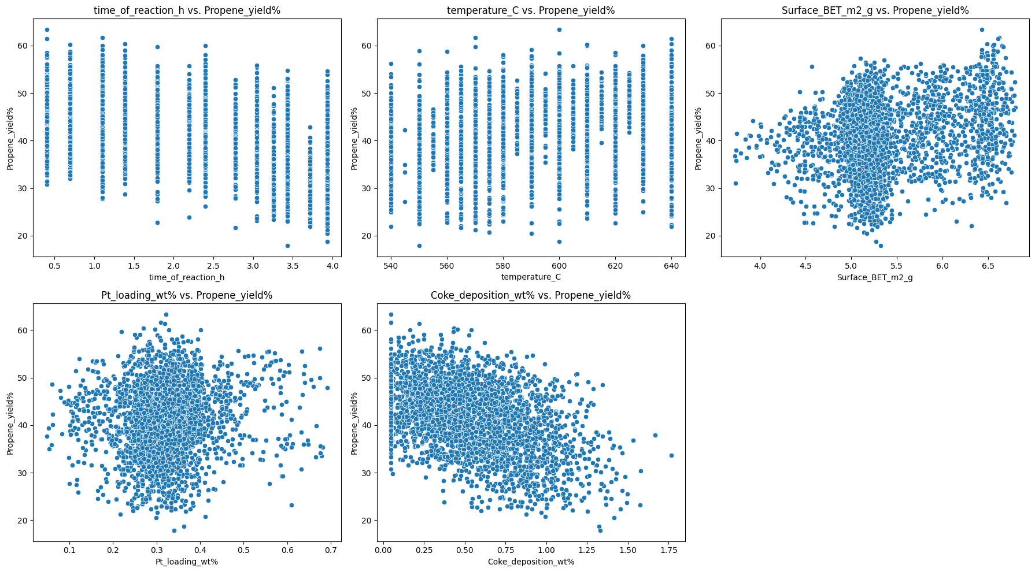
Box plot:
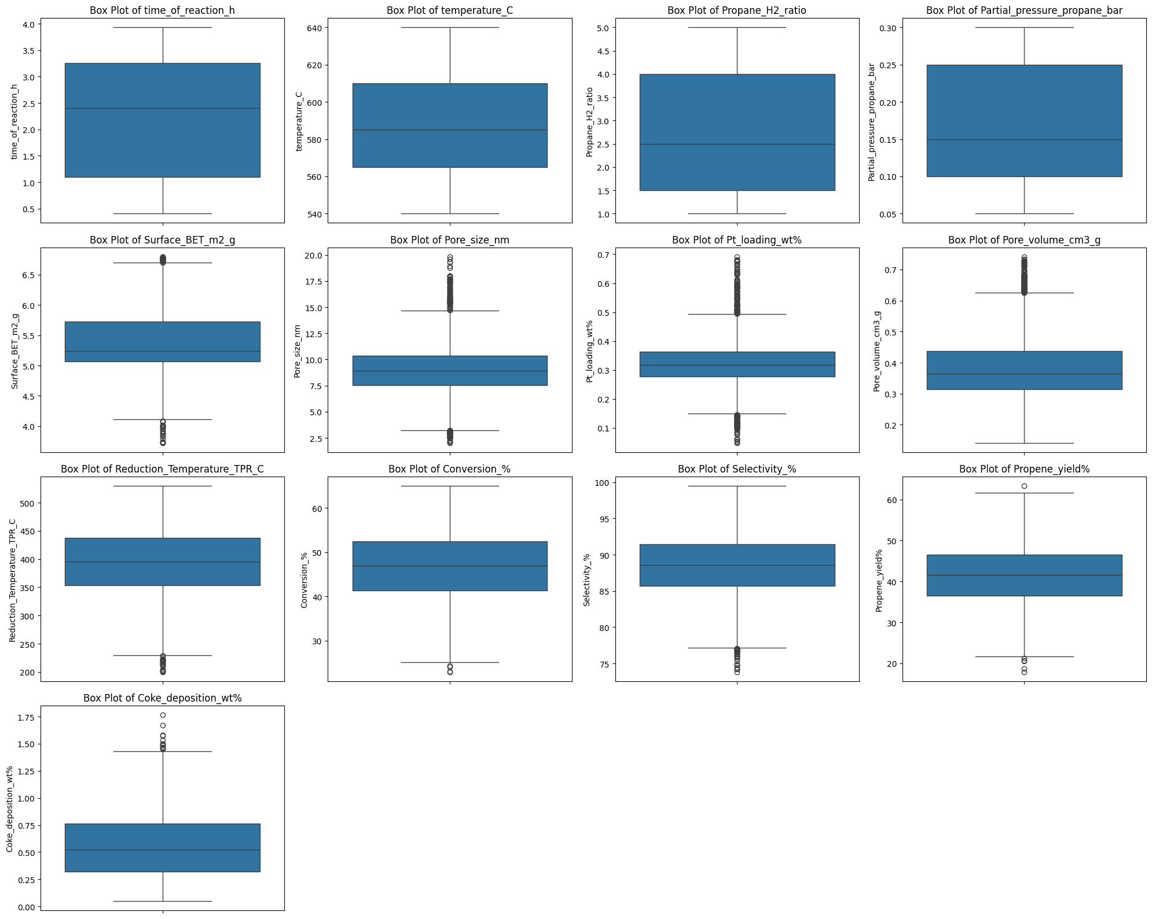
2D scatter plots:
Random Forest:
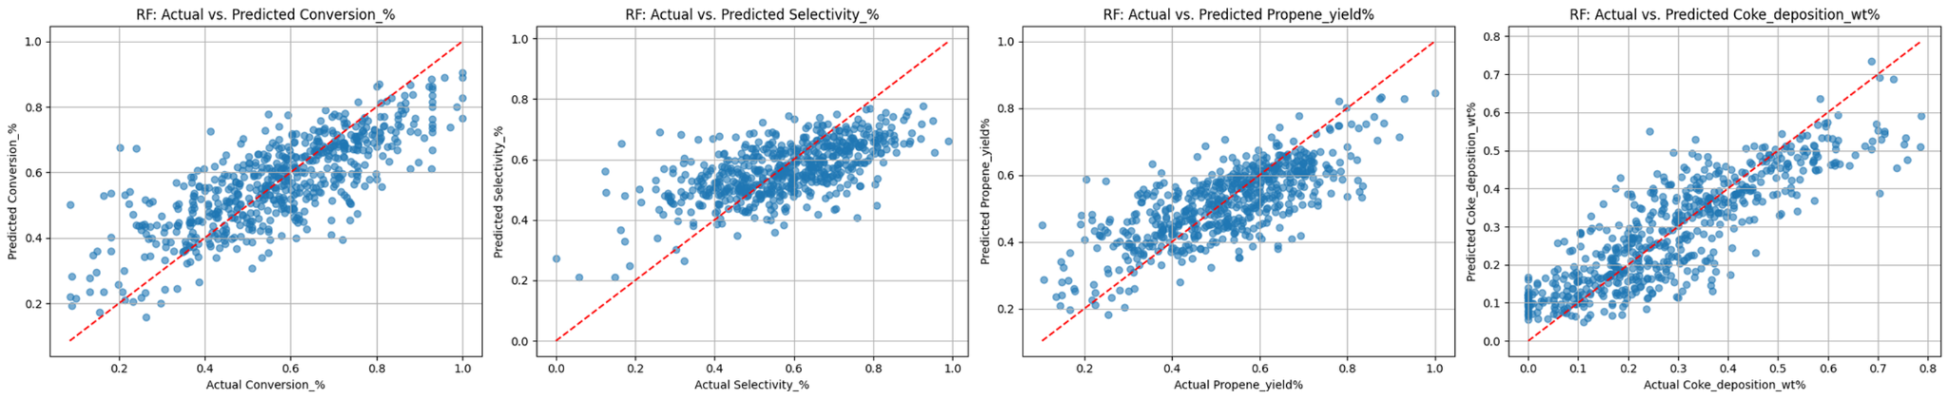

XGBoost:
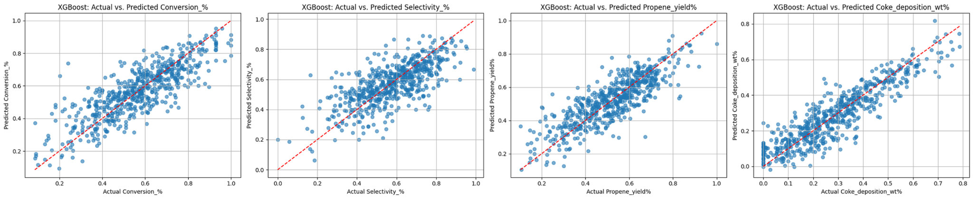
CatBoost:
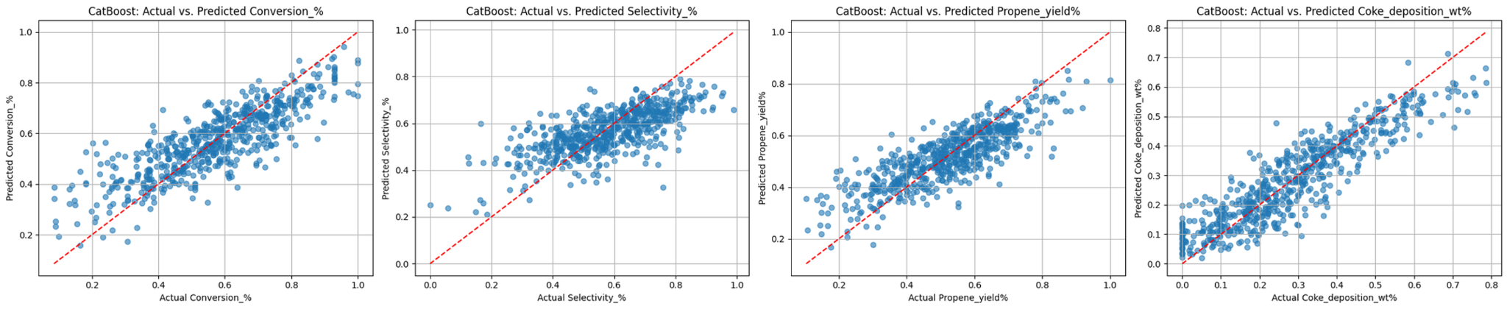
Artificial Neural Networks:
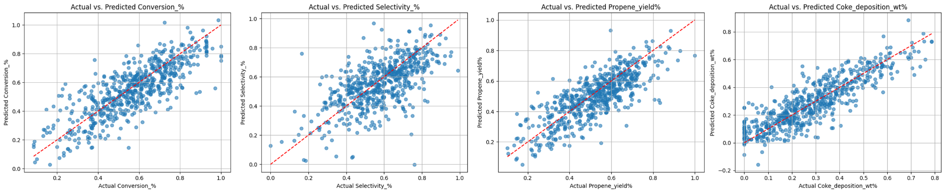
Physics-Informed Neural Network:
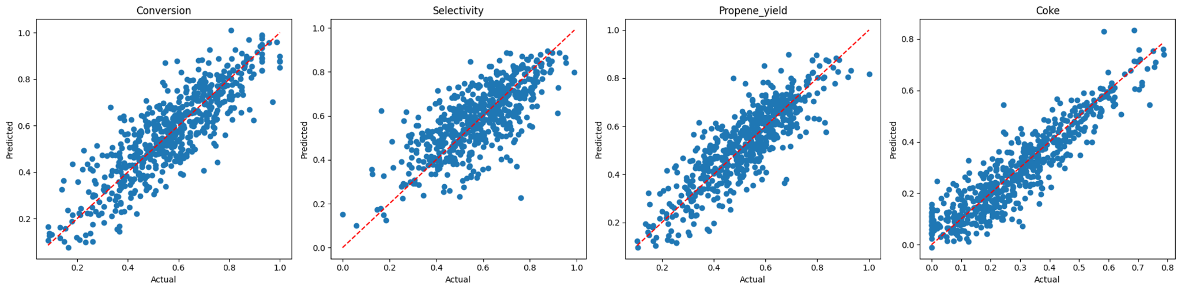
Heatmap analysis:
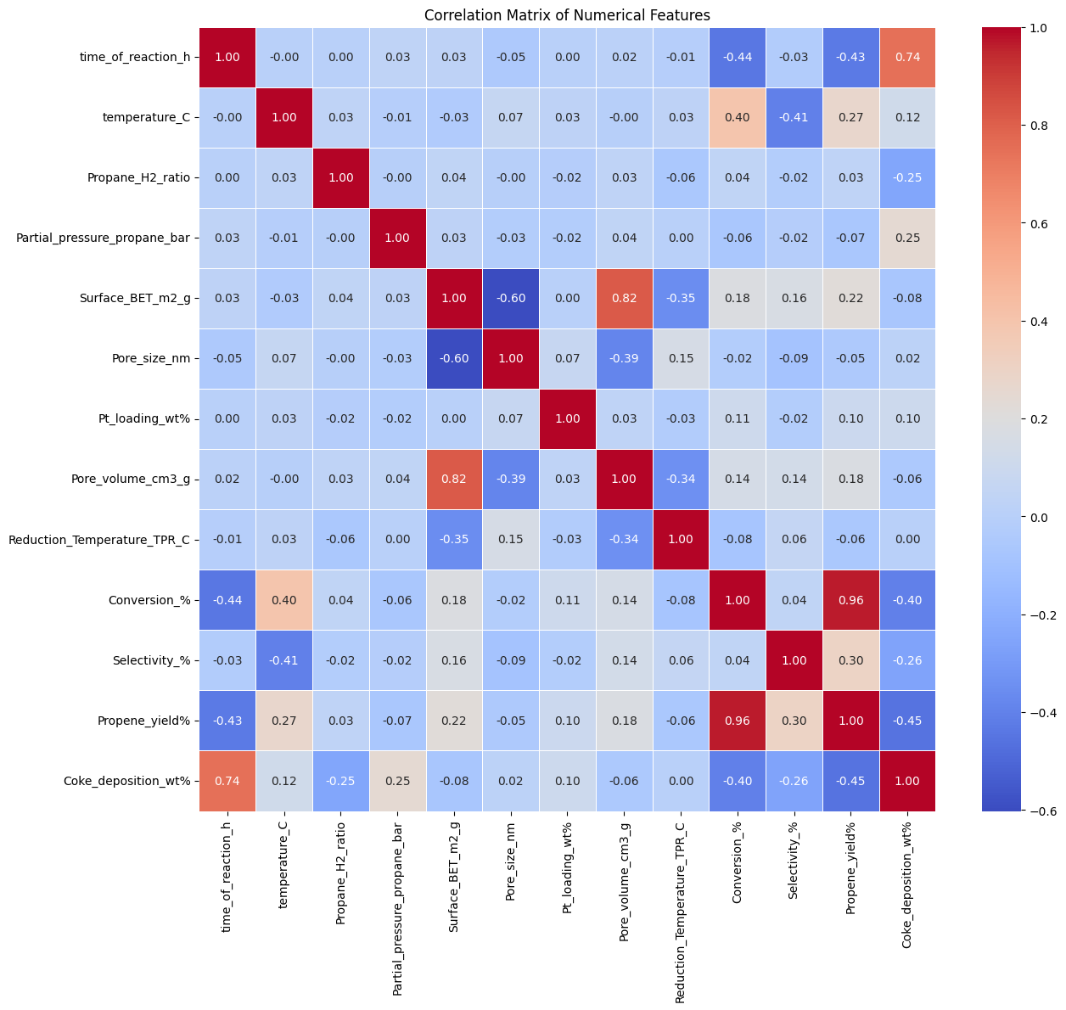
SHAP Analysis:
--- ANN SHAP Summary Plots ---
SHAP Summary Plot for ANN - Conversion_%:
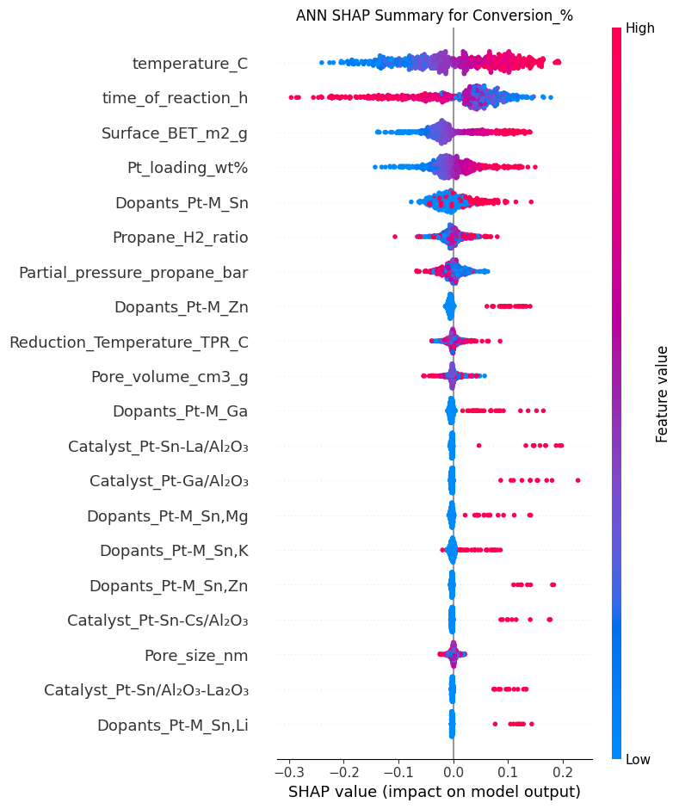
SHAP Summary Plot for ANN - Selectivity_%:
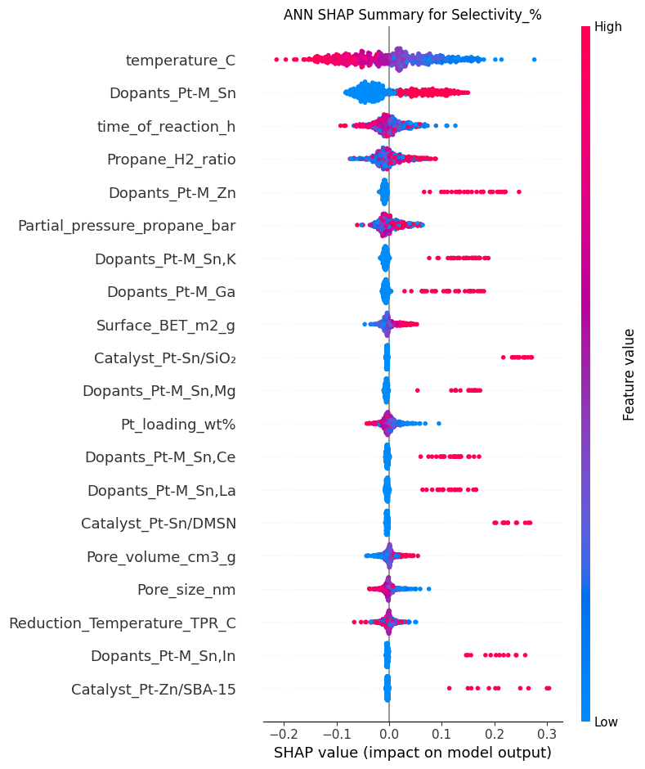
SHAP Summary Plot for ANN - Propene_yield%:
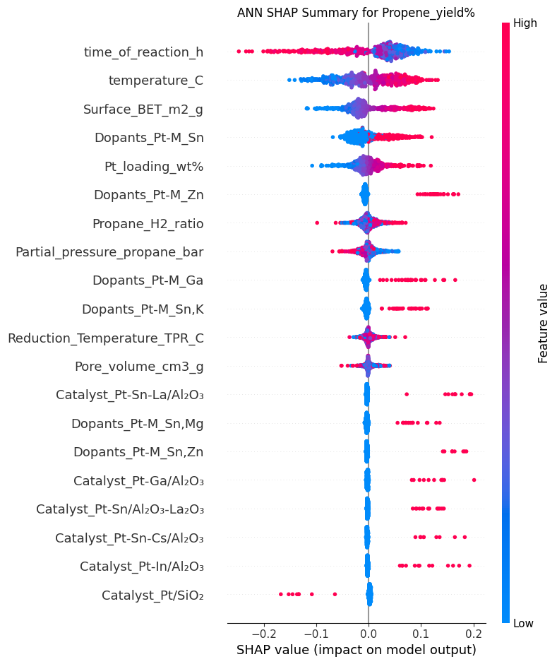
SHAP Summary Plot for ANN - Coke_deposition_wt%:
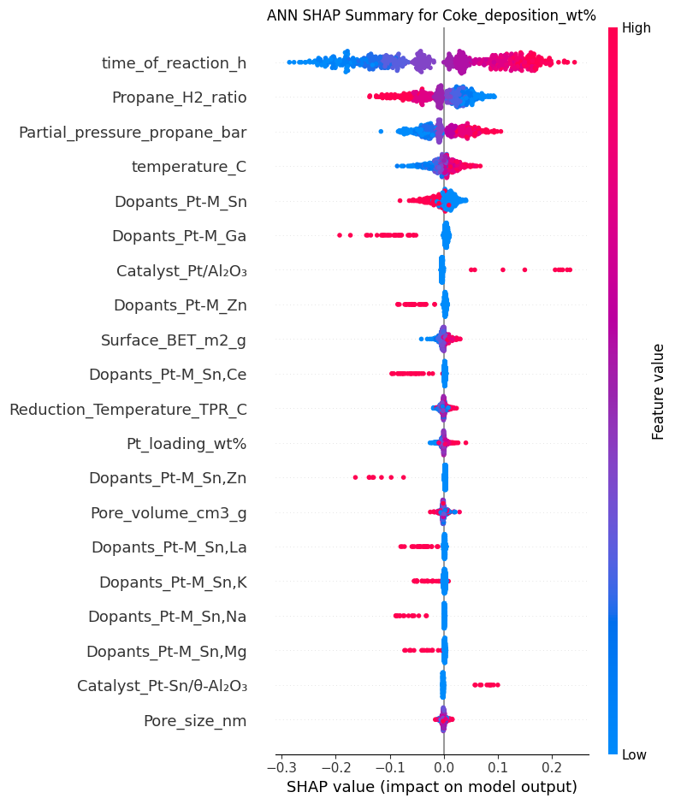
--- Random Forest SHAP Summary Plots ---
SHAP Summary Plot for Random Forest - Conversion_%:
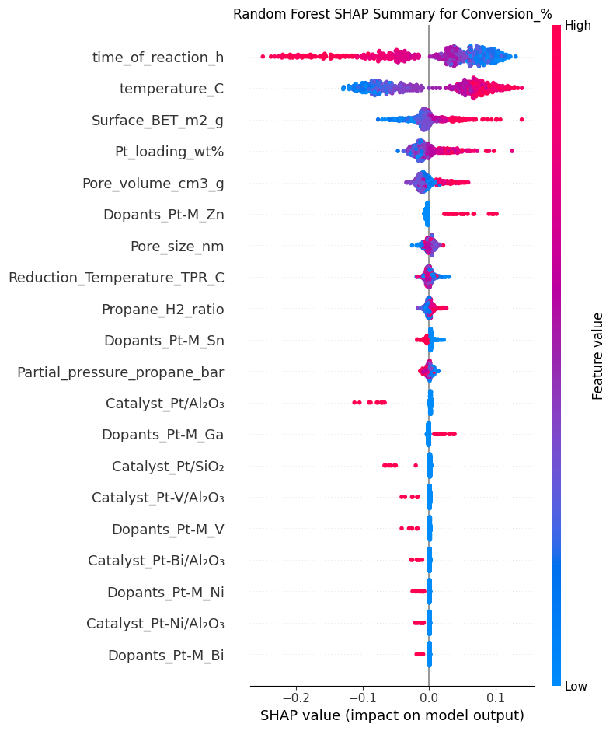
SHAP Summary Plot for Random Forest - Selectivity_%:
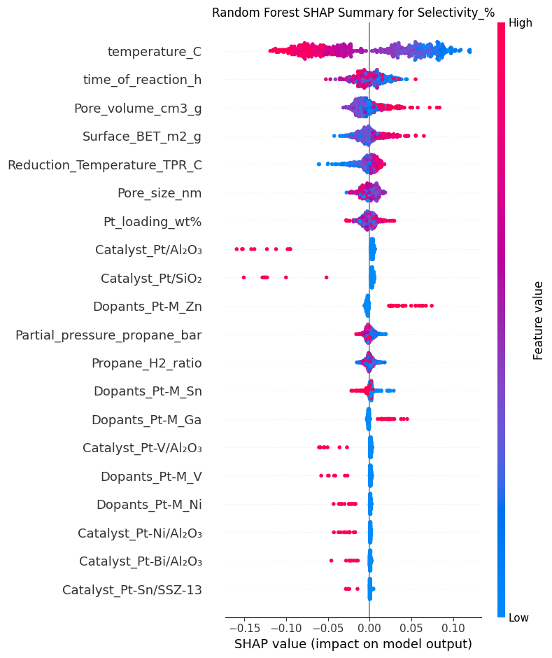
SHAP Summary Plot for Random Forest - Propene_yield%:
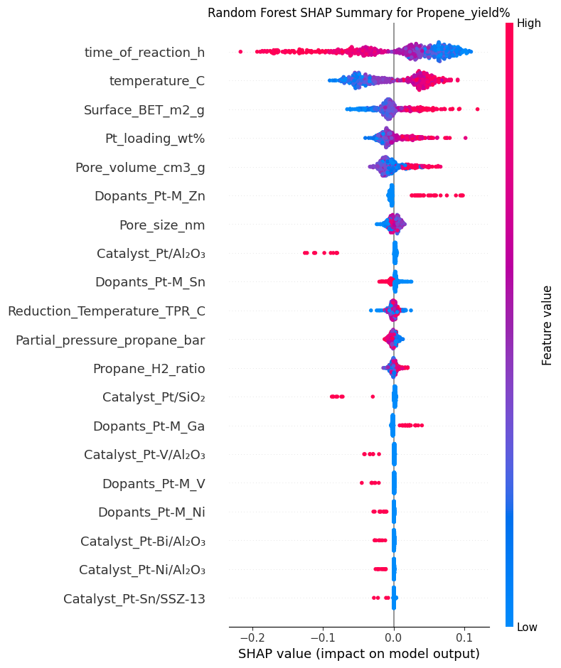
SHAP Summary Plot for Random Forest - Coke_deposition_wt%:
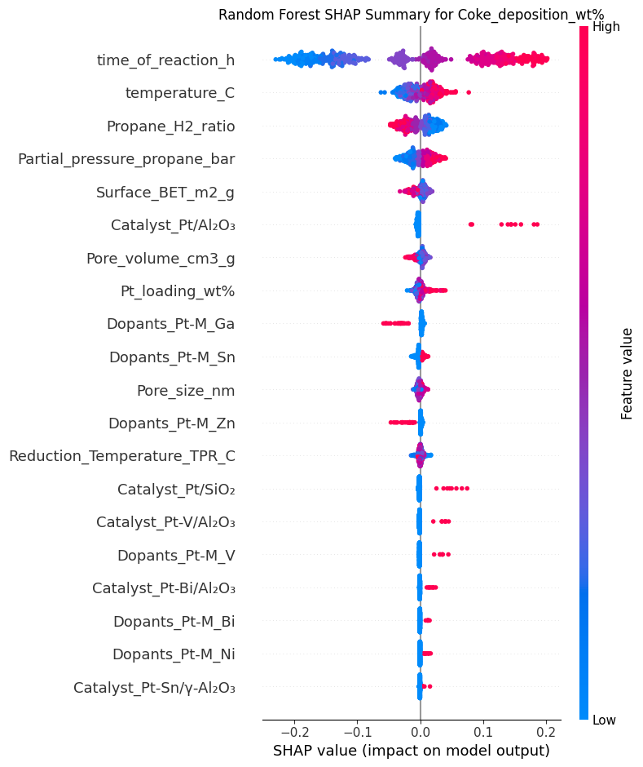
--- CatBoost SHAP Summary Plots ---
SHAP Summary Plot for CatBoost - Conversion_%:
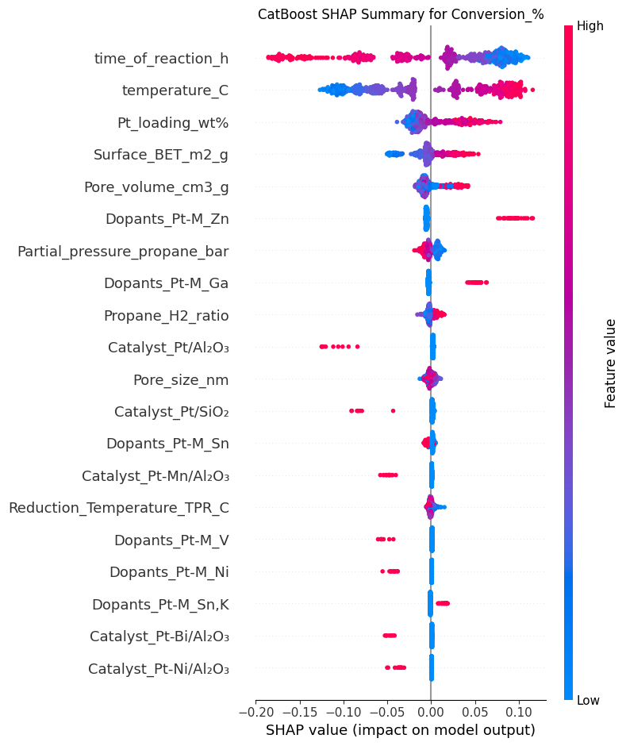
SHAP Summary Plot for CatBoost - Selectivity_%:
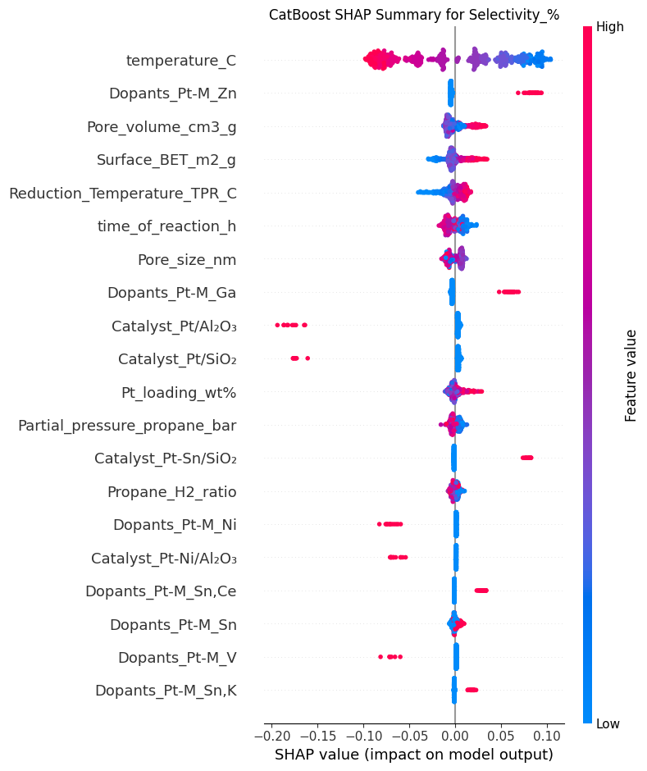
SHAP Summary Plot for CatBoost - Propene_yield%:
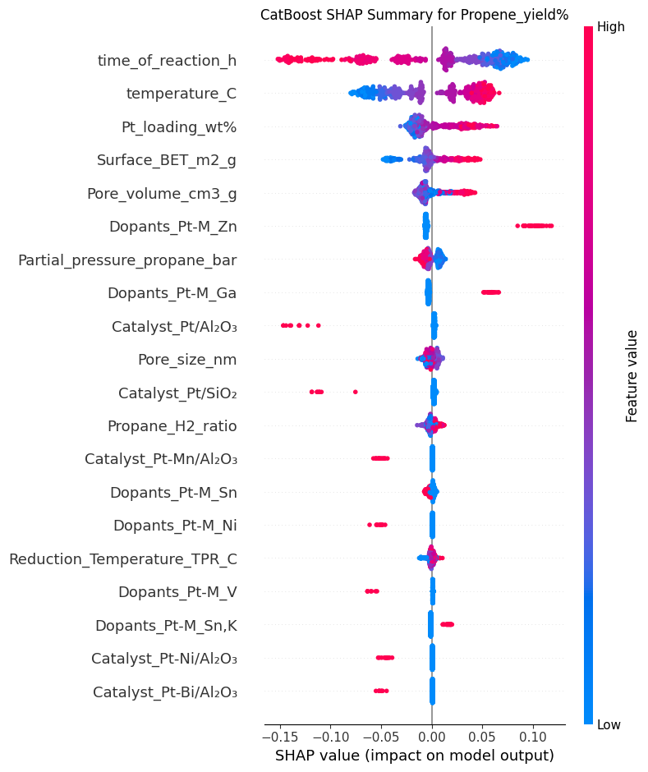
SHAP Summary Plot for CatBoost - Coke_deposition_wt%:
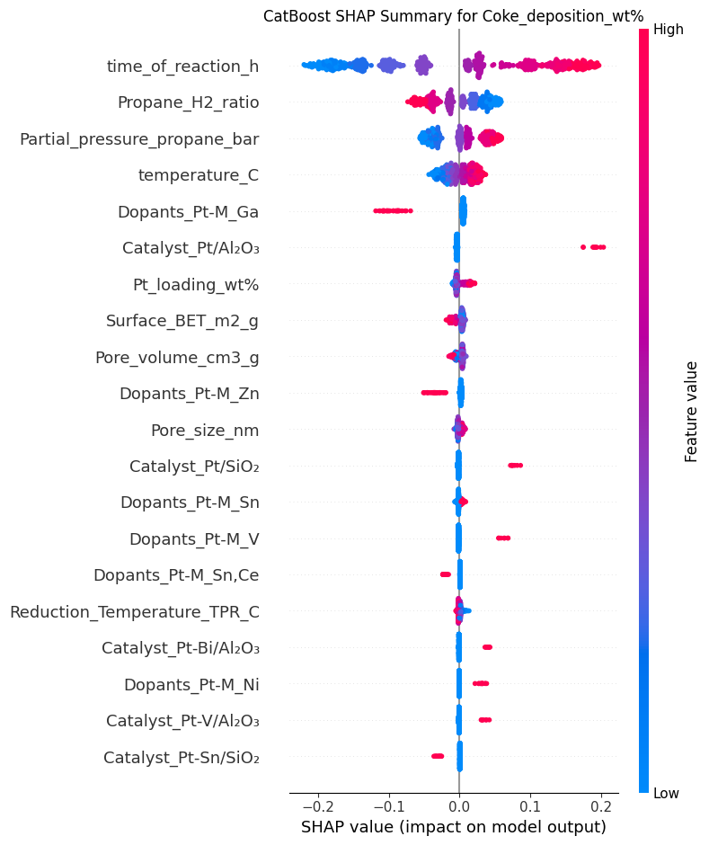
--- PI-ANN SHAP Summary Plots ---
SHAP Summary Plot for PI-ANN - Conversion_%:
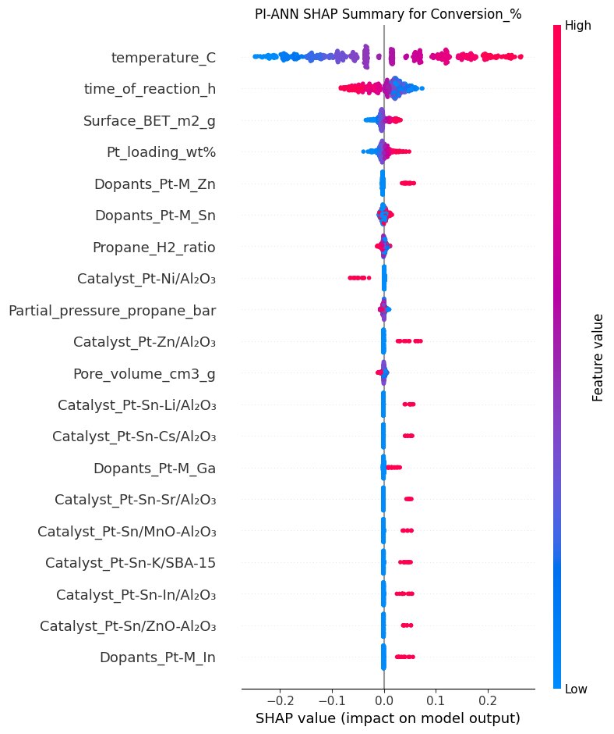
SHAP Summary Plot for PI-ANN - Selectivity_%:
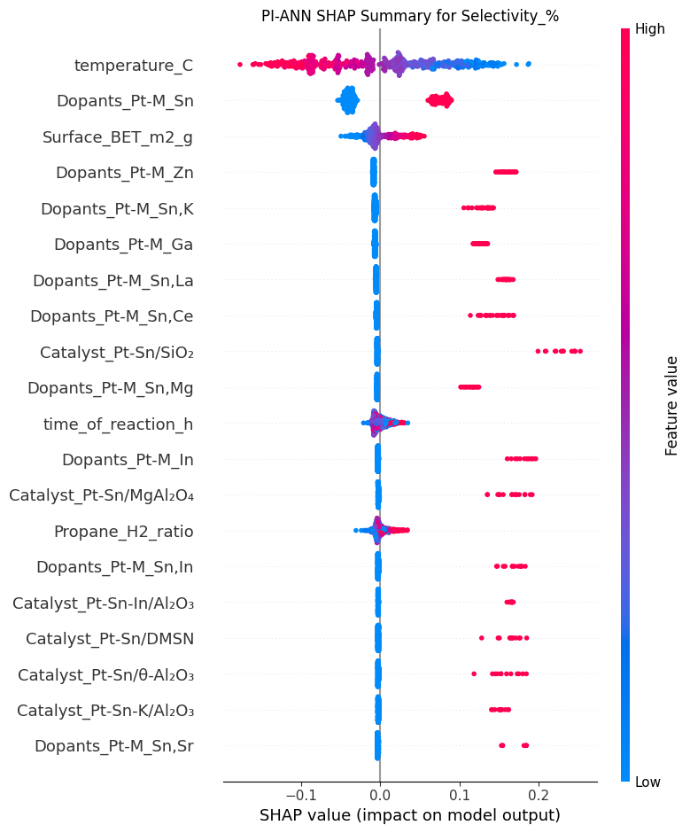
SHAP Summary Plot for PI-ANN - Propene_yield%:
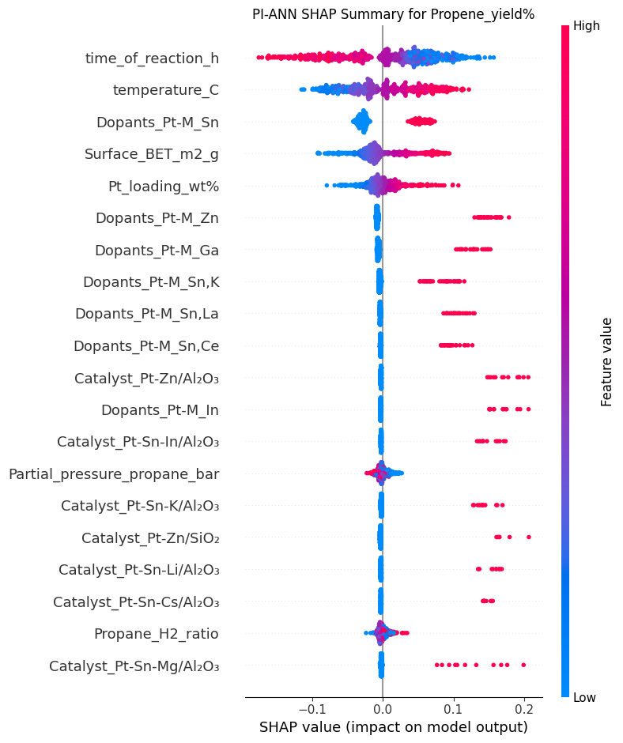
SHAP Summary Plot for PI-ANN - Coke_deposition_wt%:
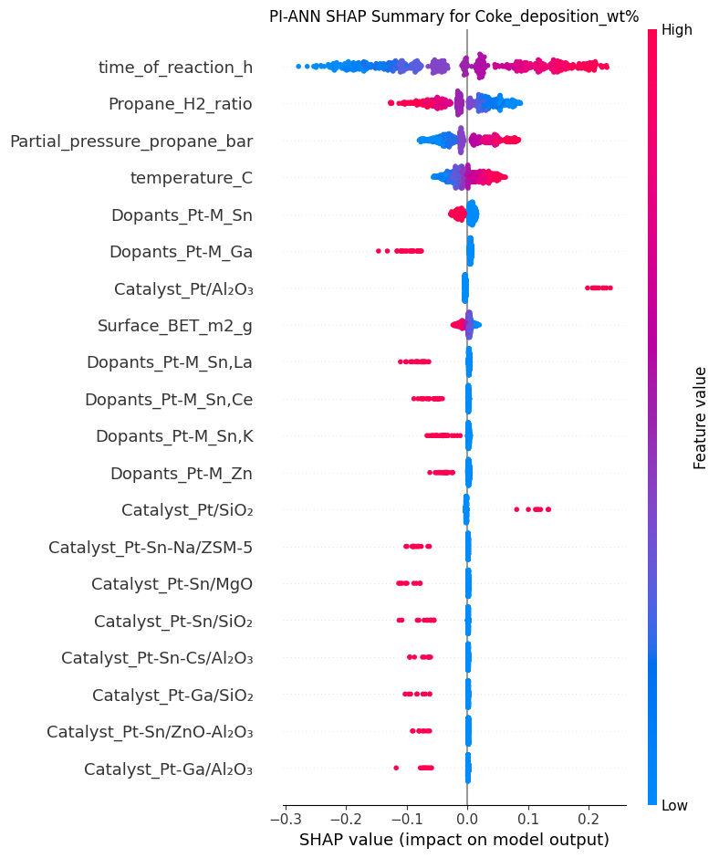
--- ANN SHAP Dependence Plots ---

Dependence Plots for ANN - Conversion_%:
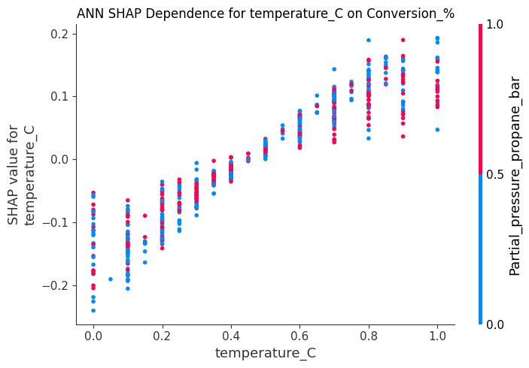
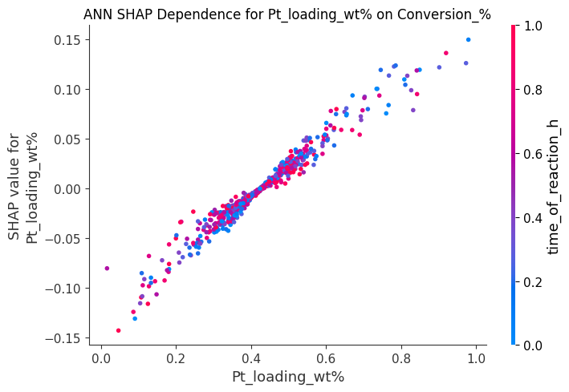
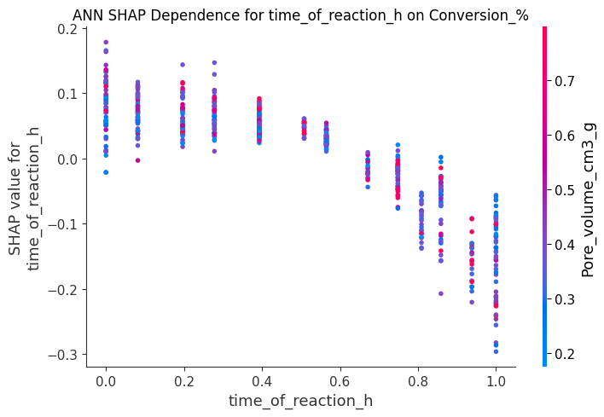

Dependence Plots for ANN - Selectivity_%:
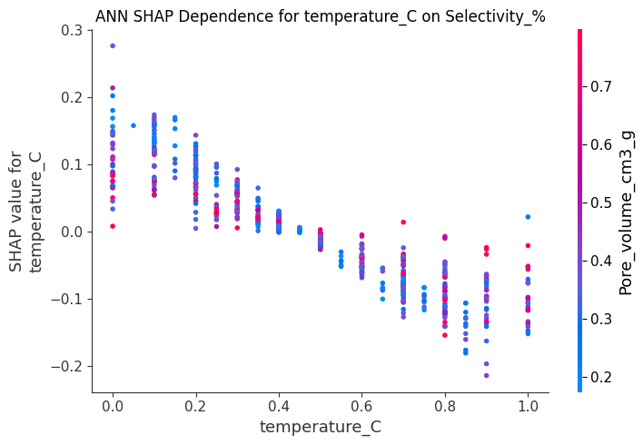
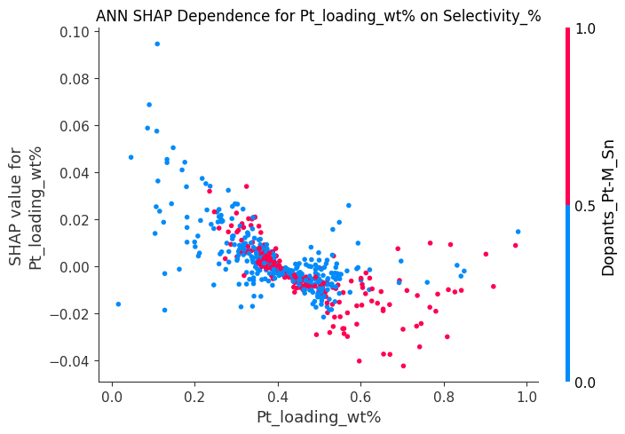
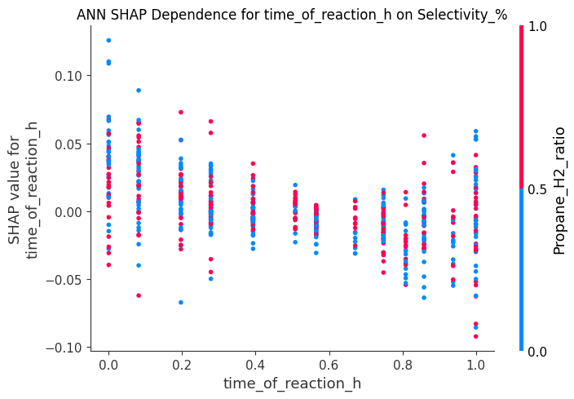
Dependence Plots for ANN - Propene_yield%:
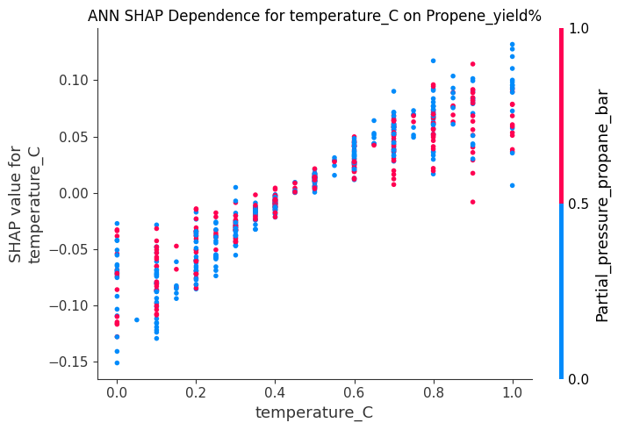
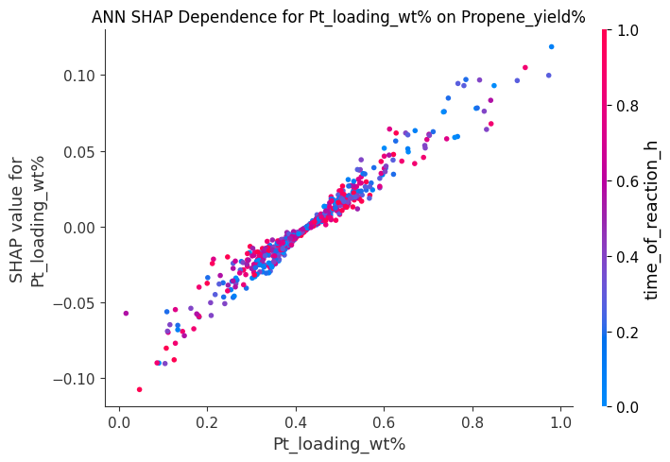
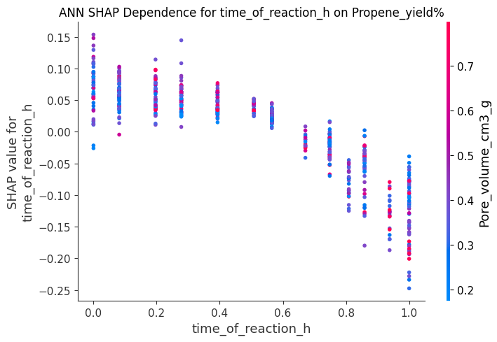
Dependence Plots for ANN - Coke_deposition_wt%:
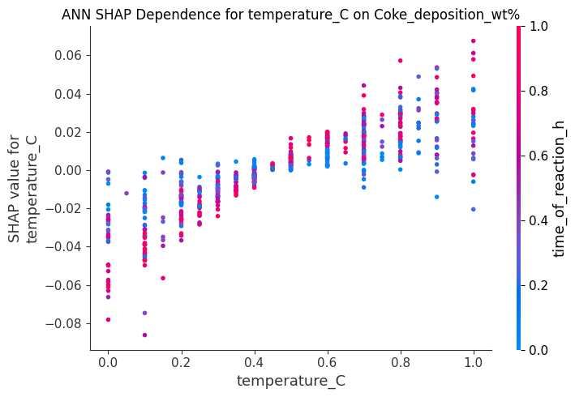
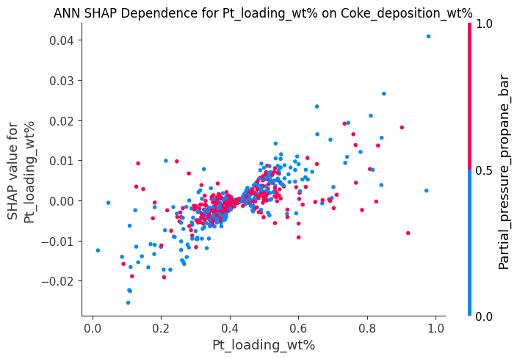
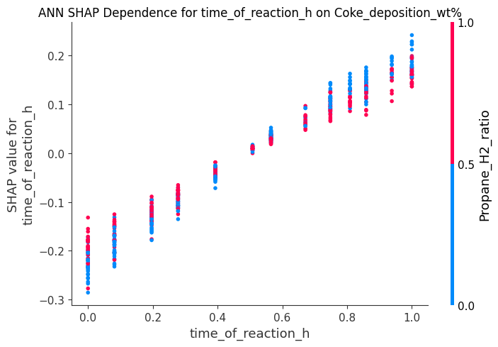
--- Random Forest SHAP Dependence Plots ---

Dependence Plots for Random Forest - Conversion_%:
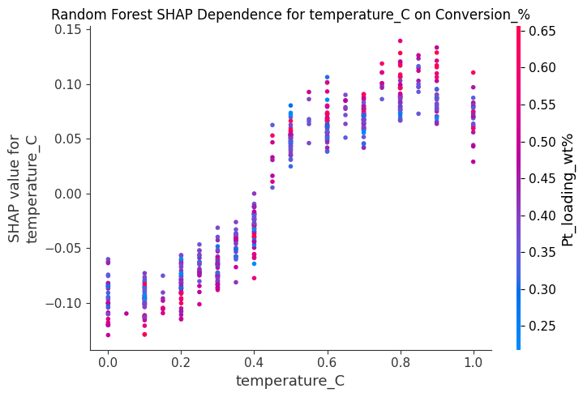
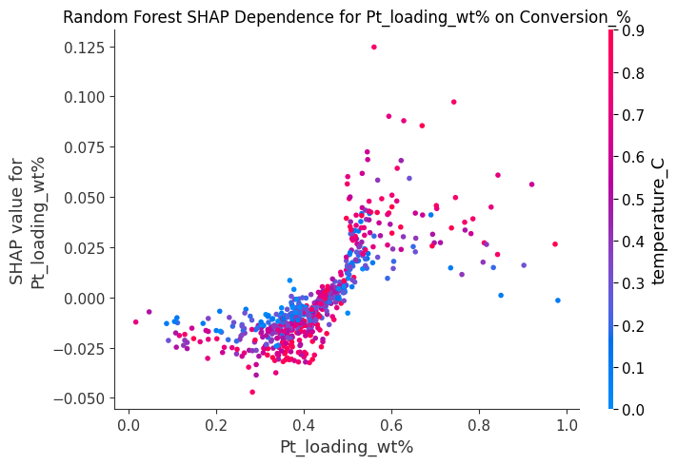
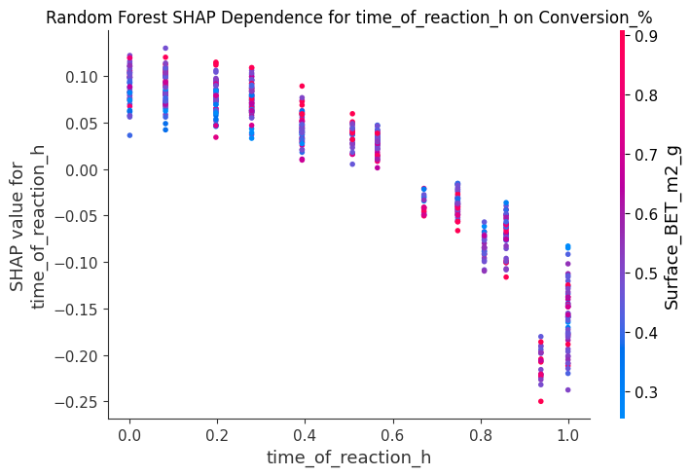
Dependence Plots for Random Forest - Selectivity_%:
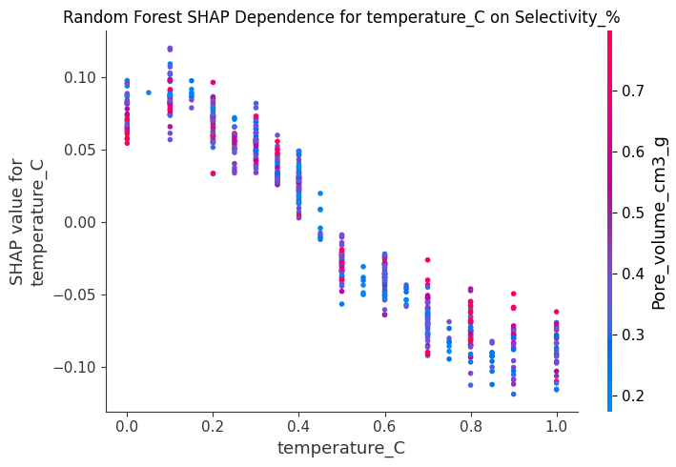
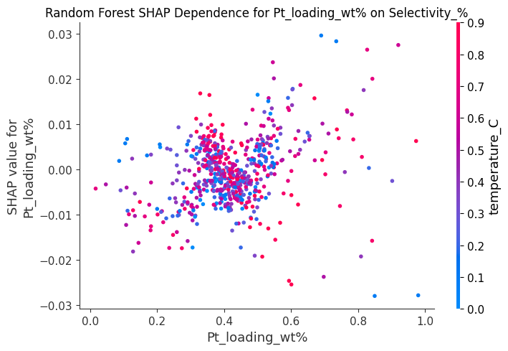
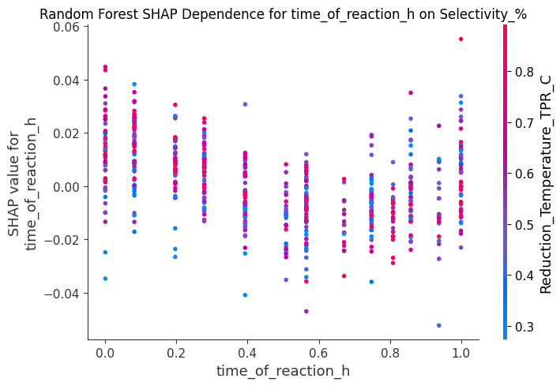
Dependence Plots for Random Forest - Propene_yield%:
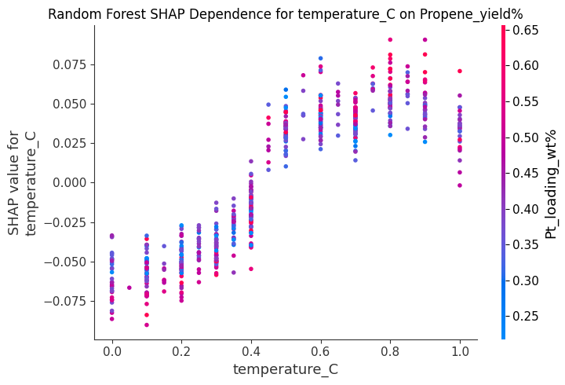
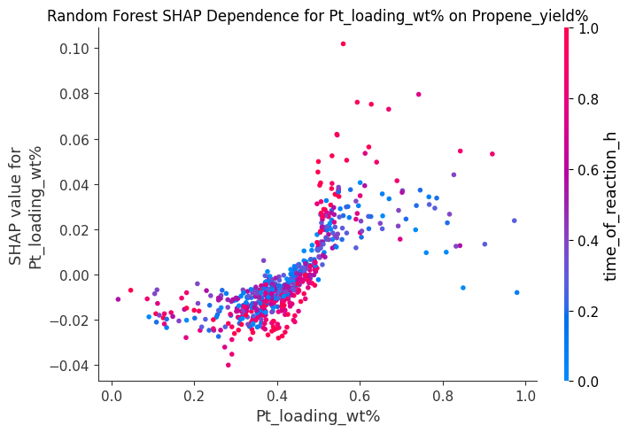
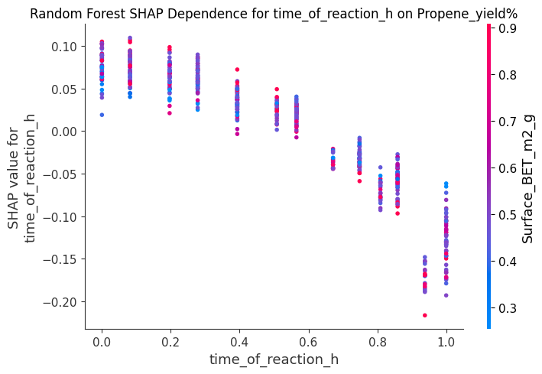
Dependence Plots for Random Forest - Coke_deposition_wt%:
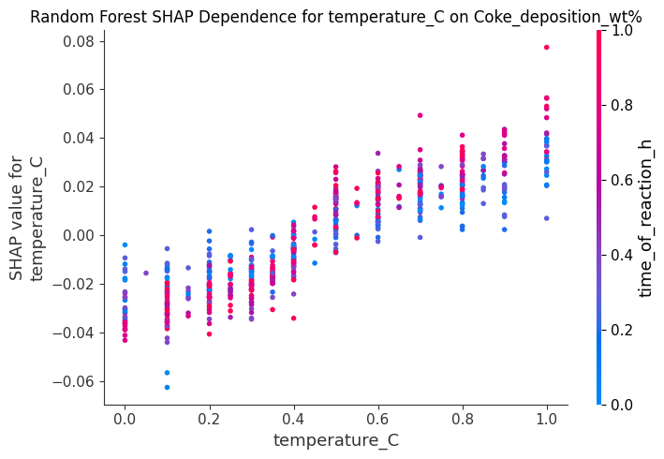
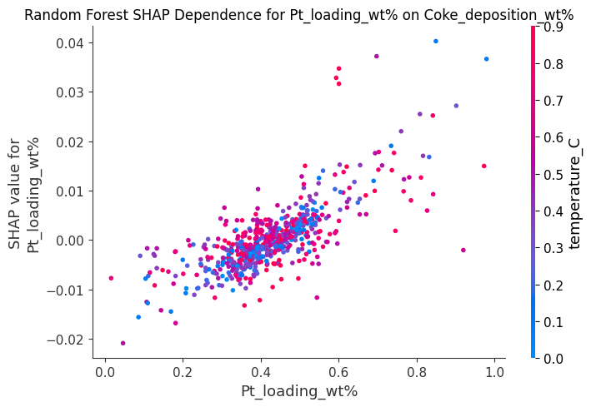
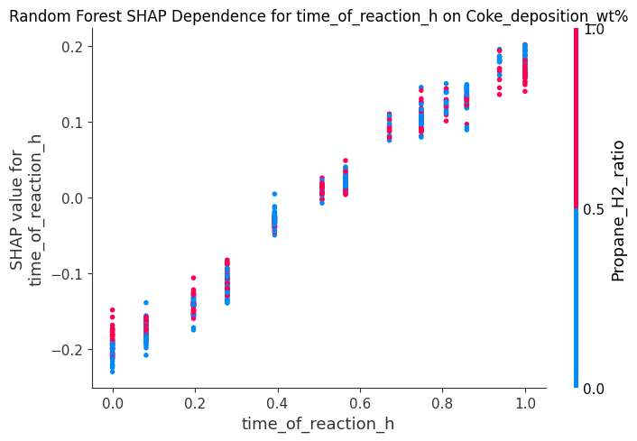
--- CatBoost SHAP Dependence Plots ---

Dependence Plots for CatBoost - Conversion_%:
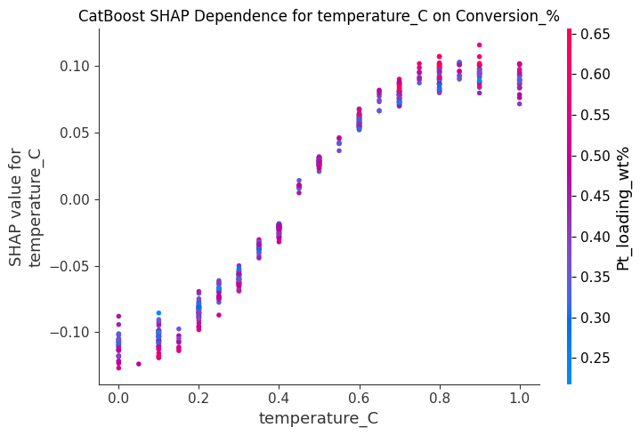
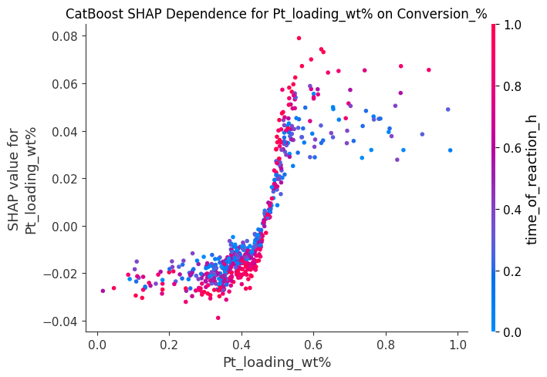
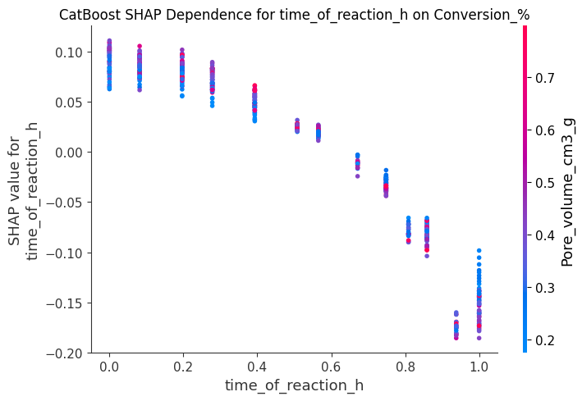
Dependence Plots for CatBoost - Selectivity_%:
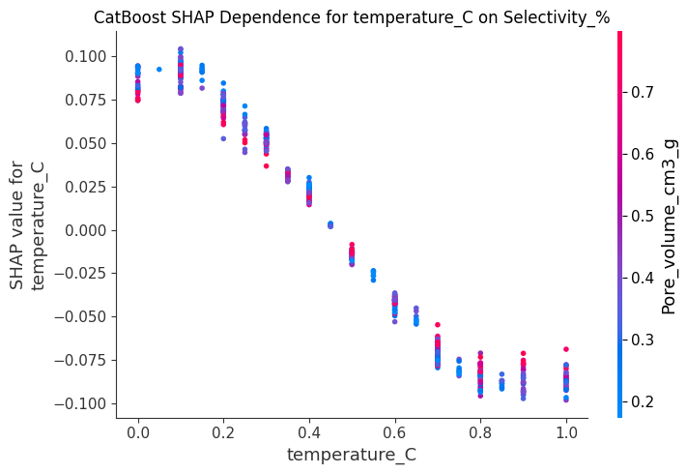
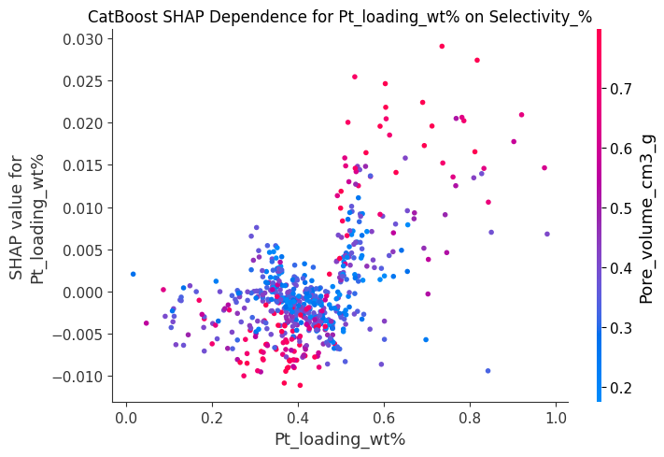
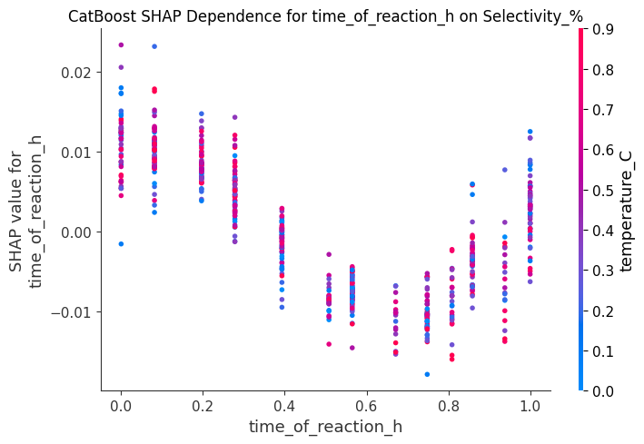
Dependence Plots for CatBoost - Propene_yield%:
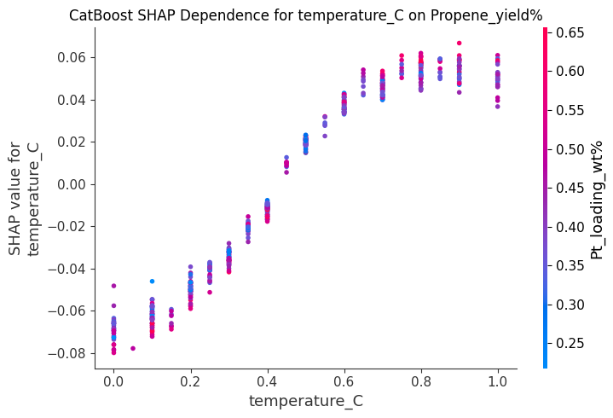
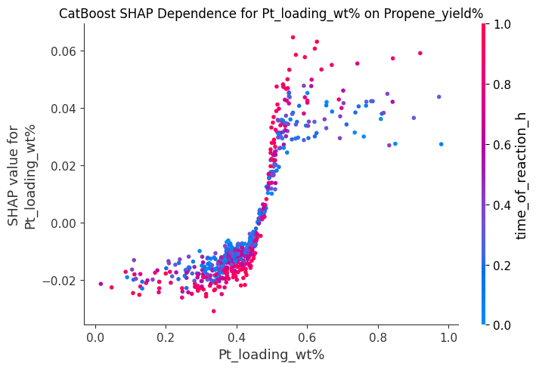
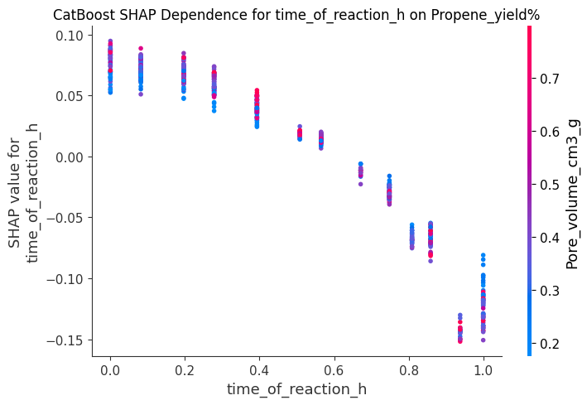
Dependence Plots for CatBoost - Coke_deposition_wt%:
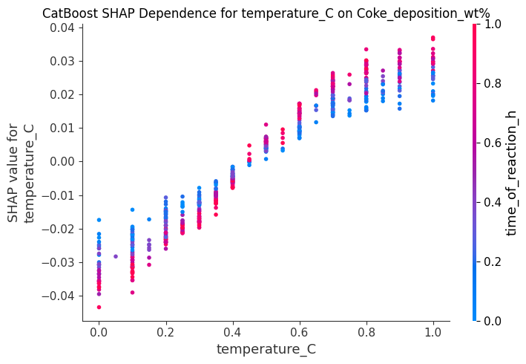
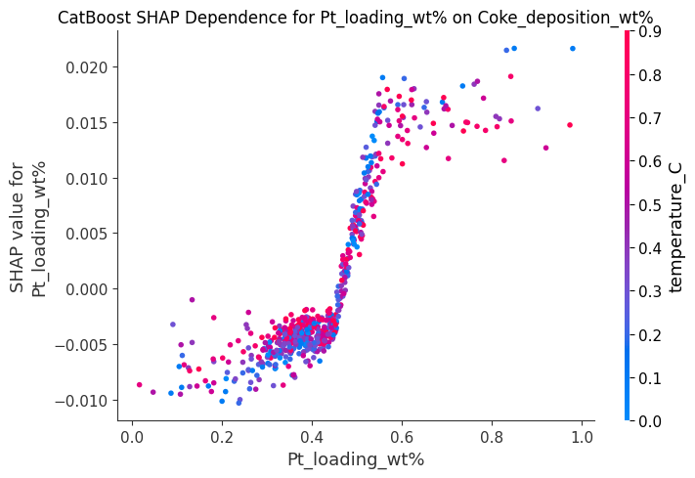
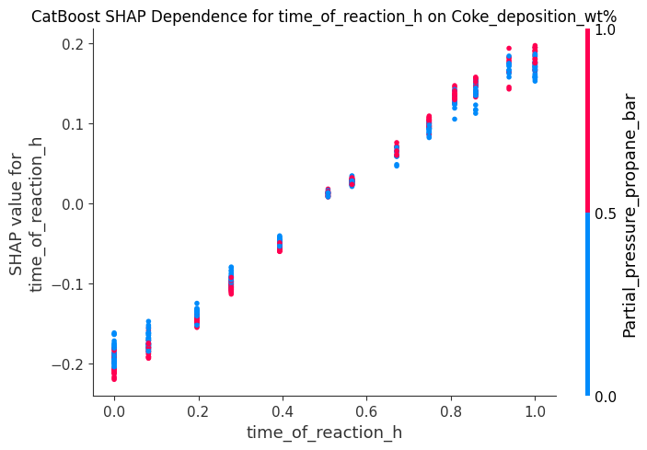
--- XGBoost SHAP Dependence Plots ---

Dependence Plots for XGBoost - Conversion_%:
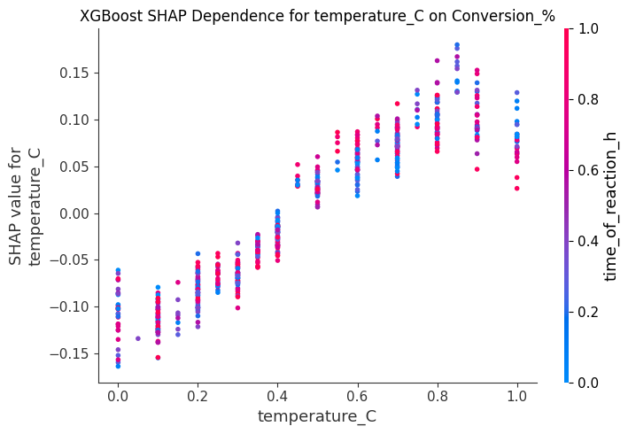
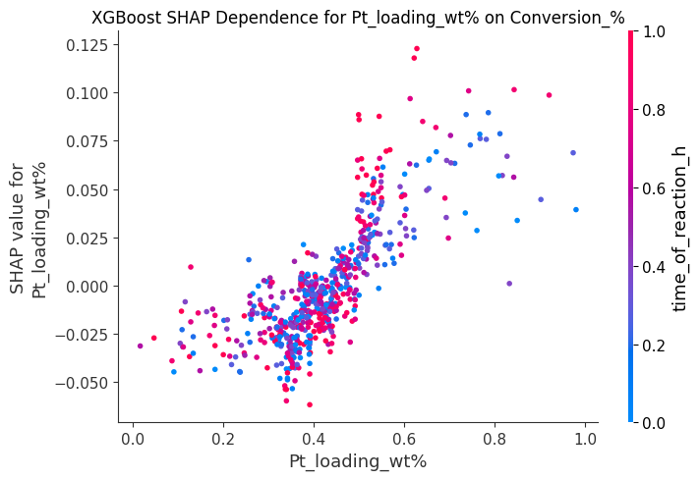
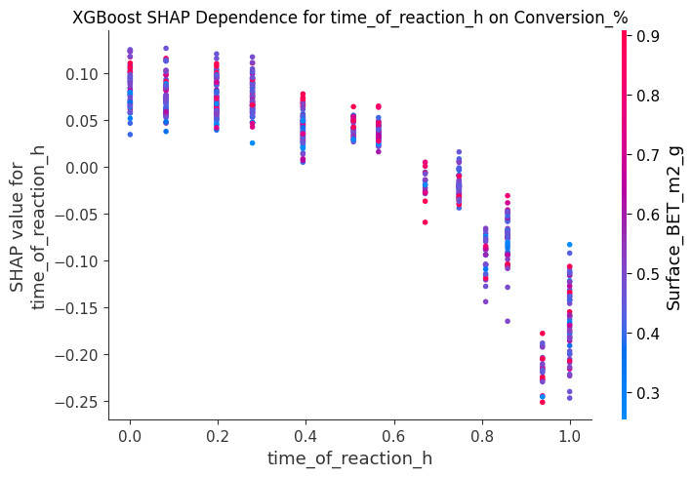
Dependence Plots for XGBoost - Selectivity_%:
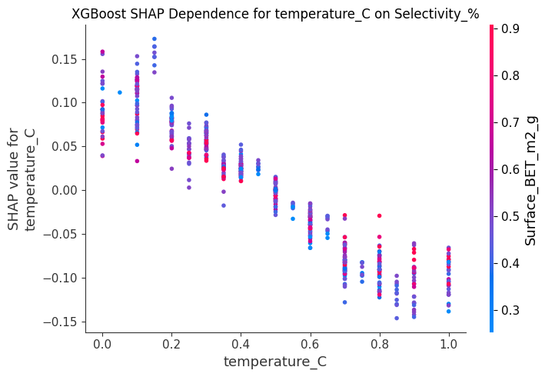
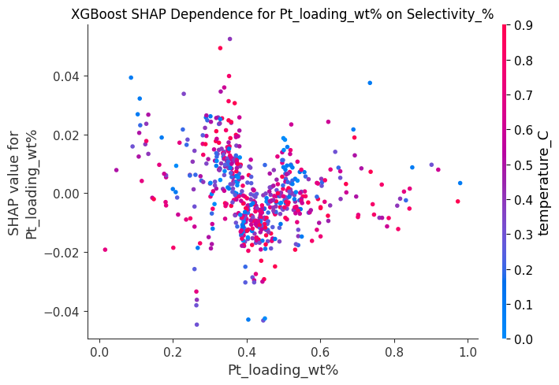
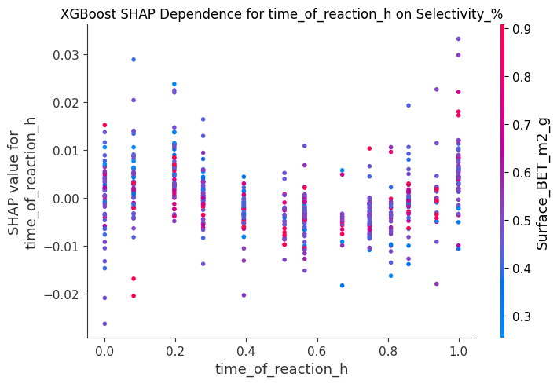
Dependence Plots for XGBoost - Propene_yield%:
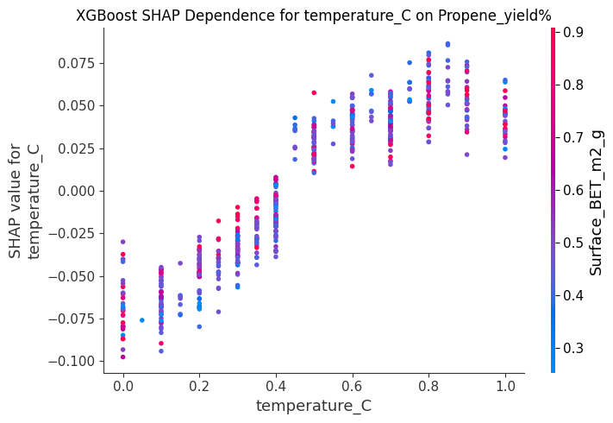
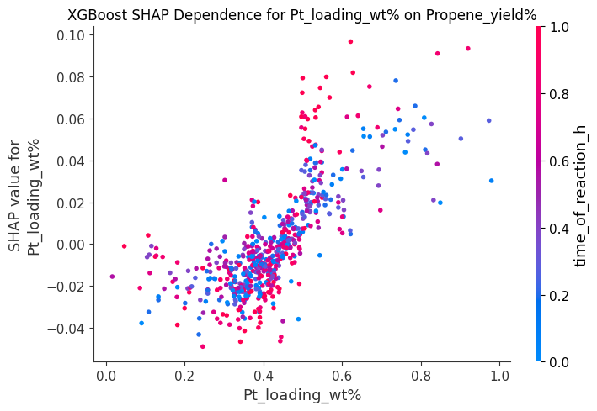
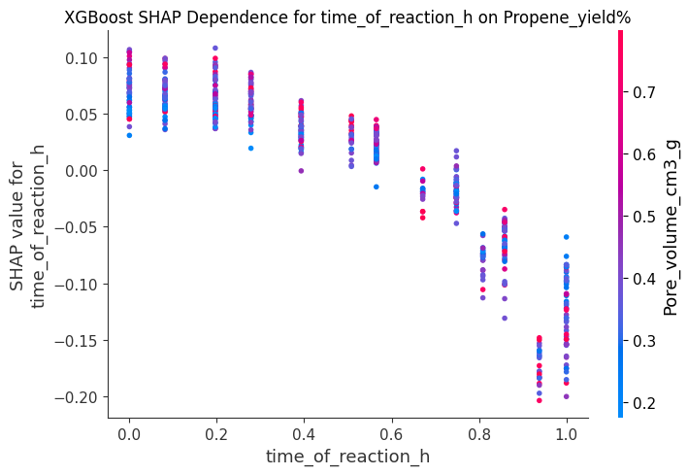
Dependence Plots for XGBoost - Coke_deposition_wt%:
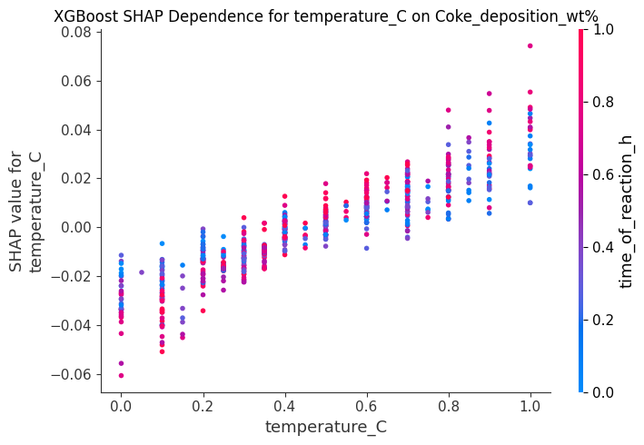
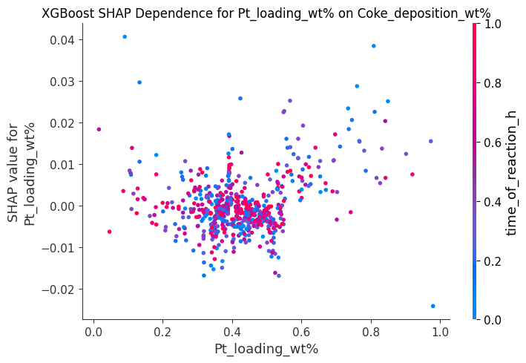
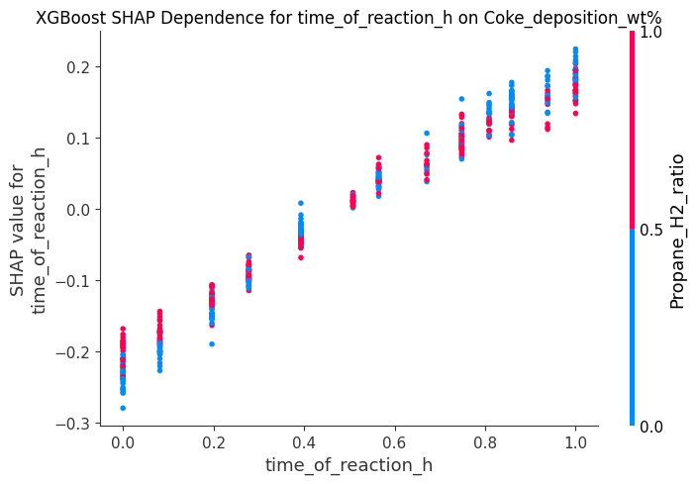
--- PI-ANN SHAP Dependence Plots ---

Dependence Plots for PI-ANN - Conversion_%:
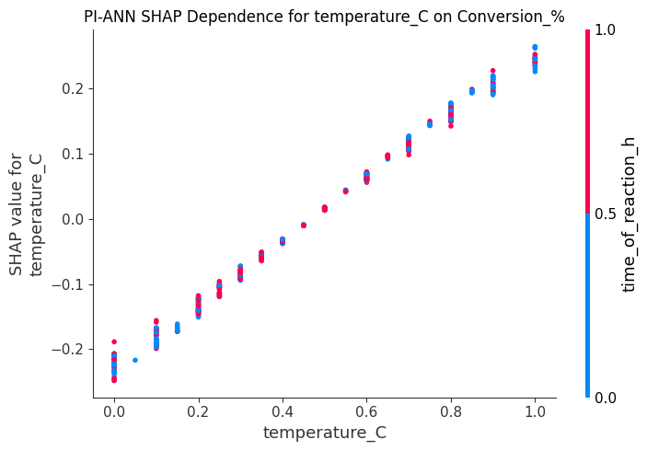
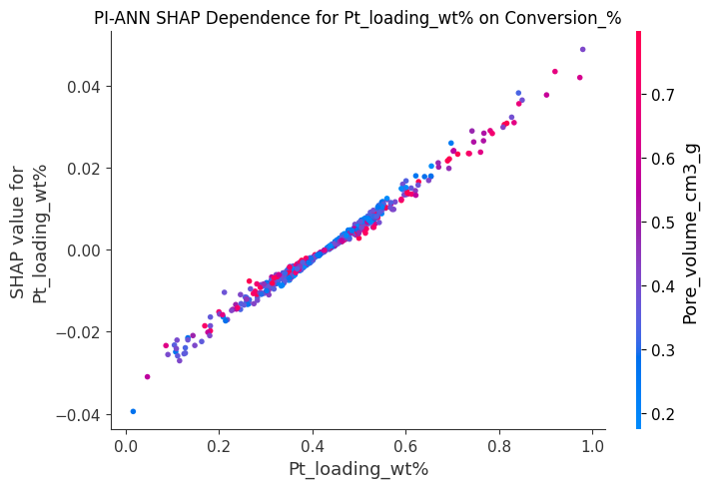
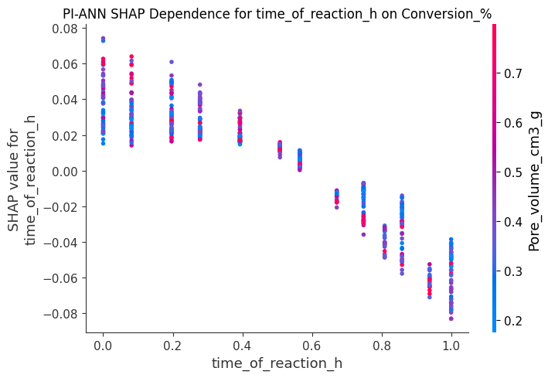
Dependence Plots for PI-ANN - Selectivity_%:
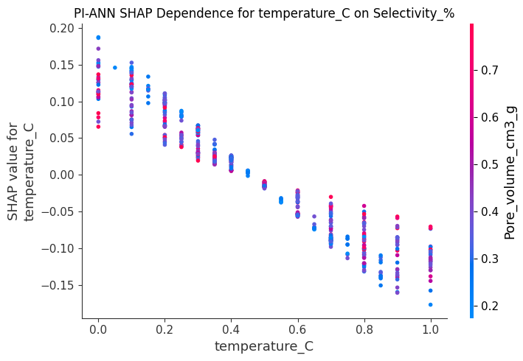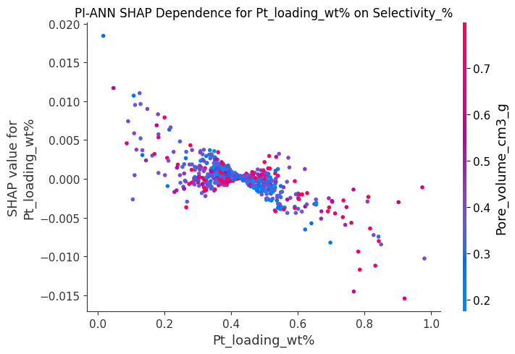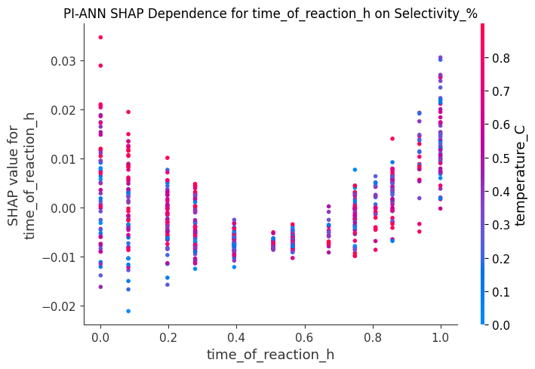
Dependence Plots for PI-ANN - Propene_yield%:
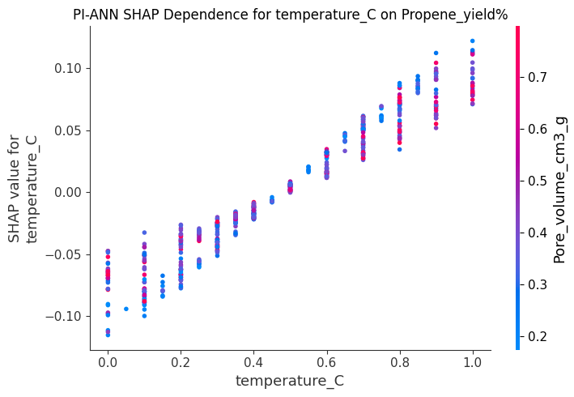
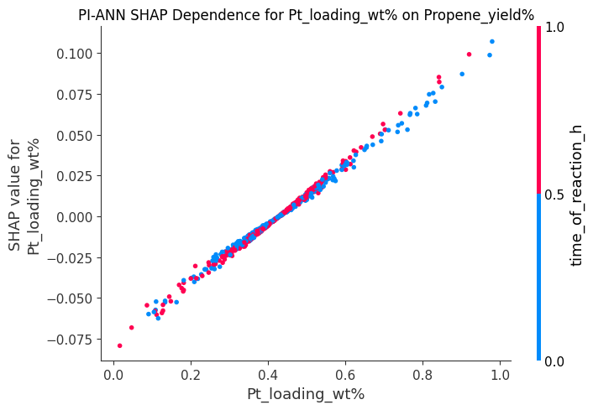
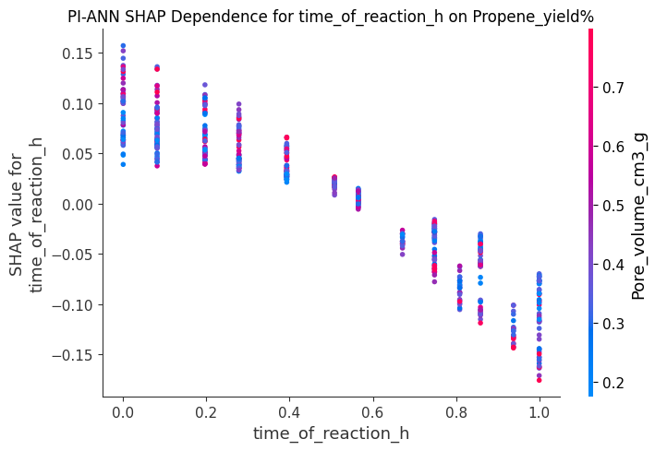
Dependence Plots for PI-ANN - Coke_deposition_wt%:
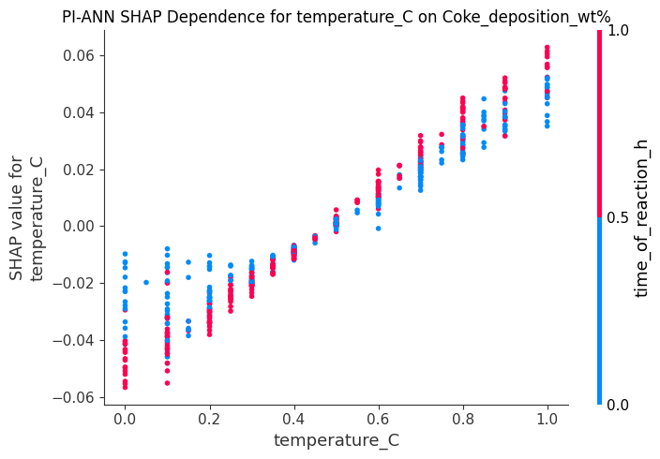
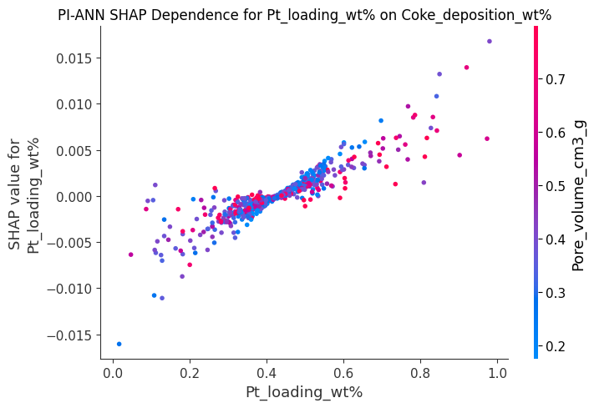
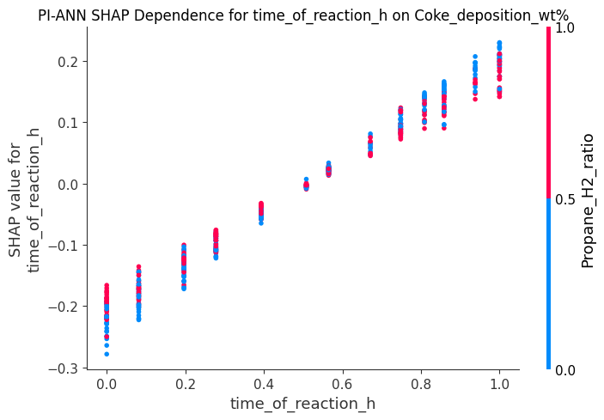

- Model Performance Summary and Comparison --

--
Application | Model | R2 | MAE | RMSE | MSE
Selectivity | ANN | 0.38 | 0.1125 | 0.141 | 0.0200
Selectivity | RF | 0.40 | 0.1013 | 0.127 | 0.0160
Selectivity | XGBOOST | 0.49 | 0.0926 | 0.116 | 0.0135
Selectivity | CATBOOST | 0.53 | 0.0926 | 0.116 | 0.0134
Selectivity | PINN | 0.58 | 0.0910 | 0.114 | 0.0130
Conversion | ANN | 0.59 | 0.0942 | 0.118 | 0.0140
Conversion | RF | 0.61 | 0.0918 | 0.115 | 0.0130
Conversion | XGBOOST | 0.68 | 0.0830 | 0.104 | 0.0110
Conversion | CATBOOST | 0.68 | 0.0838 | 0.105 | 0.0110
Conversion | PINN | 0.73 | 0.0798 | 0.100 | 0.0100
Yield | ANN | 0.57 | 0.0822 | 0.103 | 0.0106
Yield | RF | 0.56 | 0.0830 | 0.104 | 0.0108
Yield | XGBOOST | 0.67 | 0.0710 | 0.089 | 0.0080
Yield | CATBOOST | 0.66 | 0.0726 | 0.091 | 0.0082
Yield | PINN | 0.71 | 0.0702 | 0.088 | 0.0078
Coke deposition | ANN | 0.75 | 0.0726 | 0.091 | 0.0083
Coke deposition | RF | 0.73 | 0.0734 | 0.092 | 0.0085
Coke deposition | XGBOOST | 0.82 | 0.0607 | 0.076 | 0.0057
Coke deposition | CATBOOST | 0.82 | 0.0598 | 0.075 | 0.0057
Coke deposition | PINN | 0.84 | 0.0567 | 0.071 | 0.0050

