VISVESVARAYA TECHNOLOGICAL UNIVERSITY
“Jnana Sangama”, Belagavi, Karnataka


SpecTest-LLM: A Multi-Agent LangGraph System for Explainable and Iterative Test Case Generation

PROJECT SYNOPSIS REPORT

Submitted by

ABHISHEK KUMAR CHAUDHARY 1RF23IS003
ADITYA KUMAR 1RF23IS008
AMRUTA BHARGAV K 1RF23IS012
M PRANAV 1RF23IS051

Under the Guidance of
Prof Samatha R Swamy,
Assistant Professor,
Department of Information Science Engineering,
RV Institute of Technology and Management®

in partial fulfillment for the award of degree
of

Bachelor of Engineering
IN
Information Science & Engineering



RV INSTITUTE OF TECHNOLOGY AND MANAGEMENT®
(Affiliated to Visvesvaraya Technological University, Belagavi & Approved by AICTE, New Delhi)
Chaitanya Layout, JP Nagar 8th Phase, Kothanur, Bengaluru-560076

2025-26

PROJECT SYNOPSIS-Contents

CHAPTER 1 – Introduction 1
1.1 Background
1.2 Scope and Assumptions
1.3 Methodology Overview
1.4 Typical Use Cases
1.5 Stakeholders and Users
1.6 Constraints and Risks
CHAPTER 2 – Literature Survey 4
2.1 Rule-based and Template-driven Test Generation
2.2 Constraint-based and Symbolic Techniques
2.3 Random Testing and Fuzzing
2.4 LLM-based Test Generation
2.5 Multi-agent Orchestration
2.6 Schema-guided Parsing and Validation
2.7 Evaluation Metrics in Test Generation
2.8 Practical Considerations for Education
2.9 Summary of Survey Findings
CHAPTER 3 – Problem Statement 7
3.1 Design Constraints
3.2 Research Questions
CHAPTER 4 – Objectives 8
4.1 Non-functional Objectives
CHAPTER 5 – Design and Architecture 9
5.1 System Context Diagram
5.2 LangGraph Pipeline Flow
5.3 Request Sequence
5.4 Data Model Overview
5.13 Prompt-Output Contract Example
5.14 Test Category Coverage Matrix
5.15 State Transition Detail
CHAPTER 6 – Functional Requirements 13
6.1 Functional Requirements by Subsystem
6.2 Non-functional Requirements
CHAPTER 7 – Expected Outcome / Applications 15
7.1 Expected System Behaviour
7.2 Potential Applications
7.3 Limitations of Current Implementation
7.4 Suggested Evaluation Criteria
7.5 Sample Output Snapshot
CHAPTER 8 – References 17
8.1 Glossary
References (IEEE format) 18
Resources Used 19
Sl No | Title | Page No
1 | Title | 3
2 | Introduction | 3
3 | Literature Survey | 3
4 | Problem Statement | 4
5 | Objectives | 4
6 | Design /Architecture | 4
7 | Functional Requirements | 8
8 | Expected Outcome | 8
9 | Reference | 9

CHAPTER 1- INTRODUCTION
LLM roles, and a small schema layer validates all outputs. The design is meant for teaching and evaluation settings where instructors need fast, diverse, and explainable test cases that target boundary conditions, random inputs, stress cases, invalid inputs, and bug-focused scenarios.SpecTest-LLM is a lightweight, interactive system that generates explainable test cases for programming problems. The system accepts a problem statement, optional source code, and user constraints. It then orchestrates a multi-agent LLM pipeline to produce categorized test cases, grouped per student, with structured JSON output and a readable HTML view.
The implementation in this repository is intentionally minimal and focuses on clarity: a Gradio UI collects input, a LangGraph pipeline coordinates multiple
1.1 Background and Context
Test case generation is a recurring pain point in programming courses and evaluation platforms. Human-authored tests are time-consuming, and a small set of examples can miss edge cases or allow brittle solutions to pass. SpecTest-LLM responds to this need by combining natural language requirements with optional code inspection and a structured test planning step.
The pipeline uses specialized agents that each focus on a distinct task: requirements extraction, code analysis, test planning, and test generation. The system also applies validation and normalization to LLM outputs to keep the final test suites consistent and reliable.
1.2 Scope and Assumptions
Scope of the current implementation:
- Accepts a problem statement and optional code in a Gradio web interface.
- Supports a defined set of languages (python, cpp, java, javascript, go,
other) for input metadata.
- Generates a structured test plan and concrete test cases using Gemini-based
models via LangChain.
- Enforces a fixed set of test categories and per-category counts.
- Produces an HTML view and JSON report for downstream use.
Key assumptions in this synopsis:
- The user provides a clear and complete problem statement.
- The optional code is used for analysis only and is not executed.
- An API key for Gemini models is available via the environment variable
GEMINI_API_KEY.
- The system runs as a local service with no database and no external
persistence layer.
1.3 Methodology Overview
The project follows a pipeline-centric methodology that treats test case
generation as a sequence of structured transformations:
1. Requirement capture: Convert natural language statements into a structured
specification.
2. Optional code analysis: Extract potential risks and assumptions from code
without executing it.
3. Test planning: Create a balanced coverage plan with explicit targets.
4. Test generation: Produce concrete cases that match the plan constraints.
5. Validation: Normalize categories and enforce target counts.
6. Presentation: Render results as both JSON and human-readable HTML.
This methodology is chosen to keep each step auditable and to make the outputs explainable for educators. The emphasis is on structured artifacts rather than free-form text, which supports downstream evaluation and reuse.

1.4 Typical Use Cases
The system is designed for the following use cases:
- Course instructors generating diversified test suites for weekly exercises.
- Teaching assistants verifying student solutions against robust criteria.
- Competitive programming practice sessions where coverage is a concern.
- Internal code review sessions where inputs must reflect edge conditions.
By supporting multi-student generation in a single run, the tool can simulate variation between student submissions, ensuring that each student receives a different but balanced set of cases.
1.5 Stakeholders and Users
Primary stakeholders include instructors, teaching assistants, and students. Secondary stakeholders include tool maintainers and course administrators.
Stakeholder needs:
- Instructors need quick, explainable, and consistent test suites.
- TAs need structured outputs that can be reviewed rapidly.
- Students benefit from better coverage and clearer feedback.
- Maintainers need a modular system that can be extended or replaced.
1.6 Constraints and Risks
Key constraints and risks include:
- Dependence on external LLM availability and API quotas.
- Variability in LLM outputs despite schema enforcement.
- Limited refinement loops to keep latency low.
- Lack of persistent storage for long-term traceability.

CHAPTER 2- LITERATURE SURVEY
This survey focuses on the families of techniques relevant to automated test case generation and how SpecTest-LLM aligns with or differs from those approaches. The goal is to situate the project within practical software engineering practices without overclaiming beyond the codebase.
2.1 Rule-based and Template-driven Test Generation
Rule-based generators encode domain knowledge directly, such as input ranges and boundary values. These systems are predictable and easy to validate, but they scale poorly across problem domains because they require manual rules for each new specification. Template approaches also struggle with problems that depend on nuanced textual requirements. SpecTest-LLM reduces manual rule writing by extracting requirements from natural language and distributing them to multiple agents that can generalize across problem statements. The system still enforces fixed categories and
counts to retain predictability.
2.2 Constraint-based and Symbolic Techniques
Constraint solvers and symbolic execution can systematically explore program paths to generate inputs that satisfy or violate logical conditions. These approaches are powerful but typically require the program to be executable, which is not always available in educational contexts. They can also be costly to run for large programs or high-dimensional input spaces. SpecTest-LLM does not rely on program execution. Instead, it performs a lightweight static analysis via LLM interpretation when code is provided, and falls back to the problem statement when it is not. This makes it more
accessible for use with partial or draft solutions.
2.3 Random Testing and Fuzzing
Random input generation and fuzzing are effective for discovering unexpected failures, especially in robustness and input validation. The tradeoff is that random inputs often lack semantic meaning and can be difficult to explain or justify in a teaching context.
SpecTest-LLM includes a Random cases category but pairs it with other targeted categories and provides explanations for each test case. This helps preserve the exploratory value of randomness while keeping the outcomes interpretable.
2.4 LLM-based Test Generation
Large language models can synthesize test cases by interpreting problem statements and generating plausible inputs and expected outputs. Their strength is flexibility and domain breadth, but they can hallucinate or produce inconsistent formatting. The implementation in this repository uses strict Pydantic schemas and parsing guardrails. It also enforces category targets and normalizes labels to limit variability. These measures support consistent output without fully removing the creative flexibility of the model.
2.5 Multi-agent Orchestration
Multi-agent systems decompose complex tasks into smaller roles, such as requirements extraction and test planning. This decomposition can improve quality by aligning each agent with a narrow objective and by allowing refinement loops when issues are detected. SpecTest-LLM uses a LangGraph pipeline with explicit nodes for spec extraction, code analysis, plan generation, case generation, and feedback. A conditional edge triggers a single refinement cycle if test suites are missing required categories.
2.6 Schema-guided Parsing and Validation
Schema-driven validation is a pragmatic way to keep LLM outputs structured. Instead of free-form text, the output is parsed into typed models. Invalid or incomplete outputs can be detected early and corrected or discarded. SpecTest-LLM uses Pydantic models for the specification, analysis, test plan, test case list, feedback signal, and final report. This ensures a consistent contract between the UI and the pipeline, and simplifies rendering to HTML and JSON.
2.7 Evaluation Metrics in Test Generation
Common evaluation criteria include coverage, diversity, validity, and explainability. Coverage measures whether generated cases span normal and edge conditions. Diversity captures the variability of inputs and conditions. Validity ensures that inputs respect the input format or intentionally violate it for robustness testing. Explainability measures how well each case can be justified in plain language. SpecTest-LLM explicitly encodes these criteria by using multiple categories and by attaching a short explanation to each generated test case.
2.8 Practical Considerations for Education
Educational environments often prioritize interpretability and fairness. Test cases must be understandable and defensible to students. Automated systems that cannot provide explanations are frequently rejected despite technical strength. By generating an explanation for each case and grouping cases by category, the system aligns with the educational need for transparency and feedback.
2.9 Summary of Survey Findings
The literature indicates a tradeoff between systematic precision and practical usability. Rule-based and symbolic approaches provide strong guarantees but are expensive or inflexible. LLM-based approaches are flexible but must be guided with schemas and validation. A multi-agent pipeline with enforced structure is a practical middle ground for classroom-scale deployments.

CHAPTER 3- PROBLEM STATEMENT
Educational and evaluation environments need reliable, diverse test cases for programming problems. Manual authoring is time-consuming and often fails to cover edge conditions, invalid inputs, and robustness scenarios. Existing automated methods can be either too rigid or too opaque, leading to test suites that are either shallow or hard to justify.
The problem is to design a system that generates explainable, categorized test cases from natural language problem statements, optionally using submitted code for additional analysis. The system must output structured data suitable for review, reuse, and downstream tooling, while remaining lightweight enough to run as a local interactive service.
3.1 Design Constraints
The system operates under several constraints derived from the repository:
- It relies on external LLMs accessed through API keys.
- It does not execute user-provided code, only analyzes it.
- It does not store test suites or metadata persistently.
- It is designed for interactive, single-session use.
These constraints shape the architecture and require strong input validation
and structured output handling.
3.2 Research Questions
The project implicitly addresses the following questions:
1. Can structured prompting and schema validation produce consistent test
suites from natural language specifications?
2. Does multi-agent decomposition improve test coverage compared to a single
prompt approach?
3. How much can output normalization mitigate LLM variability in practice?
These questions guide the design of the pipeline and the inclusion of a
feedback and refinement step.
CHAPTER 4 – OBJECTIVES
The primary objectives of SpecTest-LLM are:

1. Extract a concise, structured specification from a natural language problem statement and user-provided constraints.
2. Analyze optional source code for potential risks and assumptions without executing it.
3. Create a balanced test plan that covers essential categories such as basic, boundary, random, stress, invalid, and bug-targeted cases.
4. Generate concrete test cases per student with explanations and literal JSON inputs, avoiding expressions or dynamic code.
5. Normalize and enforce category counts to guarantee coverage consistency.
6. Provide an interactive UI for input collection and an easy-to-read HTML output for instructors.
7. Offer a clean JSON report for programmatic use or downstream processing.
4.1 Non-functional Objectives
In addition to functional goals, the system targets the following qualities:
- Usability: minimal steps to generate results via a web UI.
- Reliability: consistent category names and required counts.
- Transparency: explanations for each test case.
- Maintainability: clear module boundaries and typed schemas.
- Portability: runs locally with a minimal dependency set.

CHAPTER 6- DESIGN AND ARCHITECTURE
The system is implemented as a LangGraph workflow with parallel branches for specification extraction and code analysis. Both branches converge into a test planning node, followed by test generation and feedback analysis. If the feedback indicates gaps or parsing failures, the plan is refined and the generation loop continues until a final report is produced.
SpecTest-LLM is composed of a small set of Python modules that together form a
complete pipeline. The design emphasizes modularity and explicit data flow.

- app.py hosts the Gradio UI and renders the HTML report.
- graph.py defines the LangGraph pipeline and output processing logic.
- agents.py defines LLM prompts and parsers for each role.
- schemas.py defines Pydantic models that structure all data.
- llms.py configures Gemini model access via environment variables.
5.1 System Context Diagram
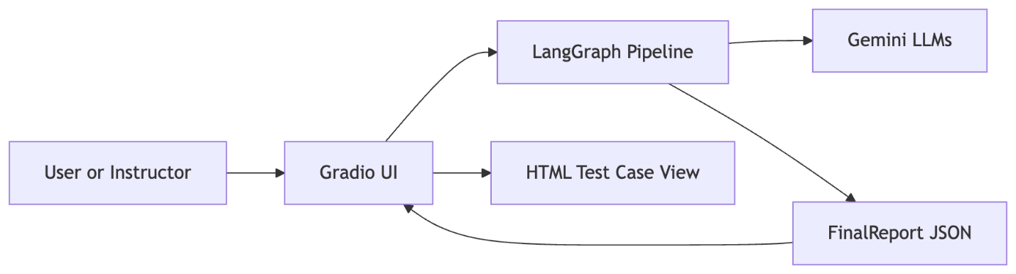
Figure 1: System Context Diagram

This diagram shows the top-level system components and their interactions. The
UI is a thin layer that triggers the pipeline and displays results. The
pipeline orchestrates multiple LLM calls and returns a structured report.

5.2 LangGraph Pipeline Flow

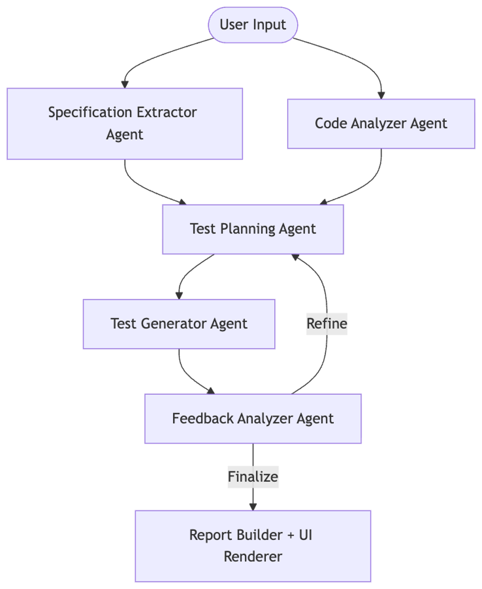
Figure 2: LangGraph Pipeline Flow
The pipeline has explicit parallel preparation steps (spec extraction and code
analysis) that converge into a test plan. Generation produces test cases per
student, and feedback decides whether to refine once before finalizing.
5.3 Request Sequence
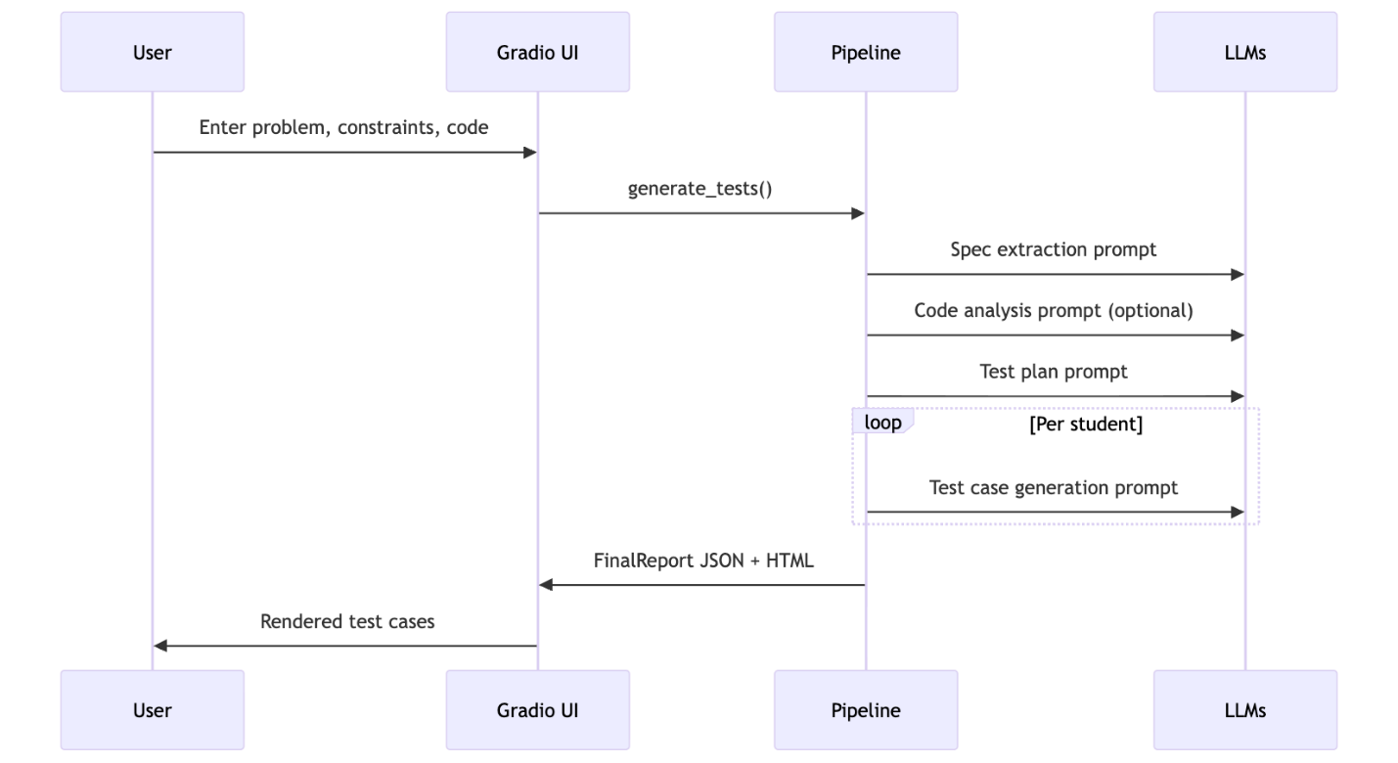
Figure 3: Request Sequence Diagram
The sequence emphasizes the separation of concerns between UI, pipeline, and
LLM roles. Each prompt is designed to return JSON that maps to a schema.

5.4 Data Model Overview
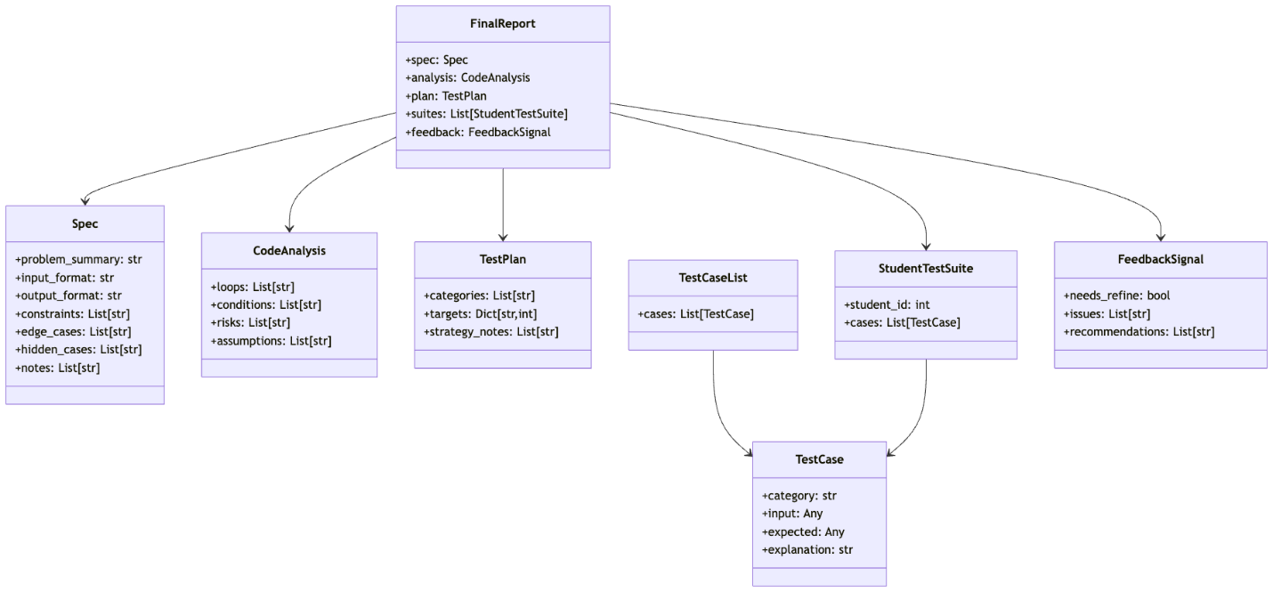
Figure 4: Data Model Overview
These classes define the contract for every stage. LLM outputs are parsed into
these structures, and the final report includes all upstream artifacts.

5.13 Prompt-Output Contract Example

Example output for a single test case list (simplified):
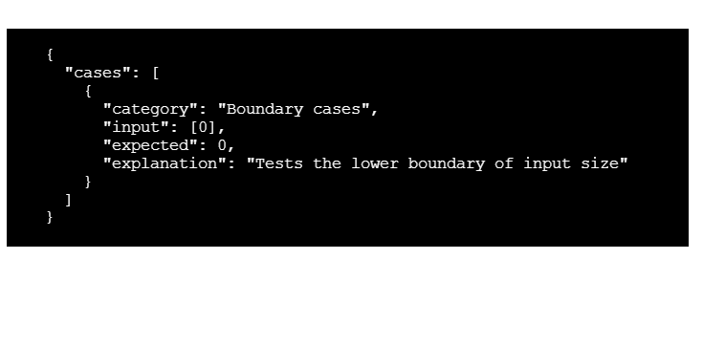
Figure 5: Prompt-Output Contract Example
This illustrates the JSON-only contract required from the LLM. The parser
expects literal JSON values without expressions or code.
5.14 Test Category Coverage Matrix
The fixed category set guarantees coverage across multiple risk areas:

Category | Purpose | Typical Example
Basic cases | Validate normal inputs | Small valid arrays
Boundary cases | Stress edges of constraints | Min and max sizes
Random cases | Explore input space | Random valid inputs
Stress cases | Performance pressure | Large input sizes
Invalid/robustness cases | Error handling | Empty or malformed inputs
Bug-targeted cases | Known failure patterns | Off-by-one inputs

This matrix can be used to explain the coverage rationale to evaluators.

5.15 State Transition Detail

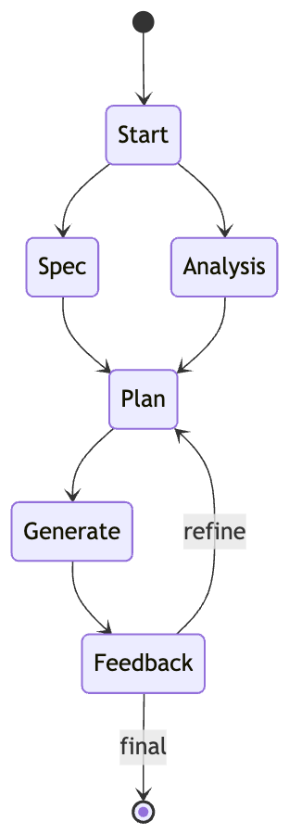
Figure 6: State Transition Detail
This view emphasizes the conditional refinement and the parallel entry paths
for spec extraction and code analysis.
6. Functional Requirements
The functional requirements are derived directly from the implemented modules
and the UI behavior.

1. Accept a non-empty problem statement and reject empty submissions.
2. Accept optional source code for analysis without executing it.
3. Allow users to specify a language from a predefined list.
4. Allow users to specify the number of students (1 to 50).
5. Allow users to specify cases per category (2 to 3).
6. Extract a structured specification from problem statement and constraints.
7. Perform optional code analysis and record potential risks and assumptions.
8. Generate a test plan with fixed categories and target counts.
9. Generate concrete test cases per student based on the plan targets.
10. Normalize category labels to the canonical six categories.
11. Enforce per-category targets and track missing categories as issues.
12. Provide a JSON report containing spec, analysis, plan, suites, and feedback.
13. Provide an HTML rendering of test cases grouped by student and category.
14. Provide a copy button to copy one student suite at a time.

6.1 Functional Requirements by Subsystem
UI Requirements (app.py)

1. Render input fields for problem, description, constraints, and code.
2. Provide a language dropdown with predefined choices.
3. Provide sliders for student count and cases per category.
4. Render the generated report as HTML and JSON in the same interface.

Pipeline Requirements (graph.py and agents.py)

1. Use dedicated agents for spec extraction, code analysis, planning,
generation, and feedback.
2. Re-run planning once when feedback or missing categories indicate issues.
3. Use fixed category names and per-category targets for all test suites.

Model Integration Requirements (llms.py)

1. Instantiate Gemini-based LLMs with configured temperature per role.
2. Fail fast when GEMINI_API_KEY is not set.

Data Contract Requirements (schemas.py)

1. Enforce structured JSON for all intermediate and final outputs.
2. Ensure every test case has a category, input, and explanation.
3. Store final results as a composite FinalReport model.

6.2 Non-functional Requirements
1. Usability: Generate results within a small number of clicks.
2. Performance: Handle up to 50 students with minimal UI lag.
3. Reliability: Enforce fixed category coverage per student.
4. Maintainability: Keep logic separated across app, graph, agents, and schemas.
5. Security: Do not execute user-provided code.
6. Portability: Run locally without additional services beyond the LLM API.

\pagebreak

6.3 Input Validation Rules
Validation and constraints applied in the current implementation:

- Problem statement must be non-empty.
- Student count is clamped to 1..50 in the UI slider.
- Cases per category are restricted to 2..3 in the UI slider.
- Code input is optional and treated as text only.
- Output JSON must validate against Pydantic schemas.

These rules prevent invalid pipeline states and keep outputs predictable.

6.4 Output Formatting Requirements
1. JSON outputs must use literal values only.
2. Category labels must match the canonical set after normalization.
3. Each test case must include a category, input, and explanation.
4. HTML output must group by student and by category.
5. Copy-to-clipboard must include a text summary of the student's cases.

6.5 Observability and Diagnostics
While no explicit logging framework is included, diagnostic behavior exists in
the form of issue lists and feedback signals. These fields can be exported for
analysis or debugging if desired.

Potential future enhancements could add structured logs or telemetry, but the
current repository intentionally keeps runtime minimal.

\pagebreak

7. Expected Outcome
SpecTest-LLM should produce clear, categorized test suites that improve
coverage of typical student solutions and reduce the burden of manual test
authoring. The expected outcome includes both a human-friendly view and a
machine-friendly report.

Key outcomes:

- A structured specification summarizing the problem statement.
- A test plan with targets across six categories.
- Per-student test suites that meet category quotas.
- A JSON report that can be reused by evaluators or tools.
- An HTML display that supports quick review and copy-to-clipboard actions.

\pagebreak

7.1 Success Criteria
The system is considered successful if it meets the following criteria:

1. Produces non-empty test suites when provided with a valid problem statement.
2. Maintains consistency of category names and per-category counts.
3. Avoids invalid JSON in output and provides structured data for every stage.
4. Supports multiple students in a single run without cross-contamination.
5. Provides clear explanations that justify the intent of each test case.

7.2 Limitations
The current implementation has the following limitations:

- Only a single refinement cycle is performed, which may not fully correct
persistent generation errors.
- No persistent storage is provided for versioning or audit trails.
- The system does not validate expected outputs against an oracle program.
- LLM outputs can still vary between runs, especially for complex statements.

These limitations are acceptable for prototype and educational use but may
need extension for production-grade assessment platforms.

7.3 Future Enhancements
1. Add a persistence layer to store generated suites and metadata.
2. Support user-defined categories and per-category counts.
3. Integrate an optional reference solution to validate expected outputs.
4. Add automated evaluation metrics such as coverage proxies.
5. Provide a batch mode for multiple problem statements.

7.4 Evaluation Plan
Evaluation can be performed along three axes:

- Coverage: measure whether generated cases reflect edge and boundary
conditions stated in the input.
- Consistency: confirm category counts and schema validity across runs.
- Usability: collect feedback from instructors on readability and utility.

Metrics can be gathered by sampling multiple problem statements and comparing
the distribution of categories and issue counts.

7.5 Sample Output Snapshot
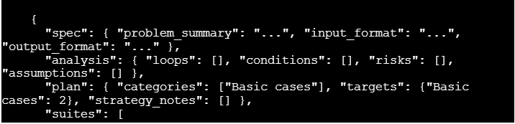
Figure 7: Sample Output Snapshot (1)
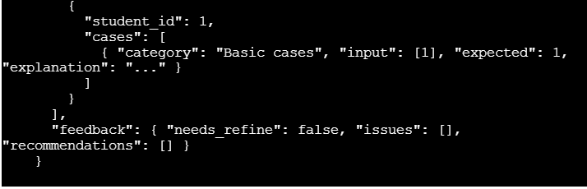
Figure 8: Sample Output Snapshot (2)

This snapshot demonstrates the shape of the report. Actual content depends on
the problem statement and LLM output.

8. References
Project source files:

- app.py
- agents.py
- graph.py
- llms.py
- schemas.py
- requirements.txt

Key runtime dependencies as listed in requirements.txt:

- langgraph
- langchain
- langchain-google-genai
- pydantic
- python-dotenv
- gradio

Notes:

- This synopsis is based on the current repository contents and does not
include external datasets or third-party services beyond the listed
dependencies.

8.1 Glossary
- LLM: Large Language Model used for prompt-based generation.
- Schema: A structured definition of expected JSON fields.
- Test plan: A set of category targets that guide test generation.
- Test suite: A collection of test cases for a specific student.
- Refinement: A re-run of planning to address detected issues

References
[1] K. Zheng et al., “What makes large language models reason in (multi-
turn) code generation?,” arXiv preprint, 2024.
[2] J. Cai et al., “CodeContests-O: Powering LLMs via feedback-driven
iterative test case generation,” arXiv preprint, 2025.
[3] S. Kuang et al., “On the effectiveness of training data optimization for
LLM-based code generation,” arXiv preprint, 2025.
[4] Majumdar et al., “Increasing LLM coding capabilities through a syn-
thetic data pipeline,” arXiv preprint, 2024.
[5] Tian et al., “Fixing large language models’ specification misunderstand-
ing for better code generation,” arXiv preprint, 2024.
[6] A. M. Sami et al., “A tool for test case scenarios generation using large
language models,” in Proc. [Conference], 2024.
[7] P. Kumari, “Intelligent test automation: A multi-agent LLM framework,”
arXiv preprint, 2025.
[8] M. L. Siddiq et al., “Using large language models to generate JUnit
tests: An empirical study,” in Proc. [Conference], 2024.
[9] A. Lops et al., “A system for automated unit test generation using large
language models,” in Proc. [Conference], 2024.
[10] Wang et al., “Benchmarking large language models for test case gener-
ation,” arXiv preprint, 2025.
[11] Q. Zhang et al., “Exploring automated assertion generation via large
language models,” arXiv preprint, 2025.
[12] P. K. Patel et al., “LLM-driven automated test case generation: A multi-
modal context-aware framework,” in Proc. [Conference], 2022.
[13] D.-K. Lee, “A GPT-based code review system for programming language
learning,” [Journal], 2024.
[14] K. Li et al., “Large language models as test case generators: Performance
evaluation and enhancement,” arXiv preprint, 2024.
[15] Chen et al., “Towards collective intelligence of LLMs via test case driven
LLM debate for code generation,” arXiv preprint, 2025.
[16] Y. Cao et al., “Can LLMs generate reliable test case generators? A study
on competition-level programming problems,” arXiv preprint, 2025.
[17] A. Li et al., “Knowledge matters: Injecting project and testing knowledge
into LLM-based unit test generation,” arXiv preprint, 2026.
[18] K. Liu et al., “LLM-powered test case generation for detecting tricky
bugs,” in Proc. [Conference], 2024.
[19] Yang et al., “Can LLMs generate high-quality test cases for algorithm
problems? TestCase-Eval: A systematic evaluation of fault coverage and
exposure,” arXiv preprint, 2025.
[20] Korrapolu et al., “A tool for test case scenarios generation using large
language model,” in Proc. [Conference], 2025.

Resources used

1. LangGraph Documentation: https://langchain-ai.github.io/langgraph/
2. LangChain Documentation: https://python.langchain.com/
3. Google Gemini API Documentation: https://ai.google.dev/
4. Gradio Documentation: https://www.gradio.ap

