Pull request url -> https://github.com/Aditya010305/github-skills-challenge/pull/1

Github Workflows ->
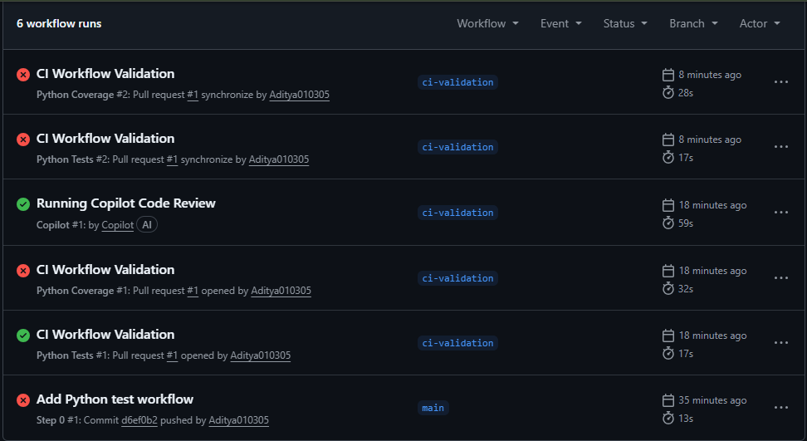

successful test workflow execution ->
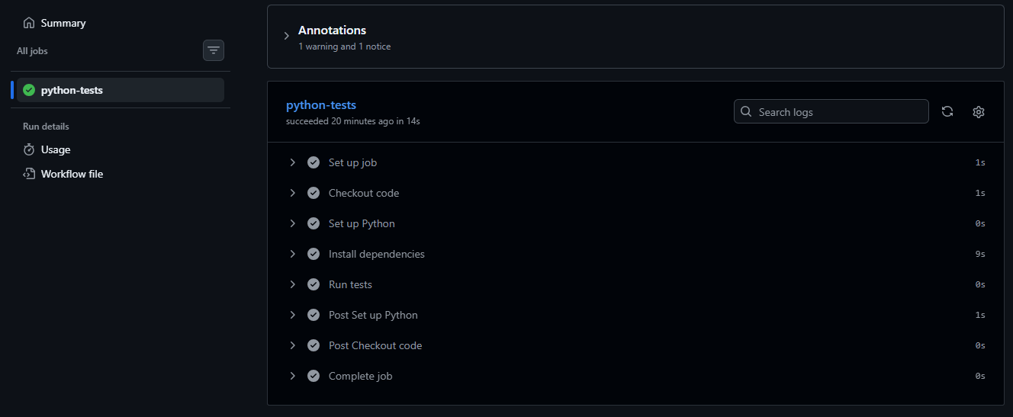

the coverage result/comment on the pull request ->

