Steps to setup UI project
- Download & Install latest node from https://nodejs.org/en/
- Once node is installed open CMD and type bellow command to make sure node is installed successfully.
node -v
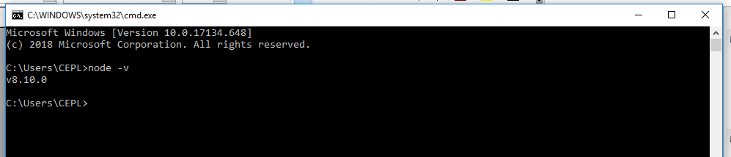

- Run below command to install grunt-cli globally:
npm install -g grunt-cli
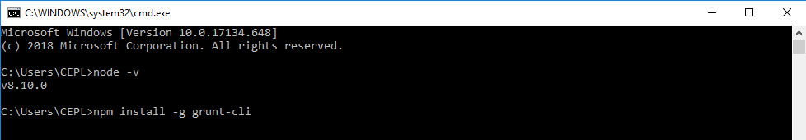

- Get latest UI code from VS, goto mapped folder.
Make sure you are in the parent folder where you can see the child "app" folder.
Open CMD there and execute below command:
npm install
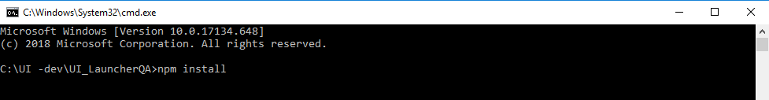

- Then run below command to run the code:
grunt serve
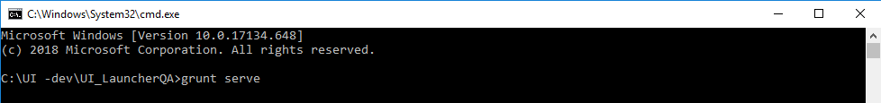
You will see a login page similar to below: (we use chrome for dev and testing)
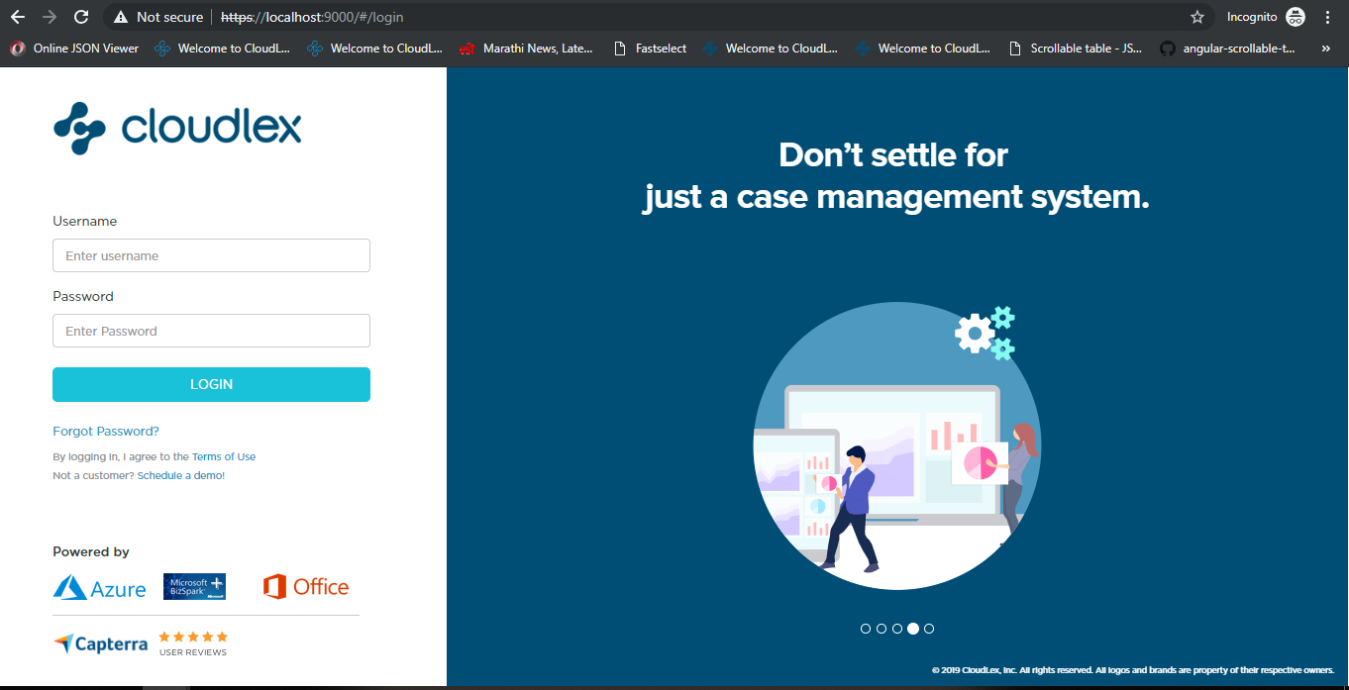

To login :
1) Make sure your constant file is pointing to demo environment. Constant.js file is present inside app folder. constants.env = "https://demoapi.cloudlex.net/";
- User : Partner
- Pass: Lexvia#2016
- Before login open below website in second tab. Make sure you do this to avoid certification problem. “https://demoapi.cloudlex.net/”

