**Part 1: Code Review & Debugging**

**Problem 1 : Existence of all the required fields not being checked.**

The given code assumes that all the fields are present in the data.

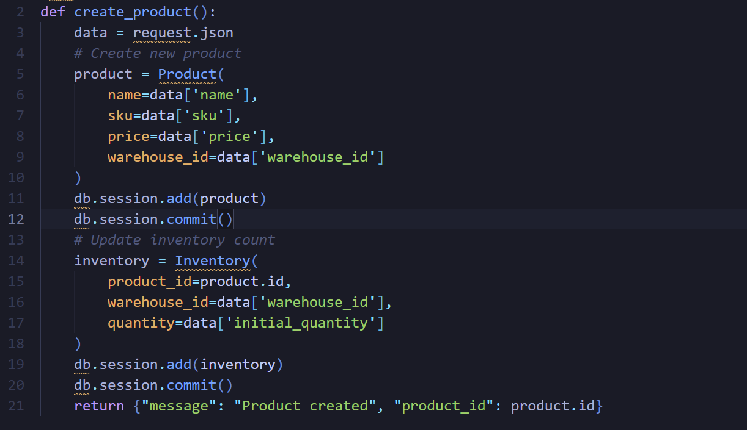

**Impact :**

In the case of a missing field, the API returns a 500 error with no explanation.

**Solution :**

A loop to check for missing fields and returns a 400 Bad Request with a clear error message.

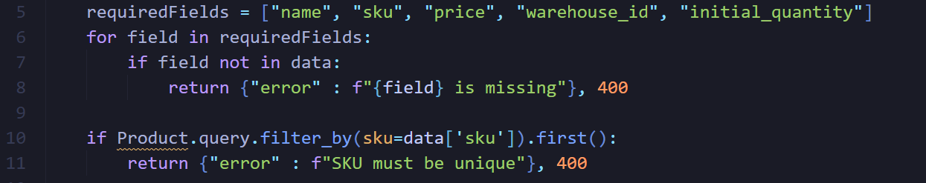

**Problem 2 : SKU should be unique, no checks done if not.**

Products can be created with duplicate SKUs.



**Impact :**

Two products sharing the same SKUs will create confusions and break business rules.

**Solution :**

Added a uniqueness check in the API.



**Problem 3 : Price stored as a float.**

Storing a currency as a float is not recommended as they lose precision.



**Impact :**

Wrong totals while billing and inaccuracies in finances.

**Solution :**

The price is now stored as a Decimal which ensures precision.

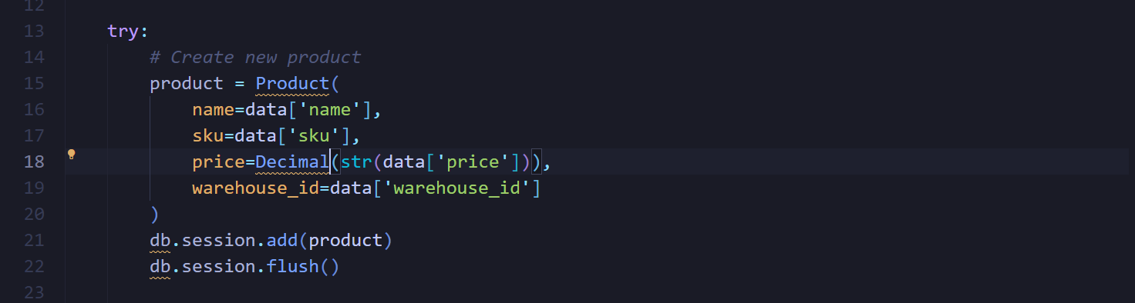

**Problem 4 : Initial quantity is not optional.**

Code always expects “initial_quantity”.



**Impact :**

If it is not provided, the API crashes.

**Solution :**

The API now defaults it to zero if not entered.

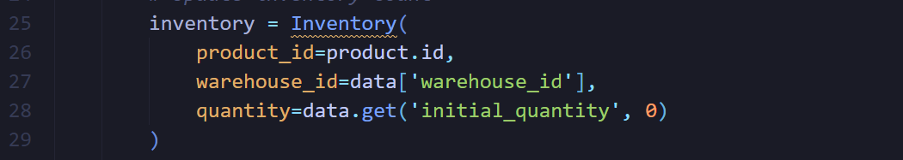

**Problem 5 : No error handling**

The code will crash if an error related to db occurs.

**Impact :**

API returns a 500 Bad Request with no clear exception.

**Solution :**

Try/except blocks added with db.session.rollback(). This ensures clear error response.

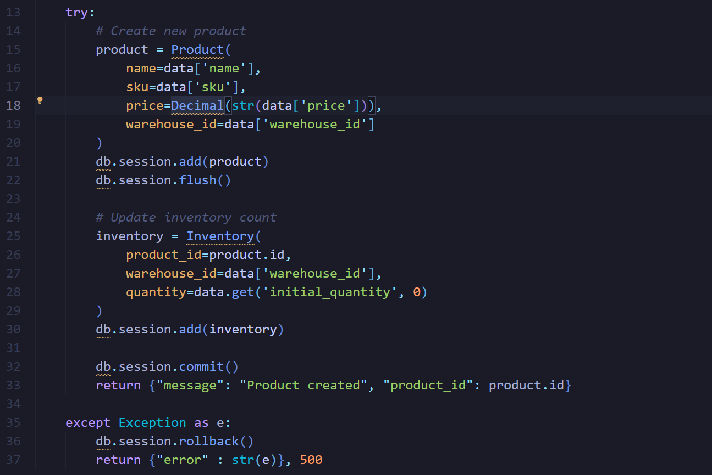

**Part 2: Database Design**

**Tables & Relationships:**

Company (id, name)

Warehouse (id, company_id FK, name, location)

Product (id, name, sku UNIQUE, price DECIMAL, type [normal/bundle])

Inventory (id, product_id FK, warehouse_id FK, quantity, last_updated)

InventoryHistory (id, inventory_id FK, change_amount, reason, timestamp)

Supplier (id, name, contact_email)

SupplierProduct (supplier_id FK, product_id FK, lead_time_days)

BundleItems (bundle_id FK → Product.id, component_id FK → Product.id, quantity)

**Gaps/questions:**

1. Do bundles affect stock, or are they just for grouping?
2. Are there multiple suppliers for the same products?
3. How do we handle deleted products?
4. Do warehouses belong to just one company?

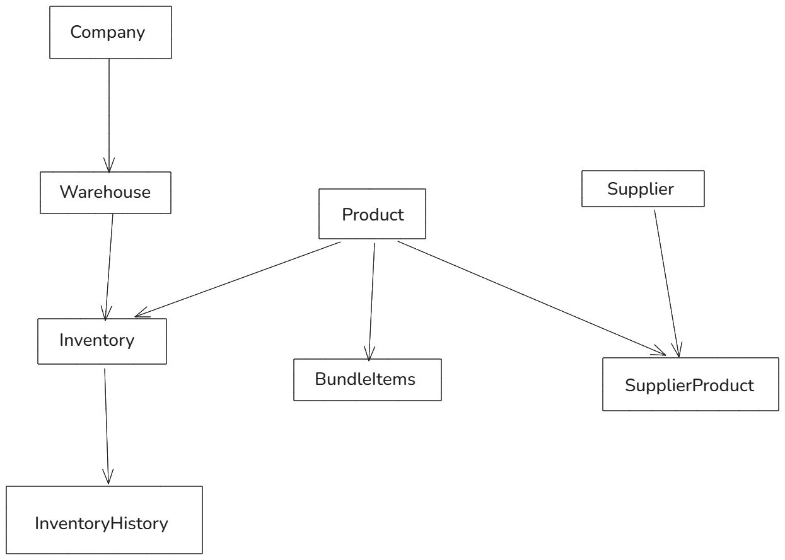

**Part 3: API Implementation**

Assumptions/Pre-requisites for the API:

1. Product table requires a new column called “low_stock_threshold”.
2. Only recent Sales are available. So the products that are not being sold are not included there.
3. I have not defined any function for “estimate_stockout_days”. Although it will be just simple division i.e. stockout_days = current_stock/average_daily_sales.