Assignment-2
Name : Aditya Raj
H.No. : 2303A53031
Batch : 46

Task 1 — Statistical Summary using Google Gemini (Colab)
Create a Python function that finds:
- Mean
- Minimum
- Maximum
from a list of numbers using Gemini in Colab.
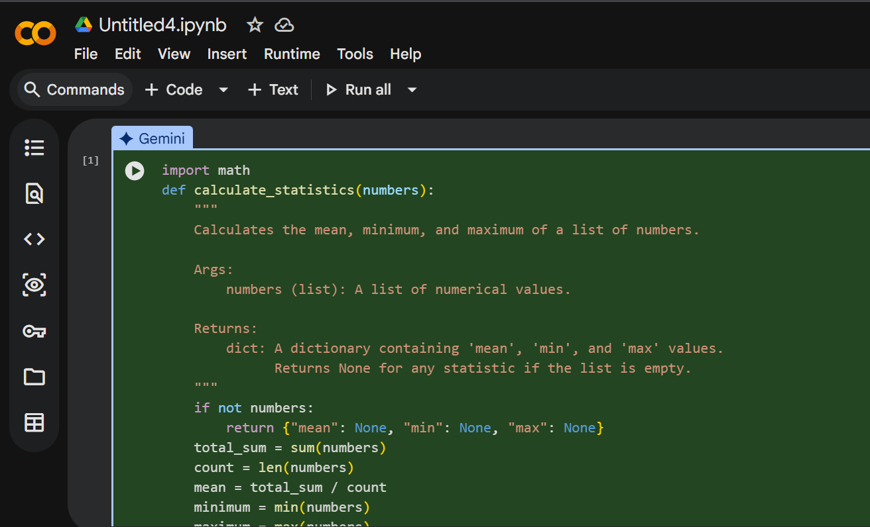

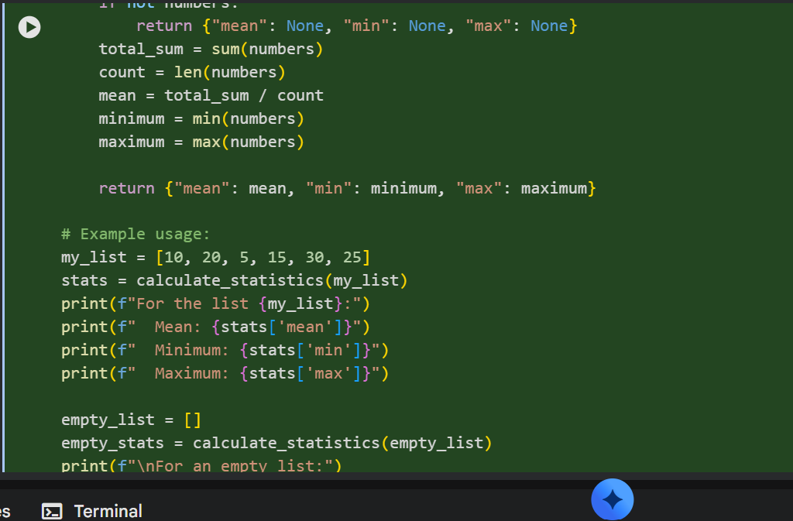

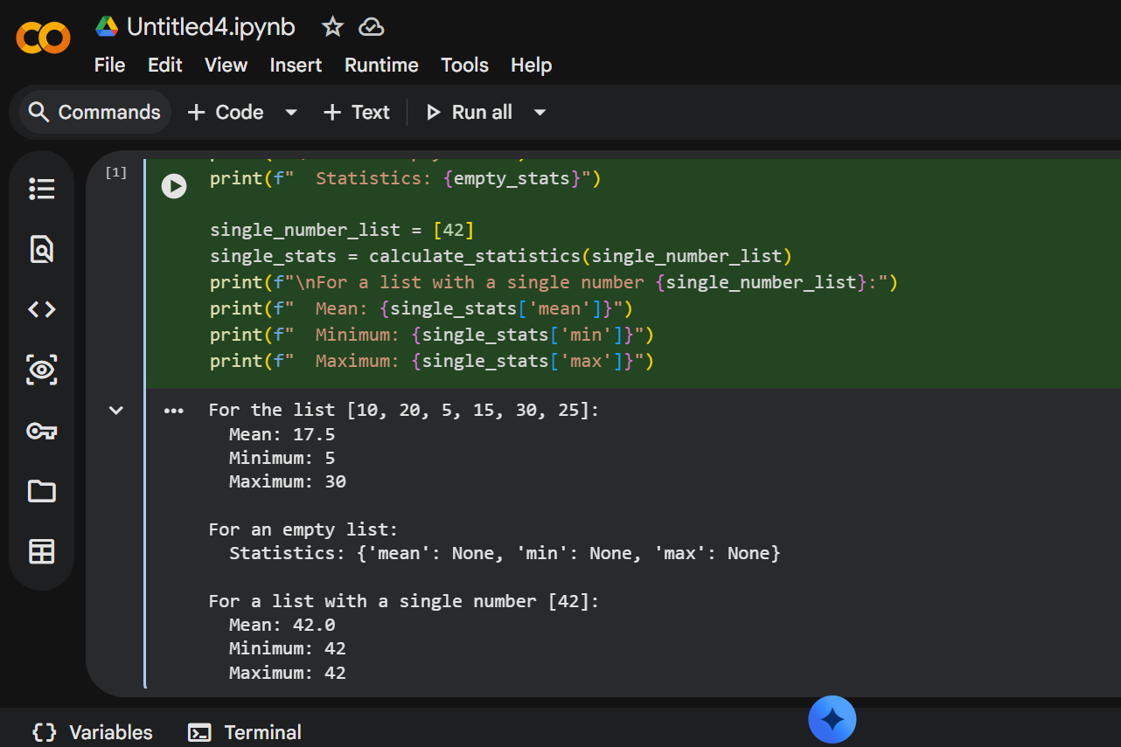

Task 2 — Armstrong Number (Gemini vs Copilot)
Generate Armstrong number checker using:
- Gemini
- GitHub Copilot ,Then compare them.

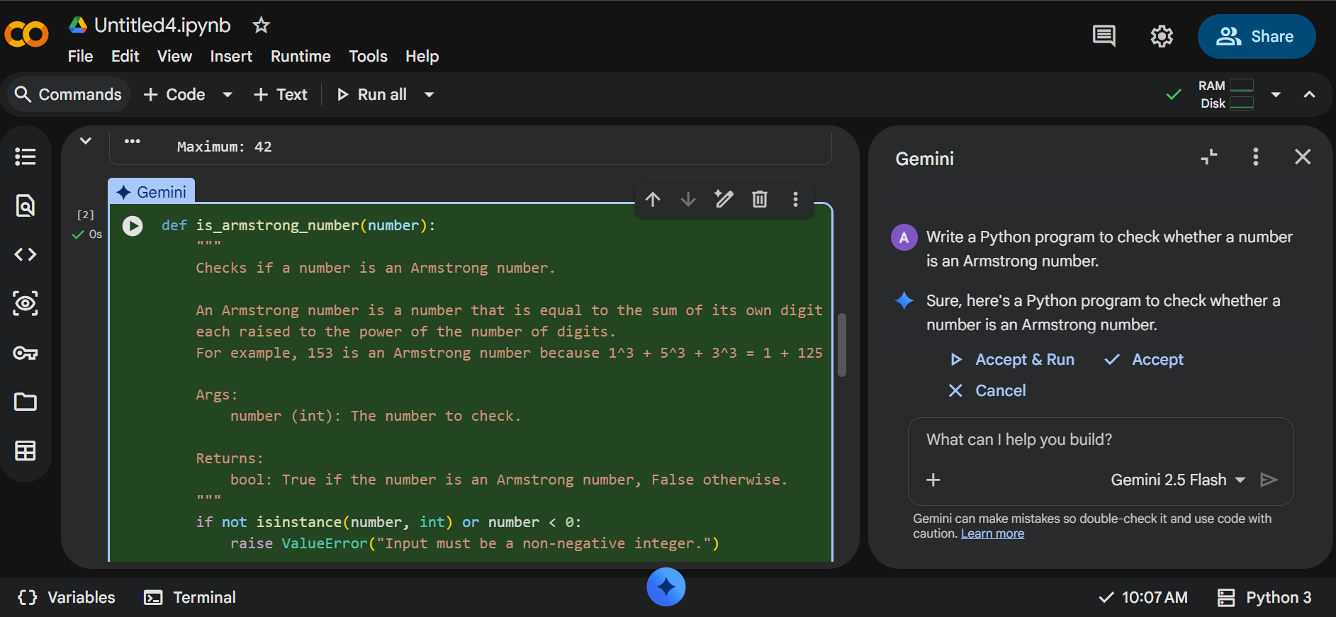

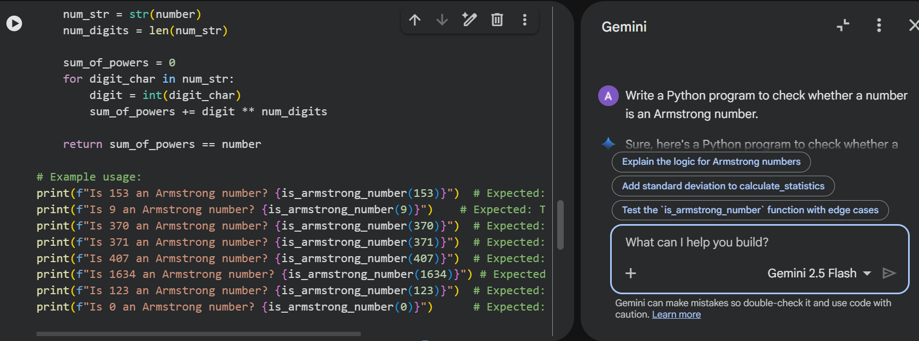

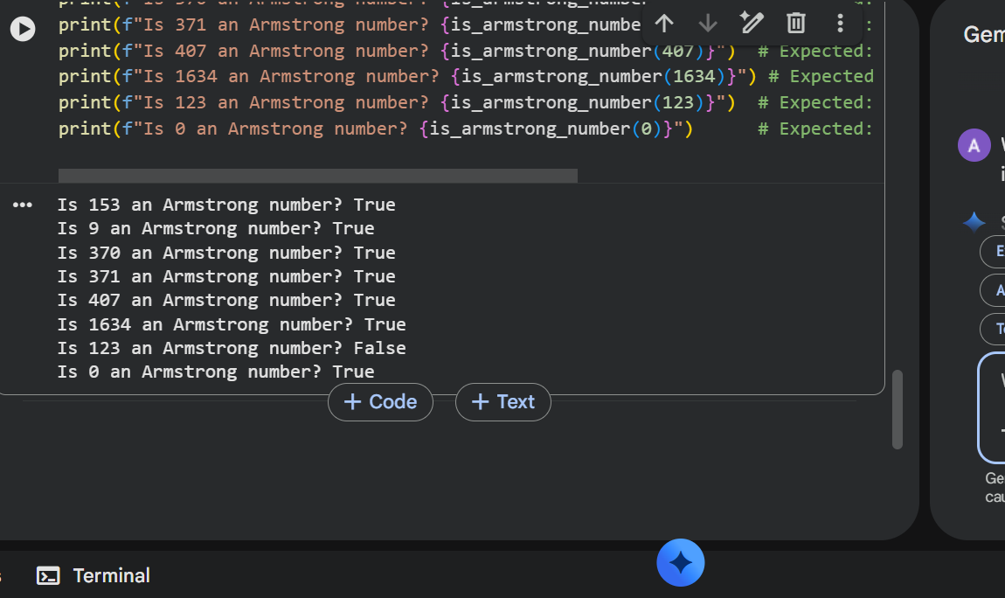

Feature | Gemini | Copilot
Logic | Uses step-by-step digit extraction and power calculation, easy to follow | Uses the same core logic but often written in a more compact style
Code Clarity | Well-structured code with meaningful variable names and comments | Shorter code, fewer comments, more developer-style
Readability | Very beginner-friendly and easy to understand | Slightly less verbose but clean and professional

Task 3 — Leap Year using Cursor AI
Generate leap year program using two different prompts

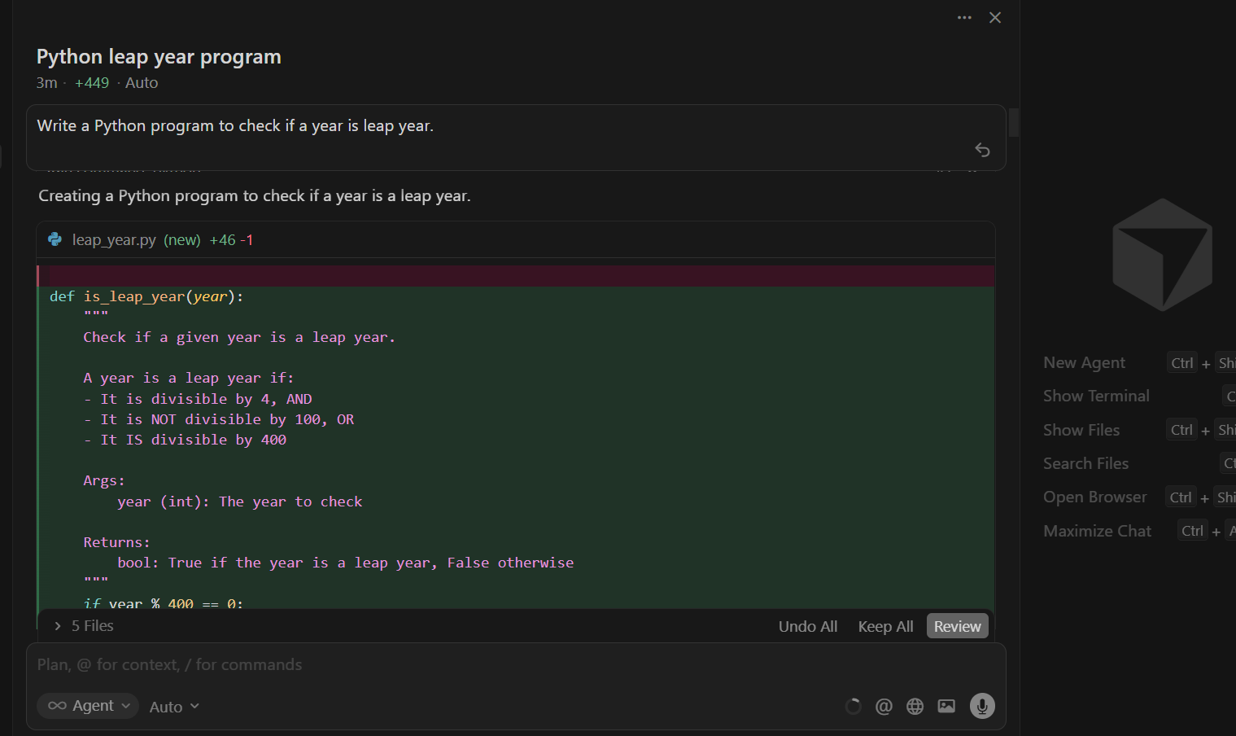

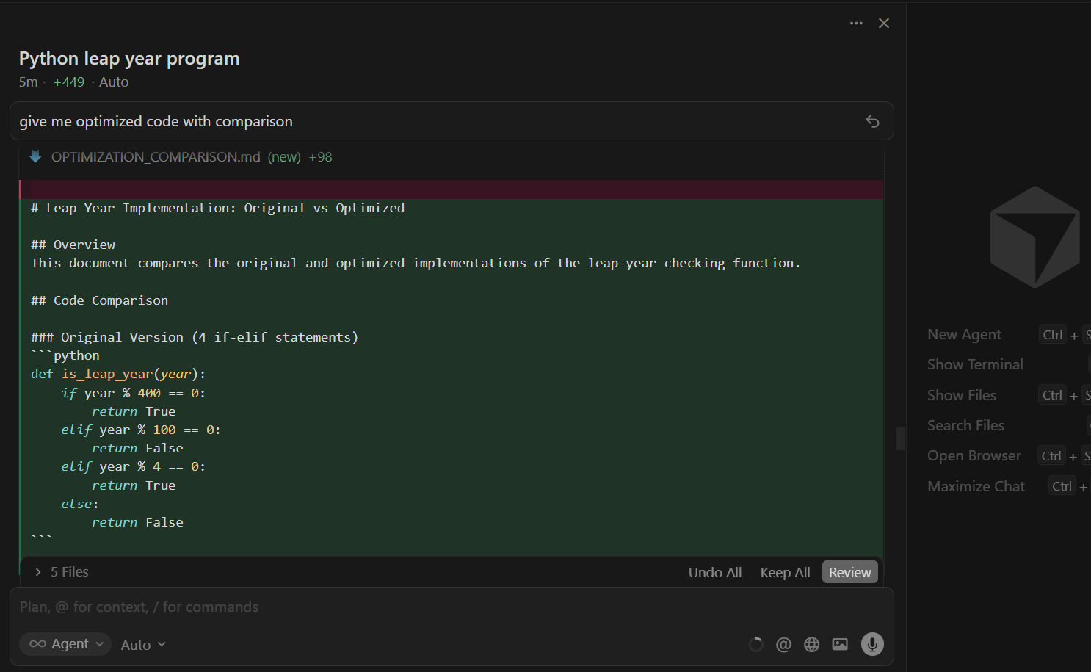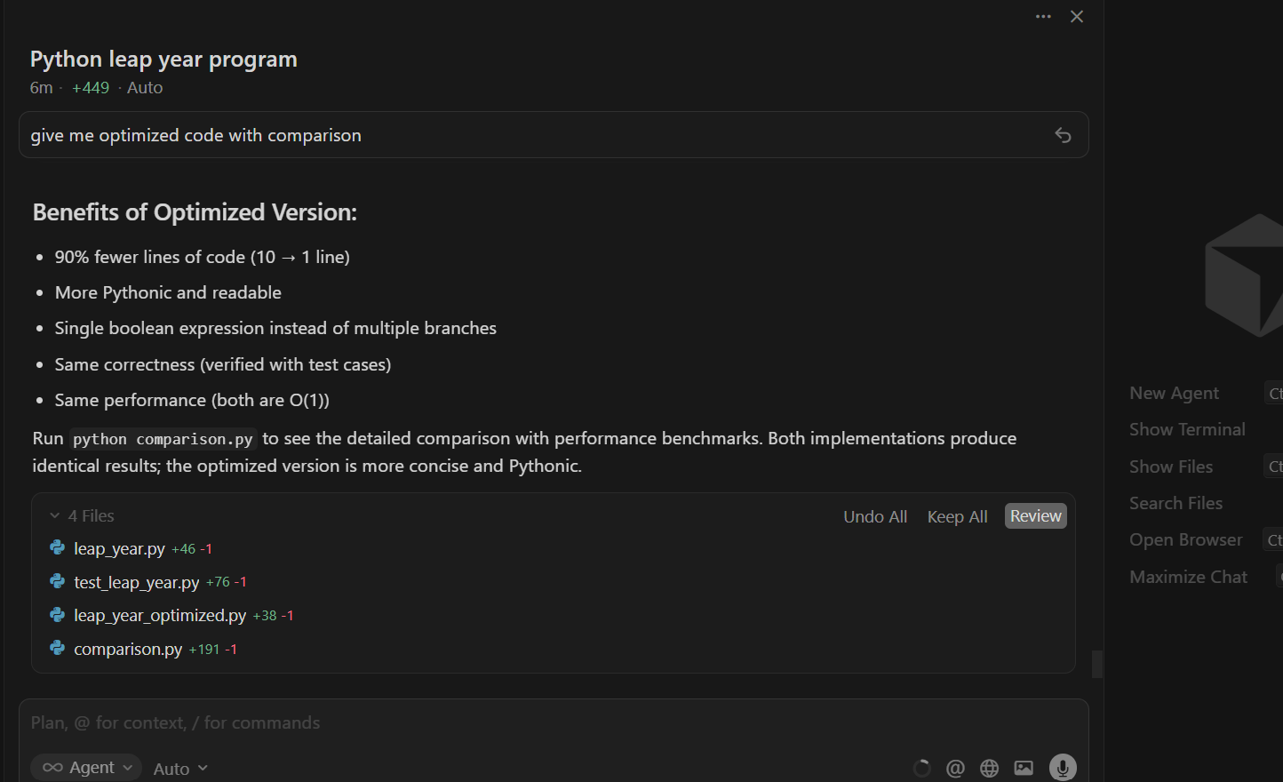

Task 4 — Odd/Even Sum (Manual + AI Refactor)
Manual Code
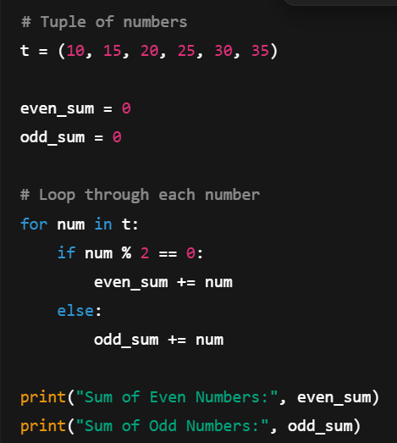
Output:
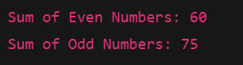

AI Refactored Code (Optimized Version)
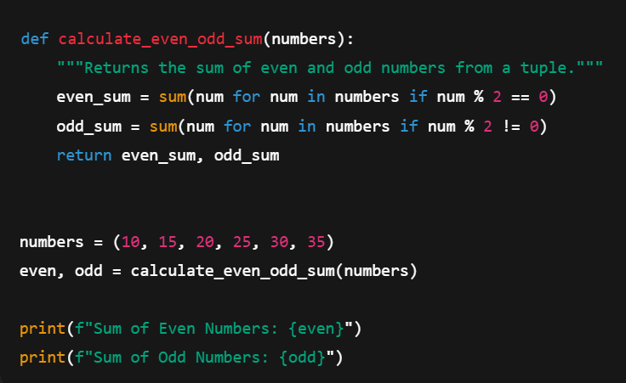
Output : 