NIP Project — Submission Template
Pega Platform project · This document is your complete submission
Read this before you start:
1. Fill in Section 1 completely. The Pega application name must follow the format NIP-[Project]-[YourName].
2. Create a new Operator in Pega with your full name and log in as that operator before taking any screenshot.
3. When you create your test case, enter YOUR FULL NAME in the Issue Description (Vehicle) or Movie Name (Movie) field.
4. Complete only the section for your chosen project. Delete the other project section.
5. Paste one screenshot per user story (10 total). Follow the screenshot rules in your selected project section.
6. Answer every question in Sections 3 and 4 in your own words.
7. Save the file using this format: ProjectName_FirstName_LastName.docx. Use VehicleService or MovieTicket as the ProjectName. Examples: VehicleService_Ravi_Kumar.docx or MovieTicket_Ravi_Kumar.docx.

Section 1 — Your Details
Full Name | Aditya Kumar
Email ID (registered on NIP) | Adityakumaraman73@gmail.com
Phone Number | 9301018952
College Name | Noida Institute of Engineering and technology
Course (e.g. IT, CS) | CSE-(AI)
State | Delhi
Project Chosen (Vehicle Service OR Movie Ticket Booking) | Vehicle Service Management
Pega Application Name (e.g. NIP-VehicleService-YourName) | NIP-VehicleServiceManagement-AdityaKumar
Case Type Name (exact) | Vehicle Service Request
Pega Instance URL | Pega App Studio
Operator Name (created in Pega with your full name) | Aditya Kumar

Section 2A — Vehicle Service Management Application
Complete this section only if you selected this project. Delete the other project section before submitting.

Screenshot rules — IMPORTANT before you start:
1. Name your Pega application as: NIP-VehicleService-YourName OR NIP-MovieTicket-YourName
2. Create a new Operator in Pega with your full name (Security → Operators) and log in as that operator.
3. When you create your test case, enter YOUR FULL NAME in the Issue Description (Vehicle) or Movie Name (Movie) field.
4. The logged-in operator name must be visible in every screenshot wherever the Pega interface displays it.
5. The student's full name must be visible in all running-case screenshots.
6. Configuration screenshots must clearly show the relevant application or rule name.
Screenshots that do not show these will not be accepted.

US-001 — Submit Vehicle Service Request
What is expected:
Case created, customer submits Vehicle ID, Vehicle Model, Issue Description. Validation applied.
Screenshot — paste your screenshot below this line:
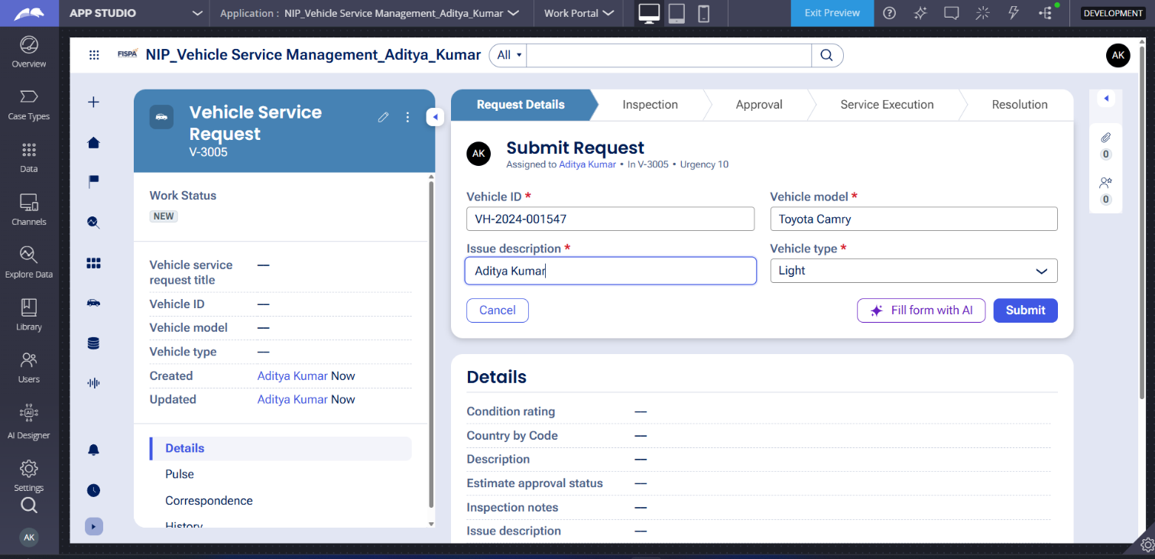

What I built for this (1–2 lines in your own words):
For US-001, create the Vehicle Service Request case type and build an initial stage for the Customer to capture validated Vehicle ID, Vehicle Model, and Issue Description fields. Additionally, associate this case with a reusable Vehicle data object to maintain data consistency.

US-002 — Perform Vehicle Inspection
What is expected:
Inspection stage with Service Advisor step. Inspection Notes and Condition Rating captured.
Screenshot — paste your screenshot below this line:
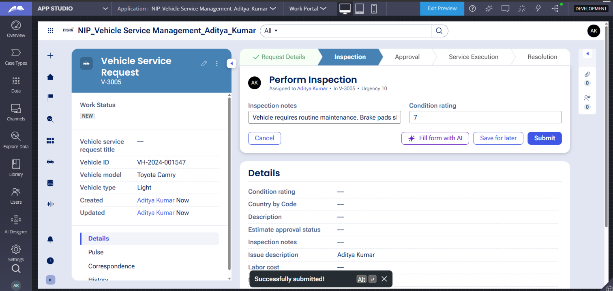

What I built for this (1–2 lines in your own words):
For US-002, add a mandatory Inspection stage to the case lifecycle assigned to the Service Advisor persona. Within this stage, configure a step to record the Inspection Notes and Condition Rating properties before the process can move forward to the estimate generation.

US-003 — Generate Service Estimate
What is expected:
Labor Cost and Parts Cost captured. Total Cost calculated automatically by declare expression.
Screenshot — paste your screenshot below this line:
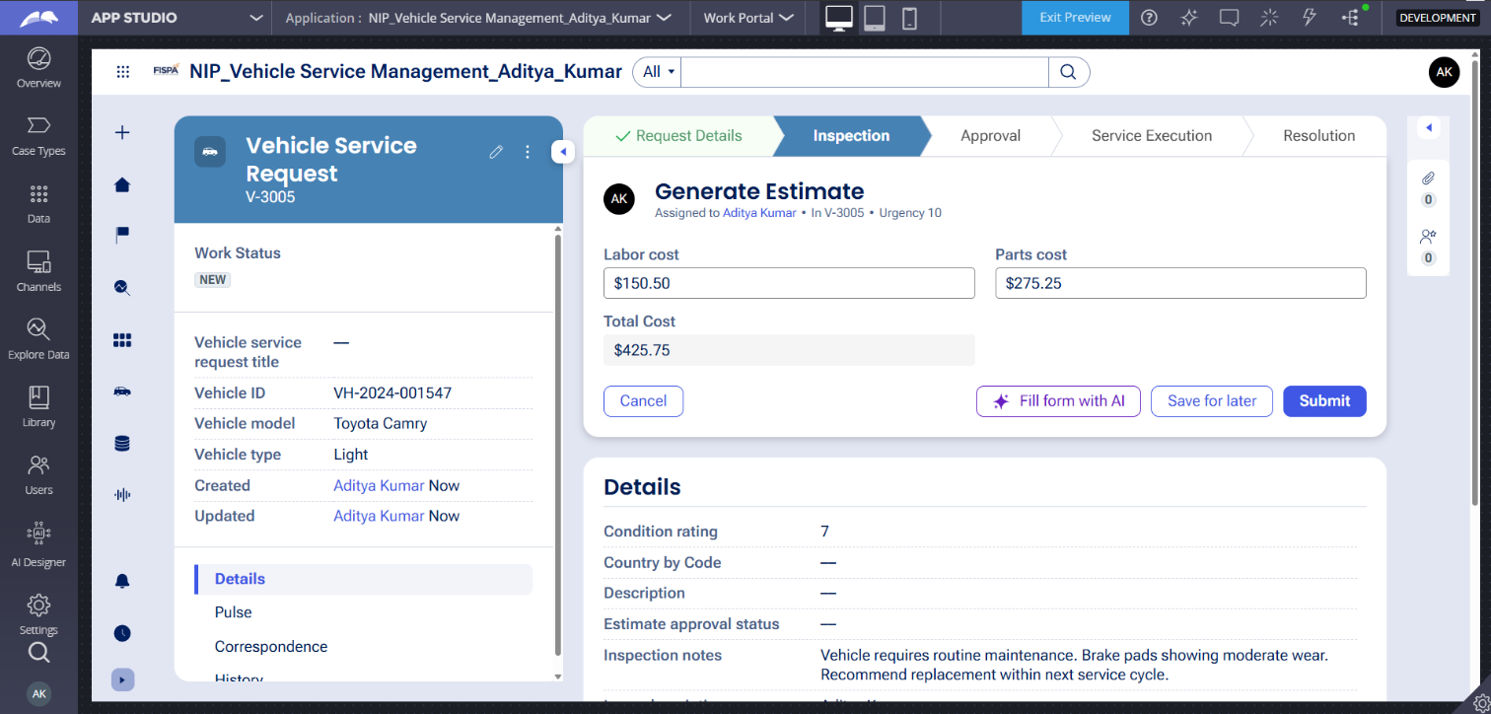

What I built for this (1–2 lines in your own words):
For US-003, add a step within the Inspection stage where the Service Advisor inputs the Labor Cost and Parts Cost. You must also configure a business rule to automatically calculate the Total Cost by aggregating these two values.

US-004 — Approve Service Estimate
What is expected:
Approval stage assigned to Customer. Approval Status captured. Flow branches on approve/reject.
Screenshot — paste your screenshot below this line:
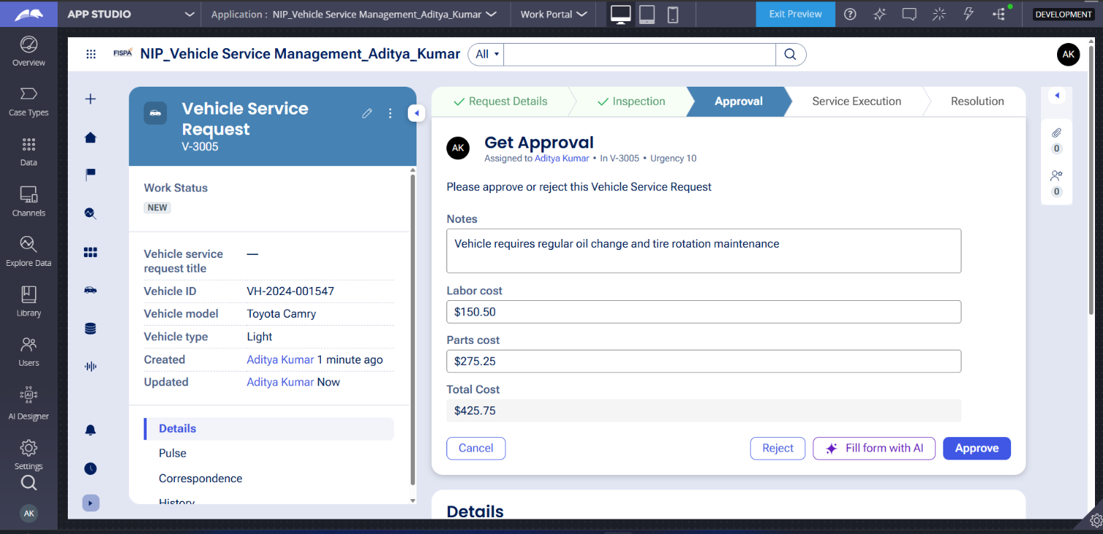

What I built for this (1–2 lines in your own words):
For US-004, add an Approval stage assigned to the Customer persona to capture their decision using an Approval Status property. Configure the workflow so that approved requests move forward to service execution, while rejected requests are resolved.

US-005 — Maintain Vehicle Data
What is expected:
Reusable Vehicle data object created with Vehicle ID, Model, Type — linked to case.
Screenshot — paste your screenshot below this line:
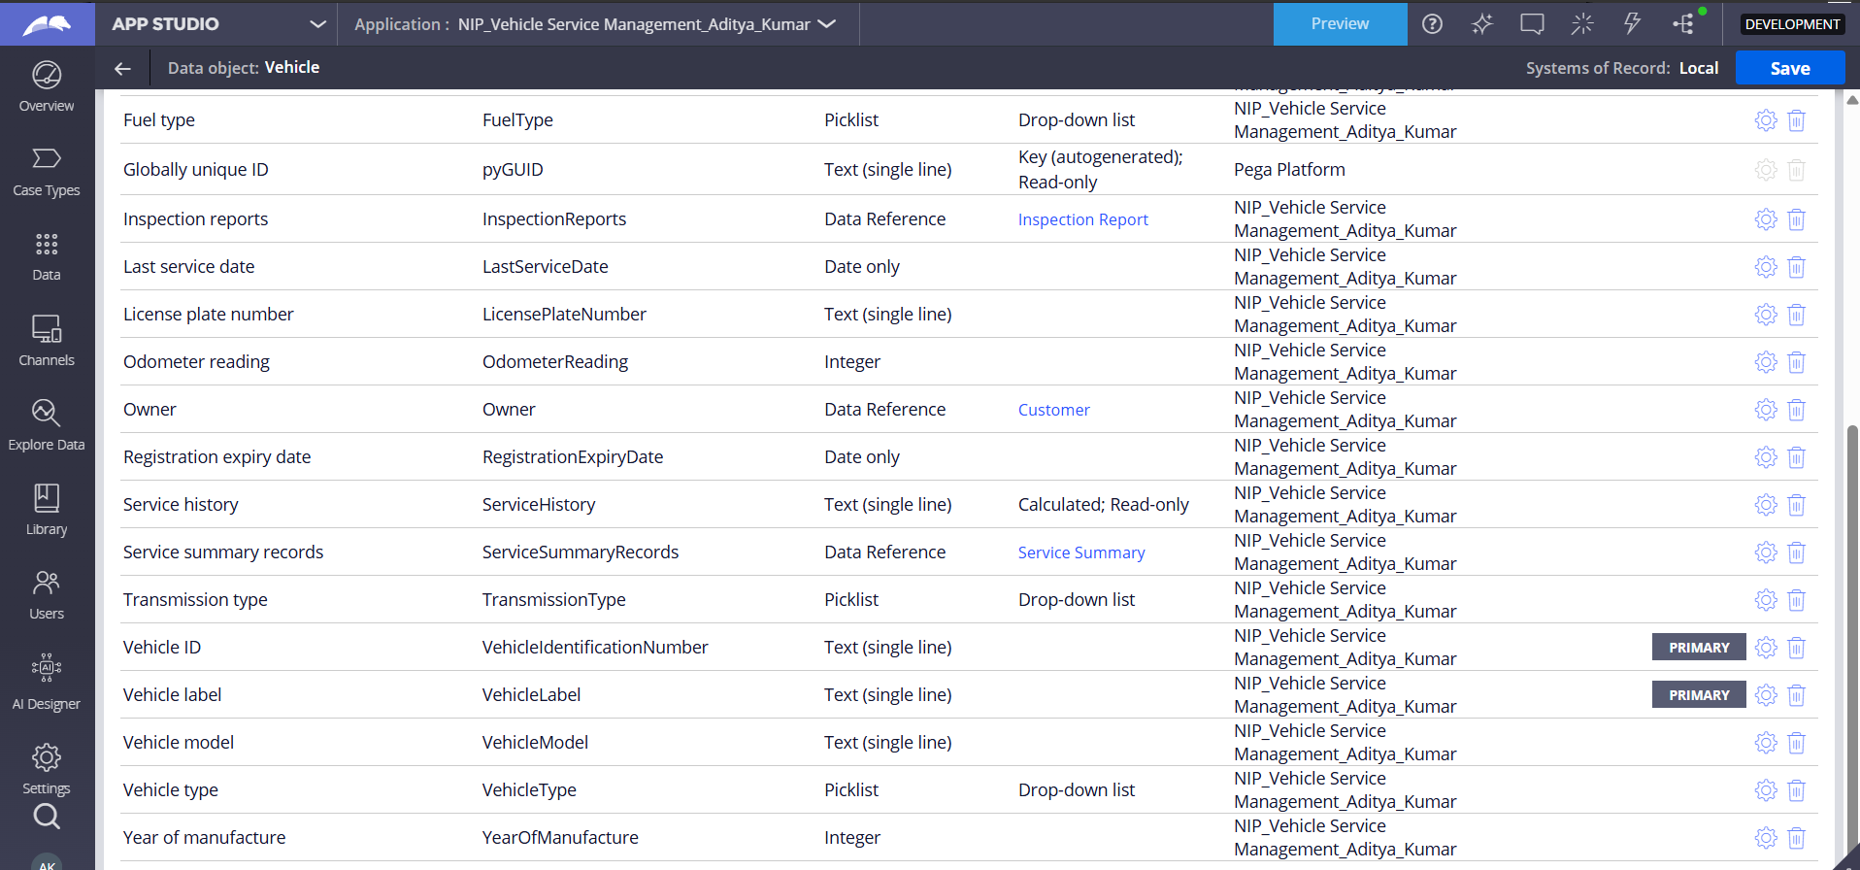

What I built for this (1–2 lines in your own words):
​US-005: Create a reusable Vehicle data object to store properties like Vehicle ID, Model, and Type, and associate it with the case to track service history across multiple requests.

US-006 — Review Service Estimate
What is expected:
Approval screen shows Labor Cost, Parts Cost and Total Cost clearly to the Customer persona.
Screenshot — paste your screenshot below this line:


What I built for this (1–2 lines in your own words):
​US-006: Configure the approval step interface to clearly display the Labor Cost, Parts Cost, and calculated Total Cost so the Customer can review them before making a decision.

US-007 — Auto Assign Technician
What is expected:
Service Execution stage with routing to HeavyVehicleQueue or LightVehicleQueue. Assigned Technician and Service Status properties maintained.
Screenshot — paste your screenshot below this line:
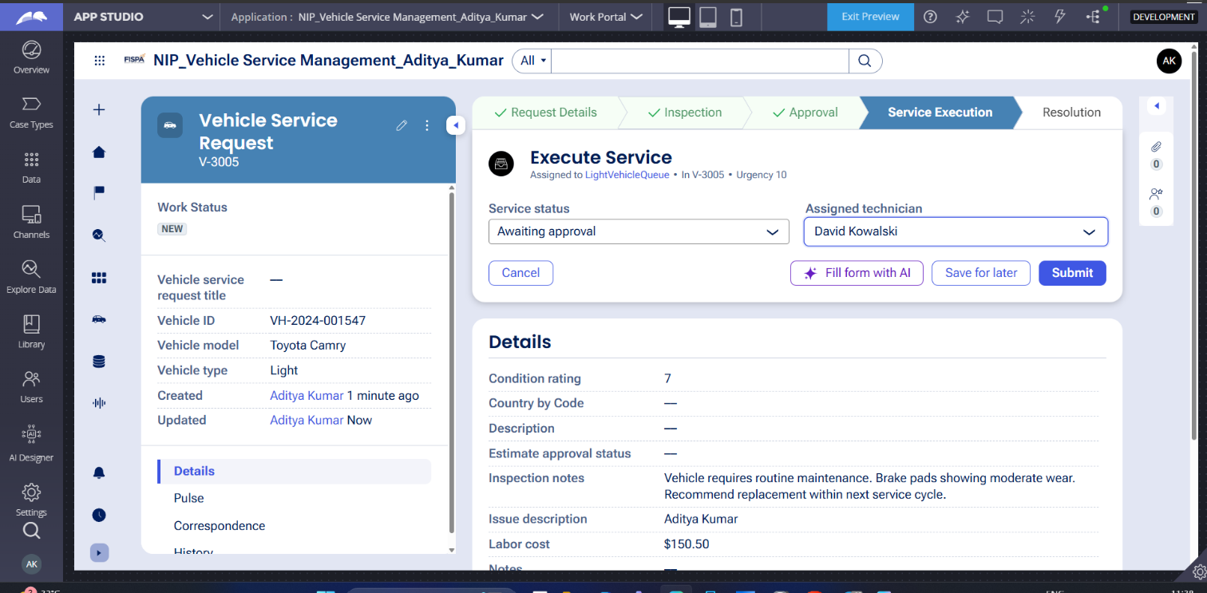

What I built for this (1–2 lines in your own words):
​US-007: Add a Service Execution stage with an assignment step that automatically routes the case to a Technician persona or work queue, maintaining Assigned Technician and Service Status properties.

US-008 — Notify Service Completion
What is expected:
Correspondence rule created and triggered on case resolution. Email includes case and vehicle details.
Screenshot — paste your screenshot below this line:
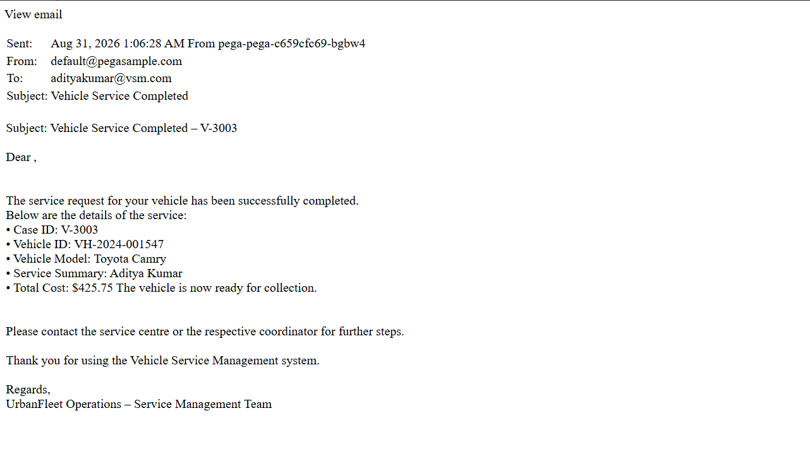

What I built for this (1–2 lines in your own words):
​US-008: Trigger a Correspondence rule upon case resolution to notify the Customer, ensuring the email includes the Case ID, Vehicle ID, Vehicle Model, Service Summary, and Total Cost.

US-009 — Define Service SLA
What is expected:
SLA configured on the case type. Goal: 2 days. Deadline: 3 days. Priority increases on breach.
Screenshot — paste your screenshot below this line:
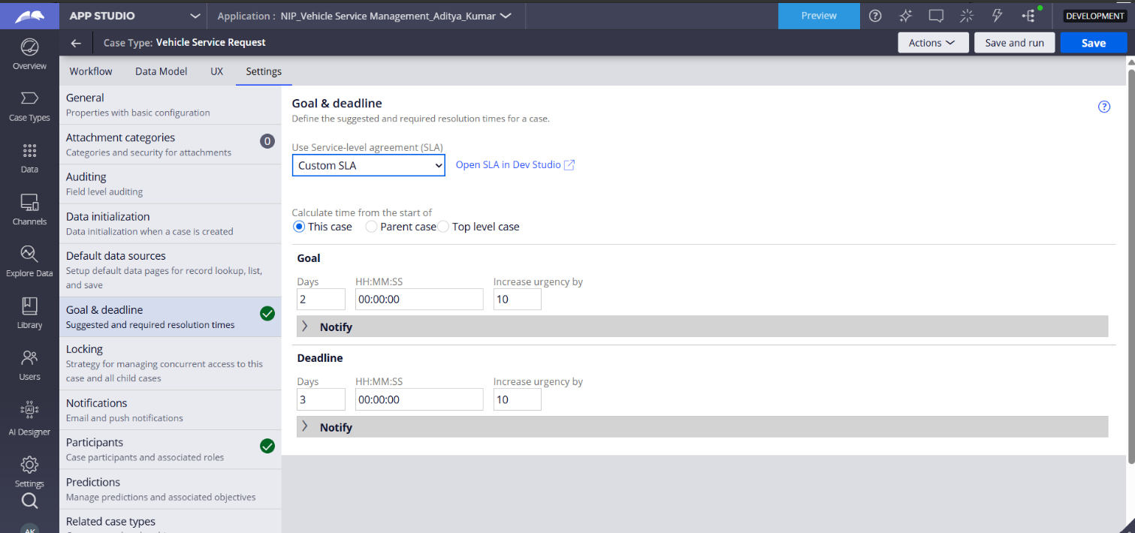

What I built for this (1–2 lines in your own words):
​US-009: Configure a Service-Level Agreement (SLA) on the case type with a Goal of 2 days and a Deadline of 3 days, setting the system to automatically increase case priority if the deadline is missed.

US-010 — Route by Vehicle Type
What is expected:
Routing rule or Decision Table routes to HeavyVehicleQueue or LightVehicleQueue based on Vehicle Type property.
Screenshot — paste your screenshot below this line:


What I built for this (1–2 lines in your own words):
​US-010: Implement a When rule or Decision Table within the Service Execution stage to automatically route cases to either the HeavyVehicleQueue or LightVehicleQueue based on the Vehicle Type property.

Section 3 — About Your Application
These answers are checked against your screenshots. Write exactly what is in your application.

Q1. List your stages in the order they appear in your case lifecycle.
Stage names in order, separated by commas.
Request Details, Inspection, Approval, Service Execution, Resolution

Q2. Name the data object(s) you created and the properties inside them.
Data object name and its properties.
Data Object Name: Vehicle
Properties: Vehicle ID, Model, Type

Q3. What is the exact name and type of the rule you used to calculate Total Cost?
Provide:
• Rule Name
• Rule Type
• Properties used in the calculation
• Formula used
​Rule Name: Total Cost
​Rule Type: Calculated Field (or Declare Expression)
​Properties used in the calculation: Labor Cost, Parts Cost
​Formula used: Labor Cost + Parts Cost

Section 4 — Your Understanding
Short, honest and specific answers score well.

Q4. What did Blueprint generate for you, and what did you add or change yourself afterwards?
Be specific about what was already there and what you built or modified on top.
Blueprint generated the initial application scaffold, the base Vehicle Service Request case type, the primary stages, and the default personas. Afterward, I manually configured the Total Cost calculated field (Labor Cost + Parts Cost), set up the automatic routing logic to assign cases to either the HeavyVehicleQueue or LightVehicleQueue based on the vehicle type, and implemented the Service SLA with a 2-day goal and a 3-day deadline. I also configured the automated correspondence email triggered upon resolution.

Q5. Was there anything Blueprint created that you had to correct or configure further? Describe one example.
A real example from your own work.
Blueprint generated default naming conventions for fields that I had to manually correct to match the exact project specifications. For example, in the Vehicle data object, Blueprint created a standard identification property, which I had to specifically rename to Vehicle ID to ensure strict compliance with the required data structure.

Q6. Explain your case flow from creation to resolution, in order.
What happens first, who does what, when the case closes.
Blueprint generated default naming conventions for fields that I had to manually correct to match the exact project specifications. For example, in the Vehicle data object, Blueprint created a standard identification property, which I had to specifically rename to Vehicle ID to ensure strict compliance with the required data structure.

Q7. Pick two design choices you made in your application and explain why you made them.
For each design choice, provide:
• What you implemented
• Why you chose that approach
• What benefit it provides to the application
Design Choice 1: Automated Routing by Vehicle Type
​What I implemented: I configured automatic routing in the Service Execution stage to direct cases to either the HeavyVehicleQueue or LightVehicleQueue based on the value of the Vehicle Type property.
​Why I chose that approach: The project required the system to handle routing automatically without manual assignment.
​What benefit it provides: It ensures efficient work distribution by automatically assigning the service task to the correct team for that specific vehicle type.
​Design Choice 2: Reusable Vehicle Data Object
​What I implemented: I created a distinct data object named Vehicle to store information like Vehicle ID, Model, and Type.
​Why I chose that approach: Storing this information independently from the main case type prevents data duplication.
​What benefit it provides: It ensures data consistency across the application and allows vehicle data to be reused across multiple service requests to track service history.

Q8. What was the hardest part, and how exactly did you fix it?
Specific and honest. A real challenge scores much better than a generic answer.
The hardest part was ensuring strict adherence to the exact naming conventions required for the project submission, specifically for properties generated automatically by Blueprint. For example, Blueprint initially created a default identification field for my data object, but the project strictly required the property to be named exactly Vehicle ID. I fixed this by manually reviewing my data model against the project document and renaming the property directly in App Studio to ensure the application matched the exact requirements before capturing my final screenshots.

Q9. If the approval step was only needed when Total Cost is above a certain amount, what would you change in your application?
Explain what you would change and where. You do not need to build this.
I would modify the configuration of the Approval stage by adding a custom condition using a When rule. This rule would evaluate the calculated Total Cost property. If the Total Cost is less than or equal to the designated threshold, the system would evaluate the condition as false, automatically skip the approval step entirely, and route the case directly forward to the Service Execution stage.

Q10. List three exact rule names from your application that you personally created or modified.
Include the rule name and rule type for each one (for example: CalculateTotalCost - Declare Expression).
Total Cost - Calculated Field (or Declare Expression) used to aggregate Labor Cost and Parts Cost.
​RouteByVehicleType - Decision Table (or When Rule) used to route cases in the Service Execution stage based on the vehicle type.
​Service Completion Notification - Correspondence Rule used to generate the final email to the customer containing the summary and costs.

Q11. List all personas used in your application.
List the persona names exactly as they appear in your application.
Customer, Service Advisor, Technician.

Q12. List all work queues used in your application and explain when each one is used.
For each work queue, provide its exact name and the condition or type of work routed to it.
​HeavyVehicleQueue: This queue is used automatically during the Service Execution stage when a service request's Vehicle Type property is set to heavy vehicles.
​LightVehicleQueue: This queue is used automatically during the Service Execution stage for all other service requests that do not fall under the heavy vehicle category.

Before You Submit — Check These
Read through once before uploading.
1. Section 1 filled in. Application named as NIP-[Project]-[YourName]. Names match the actual application.
2. New Operator created in Pega with my full name. I logged in as that operator for all screenshots.
3. Only my chosen project section remains — the other project section is deleted.
4. All 10 user story screenshots are pasted and follow the operator, running-case, application, and rule-name evidence requirements.
5. Every question in Sections 3 and 4, including Q10, Q11, and Q12, is answered in my own words.
6. This file is named using the required format: ProjectName_FirstName_LastName.docx (for example, VehicleService_Ravi_Kumar.docx or MovieTicket_Ravi_Kumar.docx) and uploaded as required.

