**SOFTWARE REQUIREMENT SPECIFICATION FOR ONLINE MEDICINE DELIVERY SYSTEM.**

Prepared by

**ADITYA MISHRA**

Proposed to

**GEETANJALI MAM**

**10-03-2022**

Table of Content

1. **Introduction**

1.1 Purpose

* 1. Scope
  2. Definitions
     1. Audience Definitions
     2. Acronyms
  3. References
  4. Overview

**2. Overall Description**

2.1 Product Perspective

2.2 Product Functions

2.3 User Characteristics

2.4 Constraints

2.5 Operating Environment

**3. Functional Requirements**

3.1 Administrator

3.2 Descriptions

3.3 Visitor

3.4 Shop Owner

3.5 Customer care

**4. Non-Functional Requirements**

4.1 Performance Requirement

4.2 Safety Requirement

4.3 Security Requirement

4.4 Error handling

**5.** **Interface Requirement**

5.1 Customer Interface

5.1.1 Login

5.1.2 Registration Interface

5.1.3 Personal data editing

5.1.4 Search

5.1.5 Add as favourite

5.1.6 Cart

5.1.7 Payment

5.1.8 Support

5.2 Interface for Shop Owner

# 1. Introduction

**1.1 Purpose**

* The Online Medicine Store (OMS) web application is intended to provide complete solutions for vendors as well as customers through a single gateway using the internet as the sole medium. It will enable vendors to setup online Medical shops (Medicine, Syrup, etc.), customer to browse through the shop and purchase them online without having to visit the shop physically. The administration module will enable a system administrator to approve and reject requests for new shops and maintain various lists of shop category
* This document is meant to discuss the features of OMS, so as to serve as a guide to the developers on one hand and a software validation document for the prospective client on the other.

**1.2 Scope**

This system allows the customer’s to maintain their cart for add or remove the product over the internet.

**1.3 Definitions**

**1.3.1 Audience Definitions**

The intended readers of this document are the developers of the site, testers, website owners, managers and coordinators.

**1.3.2 Acronyms**

|  |  |
| --- | --- |
| **Acronym** | **Meaning** |
| OMS | Online Medicine Store |

**1.4 References**

* IEEE 830-1998 standard for writing SRS document.

**1.5 Overview**

* This system provides an easy solution for customers to buy the product without going to the shop and also to shop owner to sale the product.
* This proposed system can be used by any naïve users and it does not require any educational level, experience or technical expertise in computer field but it will be of good use if user has the good knowledge of how to operate a computer.

**2. Overall Description**

**2.1 Product Perspective**

* OMS is aimed towards the vendors who want to reach out to the maximum cross-section of customer and common people who can be potential customer. This project envisages bridging the gap between the seller, the retailer and the customer. OMS should be user-friendly, ‘quick to learn’ and reliable software for the above purpose. OMS is intended to be a stand-alone product and should not depend on the availability of other software. It should run on all platform.

**2.2 Product Functions**

**THE FUNCTION WILL BE LIKE:**

[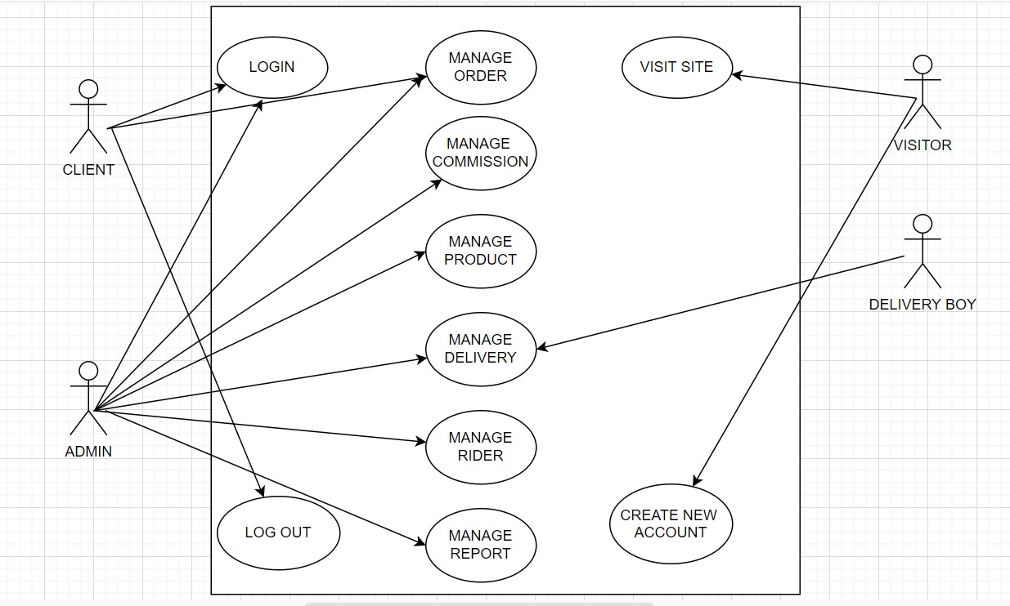](blob:file:///eafadb03-ece2-4485-a2a1-8839a539657b)

* User: Administrator
* Functions: The Administrator is the super user and has complete control over all the activities that can be performed. The application notifies the administrator of all shop creation requests, and the administrator can then approve or reject them. The administrator also manages the list of available product categories. The administrator can also view and delete entries in the guestbook.
* User: Shop Owner
* Functions: Any user can submit a shop creation request through the application. When the request is approved by the Administrator, the requester is notified, and from there on is given the role of Shop Owner. The Shop Owner is responsible for setting up the shop and maintaining it. The job involves managing the sub-categories of the items in the shop. Also, the shop owner can add or remove items from his shop. The Shop Owner can view different reports that give details of the sales and orders specific to his shop. The Shop Owner can also decide to close shop and remove it from the website.
* User: Customer/Guests
* Functions: A Customer can browse through the shops and choose products to place in a virtual shopping cart. The shopping cart details can be viewed and items can be removed from the cart. To proceed with the purchase, the customer is prompted to login. Also, the customer can modify personal profile information (such as phone number and shipping address) stored by the application. The customer can also view the status of any previous orders, and cancel any order that has not been shipped yet.
* User: Employees
* Functions: Purchase department under a Purchase manager to overlook purchasing activities if warehousing needs arise.
* Functions: Sales department under a Sales manager who will look after the sale of products and services, the most important activity.
* Functions: Accounts department under an Accounts manager to look after the accounting activities of the enterprise

## 2.3User characteristics

* The user should be familiar with the Medicine Shopping related terminology like Shopping cart/Checking out/Transaction etc.
* The user should be familiar with the Internet.

## 2.4Constraints

* There is no maintainability of back up so availability will get affected.
* Real-life credit card validation and Banking system is not implemented.
* No multilingual support

**2.5 Operating Environment**

The OMS is a website that shall operate in all famous browsers.

**3.Functional Requirements**

* 1. **Administrator:**
* **Database Management:** Control the database and keep track of all records of customers and employee details.
* **Contact and Giving Permission to Vendors:** Contact with the vendors and give permission to sell their product under the site after testing the product’s quality and expiry date.
* **View all details:** View the details of all employees and control the whole site.
* **Advertising the Site:** Responsible for making advertisements for the site.
  1. **Descriptions:**
* **Login:** Customers must have a valid login id to enter into the site.
* **Registration:** New users can sign up by creating new ID.
* **Choosing and comparing products:** Can view all available products and can compare them and make a choice for purchasing products.
* **Purchasing:** Can purchase any product through valid credit card.
* **Giving Feedback to Customer Care:** Can give feedback to the 24X7 Customer Care Service center about their impression for the site and services.
* **Logout:** Customer must logoutof the site after purchasing products.
  1. **Visitors:**
* **Visiting the Site:** Can only visit the site without registration.
* **Register** 
  1. **Shop Owner:**
* **Taking Permission from Administrator:** Vendors must take permission from the Administrator for selling their products under the site. Administrator will test product’s quality according to its market price to permit vendor for selling purpose.
* **Consulting with Administrator:** Can consult with the Administrator regarding product’s quality and advertisements.
* **Advertising Vendor’s Own Products:** Responsible for making advertisements of his products, but the site will not be responsible for any kind of advertisements about products.
  1. **Customer Care:**
* **Getting Feedback from the Customers:** Responsible for receiving complaints, queries and feedback from the customers.
* **Providing Solutions to Customers:** Provide feasible solutions to the customers on their complaints and queries.

**4. Non-functional Requirements**

**4.1 Performance Requirements**  
• The system shall accommodate high number of items and users without any fault.  
• Responses to view information shall take no longer than 5 seconds to appear on the screen.

**4.2 Safety Requirements**  
• System use shall not cause any harm to human users.

**4.3 Security Requirements**  
• System will use secured database  
• Normal users can just read information but they cannot edit or modify anything except their personal and some other information.  
• System will have different types of users and every user has access constraints.

**4.4 Error handling**

OFS shall handle expected and non expected errors in ways that prevent loss in information and long downtime period.

**5. Interfaces Requirement:**

**5.1 Customer’s Interface:**

**5.1.1 Login:**

This interface will consist of two compulsory fields namely, “User Name” and “Password”. There will also be options for “New User’s Registration” which will redirect to “Registration” page and a “Forgot Password” option in case a user forgets the password.

If the password entered is correct the Main User Interface opens up else an error message is displayed.

**5.1.2 Registration Interface**

The user will enter his personal details like Name, User Name, Password, Date Of Birth, Address, Registration Type, etc.

Users will be warned about any mistakes on data format or any other constrains by validation notes and error messages.

When the button "save" button is clicked, the server will check if the username or email is already taken and alert the user.

If everything is entered correctly and saved a new user will be created.

**5.1.3 Personal Data Editing**

If any member wants to change his personal information he can enter his profile by clicking on his name at the top right of the main page and he will be directed to the personal details editing page.

**5.1.4. Search**

The customer can enter the type of Medicine or product he/she is looking for and the specifications he is interested in them he can click on “Search”. User can also use advanced search for more options. For eg: the user can filter the results basing on various aspects such as brand, Types of disease, etc and also they can sort the product display according to their wish (relevance, price in ascending or descending, popularity)

**5.1.5 Add as favourites**

The user can shortlist his/her favourite item as a list for future reference.

**5.1.6 Cart**

This will be a space for the customer where he/she can store the items he/she whishes to buy. The user can also remove items from cart prior to checkout. Once the user decides to buy the items it cart, the user is directed to the payment page for making payment.

**5.1.7 Payment**

The user given options with various modes of payment (online payment through credit/debit cards, via net or mobile banking or cash on delivery) out of which he chooses one. The chose mode of transaction is carried therefore by proper verification and authentication of bank details.

**5.1.8 Support**

The user can contact with the customer care via phone call or via messages. User can ask for an assistance or can give feedback on a particular aspect.

**5.2 Interface for Shop owner**

The shop owner will have a different login id using which he can access his account that contains a control panel that allows him to contact the administrator, set up/ maintain shop etc.

This control panel will allow the shop owner to do the following things:

* Request the admin for a permission to set up a shop.
* Set up the catalog for his shop and upload it so that the admin can make it visible in the website.
* Add/Remove items. The corresponding changes will be done in the database by the Admin.
* Create advertisements for his products.
* Generate a sales report.
* Discontinue the shop.