Product recommender systems rely on average ratings.

We propose a novel format for the visualisation of product ratings based on the time they were sold to enhance accuracy and fairness.

Key Words – Markovity, Multimodal Time Binning (& Analysis)

* Select a product (preferably) with the following properties  
  1) Time of extraction **-** Time the product was introduced in the market **>=** 4

2) Number of product ratings / votes >= 500

3) Product ratings evenly distributed along the time axis.

[Iphone 12- Flipkart](https://www.flipkart.com/apple-iphone-12-black-64-gb/product-reviews/itma2559422bf7c7?pid=MOBFWBYZU5FWK2VP&lid=LSTMOBFWBYZU5FWK2VPFMEI56&marketplace=FLIPKART)

* We create the following plots

**Linear Time Bins**

1. X axis – Evenly distributed time frames (1 month) (Equi-sized Time Bins)

Y-Axis – Total ratings / votes (On a scale of 1-5)

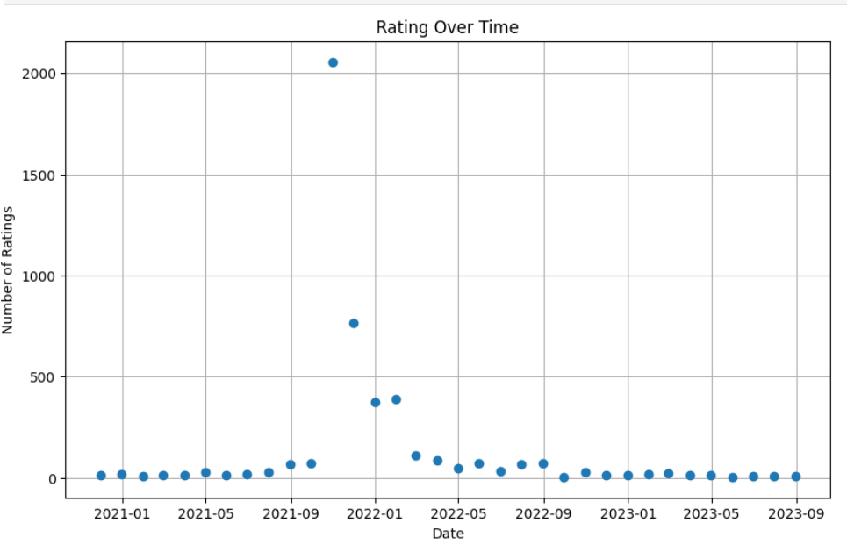

1. For each rating / vote X (1 to 5), we plot the following

X- Axis - Evenly distributed time frames (1 month) (Equi-sized Time Bins)

Y-Axis – Total Count of ratings / votes X.

1. X Axis – Evenly distributed time frames (1 month) (Equi-sized Time Bins)

Y-Axis – Average rating

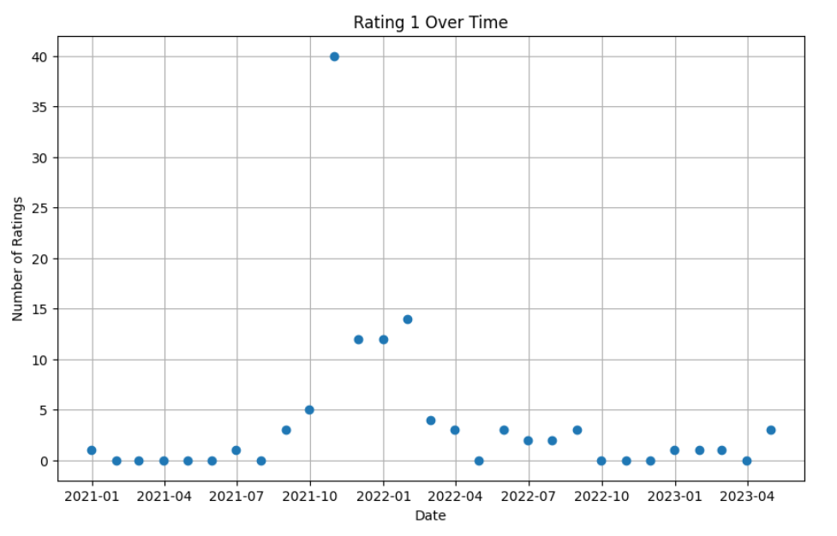

**Non Linear Time Bins**

1. X axis – Time frames (further categorized into bins *)

Y-Axis – Total ratings / votes (On a scale of 1-5)

1. X Axis – Time Frames (further categorized into bins *)

Y-Axis – Average rating

* We find time intervals where the product votes peak (monotonically increasing with local minima(s))

We categorize these modes into separate bins / groups.

In the new multimodal plot, we examine the difference in number of votes in the adjacent bins.

IF the total votes are (drastically) different

1. Plot the following

For each rating / vote X (1 to 5),

X- Axis – Time Frames (further categorized into bins *)

Y-Axis – Total Count of ratings / votes X.

* Check difference in individual ratings.