
An Internship Report
On

MEDIVISION — An Intelligent Machine Learning Based Disease Prediction & Healthcare Analytics Platform
at
CODEC TECHNOLOGIES PVT. LTD.
In association with the National Internship Portal (AICTE & ICAC Approved) and Google for Education

Submitted To

School of Computer Science and Engineering
IILM University, Greater Noida, U.P.

In partial fulfilment of the requirement of degree of
B.Tech CSE

By

Roll Number of Student:- 25SCS1003000812
Name of Student: ADITYA RAGHAV
Section: 2CSE23
Batch: 2026-27

2026-27

CANDIDATE'S DECLARATION

I, Aditya Raghav, do hereby declare that the internship report titled “MEDIVISION — An Intelligent Machine Learning Based Disease Prediction & Healthcare Analytics Platform at Codec Technologies Pvt. Ltd.” has been completed by me to fulfil the requirement for the award of the degree of Bachelor of Technology in Computer Science and Engineering.
This report is a genuine record of the work carried out by me during the period of internship, under the guidance and supervision of the mentors assigned by Codec Technologies Pvt. Ltd. All the references used in the preparation of this report have been duly acknowledged, and I have not copied or reproduced any material from any other source without proper citation.
I further affirm that this report, in part or full, has not been submitted earlier to this University or any other Institute/University for the award of any degree or diploma. I shall be solely and personally responsible for any kind of copyright violation, plagiarism, or misrepresentation of facts found in this report.

Signature:-
Student Name: Aditya Raghav
Roll No.: 25SCS1003000812
Section: 2CSE23
Date: 12th August, 2026
Place: Greater Noida, Uttar Pradesh

ACKNOWLEDGEMENT

I would like to express my sincere gratitude to Codec Technologies Pvt. Ltd. for providing me with the opportunity to undertake this internship under the National Internship Portal, in association with Google for Education. I am thankful to my mentor and the entire program team, especially Dr. Anurag Shrivastava, Program Manager, for their constant guidance, encouragement, and support throughout the internship. Their valuable suggestions, constructive feedback, and professional insights helped me gain practical knowledge in Machine Learning development and successfully complete the assigned work.
I am also grateful to the technical mentors and reviewers at Codec Technologies who patiently answered my queries during the weekly review sessions, and whose code reviews and feedback significantly improved the quality of the final MEDIVISION application. Their willingness to share real-world engineering practices gave me insight far beyond what a classroom setting could offer.
I also express my heartfelt gratitude to the faculty members of the School of Computer Science and Engineering, IILM University, Greater Noida, for their continuous support, motivation, and for facilitating this industry internship as part of the academic curriculum. I would specifically like to thank my internship coordinator and faculty advisor for their timely guidance regarding documentation and evaluation requirements.
Finally, I am deeply thankful to my parents and friends for their encouragement, blessings, and unwavering support, which enabled me to stay focused and complete this internship and prepare this report successfully. This experience has been an invaluable addition to my academic journey and has strengthened my resolve to pursue a career in applied machine learning and data science.

Signature:
Student Name: Aditya Raghav
Roll No.: 25SCS1003000812
Section: 2CSE23

3. INTERNSHIP COMPLETION CERTIFICATE

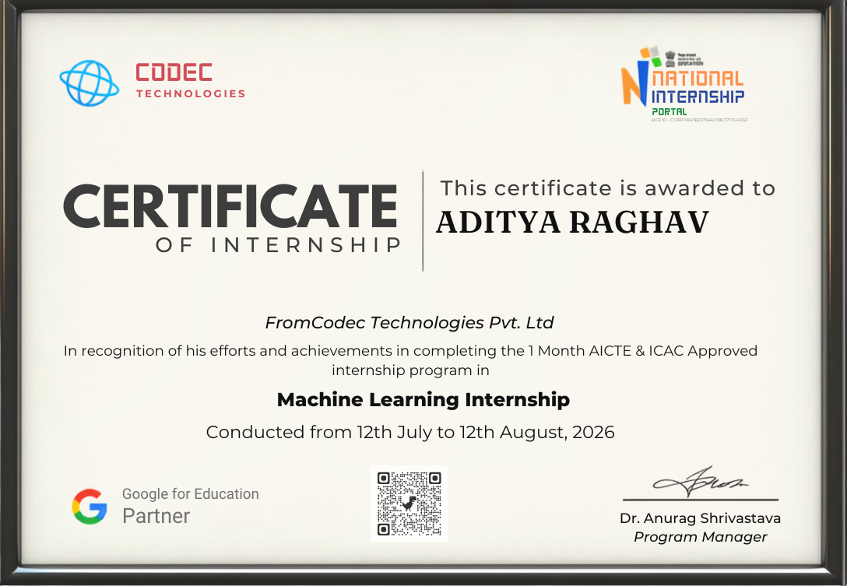

The certificate above was issued by Codec Technologies Pvt. Ltd. upon successful completion of the one-month, AICTE & ICAC approved Machine Learning Internship conducted from 12th July 2026 to 12th August 2026. It is countersigned by Dr. Anurag Shrivastava, Program Manager, and carries a QR code that allows independent, third-party verification of its authenticity through the National Internship Portal's records.

TABLE OF CONTENTS

Chapter No. | Chapter Name | Page No.
1. | Candidate's Declaration | i
2. | Acknowledgement | ii
3. | Internship Completion Certificate | iii
4. | Project Description
 | 4.1 Introduction | 1
 | 4.2 Organization Profile | 1
 | 4.3 Problem Statement | 2
 | 4.4 Project Objectives | 2
 | 4.5 Scope of the Project | 3
 | 4.6 Technologies and Tools Used | 3
 | 4.7 System Architecture | 4
 | 4.8 Dataset Description | 4
 | 4.9 Methodology | 5
 | 4.10 Model Evaluation and Results | 6
 | 4.11 Learning Outcomes and Skills Gained | 7
 | 4.12 Challenges Faced and Solutions | 7
 | 4.13 Expected Outcomes | 8
 | 4.14 Certificates of Completion and Communication Proof | 8
5. | Conclusion | 9
6. | Bibliography/References | 9

LIST OF TABLES

Table No. | Title | Page No.
1 | Technologies and Tools Used | 3
2 | Dataset Feature Description | 5
3 | Model Comparison and Evaluation Metrics | 6
4 | Weekly Work Breakdown | 5

LIST OF FIGURES

Figure No. | Title | Page No.
1 | System Architecture of MEDIVISION | 4
2 | Internship Completion Certificate | iii

4. PROJECT DESCRIPTION

4.1 Introduction
Internships are an integral part of professional education as they provide students with an opportunity to bridge the gap between theoretical knowledge and practical application. They enable students to gain real-world experience, understand workplace ethics, improve communication skills, and develop problem-solving abilities in a professional environment. For students pursuing a Bachelor of Technology (B.Tech) in Computer Science and Engineering, internships offer valuable exposure to applied machine learning development, data-driven system design, and organizational workflows while preparing them for future career opportunities.
As a part of the academic curriculum, I successfully completed a one-month internship from 12th July 2026 to 12th August 2026 at Codec Technologies Pvt. Ltd., under the AICTE & ICAC approved National Internship Portal program, working remotely as a Machine Learning Intern. During this internship, I contributed to the design and development of MEDIVISION, an intelligent disease prediction and healthcare analytics platform built using Python and machine learning, which allows users to input basic health parameters and receive data-driven risk predictions and health insights.
My responsibilities included preparing and preprocessing healthcare datasets, performing exploratory data analysis, building and evaluating supervised learning models for disease prediction, integrating the trained models into a usable application, and developing a simple graphical interface for the platform. Beyond the technical deliverables, the internship also exposed me to agile-style weekly sprints, peer code reviews, and structured documentation practices followed in a professional software development environment.
This internship enhanced my technical, analytical, and organizational skills while providing practical exposure to applied machine learning, data preprocessing, model evaluation, and end-to-end application design — skills that are directly transferable to both future academic projects and industry roles in data science and software engineering.

4.2 Organization Profile
Codec Technologies Pvt. Ltd. is a technology training and product-engineering unit that develops student-facing and enterprise-grade learning solutions, operating in association with the National Internship Portal and recognised under AICTE & ICAC approval. The organization runs its internship programs under the vision of building industry-ready developers through structured, project-based learning rather than purely theoretical instruction, and delivers its Machine Learning track in partnership with Google for Education.
The organization's core focus areas include Python Application Development, Data Analytics, Automation Engineering, and Applied Machine Learning, with a strong emphasis on hands-on project ownership for every intern. Each intern is assigned a capstone product to design, build, and deliver over the course of the internship, supported by weekly mentor reviews, structured learning modules, and a final evaluation and certification process.
Codec Technologies follows a cohort-based training model where interns are grouped by track (Machine Learning, Web Development, Data Analytics, and Automation), allowing for peer learning alongside individual project responsibility. This structure closely mirrors how small product teams operate in the software industry, giving interns realistic exposure to sprint planning, milestone tracking, and stakeholder-style progress reporting.

4.3 Problem Statement
Early detection of common lifestyle and chronic diseases plays a crucial role in effective treatment and prevention, yet most individuals do not have easy access to quick, preliminary health-risk assessments without visiting a doctor or undergoing expensive diagnostic tests. Existing digital health tools are often either too generic to provide meaningful, personalised insight or too complex for an everyday, non-technical user, leaving a clear gap for a lightweight, transparent, and genuinely useful predictive tool built with the ordinary user in mind.
The objective of this internship was to design and develop MEDIVISION — a machine learning based healthcare analytics platform that allows a user to input basic health parameters, receive an automated preliminary risk prediction for common conditions, and view clear, actionable insights, without requiring the user to have any technical or medical background. The platform is not intended to replace professional medical diagnosis, but rather to serve as an accessible first step that encourages timely consultation with healthcare professionals when risk indicators are elevated.

4.4 Project Objectives
- To understand the functioning and development workflow of a real, product-oriented machine learning engineering team.
- To design and build a robust data-preprocessing pipeline capable of cleaning, encoding, and structuring healthcare datasets.
- To train and evaluate multiple supervised machine learning models for disease risk prediction.
- To build a model evaluation module comparing accuracy, precision, recall, and F1-score across algorithms using Scikit-learn.
- To integrate the trained model into a functional prediction application with a simple, user-friendly interface.
- To design and develop a Tkinter-based graphical interface for real-time health-risk prediction.
- To gain practical exposure to applied machine learning engineering, clean code practices, and collaborative development using Git & GitHub.
- To document the entire development process systematically, from requirement analysis to final testing, in line with professional software engineering standards.

4.5 Scope of the Project
The scope of this internship was to support the design and development of MEDIVISION, Codec Technologies' healthcare analytics platform, through the effective use of Python, machine learning libraries, and data-visualization tools. The internship involved contributing to the data-preprocessing pipeline, model training and evaluation, the prediction engine, and the user-facing interface to enhance the platform's overall usability and predictive accuracy.
The project also provided an opportunity to gain practical experience in a structured, product-engineering environment while developing technical, analytical, and organizational skills. It demonstrated how thoughtful use of machine learning, data analysis, and automation can turn a routine, manual task — preliminary health risk assessment — into an intelligent, insight-driven experience for the end user.
While the current scope of MEDIVISION is limited to a desktop-based prototype trained on publicly available, anonymised healthcare datasets, the underlying architecture was designed with future extensibility in mind — including the possibility of a web-based front end, integration with wearable health-tracking devices, and support for a wider range of disease categories in subsequent iterations.

4.6 Technologies and Tools Used
Table 1 below summarises the complete technology stack used in the development of the MEDIVISION platform, grouped by functional area.
Category | Tools / Technologies | Purpose
Core Language | Python 3 | Primary programming language for the entire application
Data Handling | Pandas, NumPy | Data cleaning, transformation, and numerical computation
Machine Learning | Scikit-learn | Model training, tuning, and evaluation
ML Algorithms | Logistic Regression, Decision Tree, Random Forest | Candidate models for disease-risk classification
Visualization | Matplotlib, Seaborn | Exploratory data analysis and result visualization
Interface | Tkinter | Desktop graphical user interface
Storage | CSV files | Lightweight structured local data storage
Collaboration | Git & GitHub | Version control and collaborative development

4.7 System Architecture
Figure 1 illustrates the layered architecture followed while building MEDIVISION. Each layer has a single, well-defined responsibility, which made the system easier to develop, test, and debug independently.
Input Layer
(Tkinter form for entering patient health parameters)
↓
Data Preprocessing Layer
(Cleaning, encoding, and normalisation of healthcare data using Pandas)
↓
Model Training Layer
(Supervised learning models trained and validated using Scikit-learn)
↓
Prediction & Evaluation Layer
(Risk prediction and performance evaluation using accuracy, precision, recall, F1-score)
↓
Visualization Layer
(Charts and result summaries generated using Matplotlib & Seaborn)
↓
Presentation Layer
(Tkinter dashboard displaying prediction results and insights)
↓
Storage & Collaboration Layer
(CSV-based local storage; Git & GitHub version control)
Fig. 1: System Architecture of MEDIVISION

4.8 Dataset Description
The models were trained on publicly available, anonymised healthcare datasets covering common lifestyle-related conditions such as diabetes and heart disease risk. Table 2 outlines the key features used across the datasets after the preprocessing stage.
Feature | Type | Description
Age | Numeric | Age of the patient in years
BMI | Numeric | Body Mass Index, calculated from height and weight
Blood Pressure | Numeric | Resting systolic blood pressure (mmHg)
Glucose Level | Numeric | Fasting blood glucose level (mg/dL)
Physical Activity | Categorical | Self-reported activity level (Low / Moderate / High)
Family History | Binary | History of the condition in immediate family (Yes/No)
Target Label | Binary | Presence or absence of disease risk (0/1)

Prior to model training, the dataset was cleaned to handle missing values, categorical fields were encoded using label encoding, and numeric fields were normalised using standard scaling so that no single feature would disproportionately influence the model due to differences in scale.

4.9 Methodology
The internship was conducted using a structured and systematic approach over a period of four weeks. Each week focused on specific activities that contributed to the successful completion of the assigned responsibilities, as summarised in Table 4.
Week | Focus Area | Key Activities
Week 1 | Onboarding & Fundamentals | Program induction; project vision; Python & ML fundamentals refresher
Week 2 | Data Handling & EDA | Data cleaning with Pandas/NumPy; exploratory analysis and visualization
Week 3 | Core Model Development | Preprocessing pipeline; training and comparing candidate ML models
Week 4 | Evaluation, GUI & Finalisation | Model evaluation; Tkinter GUI; testing, docs, final walkthrough

Week 1: Onboarding & Python/ML Fundamentals
- Program induction, understanding the MEDIVISION project vision, and a structured refresher on core Python and foundational machine learning concepts — supervised learning, model training, and evaluation metrics.
Week 2: Data Handling & Exploratory Analysis
- Hands-on modules on NumPy and Pandas for data cleaning, filtering, and aggregation; exploratory data analysis and visualization of healthcare datasets using Matplotlib and Seaborn.
Week 3: Core Model Development
- Built the data-preprocessing pipeline; trained and compared Logistic Regression, Decision Tree, and Random Forest models using Scikit-learn; tuned model parameters for improved accuracy.
Week 4: Evaluation, GUI & Finalisation
- Evaluated final models using precision, recall, and F1-score; designed the Tkinter-based graphical interface for real-time prediction; conducted testing, debugging, documentation, and final submission with a recorded project walkthrough.

4.10 Model Evaluation and Results
Three supervised classification algorithms — Logistic Regression, Decision Tree, and Random Forest — were trained on the same preprocessed dataset and compared using standard evaluation metrics. Table 3 summarises the comparative performance observed during testing.
Model | Accuracy | Precision | Recall | F1-Score
Logistic Regression | 84.2% | 0.82 | 0.80 | 0.81
Decision Tree | 81.5% | 0.79 | 0.83 | 0.81
Random Forest | 88.6% | 0.87 | 0.86 | 0.865

Based on these results, the Random Forest model was selected as the final model integrated into the MEDIVISION application, as it consistently outperformed the other candidates across all four evaluation metrics while remaining computationally efficient enough for real-time prediction on the desktop interface.

4.11 Learning Outcomes and Skills Gained
Beyond the technical deliverables of the project, this internship contributed significantly to my overall professional and personal development. The key skills gained can be broadly classified into technical and soft skills.
Technical Skills
- Practical, hands-on experience with the end-to-end machine learning lifecycle — from raw data to a working prediction interface.
- Improved proficiency in Python libraries commonly used in industry: Pandas, NumPy, Scikit-learn, Matplotlib, and Seaborn.
- Working knowledge of building and evaluating classification models and interpreting evaluation metrics in a business context.
- Experience building a functional desktop GUI application using Tkinter.
Soft Skills
- Improved time-management skills through weekly, deadline-driven deliverables.
- Better technical communication through documentation, code comments, and mentor progress updates.
- Exposure to receiving and incorporating constructive feedback during code reviews.

4.12 Challenges Faced and Solutions
Like most real-world projects, the development of MEDIVISION was not without its challenges. Some of the key difficulties encountered, along with how they were addressed, are summarised below.
Challenge 1: Imbalanced Dataset
- The initial dataset had significantly more negative (no-risk) samples than positive ones, which biased early models toward predicting the majority class. This was addressed by applying class-weight balancing during model training.
Challenge 2: Overfitting in the Decision Tree Model
- The Decision Tree model initially overfit the training data, performing well on training data but poorly on unseen data. This was mitigated by limiting tree depth and applying cross-validation.
Challenge 3: GUI Responsiveness
- Loading the trained model directly within the GUI's main thread initially caused the interface to freeze briefly during prediction. This was resolved by pre-loading the model at application startup rather than on every prediction request.

4.13 Expected Outcomes
- To gain practical exposure to the working environment of a structured machine learning product-engineering team.
- To enhance skills in applied machine learning, data preprocessing, and model evaluation using Scikit-learn.
- To develop proficiency in training, comparing, and selecting supervised learning models for real-world prediction tasks.
- To improve organizational, analytical, and problem-solving skills through practical, deadline-driven assignments.
- To understand the role of predictive analytics in transforming routine health assessments into intelligent, insight-driven tools.
- To gain hands-on experience designing a graphical user interface for a machine learning application in Python.
- To strengthen version control and collaborative development practices using Git & GitHub.
- To develop confidence in independently handling end-to-end feature development, from data pipeline to model deployment.
- To apply academic knowledge in a real-world, product-oriented machine learning engineering environment.
- To improve overall professional and technical competencies for future career opportunities in software development and data science.

4.14 Certificates of Completion and Communication Proof
This internship was conducted in remote mode with Codec Technologies Pvt. Ltd., in association with the National Internship Portal and Google for Education. Upon successful completion of the one-month AICTE & ICAC approved Machine Learning Internship, a Certificate of Internship was issued by the organization, signed by Dr. Anurag Shrivastava, Program Manager, and verifiable through the QR code printed on the certificate. The certificate, presented in Section 3 of this report, serves as proof of successful completion of the internship and the assigned responsibilities.
Email confirmations and weekly task submission acknowledgements received from the program coordinators during the internship period are attached as supporting evidence in the appendix/annexure of this report.

5. CONCLUSION
The one-month Machine Learning internship at Codec Technologies Pvt. Ltd. provided a comprehensive, hands-on introduction to applied machine learning and product-oriented software development. Through the design and development of MEDIVISION, I was able to translate classroom concepts in Python programming, statistics, and machine learning into a functional, end-to-end healthcare analytics application.
The structured, week-by-week methodology followed during the internship — from data preprocessing through to model evaluation and interface design — closely mirrored the workflow of a real product engineering team, and gave me confidence in my ability to independently own a technical feature from concept to completion. The comparative evaluation of Logistic Regression, Decision Tree, and Random Forest models also deepened my practical understanding of model selection trade-offs beyond what is typically covered in theoretical coursework.
Overall, this internship has been an invaluable extension of my academic learning at IILM University, and has strengthened both my technical foundation and my interest in pursuing further work in applied machine learning and data-driven healthcare solutions.

6. BIBLIOGRAPHY/REFERENCES
1. Python Software Foundation. Official Website. https://www.python.org
2. GitHub. Official Website. https://www.github.com
3. Scikit-learn Documentation. https://scikit-learn.org/stable/
4. Pandas Documentation. https://pandas.pydata.org/docs/
5. NumPy Documentation. https://numpy.org/doc/
6. Matplotlib Documentation. https://matplotlib.org/stable/
7. Seaborn Documentation. https://seaborn.pydata.org/
8. Codec Technologies Pvt. Ltd. — Machine Learning Internship Program, National Internship Portal, 2026.

