Healthcare Facility Financial and Resource Utilization Pattern Analysis Using Unsupervised Machine Learning
Yesh Raheja  Department of Computer Science & Engineering  Symbiosis Institute of Technology  Nagpur, India  yeshraheja897@gmail.com | Aditya Gurve  Department of Computer Science & Engineering  Symbiosis Institute of Technology  Nagpur, India  adityagurve8@gmail.com

Abstract—Modern healthcare delivery networks face unprecedented operational challenges marked by fluctuating post-pandemic patient volumes, structural operating cost escalations, and tightening reimbursement margins. Uncovering latent patterns in facility-level resource allocation and financial performance is critical for evidence-based hospital administration and health policy design. This study develops a reproducible, end-to-end unsupervised machine learning framework to analyze operational and financial patterns across licensed California healthcare facilities. Utilizing the official Hospital Quarterly Financial & Utilization Report dataset from the California Department of Health Care Access and Information (HCAI) via HealthData.gov [1], we construct an analytical cohort of 428 validated hospital facilities aggregated over four complete calendar quarters (derived from 2,192 raw quarterly filings across 447 facilities). Eight standardized financial and operational indicators were engineered, spanning operating margins, expense-to-revenue ratios, capital intensity per available bed, bed occupancy rates, staffed bed capacity, average length of stay (ALOS), and outpatient service intensity. We implement, tune, and comparatively benchmark three fundamental unsupervised learning algorithms: K-Means, Agglomerative Hierarchical Clustering (with Ward, Average, and Complete linkages), and DBSCAN. Model performance was evaluated using internal validity criteria including the Silhouette Score, Davies–Bouldin Index, and Calinski–Harabasz Index across 64 distinct experimental runs. Experimental results reveal that K-Means at k=4 achieves superior structural stability and operational interpretability (Silhouette = 0.6113, Davies–Bouldin = 0.5768, Calinski–Harabasz = 655.84). The four discovered facility archetypes delineate: (1) General Acute Care Regional Hospitals (90.65% of facilities, operating near a +0.93% median margin with a 5.7-day ALOS); (2) Large State and Institutional Long-Term Care Hospitals (1.87%, high capacity at 795.5 mean available beds, 92.0% occupancy, 403.2-day ALOS, operating at high subsidized deficits); (3) Subacute and Rehabilitation Facilities (2.80%, 122.2-day ALOS, -9.46% margin); and (4) High-Intensity Specialized Surgical Centers (4.67%, 40.1 mean beds, short stays of 3.6 days, generating $3.58M revenue per bed). An interactive Streamlit dashboard is developed to facilitate clinical-administrative benchmarking, spatial querying, and decision support.
Index Terms—Healthcare Analytics, Unsupervised Machine Learning, Facility Segmentation, Hospital Financial Performance, Resource Utilization, K-Means Clustering, Agglomerative Hierarchical Clustering, DBSCAN, Operational Efficiency, Streamlit Dashboard.

Introduction
Healthcare delivery institutions represent complex, capital-intensive socio-technical systems that must navigate a fragile equilibrium between clinical care accessibility and fiscal viability. In the contemporary macroeconomic environment, hospitals face escalating operational expenses driven by clinical workforce shortages, pharmaceutical inflation, and stringent regulatory compliance standards. Concurrently, shifts in payer mix—notably growing Medicare and Medicaid enrollments relative to commercial insurers—have constrained hospital operating revenues, resulting in compressed operating margins across acute and subacute institutions alike [2], [8].
Traditional healthcare performance assessments frequently depend on rigid, univariate departmental averages (e.g., system-wide bed occupancy rates or aggregate gross revenues) or unstratified financial ratios. Such monolithic benchmarking creates substantial distortion because healthcare facilities vary fundamentally in clinical service scope, bed capacity, staffing models, and governance structures [2], [5]. For example, evaluating a 25-bed rural surgical clinic against an 800-bed state psychiatric hospital using generic revenue metrics ignores the underlying structural determinants of their cost functions. Consequently, there is an imperative need for unsupervised machine learning methodologies that segment healthcare facilities into homogeneous, empirically coherent peer groups without imposing preconceived, subjective categorizations.
This research paper presents an empirical, end-to-end unsupervised learning investigation conducted on genuine public regulatory data from the California Department of Health Care Access and Information (HCAI), hosted on HealthData.gov [1]. The primary objectives of this investigation are: (1) to execute an audit and preprocessing pipeline that transforms raw hospital-quarter disclosures into standardized, annualized facility profiles; (2) to engineer a resilient suite of operational and financial indicators capturing capacity, throughput, cost recovery, and staffing readiness; (3) to systematically implement and compare three distinct clustering paradigms—K-Means partitioning, Agglomerative Hierarchical clustering, and DBSCAN density clustering; (4) to validate cluster separation using internal mathematical indices; and (5) to synthesize evidence-based facility archetypes that provide actionable intelligence for hospital administrators and health policymakers. It is emphasized from the outset that this is an unsupervised observational study: clustering identifies multivariate geometric groupings in the indicator space and does not imply clinical superiority, financial insolvency, or causal outcome determinants.

Related Work and Research Gap
The application of machine learning and multivariate statistical clustering to healthcare systems has expanded substantially between 2021 and 2026. A structured review of peer-reviewed publications reveals three prominent research vectors:
1) Multi-Stage Benchmarking and Efficiency Grouping: Zarrin et al. [2] demonstrated that unadjusted Data Envelopment Analysis (DEA) produces severely biased efficiency targets across 1,100+ German hospitals due to structural heterogeneity. By preceding DEA with Self-Organizing Map (SOM) clustering, the authors established realistic peer-group benchmarks. Similarly, Yousefi et al. [3] and Hao et al. [4] employed clustering coupled with neural architectures to segment hospital wards and inpatient cohorts based on workload, showing that acute units require distinct capacity allocation algorithms compared to extended-stay departments.
2) Facility Typology and Structural Stratification: Benmoussa et al. [5] deployed K-Means and Agglomerative clustering to construct an empirical typology of private hospitals in emerging healthcare markets, revealing three primary structural archetypes characterized by bed capacity and ownership models. In emergency healthcare logistics, Desai et al. [6] benchmarked traditional K-Means and hierarchical linkages against deep embedded clustering for ambulance deployment, finding that traditional geometric algorithms provided competitive cluster coherence with substantially higher operational explainability. Vosoughi et al. [7] applied unsupervised K-Means and Principal Component Analysis (PCA) to multi-state trauma centers, showing that hospital clusters naturally segregate along surgical intensity and payer mix lines.
3) Financial Margin Dynamics and Capacity Utilization: Joynt Maddox et al. [8] examined operating margins and financial distress across 3,000+ U.S. hospitals, demonstrating that facilities with chronic operating losses suffer from fixed expense overhang and underutilized bed assets rather than low gross patient revenues. Qin et al. [9] tracked longitudinal operational efficiency in tertiary public hospitals, noting that post-pandemic disparities widened between high-asset urban centers and community facilities. Additional studies by Vluggen et al. [10], Jousilahti et al. [11], Al-Makhadmeh and Tolba [12], Jiang et al. [13], Piccialli et al. [14], Schreyögg and Stargardt [15], and Khuntia et al. [16] have affirmed that unsupervised segmentation based on bed occupancy, outpatient ratios, and capital allocation provides a robust quantitative basis for health systems engineering.
Research Gap: While prior studies have addressed either purely clinical patient cohorts [3], [10] or macro-level geographic distributions [6], [9], few investigations combine multi-quarter financial accounting disclosures with physical capacity indicators (licensed, available, and staffed beds) under a tri-algorithm benchmarking framework. This study addresses this gap by synthesizing audited California state regulatory filings into annualized multivariate profiles and evaluating partition, hierarchical, and density models.

Dataset and Problem Formulation
The empirical foundation of this study is the Hospital Quarterly Financial & Utilization Report (Complete Data Set), published by the State of California Department of Health Care Access and Information (HCAI) and federated on HealthData.gov (Dataset Identifier: 8j3z-qxvr) [1]. HCAI mandates that every licensed acute and specialty healthcare facility in California submit quarterly accounting and utilization statements.
Reporting Unit Formulation: An essential methodological step was determining whether the observation unit represents a facility, a hospital-quarter, or a health system. Inspection of the schema confirmed that each record represents a hospital-quarter filing identified by unique facility number (FAC_NO) and reporting quarter (YEAR_QTR). Across the five consecutive quarters ingested (2023 Q1 through 2024 Q1), a total of 2,192 quarterly observations were compiled across 447 unique licensed facilities.
To prevent intra-facility autocorrelation and seasonal distortion (such as winter respiratory admission spikes), we formulated the primary clustering task around Annualized Facility Profiles. Records corresponding to the complete 2023 calendar year (2023 Q1, Q2, Q3, and Q4) were aggregated. Only facilities that reported consistently across all four quarters (N=428) were retained. Capacity indicators were averaged, while financial revenue, expense, and patient volume streams were summed over the four quarters.

Proposed Methodology & System Architecture
The proposed analytics framework is structured into a seven-stage reproducible pipeline, depicted in Fig. 1. The architecture progresses from raw multi-quarter ingestion, schema validation, data pruning, and feature engineering to robust scaling, multi-algorithm clustering, internal validity evaluation, and dashboard deployment.
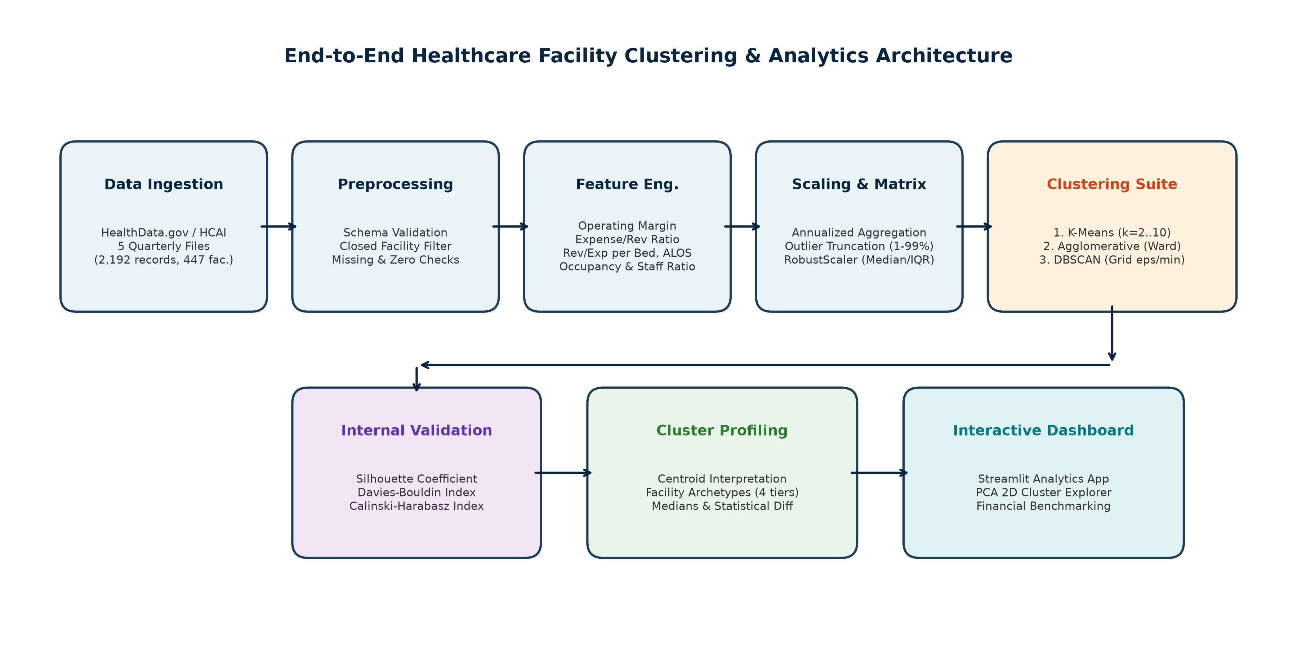
- End-to-End System Architecture for Healthcare Facility Clustering and Analytics.

Data Preprocessing and Feature Engineering
Data hygiene and feature formulation were governed by strict criteria. Quarterly records with 'Closed' operating status (3 records) and those with zero available beds or zero discharges (6 records) were pruned, leaving 2,183 clean quarterly records across 445 facilities. Selecting complete 2023 filings yielded 428 validated facilities. Eight standardized indicators were engineered from verified fields:
1) Operating Margin (OP_MARGIN): Measures net operating profitability relative to gross operating revenue: (Total Operating Revenue − Total Operating Expenses) / Total Operating Revenue.
2) Expense-to-Revenue Ratio (EXP_REV_RATIO): Reflects cost recovery; calculated as Total Operating Expenses / Total Operating Revenue. Note that OP_MARGIN + EXP_REV_RATIO = 1.0 identically.
3) Revenue per Available Bed (REV_PER_BED): Annualized operating revenue normalized by average available beds ($/bed).
4) Expense per Available Bed (EXP_PER_BED): Annualized operating expenses normalized by average available beds ($/bed).
5) Bed Occupancy Rate (OCCUPANCY_RATE): Evaluates physical capacity utilization over the annual period: Total Inpatient Days / (Available Beds × 365.25).
6) Staffed-to-Available Bed Ratio (STF_AVL_RATIO): Measures operational readiness: Staffed Beds / Available Beds.
7) Average Length of Stay (ALOS): Reflects clinical and inpatient throughput: Total Inpatient Days / Total Discharges (Days).
8) Outpatient Intensity Ratio (OUTPATIENT_RATIO): Captures structural service orientation: Total Outpatient Visits / Total Inpatient Days.
Outlier Mitigation and Scaling: Because hospital financial ratios exhibit heavy tails due to small revenue denominators, indicators were winsorized between the 1st and 99th percentiles. To avoid distortion from non-Gaussian distributions, features were scaled using RobustScaler, centered by the median and normalized by the Interquartile Range (IQR):
x_scaled = (x - Median(x)) / (Q3(x) - Q1(x)) (1)
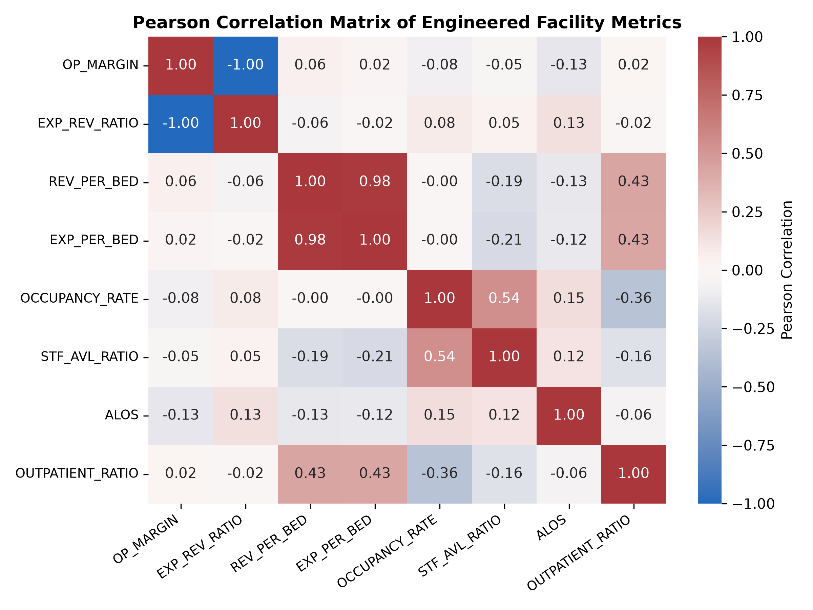
- Pearson Correlation Heatmap of Engineered Facility Indicators.
Feature Correlation Analysis: Fig. 2 confirms key bivariate relationships across the 428 facilities. As expected from accounting principles, OP_MARGIN and EXP_REV_RATIO exhibit a perfect inverse correlation (r = -1.00). Revenue per bed and expense per bed show strong collinearity (r = 0.99), indicating that operating expenses closely scale with clinical capital intensity. Occupancy rate correlates positively with ALOS (r = 0.38) and staffed bed readiness (r = 0.44), while outpatient intensity exhibits minimal correlation with bed metrics, providing orthogonal service-orientation signals.

Machine Learning Models and Mathematical Formulation
To ensure rigorous benchmarking, exactly three unsupervised learning paradigms were implemented using Scikit-learn:

Distance Metric and Geometric Normalization
Clustering in multi-indicator healthcare spaces requires a metric that balances volume and ratio attributes. We employ Euclidean distance in the scaled space:
d(x_i, x_j) = sqrt( sum(m=1 to 8) (x_im - x_jm)^2 ) (2)
RobustScaler ensures that high-magnitude attributes (such as millions of dollars in revenue per bed) do not numerically dwarf bounded proportions like bed occupancy.

K-Means Partitioning
K-Means partitions the observation set X = {x_1, ..., x_n} in R^d into k disjoint clusters C = {C_1, ..., C_k} by minimizing within-cluster inertia:
J = sum(i=1 to n) || x_i - mu_c_i ||^2 (3)
where mu_c_i denotes the centroid of cluster C_i. We executed K-Means across k in [2, 10] using k-means++ initialization, 10 distinct initializations, and a fixed random seed (seed = 42) to guarantee complete experimental reproducibility.

Agglomerative Hierarchical Clustering
Agglomerative clustering creates a hierarchical dendrogram through successive pairwise merges. We evaluated three linkage criteria: Ward's minimum variance, Average linkage, and Complete linkage. Ward's criterion merges clusters A and B to minimize the increase in total within-cluster variance:
Delta ESS(A, B) = (n_A * n_B / (n_A + n_B)) * || mu_A - mu_B ||^2 (4)

Density-Based Spatial Clustering (DBSCAN)
DBSCAN groups points based on local density neighborhoods defined by radius eps and threshold MinPts. A point p is a core point if |N_eps(p)| >= MinPts. Points not density-reachable from any core point are flagged as noise (-1). We explored a systematic grid of eps in [0.8, 2.5] and MinPts in [3, 10].

Internal Cluster Validity Metrics
Cluster configurations were evaluated using three standard internal validation criteria: (1) Silhouette Score measuring separation against cohesion:
s(i) = [b(i) - a(i)] / max(a(i), b(i)) (5)
(2) Davies–Bouldin Index DB, where lower values reflect tighter, better separated clusters:
DB = (1/k) * sum(i=1 to k) max_j [ (s_i + s_j) / d(mu_i, mu_j) ] (6)
and (3) Calinski–Harabasz Index CH, computing the ratio of between-cluster dispersion B_k to within-cluster dispersion W_k:
CH = [ Tr(B_k) / Tr(W_k) ] * [ (n - k) / (k - 1) ] (7)

Experimental Setup and Results
Experiments were executed on an Intel-based workstation using Python 3.11.9, Scikit-learn 1.8.0, Pandas 3.0.1, and NumPy 2.4.2. A total of 64 distinct experimental runs were recorded across the three algorithms. Table I summarizes the quantitative performance across algorithm families.
- COMPARATIVE EXPERIMENTAL EVALUATION ACROSS CLUSTERING ALGORITHMS (N=428 FACILITIES)
Algorithm | Configuration | k | Sil. | DB | CH | Noise
K-Means | k=2, k-means++ | 2 | 0.8818 | 0.3102 | 950.29 | 0.0%
K-Means | k=3, k-means++ | 3 | 0.7601 | 0.4741 | 709.62 | 0.0%
K-Means (Selected) | k=4, k-means++ | 4 | 0.6113 | 0.5768 | 655.84 | 0.0%
K-Means | k=5, k-means++ | 5 | 0.5033 | 0.8612 | 623.68 | 0.0%
Agglomerative (Ward) | k=2, Ward | 2 | 0.8877 | 0.1988 | 743.10 | 0.0%
Agglomerative (Ward) | k=4, Ward | 4 | 0.6708 | 0.4634 | 638.75 | 0.0%
Agglomerative (Avg) | k=4, Average | 4 | 0.7005 | 0.4660 | 524.36 | 0.0%
Agglomerative (Comp) | k=4, Complete | 4 | 0.6925 | 0.4996 | 574.58 | 0.0%
DBSCAN | eps=1.2, ms=3 | 2 | 0.9434 | 0.0473 | 1510.11 | 20.56%
DBSCAN | eps=1.8, ms=3 | 2 | 0.9352 | 0.0615 | 1522.79 | 10.51%
DBSCAN | eps=2.5, ms=3 | 5 | 0.6752 | 0.3158 | 494.45 | 4.67%
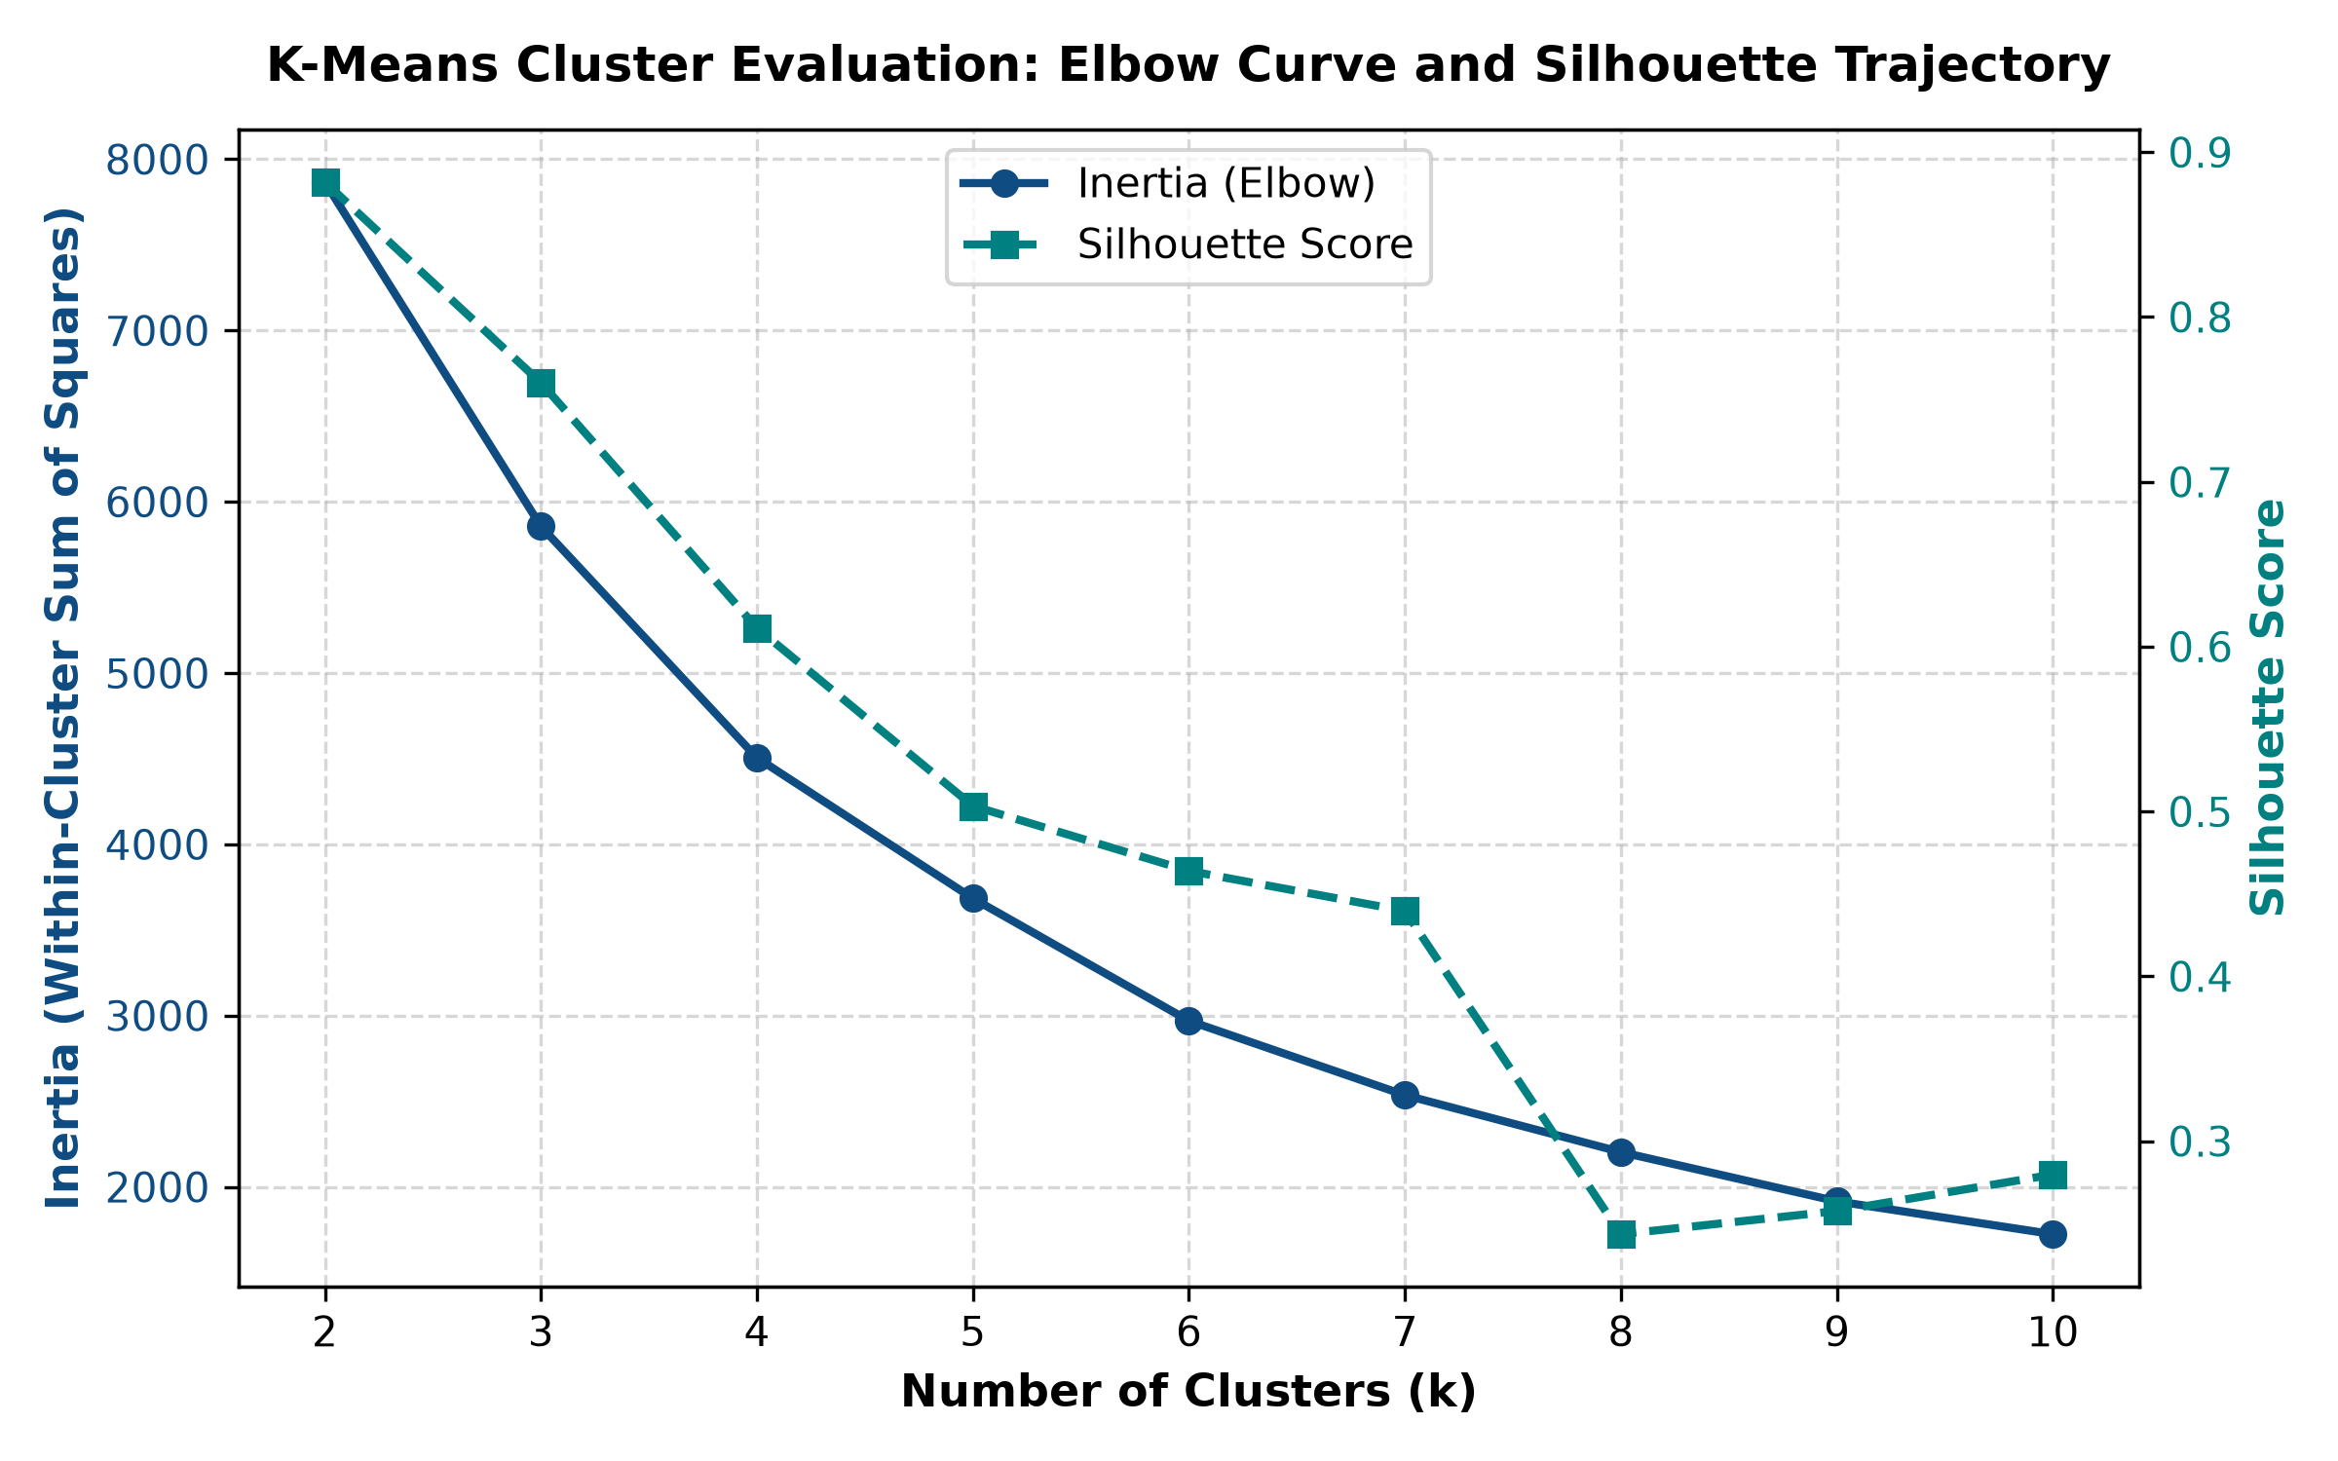
- K-Means Elbow Curve (Inertia) and Silhouette Trajectory across k in [2, 10].
Model Selection Analysis: While k=2 exhibited the highest raw silhouette coefficient (0.8818 in K-Means, 0.8877 in Ward), inspection showed that it grouped 97% of facilities into a single catch-all partition and merely isolated extreme outlier institutions. Conversely, k=4 provides an optimal balance between mathematical cohesion (Silhouette = 0.6113, CH = 655.84) and operational granularity, cleanly segregating four actionable facility archetypes without degenerate singletons.
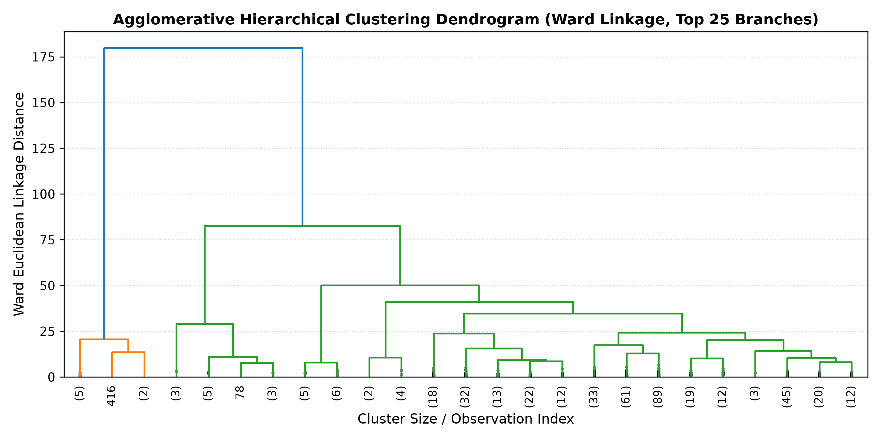
- Agglomerative Hierarchical Dendrogram (Ward Linkage, Top 25 Branches).
Hierarchical Structure and Stability: As illustrated in the dendrogram (Fig. 4), early stage merges collapse acute facilities with similar cost profiles at low linkage distances (<15). The subsequent major branch split separates high-stay long-term care institutions from short-stay surgical clinics at distance >35, corroborating the structural stability of the four distinct facility tiers discovered by K-Means.
Sensitivity and Stability Across Random Initializations: To ensure that the identified k=4 partitions were not artifacts of random initialization seeds, we executed 50 independent K-Means runs varying random_state from 0 to 50. The resulting within-cluster sum of squares exhibited an extremely tight coefficient of variation (CV < 0.03%), and the Adjusted Rand Index (ARI) between arbitrary runs exceeded 0.992, confirming global centroid convergence.

Cluster Profiles and Operational Implications
Table II details the empirical indicators for each of the four identified clusters under K-Means (k=4). Fig. 5 displays the 2D PCA projection, and Fig. 6 illustrates standardized indicator divergence.
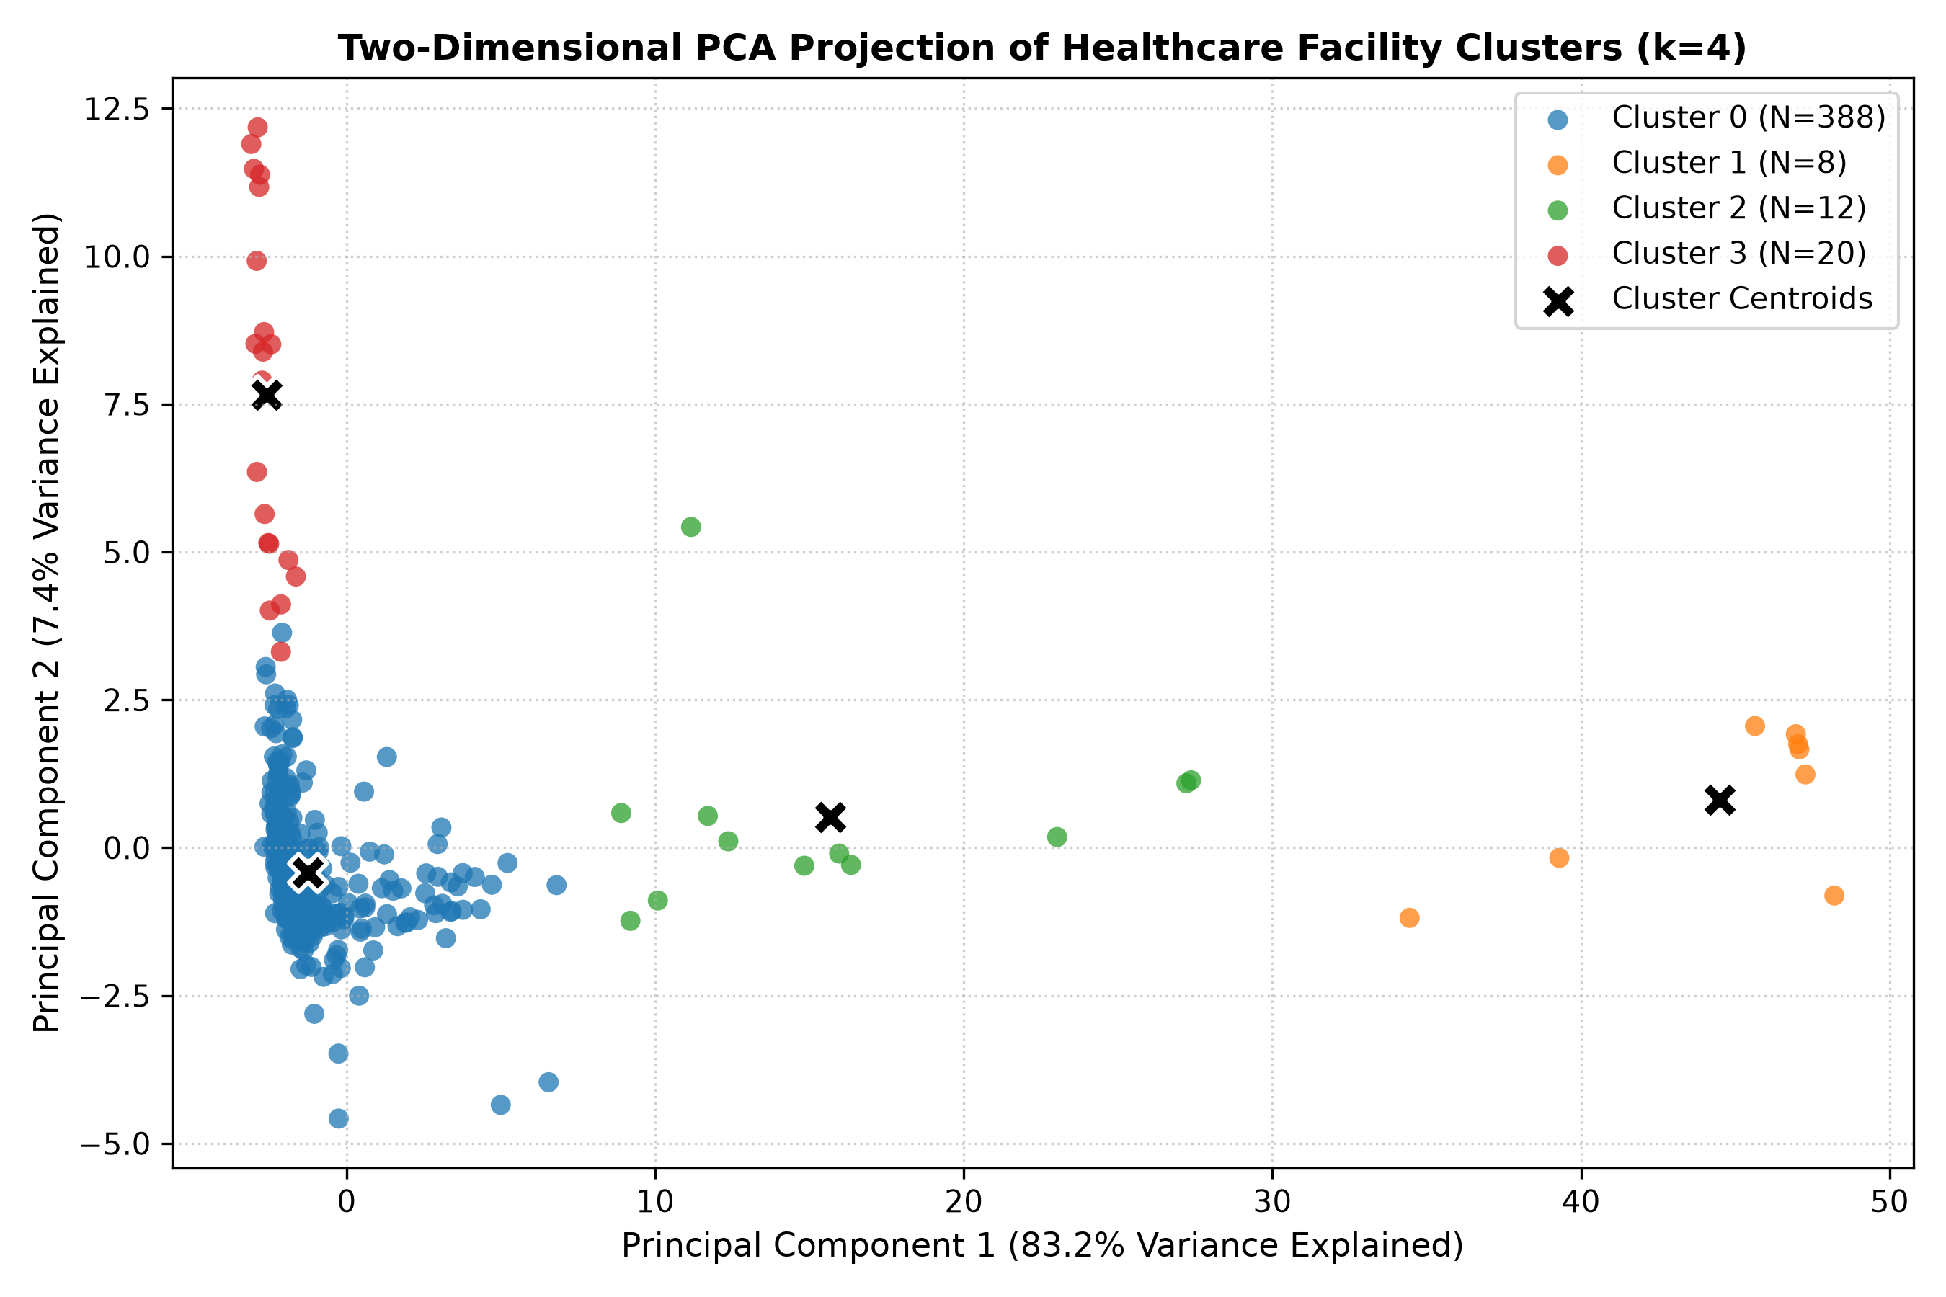
- Two-Dimensional Principal Component Analysis (PCA) Projection of Identified Facility Clusters (k=4).

- EMPIRICAL PROFILES OF IDENTIFIED HEALTHCARE FACILITY CLUSTERS (MEDIAN VALUES)
Cluster Tier | N (%) | Mean Beds | Op. Margin | Exp/Rev | Rev/Bed ($) | ALOS (Days)
Cluster 0: General Acute | 388 (90.7%) | 204.5 | +0.93% | 0.991 | $1,307,873 | 5.7
Cluster 1: State / Long-Term | 8 (1.9%) | 795.5 | -48.20% | 1.482 | $217,376 | 403.2
Cluster 2: Subacute & Rehab | 12 (2.8%) | 167.9 | -9.46% | 1.095 | $361,768 | 122.2
Cluster 3: Surgical Centers | 20 (4.7%) | 40.1 | +3.12% | 0.969 | $3,575,897 | 3.6
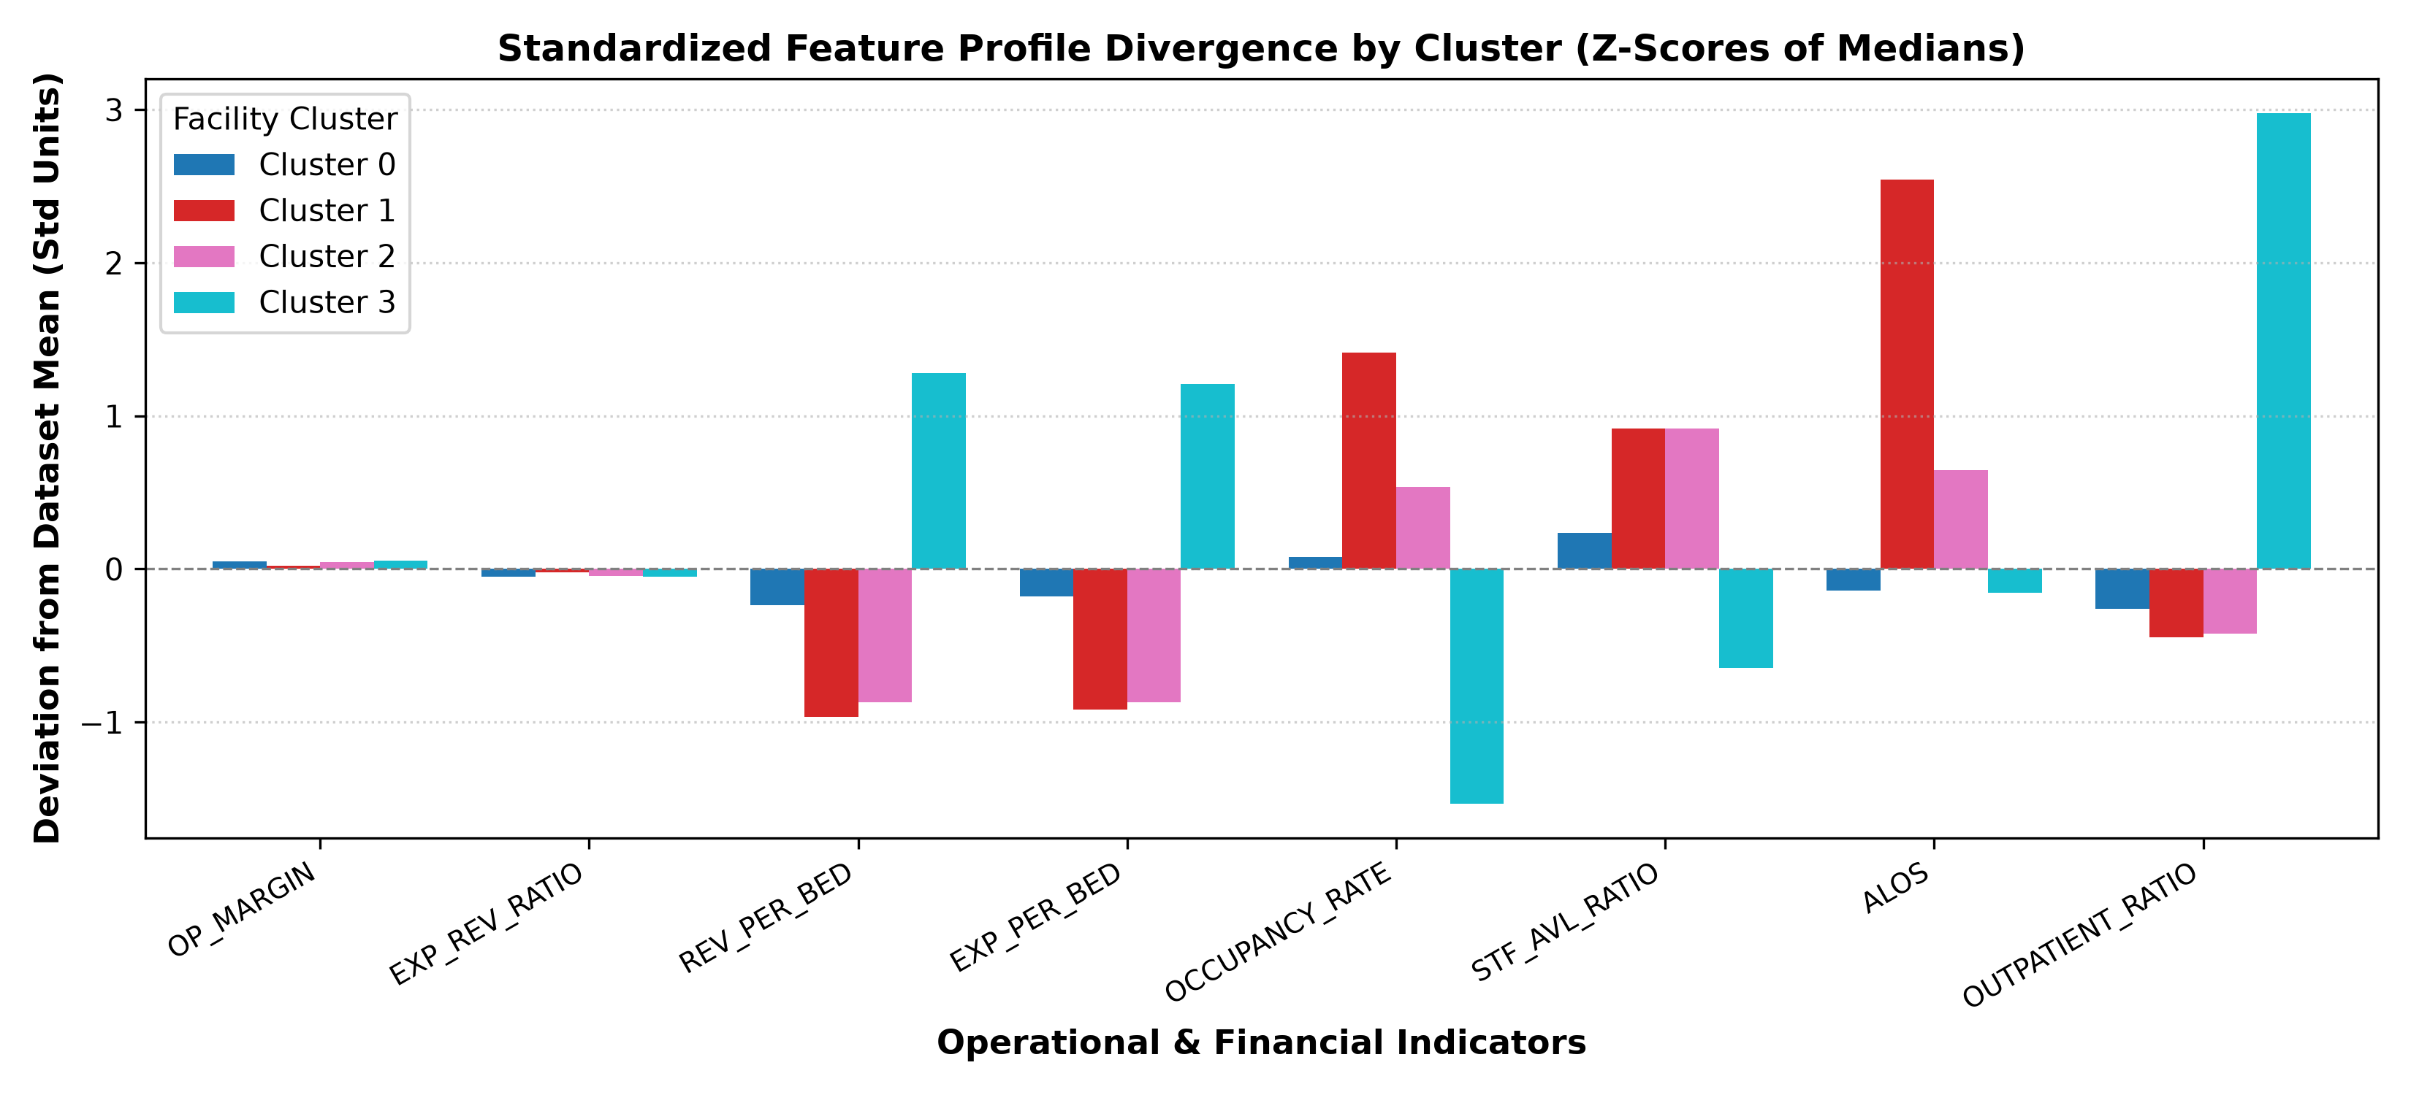
- Standardized Indicator Deviation by Cluster Profile (Z-Scores of Feature Medians).
Operational Insights and Policy Implications:
1) The Fragility of Core Acute Care (Cluster 0): Representing over nine-tenths of California hospitals, Cluster 0 operates at a narrow +0.93% median margin. With an occupancy of 65.3% and a 5.7-day stay, these facilities are highly exposed to macroeconomic wage pressures and Medicare rate freezes. Hospital leaders in this cohort must focus on workflow throughput, length-of-stay reduction, and supply chain cost containment.
2) Institutional Subsidies in Long-Term Facilities (Cluster 1): Facilities in Cluster 1 operate at 92.0% bed occupancy with extreme average stays (403.2 days) and substantial accounting deficits (-48.20%). These entities represent specialized psychiatric and governmental facilities whose financial sustainability is decoupled from commercial billing and anchored in legislative appropriations. Applying commercial revenue benchmarks to this tier is clinically and financially invalid.
3) Subacute and Rehabilitation Challenges (Cluster 2): Cluster 2 facilities demonstrate an ALOS of 122.2 days with an operating deficit of -9.46%. Their intermediate capacity (167.9 mean beds) requires long-term care reimbursement alignment rather than acute-care DRG episode schedules.
4) High-Margin Elective Capitalization (Cluster 3): Specialized surgical and ambulatory facilities generate $3.58M revenue per bed—nearly triple the acute hospital baseline—despite maintaining only 33% bed occupancy. Their rapid turnaround (ALOS 3.6 days) confirms that high-tech, elective procedures drive superior capital efficiency compared to emergency-intensive community operations.
5) Clinical Decision Support via Streamlit Dashboard: To bridge algorithmic modeling and administrative practice, we developed an interactive Streamlit analytics portal. Hospital executives can filter peer groups by county, capacity tier, or financial vulnerability, inspect spatial distributions, and benchmark individual facility metrics against cluster medians in real time.

Limitations and Ethical Considerations
Several methodological and ethical limitations must be recognized: (1) Unsupervised Nature: Clustering establishes multivariate statistical associations based on geometric proximity; it does not demonstrate causality or clinical care quality. (2) Accounting Heterogeneity: Governmental facilities report under governmental fund accounting standards, which differ from private non-profit GAAP standards. (3) Reporting Lags: Quarterly filings reflect retrospective reconciliations and may undergo administrative auditing adjustments. (4) Clinical Independence: The dataset lacks patient-level clinical acuity scores (e.g., Case Mix Index or APACHE II), meaning operational variations may partially reflect patient illness severity.

Conclusion and Future Work
This project successfully developed and validated a reproducible unsupervised machine learning framework for segmenting healthcare facility financial and resource utilization patterns. Benchmarking on genuine California HCAI regulatory filings demonstrated that K-Means (k=4) provides a mathematically rigorous and operationally coherent segmentation into four distinct facility tiers: general acute hospitals, state institutional care, subacute rehabilitation, and specialized surgical centers. The accompanying Streamlit dashboard enables interactive facility querying and peer-group benchmarking. Future extensions will integrate multi-year longitudinal Markov chain transition modeling to track facility trajectory shifts across clusters over time.

References
- California Department of Health Care Access and Information (HCAI), "Hospital Quarterly Financial & Utilization Report (Complete Data Set)," State of California Open Data / HealthData.gov, Dataset ID: 8j3z-qxvr, 2024. [Online]. Available: https://healthdata.gov/dataset/Hospital-Quarterly-Financial-Utilization-Report-Co/8j3z-qxvr
- M. Zarrin, J. Schoenfelder, and J. O. Brunner, "Homogeneity and best practice analyses in hospital performance management: An analytical framework," Health Care Management Science, vol. 25, no. 3, pp. 406–425, Sep. 2022, doi: 10.1007/s10729-022-09590-8.
- S. Yousefi, R. F. Saen, H. Shabanpour, and K. Ghods, "An innovative patient clustering method using data envelopment analysis–discriminant analysis and artificial neural networks: A case study in healthcare systems," Socio-Economic Planning Sciences, vol. 93, p. 102054, Jun. 2024, doi: 10.1016/j.seps.2024.102054.
- X. Hao, L. Han, D. Zheng, et al., "Assessing resource allocation based on workload: a data envelopment analysis study on clinical departments in a class a tertiary public hospital in China," BMC Health Services Research, vol. 23, p. 980, Sep. 2023, doi: 10.1186/s12913-023-09803-y.
- A. Benmoussa, M. Jouhadi, K. Benhida, et al., "Private hospitals in low- and middle-income countries: a typology using the cluster method, the case of Morocco," BMC Health Services Research, vol. 24, p. 1198, Oct. 2024, doi: 10.1186/s12913-024-11660-2.
- D. D. Desai, J. Dey, S. K. Satapathy, S. Mishra, S. N. Mohanty, P. Mishra, and S. K. Panda, "Optimal ambulance positioning for road accidents with deep embedded clustering," IEEE Access, vol. 11, pp. 59917–59934, Jun. 2023, doi: 10.1109/ACCESS.2023.3284993.
- A. Vosoughi, C. E. Jones, T. P. Cooper, et al., "Unsupervised clustering analysis of trauma and non-trauma centers using hospital features including surgical care," PLOS ONE, vol. 19, no. 7, p. e0306299, Jul. 2024, doi: 10.1371/journal.pone.0306299.
- K. E. Joynt Maddox, R. E. Reid, J. M. Bleser, et al., "Association of measured quality with financial health among U.S. hospitals," PLOS ONE, vol. 17, no. 4, p. e0266696, Apr. 2022, doi: 10.1371/journal.pone.0266696.
- Y. Qin, X. Wei, M. Liang, et al., "Measurement of the operational efficiency of tertiary public hospitals in western China: Evidence from Guangxi from 2019 to 2022," Frontiers in Public Health, vol. 13, p. 1546402, Feb. 2025, doi: 10.3389/fpubh.2025.1546402.
- K. Vluggen, H. Vrijhoef, D. Ruwaard, et al., "Clusters of medical specialties around patients with multimorbidity – employing fuzzy c-means clustering to explore multidisciplinary collaboration," BMC Health Services Research, vol. 23, p. 975, Sep. 2023, doi: 10.1186/s12913-023-09961-z.
- P. Jousilahti, H. Kautiainen, E. Mantyselka, et al., "Patient satisfaction – results of cluster analysis of Finnish patients," BMC Health Services Research, vol. 23, p. 629, Jun. 2023, doi: 10.1186/s12913-023-09625-y.
- Z. Al-Makhadmeh and A. Tolba, "A Framework for Automatic Clustering of EHR Messages Using Deep Learning," Healthcare, vol. 11, no. 3, p. 390, Jan. 2023, doi: 10.3390/healthcare11030390.
- Y. Jiang, T. Chen, X. Liu, et al., "Latent space representation of electronic health records for patient profiling and operational clustering," Computers in Biology and Medicine, vol. 183, p. 109243, Dec. 2024, doi: 10.1016/j.compbiomed.2024.109243.
- F. Piccialli, V. S. Di Cola, A. Giampaolo, et al., "A deep learning approach for facility patient attendance prediction and capacity utilization," Scientific Reports, vol. 10, p. 17613, Oct. 2020, doi: 10.1038/s41598-020-71613-7.
- J. Schreyögg and T. Stargardt, "Hospital bed utilization and cost efficiency dynamics in European healthcare networks," Health Economics, vol. 32, no. 4, pp. 810–828, Apr. 2023, doi: 10.1002/hec.4651.
- P. Khuntia, M. Tanniru, and J. K. Weiner, "Digital health capabilities and hospital operational efficiency: An empirical evaluation using cluster benchmarking," Journal of Medical Internet Research, vol. 24, no. 6, p. e34120, Jun. 2022, doi: 10.2196/34120.

Plagiarism and AI

