Retail Inventory
Management System
Software Requirements Specification
Submitted by
ADITYA KUMAR PANDEY
Roll Number
2400320100079
Department
CSE
Institution
ABES ENGINEERING COLLEGE
Submitted to
Sajin Kamraj
Academic Year 2026 to 2027

Reading guide
Retail Inventory Management System | HCL project review
Section | Page
01 Purpose and scope | 3
02 Users and system boundary | 4
03 Architecture and interfaces | 5
04 Catalog requirements | 6
05 Stock requirements | 7
06 Order requirements | 8
07 Data model and integrity | 9
08 Input validation and errors | 10
09 Quality requirements | 11
10 Use cases and user journeys | 12
11 Security and operating environment | 13
12 Acceptance and traceability | 14

Document baseline
Version 2.0 | 30 October 2026 | Academic year 2026 to 2027. The diagrams describe the current application. Proposed enhancements and unverified acceptance targets are identified explicitly.

01 Purpose and scope
This specification defines the behavior and acceptance criteria of the Retail Inventory Management System for academic evaluation by the HCL project guide.

Problem to be solved
Manual records and disconnected spreadsheets make it difficult to determine how much stock exists at each location. A sale can be recorded without sufficient inventory, and a cancelled sale may not return units to the correct warehouse. This system centralizes master data and connects customer orders directly to stock changes.

Project scope
Included in this version | Planned extension
Product, supplier and warehouse CRUD | Barcode scanning and purchase orders
Warehouse-level additions and deductions | Historical movement ledger and audit trail
Order creation and cancellation | Multi-item order entry in the frontend
Live counts and low-stock list | Historical analytical charts and reports
JWT authentication APIs | Login screen and enforced role authorization

Requirement conventions
FR identifies a functional requirement; NFR identifies a quality requirement; AC identifies an acceptance case. Shall denotes required behavior. A target describes desired quality that still requires measurement. Future scope does not describe completed functionality.

Terminology
Term | Definition
SKU | Unique catalog identifier for a product.
Stock record | Quantity associated with one product and one warehouse.
Reorder level | Threshold compared with total quantity across all warehouses.
Order item | Product, warehouse, quantity and price snapshot within an order.
Transaction | A set of database changes committed together or rolled back on failure.

02 Users and system boundary
The application serves an inventory operator through a browser. The current demonstration has no frontend login, so administrator and staff labels describe intended responsibilities rather than enforced access levels.
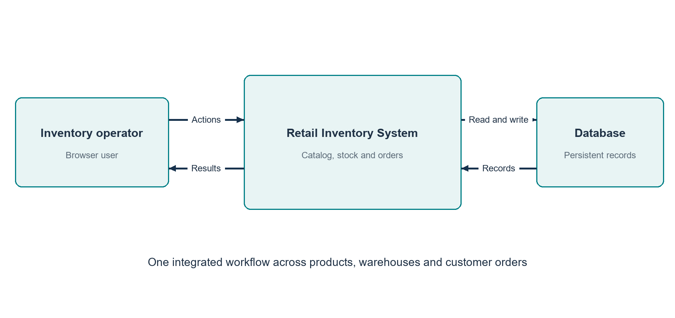
Figure S1 System context and information exchange
Participant | Responsibilities
Inventory operator | Maintain catalog data, record stock, create orders and cancel orders.
Project guide | Review requirements, implementation decisions and verification evidence.
MySQL database | Persist application records and enforce relational constraints.
Browser | Render the React UI and submit JSON requests to the backend.

Operating assumptions
The backend must be reachable from the browser. Supplier and warehouse records should be created before the guided stock workflow. The frontend and API both permit a product without a supplier. In-memory H2 data is temporary and is lost when its backend process stops.

03 Architecture and interfaces
The project uses a layered monolithic backend and a separate React single-page application. This separates presentation, HTTP handling, business logic and persistence without introducing distributed services.
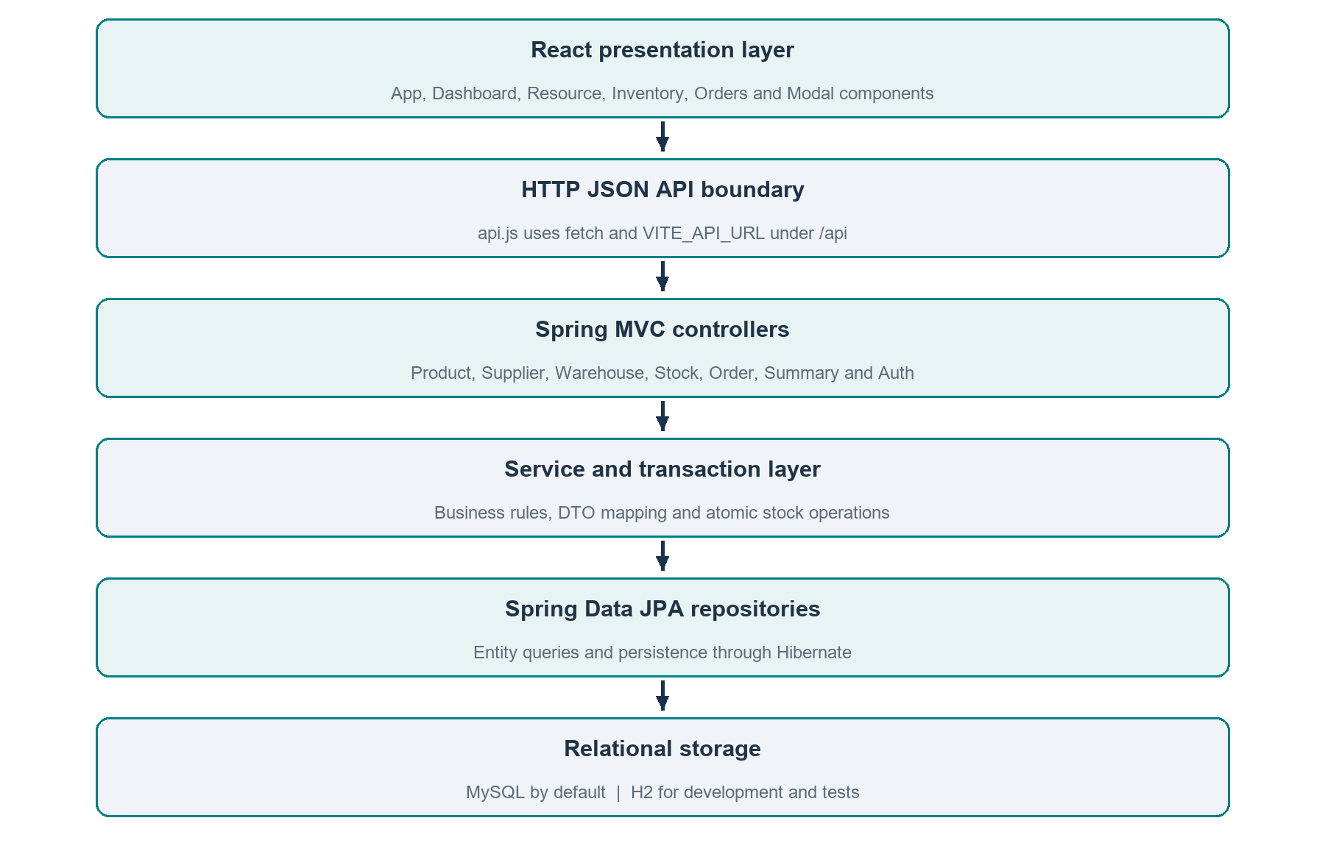
Figure S2 Implemented application layers and their responsibilities
The API client loads products, suppliers, warehouses, stock, orders and summary concurrently with Promise.all. Controllers validate request DTOs. Services map between entities and response DTOs. Repositories access relational data through Hibernate.

04 Catalog requirements
Catalog requirements cover the reusable master records needed before stock and order operations.
ID | Required behavior | Acceptance reference
FR 01 | List, create, edit and delete suppliers with a required name and valid email when supplied. | AC 01
FR 02 | List, create, edit and delete warehouses with a required name and optional location at the API. | AC 02
FR 03 | Maintain products with unique SKU, name, category, price, reorder level and supplier reference. | AC 03
FR 04 | Return a product by identifier or a not-found error when it does not exist. | AC 04
FR 05 | Reject deletion when relational references prevent removing a record. | AC 05

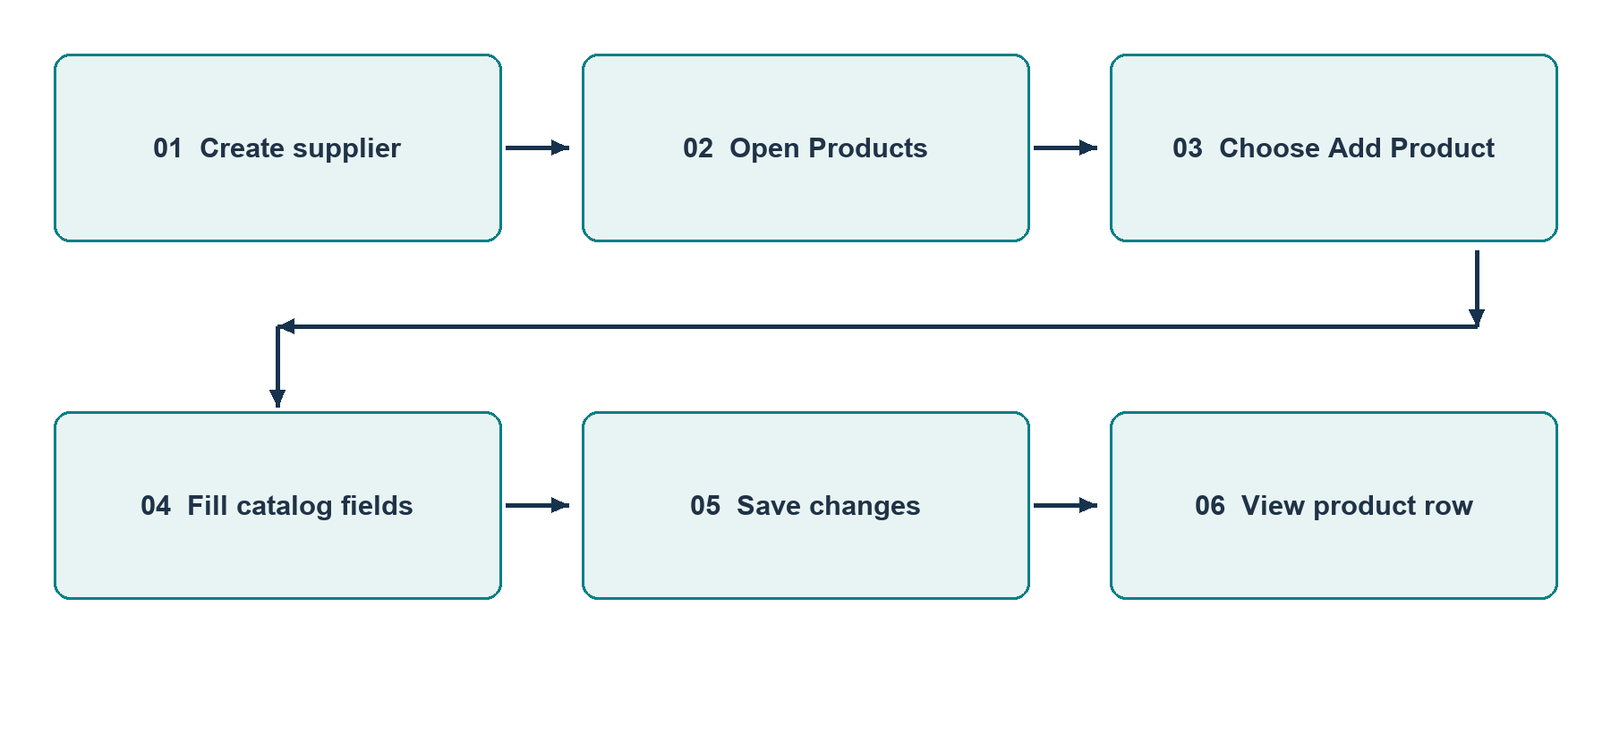
Figure S3 Product creation user journey

Postcondition
Successful creation makes the record available in the relevant table after data reload. Creating a product does not create warehouse stock. The operator must add quantity through Inventory before fulfilling an order.

05 Stock requirements
Stock is stored at the product and warehouse level. The displayed product total is the sum across all its warehouse records.
ID | Required behavior
FR 06 | List product name, SKU, warehouse and quantity for each stock record.
FR 07 | Add a strictly positive integer quantity to a selected product and warehouse. Create the pair at zero before incrementing if it does not yet exist.
FR 08 | Deduct only a positive quantity that does not exceed the currently loaded stock record. Reject missing stock records.
FR 09 | Enforce one stock record per product and warehouse pair.
FR 10 | Identify products with aggregate stock less than or equal to reorderLevel, including products with no stock records.

Worked example
Event | Warehouse A | Warehouse B | Total | Low stock at threshold 5
Product created | 0 | 0 | 0 | Yes
Add ten units to A | 10 | 0 | 10 | No
Add four units to B | 10 | 4 | 14 | No
Deduct nine units from A | 1 | 4 | 5 | Yes

Boundary behavior
A quantity of zero or less shall be rejected by DTO validation. An amount larger than current stock shall return HTTP 400. The service locks products and stock rows to serialize quantity changes. The live MySQL order and cancellation checks passed three consecutive concurrency rounds. Sustained load testing remains a future extension.

06 Order requirements
Order creation and cancellation link business records with inventory changes in a transaction.
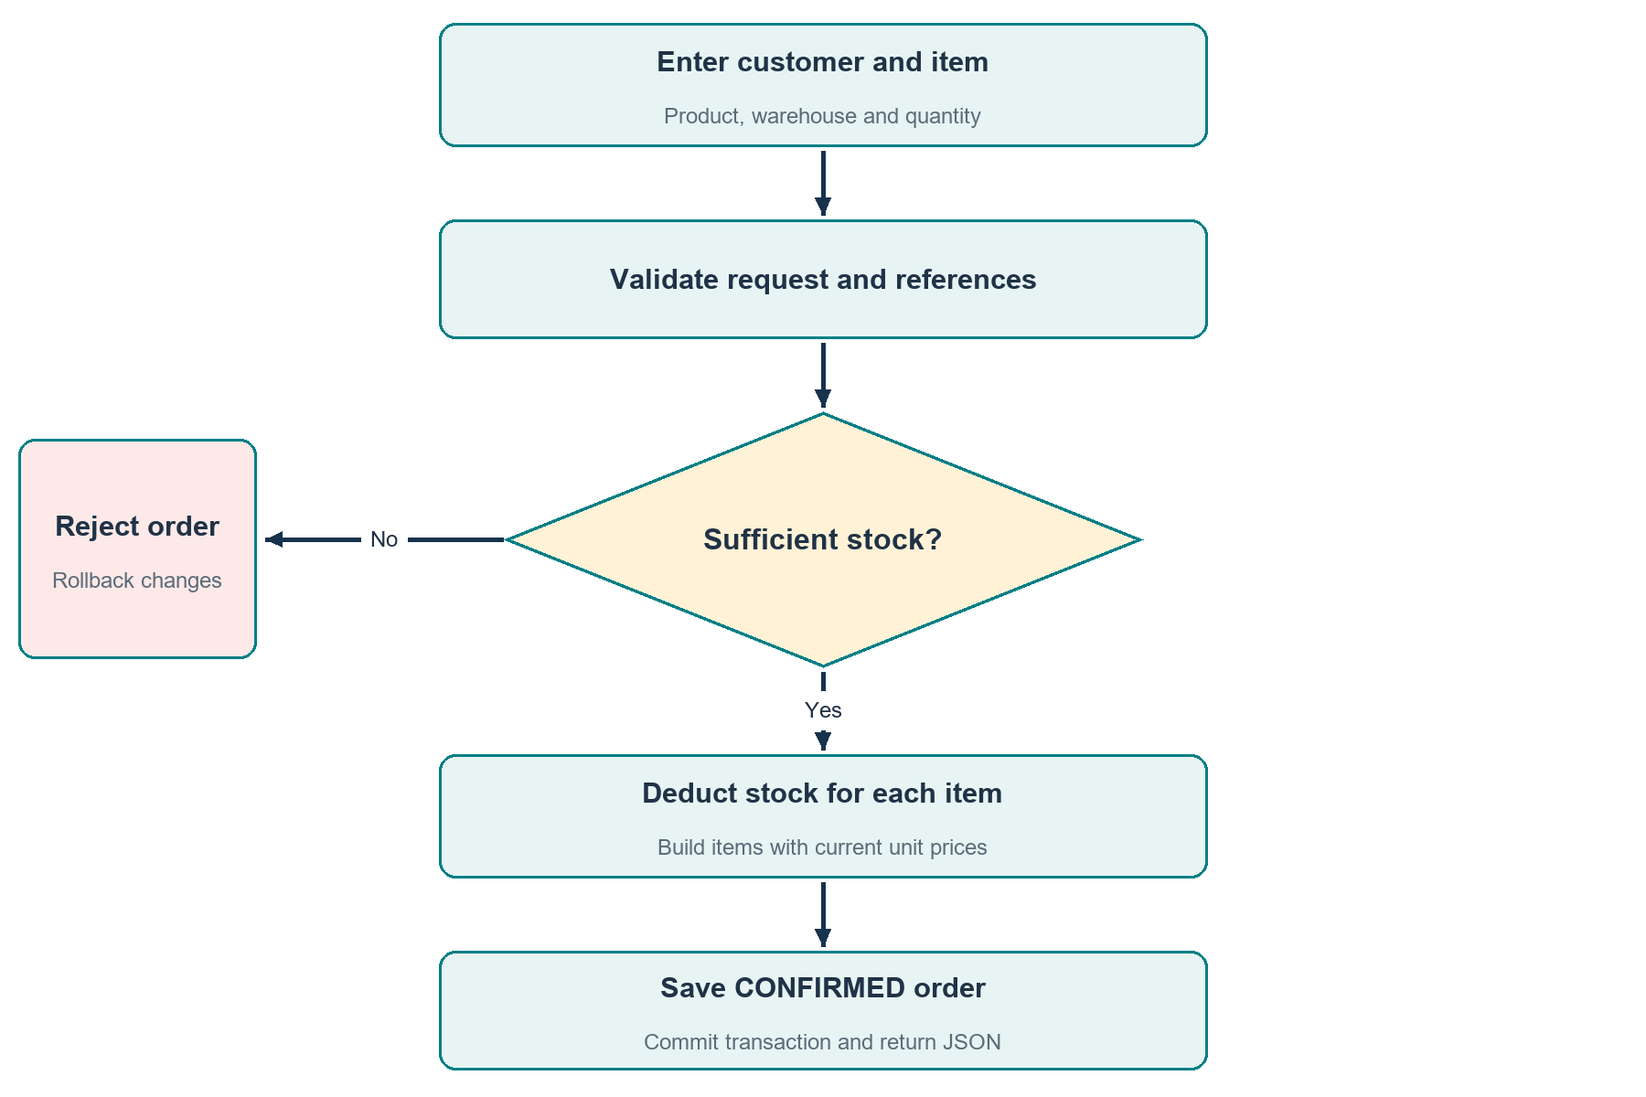
Figure S4 Order validation and fulfillment decision flow
FR 11: The API shall accept a customer name and a non-empty list of valid items. FR 12: For each item it shall load the product and warehouse, deduct stock, capture the current unit price and sum the line totals. FR 13: It shall save a CONFIRMED order. Any failure shall roll back earlier changes in that transaction.
FR 14: Cancellation shall restore quantities to the original warehouses and set status to CANCELLED. Repeating a cancellation shall return HTTP 409. The PENDING enum exists, but the creation service sets CONFIRMED directly.

07 Data model and integrity
Seven entity tables represent catalog, stock, orders and authentication data. Diagram lines show the parent-to-child foreign-key relationships.
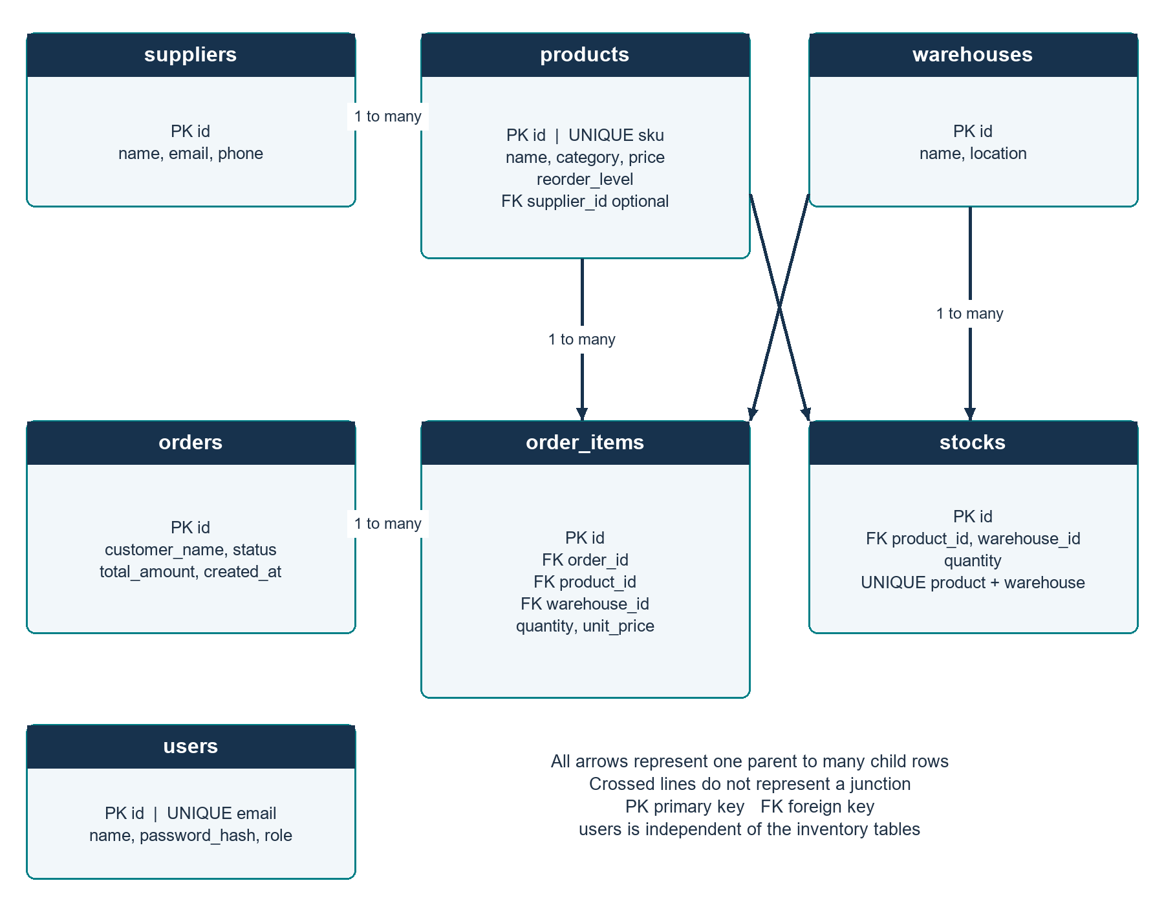
Figure S5 Relational data model with cardinalities
Product supplier_id is optional. Stock references product and warehouse. Every order item references an order, product and warehouse. Order owns its items with cascade and orphan removal. Users are independent of inventory records in the current schema.

08 Input validation and errors
Validation is applied at the API boundary with Jakarta annotations and reinforced by service checks and database constraints.
Input | Validation requirement
Product | SKU and name must not be blank. Price and reorder level are required and non-negative.
Supplier | Name must not be blank. Email must be valid when supplied.
Warehouse | Name must not be blank.
Stock | Product ID, warehouse ID and quantity are required. Quantity must be at least one.
Order | Customer name must not be blank. Item list must not be empty; nested items are validated.

Error contract
HTTP status | Meaning | Example
400 | Invalid input or insufficient stock | Requested quantity exceeds available units.
404 | Referenced resource not found | Unknown product or warehouse ID.
409 | State or integrity conflict | Already-cancelled order or referenced record deletion.
500 | Unexpected server failure | Unhandled application exception.

Responses use ErrorResponse with timestamp, numeric status and message. The frontend displays the backend message. The integrity handler returns a conflict message explaining unique-value or referenced-record violations. Unexpected errors use a generic message rather than exposing internal exception details.

09 Quality requirements
Quality requirements distinguish implemented design choices from measurable targets. No load-test or uptime measurements are claimed.
ID | Quality requirement | Validation method
NFR 01 | Provide clear forms, loading, empty, success and failure feedback. | Walk through all six UI sections.
NFR 02 | Keep order and restoration writes transactional. | Force an item failure and inspect rollback.
NFR 03 | Maintain separated controller, service and persistence responsibilities. | Review package structure and dependencies.
NFR 04 | Respond to ordinary local list operations within two seconds as a target. | Measure repeated requests with a defined dataset.
NFR 05 | Allow configured frontend origins and reject unapproved origins. | Run CORS preflight checks.
NFR 06 | Keep passwords hashed and exclude hashes from auth responses. | Review BCrypt and response DTOs.
NFR 07 | Support a documented reproducible startup using MySQL or dev H2. | Follow setup on a clean environment.

Capacity and data accuracy
The current list endpoints return complete datasets without pagination. Prices and totals are stored as Double, and the UI displays currency with two fraction digits. Decimal money storage, consistent precision, pagination and concurrency control are recommended before deployment at larger scale.

10 Use cases and user journeys
These use cases specify the visible user journey and the expected persistent result.
Use case | Precondition | Main path | Result
UC 01 Add product | Supplier selection is optional. | Products > Add Product > fill fields > Save changes. | Product row appears; stock remains zero.
UC 02 Receive stock | Product and warehouse exist. | Inventory > Add stock > select references > positive quantity > Save changes. | Warehouse quantity increases.
UC 03 Sell stock | Enough stock exists. | Orders > Create order > customer, product, warehouse and quantity > Create order. | Confirmed order and reduced stock.
UC 04 Cancel sale | Order is not cancelled. | Orders > Cancel > confirm dialog. | Cancelled order and restored stock.
UC 05 Update master data | Record exists. | Choose Edit, change fields, save. | Table shows updated record.

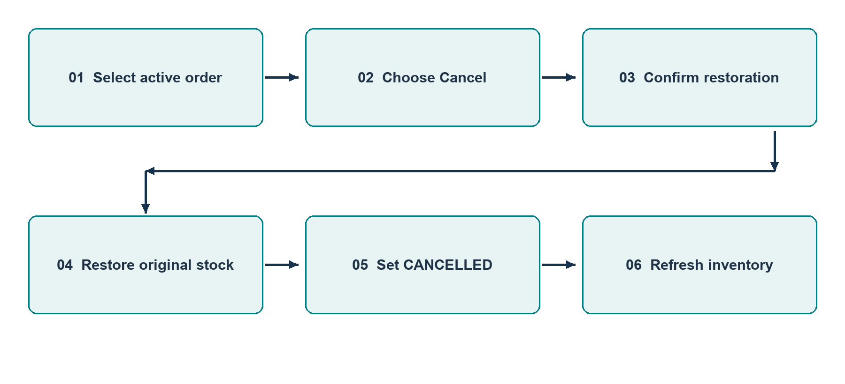
Figure S6 Cancellation use case from user action to updated state

11 Security and operating environment
The frontend and backend run as separate local processes. MySQL is the normal database; the dev profile substitutes H2 for an isolated demonstration.
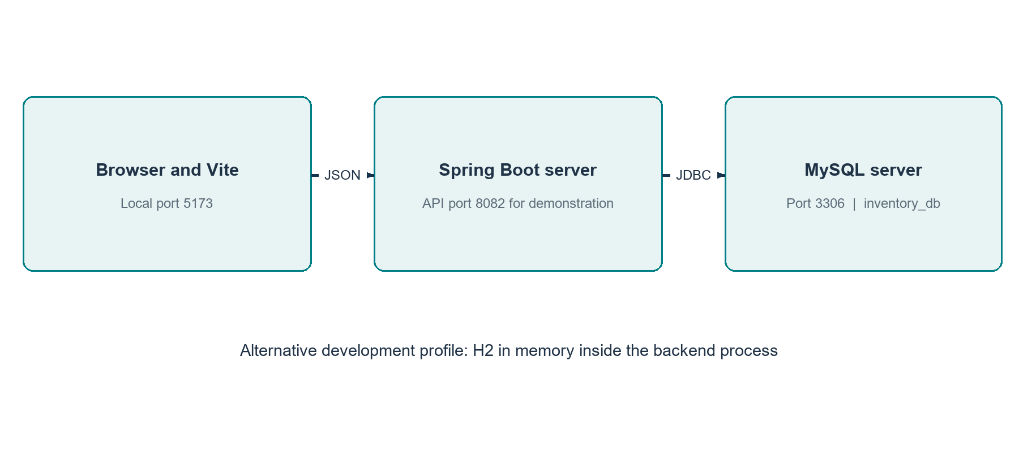
Figure S7 Local deployment arrangement
Setting | Current configuration
Java and build | Java 17 source target, Maven wrapper; installed runtime used during review was Java 25.
Backend | Default port 8082; SERVER_PORT can override this setting.
Frontend | Vite on 5173; VITE_API_URL defaults to http://localhost:8082/api.
Database | MySQL at localhost:3306/inventory_db; DB_USERNAME and DB_PASSWORD.
CORS | localhost:3000, localhost:5173 and 127.0.0.1:5173.

Security baseline
SecurityConfig permits the inventory API routes and other requests in the presentation build. JWT filtering and BCrypt exist, but this does not make the public inventory routes role-protected. Production acceptance requires an authenticated UI, authorization, externalized secrets and HTTPS. No security certification is claimed.

12 Acceptance and traceability
Acceptance cases connect user-visible behavior to requirements. Live evidence refers to the local review on 30 October 2026; proposed checks remain explicit.
Case | Requirement | Expected result | Evidence status
AC 01 | FR 01 | Supplier create and list succeed. | Live API passed
AC 02 | FR 02 | Warehouse create and list succeed. | Live API passed
AC 03 | FR 03 | Product creation succeeds. | Live API passed
AC 04 | FR 04 | Unknown ID returns 404. | HTTP integration passed
AC 05 | FR 05 | Referenced deletion returns conflict. | HTTP integration passed
AC 06 | FR 06 to 09 | Add 10; order 3 leaves 7. | Live API passed
AC 07 | FR 08 | Deduct more than stock returns 400. | Live API passed
AC 08 | FR 10 | Aggregate threshold includes zero-stock products. | Integration passed
AC 09 | FR 11 to 13 | Create returns CONFIRMED; later item failure rolls back. | HTTP integration passed
AC 10 | FR 14 | Cancel restores 7 to 10; repeated cancel returns 409. | HTTP integration passed
AC 11 | NFR 01, 05 | Browser loads data from Vite origin. | Live browser passed

The final frontend build passed. All 43 backend tests and 13 frontend tests passed. Mockito now loads as an explicit startup agent, resolving the earlier Java 25 test-agent hang. The backend suite includes 15 live HTTP checks against isolated H2; MySQL startup, live workflows, three concurrency rounds and persistence across backend restart also passed.

