Retail Inventory
Management System
Detailed Project Report
Submitted by
ADITYA KUMAR PANDEY
Roll Number
2400320100079
Department
CSE
Institution
ABES ENGINEERING COLLEGE
Submitted to
Sajin Kamraj
Academic Year 2026 to 2027

Reading guide
Retail Inventory Management System | HCL project review
Section | Page
01 Project overview | 3
02 Problem and solution | 4
03 Technology and design choices | 5
04 Layered application architecture | 6
05 Database and entity design | 7
06 Frontend design and navigation | 8
07 Guide to adding suppliers and warehouses | 9
08 Guide to adding and editing products | 10
09 Guide to stock management | 11
10 Guide to creating orders | 12
11 Guide to order cancellation | 13
12 API and backend implementation | 14
13 Deployment and setup | 15
14 Verification evidence | 16
15 Limitations and future development | 17
16 Conclusion and source guide | 18
Product archive and restore | 19
Hosted deployment and verification | 20

Document baseline
Version 2.0 | 30 October 2026 | Academic year 2026 to 2027. The diagrams describe the current application. Proposed enhancements and unverified acceptance targets are identified explicitly.

01 Project overview
The Retail Inventory Management System provides a connected workflow for catalog maintenance, warehouse inventory and customer orders. It is implemented with React, Vite, Spring Boot, JPA and MySQL.

Abstract
The project addresses the difficulty of tracking stock across multiple storage locations with disconnected manual records. The operator creates suppliers, products and warehouses, receives units into warehouse-specific stock, and fulfills customer orders. Stock deduction and order persistence share a transaction so an unsuccessful order does not intentionally leave partial deductions. Cancellation returns each quantity to its original location.
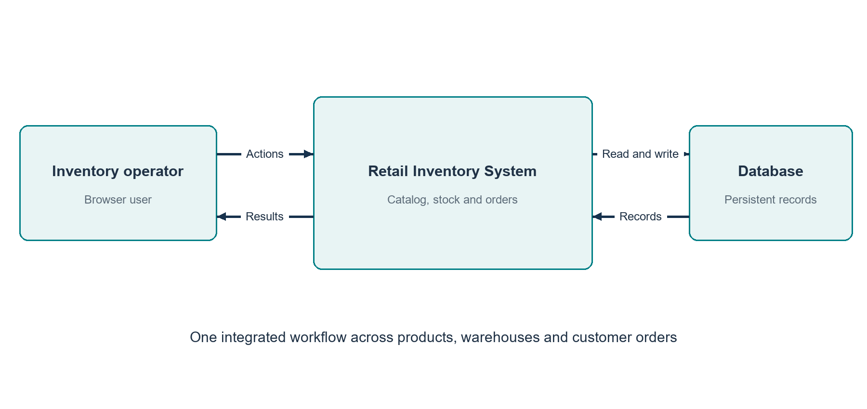
Figure R1 Project context and external interactions

Delivered capability
Six frontend sections support the working demonstration: Dashboard, Products, Inventory, Orders, Suppliers and Warehouses. The backend adds authentication APIs and multi-item order support. Live dashboard counts and low-stock information reflect database records; the weekly movement chart is explicitly a demonstration visualization.

02 Problem and solution
The design connects what the shop sells, where it is stored and how each order affects quantity.
Operational problem | Project response | Business value
Stock stored in separate registers | One stock record per product and warehouse | Clear location-based availability
Sales accepted without quantity checks | Stock check before each deduction | Rejects an ordinary oversell request
Cancelled orders need manual correction | Restore original item quantities | Consistent cancellation workflow
Catalog and supplier records disconnected | Product references supplier | Traceable source relationship
Low-stock products hard to identify | Aggregate stock compared with threshold | Highlights replenishment needs

End-to-end example
Create supplier Tech Supplies and warehouse Main Store. Add product Wireless Mouse with SKU ELEC-001, price 125.50 and reorder level 5. Receive 10 units into Main Store. An order for 3 units is confirmed with a total of 376.50 and quantity falls to 7. Cancelling it returns quantity to 10. These values illustrate the same stock transitions verified during the live API review.

Scope boundaries
The application manages inventory and customer order records. It does not currently implement payment processing, tax invoices, shipping integrations, purchase orders or a historical stock-movement ledger. Those extensions would require additional data structures and workflows.

03 Technology and design choices
The technology choices favor a straightforward local development and review workflow with clear separation between the browser and API.
Technology | Implemented role | Reason for the choice
React 19 | State-driven components and forms | Reusable presentation and data refresh.
Vite 8 | Development server and production bundling | Fast frontend feedback and compact build output.
Java and Spring Boot 4.1.1 | REST application and dependency injection | Structured controllers and services.
Spring Data JPA and Hibernate | Entity mapping and repository access | Relational persistence with less query boilerplate.
MySQL | Default database | Durable relational records and constraints.
H2 | Dev and test profiles | Isolated in-memory execution.
Jakarta Validation | Request constraints | Reject missing or invalid input at the API.
Spring Security and JJWT | Authentication components | BCrypt hashes and token support.
Maven wrapper and npm | Build and dependencies | Repeatable build entry points.

Architectural choice
The backend is a modular monolith, not a microservice system. A single backend process coordinates order and stock transactions with one database. This fits the project scale and avoids distributed transaction and service-discovery requirements.

04 Layered application architecture
A browser action passes through a single API boundary and then through the backend layers. Each layer has a defined responsibility.
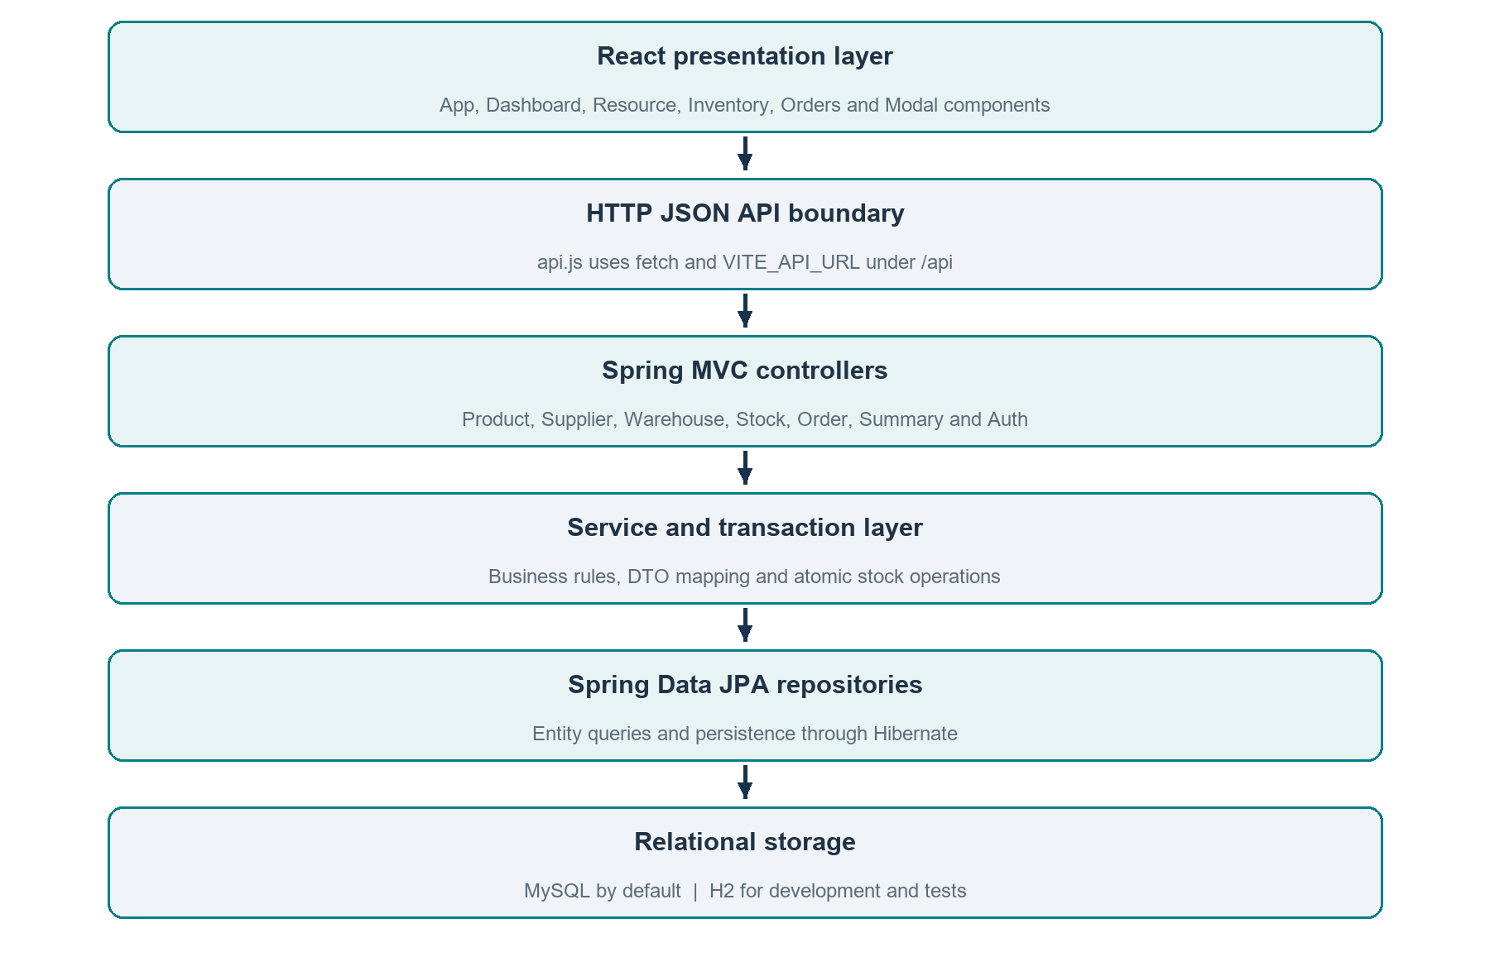
Figure R2 Implemented layered architecture
Controllers translate HTTP requests into service calls. Services resolve referenced records, apply business rules and map results into DTOs. Repositories provide entity persistence. GlobalExceptionHandler translates common application failures into consistent HTTP error responses.

05 Database and entity design
The data model expresses both warehouse availability and the original source of every fulfilled order item.
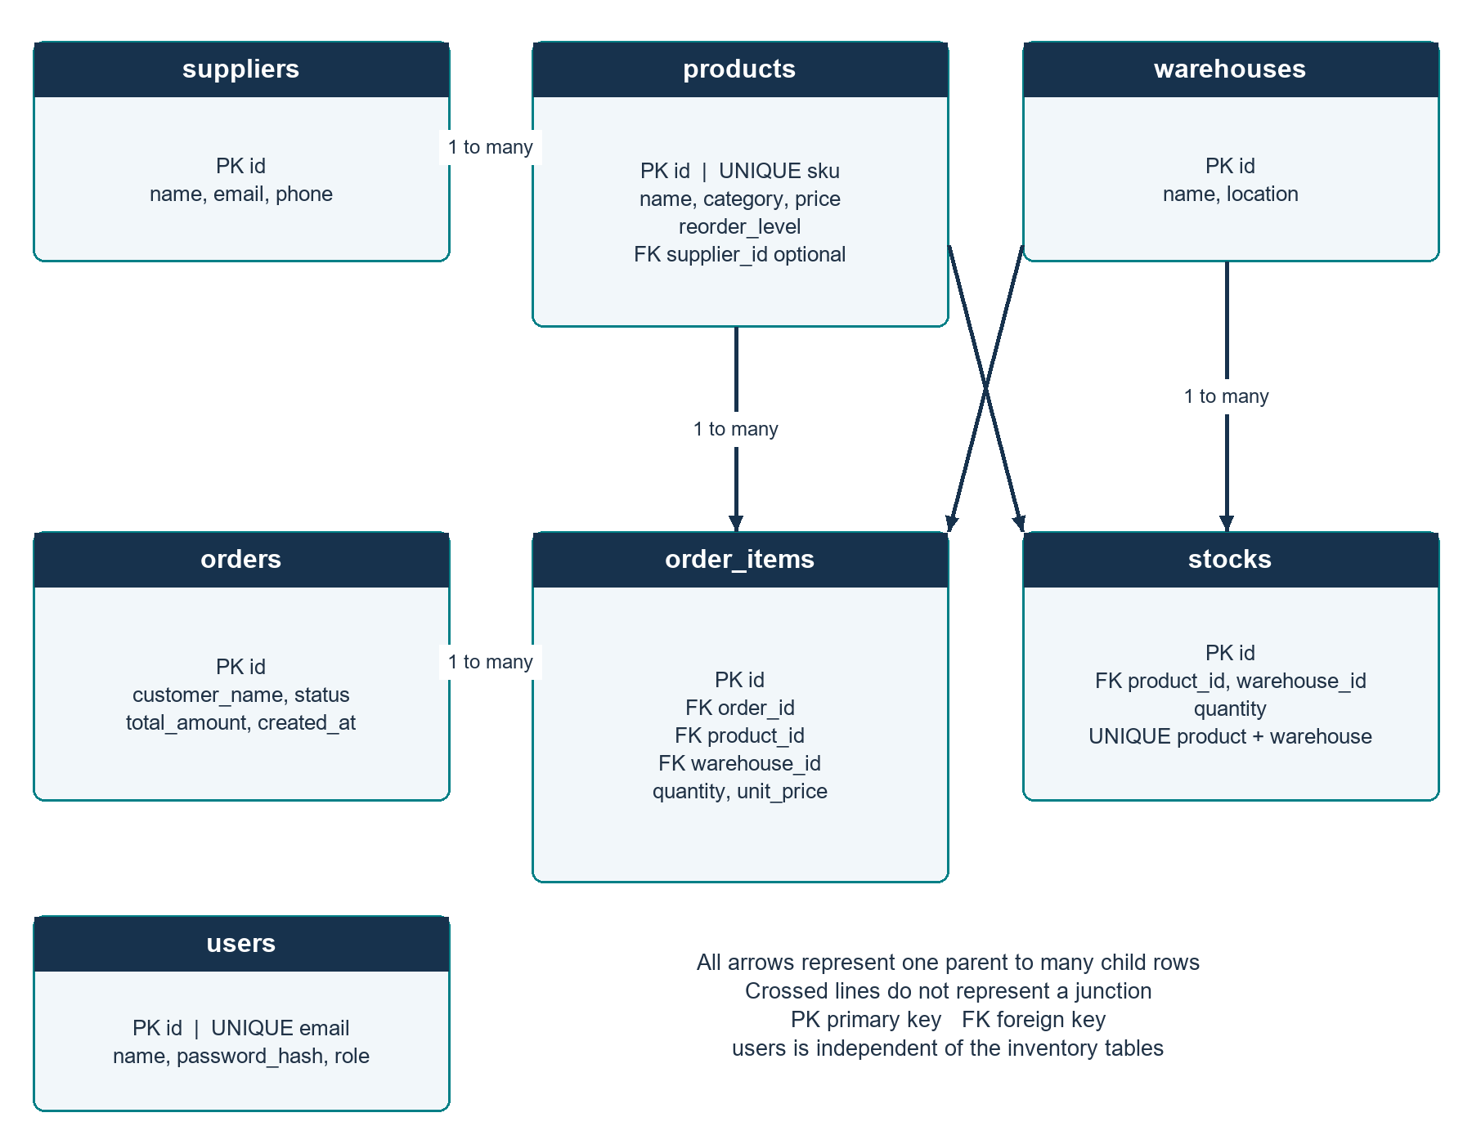
Figure R3 Entity relationship diagram of all seven tables
stocks has a composite uniqueness constraint on product_id and warehouse_id. products.sku and users.email are unique. order_items stores quantity and unit_price separately from the current product price, preserving the price captured at order creation. users has no foreign-key relationship with orders in this version.

06 Frontend design and navigation
The interface is a React single-page application. Sidebar buttons update the active page state instead of navigating through a routing library.
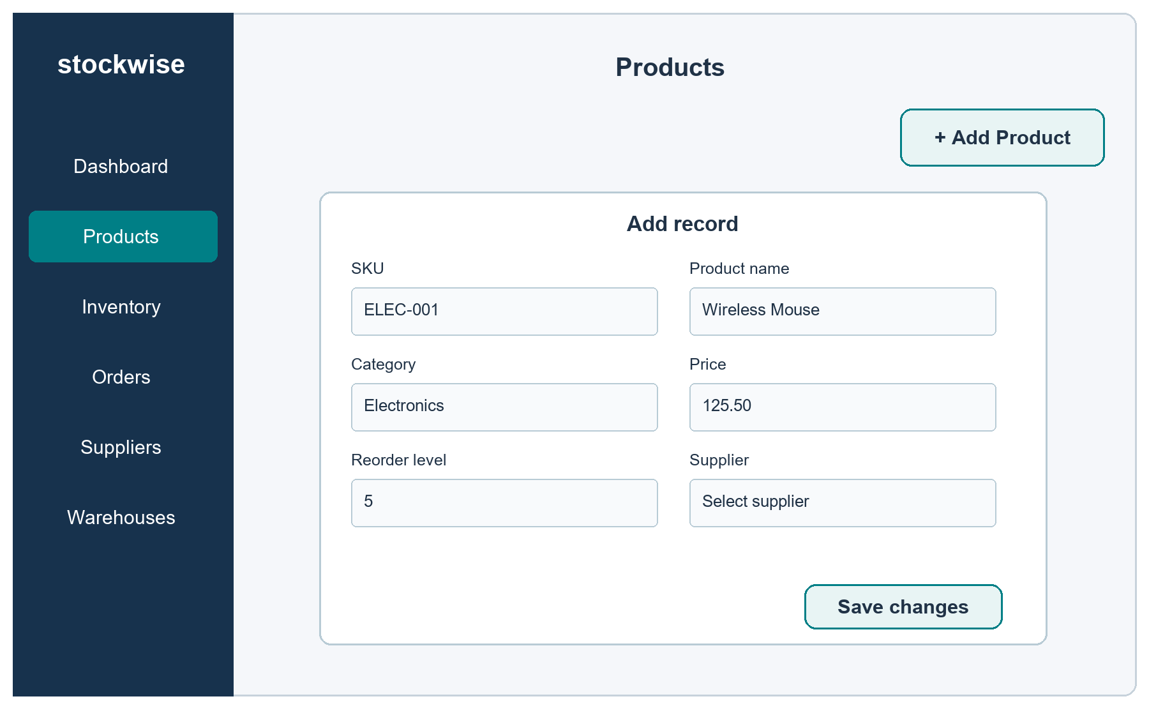
Figure R4 Product-entry interface schematic based on the actual JSX labels
Component or file | Responsibility
App.jsx | Owns page, modal, data, loading and notice state; coordinates operations.
Dashboard and Chart | Live counts and lists; fixed example weekly bars.
Resource, Inventory and Orders | Master-data tables, stock adjustment and order actions.
Modal and Field | Shared entry forms with browser constraints and saving state.
api.js | Fetch wrapper, JSON parsing and resource-specific requests.
styles.css | Navigation, grid layout, tables, forms and responsive styling.

After a successful mutation, the UI reloads its six datasets, closes the modal and displays a notice. Error messages remain visible when a save fails. The form schematic above is an explanatory drawing, not a captured application screenshot.

07 Guide to adding suppliers and warehouses
Create supporting records first so the product and stock selectors contain valid choices.

01 Open Suppliers
Choose Suppliers in the sidebar, then Add Supplier. The dialog title is Add record.

02 Enter supplier details
Fill Supplier name, Email and Phone, then choose Save changes. Only Supplier name is required; Email is validated when provided and Phone is optional.

03 Check the supplier row
Confirm the saved supplier appears with the expected contact details. The success notice confirms the operation.

04 Open Warehouses
Choose Warehouses, then Add Warehouse. Enter Warehouse name and Location, and save.

05 Verify the location
Confirm the warehouse appears in the table. It can now be selected when adding stock or creating an order.

Editing and removal
Each master-data row provides Edit and Delete actions. Edit opens the existing values. Delete opens a browser confirmation dialog. Database references can prevent deletion; a conflict response is then displayed. Remove only the intended record after checking its role in the workflow.

08 Guide to adding and editing products
A product is a catalog record. Available inventory is added separately through the Inventory section.
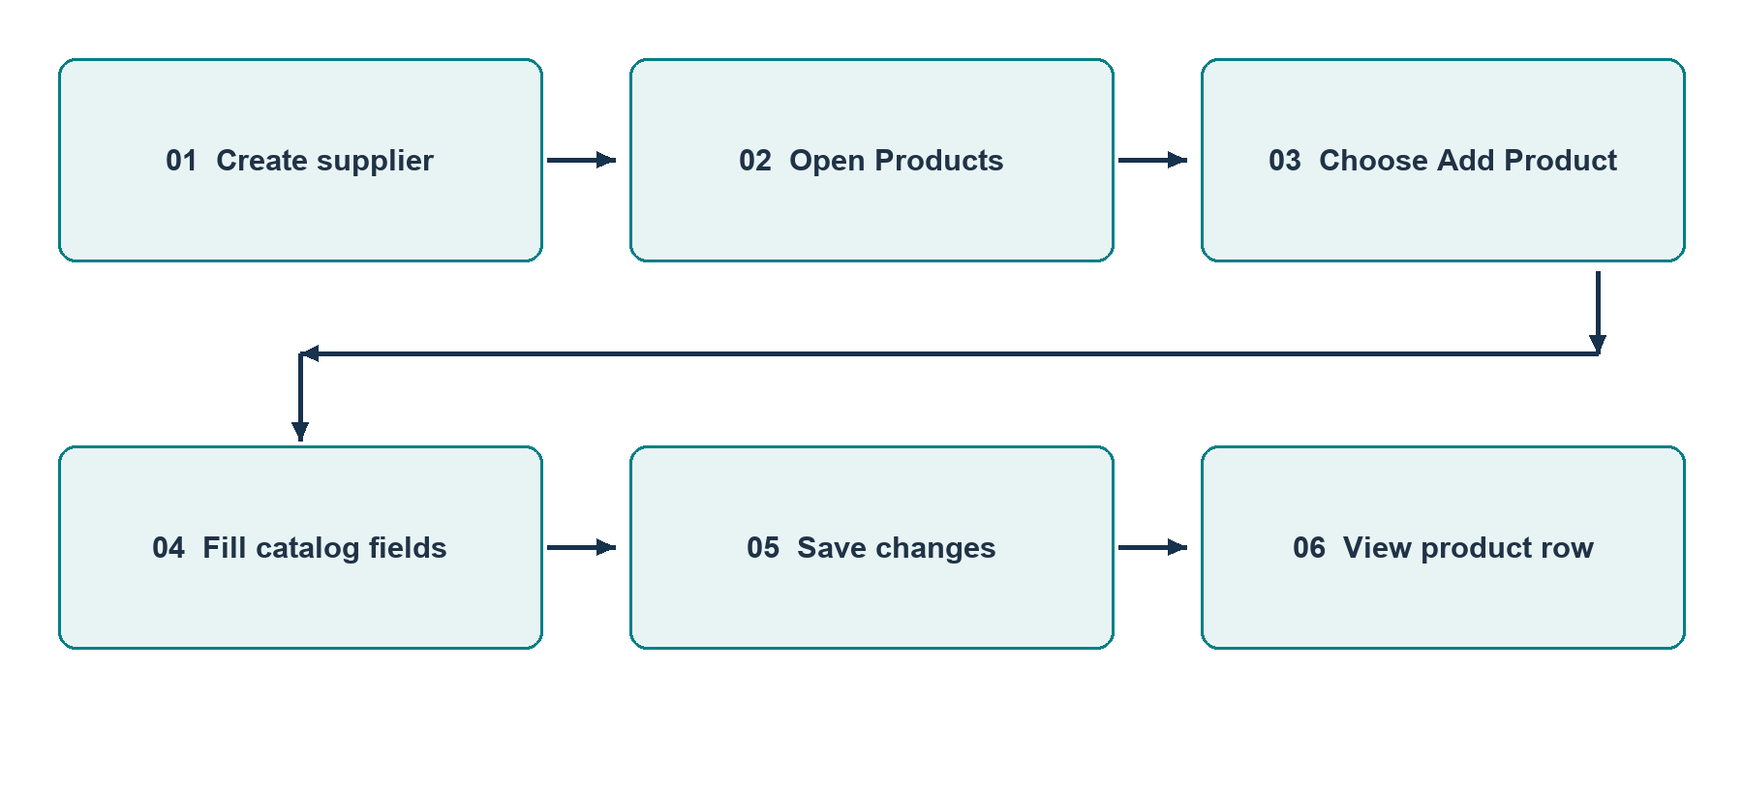
Figure R5 Step-by-step product creation flow

01 Choose Products and Add Product
The Add record dialog opens with SKU, Product name, Category, Price, Reorder level and Supplier fields.

02 Enter the catalog data
Use a unique SKU such as ELEC-001. Enter Wireless Mouse, Electronics, price 125.50 and reorder level 5. Select an existing supplier.

03 Save and inspect
Choose Save changes. Confirm the product name, SKU, supplier and values in the table. The displayed currency retains two decimal places.

04 Edit a product
Choose Edit in the product row, change the intended fields and save. The update uses PUT /api/products/{id}.
Supplier selection is optional in both the frontend and API. Duplicate SKUs violate the database constraint and return HTTP 409.

09 Guide to stock management
Stock adjustments connect a product with a warehouse and a positive integer quantity.

01 Receive new inventory
Open Inventory and choose Add stock. Select Product and Warehouse, enter Quantity 10, and choose Save changes.

02 Check the stock row
The row shows the product, SKU, warehouse and quantity. Adding more to the same pair increments the existing record.

03 Record a deduction
Choose Deduct stock, select the same product and warehouse and enter the number of units to remove. Save changes applies the deduction.

04 Review low stock
Open Dashboard. Products whose total quantity is at or below their reorder level appear in Low-stock products.
Operation | Starting quantity | Adjustment | Expected quantity
Receive units | 0 | +10 | 10
Create order | 10 | -3 | 7
Cancel order | 7 | +3 | 10
Invalid deduction | 10 | -11 | Rejected; remains 10

Warehouse-level validation
Availability is checked in the selected warehouse. Having units in another location does not automatically fulfill an order. The current system does not transfer stock between warehouses; separate additions and deductions should not be described as an audited transfer workflow.

10 Guide to creating orders
The current frontend creates a single-item customer order. The backend request accepts a list and can process several items in one transaction.
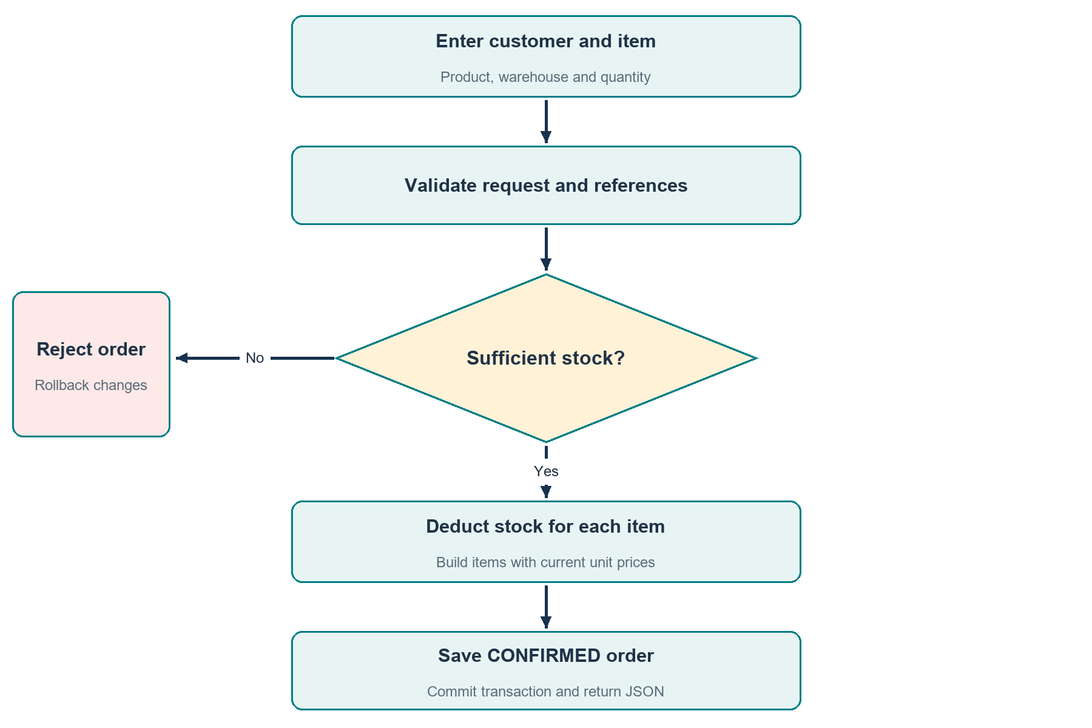
Figure R6 Order processing with the insufficient-stock branch
Open Orders > Create order. Fill Customer name, select Product and Warehouse, and enter Quantity. Choose Create order. The service deducts each item, records its current price, calculates the total and saves CONFIRMED status. An invalid reference or insufficient quantity causes failure and rollback rather than a confirmed sale.

11 Guide to order cancellation
Cancellation reverses the quantity effects of an existing order using its stored item references.
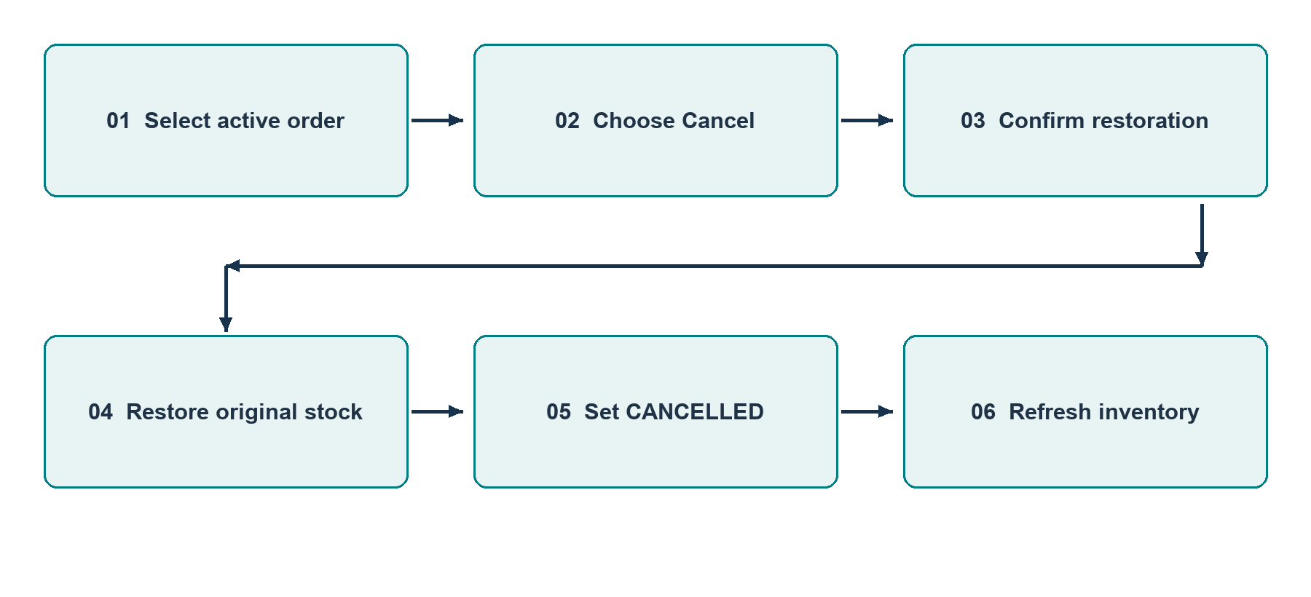
Figure R7 Cancellation workflow and restoration

01 Locate the intended order
Open Orders and identify it by order ID and customer. Check the status before taking action.

02 Choose Cancel and confirm
Select Cancel on a non-cancelled row. Read the confirmation asking to cancel and restore stock, then confirm.

03 Verify both results
The order displays CANCELLED and the Cancel action is removed. Open Inventory and verify the original warehouse quantity increased by the ordered amount.

State behavior
The service rejects an already-cancelled order with HTTP 409. Although PENDING is defined in the enum, this implementation creates orders directly as CONFIRMED. The documented primary transition is CONFIRMED to CANCELLED; there is no implemented dispatch or payment status transition.

12 API and backend implementation
The API is grouped under /api and exchanges JSON. This sequence illustrates the implemented order request across backend layers.
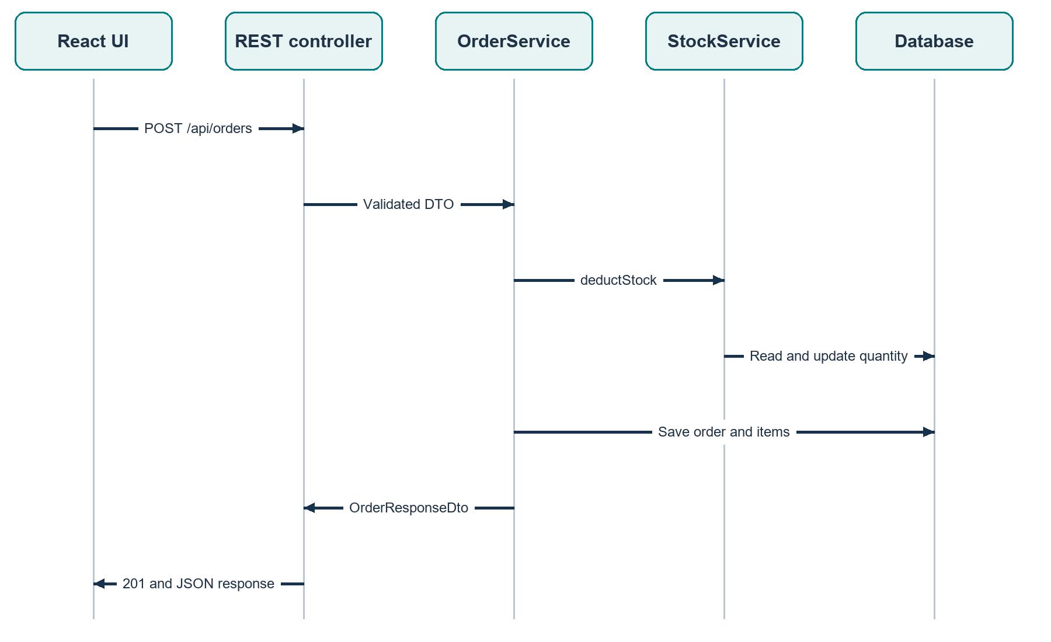
Figure R8 Order creation sequence across the application layers
Resource | Methods and route pattern
Products, suppliers, warehouses | GET and POST /api/{resource}; GET, PUT, DELETE /api/{resource}/{id}
Stock | GET /api/stock; POST /api/stock/add and /deduct; GET /api/stock/low
Orders | GET and POST /api/orders; GET /api/orders/{id}; PUT /api/orders/{id}/cancel
Summary and auth | GET /api/summary; POST /api/auth/register and /login

13 Deployment and setup
The following startup procedure matches the API base URL used by the frontend.
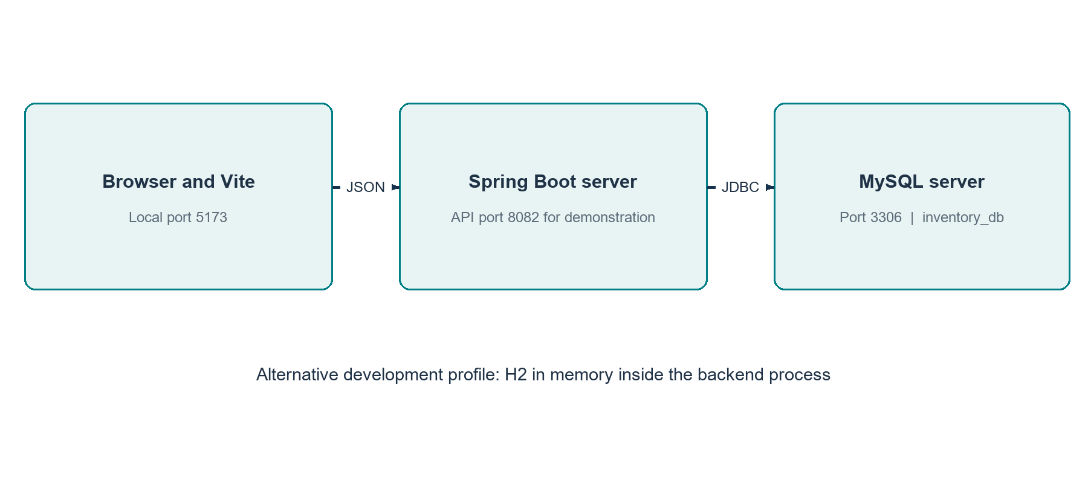
Figure R9 Local deployment and alternative database profile

01 Prepare the database environment
Install JDK 17 or a supported later runtime and start MySQL. Set DB_USERNAME and DB_PASSWORD in the backend shell; never include real passwords in the submitted report.

02 Start the MySQL backend
From Inventory, run .\mvnw.cmd spring-boot:run "-Dspring-boot.run.arguments=--server.port=8082". The URL targets inventory_db on MySQL port 3306.

03 Use isolated dev mode when needed
Add "-Dspring-boot.run.profiles=dev" to use in-memory H2. This is suitable for temporary demonstrations; records disappear when the process stops.

04 Start the frontend
From inventory-frontend, run npm install if needed, then npm run dev. Open the displayed address, normally http://localhost:5173/.

05 Build and configure
npm run build produces dist. Set VITE_API_URL before building if the API uses another host. mvnw.cmd test runs backend tests; use the intended Java environment.

14 Verification evidence
Evidence distinguishes observed local behavior, source inspection and verification still to be completed. Checks were performed on 30 October 2026 using isolated H2 tests and the live MySQL-backed application.
Check | Observed result
Production frontend build | Passed twice in the earlier review; Vite generated HTML, CSS and JavaScript assets.
Backend dev startup | Spring Boot started on port 8082 with MySQL; isolated H2 tests also passed.
Catalog setup | Supplier, warehouse and product were created through the live API.
Order and restoration | Stock changed 10 to 7 after ordering 3; cancellation returned it to 10.
Insufficient stock | A deduction of 11 against stock 10 returned HTTP 400.
CORS correction | 127.0.0.1:5173 added to allowed origins; HTTP 200 with matching CORS header verified.
Browser data load | Dashboard loaded without the earlier Failed to fetch banner.

Automated test status
All 50 backend tests passed on the installed Java 25 runtime, including 19 real HTTP workflow tests. Mockito loads explicitly as a Java agent, resolving the earlier attachment hang. All 15 React and API-client tests passed, and Maven verify produced the executable backend JAR.

Additional regression cases
Repeated cancellation, multi-item rollback, duplicate SKU conflicts, referenced deletion, concurrent deductions and concurrent first additions passed. MySQL startup, live workflows, three concurrency rounds and persistence across backend restart passed. Live visual browser control was disabled; frontend interactions were checked with automated DOM tests.

15 Limitations and future development
The project delivers the central inventory workflow, with several clear engineering steps available for the next release.
Current boundary | Recommended extension | Benefit
Public demonstration routes | Add login UI and enforce admin and staff authorization | Controlled access
Product and stock write locks | Extend the passed MySQL concurrency checks to sustained load | Verifies database behavior at scale
Double storage and decimal UI display | Use BigDecimal and decimal columns; align UI precision | Consistent currency calculations
Fixed example weekly bars | Store stock movements and aggregate historical data | Genuine trend reports
Complete list endpoints | Introduce pagination and filters | Larger catalogs
One item per frontend order | Add editable item rows and combined availability feedback | Multi-product user workflow
No audit ledger | Record actor, reason, time and quantity changes | Operational traceability

Security hardening
The hosted demonstration uses private environment settings, HTTPS and verified database TLS. Further security hardening requires an authenticated UI, role authorization and abuse controls. JWT components provide a starting point; current inventory routes remain public.

16 Conclusion and source guide
The application demonstrates an integrated inventory workflow with reusable master data, warehouse quantities and transactional order changes. The main review focus is the relationship between user actions and their database effects.

Technical conclusion
The layered architecture keeps browser rendering separate from REST handling and inventory rules. JPA entities express relational dependencies, DTOs define the boundary, and service transactions coordinate changes. The live review demonstrated order deduction, cancellation restoration and insufficient-stock rejection. The project can be extended through authenticated access, further MySQL load verification, accurate decimal money and historical stock reporting.

Source guide for the reviewer
Source location | What to inspect
inventory-frontend/src/App.jsx | Screens, form labels, one-item order form and fixed chart values.
inventory-frontend/src/api.js | Fetch wrapper and parallel loading of six datasets.
Inventory/src/main/java/com/hcl/Inventory/service | ProductService, StockService, OrderService and transaction logic.
Inventory/src/main/java/com/hcl/Inventory/entity | Tables, foreign keys, uniqueness and order cascade.
Inventory/src/main/java/com/hcl/Inventory/config | Public presentation security and CORS origins.
Inventory/src/main/java/com/hcl/Inventory/exception | HTTP error mapping.
Inventory/src/main/resources | MySQL configuration and dev H2 profile.
Inventory/src/test | Service tests, context test and test H2 profile.

Prepared for HCL project review by ADITYA KUMAR PANDEY, roll number 2400320100079, CSE, ABES ENGINEERING COLLEGE. Submitted to Sajin Kamraj for academic year 2026 to 2027.

Product archive and restore
Products used in orders must remain available to historical records. Archive removes a product from the active catalogue and new-order selection while keeping its stock, supplier association and order history. Restore makes the same product available again.
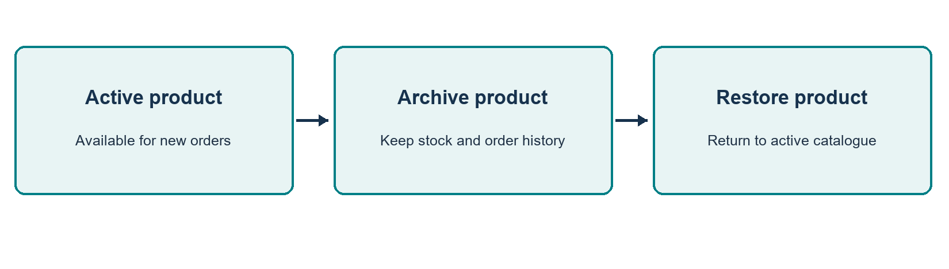
Operation | Required behaviour
Archive | PUT /api/products/{id}/archive sets archived to true and retains all linked records.
Restore | PUT /api/products/{id}/restore sets archived to false. The product keeps its original identifier and SKU.
New order | The service locks the product and rejects archived products with HTTP 409. The UI omits them from product selection.
Existing order | Order history remains readable. Cancellation still restores stock for an archived product.
Permanent delete | Allowed only when no orders reference the product and no positive stock remains. Empty stock rows are removed first.
Database | products.archived is BOOLEAN NOT NULL DEFAULT FALSE. Existing products remain active; archived SKUs stay reserved.
User steps: open Products, choose Archive and confirm. Select Include archived products to view hidden records, then choose Restore. Archived stock remains available on the Inventory page for adjustments and order returns.

Hosted deployment and verification
Live demonstration: https://retail-inventory-management.onrender.com/
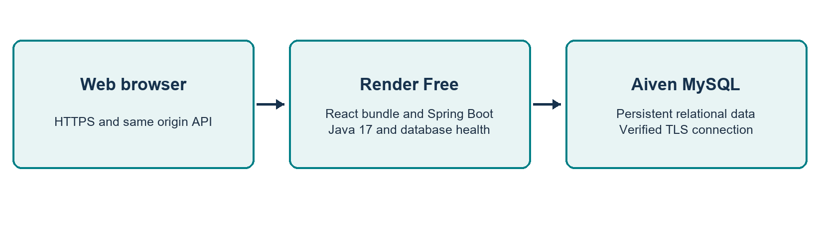
The multi-stage Docker build compiles React with the relative /api address and bundles it into Spring Boot static resources. Render serves both parts from one HTTPS origin. Database credentials are supplied through private environment variables; the Aiven CA certificate enables hostname and certificate verification. The application binds to Render PORT on 0.0.0.0.
Verification | Evidence from 30 October 2026
Automated tests | 50 backend tests, including 19 HTTP integration cases, and 15 frontend tests passed.
Public workflow | Homepage, JS and CSS assets, six concurrent data requests, stock, orders, cancellation, rollback and three concurrency rounds passed.
Persistence | After a user-confirmed Render restart, the saved product, supplier, warehouse, stock quantity and four cancelled review orders were preserved.
Readiness | GET /api/health validates a database connection. HTTP 200 reports UP; database failure reports HTTP 503 and DOWN.
Free hosting | The server sleeps after inactivity and may need a few minutes to wake. The first concurrent dashboard load measured about 15 seconds.
This is an unauthenticated academic demonstration using fictional data. Login and roles remain future work. The weekly chart is labelled demonstration content. These functional checks do not constitute sustained-load testing or security certification.

