Fan Den Intern Task

Name:-Aditya Gaikwad

Technologies/Frameworks:- MongoDb,Node.js,React.js,Express.js,Tailwind CSS.

File Structure :-

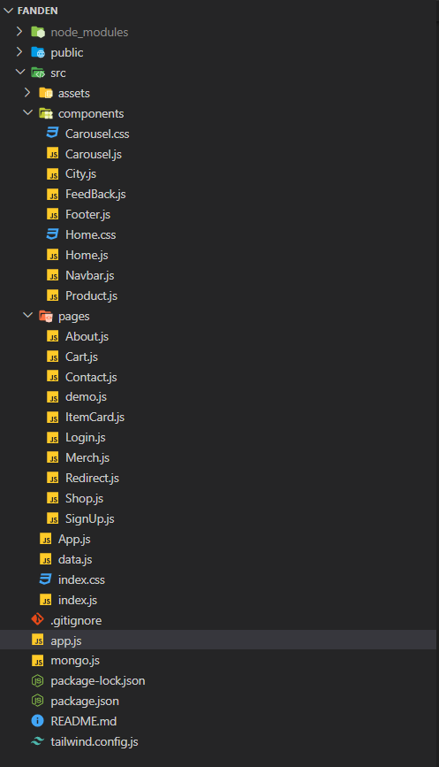

Dependencies used:

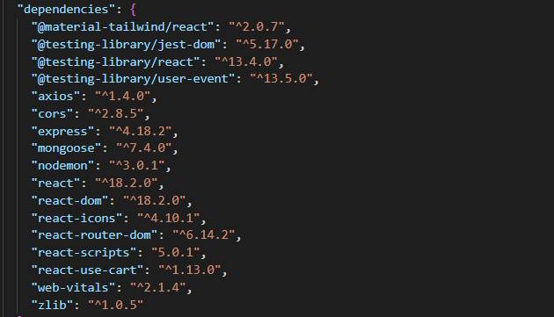

Enhancements:-

1. New Page Added (“Upcoming events”)

So the users can now able to see the future events hosted by FanDen

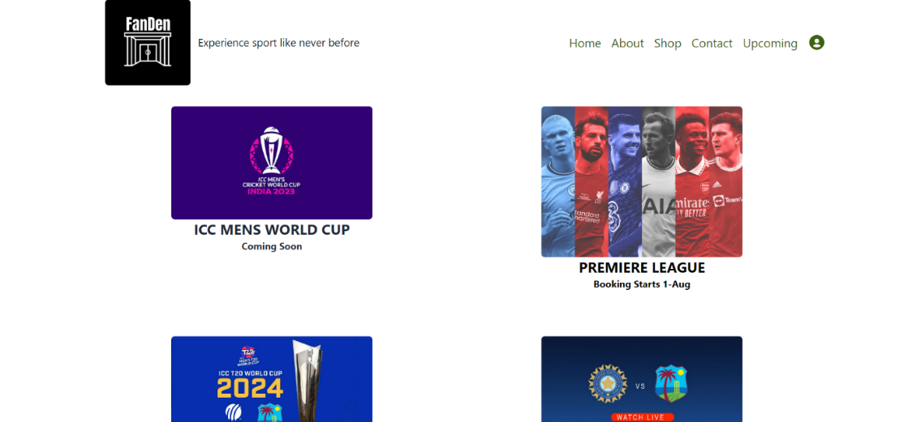

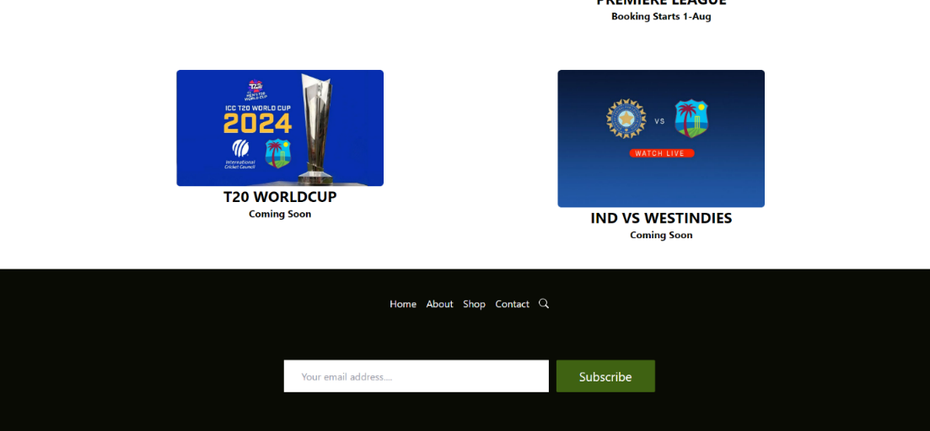

1. Made the Website SPA (Single Page Application).

With the help of react features the website is now SPA i.e Complete website wont be reloaded when moved from on page to another .

3)Checkout Page

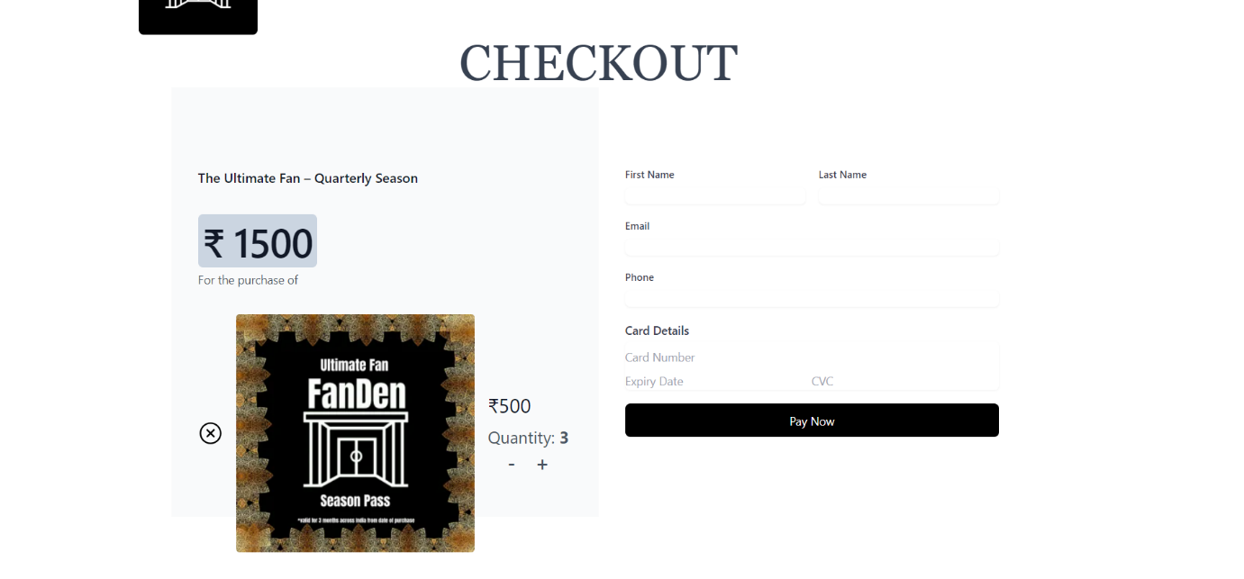

4)Gmail Notification.

Whenever a user submits the form or subscribes the newsletter the owner will get a notification immediately.

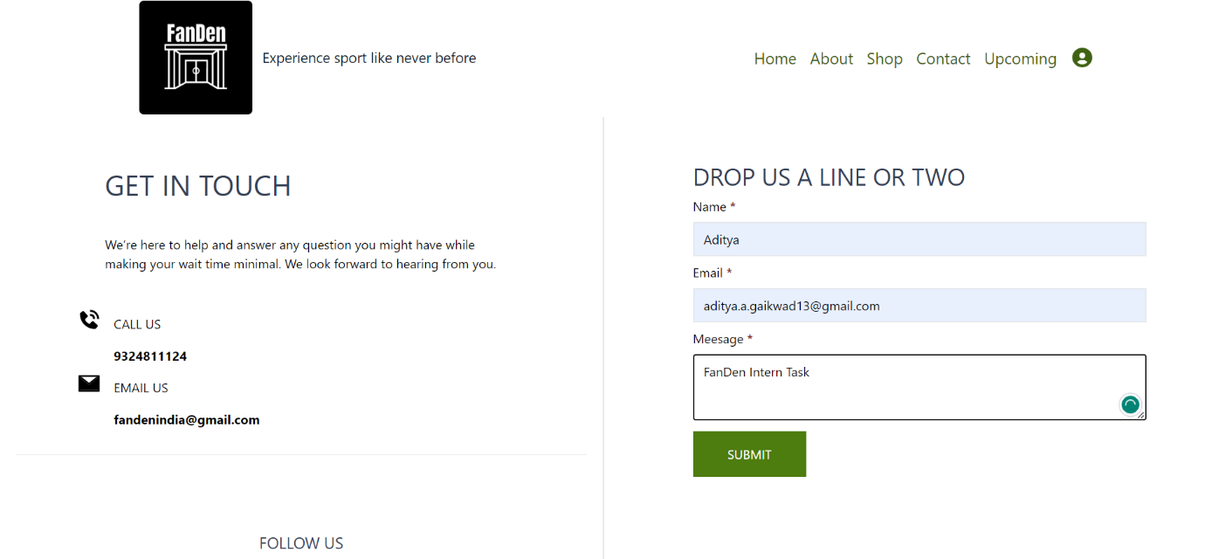

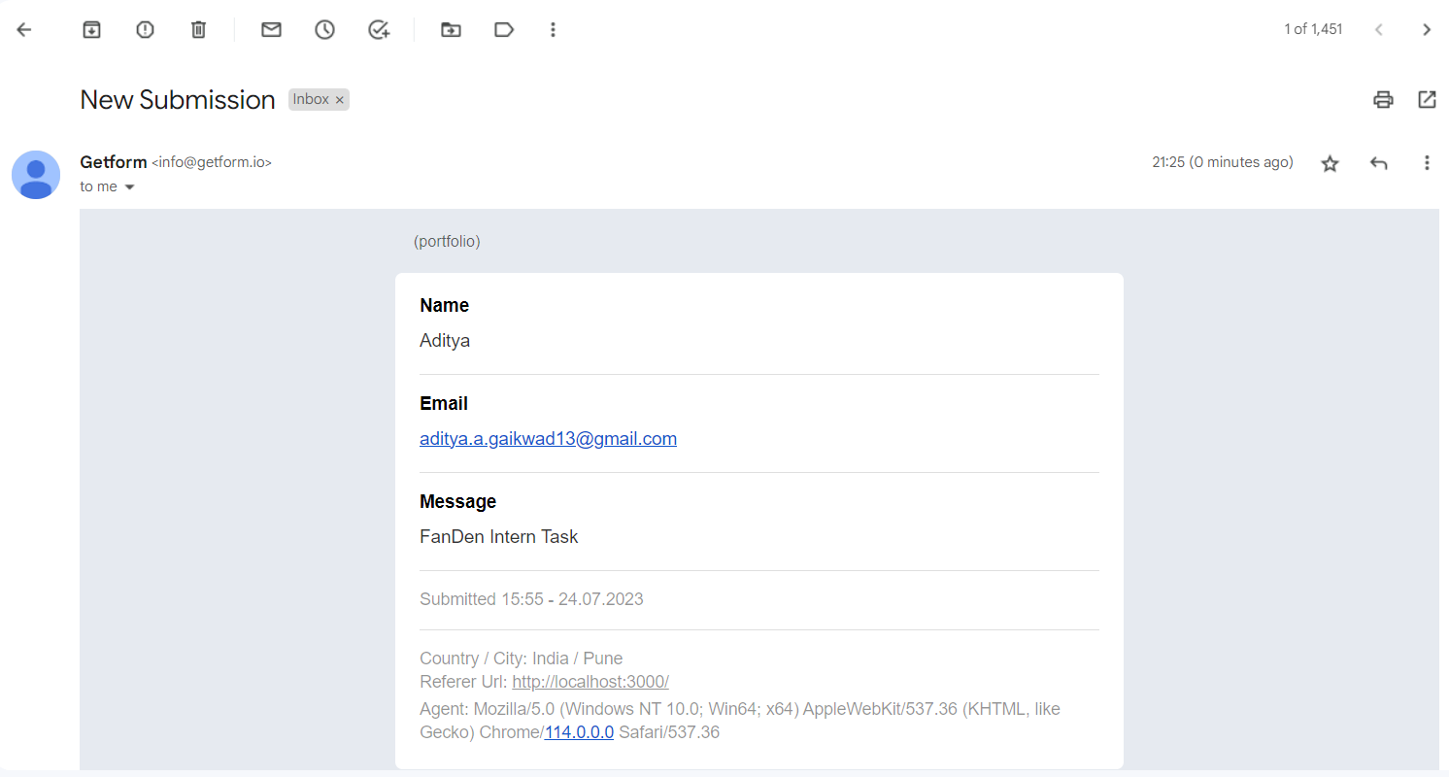

Challenges Faced:-

* Login and Signup Issue with Axios.

Solution:-

* Debugging the Server.js file and find the bug with axios 404 error.

Conclusion:

With the Help of MERN Stack created a FanDen Clone with some additional

functionalities.