## LoRa Based Fire Detection Alarm

A project report submitted in partial fulfillment of the requirements for the degree of

### Bachelor of Engineering In

**Electronics and Computer Science**

|  |  |  |
| --- | --- | --- |
|  | by |  |
| **Aman** | **Gupta** | **(9752)** |
| **Aditya** | **Gurav** | **(9753)** |
| **Aaditya** | **Malap** | **(9754)** |

##### Abdullah Siddiqui (9759)

Under the guidance of

##### Prof.Vaibhav Godbole



DEPARTMENT OF COMPUTER ENGINEERING

##### Fr. Conceicao Rodrigues College of Engineering, Bandra (W), Mumbai - 400050

University of Mumbai (2022-23)

## Internal Approval Sheet

**CERTIFICATE**

This is to certify that the project entitled **"Lora Based Fire Detection Alarm"** is a bonafide work of **Aman Gupta(9752) , Aditya Gurav(9753), Aaditya Malap(9754), Abdullah Siddiqui(9759)** submitted to the University of Mumbai in partial fulfillment of the requirement for the award of the degree of Bachelor in **Electronics and Computer Science.**

(Name and sign) Supervisor/Guide

(Name and sign)

Head of Department

(Name and sign) Principal

## Approval Sheet Project Report Approval

This project report entitled by **Lora Based Fire Detection Alarm** by **Aman Gupta, Aditya Gurav, Aaditya Malap, Abdullah Siddiqui** is approved for the degree of Bachelor of Engineering in Electronic and Computer Science.

Examiner 1. ————————————–

Examiner 2. ————————————–

Date: Place

## Acknowledgments

We have great pleasure in presenting the report on **"Lora Based Fire Detection Alarm"**. I take this opportunity to express my sincere thanks towards the guide [Prof. Vaibhav Godbole], C.R.C.E, Bandra (W), Mumbai, for providing the technical guidelines, and the suggestions regarding the line of this work. We enjoyed discussing the work progress with him during our visits to department.

We thank Dr. Sapna Prabhu, Head of Electronics and Computer Science department, Principal and the management of C.R.C.E., Mumbai for encouragement and providing necessary infrastructure forpursuing the project.

We also thank all non-teaching staff for their valuable support, to complete our project.

Aman Gupta (9752)

Aditya Gurav (9753)

Aaditya Malap (9754)

Abdullah Siddiqui (9759)

Date:

## Contents

|  |  |
| --- | --- |
| **Abstract** | **iv** |
| **List of Figures** | **ix** |
| **Glossary** | **xi** |
| **1 Introduction** | **1** |
| 1.1 What is LoRa Based Fire Detection Alarm | 1 |
| 1.2 Motivation | 2 |
| 1.3 Objectives | 2 |
| **2 Literature Review** | 3 |
| **3 Problem Statement** | **6** |
| 3.1 Drawbacks of fire alarm system | 6 |
| 3.2 Solution To Above Problem | 6 |
| **4 Project Description** | **7** |
| 4.1 Overview of the project | 7 |
| 4.2 Requirement | 8 |
| 4.2.1 hardware requirement | 8 |
| 4.3 Circuit diagram | 12 |
| **5 System Testing** | **13** |
| **6 Implementation Details** | **14** |
| 6.1 Methodology | 14 |
| **7 Conclusion And Future Enhancements** | **15** |
| 7..1 Result Analysis | 15 |

# Chapter 1

## Introduction

### 1.1 What is LoRA Based Fire Detection Alarm

It is a smart,cost efficient System made by us to prevent unnecessary damage caused by unwanted fire breakouts caused due to various reasons.  
  
We have implemented our system in our college in

Not knowing about fire has taken place in the forest/college can cause lots of trouble like it will destroy the trees, burn down the grasses which will lead to the landslide or soil erosion, many animal will die.It will create smoke and poisonous gas which will lead to the health issues in human as well as animal.If fire take place in the college some of the part college will only get the alarm of because the range of the normal fire detector is small which will make difficulty for the people who doesn’t heard the alarm which can lead to l00’s of life and lose of property.

To overcome such problem LoRA fire detection can be used because this detector has long range it can transmit the signal in KMs range .By using this if the fire has taken place inside the college whole college will easily come to know that fire has taken place inside the college every one can get out easily before the fire has been spread . This can be used in forest also if forest fire has been started the sensor will detect and buzzer will get started .forest department will easily come to know about the fire which can save many animal ,trees etc

# 

# Chapter 5

## System Testing

### 5.1 Unit Testing

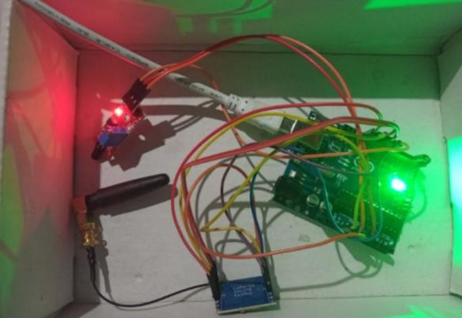

##### 5.1

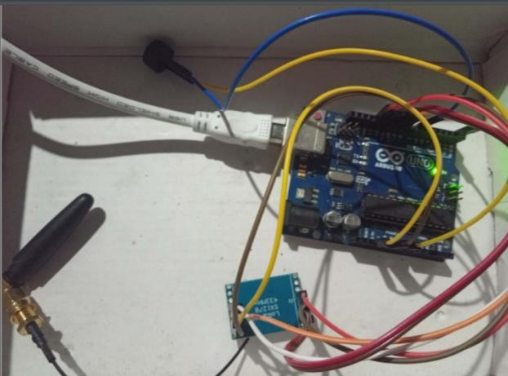

**5.2**

### APPENDIX

SENDER

#include <SPI.h>

#include <LoRa.h>

int counter = 0;

#define Fire_sensor1 8

#define Fire_sensor2 7

#define Fire_sensor3 6

#define Fire_sensor4 5

#define Fire_sensor5 4

#define Fire_sensor6 3

void setup() {

  Serial.begin(9600);

  pinMode(Fire_sensor1, INPUT);

  pinMode(Fire_sensor2, INPUT);

  pinMode(Fire_sensor3, INPUT);

  pinMode(Fire_sensor4, INPUT);

  pinMode(Fire_sensor5, INPUT);

  pinMode(Fire_sensor6, INPUT);

  while (!Serial);

  Serial.println("Sender Activated");

  if (!LoRa.begin(433E6)) {

    Serial.println("Starting LoRa failed!");

    while (1);

  }

   LoRa.setSpreadingFactor(12);

  LoRa.setSignalBandwidth(62.5E3);

  LoRa.setCodingRate4(8);

   LoRa.setSyncWord(0x22);

}

void loop() {

  if (digitalRead(Fire_sensor1) == HIGH || digitalRead(Fire_sensor2) == HIGH || digitalRead(Fire_sensor3) == HIGH || digitalRead(Fire_sensor4) == HIGH|| digitalRead(Fire_sensor5) == HIGH || digitalRead(Fire_sensor6) == HIGH) {

  LoRa.beginPacket();

  LoRa.print("F");

  LoRa.endPacket();

  delay(2000);

    }

    else {

    LoRa.beginPacket();

   LoRa.print("N");

   LoRa.endPacket();

   delay(2000);

    }

}

RECIVER

#include <SPI.h> #include <LoRa.h>

#define Buzzer 7 int counter=0; void setup() {

Serial.begin(9600); pinMode(Buzzer, OUTPUT); digitalWrite(Buzzer, LOW); while (!Serial);

Serial.println("Receiver Activated"); if (!LoRa.begin(433E6)) {

Serial.println("Starting LoRa failed!"); while (1);

}

LoRa.setSpreadingFactor(12); LoRa.setSignalBandwidth(62.5E3); LoRa.setCodingRate4(8); LoRa.setSyncWord(0x22);

}

void loop() { String LoRaData;

// try to parse packet

int packetSize = LoRa.parsePacket(); if (packetSize) {

// received a packet

while (LoRa.available()) { LoRaData = LoRa.readString(); Serial.println(LoRaData); if(LoRaData=="F")

{

Serial.println(counter); counter++; digitalWrite(Buzzer, HIGH); delay(500); digitalWrite(Buzzer, LOW);

} else {

}

}

}

Serial.println("N"); delay(1000);

}