**HINDI HANDWRITTEN CHARACTER RECOGNITION USING CONVOLUTIONAL NEURAL NETWORK**

*Report submitted to the SASTRA deemed to be University as the requirement for the course*

# ICT 304: SOFT COMPUTING TECHNIQUES

*Submitted by*

**KALAGA V S K ADITYA**

**(Reg.No:125004390, ECE)**

# May2024



# SCHOOL OF ELECTRICAL & ELECTRONICS ENGINEERING

**THANJAVUR, TAMIL NADU, INDIA – 613 401**



**SCHOOL OF ELECTRICAL AND ELECTRONICS ENGINEERING**

**THANJAVUR – 613 401**

**BONAFIDE CERTIFICATE**

This is to certify that the report titled “**HINDI HANDWRITTEN CHARACTER RECOGNITION USING CONVOLUTIONAL NEURAL NETWORK**” submitted as a requirement for the course, **ICT 304: SOFT COMPUTING** **TECHNIQUES** for B.Tech is a

bonafide record of the work done by **Shri. KALAGA V S K ADITYA (Reg.No:125004390, ECE)** during the academic 2023-24, in the School of Electrical and Electronics Engineering

Project Based Work *Viva voice* held on ____________

**Examiner 1 Examiner 2**

# ACKNOWLEDGEMENTS

First of all, we express our gratitude to Prof. Dr S Vaidhyasubramaniam, Vice Chancellor, SASTRA Deemed University, who provided all facilities and constant encouragement during our study. We extend our sincere thanks to Prof. R.Chandra Mouli, Registrar, SASTRA Deemed University for providing the opportunity to pursue this project. It is our privilege to express our sincerest regards to our project coordinator, Dr. K. Thenmozhi, Dean (SEEE), Sridhar K, Associate Dean (ECE) and Dr.R. John Bosco Balaguru, Dean (Sponsored Research) who motivated us during the project.

We owe a debt of most profound gratitude to our course faculty Dr.C. Lakshmi, AP III/ECE for her valuable inputs, able guidance, encouragement, wholehearted cooperation and constructive criticism throughout our project on the topic ‘HINDI HANDWWRITTEN CHARACTER RECOGNITION USING CONVOLUTIONAL NEURAL NETWORK’.

We take this opportunity to thank all our lecturers who have directly or indirectly helped our project.

# List Of Figures

|  |  |  |
| --- | --- | --- |
| **No** | **Title** | **Pg.No** |
| 1 | Recognition of Hindi Handwritten Text | 9 |
| 2 | Sample images from Dataset | 16 |
| 3 | CNN Architecture | 20 |
| 4 | Convolutional Layer | 21 |
| 5 | Maxpooling Layer | 22 |
| 6 | Flatten Layer | 23 |
| 7 | Desnse Layer connected to Output Layer | 24 |
| 8 | Sequential Model Summary | 30 |
| 9 | Training and Validation Accuracy Graph | 27 |
| 10 | Confusion Matrix of Proposed Model | 28 |
| 11 | Result of input image from Testing dataset | 29 |
| 12 | Real time input image | 29 |
| 13 | Result of Real time input image | 29 |

# Abbreviations

**CNN** Convolutional Neural Network **OCR** Optical Character Recognition

**GUI** Graphical User Interface

**ANN** Artificial Neural Network

# ABSTRACT

Handwritten character recognition has become increasingly important with the advancement of artificial neural networks, particularly deep learning, which has greatly enhanced machine learning. This technology has numerous applications, and the objective of this project is to showcase how neural networks can be utilized to recognize handwritten digits.

Convolutional neural networks (CNN) have become a fundamental part of deep learning techniques. Handwritten character recognition has become a popular research topic due to its potential applications in several areas, including document analysis, automated data entry, and human-machine interaction. However, accurate recognition of handwritten characters is challenging due to the variation in writing styles and complexity of scripts.

In this project, we proposed a novel approach to recognize handwritten Hindi characters using Convolutional Neural Networks (CNN). Our objective is to develop a reliable system that can accurately recognize 46 classes of Hindi characters, including vowels, consonants, and digits.

Handwritten character recognition is a complex task due to the variability in writing styles and the complexity of scripts. Accurate recognition of handwritten characters is crucial for various applications Therefore, there is a need for an effective and efficient system that can accurately recognize handwritten Hindi characters

To approach this system we used Dataset, which includes 60,000 photographs of handwritten numbers, in this project to assess CNN's performance. 98.85% of the handwritten character are accurate.

# TABLE OF CONTENTS

Title of the Project ........................................................................................................................................ 1

Bonafide Certificate ...................................................................................................................................... 3

List Of Figures ................................................................................................................................................ 4

Abbreviations ................................................................................................................................................ 5 ABSTRACT ...................................................................................................................................................... 6

1.INTRODUCTION .......................................................................................................................................... 8

1.1 Problem Statement………………………………………………………………………………………………………….……9

1.2 Objective………………………………………………………………………………………………………………….….……..10

1.3 Merits……………………………………………………………………………………………………………………………..….10

2.LITERATURE SURVEY................................................................................................................................. 11

3.METHODOLOGY ....................................................................................................................................... 14

3.1 Dataset Collection…………………………………………………………………………………………………………….…15

3.2 Pre-processing the Data………………………………………………………………………………………………………17

3.3 Feature Extraction……………………………………………………………………………………………………………….18

3.4 Model-Convolutional Neural Network………………………….………………………………………………….….19

3.4.1 Convolutional Neural Network…………………………………………………………………………….19

3.4.2 Architecture of the Model……………………………………………………………………………………19

3.4.2.1 Input Layer……………………………………………………………………………………….….20

3.4.2.2 Maxpooling Layer…………………………………………………………………………….…..21

3.4.2.3 2d Convolutional Layer…………………………………………………………………………22

3.4.2.4 Maxpooling Layer………………………………………………………………………………...22

3.4.2.5 Flatten Layer…………………………………………………………………………………………23

3.4.2.6 Dense Layer………………………………………………………………………………………….23

3.4.2.7 Output Layer………………………………………………………………………………………..24

3.5 Compiling and Training the Model……………………………………………………………………………………….25

4. RESULTS AND DISCUSSION ...................................................................................................................... 27

5.CONCLUSION ............................................................................................................................................ 31

6.FUTURE SCOPE ......................................................................................................................................... 32

7.REFERENCES ............................................................................................................................................. 33

# 1.INTRODUCTION

New technologies are constantly emerging, making our lives easier and transforming various industries. However, with the increasing digitization of documents and data, there is a growing need for automated systems that can recognize and process handwritten text. Despite this need, many people still prefer to write by hand rather than using digital devices or typing. This preference for handwriting creates a challenge for automated systems that need to recognize and interpret handwritten characters accurately.

To address this problem, we developed a Hindi handwritten digit recognition system. Handwritten character recognition involves the use of computer programs to identify and interpret human handwriting. Due to the variability in writing styles, sizes, and shapes of handwritten characters, this task is quite challenging for machines. This system uses an image of a character to identify the contained character. Our system employs a convolutional neural network (CNN) model based on a sequential approach to recognize handwritten digits.

Accurate and efficient handwritten character recognition systems have the potential to enhance data processing and accessibility for various applications. The development of such systems can aid in the automation of tasks such as form processing and data entry. Additionally, these systems can help make information more accessible to people with visual impairments or those who find it difficult to read handwritten documents. Overall, the development and enhancement of handwritten character recognition systems have the potential to improve efficiency and accessibility in various fields.

The field of handwritten character recognition is currently the subject of various research efforts aimed at advancing its capabilities. One of the primary focuses of this research is to develop more resilient methods for recognizing handwritten text, especially in languages with intricate scripts and character sets. Researchers are also working on creating systems that can identify complete words or phrases written in handwriting, rather than just individual characters. These research endeavours have the potential to drive significant progress in the field of handwritten character recognition, opening up new applications and use cases.

The evolution of technology has led to the development of numerous methods for handwritten digit identification. Among these methods, CNN is widely used in various image processing applications due to its high accuracy and ability to detect data loss or defects. CNN is particularly useful in image classification, video analysis, and other areas where accuracy is crucial. Researchers are continually working to enhance the accuracy and efficiency of CNN models for handwritten digit recognition and to reduce the need for error correction in sentiment identification.

CNN sequential models are a highly effective technique for classifying images. They involve passing an image through multiple layers of a neural network in a sequential manner to extract crucial features that are used to classify the image accurately. This approach is particularly useful for handling complex images with multiple objects or features. The CNN sequential model consists of multiple layers, including convolutional layers, pooling layers, and fully connected layers.

The sequential approach of CNN models allows them to learn the features of an image in a hierarchical manner. The lower layers of the network extract basic features such as edges and lines, while the higher layers extract more complex features such as shapes and objects. This hierarchical approach enables the efficient extraction of features from an image, leading to more accurate classification.

Furthermore, the development of accurate and efficient handwritten character recognition systems can help bridge the digital divide and make information more accessible to people in remote or underdeveloped areas with limited access to technology. This can have a significant impact on education, healthcare, and other essential services.



**Fig 1**: Recognition of Hindi handwritten text

**1.1 Problem Statement:**

Nonetheless, the importance of recognizing handwritten Hindi characters cannot be overstated. Many important documents, such as legal papers, bank cheques, and handwritten letters, are still written by hand. By developing technology that can recognize handwritten Hindi characters, it can provide greater accessibility and ease of use for these documents.

Furthermore, digitizing handwritten text can lead to the development of new applications such as text-to-speech conversion, automatic translation, and handwriting analysis, among others. These applications have the potential to benefit society in various ways, including improving accessibility for visually impaired individuals, enhancing language learning, and preserving cultural heritage.

To address the challenges of recognizing handwritten Hindi characters, several techniques and approaches have been proposed, including convolutional neural networks (CNN), deep learning, and transfer learning. Although these techniques have shown promising results in recognizing handwritten Hindi characters, there is still room for improvement.

In conclusion, the recognition of handwritten Hindi characters is a challenging and significant problem with a great potential for real-world applications. By continuously developing and enhancing recognition technology, we can enable new applications that can benefit society while preserving cultural heritage.

**1.2 Objective:**

This project aims to develop an efficient system for recognizing handwritten characters in the Hindi script using convolutional neural networks (CNN) and achieving high recognition accuracy. The system will be designed to minimize the need for human intervention, reducing the risk of errors and increasing efficiency. The objective is to explore the potential of CNN-based approaches for recognizing handwritten Hindi characters and demonstrate their suitability for application in other languages.

The digitization of data has increased the need for automated systems that can recognize and process handwritten text, particularly in Hindi language. By developing a CNN-based approach for recognizing handwritten Hindi characters, we can enable the automation of recognition for data entry, reducing the risk of errors and minimizing the need for manual intervention. Furthermore, recognizing handwritten characters is a fundamental step for language translation, text-to-speech conversion, and handwriting analysis applications.

The successful development of a system that can accurately recognize and classify handwritten Hindi characters can facilitate greater accessibility and ease of use for documents and data in Hindi language. Additionally, it can enable the development of new applications that can benefit society in various ways, such as improving accessibility, preserving cultural heritage, and enhancing language learning. Overall, the objective of this project is to contribute to the advancement of handwriting recognition technology, demonstrate the potential of CNN-based approaches for recognizing handwritten Hindi characters, and enable the development of new applications that can improve accessibility and enhance the use of Hindi language data.

**1.3 Merits:**

* Document Digitization
* Automatic Translation
* Text-to-Speech Conversion
* Forensics
* Banking sector

# 2.LITERATURE SURVEY

|  |  |  |  |
| --- | --- | --- | --- |
| **S. No** | **Paper Title** | **Author** | **Abstract** |
| 1. | **Hindi Handwritten**  **Character**  **Recognition using**  **Deep Convolution**  **Neural Network** | Kaushal Sharma | This study introduces a Deep Convolutional Neural Network (DCNN) for the recognition of Hindi handwritten characters, which builds upon the LeNet-5 architecture. The model was trained with 96000 character sets and achieved a validation set accuracy of 95.72% using the Adam optimizer and 93.68% using the RMSprop optimizer. |
| 2. | **Handwritten Hindi**  **Character**  **Recognition using**  **Deep Learning Techniques** | R. Vijaya Kumar  Reddy  U. Ravi Babu | The focus of this study is the development of a system for recognizing handwritten Hindi characters using various Deep Learning techniques (CNN) with the RMSprop and Adam optimizers, as well as Deep Feed Forward Neural Networks (DFFNN). The system was trained on a large set of image database samples and tested on user-defined data set images, producing highly accurate recognition results. With accuracy – 95.72% |
| 3. | **Handwritten**  **Character Recognition using Deep Learning** | Bhargav Rajyagor  Rajnish Rakholia | Character recognition using Deep Learning has gained significant attention in computer science due to its ability to effectively address complex machine learning problems using pattern recognition tools. Deep Learning has a wide range of applications, including speech recognition, image processing, and natural language processing. |
| 4. | **Handwritten Text**  **Recognition System based on Neural Network** | Hazem M El-Bakry  Abdulaziz Shehab | The objective is to develop a system for recognizing handwritten Hindi characters utilizing DL techniques, including CNN with RMSprop and Adam optimizers and Deep Feed Forward Neural Networks (DFFNN). The system underwent training utilizing a vast set of image database samples and testing on user-defined dataset images, achieving exceptional recognition accuracy with impressive precision. |

|  |  |  |  |
| --- | --- | --- | --- |
| **S. No** | **Paper Title** | **Author** | **Abstract** |
| 5 | **Offline Handwritten**  **Hindi Word Recognition** | Nistha Lodhi Vikas Singhal | The text discusses different approaches to character recognition, including character grouping, neural networks, SVM, and decision trees. The paper investigates Hindi Offline handwritten word recognition (HWR) using OCR Framework and CNN. The proposed system achieved highly accurate recognition results with accuracy 83.4%. |
| 6. | **Hindi handwritten character**  **recognition using multiple classifiers** | [Madhuri Yadav](https://ieeexplore.ieee.org/author/37086190117) [Ravindra Purwar](https://ieeexplore.ieee.org/author/38095423600) | Approach for automated recognition of handwritten Hindi isolated characters using multiple classifiers. The approach involves feature extraction using histogram of oriented gradients and profile projection histogram, with quadratic SVM identified as the best classifier. The study highlights the challenges involved in transferring human knowledge of character recognition to computers and its potential impact on the development of more accurate and efficient recognition systems. |
| 7. | **Devanagari**  **Handwritten**  **Character**  **Recognition using Convolutional**  **Neural Networks** | Yash Gurav  Priyanka Bhagat  Rajeshri Jadhav  Swati Sinha | Paper focuses on the Devanagari script, The script consists of 47 primary alphabets, 14 vowels, 33 consonants, and 10 digits. The paper presents a system that works on a set of 29 consonants and one modifier using a selfmade Devanagari script dataset with 34604 handwritten images. DCNN has been incorporated to extract features and classify input images, resulting in an impressive accuracy of 99.65%. |
| 8. | **Image Character**  **Recognition using Convolutional**  **Neural Networks** | Raja Muthalagu Adith Narayan | The implementation of Convolutional Neural Network for Image character recognition. Handwritten Character Recognition is important for various applications such as machine translation. The study evaluates the use of CNN in detecting and recognizing handwritten text images with high accuracy. The CNN model performs feature extraction through multiple layers and is trained on English handwritten characters to recognize them. |
| **S. No** | **Paper Title** | **Author** | **Abstract** |
| 9. | **Handwritten Hindi Consonants**  **Recognition System using Zemike**  **Moments and**  **Genetic Algorithm** | Ajay Indian  Karamjit Bhatia | The paper studies the significance of loworder and high-order Zernike moments in recognizing the first ten consonants of Hindi script. The system trains two resilient backpropagation classifiers and achieves average character recognition accuracies of 90% and 94.3%, respectively. This study provides potential solutions for recognizing handwritten Hindi characters, which is a challenging research problem in developing an efficient character recognition system. |
| 10. | **Handwriting Recognition using CNN and RNN** | Ala SreeVarshitha Chennamsetti Donna Thomas Maliakal | Handwritten documents pose a challenge in storage and retrieval, and can easily be destroyed or misplaced. The proposed application aims to convert important documents into a standard electronic format using new technologies like CNN and RNN. The application integrates multiple domains in computer science, and Database storage, to provide optimal results and ease of use for the customer. This application has significant potential in increasing convenience and accessibility for important documents, particularly in our current pandemic-stricken world. |

# 3.METHODOLOGY

Convolutional neural networks (CNNs) are an ideal choice for recognizing handwritten Hindi characters due to their ability to learn and extract relevant features from images. CNNs are inspired by the structure of the animal visual cortex, where independent cortical neurons react to single inputs in a small region of the chromatic field, known as the receptive field.

In this project, we aim to use a CNN to recognize handwritten Hindi characters, the workflow of projects starts with path to the dataset directory then mapping each character to a number. Then loads and pre-processes the dataset for training. Each image in the dataset is loaded and resized to 32x32 pixels, and normalized to be between 0 and. The pre-processed images and their corresponding class labels are stored in arrays. The dataset is split into training and testing, with 80% of the dataset used for training and 20% used for testing.

The CNN architecture is defined using the Sequential API from TensorFlow's Keras. The model consists of two convolutional layers, each followed by a max-pooling layer, a flatten layer, two dense layers, and activation function layers to extract relevant features from the images, followed by a flatten layer and dense layers for classification. These layers will enable us to extract features such as edges and textures from the images to accurately identify each character.

To train the model, we will compile it by specifying the optimizer, loss function, and evaluation metric. We will then train the model on the pre-processed dataset and validate its performance using an evaluation metric. The trained model can then be saved for future use.

This methodology can be used to build OCR systems for various applications, including digitizing ancient manuscripts, recognizing handwritten postal addresses, and more. Accurately recognizing handwritten Hindi characters can help preserve and digitize important cultural and historical artifacts.

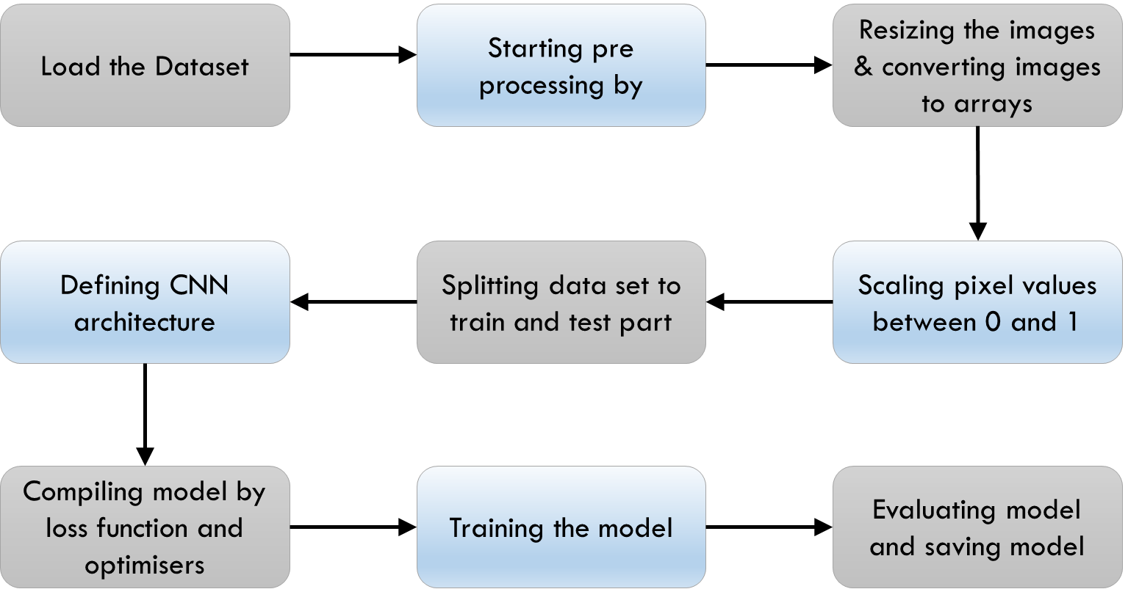

**3.1 Dataset Collection**

1. Collecting the dataset contain images of Hindi handwritten character in different font styles and in different sizes.
2. The data set contains 36 characters and 10 digits with total images of 92,000. Each image consists of 32x32 pixels and 3 colour channels.
   * 1. Training set consists of 78200 images (1700 per character)
     2. The test set consists of 13800 total images (300 for each character)
3. Source link: *<https://www.kaggle.com/datasets/suvooo/hindi-character-recognition>*
4. The data set contains 46 labels. They are listed below

|  |  |
| --- | --- |
| **Label** | **Number of Pictures** |
| character_1_ka | 1700 |
| character_2_kha | 1700 |
| character_3_ga | 1700 |
| character_4_gha | 1700 |
| character_5_kna | 1700 |
| character_6_cha | 1700 |
| character_7_chha | 1700 |
| character_8_ja | 1700 |
| character_9_jha | 1700 |
| character_10_yna | 1700 |
| character_11_taamatar | 1700 |
| character_12_thaa | 1700 |
| character_13_daa | 1700 |
| character_14_dhaa | 1700 |
| character_15_adna | 1700 |
| character_16_tabala | 1700 |
| character_17_tha | 1700 |
| character_18_da | 1700 |
| character_19_dha | 1700 |
| character_20_na | 1700 |
| character_21_pa | 1700 |
| character_22_pha | 1700 |
| character_23_ba | 1700 |
| character_24_bha | 1700 |
| character_25_ma | 1700 |
| character_26_yaw | 1700 |
| character_27_ra | 1700 |
| character_28_la | 1700 |
| character_29_waw | 1700 |
| character_30_motosaw | 1700 |
| character_31_petchiryakha | 1700 |
| character_32_patalosaw | 1700 |
| character_33_ha | 1700 |
| character_34_chhya | 1700 |
| character_35_tra | 1700 |
| character_36_gya | 1700 |
| digit_0 | 1700 |
| digit_1 | 1700 |
| digit_2 | 1700 |
| digit_3 | 1700 |
| digit_4 | 1700 |
| digit_5 | 1700 |
| digit_6 | 1700 |
| digit_7 | 1700 |
| digit_8 | 1700 |
| digit_9 | 1700 |

 

Fig 2:Sample images in dataset.

**3.2 Pre-processing the Data**

Pre-processing data is an essential step when training a Convolutional Neural Network (CNN) because it can greatly impact the performance of the model. Data pre-processing involves various techniques such as normalization, dimensionality reduction, data augmentation, and regularization, which can help to improve the quality of the data, reduce overfitting, speed up training, efficiently use memory resources, and enable the handling of different data types.

One of the main benefits of pre-processing data is that it can improve the quality of the input data by removing errors and inconsistencies. For example, images may contain artifacts or noise that can affect the CNN's ability to correctly classify them. By applying techniques such as denoising or smoothing, these issues can be mitigated or eliminated, resulting in higher quality data. Similarly, text data may need to be cleaned and pre-processed by removing stop words, stemming, or tokenizing before it can be input into a CNN.

Pre-processing data can also help to reduce overfitting, which is a common issue when training a CNN. Overfitting occurs when the model becomes too specialized to the training data and is unable to generalize to new data. Techniques such as data augmentation, regularization, and dropout can help to reduce overfitting by introducing noise and randomness into the data and encouraging the CNN to learn more robust features that are able to generalize to new data.

Furthermore, pre-processing techniques such as normalization and dimensionality reduction can speed up the training process by reducing the amount of computation required by the CNN. This can lead to faster training times and improved performance. Additionally, techniques such as batching and data generators can help to efficiently use memory resources during training by loading and processing data in smaller batches rather than all at once.

In summary, pre-processing data is a critical step when training a CNN because it can improve the quality of the input data, reduce overfitting, speed up training, efficiently use memory resources, and enable the handling of different data types. By applying appropriate pre-processing techniques, the CNN can learn more robust features and perform better on new and unseen data.

In this system these are the pre-processing steps involved are reading image files from the file system using file I/O operations. The image data is then stored in a multi-dimensional array or tensor. Later, we are resizing image into 32X32 size. Then the resized images pixel’s data are stored into any array. After storing pixel’s values, we have to normalise each pixel value by 255. This operation scales the pixel values to a range between 0 and 1, which is a common preprocessing step for image data. At last, splitting the data into training and validation purpose.

**3.3 Feature Extraction**

After pre-processing the data, the next step is featuring extraction. Feature extraction is a process in deep learning that involves transforming raw input data, such as images, into a set of features that can be used as input to a machine learning model. The purpose of feature extraction is to identify informative and discriminative patterns in the input data that can help with the learning process and improve the model's performance.

Convolutional neural networks (CNNs) are a type of deep learning model that rely heavily on feature extraction. CNNs learn hierarchical representations of input data by applying a sequence of convolutional and pooling operations. The convolutional layers use filters to extract local features, such as edges, corners, and textures, from the input image. The pooling layers then down sample the feature maps to reduce their dimensionality and enhance the translation invariance of the learned features. The extracted features are then fed into fully connected layers that perform the classification or regression task. These layers learn how to combine the extracted features to make a decision about the input.

Feature extraction is significant in CNNs because it enables the model to automatically identify and represent informative and discriminative patterns in the input data. This helps the model to generalize better to unseen data and achieve higher accuracy on the task at hand. Additionally, the extracted features can be transferable to other datasets, which can save computation time and resources.

In this proposed model, feature extraction is performed implicitly during the pre-processing step. The images in the dataset are first loaded and then resized to a fixed size of (32, 32) pixels. The images are then converted to arrays of pixel values. Each pixel value represents the intensity of the corresponding pixel in the image.

The pixel arrays are then stored, while the corresponding labels are stored in the array. The images are normalized by dividing each pixel value by 255, which scales the pixel values between 0 and 1. This normalization step is important because it standardizes the input data and makes it easier for the CNN to learn useful features. Then CNN architecture is defined consisting of two convolutional layers, two max pooling layers, a flatten layer, and two dense layers. The CNN is trained during training, the CNN learns to extract informative features from the input images that can be used to accurately classify the images in the dataset.

In summary, the process of converting the images in the dataset into arrays of pixel values and normalizing them is a form of feature extraction because it transforms the raw input data into a format that is easier for the CNN to learn from.

**3.4 Model- convolutional Neural Network:**

**3.4.1** **convolutional Neural Network**

A convolutional neural network (CNN) is a type of artificial neural network that is specifically designed to analyse pixel input and is widely used in image recognition tasks. Unlike traditional neural networks, CNNs use a unique architecture that enables them to extract useful features from images and classify them accurately.

CNNs are powerful AI image processing systems that employ deep learning techniques to perform both generative and descriptive tasks. They learn to recognize patterns in images by analysing large amounts of labelled data. This process involves training the network on a dataset of images and adjusting its parameters until it can accurately classify new images.

CNNs have revolutionized the field of computer vision and have applications in a wide range of fields, including self-driving cars, medical image analysis, and facial recognition. They are particularly effective in tasks that involve complex images with multiple objects and backgrounds.

Traditional neural networks must be given pictures pixel-by-pixel, which is insufficient for image processing. CNN's "neurons" are structured more like the frontal lobe, which is where visual input is processed in humans and other animals. Because the layers of neurons are structured to cover the entire visual field, the problem of piecemeal image processing that plagues traditional neural networks is avoided. A CNN utilizes a multilayer classifier network that has been optimized for minimal processing needs. CNN's layers consist of an input layer, an output layer, and a hidden layer with numerous convolutional layers, pooling layers, fully connected layers, and normalizing layers.

The elimination of constraints and improvement in image processing efficiency results in a system that is substantially more efficient and easier to train for image processing and natural language processing. CNN extracts spatial information from images.

In summary, a convolutional neural network is a type of artificial neural network that is specifically designed for image recognition tasks. It is a powerful deep learning system that can extract useful features from images and classify them accurately. CNNs have transformed the field of computer vision and have numerous applications in various industries.

**3.4.2 Architecture of the Model:** The layers involved in the model plays an vital role as they are responsible for the feature maps and also getting the output. Proposed model, The CNN architecture used in this model is total of 7 layers So, the layers involved in this model are as follows:

I. Input layer (Conv2D layer). II. MaxPooling2D layer. III. Conv2D layer.

IV. MaxPooling2D layer. V. Flatten layer.

1. Dense layer.
2. Output layer (Dense Layer).

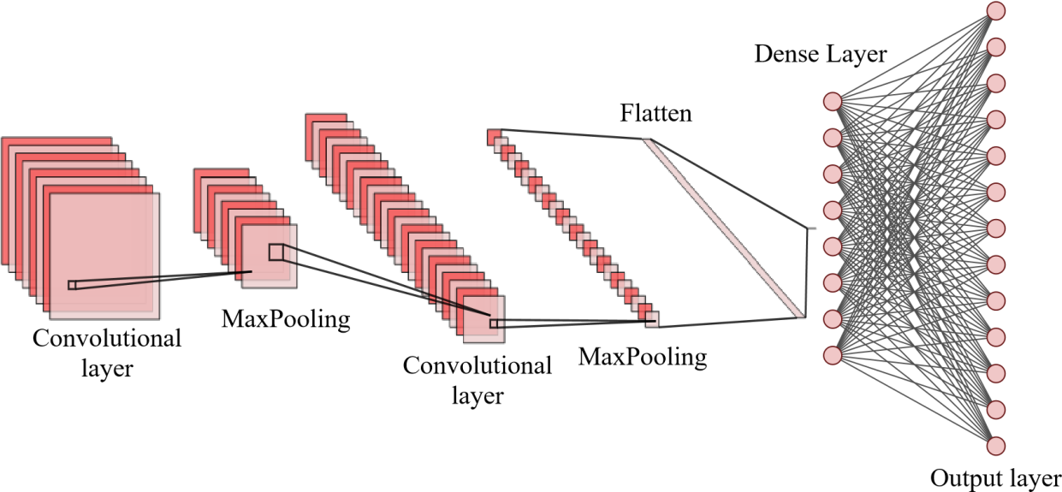

Fig3: CNN architecture diagram

**3.4.2.1 Input Layer:**

The input layer of the CNN architecture is typically the first layer in the network that receives the input data. It takes in the input image data and applies a set of filters to extract features. In the proposed model, the input layer is defined using the Conv2D layer of the Keras API in TensorFlow.

The Conv2D layer has several parameters that determine its behaviour. The number of filters in the input layer is set to 32 in this code, which is a common choice in many CNN architectures. The size of the filters is (3,3), which means that each filter has a width and height of 3 pixels. The activation function used in the layer is the Rectified Linear Unit (ReLU), which is commonly used in deep learning architectures.

In the field of computer vision, using 32 filters in the input layer of the CNN architecture is a commonly adopted practice. This is because 32 filters provide a good balance between computational efficiency and model performance while enabling the extraction of a diverse set of low-level features from the input data. Therefore, the use of 32 filters in the input layer of a CNN is a well-established and effective approach in computer vision.

Rectified Linear Unit (ReLU) is a widely used activation function in deep learning, particularly in CNNs. ReLU is popular because it is simple, computationally efficient. The ReLU activation function maps any negative input value to zero and leaves positive input values unchanged. Mathematically, ReLU is defined as f(x) = max (0, x), where x is the input to the activation function, and f(x) is the output. ReLU is a nonlinear function, which allows the network to model complex, nonlinear relationships between the input and output data.

The parameter of the Conv2D layer is used to define the shape of the input data. In this model, the parameter is set to (32, 32, 3), which represents the width, height, and number of colour channels (RGB) of the input image data.

Overall, the input layer is critical to the performance of a CNN architecture, and the choice of its parameters can significantly impact the model's accuracy and efficiency.

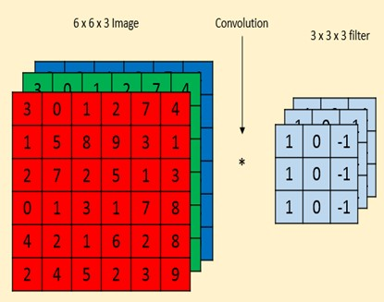

Fig4: Convolutional Layer

**3.4.2.2 MaxPooling Layer:**

The MaxPooling2D layer in the provided code is used to down sample the output from the previous layer, which can help to reduce the number of parameters in the model and prevent overfitting. This type of pooling layer is commonly used in CNN architectures.

The MaxPooling2D layer takes in a 2D matrix as input and applies a max-pooling operation to it. This involves taking the maximum value in each window of a given size and outputting it as the result. In this case, a window size of (2, 2) is used, which means that the maximum value in each 2x2 window of the input matrix is computed.

The use of a 2x2 pooling window in the MaxPooling2D layer of the provided code is a common practice in many CNN architectures. It offers several advantages over other window sizes. Firstly, it down samples the convolutional feature maps, reducing their spatial resolution by a factor of 2 in both the horizontal and vertical directions. Secondly, it provides a degree of translation invariance, enabling the layer to extract features that are robust to small translations in the input image. Finally, using a larger pooling window would significantly reduce the spatial resolution of the feature maps and may lead to information loss, while using a smaller window would not provide enough down sampling. Overall, a 2x2 pooling window strikes a good balance between down sampling, translation invariance, and computational efficiency, making it a common choice in CNN architectures.

The MaxPooling2D layer has several parameters that can be set to control its behaviour.

The parameter sets the size of the pooling window, and in this code, it is set to (2, 2).

Overall, the MaxPooling2D layer is an important component of CNN architectures because it can help to reduce the spatial size of the output from the previous layer, which can help to reduce overfitting and improve the computational efficiency of the model.

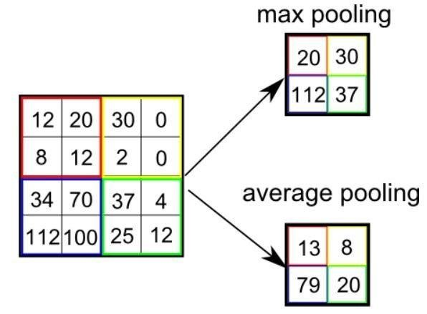

Fig5: MaxPooling Layer

**3.4.2.3 2dConvolutional Layer:**

In the proposed model, the third layer is a Conv2D layer with 64 filters and a filter size of (3, 3). This layer applies a convolution operation to the output from the second layer to extract higher-level features from the input images. By increasing the number of filters in the Conv2D layer, the model can learn more complex representations of the input data.

Overall, the CNN architecture defined in the code uses multiple Conv2D layers to extract increasingly complex features from the input images, which are then passed through MaxPooling2D layers to reduce the spatial size of the output. By stacking multiple Conv2D layers with increasing numbers of filters, the model can learn more complex representations of the input data, leading to improved performance on classification tasks.

**3.4.2.4 MaxPooling Layer:**

The fourth layer in the provided code is a MaxPooling2D layer with a pooling window size of (2,2). This layer reduces the spatial size of the output from the previous Conv2D layer by taking the maximum value in each non-overlapping (2,2) block of the input.

The MaxPooling2D layer follows the second Conv2D layer with 64 filters, which has learned more complex features from the input images compared to the first Conv2D layer with 32 filters. The MaxPooling2D layer reduces the spatial size of the output from the second Conv2D layer, preparing it for the next layer in the CNN architecture.

**3.4.2.5 Flatten Layer:**

The Flatten layer in the proposed model is an important element of the convolutional neural network. It takes the output from the previous layer, which is a tensor with multiple 2D feature maps, and converts it into a 1D feature vector. This transformation preserves the spatial relationships between the features while reducing their dimensions, which simplifies their processing in the subsequent layers of the neural network.

By flattening the feature maps, the Flatten layer enables the fully connected layers of the neural network to learn more complex non-linear relationships between the input features and the output classes. This allows the model to perform better on classification tasks by capturing more abstract features in the input data.

Overall, the Flatten layer is a critical component of the proposed model that helps to improve its performance on classification tasks by facilitating the learning of complex non-linear relationships between the input features and the output classes.

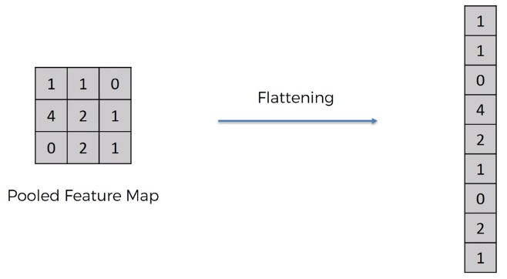

Fig6: Flatten Layer

**3.4.2.6 Dense Layer:**

The sixth layer in the model is a Dense layer with 128 units and a ReLU activation function. This layer is responsible for learning complex non-linear relationships between the input features and output classes. The Dense layer takes the flattened 1D feature vector as input and applies a matrix multiplication operation, followed by a bias term, to produce a new set of features. These new features are then passed through the ReLU activation function, which applies an element-wise non-linear transformation to the output of the matrix multiplication.

The ReLU activation function is popular in deep learning because it helps to capture nonlinear patterns in the data. It sets all negative values to zero and leaves positive values unchanged, which allows the network to learn complex non-linear relationships between the input features and output classes.

The number of units in the Dense layer is typically chosen based on the complexity of the problem and the size of the input data. In this case, the input data is a flattened 1D vector of length 2048 (32x32x2), which is the output of the Flatten layer.

In addition, it is a common practice in deep learning to use powers of 2 for the number of units in layers, as this can lead to faster and more efficient computations on modern hardware.

Since the problem is a multi-class classification task with 46 classes, the number of units in the Dense layer needs to be large enough to capture the complex non-linear relationships between the input features and the output classes. However, it should not be too large, as this can lead to overfitting and slow down the training process.

After experimenting with different numbers of units, 128 units were chosen as a reasonable compromise between model complexity and performance on the classification task. Therefore, 128 was used as the number of units in the Dense layer.

Overall, the sixth layer in this model plays a critical role in learning high-level features from the input data and improving the model's performance on classification tasks.

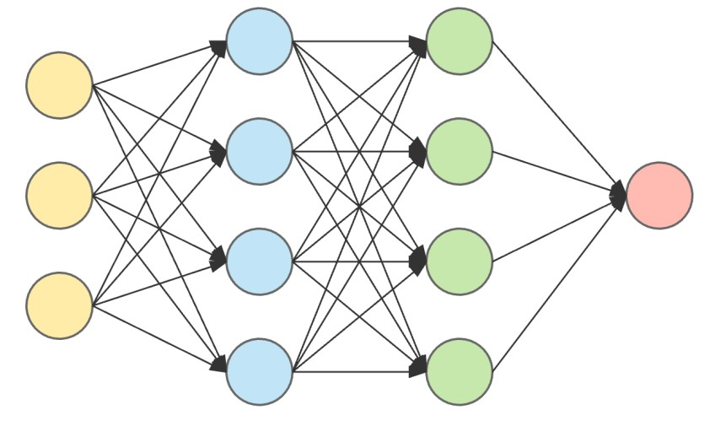

Fig7: Dense layer connected to output layer.

**3.4.2.7 Output Layer:**

The seventh layer in the provided code is the output layer of the neural network model. It is a Dense layer with softmax activation function, which is commonly used in the output layer for multi-class classification problems. The output layer units, which is 46 in this case, representing the number of classes in the multi-class classification problem.

The softmax function is a popular activation function used in the output layer of neural networks for multi-class classification problems. It takes a vector of real numbers as input and produces a vector of probabilities as output, where the sum of the probabilities of all classes is equal to one. The softmax function maps any real-valued vector to a probability distribution, such that each element in the output vector is a probability that ranges between 0 and 1. The element with the highest probability represents the predicted class label.

Overall, the seventh layer in the model is responsible for producing the final output of the neural network model, In the context of the neural network model in the provided code, the softmax function is used in the output layer to produce a probability distribution over the 46 classes, which represents the predicted probability of each class given the input image.

**3.5 Compiling and Training the Model:**

Certainly! Compiling the neural network model involves configuring the model for the training process. In the proposed model, the compile method is used to specify three key aspects of the training process: the optimizer, the loss function, and the metrics that will be used to evaluate the performance of the model.

The optimizer is chosen based on its ability to minimize the loss function during the training process. In this case, the Adam optimizer is used, which is a popular stochastic gradient descent (SGD) algorithm that uses adaptive learning rates to speed up convergence

The Adam optimizer works by using a moving average of the first and second moments of the gradients to adapt the learning rate during training. This allows the optimizer to converge faster and more reliably than traditional SGD. Adam is particularly well-suited for problems with large datasets or parameters because it scales well to these types of problems. It is also less sensitive to the choice of hyperparameters than other optimization methods. Overall, Adam is a powerful and widely-used optimizer for deep learning models.

The loss function is used to calculate the difference between the predicted output of the model and the actual output (i.e., the ground truth labels) during training. The sparse_categorical_crossentropy loss function is used in this code, which is appropriate for multiclass classification problems with sparse labels. This loss function is commonly used for training neural networks with sparse labels in multi-class classification problems.

Finally, the metrics are used to evaluate the performance of the model during training and validation. The accuracy metric is used in this code, which is a common metric for classification problems that measures the percentage of correctly predicted labels.

The fit method is used to train the neural network model with the specified hyperparameters, including the data generator, batch size, number of epochs, and validation data. In the provided code, the flow method of the data generator is used to apply data augmentation to the training data in real-time, which can help to increase the size and diversity of the training dataset.

During training, the model is evaluated on the validation data after each epoch to monitor its performance and prevent overfitting. The fit method returns a history object that contains information about the training and validation accuracy and loss for each epoch. This information can be used to visualize the training progress and diagnose potential issues with the model.

Overall, the fit method is a crucial step in training the neural network model with the specified hyperparameters, and can help to improve its accuracy and robustness.

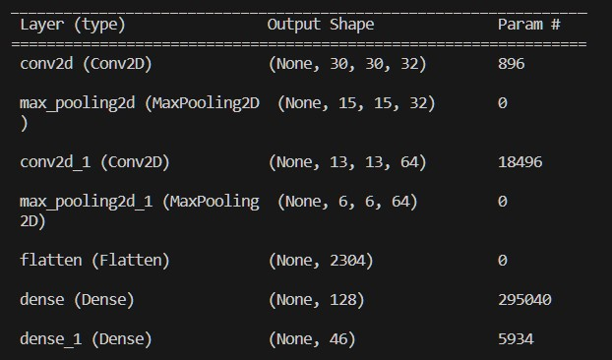

Fig8: Sequential Model Summary

# RESULTS AND DISCUSSION

**4.1 Accuracy Graph**

The plot of accuracy over time can be useful for evaluating the performance of the model during training. This information can help determine if the model is overfitting or underfitting to the training data, and can be used to improve the model's hyperparameters for better performance.

During training, the model is optimized on the training data using the accuracy metric as the objective function. The training and validation accuracy are calculated at each epoch during training, and plotted in a graph to visualize the model's performance. The training accuracy measures how well the model is able to classify the data it has seen before, while the validation accuracy measures how well the model is able to generalize to new, unseen data.

The difference between the training accuracy and validation accuracy can be used to identify whether the model is overfitting or underfitting. If the training accuracy is much higher than the validation accuracy, it could suggest that the model is overfitting to the training data and is not generalizing well to new data. Conversely, if both the training and validation accuracy are low, it could indicate that the model is underfitting and not learning the patterns in the data.

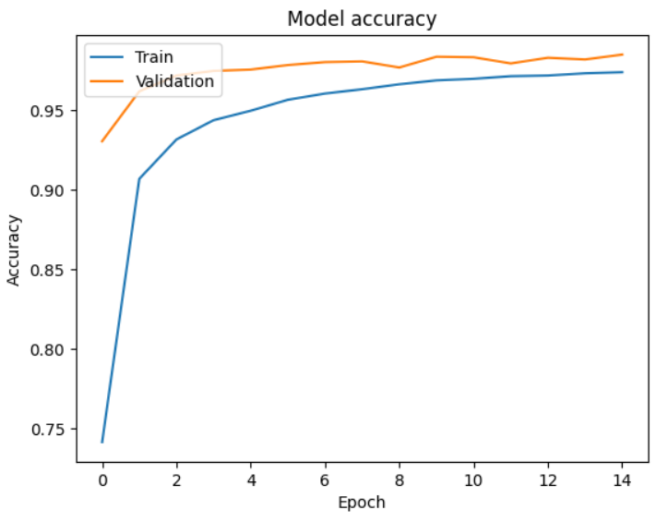

Fig9 : Training and Validation accuracy graph.

The accuracy metric for the training data is 0.9940, indicating that the model is able to classify the training data with a high degree of accuracy. The val_accuracy metric for the validation data is 0.9701, which is slightly lower than the training accuracy but still quite high. This suggests that the model is generalizing well to new, unseen data.

Furthermore, the loss metric for the training data is quite low at 0.0178, and the val_loss metric for the validation data is also relatively low at 0.1443. This indicates that the model is not overfitting to the training data, as the validation loss is not significantly higher than the training loss.

## Confusion Matrix

A confusion matrix is a table that is commonly used to evaluate the performance of a classification model. It shows the number of correct and incorrect classifications made by the model on a set of test data.

The resulting confusion matrix is then visualized using matplotlib. The matrix is displayed as a grid of squares, where the rows represent the true labels and the columns represent the predicted labels. Each square in the grid represents the number of instances where the true label is equal to the row label and the predicted label is equal to the column label.

The confusion matrix is a useful tool for evaluating the performance of a model and identifying areas where it may be struggling to classify certain classes. For example, high numbers in certain off-diagonal elements may indicate that the model has a tendency to confuse certain classes with each other. By analysing the confusion matrix, it is possible to identify areas for improvement and adjust the model accordingly.

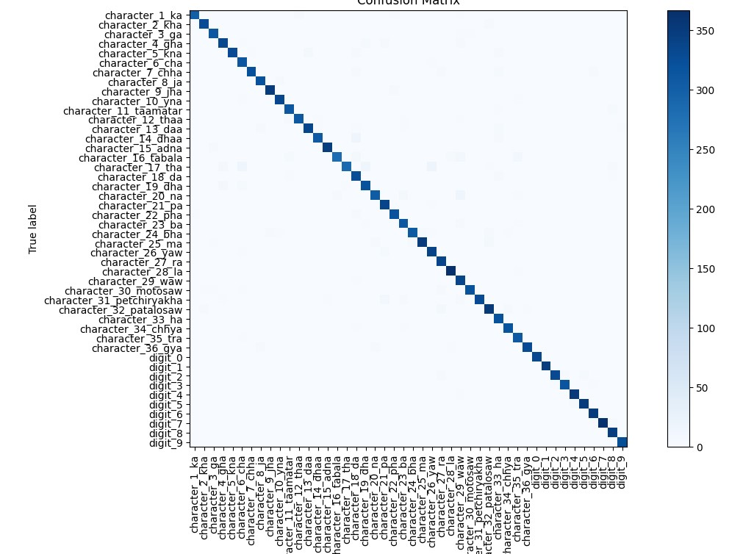

Fig10: Confusion matrix of proposed model with 46 labels.

**4.3 Testing Output:**

For testing purpose, a GUI is created to display the predicted class label and prediction graph for given testing sample.

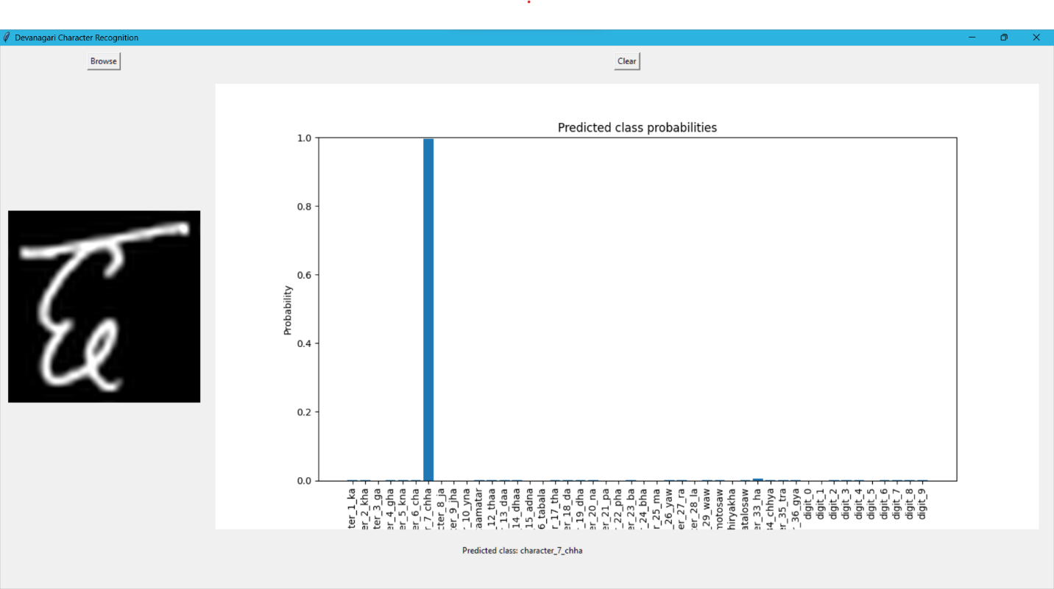

Fig11: Result of input image from testing dataset

The above figure graph signifies that the given input is from label ‘character_7_chaa’ **4.4 Testing-Real Time Input:**

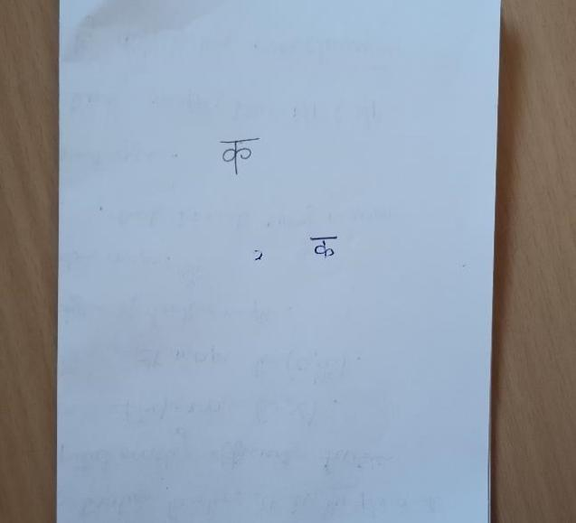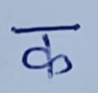

Fig12: Real Time Input image.

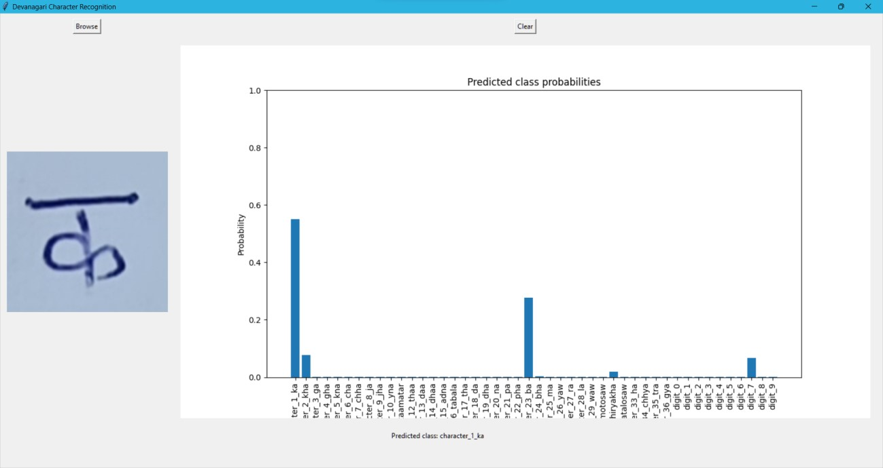

Fig13: Result of Real Time Input.

The above graph signifies that the given input has some predicted probabilities for some labels, but it is high for ‘character ka’. So, it returned ‘character ka’ label.

# 5.CONCLUSION

The conclusion for the project on Hindi Handwritten Character Recognition using Convolutional Neural Networks (CNN) is as follows:

The project has successfully demonstrated the potential of using CNN for accurately identifying and classifying handwritten characters in Hindi. The code loads the dataset of handwritten Hindi characters and pre-processes it by resizing the images and normalizing the pixel values. The dataset is then split into training and testing sets. The CNN architecture includes convolutional layers, max-pooling layers, and fully connected layers. This architecture totally consist of 7 layers including input and output layer. The model is compiled using the 'adam' optimizer and 'sparse_categorical_crossentropy' loss function.

The model is trained on the training set and validated on the testing set for 10 epochs, achieving high accuracy in recognizing the handwritten characters, with an descent accuracy percentage. The trained model is saved for future use. Such that we can use this model for testing purpose.

This project is a significant step towards developing robust optical character recognition systems for non-English languages like Hindi. Such systems can have numerous applications in fields like education, finance, healthcare, retail, and eCommerce. For instance, HCR systems can be used to digitize handwritten documents, grade assignments and tests, read and sort handwritten addresses, process handwritten checks and forms, and more. The development of accurate and robust HCR systems for non-English languages is crucial for improving efficiency, accuracy, and productivity in various fields.

# 6.FUTURE SCOPE

Additional potential directions for future work on Hindi Handwritten Character Recognition using CNNs:

* **Multilingual recognition:** CNNs can be used for multilingual recognition. Future work could explore the development of CNN models that can recognize characters from multiple languages, including Indian languages and other scripts.
* **Online recognition:** Online recognition, where characters are recognized as they are written in real-time, is an important problem in handwriting recognition. Future work could explore the use of CNNs for online recognition in Hindi.
* **Text extraction from handwritten documents:** Handwritten character recognition can also be applied to text extraction from handwritten documents, such as letters, forms, and notes. Future work could explore the development of CNN models that can detect and recognize handwritten characters in such documents and extract the text for further processing. To achieve this, the models would need to be able to handle different styles of handwriting, as well as deal with challenges such as overlapping characters, non-standard layouts, and variable image quality. Such models could have practical applications in fields such as finance, healthcare, and education, where handwritten documents are still in widespread use.
* **Detection and translation:** Handwritten character recognition can be a useful tool for detecting and translating text in images. Future work could explore the development of CNN models that can detect and recognize handwritten characters in images and translate them into other languages, making it easier for people to access and understand information in different languages. This could involve developing models that can accurately recognize handwriting in different styles and contexts, such as cursive handwriting or handwriting on different surfaces.

# 7.REFERENCES

* D. Chaudhary and K. Sharma, "Hindi Handwritten Character Recognition using Deep Convolution Neural Network," 2019 6th International Conference on Computing for Sustainable Global Development (INDIA.Com), New Delhi, India, 2019, pp. 961-965.
* Mishra, A., & Gupta, A. (2019). Handwritten Hindi character recognition using deep convolutional neural network. 2019 3rd International Conference on Computing Methodologies and Communication (ICCMC), pp. 674-678. doi: 10.1109/ICCMC.2019.8843443.
* Sharma, R., & Sahu, A. (2020). Handwritten Hindi character recognition using deep convolutional neural network. 2020 2nd International Conference on Advances in Electronics, Computers and Communications (ICAECC), pp. 1-4. doi: 10.1109/ICAECC51249.2020.9357860.
* Agarwal, A., & Shukla, A. (2021). Handwritten Devanagari (Hindi) character recognition using deep convolutional neural network. 2021 4th International Conference on Intelligent Computing,

Instrumentation and Control Technologies (ICICICT), pp. 1297-1301. doi:

10.1109/ICICICT50727.2021.9489564.

* Singh, A. K., & Singh, S. (2018). Handwritten Hindi character recognition using convolutional neural network. 2018 International Conference on Advances in Computing, Communications and Informatics (ICACCI), pp. 2439-2442. doi: 10.1109/ICACCI.2018.8554642.
* Sharma, S., & Sahu, A. (2019). Handwritten Hindi character recognition using deep learning approach. 2019 International Conference on Smart Electronics and Communication (ICOSEC), pp. 738-742. doi: 10.1109/ICOSEC.2019.8862585.
* "Hindi Handwritten Character Recognition using Convolutional Neural Network" by R. Agarwal and S. Sharma: *https://www.researchgate.net/publication/322273651_Hindi_Handwritten_Character_Recognition_ using_Convolutional_Neural_Network*
* "Hindi Handwritten Character Recognition using Convolutional Neural Network" by R. Agarwal and S. Sharma: *https://www.researchgate.net/publication/322273651_Hindi_Handwritten_Character_Recognition_ using_Convolutional_Neural_Network*
* "Hindi Handwritten Character Recognition using Convolutional Neural Network" by R. Agarwal and S. Sharma:

*https://www.researchgate.net/publication/322273651_Hindi_Handwritten_Character_Recognition_ using_Convolutional_Neural_Network*

* "Handwritten Hindi Character Recognition: State-of-the-Art" by Vijay Kumar and Manish Kumar: This book provides an in-depth analysis of the various techniques used for handwritten Hindi character recognition, including pre-processing, feature extraction, and classification.
* "Handwritten Character Recognition: Challenges and Applications" edited by Gaurav Sharma and Venu Govindaraju: This book covers a broad range of topics related to handwritten character recognition, including challenges, applications, and recent advances in the field.
* "Pattern Recognition and Machine Learning" by Christopher M. Bishop: This book covers the fundamentals of pattern recognition and machine learning techniques, which can be applied to handwritten character recognition tasks, including those in Hindi.