# RETINAL BLOOD VESSEL SEGMENTATION USING STAIRCASE-NET ARCHITECTURE

Report submitted to the SASTRA Deemed to be university as the requirement for the course

**ICT304: SOFT COMPUTING TECHNIQUES**

*Submitted by,*

**NAME: SHYAM SAI RAJ ADABALA**

**Reg. No.124004294**

B. Tech, Electronics, and Communication Engineering



**SCHOOL OF ELCTRICAL AND ELCTRONICS ENGINEERING**

**THANJAVUR, TAMILNADU, INDIA - 613401**



**SCHOOL OF ELECTRICAL AND ELECTRONICS ENGINEERING**

**THANJAVUR, TAMIL NADU, INDIA- 613 401**

# Bonafide Certificate

This is to certify that the report titled “**Retinal Blood vessel segmentation using staircase-net architecture**” submitted as a requirement for the course, ICT304: SOFT COMPUTING TECHNIQUES for B.Tech. ECE programme is a bona-fide record of the work done by Mr. ADABALA SHYAM SAI RAJ (Reg. No.124004294, ECE) during the academic year 2023-2024, in the School of Electrical & Electronics Engineering

Project Based Work Vivavoice held on _____________.

**Examiner 1 Examiner 2**

# 

**ACKNOWLEDGEMENTS**

First of all, I would like to express my sincere gratitude to Prof. Dr. S Vaidhya Subramaniam, Vice Chancellor, SASTRA Deemed University, who provided all facilities and constant encouragement during the span of my academic life at SASTRA Deemed University.

We extend our sincere thanks to Prof. R. ChandraMouli, Registrar, SASTRA Deemed University for providing the opportunity to pursue this project.I would forever remain grateful .

We owe a debt of most profound gratitude to our mentor Dr. LAKSHMI C(ACP/ECE/SEEE) for her valuable inputs, able guidance, encouragement, wholehearted cooperation, and constructive criticism throughout our project on the topic “RETINAL BLOOD VESSEL SEGMENETATION USING STAIRCASE NET ARCHITECTURE” .We would like to express our gratitude to all the professors who have supported us in our project, ither directly or indirectly. Additionally, we extend our thanks to the teaching and non-teaching staff, as well as all others who have offered us support, encouragement, and assistance throughout our academic journey at SASTRA Deemed University, enabling us to successfully complete all of our courses. The guidance and mentorship we received from all these individuals will undoubtedly prove invaluable to us as we move forward in our professional careers.

# ABSTRACT

Accurate retinal vessel segmentation has become a requirement for automated or computer assisted systems because the retinal blood vessel has been recognised as the most crucial organ in the human body for supplying blood to the retinal neurons and also for ophthalmological disease diagnosis.

Diseases including hypertensive retinopathy, tortuosity, glaucoma, and diabetic retinopathy have a huge impact on the retinal blood vessels. As a result, automated retinal blood vessel segmentation helps an ophthalmologist detect disorders like hypertensive retinopathy and diabetic retinopathy immediately on.

In this study, segmenting retinal blood vessels is made easier by using image processing followed by a trained Convolutional Neural Network (CNN). STARE, DRIVE, and CHASE_DB1, three freely accessible datasets, are utilised for this study. The pictures in data sets go through a number of changes in the pre-processing stages, including the conversion of RGB to LAB and the CLAHE algorithm . Image enhancement and feature extraction follow green channel extraction because it also contains the feature details. A new model called "Staircase-Net" is employed, which consists of a sequence of convolution layers followed by layers for feature extraction (specifically, features for thin blood vessels) and up sampling and down sampling.

**KEYWORDS**: CNN, fundus images, Retinal vessels.

# List of Figures

|  |  |  |
| --- | --- | --- |
| **Figure No.** | **Title** | **Page No.** |
| 1.1 | Sample Fundus image and segmented image | 1 |
| 3.1.1 | DRIVE dataset images | 5 |
| 3.1.2 | CHASE_DB1 dataset images | 6 |
| 3.1.3 | HRF databse image | 6 |
| 3.2.1 | Data augmentation sample output | 7 |
| 3.3.1 | Sample image of RGB TO LAB | 8 |
| 3.3.2 | Sample image of L channel extraction | 8 |
| 3.3.3 | Sample image of CLAHE | 9 |
| 3.3.4 | Sample image of green channel extraction | 9 |
| 3.3.5 | Final pre-processed image | 9 |
| 3.4.1 | Basic CNN architecture | 10 |
| 3.4.2 | Staircase-Net architecture | 11 |
| 5.1 | Loss Vs Validation loss graph | 14 |
| 5.2.1 | Output of drive dataset image | 14 |
| 5.2.2 | Output of Chase_db1 image | 14 |

# TABLE OF CONTENTS

|  |  |
| --- | --- |
| **TITLE** | **PAGE.NO** |
| Bonafide certificate | ii |
| Acknowledgements | iii |
| Abstract | iv |
| Abbreviations | v |
| List of Figures | Vi |
| Chapter 1 Introduction | 1 |
| Chapter 2 Literature survey | 2 |
| Chapter 3 Methodology | 5 |
| Chapter 3.1 Data Extraction | 5 |
| Chapter 3.2 Data Augmentation | 7 |
| Chapter 3.3 Image processing | 8 |
| Chapter 3.4 Staircase-Net architecture | 10 |
| Chapter 4 Metrics & Outputs references | 11 |
| Chapter 5 conclusion & feature plans | 15 |

**CHAPTER 1**

**INTRODUCTION**

Since one of the body's most crucial organs is the retina. The retinal organs are supplied with nutrients and oxygen through retinal blood vessels. The retinal blood arteries are very significant because they deliver pure blood from the heart to the retina. Retinal vascular issues can make a patient blind or severely impair their eyesight.

Early detection of retinal illnesses including hypertensive retinopathy and diabetic retinopathy is important. Examining the vessels' characteristics of width, length of sentence, and tortuosity might help with the diagnosis. Ophthalmologists require segmented pictures of each fundus image in order to examine the aforementioned features.

Due to the low contrast blood vessel areas, manual segmentation for diagnosis, is challenging and it will take more time. So, in order to diagnose retinal disorders brought on by retinal vascular issues, ophthalmologists require an automated system that can segment pictures of retinal blood vessels.

In this work, segmenting retinal blood vessels is made faster by using image processing followed by a trained Convolutional Neural Network (CNN).

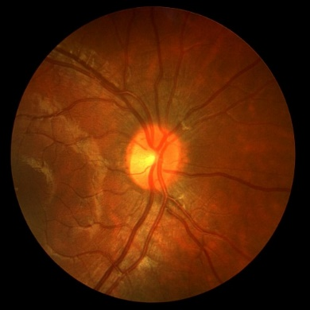 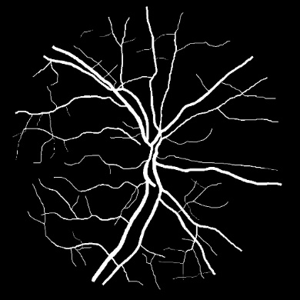

Fig. 1.1 - Sample fundus image and segmented blood vessels

CHAPTER 3

# METHODOLOGY

Staircase-Net architecture

Image processing

Data Augmentation

Data Extraction

**3.1 Data Extraction:**

Datasets used for model training are DRIVE, CHASE_DB1 dataset and for evaluation of CNN model along with mentioned datasets HRF dataset is used for testing.

DRIVE: [[1]](https://drive.grand-challenge.org/DRIVE/) contains 40 high resolution-coloured Retinal images called as fundus images It is a freely accessible dataset on Kaggle. The DRIVE database includes images that were taken as part of a screening programme for diabetic-retinopathy that was run in The Netherlands. Each picture is 564x584 pixels in size and has been JPEG compressed. 20 photos were used for training and 20 images were used for testing, each with its own mask or ground truth.



CHASE_DB1 [[2]](https://researchdata.kingston.ac.uk/96/) The Kingston University-provided comprises of 28 fundus pictures (14 right eye images and 14 left eye images) that were taken from 14 schoolchildren in England and have an image size of 999x960 pixels. It includes fundus photos along with two ground truth images that were correctly anticipated by skilled physicians. It is an openly accessible dataset.

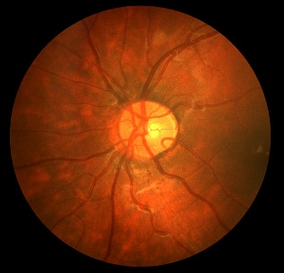 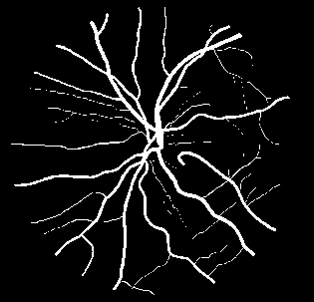 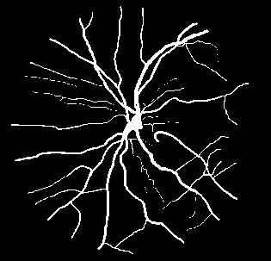

Ground truth_2 truth

Ground truth_1 truth

Left eye

Fig. 3.1.2 CHASE_DB1 dataset images

HRF (HIGH RESOLUTION FUNDUS) [[3]](https://www5.cs.fau.de/research/data/fundus-images/) The Department of Ophthalmology's Pattern Recognition Lab (CS5) offers a free picture database for research purposes that includes 15 fundus photographs of healthy individuals, 15 photographs of diabetic retinopathy, and 15 photographs of glaucoma effected persons. Each fundus images having its respective mask with size of 3504x2336 pixels .This dataset segmented into training and testing dataset with each of 24 and 21. In this paper we have used the testing data. 

Due to less size of dataset, we created new dataset using DRIVE and CHASEDB_1.

|  |  |  |  |
| --- | --- | --- | --- |
| DATASET | DRIVE | CHASEDB_1 | HRF |
| Training | 20 | 14 | 0 |
| Test | 20 | 14 | 24 |

**3.2 Data augmentation:**

For training a CNN model we need a large dataset. We have a database containing 34 images so we need data augmentation. It is the common process to create more diverse and representative examples for the model to learn which can improve its generalization performance.

As the dataset contains various size of images making as a unique size of 512X512.

Data augmentation techniques in this project are:

* **Horizontal Flip:** Horizontal flipping is the act of turning a picture such that the left side is now the right side and vice versa.
* **Vertical Flip:** data augmentation process involves flipping an image vertically, so that the top becomes the bottom and vice versa.
* **Elastic transform:** data augmentation process involves distorting an image using a combination of random elastic deformations and smoothing, to create more varied training examples for the model.
* **Grid Distortion:** Grid distortion data augmentation process involves dividing an image into a grid and randomly displacing the grid points to create a distorted version of the original image for training the model.
* **Optical Distortion:** data augmentation process involves simulating lens distortion, such as barrel or pincushion distortion, to augment images for training themodel.
* **Shiftscalerotate:** ShiftScaleRotate data augmentation process involves randomly applying affine transformations including shifting, scaling, and rotating an image to create new training examples for the model.

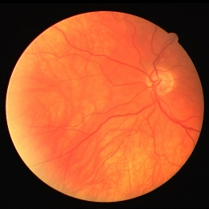 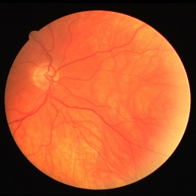 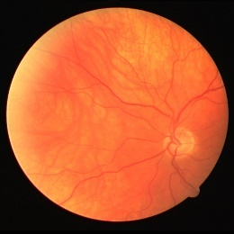

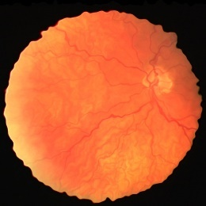 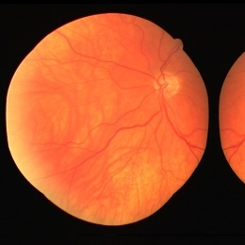 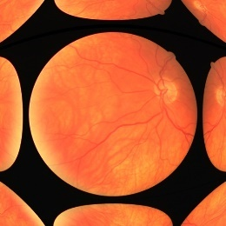

Fig.3.2.1 Data augmentation sample output

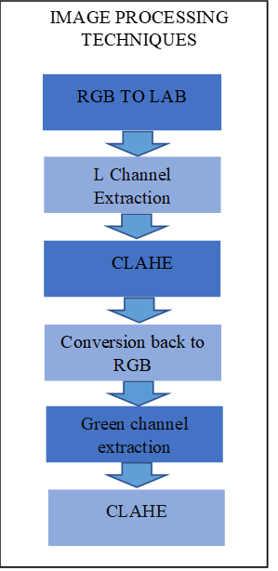

**3.3 Image Processing:**

* **RGB TO LAB:**

In RGB to LAB conversion the colour channels are

Split into A, B components to make the image as

Device independent where A indicates Green – red

Channels and B – Blue and yellow channel because

LAB has more uniformity compared than RGB.

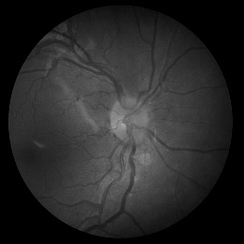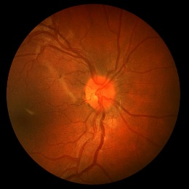

Fig. 3.3.1 sample image of RGB TO LAB

* **L Channel Extraction:**

L channel represents the grayscale image and

contains information about luminance.

extraction of the L channel for use in further image processing from the A and B components.

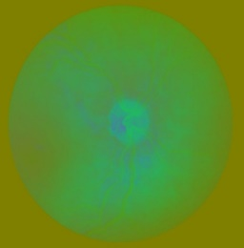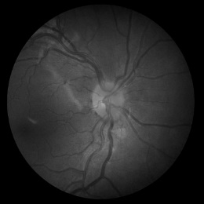

Fig. 3.3.2 sample image of

L channel extraction

* **CLAHE:**

By altering the intensity distribution of the image by dividing it into small regions called tiles and applying adaptive histogram equalisation, CLAHE is used to improve contrast and prevent the over amplification of noise in low contrast areas.

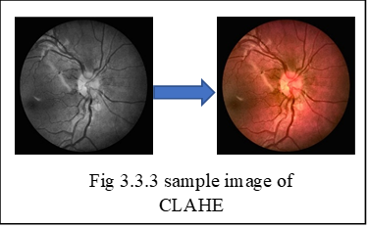

* **Green Channel Extraction:**

Extracting the green channel information from RGB will enhance the contrast of image in grayscale and reduce noise. It will improve contrast in the retina pictures between the blood vessels and background.

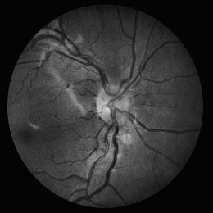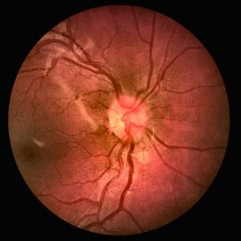

Fig.3.3.4 sample image of green channel extraction

Applying the CLAHE algorithm will increase the contrast of the blood vessels alone.

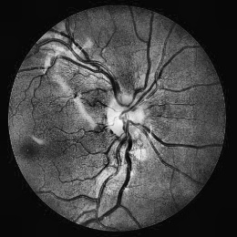

Fig. 3.3.5 Final pre-processed image

**3.4 Staircase-Net architecture:**

The Staircase-Net architecture is a variant of U-Net CNN architecture that involves a sequence of convolutional blocks with alternating up sampled layers and down sampled layers, followed by concatenation of previous output.

The input data determines the convolution layers' filter sizes in the convolutional blocks, which are made up of convolution Network layers. A popular deep learning approach for picture categorization is the convolution neural network. Convolutional, pooling, and fully linked layers make up this structure. Convolution layers are made up of two-dimensionally shaped filters that create feature maps. The features of the photos may be extracted with the use of feature maps.

Activation layer introduces non-linearity between the layers using activation function to learn complex relationships and patterns in the input data. Pooling layers Down sampling reduces the spatial dimensionality of the feature maps, which speeds up computation and guards against overfitting. At last, the data is passed through a feed forward network where predictions and classification can be done.

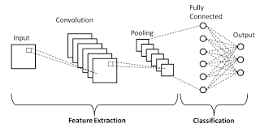

Fig.3.4.1 Basic CNN architecture

Two FCNNs that are comparable to one another are cascaded to form the staircase-net model. Concatenated and given as input to the second FCNN is the input picture and output of the first FCNN. A sequence of convolution layers are followed by up- and down sampling in the FCNN Layers.

Thin vessel features are extracted using up sampling layers, while thick vessel features are extracted using down sampling.

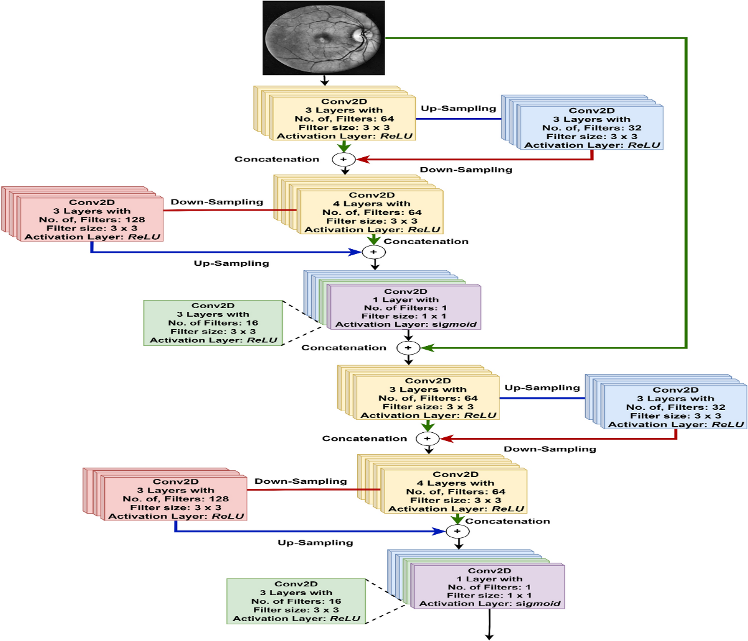

Fig 3.4.2 Staircase-Net architecture

There are total 12 convolution blocks with total 36 convolution layers with filter size of 3x3 with padding as same which means the output shape of the image is same as the input shape with activation function as ReLu (RECTIFIED LINEAR UNIT) and the output layer of FCNN consists of activation function as sigmoid activation function to produce binary image with filter size as 1x1.

In order to increase the performance of the model, batch normalization is performed. Conv2D transpose and a number of filters are used for up sampling, together with the preceding convolution block and padding. Maxpooling2D is used for down sampling, along with the previous layers' filters.

The input shape features to the model are (Batch size, size of the image, color channel). Total trainable parameters are 17,24,258. Input shape of the image should be 512,512 and Batch size can be any as it is not mentioned as the padding is same for every layer as the Input image size and output size image should be same. This architecture implemented using TensorFlow and keras module they are open sources to work with them

# CHAPTER 4

# Metrics

The model is evaluated using metrics. Our model uses the Binary Cross-Entropy loss computation, which is regulated by the validation loss performance indicator. Other metrics for the model include specificity, sensitivity, and area under the curve. In binary classification tasks, the loss function known as Binary Cross-Entropy (BCE) is frequently used. It measures the difference between the target labels' actual probability distribution and the anticipated probability distribution.

The formula for BCE can be expressed as,



Other metrics used for evaluation are specificity, sensitivity, Area under curve, accuracy, validation loss. In below we can discuss briefly about every metric.

A performance indicator called sensitivity assesses a model's accuracy in identifying positive samples. It gauges the percentage of true positives (TP) among all real positives (TP + FN) in more detail. TP is determined as the sensitivity formula as TP divided by the total of TP and FN.

The formula for specificity is as follows:



The AREA UNDER CURVE (AUC) is a metric commonly used to assess the performance of a model in distinguishing between positive and negative classes in binary classification problems. A higher AUC indicates better performance. The AUC is typically calculated using a Using different classification thresholds, the true positive rate (sensitivity) is shown versus the false positive rate (1-specificity) on the Receiver Operating Characteristic (ROC) curve. AUC cannot be calculated using a single equation since it relies on how the ROC curve is shaped.

Accuracy is a popular metric used to assess classification models. It measures the proportion of samples that were correctly classified as either true positives or true negatives, out of all samples evaluated.



A performance statistic called validation loss is used in machine learning to assess how well a model performs on a different validation dataset. The goal is to evaluate how effectively the model generalises to fresh, untested data. The training loss—the discrepancy between the model's predictions and the actual labels on the training dataset—is minimized while the model is being trained. As a result, the validation dataset is used to test the model after each training epoch, and the validation loss is calculated by computing the error between the model's predictions and the validation data's real labels. This makes it possible to monitor the model's generalization abilities and decide when to halt training to prevent overfitting.

**OUTPUT REFERNCES**

Analysis:

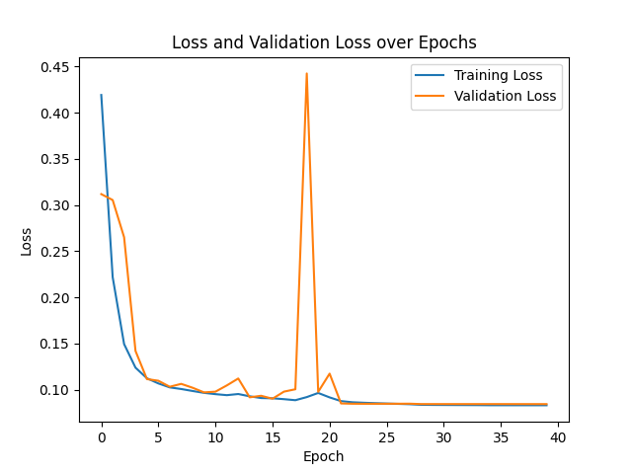

Fig 5.1 Loss vs Validation Loss

Pre-processed

Segmented image

Ground truth

Input image

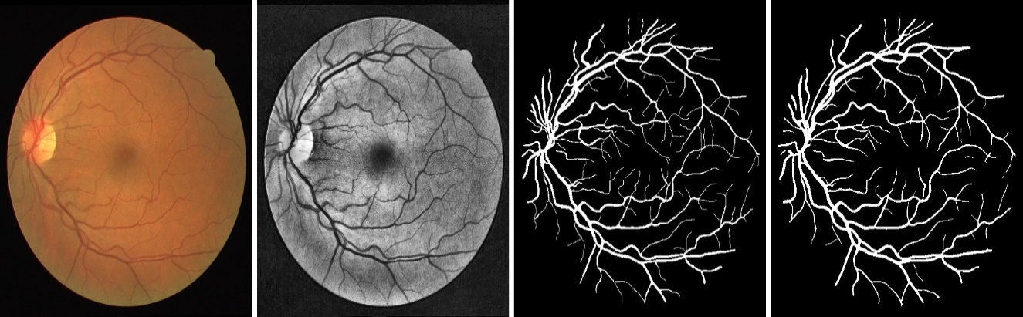

Fig 5.2.1 Output of Drive dataset

Input image

Ground truth

Pre-processed

Segmented image

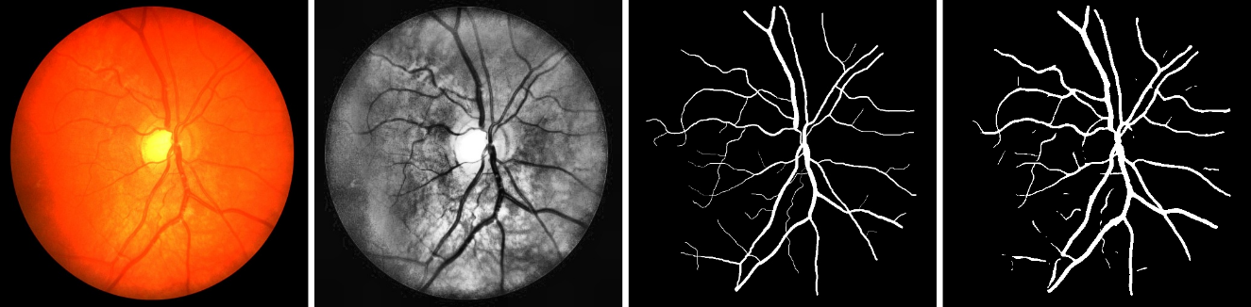

Fig 5.2.2 Output of Chase_db1 dataset

|  |  |  |  |  |
| --- | --- | --- | --- | --- |
| Dataset | F1 | JACCARD | RECALL | PRECISION |
| Drive + Chasedb1 | 0.55096 | 0.38036 | 0.8907 | 0.39838 |
| HRF | 0.7307 | 0.5792 | 0.8540 | 0.64798 |

# Table comparsion of DRIVE,CHASEDB_1 and HRF dataset

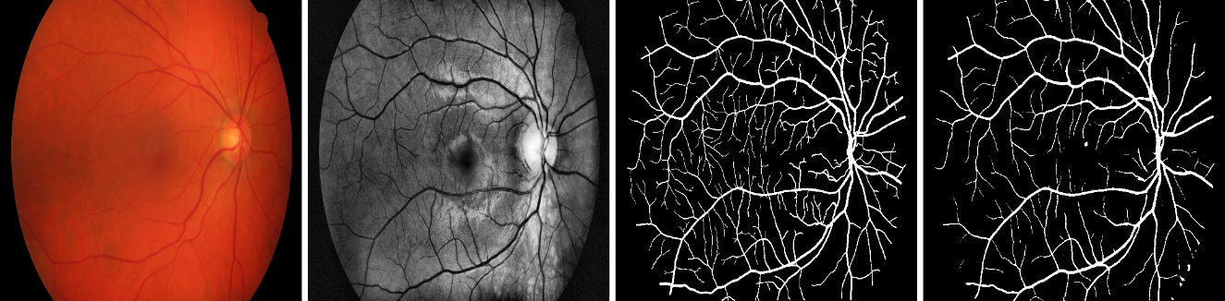

HRF SAMPLE OUTPUT

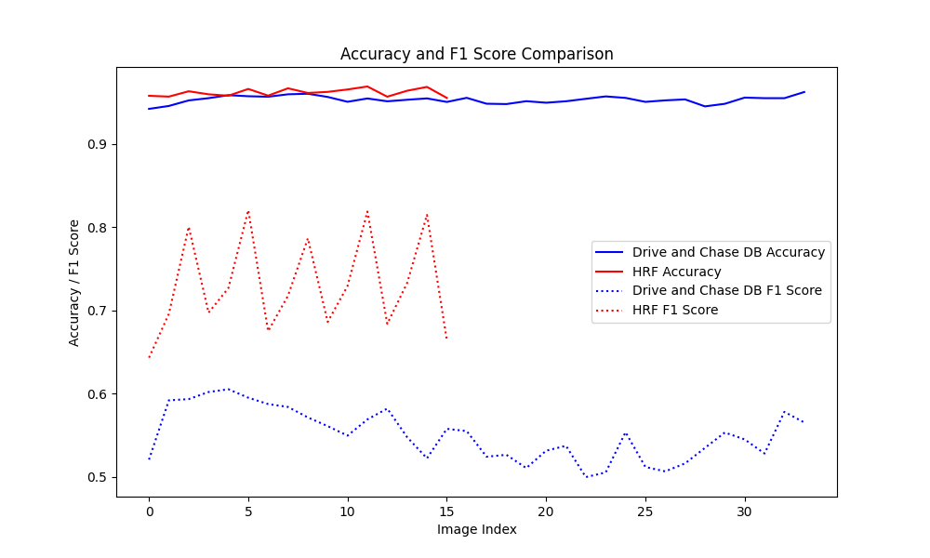

# Chapter 5

# Conclusion & Feature plans

An original method for segmenting retinal blood vessels is presented in our paper. We scaled the photographs to avoid image augmentation from having an impact on the data. The model has reduced sensitivity due of the segmented images' high percentage of negative pixels, but this is a worthwhile trade-off given how well it performs on other metrics. The model's quick execution time helps our suggested solution perform very well. It is appropriate for clinical applications with an average execution time of 0.3632 seconds per picture. Our network has a cascaded design that consists of layers of up-sampling and down-sampling. It prioritizes blood vessel location and feature extraction. Despite limited sensitivity caused by negative pixels, we can enhance performance by adding more data or increasing the importance of the balanced loss function for vessel features. We achieved better performance by applying various pre-processing steps to the images.

**Feature plans:**

We can use this segmented image for further pre processing techniques and we can classify arteries and veins. By classifying arteries and veins we can calculate AVR(arteries to veniole ratio) useful to detect various diseases.

We can use this AVR values to find the degree of hypertensive retinopathy ,Using segmented images we can find arteries and veins occlusion some of the images can be used to diabetic retinopathy also.

# REFERENCES

" Staircase-Net: a deep learning-based architecture for retinal blood vessel segmentation by Varun. (2022) – <https://link.springer.com/article/10.1007/s12046-022-01936-w>

“Impact of Image Enhancement Technique on CNN Model for Retinal Blood Vessels Segmentation " by Ahmed j . afifi, Ali Shah, Soomoro, Gulsher Ali Baloch. (2019) - <https://ieeexplore.ieee.org/abstract/document/8886493>

" Encoder Enhanced Atrous (EEA) Unet architecture for Retinal Blood vessel segmentation " by Indumathi et al. (2016) - <https://www.sciencedirect.com/science/article/pii/S1389041721000085>

"Retinal Blood Vessel Segmentation Using Line Operators and Support Vector Classification" by E. Ricci et al. (2007) - <https://ieeexplore.ieee.org/abstract/document/4336179>

" Robust retinal blood vessel segmentation using convolutional neural network and support vector machine" by Bala subramanian et al. (2019) <https://link.springer.com/article/10.1007/s12652-019-01559-w>

" Fast and efficient retinal blood vessel segmentation method based on deep learning network " by Henda et al. (2018) - <https://ieeexplore.ieee.org/document/8545136>

" Sine-Net: A fully convolutional deep learning architecture for retinal blood vessel segmentation" by Atli et al. (2021) –<https://www.sciencedirect.com/science/article/pii/S221509862030330X>

“Ridge-based vessel segmentation in color images of the retina” by Staal et al <https://ieeexplore.ieee.org/abstract/document/1282003>

"Retinal Vessel Segmentation Using Deep Learning Networks with Maxo "Retinal Vessel Segmentation Using Deep Learning Networks with Max out and Residual Units" by Narasimhan et al. (2018) - UT and Residual Units" by Narasimhan et al. (2018) –

<https://www.ncbi.nlm.nih.gov/pmc/articles/PMC6249017/>

