PMS2
Pharmacy Management System
Low-Level Design (LLD) Document
Source: github.com/Aditya149202/lld3
Compiled from repository architecture, domain, service-layer, database and flow diagrams

Table of Contents
1. Introduction
1.1 Purpose
1.2 Scope
1.3 System Overview
2. Solution Architecture
3. UserAuthService
3.1 Domain Model
3.2 Database Schema
3.3 Service Layer
3.4 Sequence Diagrams – Auth Flows
4. OrderService
4.1 Domain Model
4.2 Database Schema
4.3 Service Layer
4.4 Payment Flow
4.5 Verify & Pickup Flow
4.6 Cancel Order Flow
5. SupplierInventoryService
5.1 Domain Model
5.2 Database Schema
5.3 Service Layer
6. Scheduled Background Jobs
6.1 Overview
6.2 Stock Reservation Expiry Job
6.3 Stale Order Auto-Cancel Job
7. Appendix – Diagram Index

1. Introduction

1.1 Purpose
This document captures the low-level design (LLD) of PMS2, a pharmacy ordering platform, as represented by the architecture, domain-model, service-layer, database, and flow diagrams stored in the project repository. It consolidates those diagrams into a single reference covering system structure, data model, service contracts, and runtime behaviour.

1.2 Scope
The design spans three backend microservices — UserAuthService, OrderService, and SupplierInventoryService — fronted by a single API Gateway, along with two scheduled background jobs (Stock Reservation Expiry and Stale Order Auto-Cancel) that run inside OrderService.

1.3 System Overview
Doctors authenticate through UserAuthService, browse and order drugs through OrderService, and pay via an integrated Razorpay checkout. OrderService reserves and commits stock by calling internal endpoints on SupplierInventoryService. Admin users verify, hand over, and cancel orders; two background jobs keep abandoned payments and stale orders from blocking stock indefinitely.
Source-file duplicates were consolidated: where the repository contained both a plain and a redrawn/coloured version of the same diagram (service-layer and entity-relationship diagrams), only the clearer version is shown here. The mapping is listed in the appendix (Section 7).

2. Solution Architecture
The diagram below shows the overall deployment topology: a YARP-based API Gateway performs JWT validation and routes traffic to the three services, each of which owns its own database.
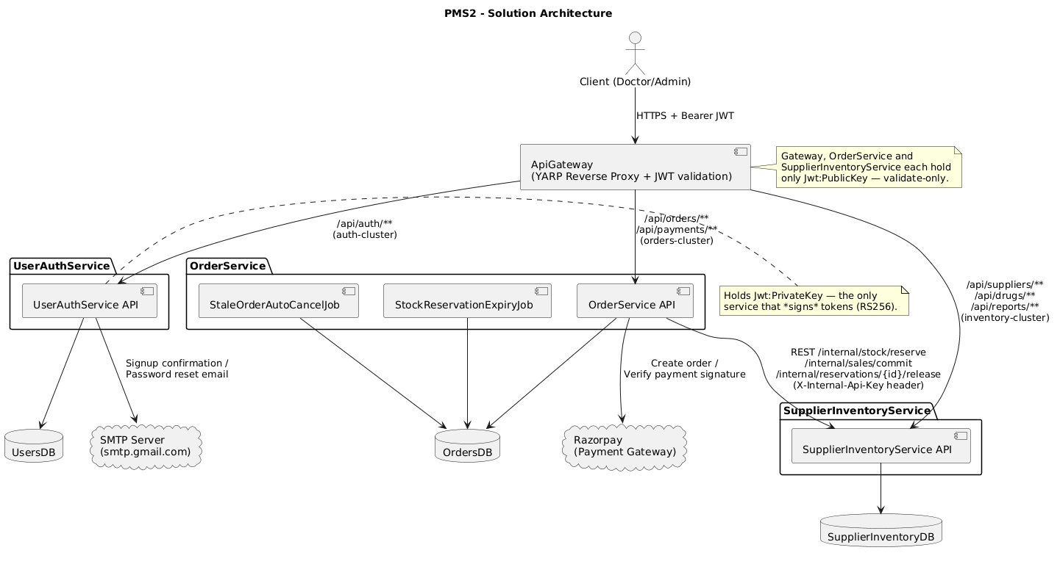
Figure 2.1 – PMS2 Solution Architecture
- ApiGateway (YARP reverse proxy) validates the Bearer JWT on every request and routes by path prefix: /api/auth/** to UserAuthService, /api/orders/** and /api/payments/** to OrderService, and /api/suppliers/**, /api/drugs/**, /api/reports/** to SupplierInventoryService.
- Only UserAuthService holds the JWT private key and signs tokens (RS256); the Gateway, OrderService, and SupplierInventoryService each hold only the public key and validate signatures — they never issue tokens.
- OrderService calls SupplierInventoryService's internal endpoints (stock reserve / release / sale commit) using an X-Internal-Api-Key header, separate from end-user JWTs.
- UserAuthService integrates with an SMTP server for signup-confirmation and password-reset emails; OrderService integrates with Razorpay as the external payment gateway.
- Two background jobs (StaleOrderAutoCancelJob and StockReservationExpiryJob) run inside the OrderService process and share its database.

3. UserAuthService
UserAuthService owns identity, authentication, and token lifecycle management for doctors and admins.

3.1 Domain Model
A Role has many Users; each User owns many RefreshTokens (one per active session/device) and many PasswordResetTokens (issued on a forgot-password request).
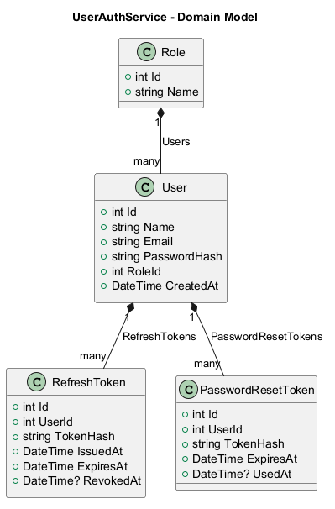
Figure 3.1 – UserAuthService Domain Model

3.2 Database Schema
The physical schema mirrors the domain model: Roles, Users (FK to Roles), RefreshTokens and PasswordResetTokens (both FK to Users).
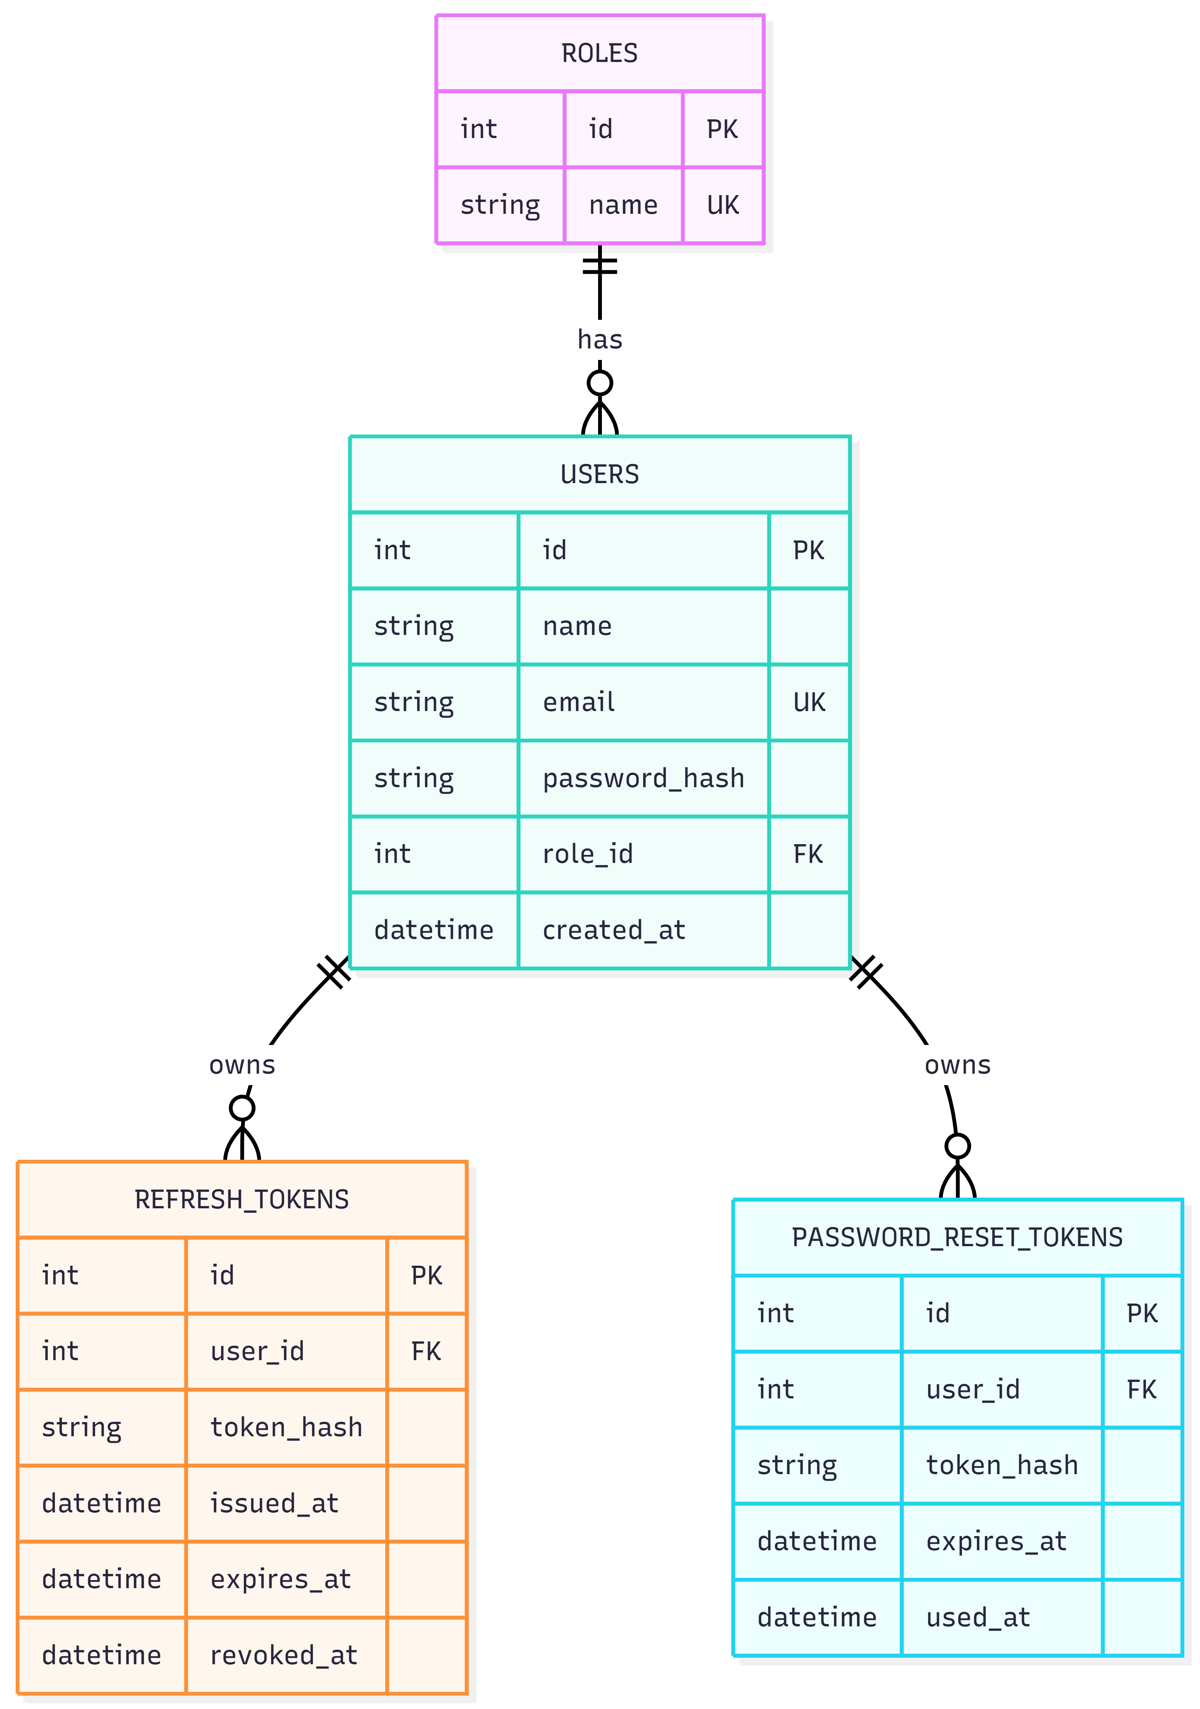
Figure 3.2 – UserAuthService Database Schema

3.3 Service Layer
AuthService implements IAuthService and coordinates four supporting components: ITokenService (access/refresh token generation and hashing), IEmailService (signup confirmation and password-reset email), IPasswordHasher<User> (ASP.NET Identity, external), and four repositories — IUserRepository, IRoleRepository, IRefreshTokenRepository, and IPasswordResetTokenRepository.
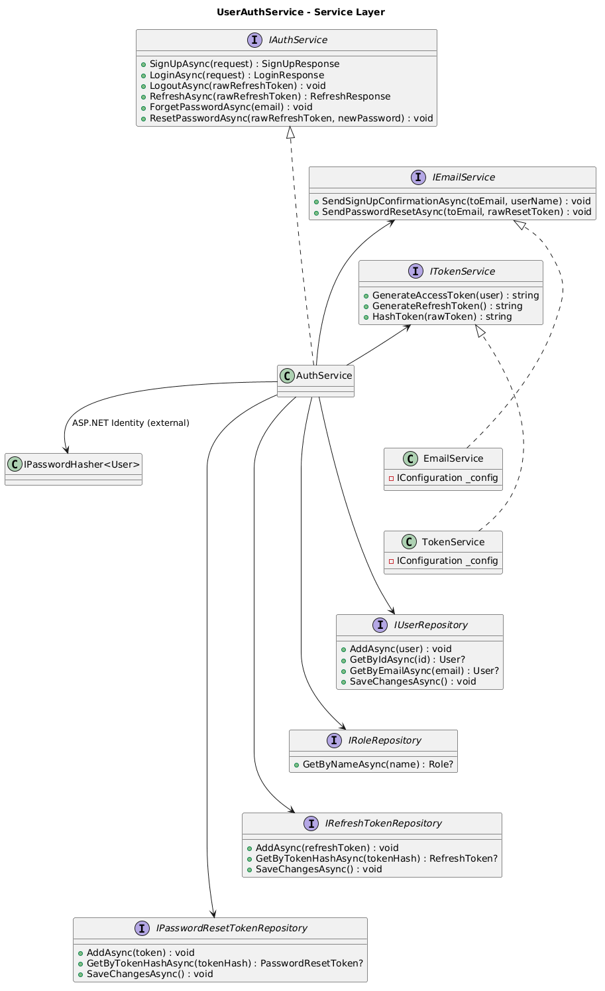
Figure 3.3 – UserAuthService Service Layer

3.4 Sequence Diagrams – Auth Flows
Covers Login, Refresh, Logout, and Forgot/Reset Password, all forwarded through the ApiGateway to AuthController → AuthService.
- Login: validates credentials against the stored password hash, then issues a new access token and refresh token pair, persisting the refresh token.
- Refresh: hashes the incoming raw token, looks it up, rejects it if revoked or expired, revokes the old token, and issues a new access/refresh pair.
- Logout: hashes and looks up the refresh token, then marks it revoked.
- Forgot Password: silently returns 204 even if the email is unknown (anti-enumeration), otherwise issues a short-lived reset token and emails it.
- Reset Password: validates the reset token has not already been used or expired, then updates the password hash and marks the token used.
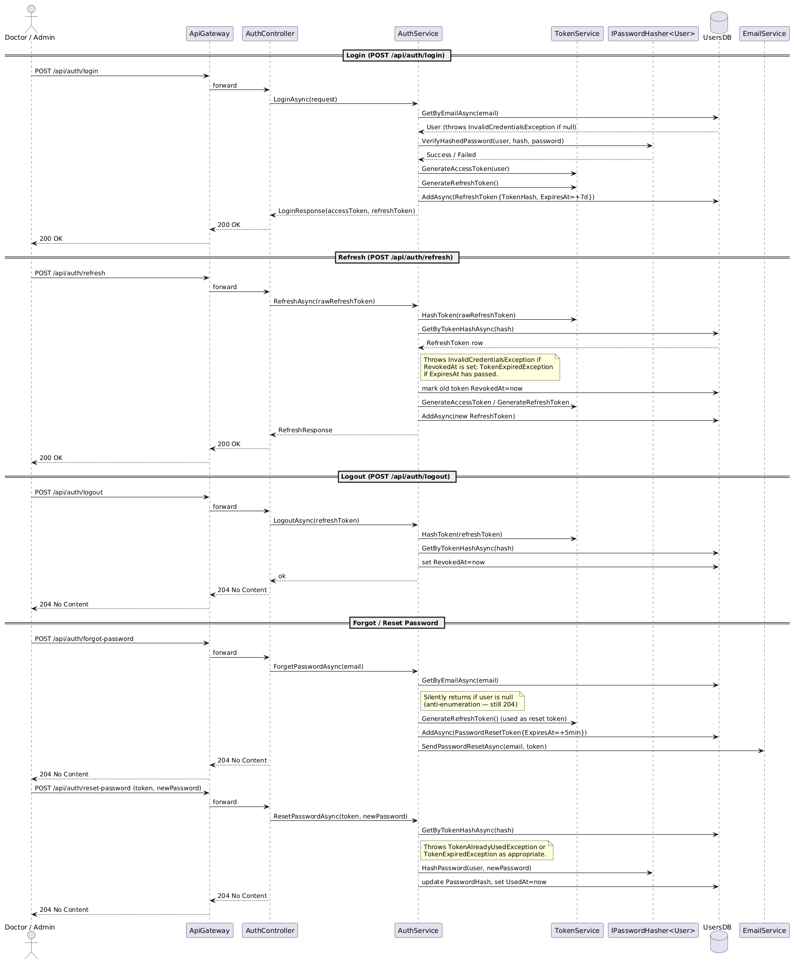
Figure 3.4 – Login / Refresh / Logout / Forgot-Reset Password Sequence

4. OrderService
OrderService owns the order and payment lifecycle: initiating and confirming Razorpay payments, creating orders, and driving them through verification, pickup, and cancellation.

4.1 Domain Model
An Order has exactly one PaymentIntent and many OrderItems. OrderStatus (NEW, VERIFIED, COMPLETED, CANCELLED), PaymentIntentStatus (CREATED, PAID, FAILED, EXPIRED) and CancelledBy (ADMIN, SYSTEM, DOCTOR) are modelled as enums. OrderItem.DrugId is a logical, cross-service reference to Drug in SupplierInventoryService — there is no database foreign key across service boundaries.
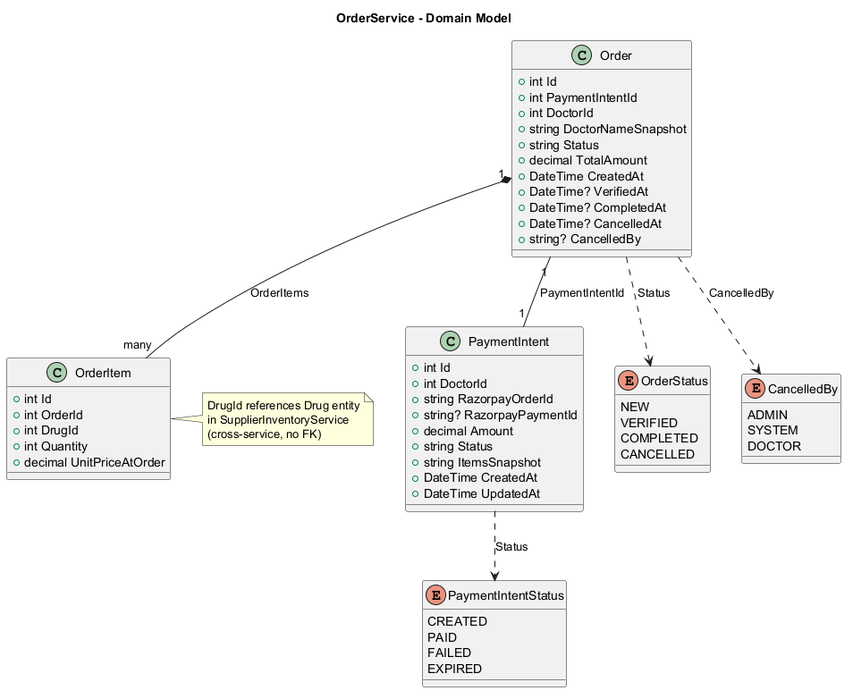
Figure 4.1 – OrderService Domain Model

4.2 Database Schema
PaymentIntents, Orders (FK to PaymentIntents), and OrderItems (FK to Orders) make up the physical schema; DoctorId and DrugId are logical references into UserAuthService and SupplierInventoryService respectively.
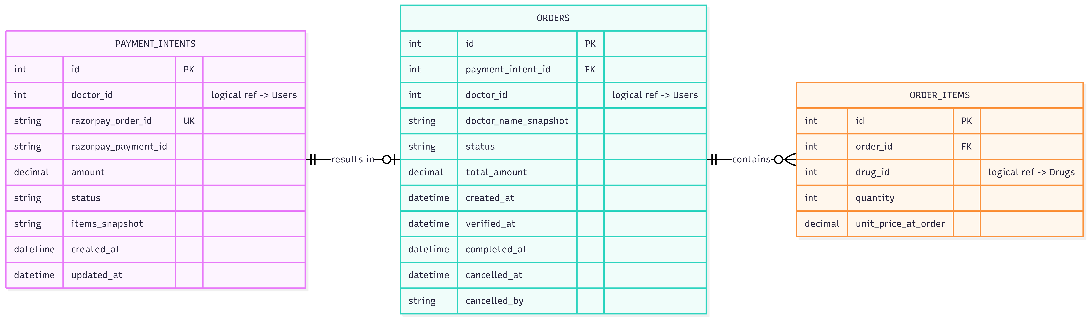
Figure 4.2 – OrderService Database Schema

4.3 Service Layer
OrderService implements IOrderService and PaymentService implements IPaymentService. Both depend on IOrderRepository; PaymentService additionally depends on IPaymentIntentRepository and IPaymentGatewayClient (Razorpay), and both call out to ISupplierInventoryClient for stock reservation, commit, and release.
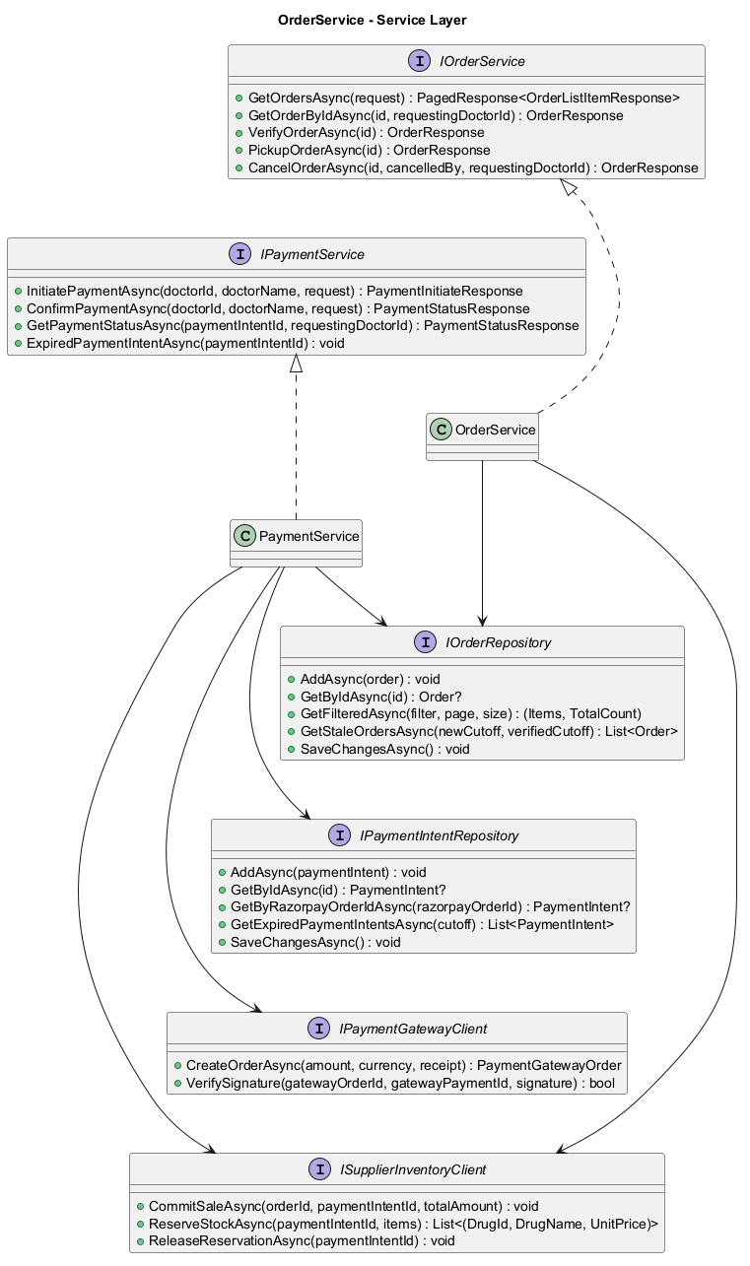
Figure 4.3 – OrderService Service Layer

4.4 Payment Flow
A PaymentIntent row is inserted first, before any external call, because a real database id is required before calling SupplierInventoryService to reserve stock. If reservation fails (drug not found, insufficient stock, or invalid request) the PaymentIntent is marked FAILED and the appropriate error is returned. On success, a Razorpay order is created and the PaymentIntent is updated with the gateway order id, amount, and items snapshot. On payment confirmation, the signature is verified, the intent is looked up by Razorpay order id with an ownership check (anti-enumeration), and — if already processed — the existing status is returned idempotently rather than creating a duplicate order. Otherwise the intent is marked PAID and the Order plus its OrderItems are inserted.
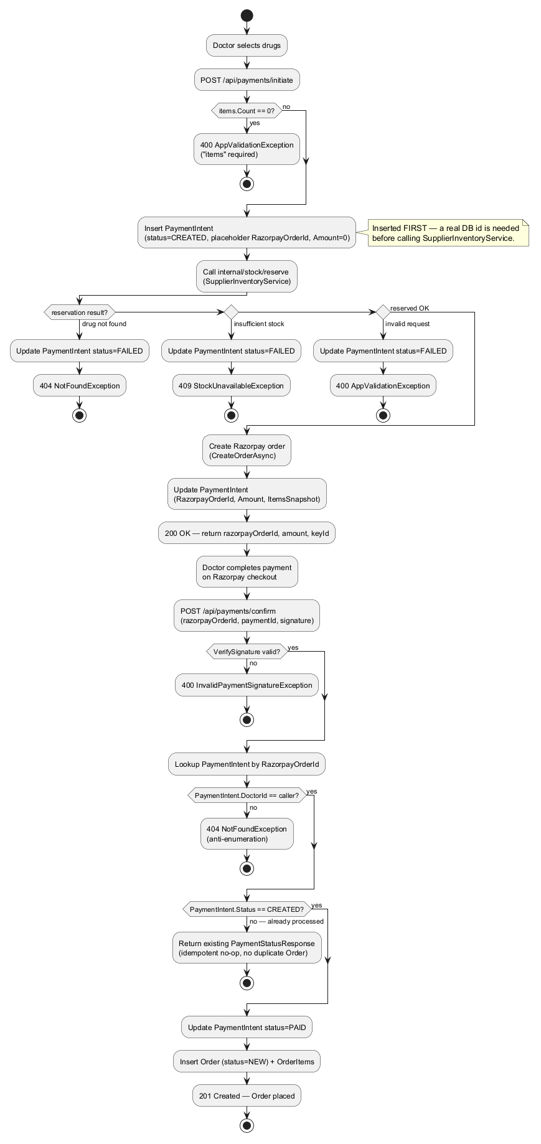
Figure 4.4a – Payment Flow (Activity Diagram)
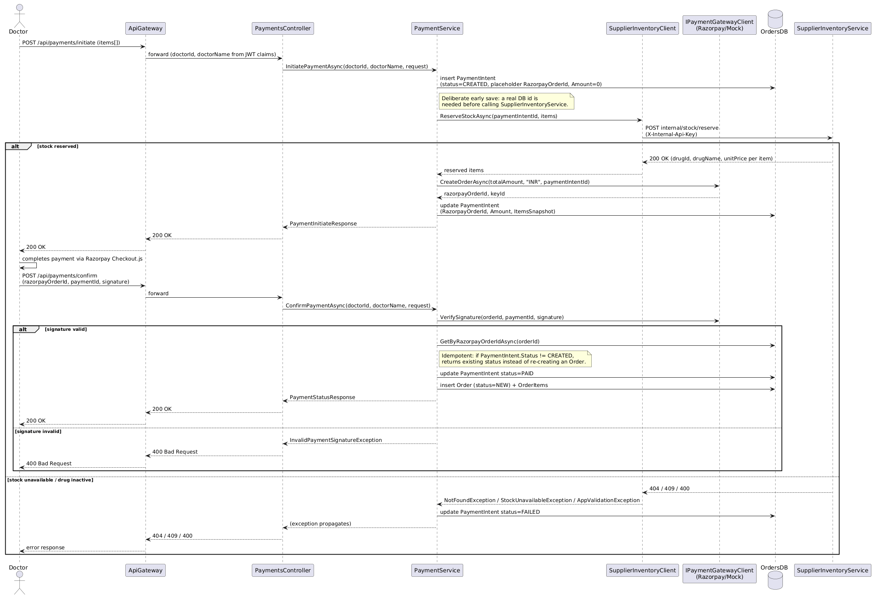
Figure 4.4b – Payment Flow (Sequence Diagram)

4.5 Verify & Pickup Flow
An Admin verifies a NEW order (moving it to VERIFIED); attempting to verify from any other state returns a 409 InvalidOrderStateException. From VERIFIED, the flow splits two ways: pickup or cancellation.
- Pickup (Admin only, from VERIFIED): commits the sale on SupplierInventoryService — idempotent via a ProcessedEvents table keyed by orderId, so a retried call is a safe no-op rather than a duplicate sale — then moves the order straight to COMPLETED. Pickup and completion are a single call; there is no separate "complete" step.
- Cancellation (Admin or the stale-order job, as SYSTEM): releases the stock reservation and moves the order to CANCELLED. A doctor cannot cancel from VERIFIED — only from NEW (see Section 4.6).
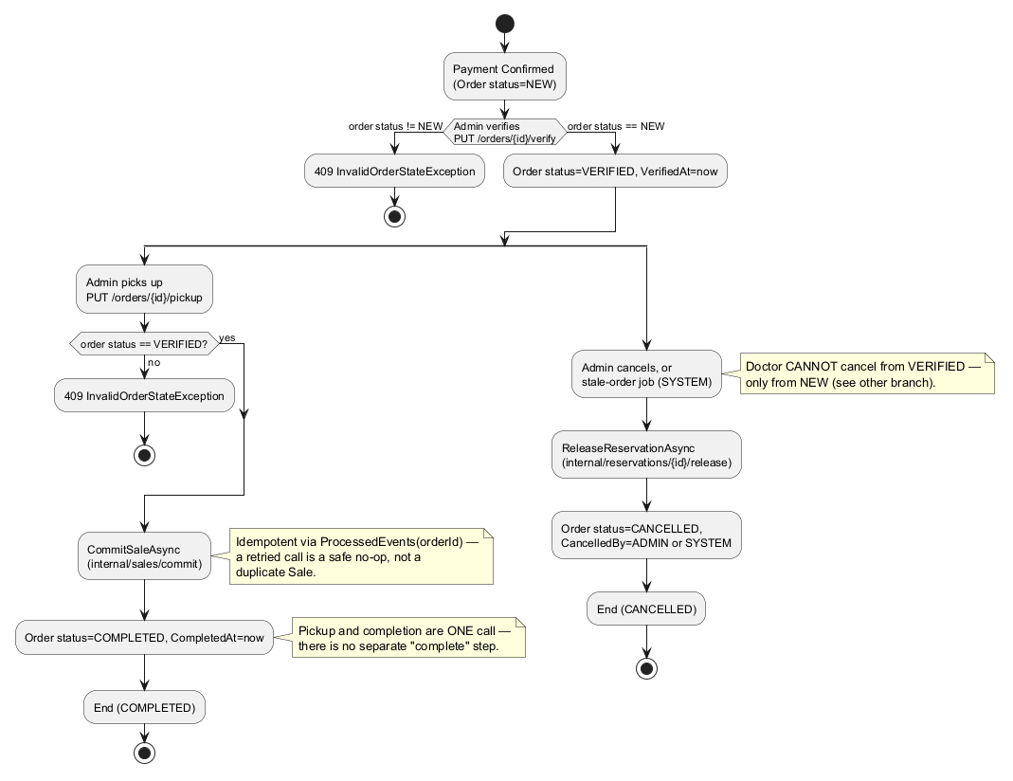
Figure 4.5a – Verify & Pickup Flow (Activity Diagram)
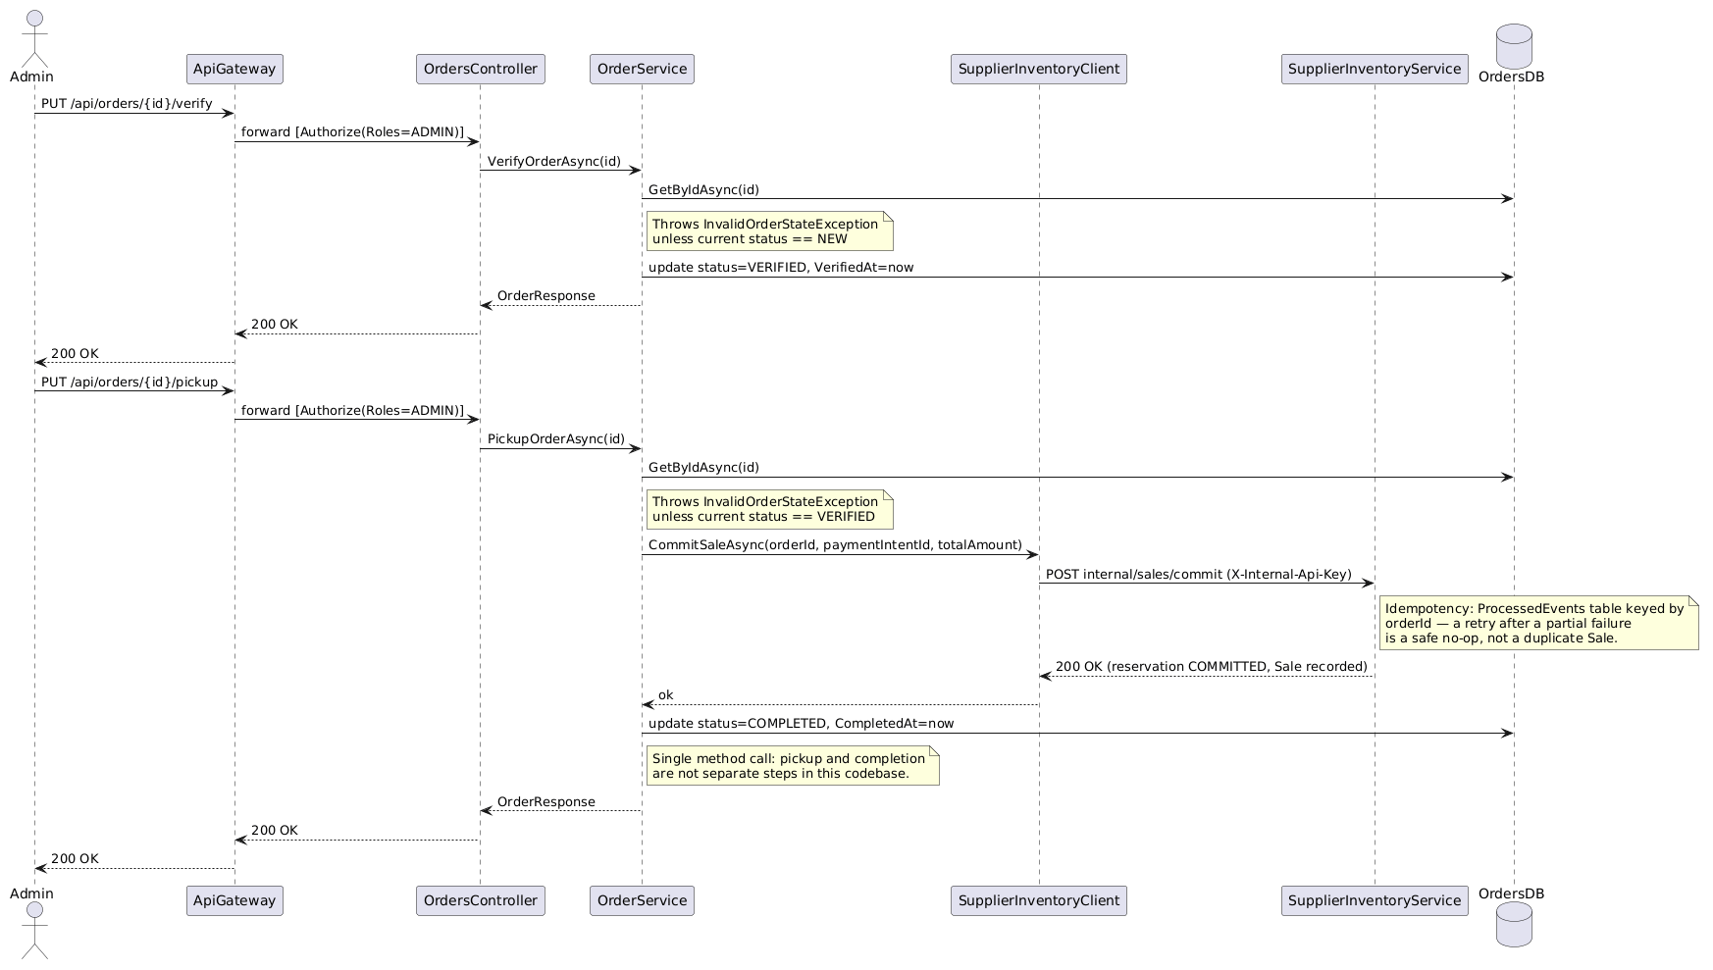
Figure 4.5b – Verify & Pickup Flow (Sequence Diagram)

4.6 Cancel Order Flow
Either an Admin or the owning Doctor may request cancellation. Ownership is checked first: a doctor cancelling another doctor's order gets a 404 (not 403, to avoid confirming the order's existence). A doctor may only cancel from NEW; an Admin may cancel from NEW or VERIFIED — cancelling from any other state returns 409. A valid cancellation releases the stock reservation and updates the order to CANCELLED with the appropriate CancelledBy value.
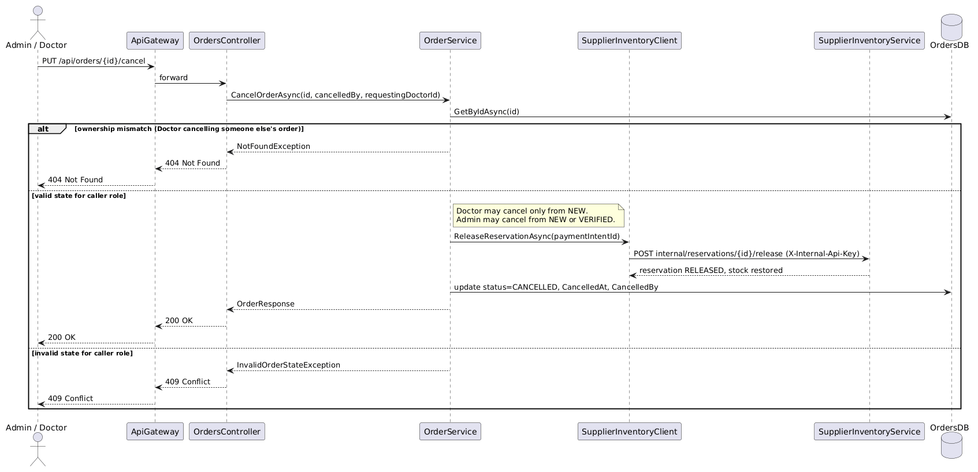
Figure 4.6 – Cancel Order Flow (Sequence Diagram)

5. SupplierInventoryService
SupplierInventoryService owns suppliers, drugs, stock reservations, sales, and sales reporting, and exposes an internal API consumed only by OrderService.

5.1 Domain Model
A Supplier has many Drugs; a Drug has many StockReservations (with status ACTIVE, RELEASED, or COMMITTED). Sale and ProcessedEvent both carry a logical, cross-service reference to Order/PaymentIntent in OrderService rather than a database foreign key.
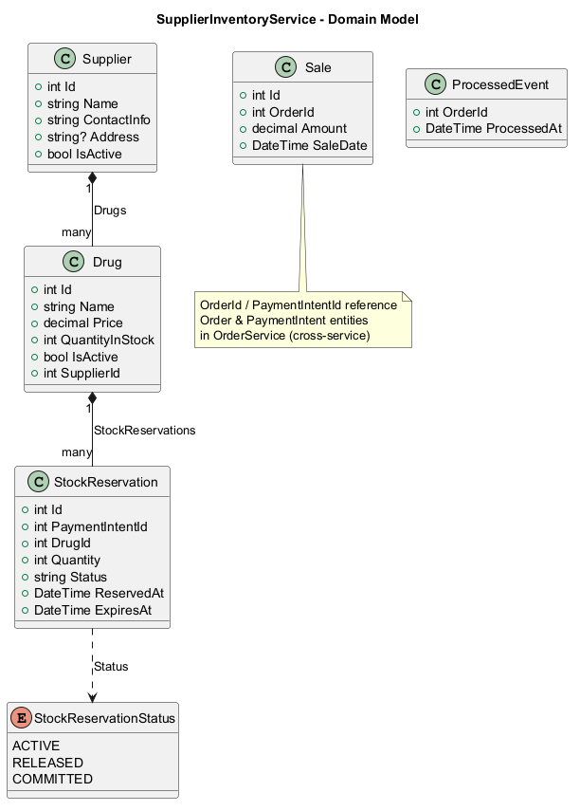
Figure 5.1 – SupplierInventoryService Domain Model

5.2 Database Schema
Suppliers, Drugs (FK to Suppliers), StockReservations (FK to Drugs, logical ref to PaymentIntents), Sales (logical ref to Orders), and ProcessedEvents (logical ref to Orders, used for idempotency).
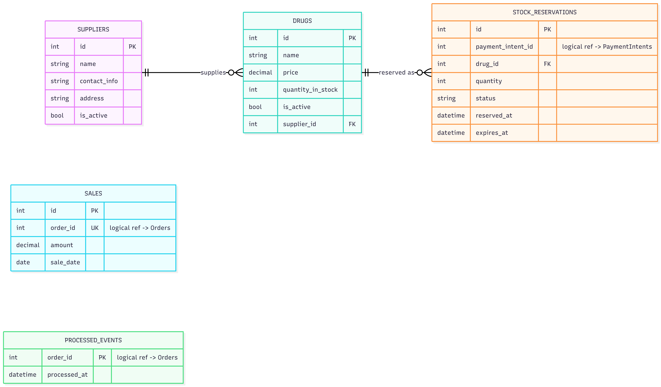
Figure 5.2 – SupplierInventoryService Database Schema

5.3 Service Layer
Four services implement four public interfaces: DrugService (IDrugService), SupplierService (ISupplierService), InternalService (IInternalService — reserve/commit/release, called only by OrderService), and ReportService (IReportService). Five repositories back them: IDrugRepository, ISupplierRepository, IStockReservationRepository, ISalesRepository, and IProcessedEventRepository.
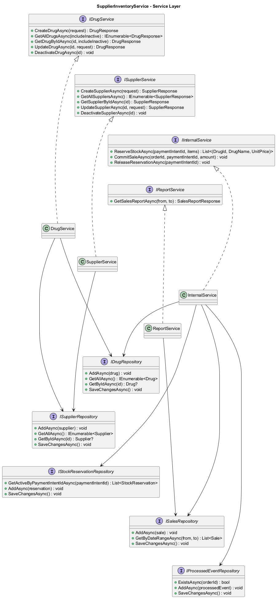
Figure 5.3 – SupplierInventoryService Service Layer

6. Scheduled Background Jobs
Two BackgroundService jobs run inside OrderService on independent polling loops (default interval 15 minutes each) to reclaim stock that would otherwise stay locked indefinitely.

6.1 Overview
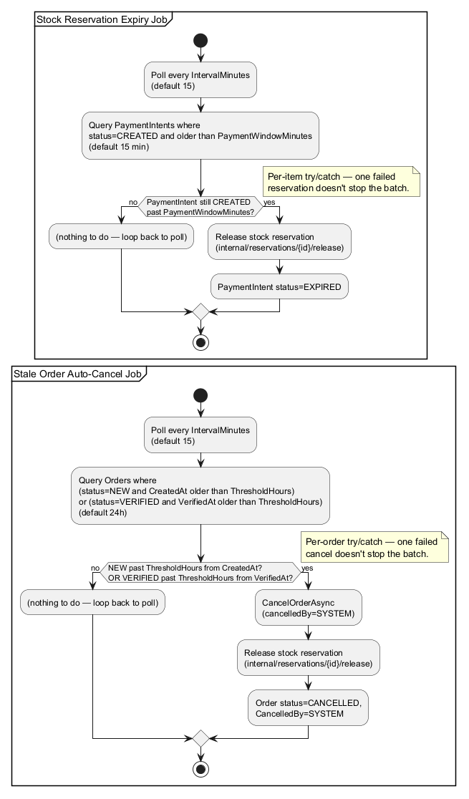
Figure 6.1 – Stock Reservation Expiry Job & Stale Order Auto-Cancel Job (Activity Diagram)

6.2 Stock Reservation Expiry Job
Every IntervalMinutes (default 15), the job queries PaymentIntents still in status CREATED beyond PaymentWindowMinutes (default 15 minutes). For each one, PaymentService.ExpiredPaymentIntentAsync is invoked in-process: it is a no-op if the status has already moved on, otherwise it releases the stock reservation on SupplierInventoryService and marks the PaymentIntent EXPIRED. Per-item try/catch means one failed reservation release does not stop the rest of the batch.
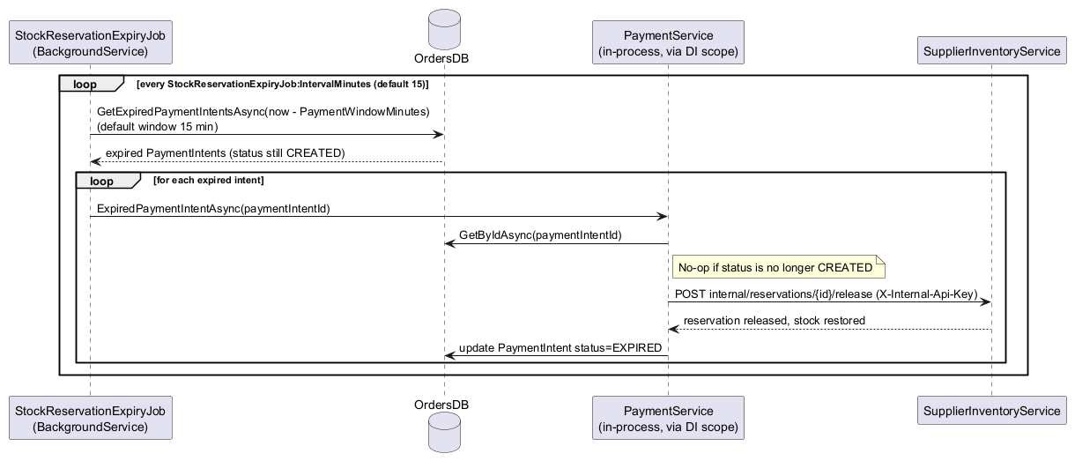
Figure 6.2 – Stock Reservation Expiry Job (Sequence Diagram)

6.3 Stale Order Auto-Cancel Job
Every IntervalMinutes (default 15), the job queries Orders that are either NEW and older than ThresholdHours (default 24h) since creation, or VERIFIED and older than ThresholdHours since verification. Each matching order is cancelled with cancelledBy=SYSTEM, its stock reservation is released, and its status is set to CANCELLED. Per-order try/catch isolates one failed cancellation from the rest of the batch.
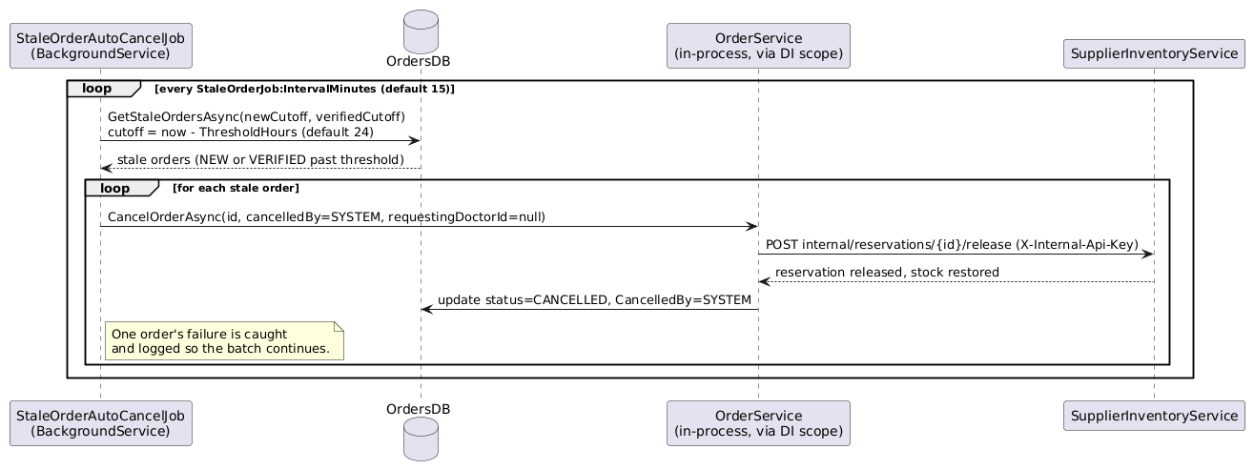
Figure 6.3 – Stale Order Auto-Cancel Job (Sequence Diagram)

7. Appendix – Diagram Index
The table below maps every figure in this document back to its source file in the repository. Where the repository contained both a plain and a redrawn/coloured duplicate of the same diagram, the clearer file was selected and the alternate is noted.
# | Diagram | Source File(s) Used | Section
1 | Solution / Deployment Architecture | solndiagram.png | 2
2 | UserAuthService – Domain Model | UserAuthService.png | 3.1
3 | UserAuthService – Database Schema | user er diagram.png (clearer than db1.png) | 3.2
4 | UserAuthService – Service Layer | userauthservice_refactor.png (clearer, redrawn version of UserAuthService_ServiceLayer.png) | 3.3
5 | UserAuthService – Auth Sequence (Login/Refresh/Logout/Forgot/Reset) | auth_seq_refactor.png | 3.4
6 | OrderService – Domain Model | OrderService.png | 4.1
7 | OrderService – Database Schema | order er diagram.png (clearer than db2.png) | 4.2
8 | OrderService – Service Layer | OrderService_ServiceLayer.png | 4.3
9 | Payment Flow – Activity Diagram | PaymentFlow.png | 4.4
10 | Payment Flow – Sequence Diagram | order_payment_seq_refactor.png | 4.4
11 | Verify & Pickup Flow – Activity Diagram | VerifyPickupFlow.png | 4.5
12 | Verify & Pickup Flow – Sequence Diagram | verify_pickup_seq_claude_refactor.png | 4.5
13 | Cancel Order Flow – Sequence Diagram | cancel_order_seq_refactor.png | 4.6
14 | SupplierInventoryService – Domain Model | SupplierInventoryService.png | 5.1
15 | SupplierInventoryService – Database Schema | supplier er diagram.png (clearer than db3.png) | 5.2
16 | SupplierInventoryService – Service Layer | SupplierInventoryService_ServiceLayer.png | 5.3
17 | Scheduled Jobs – Activity Diagram (both jobs) | ScheduledJobsFlow.png | 6.1
18 | Stock Reservation Expiry Job – Sequence Diagram | StockReservationExpiryJob.png | 6.2
19 | Stale Order Auto-Cancel Job – Sequence Diagram | stale_order_seq_refactor.png | 6.3

