SALES DATA CLEANING & VISUALIZATION PROJECT REPORT

Project Title
Sales Data Analysis using Python

Submitted By
Name: Aditya Patil
Course: Electronics & Telecommunication
College: D.Y Patil,Akurdi
Date: 16/05/2026

1. Introduction
Data analysis plays an important role in understanding business performance and customer behavior. Raw sales datasets often contain missing values, duplicate records, and inconsistent information. Data cleaning and visualization help improve data quality and generate meaningful business insights.

In this project, a sales dataset was analyzed using Python libraries such as Pandas, Matplotlib, and Seaborn. Various preprocessing and visualization techniques were used to study sales trends, profit distribution, and customer purchasing patterns.

2. Objectives
- To analyze sales data using Python
- To handle missing values and duplicate records
- To visualize sales trends and patterns
- To identify high-performing products and regions
- To understand business insights through graphical analysis

3. Tools & Technologies Used
- Python
- Pandas
- Matplotlib
- Seaborn
- Google Colab

4. Dataset Description
The sales dataset contains information related to product sales, profit, quantity, and customer regions.

Dataset Features:
- Order ID: Unique order number
- Product: Product name
- Category: Product category
- Sales: Sales amount
- Profit: Profit earned
- Quantity: Number of products sold
- Region: Customer region
- Order Date: Date of purchase

5. Data Cleaning Process
Several preprocessing steps were performed on the dataset.
- Handling Missing Values
Missing values were identified and replaced using suitable methods such as mean and mode replacement.

- Removing Duplicates
Duplicate records were removed to improve dataset consistency.

- Data Formatting
Date columns were converted into proper datetime format for analysis.

- Outlier Detection
Boxplots were used to identify unusual sales and profit values.

6. Data Visualization
Several visualizations were created to analyze sales performance.
- Market Distribution Graph
A histogram was used to study sales distribution.
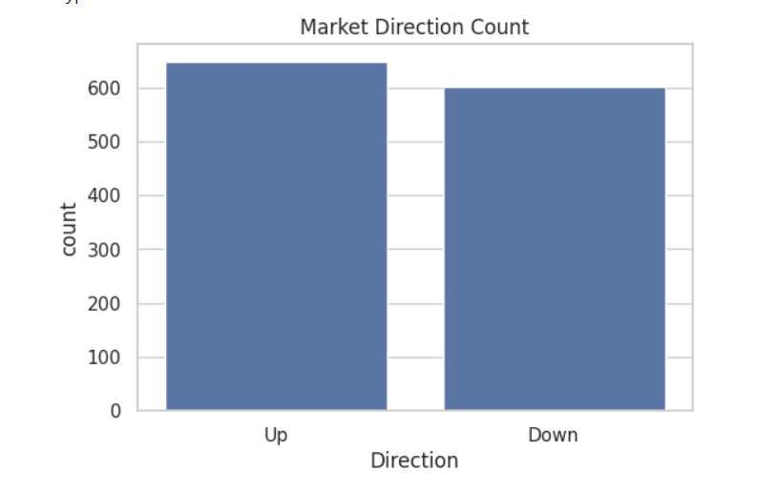
- Volume Distribution
A bar chart was created to compare Volume across categories.
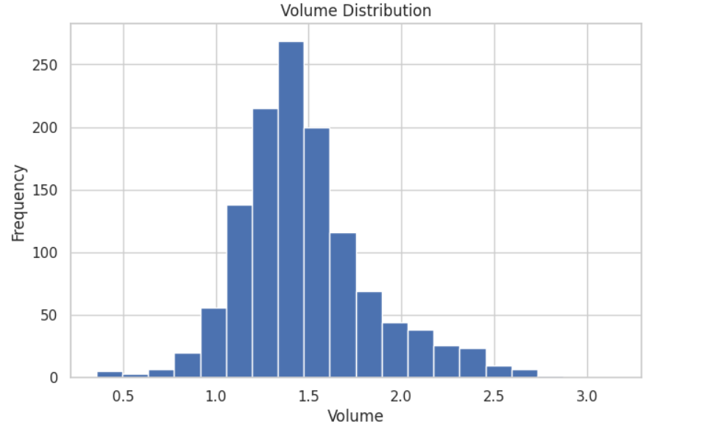
- Regional Sales Analysis
A count plot was used to analyse sales across different regions.
Observation
Certain regions had higher sales volume than others.

- Today’s Return Distribution
A histogram was used to analyse product quantity sold.
Observation
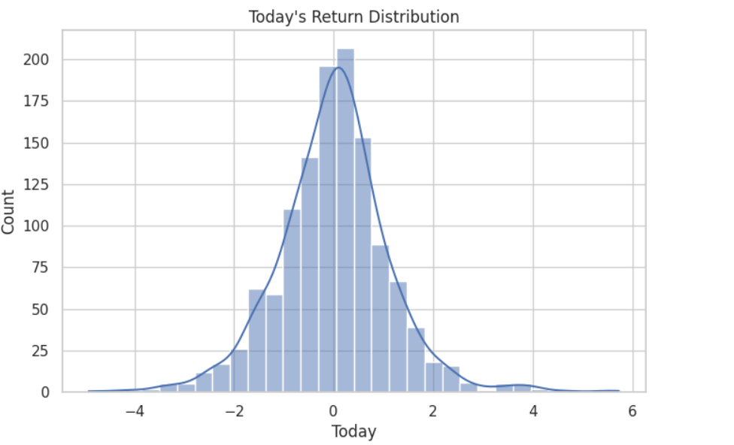
- Correlation Heatmap
A heatmap was generated to study relationships between numerical variables.
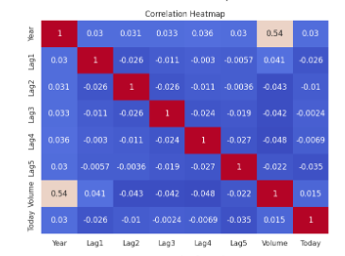

7. Insights & Findings
1. Certain product categories generated higher revenue.
2. Some regions contributed more to total sales.
3. Sales and profit were positively correlated.
4. A few extreme sales values acted as outliers.
5. Data cleaning improved overall dataset quality.

8. Conclusion
This project demonstrated the importance of data cleaning and visualization in business analytics. Using Python libraries such as Pandas, Matplotlib, and Seaborn, the sales dataset was successfully cleaned, processed, and analyzed.
The project helped in understanding:
- Data preprocessing
- Sales trend analysis
- Business visualization
- Correlation analysis
- Data storytelling
Overall, the project improved practical knowledge of Python-based business data analysis.

9. Future Scope
- Building sales prediction models
- Creating interactive dashboards
- Using machine learning for forecasting
- Analyzing customer purchasing behavior

10.References
- Pandas Documentation
- Matplotlib Documentation
- Seaborn Documentation
- Kaggle Datasets

