Trafalgar Square Rain-Adaptive Traffic Simulation Report

Baseline Condition:
- Travel Time Comparison (Boxplot)
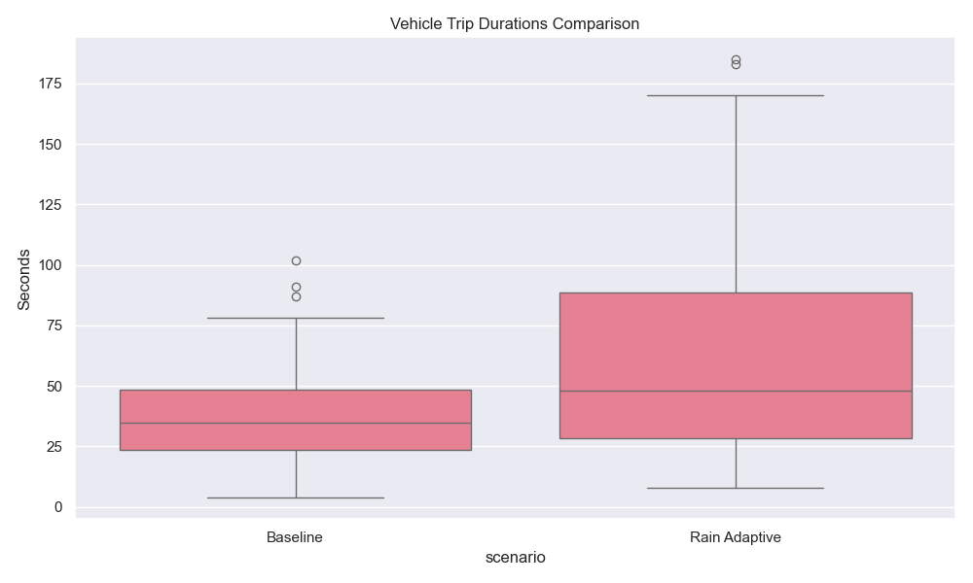
- Time Loss Analysis (Violin Plot)
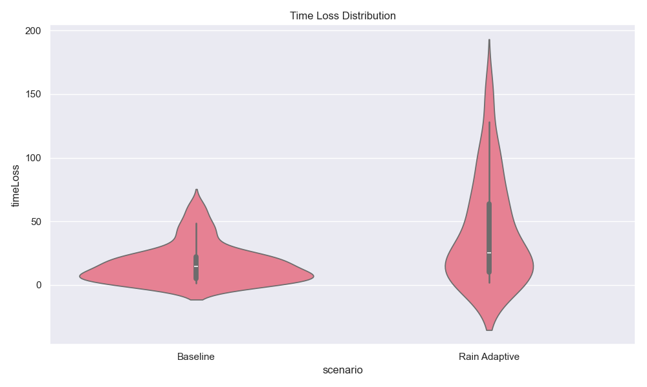
- Emissions Comparison (Bar Chart)
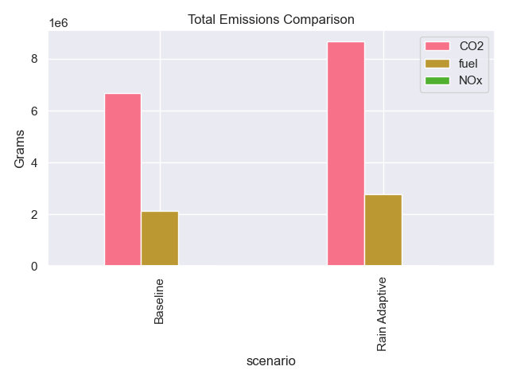
- Speed Analysis (Scatter Plot)
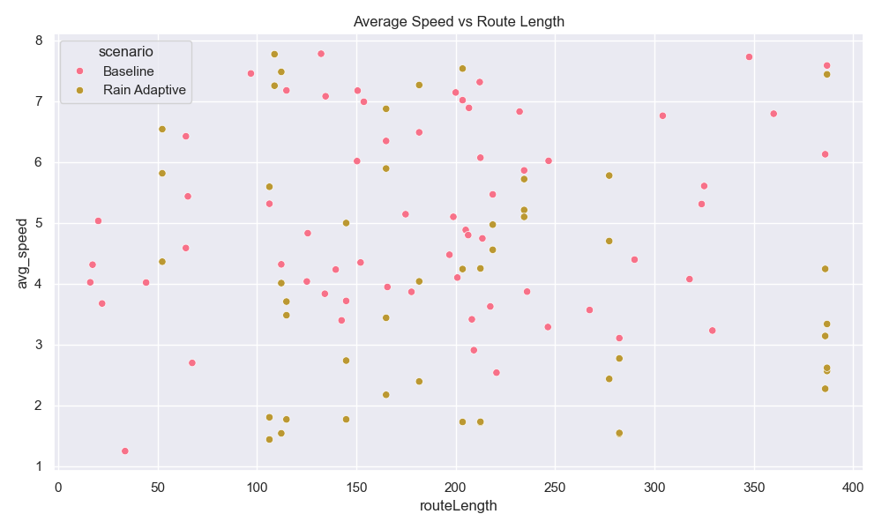
- Waiting Time Distribution (Histogram)
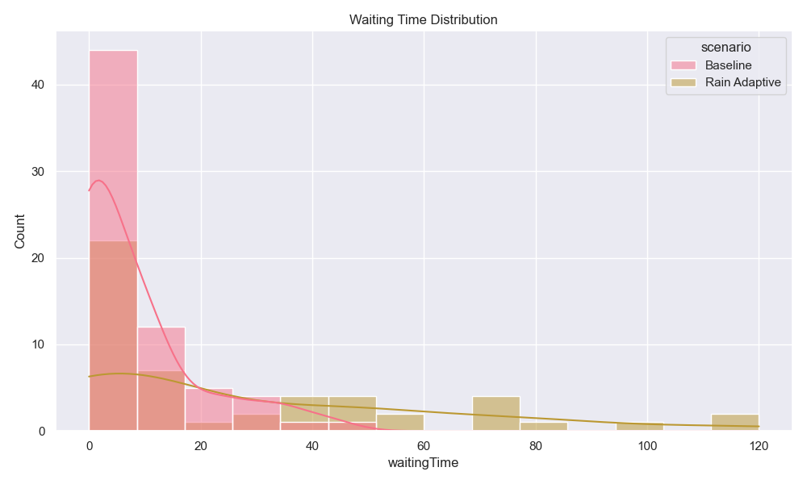

- Speed Factor Analysis (Count Plot)
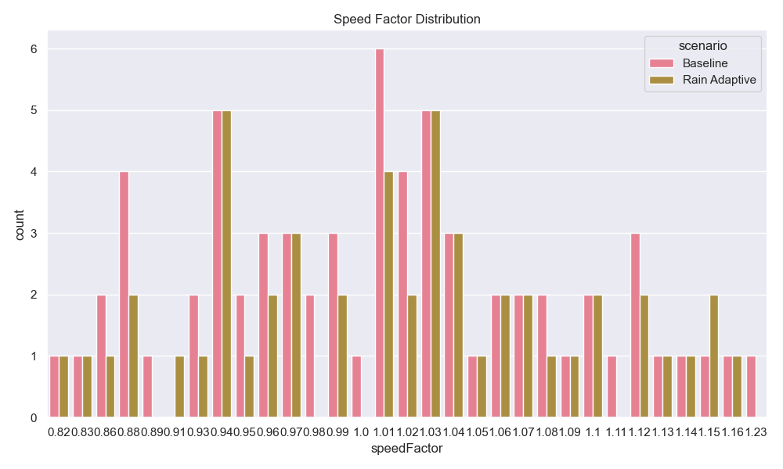

Rain Adaptive Condition
- Pedestrian Trip Durations (Boxplot)
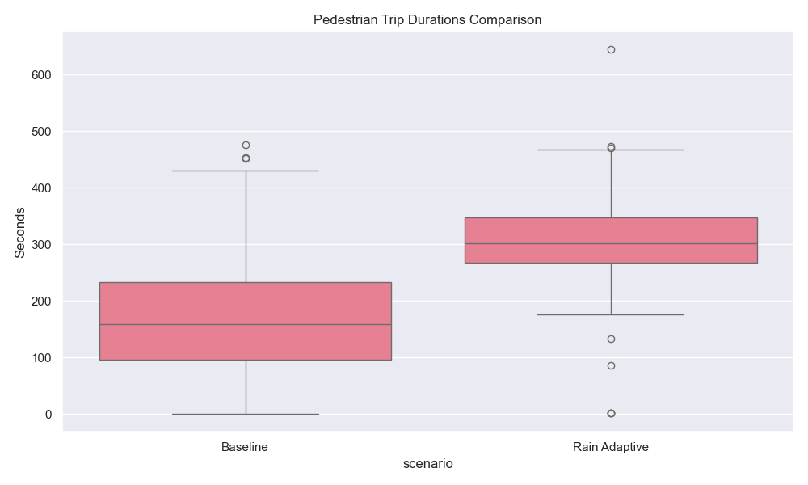
- Movement Efficiency (Violin Plot)
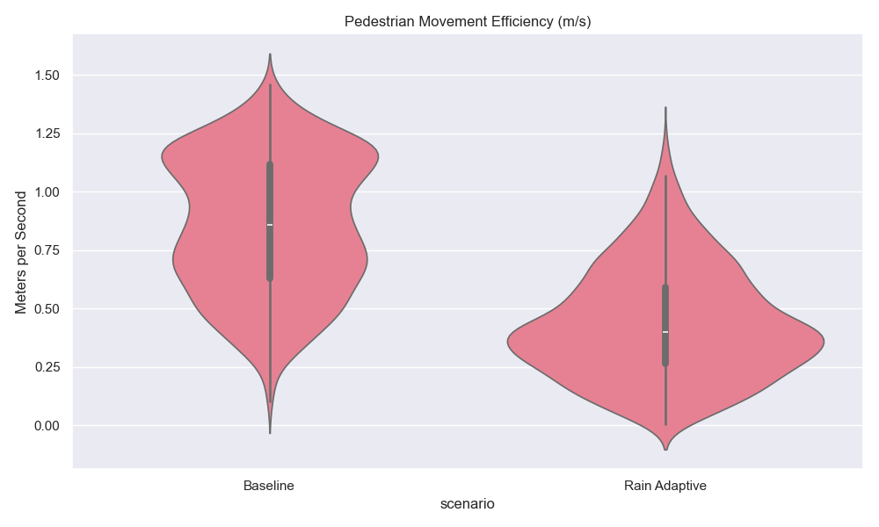

- Time Loss Distribution (Histogram)
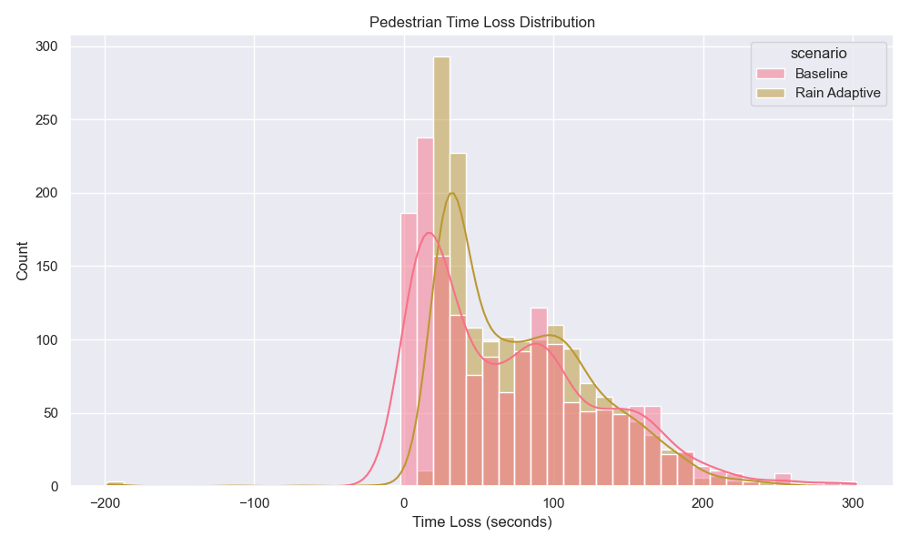

- Maximum Speed Achieved (Boxplot)
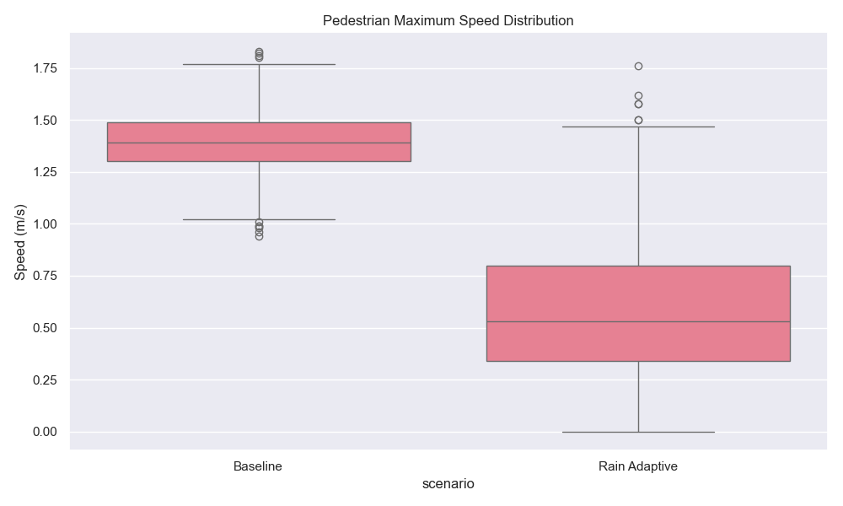

Impact Assessment of Rain-Adaptive Traffic Measures
Metric | Baseline | Rain Adaptive | Difference (%)
Average Vehicle Travel Time (s) | 38.15 | 65.18 | 70.86
Total CO2 Emissions (kg) | 6670.98 | 8660.68 | 29.83
Average Pedestrian Speed (m/s) | 0.86 | 0.43 | -49.37
Total Fuel Consumption (L) | 2127.8 | 2762.47 | 29.83
Vehicle Time Loss (%) | 43.64 | 64.19 | 47.09
Pedestrian Time Loss (%) | 42.78 | 24.98 | -41.62

The table compares key traffic performance metrics between baseline conditions and rain-adaptive scenarios at Trafalgar Square. Vehicle travel time increased by 70.9% during rainy conditions, while CO₂ emissions and fuel consumption rose by 29.8%, indicating significant environmental and efficiency trade-offs. Pedestrian movement was notably impacted, with average speeds decreasing by 49.4% but time loss improving by 41.6%, suggesting rain adaptations prioritized pedestrian safety at the expense of flow speed. These results highlight the complex balance between mobility, emissions, and safety in weather-responsive traffic management.

Key Observations:
- Vehicle travel time changed by 70.9%
- CO2 emissions changed by 29.8%
- Pedestrian speeds changed by -49.4%

Recommendations:
- Analyze road segments with the highest time loss for infrastructure improvements
- Consider adaptive traffic light timing for rainy conditions
- Investigate pedestrian routing patterns during adverse weather

