Windows Registry
Change Monitoring System
Project Documentation
────────────────────────────────────────

Name: Aditya Vinod Doshi
Subject: Cybersecurity
Language: Python 3

1. What is This Project?
This project is a cybersecurity tool written in Python. It watches over important parts of the Windows Registry and warns you if anything suspicious changes.

1.1 What is the Windows Registry?
The Windows Registry is like a big settings book that Windows reads every time it starts. It stores information such as:
- Which programs should open when Windows starts
- Whether your antivirus (Windows Defender) is turned on or off
- Whether your firewall is active
- What the Windows desktop shell looks like
- Security rules for all users

1.2 Why is it a Target for Hackers?
Because the registry controls so many important things, hackers love to change it. If a hacker can edit the registry, they can:
- Make their virus run every single time Windows starts — even after a reboot
- Turn off Windows Defender so the virus cannot be detected
- Disable the firewall so data can be secretly sent out
- Block Task Manager so you cannot see what is running
- Replace the Windows shell with their own malicious program

1.3 What Does Our Tool Do?
Our tool acts like a guard that watches the registry 24/7. It:
- Takes a 'clean photo' (baseline) of the registry when everything is normal
- Keeps checking every 30 seconds to see if anything changed
- Shouts an ALERT if it finds a change that looks like a hacker trick
- Saves all changes to a log file and a CSV report

2. Project Goals
This project has 5 main goals. Each one is explained simply below:

Goal 1 — Watch Startup Programs
Some registry keys control which programs open automatically when you log into Windows. Hackers add their virus to these keys so it runs every time you start your PC.
Our tool monitors these keys and tells you if any new program is added — especially if it is in a suspicious folder like AppData\Temp.

Goal 2 — Detect Hacker-Like Changes
Viruses often change specific registry values to make Windows less secure. For example, they set DisableAntiSpyware to 1 to turn off Defender.
Our tool knows 12 of these tricks and checks every change against this list. If it finds a match, it shows a big red ALERT.

Goal 3 — Save a Baseline Snapshot
Before any monitoring starts, we save a clean copy of all important registry values. This is called the baseline.
Later, we compare the current state to this baseline. If something is different — we know it changed and we report it.

Goal 4 — Alert You Immediately
Every change is logged with a timestamp (date and time). The severity level tells you how serious it is:
- INFO — Just information, nothing suspicious
- WARN — Something changed, worth checking
- ALERT — This looks like a hacker trick — act now!

Goal 5 — Create a Report
At the end of every monitoring session, all changes are saved to a CSV file. You can open this file in Microsoft Excel. It shows every change in a clean table with columns for: timestamp, key, type of change, old value, and new value.

3. What Parts of the Registry Do We Watch?
We monitor 11 registry key paths, grouped into 4 categories:

Category | Simple Explanation | Why We Watch It
Startup (Run) Keys | Controls which apps open at login | Hackers add viruses here for persistence
Windows Defender | Controls whether antivirus is on/off | Malware disables Defender to avoid detection
Firewall Settings | Controls whether the firewall is active | Hackers disable firewall to steal data
UAC / Policies | Controls admin security prompts | Malware turns off UAC to get full control
Winlogon / Shell | Controls what runs when you log in | Hackers replace the shell with their program
AppInit DLLs | Controls which DLLs load with every app | Used to inject malicious code into programs
IFEO Keys | Used by developers to attach debuggers | Abused to redirect programs to malware

4. What Hacker Tricks Do We Detect?
Our tool looks for 12 specific registry changes that viruses and hackers commonly make. Here are the most important ones:

Registry Value | Simple Meaning | Danger
DisableAntiSpyware = 1 | Windows Defender has been turned OFF | Very High
DisableRealtimeMonitoring = 1 | Live virus scanning is OFF | Very High
EnableFirewall = 0 | Windows Firewall is disabled | Very High
EnableLUA = 0 | User Account Control is OFF | High
ConsentPromptBehaviorAdmin = 0 | Admin never asked for permission | High
Shell changed | Windows Explorer replaced by something else | Critical
Userinit changed | Login program was modified | Critical
DisableTaskMgr = 1 | You cannot open Task Manager | Medium
DisableCMD = 1 | Command Prompt is blocked | Medium
DisableRegistryTools = 1 | Regedit is blocked | Medium

5. How to Set Up and Run the Project
Follow these steps exactly. Each step is simple.

Step 1 — Install Python
- Go to: https://www.python.org/downloads/
- Click the big yellow 'Download Python' button
- Run the installer
- IMPORTANT: Tick the box that says 'Add Python to PATH' before clicking Install
- To check it worked: open Command Prompt and type: python --version

Step 2 — Create Your Project Folder
- Open Command Prompt (search 'cmd' in the Start menu)
- Type: mkdir C:\RegistryMonitor and press Enter
- Then type: cd C:\RegistryMonitor and press Enter

Step 3 — Copy the Script
- Copy the file registry_monitor.py into the folder C:\RegistryMonitor
- That is the only file you need

Step 4 — Run as Administrator
- Search for 'cmd' in the Start menu
- Right-click on 'Command Prompt'
- Click 'Run as administrator'
- Type: cd C:\RegistryMonitor and press Enter
- Then type: python registry_monitor.py and press Enter

Step 5 — Use the Menu
When the program starts you will see a simple menu. Here is what each option does:

Menu Option | Name | What It Does
1 | Create Baseline | Saves a clean copy of current registry — do this FIRST
2 | Integrity Check | Compares the live registry to your saved baseline
3 | Detect Autoruns | Shows all programs set to start with Windows
4 | Malware Pattern Scan | Checks for known hacker tricks right now
5 | Continuous Monitor | Watches the registry every 30 seconds automatically
7 | Show Baseline Checksum | Shows a code to verify your baseline was not changed
0 | Exit | Closes the program and saves the final report

Screenshot 1: Baseline Created (Option 1)
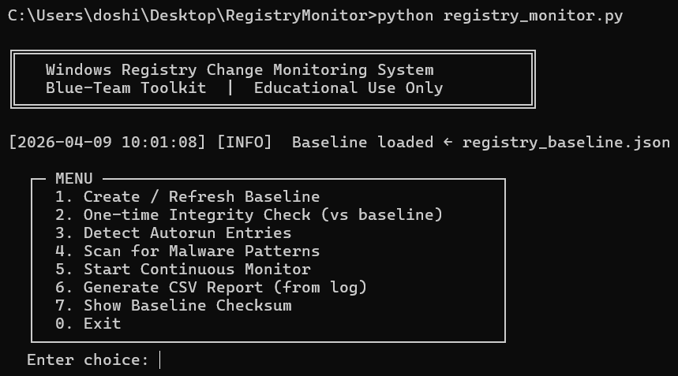

6. How to Test the Project
You can do a simple safe test to make sure the tool is working correctly:

- Step 1: Run the tool and press 1 to create a baseline
- Step 2: Press Win + R, type regedit, press Enter
- Step 3: Go to: HKEY_CURRENT_USER > SOFTWARE > Microsoft > Windows > CurrentVersion > Run
- Step 4: Right-click > New > String Value
- Step 5: Name it TestEntry and set value to C:\Windows\notepad.exe
- Step 6: Go back to the monitoring tool and press 2
- Step 7: You should see: [ADDED] HKCU\...\Run\TestEntry
- Step 8: Delete TestEntry from regedit after the test

Screenshot 4: Integrity Check — TestEntry Detected (Option 2)

7. Sample Output

7.1 What the Log File Looks Like
The file registry_changes.log contain entries like this:
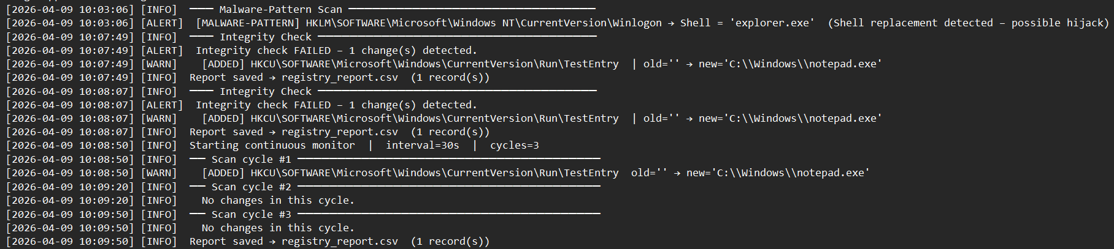

7.2 Output Files Explained
File Name | What Is It? | How to Open
registry_baseline.json | The clean snapshot saved at the start | Any text editor (Notepad)
registry_changes.log | Every alert, warning and message with time | Any text editor (Notepad)
registry_report.csv | Table of all detected changes | Microsoft Excel or Google Sheets

Screenshot 2: Autorun Detection Results (Option 3)
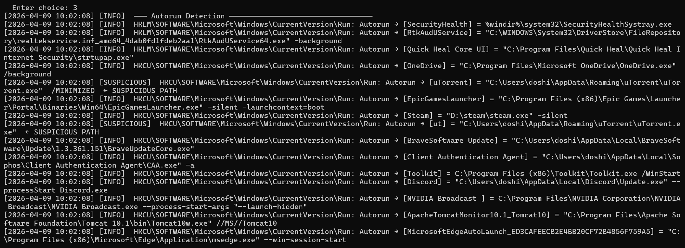

Screenshot 3: Malware Pattern Scan (Option 4)

Screenshot 5: Continuous Monitoring — 3 Scan Cycles (Option 5)
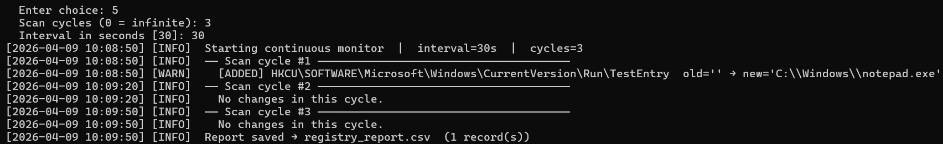

Screenshot 6: Baseline SHA-256 Checksum (Option 7)

Screenshot 7: registry_report.csv opened in Microsoft Excel

8. What You Learn From This Project

Skill Learned | Simple Explanation
Windows Registry | You now know what the registry is and why it matters
Malware Behaviour | You understand how viruses hide and persist on Windows
Defensive Monitoring | You know how security tools detect suspicious activity
Python Scripting | You wrote a real security script using only Python built-ins
Reading Log Files | You can read and understand security log entries
Incident Reporting | You know how to create a proper change report

9. References
- Python Official Documentation — docs.python.org
- Microsoft Windows Registry Guide — docs.microsoft.com
- MITRE ATT&CK — Persistence via Registry (T1547)
- MITRE ATT&CK — Modify Registry (T1112)
- MITRE ATT&CK — Impair Defenses (T1562)

