PROJECT DOCUMENTATION

USB Device Control &
Monitoring Framework
Cybersecurity Project | Python 3
━━━━━━━━━━━━━━━━━━━━━━━━━━━━━━━━━━━━━━━━

Field | Details
Name | Aditya Vinod Doshi
Language | Python 3
Platform | Windows 10 / Windows 11
Year | 2026

1. What is This Project?
The USB Device Control and Monitoring Framework is a cybersecurity project written entirely in Python. It watches your computer's USB ports and immediately alerts you when any USB drive is plugged in or removed — especially if the device is not on your trusted list.
Simple idea: Think of this tool as a security guard at every USB port. The moment an unknown USB drive is plugged in, the guard raises an alarm.

1.1 Why Are USB Drives Dangerous?
- Spread viruses — infected USB drives copy malware to every computer they touch
- Steal data — attackers silently copy private files to their USB and walk away
- BadUSB attack — a modified USB pretends to be a keyboard and types malicious commands
- Autorun viruses — older Windows systems ran programs from USB automatically when plugged in
Real example: The Stuxnet worm (2010) spread through USB drives and destroyed nuclear equipment in Iran. This shows how dangerous a simple USB drive can be.

1.2 What Does Our Tool Do?
- Detects when any USB drive is plugged in or removed within 5 seconds
- Checks if the USB serial number is in your trusted whitelist
- Raises an ALERT if the device is unknown or not trusted
- Logs every event with exact date and time to a log file
- Exports all events to a CSV file you can open in Microsoft Excel

2. Project Objectives

Objective 1 — Detect USB Connections
The tool scans drive letters D to Z every 5 seconds. When a new drive appears or disappears it is detected immediately and logged.

Objective 2 — Whitelist Checking
Every USB has a unique serial number. Our tool saves trusted serial numbers in a whitelist file. Any USB not in the whitelist triggers an ALERT.

Objective 3 — Baseline Snapshot
Before monitoring starts, we save a clean copy of all connected drives. This is the baseline. Any new drive is compared to it.

Objective 4 — Timestamped Logging
Every event is saved with exact date and time. Levels: INFO (routine), WARN (drive removed), ALERT (unknown drive connected).

Objective 5 — CSV Report
All events are exported to usb_report.csv — open it in Excel for a clean table of everything that happened.

3. Tools and Technologies Used
No pip install required. All modules below are built into Python 3 already.

Module | What It Does | Used For In This Project
os | Checks files and folders on the computer | Checking if drives and files exist
time | Adds delays | Waiting 5 seconds between each scan
datetime | Gets current date and time | Timestamping every log entry
json | Saves and reads data files | Storing the whitelist and baseline
csv | Creates spreadsheet files | Exporting the final event report
hashlib | Creates SHA-256 fingerprint codes | Verifying the baseline file
subprocess | Runs Windows system commands | Using wmic to read USB drive info

4. How to Set Up and Run

Step 1 — Install Python
- Go to python.org/downloads and download Python 3.10 or newer
- Run the installer — TICK the checkbox that says Add Python to PATH
- Open Command Prompt and type: python --version to verify

Step 2 — Create Your Project Folder
- Open Command Prompt (search cmd in Start menu)
- Type: mkdir C:\USBMonitor and press Enter
- Type: cd C:\USBMonitor and press Enter
- Copy usb_monitor.py into this folder

Step 3 — Run as Administrator
- Press Start, type cmd, RIGHT-CLICK on Command Prompt
- Click Run as administrator and click Yes
- Type: cd C:\USBMonitor and press Enter
- Type: python usb_monitor.py and press Enter

Screenshot 1: Tool Started — Main Menu
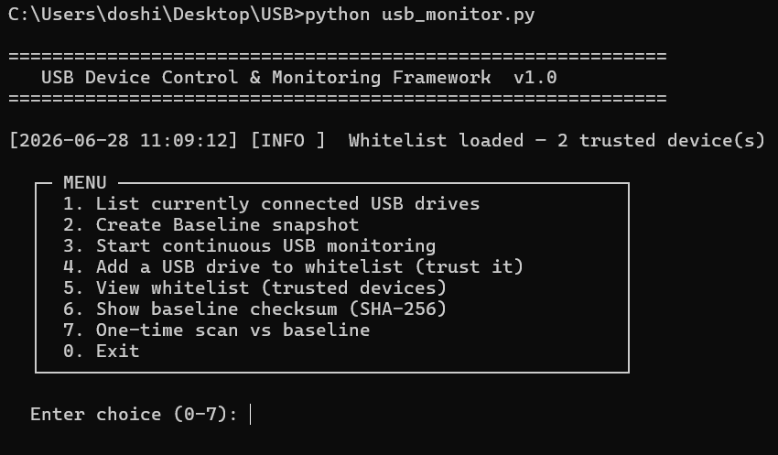

4.2 Menu Options Explained
Option | Name | What It Does | When to Use
1 | List USB Drives | Shows all currently connected drives | Anytime to check what is plugged in
2 | Create Baseline | Saves clean snapshot — DO THIS FIRST | Before you start monitoring
3 | Start Monitoring | Watches every 5 seconds automatically | This is the main monitoring option
4 | Add to Whitelist | Marks a USB drive as trusted | For your own personal USB drive
5 | View Whitelist | Shows trusted serial numbers | To check which drives are trusted
6 | Baseline Checksum | SHA-256 code of baseline file | To verify baseline was not changed
7 | One-time Scan | Quick compare vs baseline | Quick check at any time
0 | Exit | Close the tool | When done monitoring

Screenshot 2: Baseline Created Successfully

5. How to Test the Project
Simple safe test — you just need a USB drive (pen drive):

- Run the tool and press 2 to create a clean baseline
- Press 3 to start monitoring — enter 10 when asked for scans
- Plug in your USB drive while the tool is running
- Watch the screen — within 5 seconds you will see USB CONNECTED + ALERT (unknown)
- Press Ctrl+C to stop. Then press 4 and add your USB to the whitelist
- Press 3 again and plug the same USB in — now it shows OK — Trusted
- Take a screenshot showing the difference between ALERT and OK

Screenshot 3: ALERT — Unknown USB Drive Detected
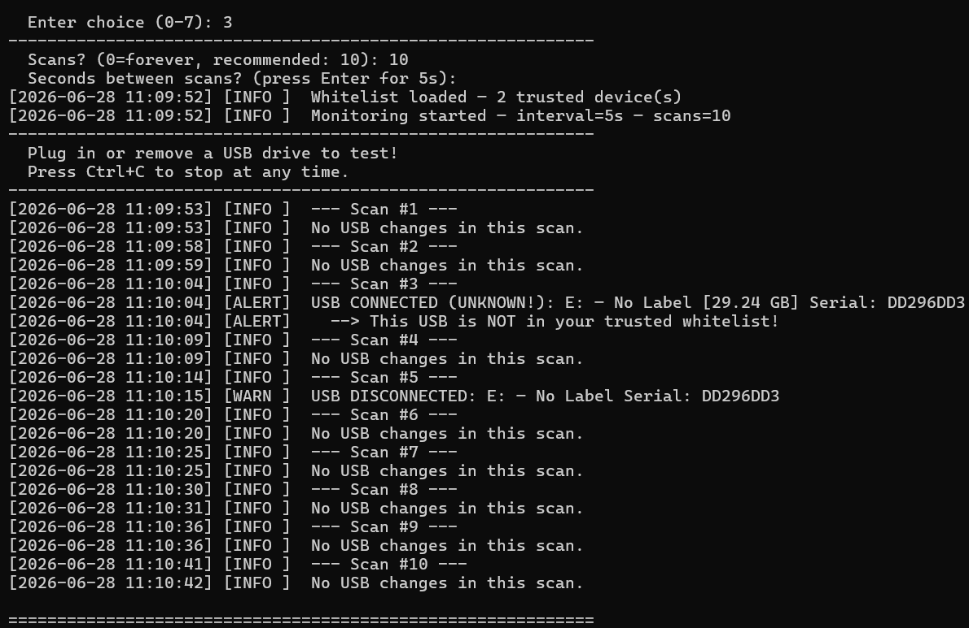
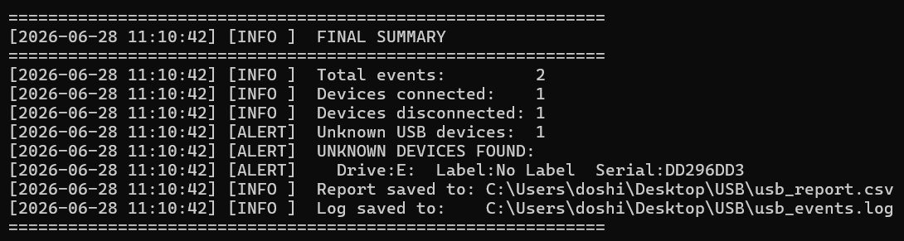

Screenshot 4: USB Drive Added to Whitelist
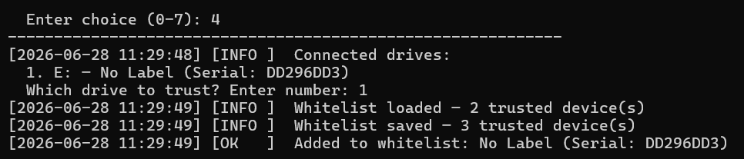

Screenshot 5: Same USB Now Trusted — OK Status
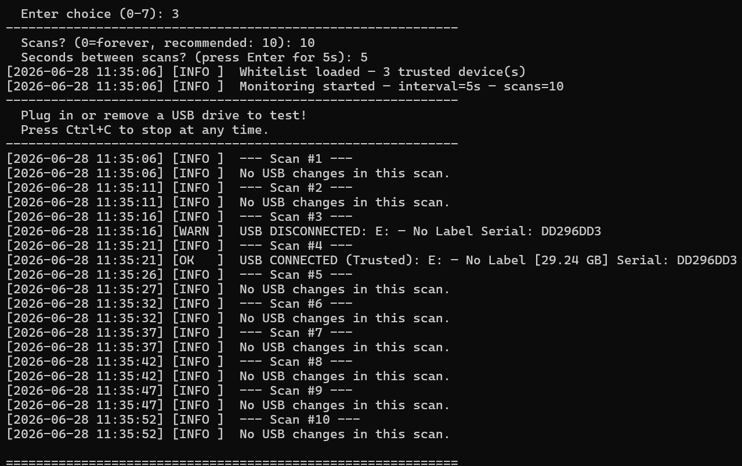

These screenshots prove your tool works correctly. The same USB goes from ALERT (unknown) to OK (trusted) after you add it to the whitelist. This is exactly how real USB security tools work.

6. Sample Output

6.1 Log File (usb_events.log)
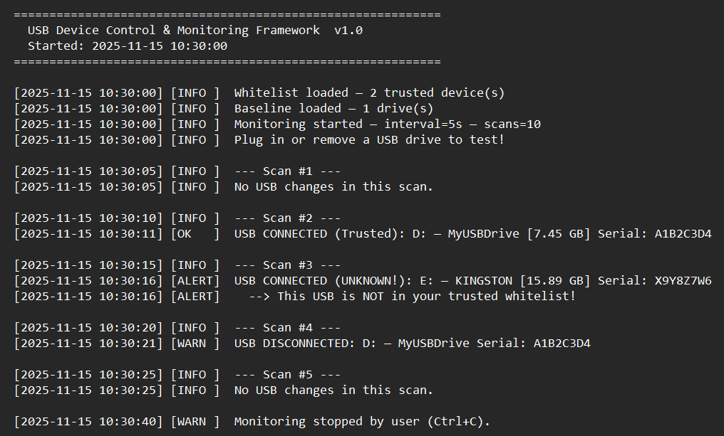

Screenshot 6: Final Summary Report After Monitoring Session

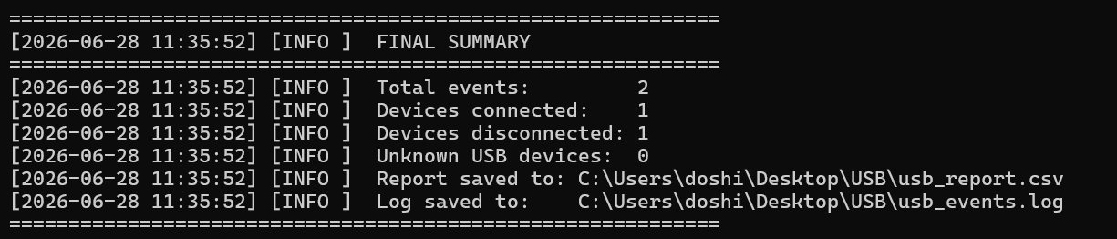

6.2 Output Files
File Name | What Is In It | How to Open
usb_events.log | All events and alerts with timestamps | Notepad
usb_report.csv | Table of all USB events | Microsoft Excel
usb_baseline.json | Clean starting snapshot of drives | Notepad
usb_whitelist.json | Trusted USB serial numbers | Notepad
Screenshot 7: usb_report.csv Opened in Microsoft Excel
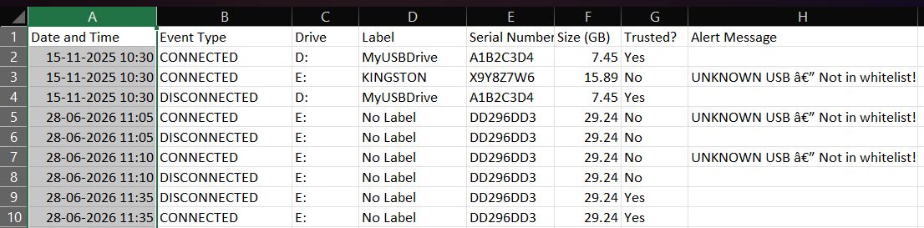

7. Learning Outcomes
Skill Learned | What You Now Understand
USB Security Threats | How USB drives are used in real attacks like Stuxnet and BadUSB
Whitelist System | How trusted device lists work — used in real endpoint security software
Baseline Method | How comparing to a clean snapshot detects security changes
Python Scripting | How to write a real security tool using only built-in Python modules
Log Files | How to create structured timestamped logs for security events
CSV Reports | How to export security events to a spreadsheet for analysis
Blue Team Thinking | How defenders monitor, detect, and respond to threats

8. References
- Python Official Documentation — docs.python.org
- MITRE ATT&CK — Replication Through Removable Media (T1091)
- Stuxnet Wikipedia article — USB worm case study
- BadUSB — DEF CON 2014 presentation by Karsten Nohl
- Python subprocess docs — docs.python.org/3/library/subprocess.html

