 Invention Disclosure Format (IDF)-B | Document No.
 | Issue No/Date
 | Amd. No/Date

1. Title of the Invention
System and Method for Recalibrating Substrate Water-Content Sensors from the Drain Onset of their Slabs and Controlling the Irrigation Valve on the Corrected Reading.

2. Field / Area of Invention
The present invention relates to the irrigation of crops grown in soilless culture, in which plants stand on slabs of a plant-growth substrate such as stone wool, an irrigation valve or pump doses nutrient solution to the slabs through drippers in short pulses, and dielectric water-content sensors inserted in the slabs report the water content that the irrigation controller steers on. More particularly, it pertains to a system and method that recalibrate each water-content sensor in place, from the moment its own slab starts to drain under the routine irrigation pulses, express each reading as the deficit of water content still missing before that slab drains, and open or hold the irrigation valve on that deficit.
Growers of tomato, cucumber, pepper and strawberry on stone wool steer irrigation by the water content (WC) of the slab: the first pulse of the day is given when the slab has dried back by a chosen amount, pulses follow while WC is below a set-point, and the slab is brought to drainage before noon. The sensors are trusted as read. In the six greenhouse compartments evaluated here (12 sensors, two per compartment, on slabs of one type, 2019-12-16 to 2020-05-30), the two sensors of one compartment, which see the same crop, the same nutrient solution and the same pulses, differed by a median of 7.3 WC % over the second half of the season, and by 15.2 WC % in the worst compartment. A controller that compares such a reading with a set-point opens the valve at the wrong times: replaying a set-point rule on the raw readings, 8 of the 12 sensors gave a different valve decision from their corrected reading on more than 20 % of the daytime sampling intervals. The technical problem addressed is to refer each slab sensor to a physical event of its own slab in place, continuously and without sampling or weighing the slab, so that the irrigation valve acts on how far each slab actually is from draining.

2.1 Technical Problem Addressed by the Invention
A dielectric slab sensor reports WC through a factory calibration for the slab type; electrode contact, position in the slab, root growth around the pins and the salinity of the solution move the reading away from the water actually present, and nothing in the irrigation loop detects it.
Two sensors in one irrigation section disagree by several WC % for weeks; a set-point that is right for one sensor is wrong for the other, and averaging the two does not tell which one is right.
Calibration by weighing slabs or by gravimetric samples needs a scale under the gutter or destructive sampling, and is done once, while the error drifts over the season.
One-off field-capacity calibration of soil sensors (Section 3, P1) irrigates in special cycles until two readings agree and sets a target relative to that reading for a single sensor; it neither refreshes the reference from routine production pulses nor brings several sensors onto one scale.
A gain error of a sensor scales the overnight dry-back that growers steer on; correcting the gain from one noisy route can make the dry-back worse rather than better.

2.2 Definitions
Irrigation section (100): a group of slabs (150) of one substrate type fed by one irrigation valve or pump (510) through drippers, carrying two or more WC sensors (110, 120).
WC reading: the water content, in % of slab volume, reported by a sensor at each sampling interval (5 minutes in the example).
Pulse: one opening of the valve (510); its volume per m2 of floor is registered by the dose meter (530).
Rise: the increase of a sensor's reading caused by one pulse, taken as the largest reading in the 3 sampling intervals from the pulse less the reading in the interval before it.
Drain onset: the pulse of a day from which the slab passes the added water to the gutter (170) instead of storing it; seen on the sensor as a collapse of the rise.
Daily plateau P_s(day): the reading of sensor s over the 30 minutes after its drain onset.
Reference plateau P_s(d): the median of the sensor's daily plateaus over the 14 days before day d.
Drain deficit D_s(t) = P_s(d) - WC_s(t): the reading still missing before the slab of sensor s drains; the offset of the sensor cancels in it.
Common plateau constant P* (optional): one value for all sensors in slabs of one substrate type; corrected reading WC* = P* - D_s, used for display and for set-points written as water contents.
Dry-back: the largest drain deficit of a slab before the first pulse of the next day.
Drain EC probe (550): the conductivity probe in the drain collector of the gutter, which the irrigation computer already reads; its reading changes when fresh drain water reaches it.

3. Prior Patents and Publications from Literature
Each reference below was checked against its own text before any statement about it was made: the abstract and first claim of each patent as published, and the full text of each publication (the abstract only for N3).

A. Prior Patent Literature
S.No. | Patent No. | Title | Comments
P1 | US 7,133,749 B2 (family: US 7,574,284 B2) | Method and apparatus for optimizing soil moisture | Automatic sensor calibration at the first scheduled cycle or on recalibration: a reading, a short irrigation, a second reading two hours later, repeated until consecutive readings agree within a set fraction; the stable reading is taken as field capacity and the target is set at a margin from it. A commissioning routine with dedicated cycles for one soil sensor per zone group; no reference refreshed from production pulses, no collapse of the pulse response, no common scale for several sensors, no substrate slab.
P2 | US 8,862,277 B1 (family: US 8,751,052 B1) | Automatic efficient irrigation threshold setting | Determines field capacity from the dynamic response of soil moisture after wetting above field capacity: a fast fall to field capacity followed by a slower fall by evapotranspiration. In an adaptive mode the value is re-determined from irrigation events or rainfall with a time constant of about ten days; the threshold is set at 70 to 80 % of field capacity, and the interrupter can only suspend scheduled watering, not start it. Also detects broken sprinkler heads and drip lines. The daily value comes from the drainage fall after wetting, not from the collapse of the rise of the refill pulses; the threshold is a fraction of the reading, so a sensor offset enters it; no reconciliation of several sensors and no gain gate.
P3 | US 9,775,308 B2 | Method and apparatus for the automatic regulation of the irrigation of plants | Computes an irrigation duration from a characteristic K, measures soil moisture after irrigating, and enlarges or reduces K according to whether a target upper moisture limit was exceeded. Adapts the dose to the reading as read; the sensor itself is not corrected.
P4 | EP 0 392 639 A2 (Rockwool/Grodan) | Method and device for measuring the moisture content of a substrate for growing | Measures the capacitance between electrodes in an artificial (rock-wool) substrate, and the resistance for its salinity. Sensor construction; no in-place recalibration.
P5 | EP 2 166 347 A1 | A substrate water content measuring device | Capacitance between two electrodes, at least one extending along an outer boundary plane of a mineral-wool slab, converted to water content. Device construction; no recalibration.
P6 | US 12,480,932 B2 | Sensor and system for monitoring a substrate | Two sensing elements in the substrate, an applied electrical signal and an electrical model with inductances, capacitance and conductance from which the water amount and nutrient concentration are computed. Improves the conversion inside one sensor; no reference from drain onset and no reconciliation between sensors.
P8 | US 11,930,744 B2 | System and method of adjusting irrigation schedules with soil moisture data | Claim 1: a predicted soil moisture value, the current value adjusted by the average or median of negative net changes of historic sensor values, is compared with a low threshold to allow the next scheduled irrigation. Uses history to anticipate drying; the reading itself and the threshold stay on the sensor's own uncorrected scale.
P9 | US 8,961,068 B2 | Device, system, and method of irrigation | Times the arrival of irrigation water at a buried moisture sensor after the valve opens, computes a drainage speed from the sensor depth and sets the remaining irrigation time to reach the root depth. Uses the wetting front in soil; no drainage plateau of a slab and no sensor correction.
P7 | EP 3 016 492 B1 (Rockwool) | Plant growth system | Claim 1: central processing receives temperature, water content and nutrient content of a hydroponic substrate from wireless detectors, stores predefined irrigation data relating such values to desired irrigation outputs, and outputs the desired irrigation input. The detectors' readings are used as reported; the text does not address their calibration.
Table 1: Prior patent literature

B. Non-Patent Literature
S.No. | Reference | Title | Comments
N1 | Hemming, de Zwart, Elings, Petropoulou, Righini (2020), Sensors 20, 6430 | Cherry tomato production in intelligent greenhouses: sensors and AI for control of climate, irrigation, crop yield, and quality | Describes the six compartments from which the example data come: cherry tomato on Grodan GT Master stone wool slabs on elevated gutters, drippers fed by an on/off irrigation pump, drain collected in the gutter and measured for quantity, EC and pH, GroSens sensors in the slabs, 5-minute data exchange. The slab sensors are used as read.
N2 | Hemming, de Zwart, Elings, Righini, Petropoulou (2019), Sensors 19, 1807 | Remote control of greenhouse vegetable production with artificial intelligence: greenhouse climate, irrigation, and crop production | First edition of the same facility with cucumber: rockwool cubes on slabs on hanging gutters, drippers operated by a valve, drain recollected in a closed loop. No sensor recalibration.
N3 | Montesano, van Iersel, Boari, Cantore, D'Amato, Parente (2018), Agric. Water Manage. 203, 20-29 | Sensor-based irrigation management of soilless basil using a new smart irrigation system | Cloud-connected wireless irrigation with dielectric moisture/salinity sensors in a perlite-coco substrate, irrigation set-points of 0.40, 0.30 and 0.20 m3/m3. The set-point is compared with the reading as reported.
N4 | van Iersel and Burnett, Decagon Devices application note (2015) | Using soil water sensors for efficient irrigation in greenhouses | Opens an irrigation valve when the substrate water content measured by EC-5 probes drops below a grower set-point; a controller takes one to four probes. The probes are taken to read the substrate correctly.
N5 | Grodan (Rockwool group), product brochure | Grodan GroSens MultiSensor System | Wireless WC, EC and temperature sensors for stone wool slabs; a Smartbox processes sensor data taking the slab type and dimension into account; more sensors give more representative figures for the irrigation section. Averaging; no reconciliation of sensor offsets.
N6 | Hemming et al., 4TU.ResearchData, doi 10.4121/uuid:88d22c60-21b3-4ea8-90db-20249a5be2a7 | Autonomous Greenhouse Challenge, second edition (2019): data set and parameter description | Defines the recorded variables: cumulative irrigation per day computed from valve minutes, daily irrigation and drain, two GroSens slab sensors per compartment (WC, EC, temperature, 5 minutes). Source of the example data.
Table 2: Non-patent literature

4. Summary and Background of the Invention

4.1 Background
Soilless culture on stone wool is steered by the water content of the slab. A drained stone wool slab holds a fixed amount of water set by its pore structure; the grower lets it dry back overnight, doses pulses from the morning until it drains again, and repeats. The sensor that reports WC is a dielectric probe with pins through the slab [N5, P4, P5, P6]. Its reading feeds the irrigation computer directly [P7, N3, N4]. In the example data the median raw readings of the two sensors in one compartment were 78.0 and 63.9 WC % (AICU), 77.5 and 65.4 (Digilog), 83.0 and 74.5 (IUA.CAAS), on slabs of one type.
Two remedies exist. A calibration can be made once, by weighing slabs or sampling, or by a commissioning routine that irrigates until readings stop rising and treats that reading as field capacity [P1, P2]; P2 also re-determines field capacity from the drainage fall after wetting, with a time constant of about ten days. The dose can be adapted to the reading or its recent history [P3, P8], or to the travel time of the wetting front [P9]. None of these takes the reference from the moment the substrate stops storing the pulses that the crop receives anyway, and none steers on the distance of each reading from its own slab's drainage, so a section with two sensors still has two different readings of the same water.

4.2 Distinctions from Prior Art
The references are distinguished below by what they teach and by the technical effect they do not produce. Where a prior teaching could be applied to the example data, it was applied with the same window and the same held-out half, and its result is given beside that of the invention.
Drainage-based calibration, once (P1). P1 runs dedicated watering cycles until one sensor's reading stops changing and keeps that reading as field capacity until a recalibration is requested. An anchor of this kind, fixed from each sensor's first 14 onset days, lay a median 4.77 WC % from the reading at the moment fresh drain reached the drain EC probe, against 1.10 WC % for the rolling drain-onset anchor; it left a median paired gap of 2.46 WC % against 1.44, and the valve decisions of the two differ on a median 49 % of daytime intervals (Sections 8.4, 8.8).
Drainage-based calibration, adaptive (P2). P2 takes field capacity from the fast fall of the reading after the soil is wetted above it, renews it from later irrigation events, sets the threshold at a fraction of it and can only suspend watering. The event differs: the fall after wetting mixes the drainage of excess water with the crop's uptake and ends gradually, whereas the collapse of the rise of the refill pulses marks the pulse at which the slab stops storing water. Applied to the example data, field capacity from the fall after the last pulse of each day, renewed over the same 14-day window, lay a median 1.75 WC % from the reading at physical drain, with 4 of 12 sensors within 1 WC %; the drain-onset anchor lay 1.10 WC % from it, with 10 of 12. The morning deficit to the drain-onset anchor also ranks the litres dosed until drain better (Spearman 0.49 against 0.43; 95 % interval of the difference 0.03 to 0.10, Section 8.8). A threshold set as a fraction of the reading keeps part of the sensor offset; the drain deficit cancels it.
Dynamic soil-moisture irrigation (P3, P7, P8, P9, N3, N4). These adapt the dose or the timing to the reading, to its recent history or to the travel time of the wetting front, but compare a reading on the sensor's own scale with a threshold. With one constant on the raw readings, the reading at physical drain lay a median 4.88 WC % from it and within 1 WC % for 0 of 12 sensors; on raw readings 8 of 12 sensors decide the valve differently from the drain deficit on more than 20 % of daytime intervals (Sections 8.5, 8.8).
Sensor construction (P4, P5, P6, N5). These improve the electrodes or the conversion inside one sensor, or average several sensors; the invention needs no change to the sensor and removes, in place, the offset that the conversion leaves behind.
Gain and delivery (P2, N5). Neither estimates a sensor gain by two physically independent routes. Applying a gain from one route always raised the median paired dry-back gap from 12.9 % to 15.0 %; applying it only when both routes agree lowered it to 11.9 % (Section 8.6). The gain-free delivery ratio between slabs is absent from all references.
No reference teaches the sequence of claim 1, from the response of each sensor to the pulses through the collapse of that response, the sensor-specific plateau and the rolling reference to the drain deficit on which the valve acts; and none of the prior anchors that could be computed on the same data reaches the agreement with the physical drain that the sequence gives.

4.3 Inventive Combination
The combination is: (i) the response of each sensor to every routine irrigation pulse; (ii) the collapse of that response relative to the same sensor's earlier pulses of the day, taken as the drain onset of its slab, a physical event that does not depend on the sensor's scale or offset; (iii) the sensor's reading after that onset as its own daily plateau; (iv) a reference built from past days only, held in a reference memory, so that the controller can apply it in real time and follow drift; (v) the drain deficit of each reading to that reference, in which the sensor's offset cancels and which needs no assumption that different slabs drain at the same water content; and (vi) the irrigation valve opened when the deficit exceeds one set-point. The effect does not hinge on particular constants: over onset fractions of 0.2 to 0.4 and windows of 7 to 28 days the median paired gap stayed between 0.96 and 1.58 WC % against 7.35 raw (Section 8.4).

4.4 Feature Mapping Against Prior Art
# | Feature | P1 | P2 | P3 | P8 | N4
F1 | Reference from the drain-onset reading of the sensor's own slab | Partial | Partial | No | No | No
F2 | Drain onset from collapse of the response to routine production pulses | No | No | No | No | No
F3 | Reference renewed from past days only | No | Partial | No | Partial | No
F4 | Valve opened on the deficit to the slab's own drain onset | No | No | No | No | No
F5 | Gain applied only when two physical routes agree | No | No | No | No | No
F6 | Gain-free delivery ratio between slabs | No | Partial | No | No | No
F7 | Irrigation valve actuated on the corrected reading | Partial | Partial | Partial | Partial | Yes
F8 | Sensor checked against the drain EC probe at the first drained pulse | No | No | No | No | No
Table 3: Feature mapping of the invention against the nearest art

4.5 Technical Effects
The corrected reading meets the physical drain: at the first pulse of each day after which the drain EC probe (550) registered fresh drain, the readings of the 12 sensors lay a median 1.10 WC % from their rolling anchors (10 of 12 sensors within 1 WC %), against 4.77 WC % from a one-off commissioning anchor and 4.88 WC % from one common constant on the raw reading (0 of 12).
The deficit follows the water the slab physically takes: against the litres dosed each morning until the drain EC probe registered drain, read without any slab sensor, the rank correlation of the morning deficit over all 12 sensors is 0.49 with the rolling anchor, against 0.26 with a one-off commissioning anchor and 0.21 with one common constant on the raw reading.
Paired sensors on one substrate type read alike: over the held-out second half, the median gap between the two sensors of a compartment falls from 7.35 to 1.44 WC % (median over 6 compartments); in the worst compartment from 15.2 to 1.8 WC %. On 427 of 473 compartment-days where the two differ the corrected gap is the smaller (sign test z = 17.52).
Valve decisions follow the water in the slab: on raw readings 8 of 12 sensors would have opened or held the valve differently from the corrected reading on more than 20 % of daytime intervals (median 42 %), and in a median 16 % of intervals called for a pulse while the corrected slab was already at its drainage plateau, so that the pulse would have passed to the gutter.
Insensitive to the constants: over windows of 7, 14 and 28 days and onset thresholds of 0.2, 0.3 and 0.4 the median gap stays between 0.96 and 1.58 WC % (raw 7.35).
Gain correction without harm: applying a gain only when the rise route and the decline route agree within 10 % lowers the median paired dry-back gap from 12.9 % to 11.9 %, while applying it always raises it to 15.0 %.
A partly closed dripper line shows without any gain: closures of 40 % injected into the measured delivery ratios raised the alarm within two to four weeks in 90 % of cases, with no alarm in the same windows without a closure.
No new instrument: the inputs are the readings of the slab sensors and the pulse volumes already registered by the dose meter; the computation takes 2.2 ms for each sensor and day on one processor core.

4.6 Applicability
The method applies to any soilless irrigation section with dielectric substrate sensors and pulsed irrigation that brings the slab to drainage on most days: stone wool and other mineral-wool slabs for tomato, cucumber, pepper, aubergine, strawberry and cut flowers, and coir slabs where the drainage plateau is equally fixed by the pore structure. It runs in the irrigation computer that already receives the sensor readings and the pulse log. Indian protected cultivation of capsicum, cucumber and tomato in polyhouses on coco-peat slabs with drip fertigation uses the same hardware.

5. Objective(s) of the Invention
The primary objective is to provide a system that recalibrates each substrate water-content sensor of an irrigation section in place, from the drain onset of its own slab under routine irrigation pulses, and opens or holds the irrigation valve on the corrected reading.
(a) To detect, every irrigated day, the moment a slab starts to drain from the collapse of the rise of the sensor reading per irrigation pulse.
(b) To keep for each sensor a reference reading at drainage plateau built from its past days only.
(c) To express every reading as its deficit to the drain onset of its own slab, so that one set-point means the same distance from drainage on every slab.
(d) To actuate the irrigation valve or pump on that deficit, and to check each sensor against the drain EC probe of the gutter.
(e) To correct the gain of a sensor only when two physically different routes agree.
(f) To compare the water delivered to two slabs per unit of their demand, free of sensor gain.
(g) To evidence the correction on real sensor records of operating greenhouse compartments.

6. Working Principle of the Invention (in brief)
[0001] An irrigation section (100) of a greenhouse holds slabs (150) of one plant-growth substrate, for example stone wool, on a gutter (170). An irrigation valve or pump (510) doses nutrient solution through drippers in pulses; a dose meter (530) registers each pulse volume and a drain meter (540) the water collected by the gutter. Two or more dielectric water-content sensors (110, 120), each with pins inserted in a different slab, report the WC reading every sampling interval to a data-processing system (900), the irrigation computer of the section.
[0002] A slab stores water from each pulse until its pores are filled to the level that the pore structure can hold against gravity; from then on, each further pulse drains through to the gutter (170). The water content at which this happens, the drainage plateau, is set by the pore structure of the slab. On the sensor it shows as a collapse of the rise of the reading per pulse: large rises in the morning while the slab is filling, small rises once it drains (Figure 3(b)).
[0003] A sensor with an offset reads the plateau high or low, and every other reading by the same amount. The difference between a reading and the same sensor's plateau reading is therefore free of the offset: it is the water content still missing before that slab drains. This holds whether or not two slabs drain at exactly the same water content, since each sensor is referred to its own slab. The system (900) therefore detects the drain onset of each sensor's slab each day as the first pulse, after the first 4 pulses of the day, whose rise falls below 0.3 of their median rise, and records the reading over the 30 minutes after it as that day's plateau reading.
[0004] The reference plateau of each sensor on day d is the median of its plateau readings over the 14 preceding days, provided at least 3 were found; otherwise the last reference is kept. It uses past days only, so the irrigation computer can apply it in real time, and it follows slow drift of the sensor, such as roots growing around the pins or a change of solution salinity.
[0005] At every interval the drain deficit of each sensor is D = P_s(d) - WC. Where the grower prefers set-points written as water contents, the deficit is shown on a common scale WC* = P* - D, P* being one plateau constant for the substrate type, in the example the median of all sensors' plateau readings over a commissioning period; a set-point S = P* - d on WC* is the same rule as d on D.
[0006] At every sampling interval the system (900) compares the drain deficit of the section with the set-point d and opens the valve or starts the pump (510) for a pulse when it is larger, and keeps it closed otherwise. A pulse is thus no longer given to a slab that is already draining because its sensor reads low, and no longer withheld from a drying slab because its sensor reads high.
[0007] A gain error of a sensor stretches its excursions from the plateau, such as the overnight dry-back. Two routes see the gain: the rise per litre dosed before the drain onset, and the fall of the reading per day as the crop takes up water. Their ratios between two sensors of a section are estimates of the relative gain from different physical processes; the system scales the excursion only when the two agree within 10 %, so that a wrong estimate from one route is not applied.
[0008] The ratio of the two routes for one sensor, the rise per litre divided by the daily fall, does not contain the sensor's gain at all. Between two slabs of a section it compares the water each slab receives from its drippers per unit of its crop's demand; the system watches its weekly value and raises a delivery alarm (430) when it drifts.
[0009] The drain EC probe (550) in the drain collector gives an independent check. Its reading moves only when fresh drain reaches it, so a step of at least 0.15 dS/m within 15 minutes of a pulse marks that pulse as drained. At the first drained pulse of a day the drain deficit of a correct sensor is near zero; the check unit (360) keeps this value for each sensor and day and issues a sensor check signal (440) when its median over the window departs from zero by more than a limit.

6.1 Claimed Function Against Example Implementation
Claimed function | Example implementation (Section 8)
Pulses delivered; readings and pulse volumes received (claim 1 (a)) | GroSens WC at 5-min intervals, two sensors per compartment; pulse volume = step of the daily cumulative irrigation, reset detected by the counter falling
Response per pulse and its collapse = drain onset (claim 1 (b), (c)); constants, claim 3 | Rise = max of 3 intervals from the pulse - interval before; onset = first pulse after the first 4 with rise < 0.3 x their median rise
Sensor-specific daily plateau (claim 1 (d)) | Median reading over 30 min after the onset
Rolling reference from the reference memory (claim 1 (e)); claim 3 | Median of plateaus over the 14 days before; >= 3 days, else last kept
Drain deficit (claim 1 (f)); common scale, claim 2 | D = P_s(d) - WC; WC* = P* - D with P* = 80.88 WC %, median of the 12 sensors' first-half plateaus
Valve on the deficit (claim 1 (g)) | Replayed rule: pulse when D > 5 (same as WC* < P* - 5), 06:00-18:00
Gated gain (claim 4) | 28-day rolling ratios by the two routes; applied if within 10 %
Delivery ratio (claim 5) | Weekly rise per litre / mean daily fall, slab 1 over slab 2
Drain-probe check (claim 6) | Drain EC step >= 0.15 dS/m within 15 min of a pulse; deficit at the first drained pulse of each day (Section 8.8)
Table 4: Claimed functional combination against the example implementation

6.2 Technical Contribution
The contribution is a change in what a substrate water-content sensor is referenced to: from a factory conversion fixed at installation to a physical event of its own slab, the drain onset, observed every irrigated day under ordinary production pulses, and from a raw reading to a deficit to that event that means the same distance from drainage on every slab. The effect is on the irrigation valve: it acts on how far each slab is from draining rather than on a reading that differs from sensor to sensor.

6.3 Drawings
Figure 1: architecture: irrigation section, dosing hardware and the data-processing system.
Figure 2: flowchart of the method.
Figure 3: physics: pulse response, drain onset and the plateau of each sensor.
Figure 4: paired-sensor agreement, sensitivity and valve decisions.
Figure 5: gain routes, dry-back, delivery ratio and coverage.
Figure 6: claim tree.
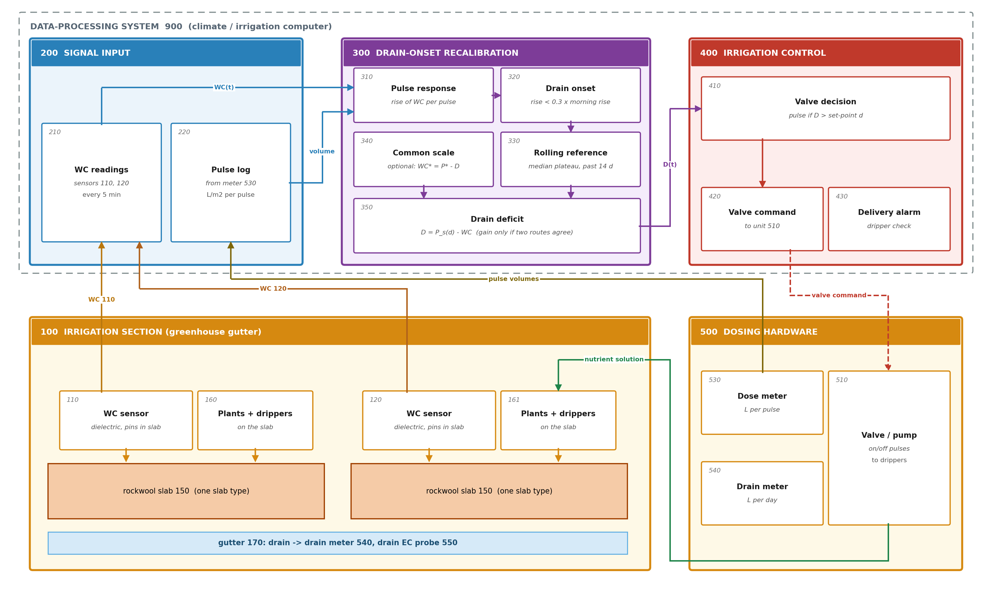
Figure 1. Irrigation section with slab water-content sensors, dosing hardware and the recalibrating controller. Sensors 110 and 120 in slabs 150 and dose meter 530 report to system 900; units 310-350 detect the drain onset and correct the reading; unit 410 sends the valve command to valve or pump 510.
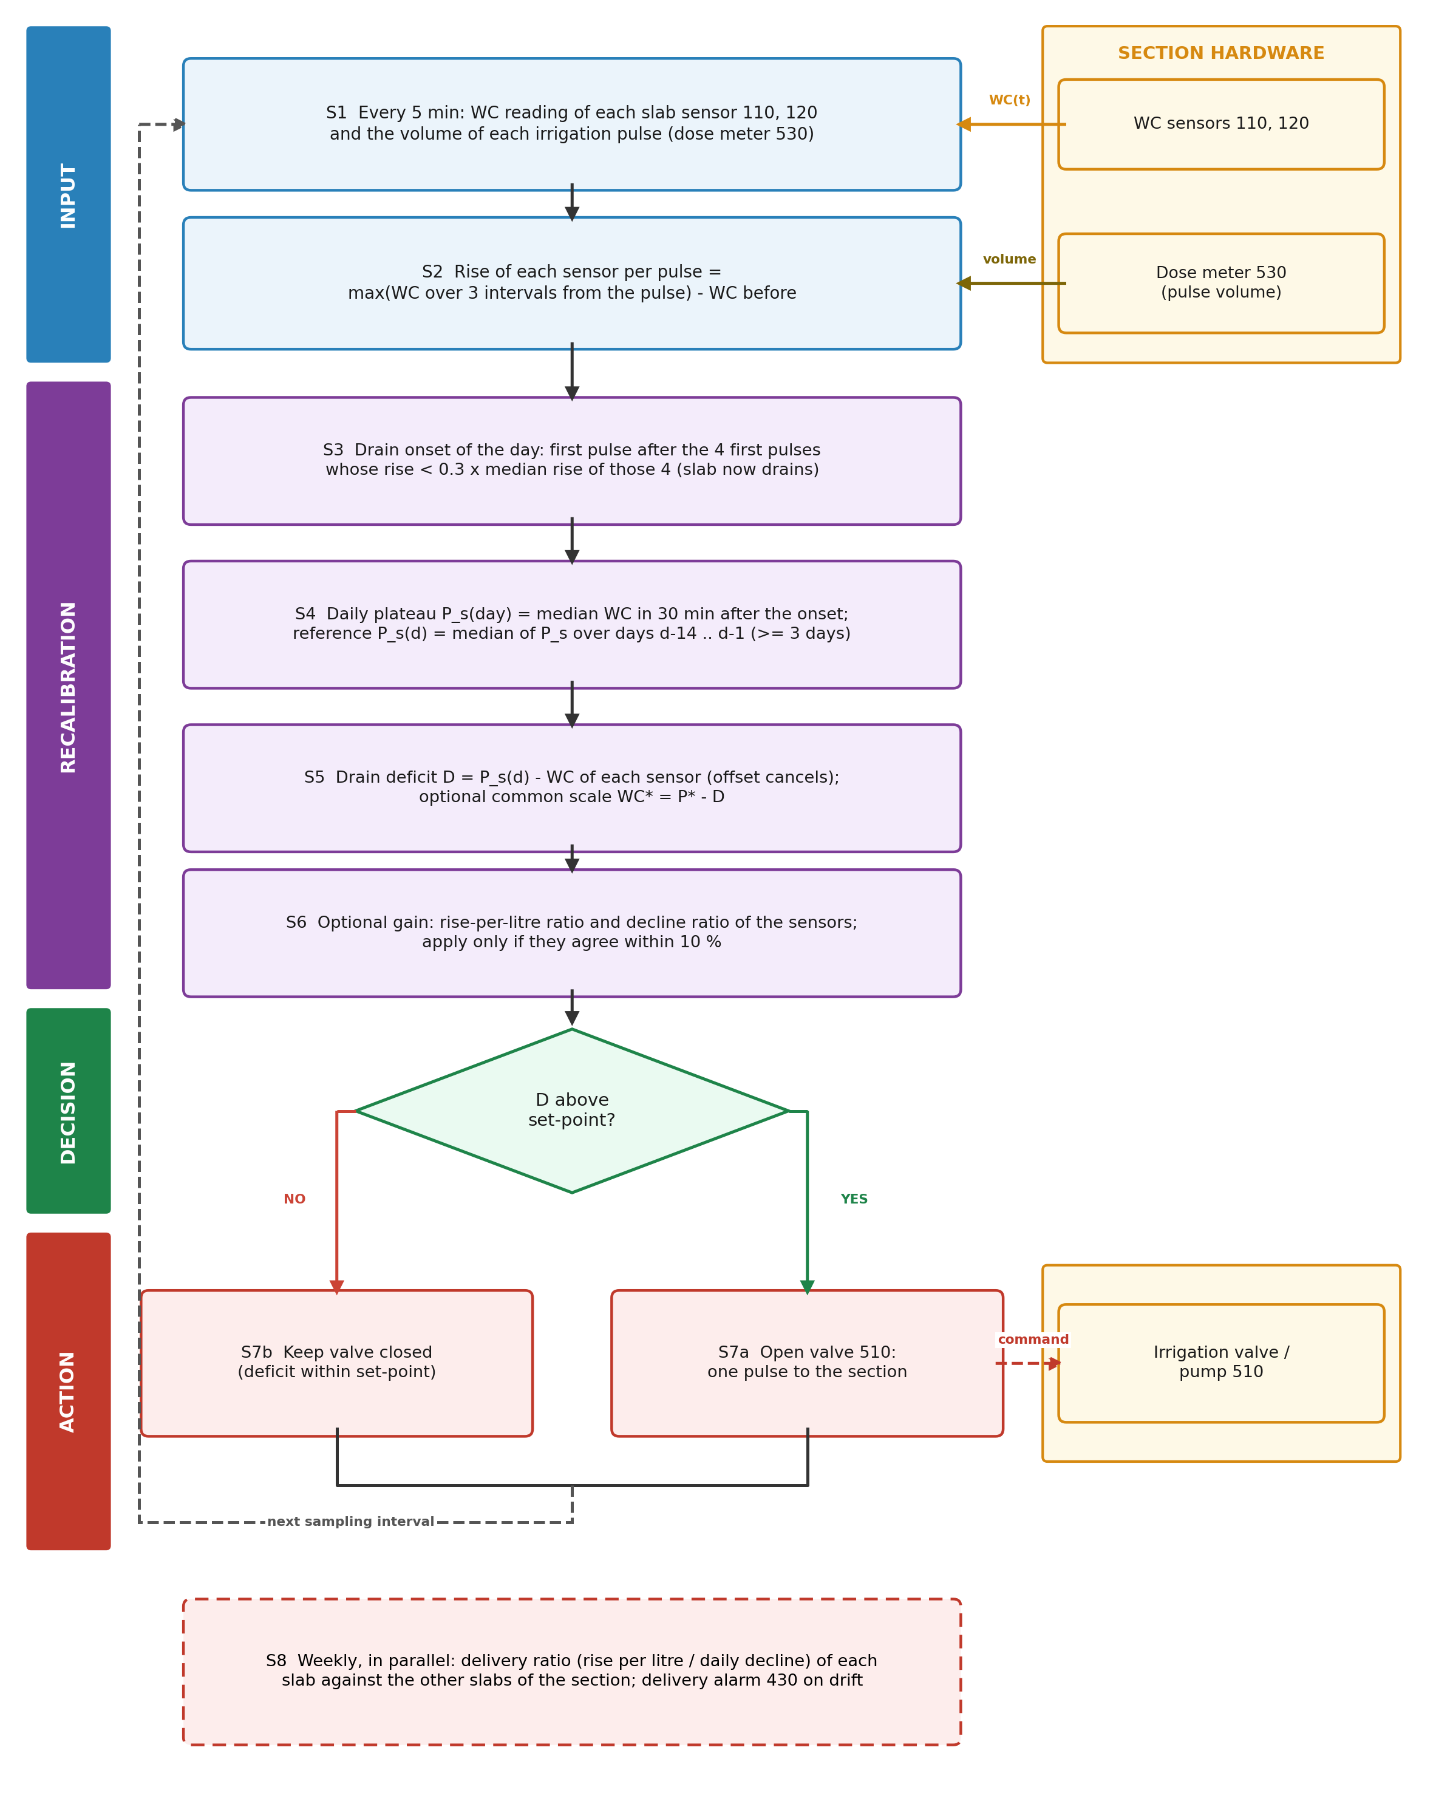
Figure 2. Flowchart of the method. S1-S6 detect the drain onset, update the rolling reference and correct the reading; the decision opens or holds valve 510 (S7a, S7b); S8 checks delivery weekly.

7. Description of the Invention in Detail

7.1 Irrigation Section Hardware
[0010] The slabs (150) are mineral-wool slabs of one product, in the example Grodan GT Master stone wool on elevated gutters [N1], each carrying plants in propagation blocks with one dripper per block. The irrigation valve or pump (510) is switched on and off by the irrigation computer and doses nutrient solution from a day tank; the dose meter (530) registers the litres per m2 of each pulse, in the example as valve minutes converted to litres (median pulse 0.3 L/m2). The gutter (170) collects the drain water and the drain meter (540) registers it per day.
[0011] Each WC sensor (110, 120) has metal pins inserted vertically through the slab about 10 cm from a block on the drain side; the sensor measures the dielectric permittivity and the bulk conductivity between the pins and converts them to WC, EC and temperature for the slab type set at installation, and transmits them wirelessly every few minutes to a receiver connected to the irrigation computer (900).

7.2 Signals
[0012] The system (900) receives every sampling interval the WC reading of each sensor and the cumulative irrigation volume of the day. The pulse volume is the step of the cumulative volume between intervals; when the counter falls, the day has been reset and the new value is the first pulse of the new day. Detecting the reset by the fall of the counter, rather than by the clock, matters: the counter of the example resets shortly after midnight, so that the midnight sample still holds the previous day's total. With this rule the pulse volumes add up to 1.00-1.01 times the daily irrigation meter in every compartment (correlation of daily totals >= 0.99).

7.3 Pulse Response and Drain Onset (310, 320)
[0013] The pulse-response unit (310) computes, for each pulse and each sensor, the rise of the reading: the largest reading over the 3 sampling intervals from the pulse less the reading in the interval before it. The window covers the wetting front reaching the pins. Rises of a filling slab in the example were 1 to 2 WC % per pulse (Figure 3(b)).
[0014] The drain-onset unit (320) takes, each day with at least six pulses, the median rise of the first 4 pulses; if it is at least 0.5 WC %, the drain onset is the first later pulse whose rise is below 0.3 of that median. Because the threshold is a fraction of the same sensor's morning rise on the same day, a sensor with a gain error finds the onset at the same pulse as a correct one; the detection does not depend on the sensor's scale or offset. Figure 3(a) shows one day of IUA.CAAS (2020-03-08): both sensors find their onset, and their plateaus differ by the sensors' offsets.
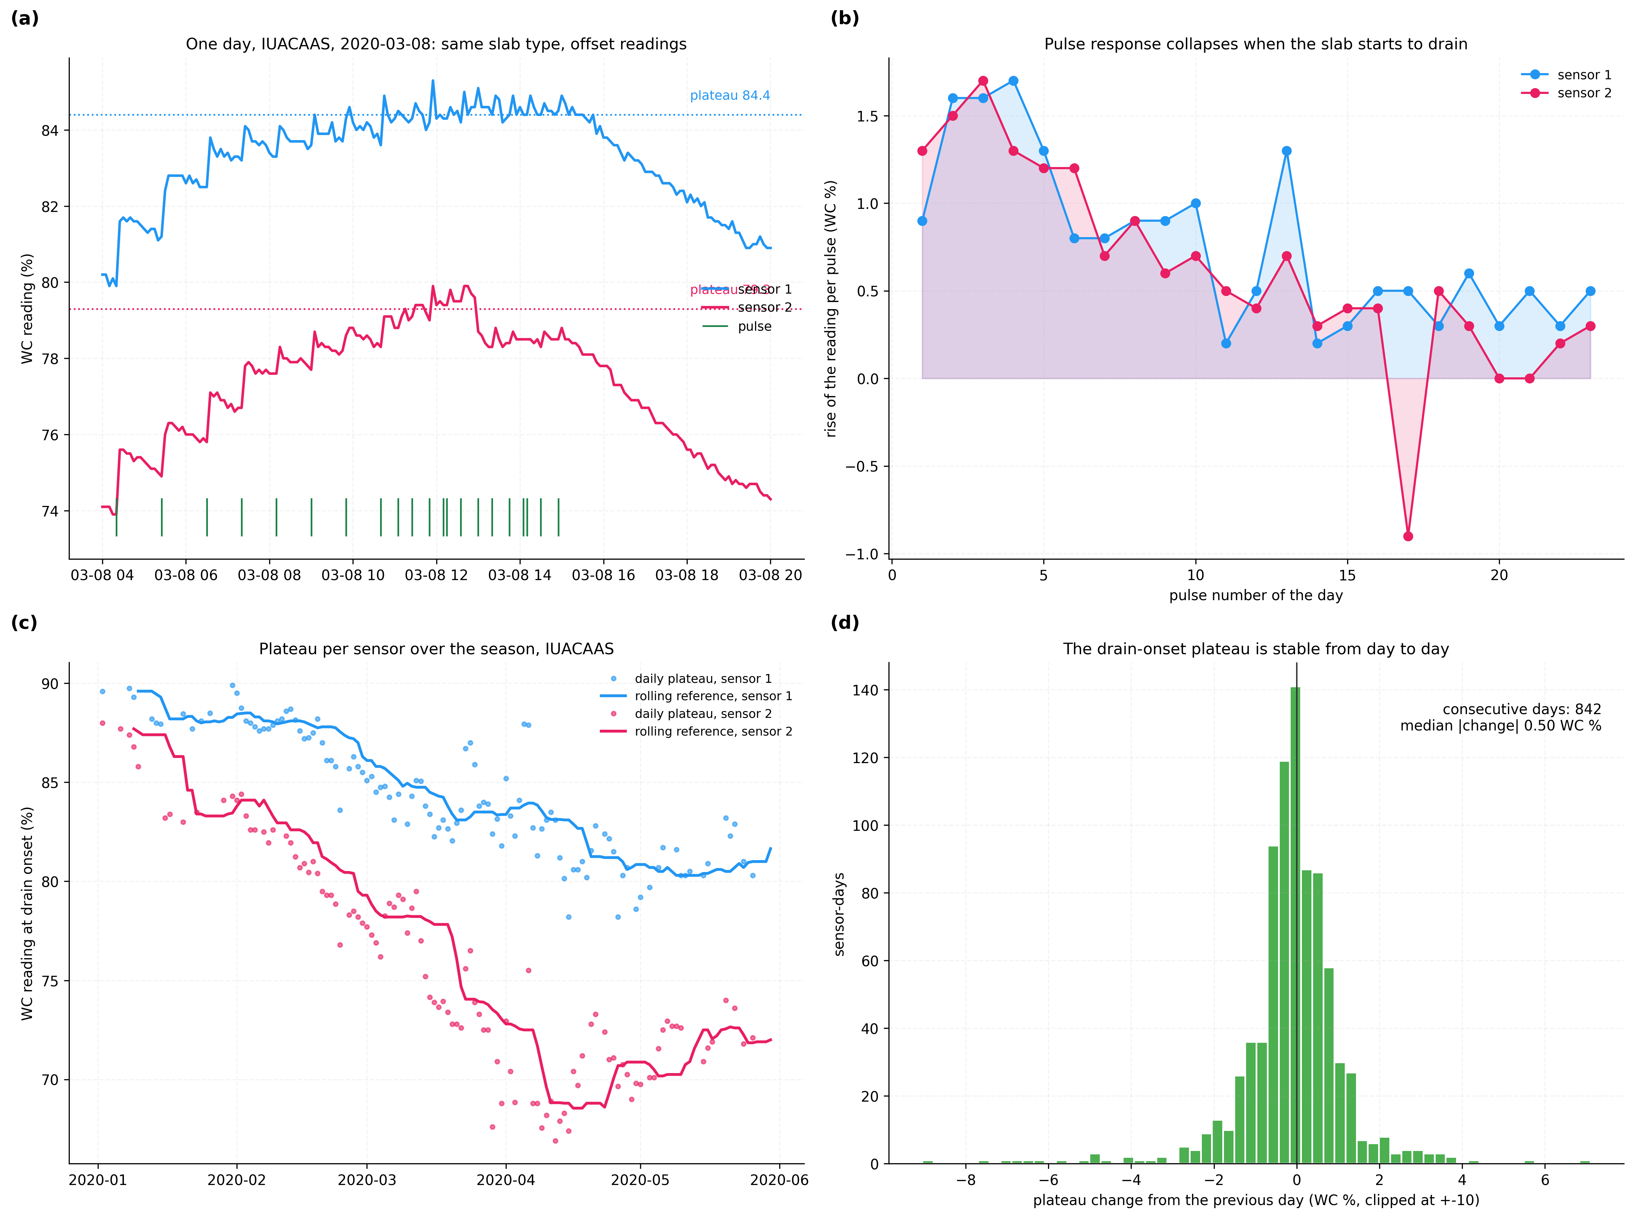
Figure 3. Pulse response, drain onset and plateau readings of slab sensors. (a) one day of readings of the two sensors of a compartment and the pulses; (b) rise per pulse; (c) daily plateau and rolling reference over the season; (d) day-to-day change of the plateau, 842 consecutive sensor-days.

7.4 Rolling Reference (330) and Common Constant (340)
[0015] The plateau of the day is the median reading over the 30 minutes after the onset. Across all twelve sensors the plateau changed by a median of 0.50 WC % from one day to the next (Figure 3(d)), so a few days suffice to fix it. The rolling-reference unit (330) takes the median of a sensor's plateaus over the 14 days before the current day when at least 3 exist, and otherwise keeps the last reference; a section irrigated with little drain, where onsets are rare, keeps its last reference until the next ones arrive.
[0016] The optional common-scale unit (340) holds one plateau value P* for the substrate type, used only to show the deficit as a water content. In the example it is the median of the first-half plateau readings of the 12 sensors, 80.88 WC %. Where the slab manufacturer states the water content of the drained slab, that value can be used instead; the valve decision on the deficit does not depend on the choice.
[0017] When a sensor is replaced, moved to another slab or re-inserted, its reference is cleared and rebuilt from the onsets that follow; until 3 have been found the sensor's reading is shown but not used for the valve decision of the section, which then uses the other sensors. A new slab type, or a slab replaced at the start of a crop, starts a new commissioning period for P*.
[0018] Example: in the IUA.CAAS compartment on 2020-03-08 the rolling references of the two sensors were 85.1 and 78.2 WC %. With P* = 80.88, a raw reading of 80.0 WC % becomes 75.8 WC % on the first sensor and 82.7 WC % on the second; a set-point of 75.88 WC % therefore calls for a pulse on the first slab and not on the second, although both raw readings are equal.

7.5 Corrected Reading and Gated Gain (350)
[0019] The correction unit (350) outputs the drain deficit D = P_s(d) - WC for every sensor at every interval. Optionally it also corrects the gain of one sensor relative to another. The rise route takes the summed rises over the summed volumes of pre-drain pulses of each sensor (WC % per L/m2), the decline route takes the mean daily fall of the reading outside pulses after a three-sample running median; both are computed weekly and their 28-day medians form the relative gain by each route. Where the two agree within 10 %, the deficit of the second sensor is divided by the gain; otherwise only the offset is corrected. In the first half of the season the routes agreed within 10 % in 4 of 6 compartments (Figure 5(a)).

7.6 Valve Control (410, 420)
[0020] The valve-decision unit (410) compares the drain deficit of the section, that of one sensor or the mean of its sensors, with a set-point d, the dry-back the grower allows during the day, and the valve-command unit (420) switches the valve or pump (510) through its output relay: a pulse when D > d, none otherwise. The first pulse of the morning, the pulse interval and the pulse volume remain set by the grower's strategy; the invention changes which reading the comparison uses.
[0021] The units 310 to 430 run in the irrigation computer (900) of the greenhouse, which already receives the sensor readings through the sensor receiver and switches the valve or pump (510) through a relay output; onset, plateau and reference are updated once a day, the correction and the comparison at every sampling interval. The state kept for each sensor is the list of plateau readings of the window, a few hundred bytes. In the example the whole computation took 2.2 ms for each sensor and day on one processor core.

7.7 Delivery Ratio and Alarm (430)
[0022] For each sensor the ratio of its weekly pre-drain rise per litre to its weekly mean daily fall is free of its gain and of the slab volume; between two slabs of a section it is the water delivered per unit of crop demand on one slab relative to the other. A clogged dripper or a slab with fewer plants moves it; the alarm unit (430) signals when it departs from 1 by more than a limit set for the section.
[0023] The limit is set from the week-to-week scatter of the ratio in the first weeks of the section; in the example the interquartile range of the weekly ratio was 0.94 to 1.07 in the growers' compartment and 0.95 to 1.06 in IUA.CAAS. With the rule 'alarm when the weekly ratio departs from the median of its previous four weeks by more than L in two consecutive weeks', L = 0.3 raised no alarm in 95 section-weeks without a recorded fault and L = 0.2 raised 3. On an alarm the grower checks the drippers of the two slabs with a measuring cup.
[0024] Where a section has three or more sensors, the corrected readings can also be compared with one another at each interval: after correction they differ by about the scatter of Section 8.3, and a sensor that departs from the others by much more, for example one pulled partly out of its slab, is reported for inspection.

7.8 Reference Numerals
Numeral | Element | Numeral | Element
100 | Irrigation section | 310 | Pulse-response unit
110, 120 | Water-content sensors | 320 | Drain-onset unit
150 | Substrate slabs | 330 | Rolling-reference unit
160, 161 | Plants and drippers | 340 | Common-scale unit (optional)
170 | Gutter | 350 | Correction (deficit) unit
200 | Signal input | 360 | Drain-probe check unit
210 | WC readings | 400 | Irrigation control
220 | Pulse log | 410 | Valve-decision unit
500 | Dosing hardware | 420 | Valve command
510 | Irrigation valve or pump | 430 | Delivery alarm
530 | Dose meter | 440 | Sensor check signal
540 | Drain meter | 550 | Drain EC probe
900 | Data-processing system
Table 5: Reference numerals

8. Experimental Validation Results

8.1 Data and Configuration
All inputs are the published records of the second Autonomous Greenhouse Challenge [N1, N6]: six greenhouse compartments of Wageningen University & Research growing cherry tomato on stone wool from 2019-12-16 to 2020-05-30, each with two GroSens slab sensors reporting every 5 minutes, the cumulative irrigation of the day and the daily irrigation and drain totals. 272965 sampling intervals carried both sensors' readings and 19799 pulses were dosed. Five compartments were operated by international teams, one by commercial growers; their irrigation strategies differed. The first half of the season (to the middle day) is used only to fix P* and, for the fixed-anchor comparison, the reference; all scores are on the second half. Table 6 lists the operating constants, read from the code that used them; they were set before the sensitivity runs of Section 8.4 and not changed for them.
Parameter | Value | Role
Sampling interval | 5 min | readings and pulse log
Rise window | 3 intervals | rise per pulse
First pulses / threshold | 4 / 0.3 of their median rise | drain onset
Plateau period | 30 min after onset | daily plateau
Rolling window | 14 days, >= 3 plateau days | reference plateau
Common constant P* | 80.88 WC % | corrected scale
Set-point in the replay | P* - 5 WC %, 06:00-18:00 | valve decision
Gain gate | routes within 10 %, 28-day ratios | gain correction
Table 6: Configuration parameters

8.2 Tests
Test | Question | Ground truth
V1 | Do the two sensors of one compartment, on the same slab type under the same pulses, read alike after correction, in the held-out half? | The physical identity of the two slabs' plateau
V2 | Do the results hold when the window and the onset threshold change, and day by day? | As V1
V3 | How often does a set-point rule decide the valve differently on raw and on corrected readings? | Corrected reading (V1)
V4 | Does a gain correction improve the paired dry-back, with and without the two-route gate? | As V1
V5 | Is the gain-free delivery ratio near 1 and stable, and does its alarm find a partly closed dripper line? | Equal slabs and drippers; closure injected into the measured ratio
V6 | How often is a drain onset found, and how long does the computation take? | Count, wall clock
V7 | Can the metered irrigation minus drain serve as a direct check of the sensor scale? | Daily irrigation and drain meters
V8 | At the moment drain reaches the drain EC probe, how far is each sensor's reading from its anchor (raw with P*, one-off commissioning, rolling)? | Drain EC probe 550, a separate instrument
V9 | Does the morning drain deficit predict the litres the slab takes before it drains? | Dose meter 530 and drain EC probe 550, no slab sensor
V10 | Do V8 and V9 separate the drain-onset anchor from a field-capacity anchor taken from the drainage fall after wetting (as P2)? | As V8 and V9
Table 7: Validation tests

8.3 Paired Sensors (V1)
For each compartment the median absolute difference between the readings of its two sensors over the second half is given raw, with each sensor's reference fixed from its first-half plateaus, and with the rolling reference (Table 8, Figure 4(a)). The rolling reference lowers the gap in every compartment whose sensors disagreed, and leaves the one compartment whose sensors already agreed unchanged. Figure 4(b) follows the daily gap of AICU, where the raw gap rose above 20 WC % while the corrected gap stayed mostly below 5 WC % once the first onsets had been found. Over the whole season after the first 14 days, the gap falls from 15.1 to 1.8 WC % in AICU and from 9.3 to 1.0 in IUA.CAAS.
Compartment | Raw | Fixed anchor | Rolling anchor | Raw p90 | Rolling p90 | Days rolling lower
Reference (growers) | 3.2 | 1.6 | 1.1 | 5.7 | 3.0 | 74 of 80
AICU | 15.2 | 3.6 | 1.8 | 21.4 | 4.4 | 77 of 77
Automatoes | 4.8 | 1.1 | 0.8 | 6.1 | 3.2 | 73 of 80
Digilog | 9.9 | 2.4 | 2.4 | 13.4 | 7.3 | 80 of 80
IUA.CAAS | 10.7 | 4.2 | 1.8 | 15.0 | 4.5 | 80 of 80
The Automators | 0.9 | 1.8 | 0.9 | 2.4 | 2.1 | 43 of 76
Median of compartments | 7.35 | 2.05 | 1.44 |  |  | 427 of 473
Table 8: Paired-sensor gap |WC1 - WC2| over the held-out half (WC %)
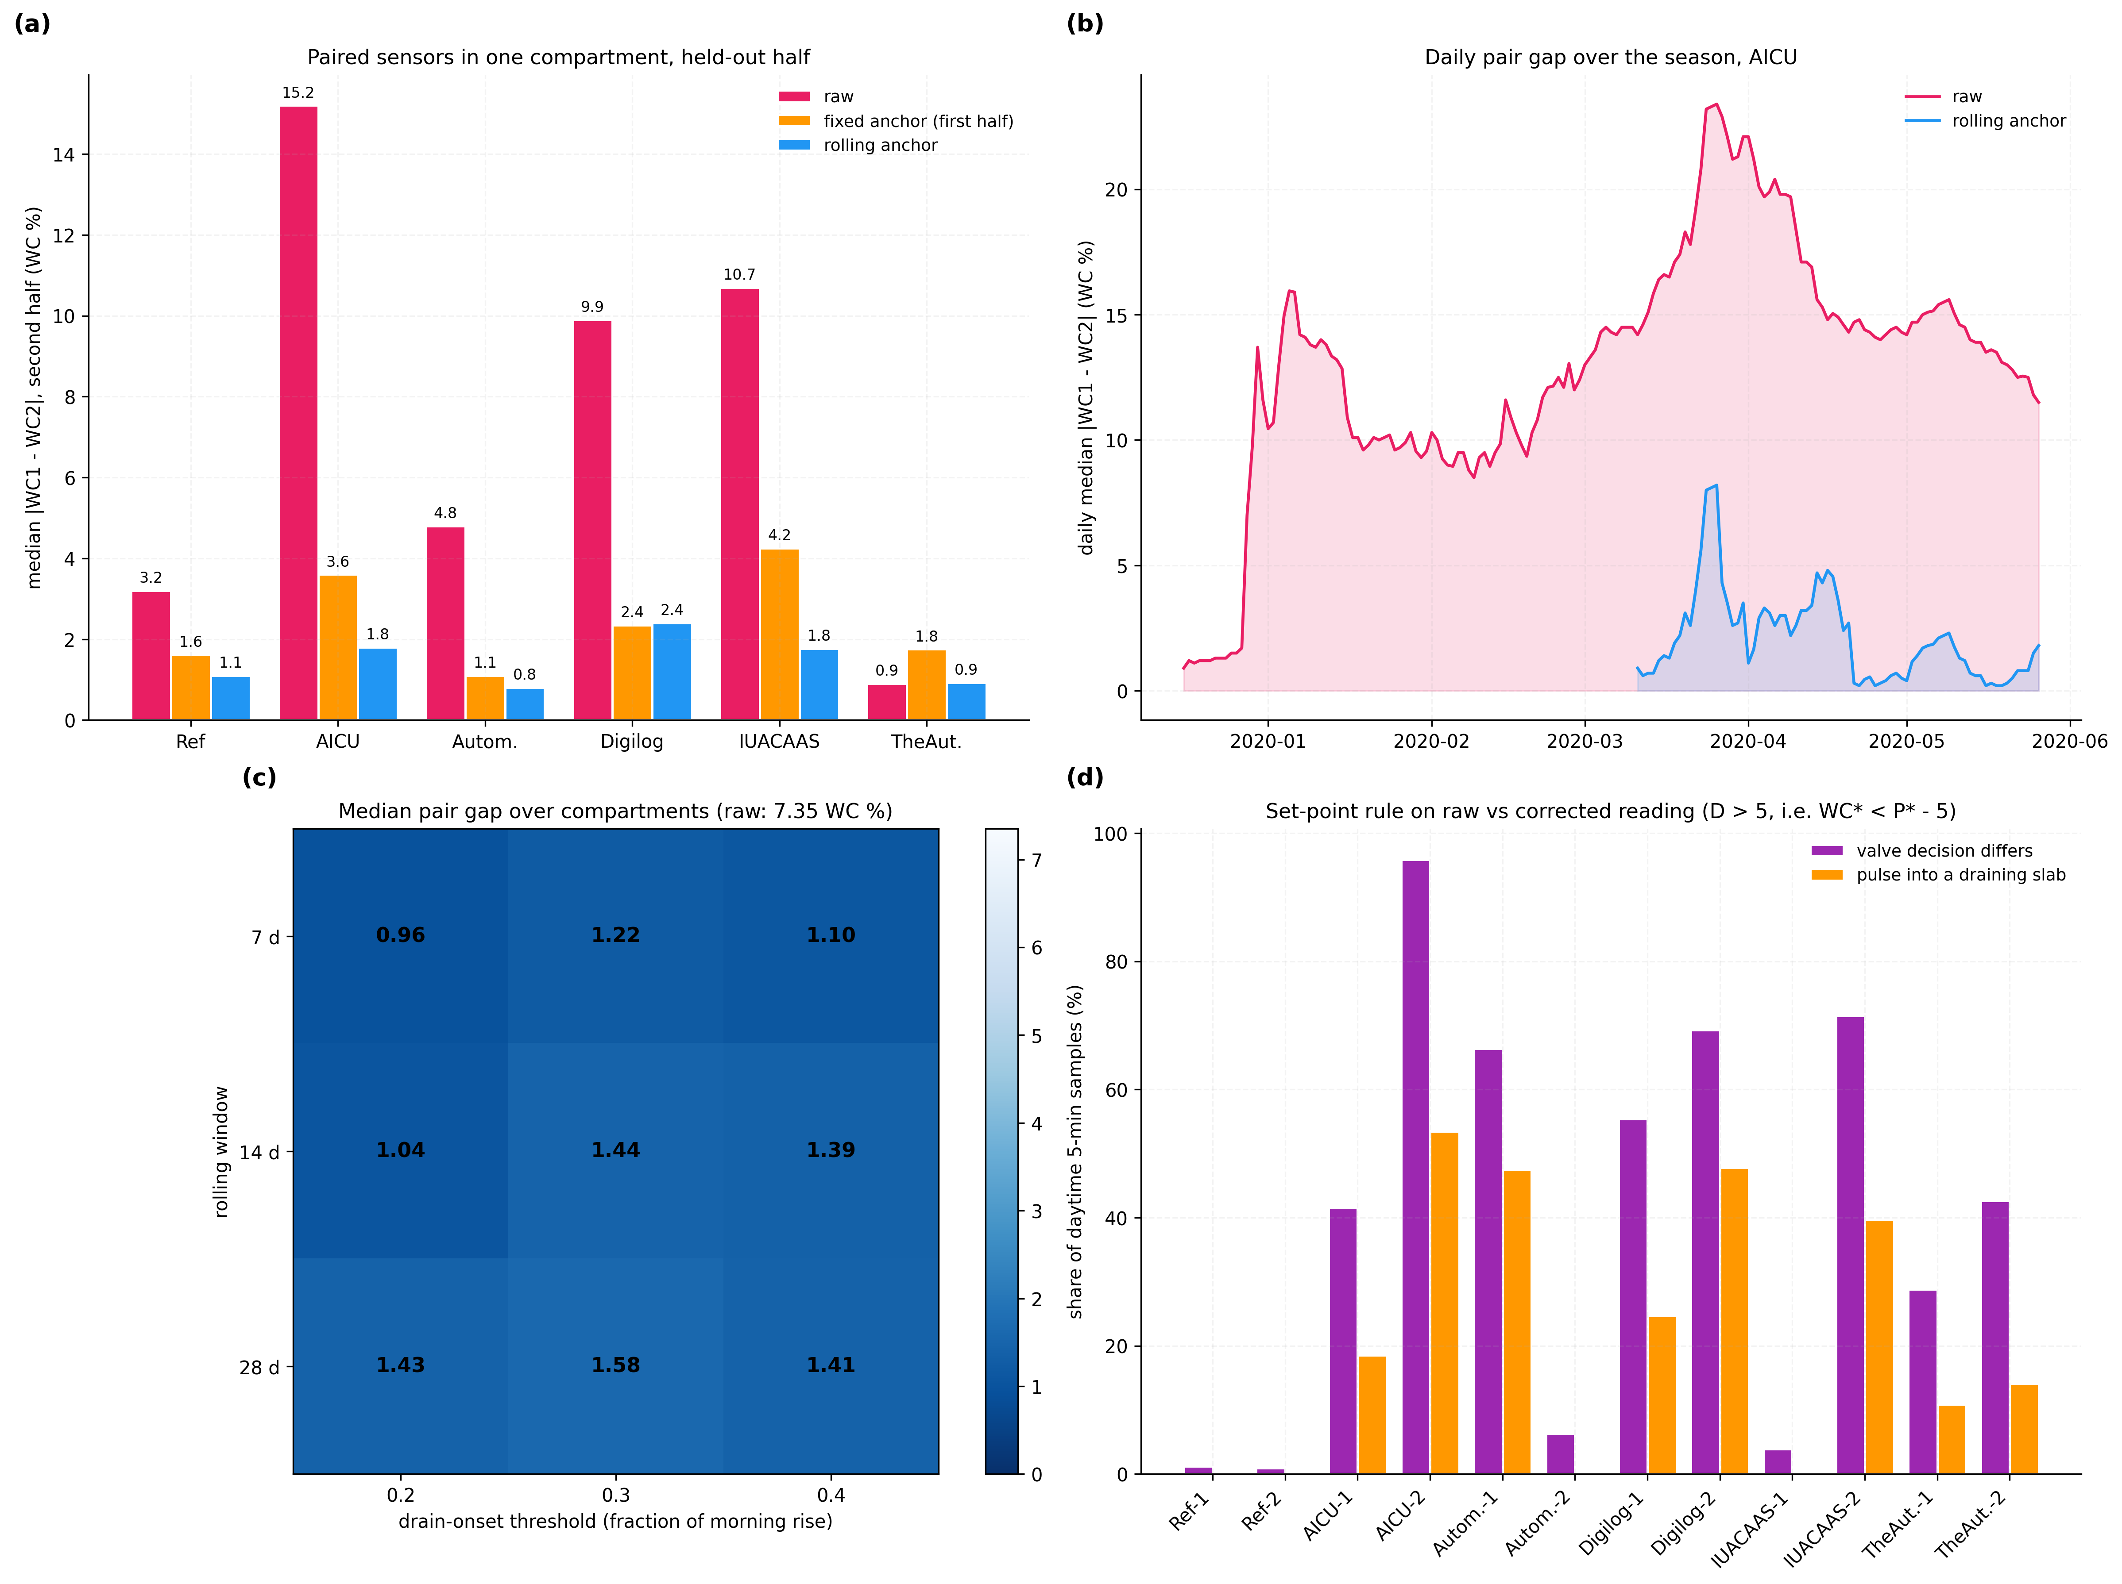
Figure 4. Paired-sensor agreement, sensitivity of the constants and valve decisions. (a) pair gap per compartment; (b) daily pair gap, AICU; (c) median gap for windows and thresholds; (d) share of daytime intervals with a different valve decision and with a pulse into a draining slab.

8.4 Constants and Daily Comparison (V2)
Over the nine combinations of window (7, 14, 28 days) and onset threshold (0.2, 0.3, 0.4) the median pair gap lies between 0.96 and 1.58 WC % against 7.35 raw (Figure 4(c)); the lowest value came at a threshold of 0.2 and a 7-day window, but the configured values were kept. Day by day, the corrected gap is the smaller on 427 of 473 compartment-days with a difference (sign test z = 17.52); in the compartment whose sensors already agreed, 43 of 76 (z = 1.15).
Against a one-off commissioning calibration, each sensor's anchor fixed from its first 14 days with an onset and kept for the season, the median paired gap over the held-out half is 2.46 WC % against 1.44 WC % for the rolling anchor; the rolling anchor is lower in 4 of the 6 compartments, level in Automatoes (0.8 and 0.8) and higher in Digilog (2.4 against 1.2), whose second sensor gave erratic plateaus (Section 8.11). Where the two corrections differ, they lead to different valve decisions on a median 49 % of daytime intervals.

8.5 Valve Decisions (V3)
A set-point rule, pulse when the reading is below S = P* - 5 = 75.88 WC %, was replayed on every daytime interval of the second half, once on the raw reading of each sensor and once on its corrected reading (Figure 4(d)). 8 of the 12 sensors give a different decision on more than 20 % of the intervals; the median share is 42 %. The worst sensor, AICU sensor 2, reads 18.4 WC % below its corrected value on average and decides differently on 96 % of the intervals; on 54 % it calls for a pulse while its slab, by the corrected reading, is at drainage plateau. The reference reading here is the corrected one; the test shows the size of the decision change, not an error measured against slab weight.

8.6 Gain, Dry-Back and Delivery (V4, V5)
In the first half the relative gain of the two sensors by the rise route and by the decline route was 1.22 / 1.22 (growers' compartment), 1.38 / 1.40 (Automatoes), 0.95 / 0.93 (IUA.CAAS) and 0.74 / 0.77 (The Automators), and disagreed in AICU (1.27 / 1.82) and Digilog (1.43 / 1.27) (Figure 5(a)). Over the second half the median relative gap of the paired overnight dry-back is 12.9 % raw, 15.0 % with the gain always applied and 11.9 % with the gain applied only where the two 28-day routes agree (Figure 5(b)); the gate is what keeps the gain from doing harm. The gain-free delivery ratio between the two slabs had a median of 1.01, 1.00 and 1.00 in three compartments, and 0.90, 0.93 and 1.22 in the others (Figure 5(c)); Digilog moved from 0.93 in its first four weeks to 1.20 in its last four. With an alarm limit of 0.3 (Section 7.7) no alarm was raised in 95 section-weeks.
No dripper fault occurred in the data, so a partial closure was injected into the measured weekly ratios. A dripper line passing a fraction k of its former flow multiplies the delivered share f of its slab by k, and with it the ratio, while leaving the gain and the uptake of the plants unchanged to first order. The closure was started in every week with four clean weeks before it and three after, in all six compartments and on either slab (154 cases for each k). With L = 0.3 the alarm was raised within two to four weeks of fault for 64 % of closures of 30 %, 90 % of closures of 40 % and 98 % of closures of 50 % (median 2 weeks), and in none of the same 77 windows without a closure. Closures of 10 % stay inside the week-to-week scatter (4 % found). With L = 0.2 a closure of 30 % is found in 86 % of cases but also raises an alarm in 9 % of windows without a fault.
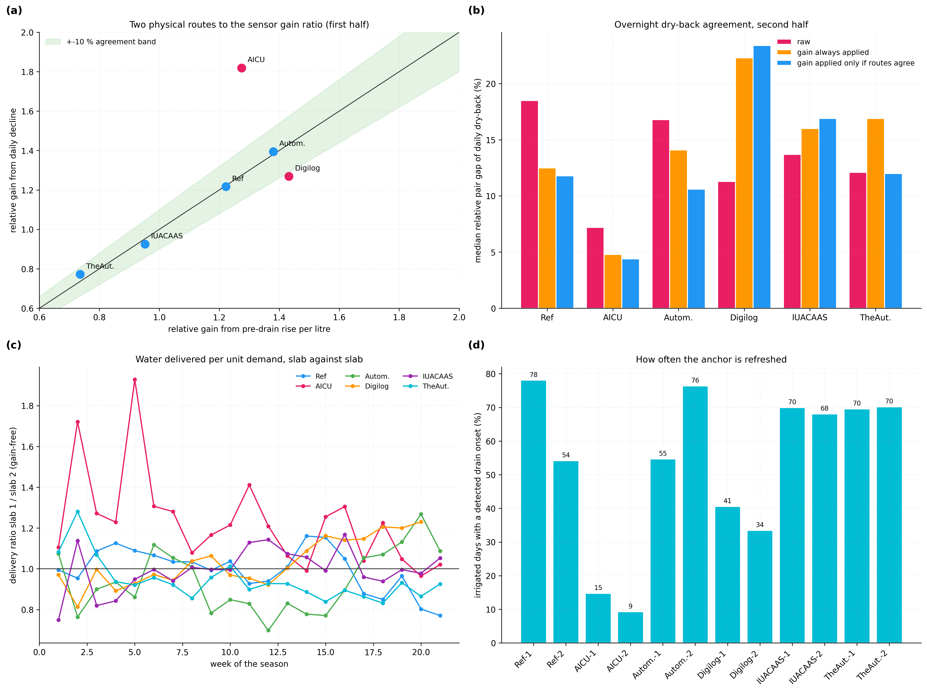
Figure 5. Gain routes, dry-back agreement, delivery ratio and drain-onset coverage. (a) relative gain by the two routes, first half; (b) paired dry-back gap; (c) weekly delivery ratio; (d) share of irrigated days with a detected drain onset for each sensor.

8.7 Coverage, Processing Time and Meter Balance (V6, V7)
A drain onset was found on 9 to 78 % of irrigated days, depending on the sensor (Figure 5(d)); the lowest values belong to AICU, whose strategy rarely drained the slabs, and the carried reference still reduced its gap (Table 8). The full computation, onset detection, reference and correction, took 2.2 ms for each sensor and day on one processor core. A direct check of the sensor scale against the metered daily irrigation minus drain was attempted and is not used as evidence: the daily drain meter registers in batches, and the correlation between the metered daily balance and the sensor's daily fall ranged from -0.32 to 0.75 across the sensors.

8.8 Check Against the Drain EC Probe and the Dose Meter (V8 to V10)
V1 to V4 compare sensors with one another. V8 compares them with an instrument that is not a slab sensor: the drain EC probe of each compartment, logged every 5 minutes by the process computer. A pulse counts as drained when the probe reading steps by at least 0.15 dS/m within 15 minutes. The label behaves as drain: it fired after 11 to 50 % of pulses, after at most 6.3 % of pulses on days whose drain meter read zero, and in at most 1.3 % of quiet intervals without pulses. Over the held-out half, 737 sensor-days had a drained pulse after the first pulse of the day. For each, the sensor's reading over 30 minutes from that pulse was compared with three anchors: the common constant P* applied to the raw reading, a one-off commissioning anchor (the sensor's first 14 onset days), and the rolling anchor from the 14 days before (Table 9, which also carries the anchor of V10). None of these anchors used the probe.
Sensor | Raw - P* | Raw - one-off anchor (as P1) | Raw - drainage-fall anchor (as P2) | Raw - rolling drain-onset anchor
Reference (growers), sensor 1 | +5.5 | +0.8 | +1.4 | +0.9
Reference (growers), sensor 2 | +2.3 | -3.0 | +3.4 | +0.4
AICU, sensor 1 | -3.7 | -9.4 | -0.6 | -0.9
AICU, sensor 2 | -19.5 | -2.1 | -0.4 | -0.5
Automatoes, sensor 1 | -6.2 | +1.2 | +1.4 | +0.3
Automatoes, sensor 2 | -1.6 | +1.2 | +0.3 | +0.2
Digilog, sensor 1 | -5.6 | -8.9 | +3.3 | +2.2
Digilog, sensor 2 | -15.7 | -10.1 | +2.8 | +0.4
IUA.CAAS, sensor 1 | +1.2 | -6.4 | -0.1 | -0.9
IUA.CAAS, sensor 2 | -10.5 | -13.8 | +1.2 | -1.3
The Automators, sensor 1 | -4.1 | -5.1 | +4.0 | -0.1
The Automators, sensor 2 | -4.8 | -5.5 | +2.6 | +0.3
Median |difference|, all sensor-days | 4.88 | 4.77 | 1.75 | 1.10
Sensors with median within 1 WC % | 0 of 12 | 1 of 12 | 4 of 12 | 10 of 12
Table 9: Reading at the first drained pulse of the day (drain EC probe) less each anchor, held-out half, median of each sensor (WC %)
With the rolling anchor the reading at physical drain is within 1 WC % of the anchor for 10 of the 12 sensors; with one common constant on the raw reading for 0, and with the one-off commissioning anchor for 1, because the plateau readings drifted over the season. This checks the corrected scale at the point that matters for irrigation, the drain, against an instrument independent of the slab sensors. The drain-onset rule itself found the onset later in the day than the probe (the median of each sensor 0 to 275 minutes later), as the rise falls off gradually; the readings at the two moments differed by a median 0.30 WC %, since the slab is on its plateau at both.
V9 checks the deficit in litres. Each morning the slab is refilled by pulses until it drains; the water dosed from the first pulse of the day up to the first pulse after which the drain EC probe registers fresh drain is what the slab took up to drainage, its overnight dry-back plus the crop's uptake during the refill. It comes from the dose meter and the drain EC probe alone, without any slab sensor and without the daily drain meter. Over 749 sensor-days of the held-out half it was a median 1.40 L/m2 (interquartile range 1.10 to 2.20). If the drain deficit before the first pulse measures the water missing from the slab, one scale must link it to those litres on every slab. Pooled over all sensors, the Spearman correlation between deficit and litres is 0.49 with the rolling anchor, 0.26 with the one-off commissioning anchor and 0.21 with the common constant P* on the raw reading; resampling the 80 days, the rise in correlation from the raw reading to the rolling anchor lies between 0.21 and 0.36 (95 % interval) and from the commissioning anchor between 0.15 and 0.31. Within one sensor, where the offset plays no part, the correlation is weaker (median 0.32, range 0.05 to 0.63), as pulse size and uptake vary from day to day. Litres per WC % of deficit, taken for each sensor, give a third route to the relative gain of a pair: it lies within 15 % of the rise route in 4 of 6 compartments and on the same side of 1 in 5.
V10 applies both checks to an anchor of the kind P2 describes: for each sensor and day, the reading at which the fast fall after the last pulse of the day gives way to the slower fall of uptake (fall over 30 minutes below 0.3 of its peak, peak of at least 0.5 WC % per 30 minutes), renewed as the median of the past 14 days exactly as the drain-onset anchor. At physical drain it lay a median 1.75 WC % from the reading, with 4 of 12 sensors within 1 WC % (Table 9), against 1.10 WC % and 10 of 12 for the drain-onset anchor; its morning deficit ranked the litres dosed until drain with a Spearman correlation of 0.43 against 0.49 (95 % interval of the difference 0.03 to 0.10 over the days). Both anchors remove most of the offset between the two sensors of a compartment (median paired gap 1.33 and 1.44 WC %); they differ in what the anchor means, and only the drain onset of the refill places it at the drainage of the slab.

8.9 Technical Effect Summary
Effect | Mechanism | Evidence
Corrected reading meets the physical drain | Deficit to the slab's own drain onset, rolling anchor | Table 9: 1.10 WC % rolling vs 4.77 commissioning vs 4.88 raw; 10 of 12 sensors within 1 WC %
Anchor placed at the slab's drainage, unlike a drainage-fall anchor (P2) | Collapse of the refill response instead of the fall after wetting | Table 9: 1.10 vs 1.75 WC %; 10 vs 4 sensors within 1 WC %
Deficit follows the metered water to drain | Deficit to the slab's own drain onset, rolling anchor | Section 8.8 (V9): Spearman 0.49 rolling vs 0.26 commissioning vs 0.21 raw with P*
Sensors of one substrate type read alike | Drain-onset plateau, rolling reference | Table 8: median gap 7.35 -> 1.44 WC %; 427 of 473 days lower (z = 17.52)
Reference follows drift | Past-days median instead of one-off calibration | Table 8: fixed 2.05 vs rolling 1.44 WC %; Section 8.4: commissioning anchor 2.46 WC %
Valve acts on the distance from drainage | Set-point on the drain deficit | Section 8.5: 8 of 12 sensors > 20 % decisions changed; median 16 % pulses into draining slabs
Constants not critical | Onset as a fraction of the same day's rise | Figure 4(c): 0.96-1.58 WC %
Gain correction without harm | Two-route agreement gate | Section 8.6: dry-back gap 12.9 % raw, 11.9 % gated, 15.0 % ungated
Partly closed dripper line found without a gain | Delivery ratio, alarm limit L = 0.3 | Section 8.6: 90 % of injected 40 % closures within 2-4 weeks; 0 of 77 fault-free windows
Table 10: Technical effects, mechanism and evidence

8.10 Insights
Offsets dominate the disagreement between slab sensors: the offset correction alone removes most of it, and the drain onset fixes the offset because it is a property of the slab, not of the sensor.
The offset drifts over a season (Figure 3(c)); a reference fixed from the first half leaves 2.05 WC % against 1.44 WC % for a reference renewed every day.
Gain errors exist and two independent routes find the same value where both are clean, but a gain applied from one route alone degrades the dry-back.

8.11 Limitations and Acceptance Criteria
The drain EC probe checks the corrected scale at the drain point (Section 8.8, V8); over the dry-back the deficit is checked only against the litres dosed until drain (V9), which include the crop's uptake during the refill and correlate with it moderately within one sensor. No slab-weight measurement was available. Acceptance: on a section with a gutter-weighing scale, the deficit times the slab volume must match the weighed water loss within the gain gate.
The plateau readings of both sensors of a compartment fell over the season (Figure 3(c)); whether the drained slab truly held less water as roots filled it, or both sensors drifted, cannot be separated without slab weights. The valve decision on the deficit does not depend on it, since in both cases the slab drains at its current plateau; only the common-scale display (claim 2) does.
The pre-pulse reading alone separates drained from undrained pulses weakly for every anchor (area under the curve 0.53 raw, 0.54 rolling): whether a pulse drains also depends on its volume and on the delay of the gutter. The check of Section 8.8 therefore uses the first drained pulse of the day.
The method needs days on which the slab drains; in a section kept below drainage for weeks the reference is carried unchanged (AICU found onsets on 9 % of days for one sensor).
One sensor (Digilog, sensor 2) showed plateaus that jumped from day to day (standard deviation of the daily change 13.5 WC %); its correction was the weakest. Acceptance: a sensor whose plateau varies by more than a set limit is flagged for inspection rather than corrected.
No dripper fault was recorded in the data; the detection rates of Section 8.6 come from closures injected into the measured ratio at first order, which leaves out the further drying of the under-watered slab. Acceptance: a dripper line of a monitored slab physically closed by 40 % for three weeks must raise the alarm.
Evaluated on six compartments of one facility and one stone wool product; coir and other mineral wool products need their own constants, and their own P* where the common scale is used.

9. Discussion
The invention gives every slab sensor a reference that the slab itself provides each day. The moment a slab starts to drain shows in the sensor's own response to the pulses that the crop receives anyway. Anchoring each sensor there, refreshing the anchor from past days, and steering the valve on the deficit to that anchor turns readings that differ by up to 15.2 WC % into deficits that differ by about 1 to 2 WC %, and a separate instrument, the drain EC probe, finds the reading at physical drain within 1.10 WC % of the anchor (median); the morning deficit ranks the litres the slab takes before it drains better than either fixed anchor. The results also mark the boundary: the size of a deficit in litres rests on the gain until slab weights confirm it, and a gain correction is applied only where two physical routes agree.

10. What Aspect(s) of the Invention Need(s) Protection?
Detecting the drain onset of a substrate slab from the collapse of the rise of its sensor reading per routine irrigation pulse, relative to the same day's first pulses.
A reference plateau reading for each sensor renewed from its past days' drain-onset readings only.
Opening or holding the irrigation valve on the deficit of each reading to its own slab's drain onset, free of the sensor's offset and of any assumption that slabs drain at one water content.
Checking each sensor against the drain EC probe of the gutter at the first drained pulse of the day.
A relative gain correction applied only when the rise-per-litre route and the daily-decline route agree.
A gain-free delivery ratio between slabs with an alarm on drift.
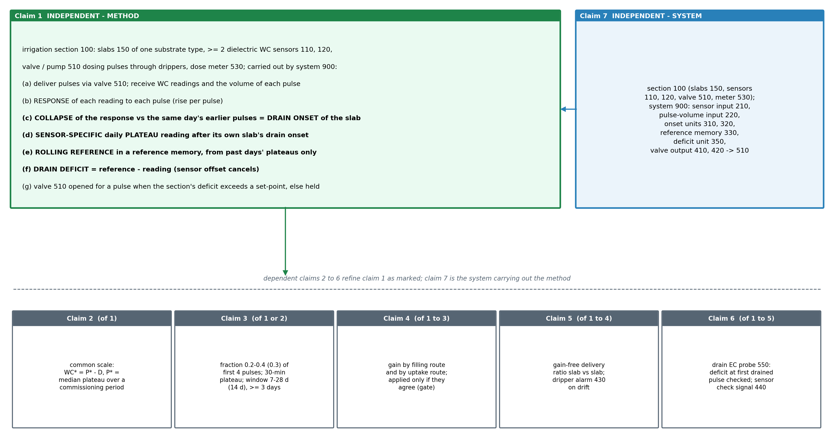
Figure 6. Claim tree. Independent method claim 1, its dependents 2 to 6, and system claim 7 carrying out the method.

Claims
Claim 1 (independent). A method of controlling the irrigation of plants grown in an irrigation section (100) of a greenhouse comprising plant-growth substrate slabs (150) of one substrate type, an irrigation valve or pump (510) that delivers nutrient solution to the slabs through drippers in pulses, a dose meter (530) that registers the volume of each pulse, and at least two dielectric water-content sensors (110, 120), each inserted in a different slab of the section and reporting a water-content reading, the method being carried out by a data-processing system (900) connected to the sensors and to the valve or pump, and comprising: (a) delivering irrigation pulses to the slabs through the valve or pump during the day, and receiving the reading of each sensor at successive sampling intervals and the volume of each pulse from the dose meter; (b) determining, for each sensor, the response of its reading to each pulse, being the rise of the reading caused by that pulse; (c) detecting, for each sensor and each day, a collapse of that response, being the first pulse of the day whose rise has fallen below a fraction of the rise caused by earlier pulses of the same day, and taking that pulse as the drain onset of the slab of that sensor, at which the slab has reached its drainage plateau and further water passes to drain, the collapse being judged relative to the same sensor's own earlier rises so that it does not depend on the scale or the offset of the sensor; (d) recording, for each sensor and each day with a drain onset, a sensor-specific daily plateau reading, being the reading of that sensor following the drain onset of its own slab; (e) storing the daily plateau readings of each sensor in a reference memory and computing, for each sensor and each day, a rolling reference plateau reading from the daily plateau readings of that sensor on preceding days only; (f) computing at each sampling interval a drain deficit of each sensor as its rolling reference plateau reading less its current reading, whereby the offset of the sensor cancels and the deficit measures how far the slab of that sensor is from its own drainage plateau, without assuming that different slabs drain at the same water content; and (g) opening the valve or starting the pump (510) to deliver a further pulse to the section when a drain deficit of the section, being the drain deficit of one of its sensors or a combination of the drain deficits of its sensors, exceeds a set-point, and otherwise keeping the valve closed or the pump stopped.
Claim 2. The method of claim 1, further comprising computing a corrected reading of each sensor as a plateau constant common to all sensors in slabs of that substrate type less its drain deficit, the plateau constant being the median of the daily plateau readings of the sensors of one or more irrigation sections with slabs of that substrate type over a commissioning period, and the set-point of step (g) being expressed as that constant less the set-point.
Claim 3. The method of claim 1 or claim 2, wherein the earlier pulses of step (c) are a number of first pulses of the day and the fraction lies between 0.2 and 0.4 of their median rise, preferably 4 pulses and 0.3; the daily plateau reading is the reading over a period following the drain onset, preferably 30 minutes; the rolling reference plateau reading is the median of the daily plateau readings in a window of 7 to 28 days before the current day, preferably 14 days, renewed only when the window holds at least 3 daily plateau readings, the previous reference being kept otherwise; and the rise is the largest reading in the 3 sampling intervals beginning with the pulse less the reading in the interval before the pulse.
Claim 4. The method of any one of claims 1 to 3, further comprising estimating a relative gain of a second sensor with respect to a first sensor of the section by two physically independent routes, (i) a filling route, as the ratio of their summed rises per summed pulse volume over pulses delivered before the drain onset, and (ii) an uptake route, as the ratio of their mean daily falls of reading between pulses; comparing the two estimates; and dividing the drain deficit of the second sensor by the relative gain before step (g) only when the two estimates agree within a predetermined tolerance, the drain deficit being left uncorrected for gain otherwise, whereby a gain estimate distorted on one route, by uneven dripper delivery on the filling route or by uneven crop uptake on the uptake route, is not applied to the valve decision; the daily dry-back of each slab, being its largest drain deficit before the first pulse of the next day, being computed from the deficits so corrected.
Claim 5. The method of any one of claims 1 to 4, further comprising computing for each sensor a delivery ratio, being its summed rises per summed pulse volume before the drain onset divided by its mean daily fall of reading, both over the same week; computing the ratio of the delivery ratios of two sensors of the section; and issuing a delivery alarm signal (430) when that ratio departs from one by more than a predetermined limit.
Claim 6. The method of any one of claims 1 to 5, wherein the gutter (170) of the section carries a drain conductivity probe (550), the method further comprising: receiving the reading of the probe at the sampling intervals; marking a pulse as drained when the probe reading changes by at least a predetermined step within a predetermined time after the pulse; recording, for each sensor and each day, its drain deficit at the first drained pulse of that day after the day's first pulse; and issuing a sensor check signal (440) for a sensor when the median of the deficits so recorded over the window departs from zero by more than a predetermined limit.
Claim 7 (independent). A system for controlling the irrigation of plants, comprising an irrigation section (100) of a greenhouse comprising plant-growth substrate slabs (150) of one substrate type, an irrigation valve or pump (510) that delivers nutrient solution to the slabs through drippers in pulses, a dose meter (530) that registers the volume of each pulse, and at least two dielectric water-content sensors (110, 120), each inserted in a different slab of the section and reporting a water-content reading; and a data-processing system (900) comprising: (i) a sensor input (210) connected to each water-content sensor and receiving its reading at successive sampling intervals; (ii) a pulse-volume input (220) connected to the dose meter (530) and receiving the volume of each pulse delivered by the valve or pump; (iii) a pulse-response unit (310) connected to both inputs that computes, for each sensor, the rise of its reading caused by each pulse; (iv) a drain-onset unit (320) that detects, for each sensor and each day, the pulse at which the rise collapses relative to the earlier rises of the same sensor on that day, and records the sensor's reading following that pulse as its daily plateau reading; (v) a reference memory (330) that holds, for each sensor, its daily plateau readings of the preceding days and supplies a rolling reference plateau reading computed from them only; (vi) a deficit unit (350) that computes at each sampling interval the drain deficit of each sensor as its rolling reference plateau reading less its current reading; and (vii) a valve-control output (410, 420) connected to the valve or pump (510) that opens the valve or starts the pump to deliver a pulse when a drain deficit of the section exceeds a set-point, and keeps it closed or stopped otherwise; the data-processing system being configured to carry out the method of any one of claims 1 to 6.

11. Technology Readiness Level of the Invention
The method runs end to end on the recorded sensor readings and pulse logs of six operating greenhouse compartments; it has not yet been connected to an irrigation valve in a greenhouse.
Research |  |  | Development |  |  | Deployment
TRL 1 | TRL 2 | TRL 3 | TRL 4 | TRL 5 | TRL 6 | TRL 7 | TRL 8 | TRL 9
Basic principles observed | Technology concept formulated | Experimental proof of concept | Technology validated in lab | Validated in relevant environment | Demonstrated in relevant environment | Prototype in operational environment | System complete and qualified | Proven in operational environment
✓ | ✓ | ✓ | ✓
Current TRL: Level 4 — Technology Validated in Laboratory.
END OF THE DOCUMENT

