 Invention Disclosure Format (IDF)-B | Document No.
 | Issue No/Date
 | Amd. No/Date

1. Title of the Invention
System and Method for Correcting the Ammonium Reading of an In-Situ River Water-Quality Sonde from the Floor of Its Own Record, Anchored at Laboratory Samples.

2. Field / Area of Invention
The present invention relates to in-situ water-quality sondes that measure ammonium in rivers with an ion-selective electrode (ISE) and report it continuously to a monitoring centre. More particularly, it pertains to a system and method that determine, at every reading, the calibration offset that the ammonium electrode of the sonde carries, from the lower envelope (floor) of the sonde's own recent record anchored to the laboratory results of grab samples taken at the sonde, and that correct the ammonium record and the offset applied by the sonde controller.
An ammonium ISE converts a membrane potential to a concentration through a calibration line whose offset is set when the sonde is calibrated and then moves: the reference junction ages, the membrane conditions and fouls, and each service or swap of the sonde sets a new offset. Between services the offset is checked against grab samples analysed in a laboratory, and the difference is applied as a correction value to later readings (US 8,691,074 B2 [P1]), or distributed between samples after the fact (Pedersen et al. [N1]). At 67 sondes of the Environment Agency of England that carried an ammonium electrode next to a laboratory sampling point, the raw reading differed from the laboratory result by a median of 0.579 mg/L N (90th percentile 4.22 mg/L), and after the best of the current corrections chosen per sonde from its own earlier samples the median error was still 0.152 mg/L, while the laboratory values themselves had a median of 0.120 mg/L. The technical problem addressed is to follow the offset of the electrode between laboratory samples, from records that already exist and without new apparatus at the sonde, so that the ammonium record and the pollution alarms raised from it follow the river and not the electrode.

2.1 Technical Problem Addressed by the Invention
The calibration offset of an ammonium electrode moves between laboratory samples, at services and by drift, and a correction value taken at the last sample is stale until the next one.
The sonde reading alone cannot separate a moved offset from a change of the river: both raise or lower the whole record.
Interpolating corrections between samples needs the next sample and so works only after the fact, not for the readings and alarms in real time.
Gross faults of the electrode (readings far above the true value for days) pass through a fixed correction value unchanged.

2.2 Definitions
Sonde (100): an in-situ water-quality instrument with an ammonium ISE (110) and a sonde controller (115) that logs readings every 15 minutes and transmits them over a telemetry link (130).
Reading A(t): the ammonium concentration (mg/L as N) reported by the sonde at time t.
Laboratory result L_j: the ammoniacal nitrogen (mg/L as N) of a grab sample taken at the sonde at time t_j.
Departure d_j: A(t_j) - L_j, the error of the reading at a laboratory sample.
Floor F(t): a low quantile of the readings over a window of several days ending at t.
Anchor gap g: the height of the floor above the true background at the site, F(t_j) - d_j, combined over earlier laboratory samples.
Offset in force: F(t) - g, subtracted from A(t).

3. Prior Patents and Publications from Literature
Each reference below was checked against its own text before any statement about it was made: the full text of each publication where it is open, and the abstract and claims of each patent as published.

A. Prior Patent Literature
S.No. | Patent No. | Title | Comments
P1 | US 8,691,074 B2 | Method for operating a measuring device having at least one probe, which has at least one ion selective electrode | Determines an apparent concentration in a first sample by standard addition and a reference concentration in a second sample by a reference method, and derives from their difference a correction value for future measured values (claim 1). One correction value until the next reference measurement; the probe's own record is not used to follow the offset.
P2 | CN 118914491 A | Water quality monitoring station calibration, compensation, data processing and evaluation method and system | Calibrates electrode sensors with standard solutions; compensates ion-selective sensors for sludge modelled from time since maintenance, flow and sludge properties; smooths data with slope and offset interpolated between concentrated-water-sample calibrations. No floor of the record anchored to laboratory results.
P3 | US 5,594,667 A | Method and apparatus for baseline drift correction for a sensor | Takes a sensor's baseline as the average of a fixed percentage of the lowest points of its own record (grain mass-flow sensor) and subtracts it. The baseline is the sensor's zero; no reference measurement fixes how far the true quantity lies above it.
P4 | EP 2 656 059 B1 | Analyte ion detection method and device | Processes the signals of several electrodes with a neural network trained to calculate ion interference and electrode interference against known concentrations (claim 1). Needs an electrode array; no use of the record floor or of field laboratory samples.
P5 | CN 111398549 A | A reagent-free multi-parameter water quality in-situ monitor | Buoy with electrode and photometric modules for temperature, conductivity, dissolved oxygen, pH, ammonia nitrogen, turbidity and chemical oxygen demand, powered by solar panels. Hardware; no correction of the electrode between samples.
Table 1: Prior patent literature

B. Non-Patent Literature
S.No. | Reference | Title | Comments
N1 | Pedersen et al. (2020), Water Research 185, 116227 | Reconstruction of corrupted datasets from ammonium-ISE sensors at WRRFs through merging with daily composite samples | Removes recalibration jumps located from the operators' maintenance logbook, using the mean of 10 observations before and after each jump, then multiplies the series by correction factors fixed on composite-sample days and linearly weighted between them. Retrospective: it needs the next sample; it does not use the floor of the record.
N2 | Capella et al. (2020), Sensors 20, 7102 | A new ammonium smart sensor with interference rejection | Supervises a set of redundant ISEs with an expert system to avoid random failures and reject interference from potassium and sodium. Needs several electrodes; no laboratory anchoring of an offset.
N3 | Research Square preprint (2026), doi 10.21203/rs.3.rs-8649960/v1 | Accurate measurement of ammonia nitrogen in water based on ammonium ion-selective electrodes with a hydrophobic layer and a parameter compensation strategy | All-solid-state ammonium ISE with potassium-ISE calibration, pH compensation and temperature coefficient correction. Compensates interferents measured by added sensors; no record floor.
N4 | Xylem / YSI application note, continuous monitoring of water utilities in the UK with the EXO Ammonium ISE | Continuous monitoring of water utilities in the UK using the EXO Ammonium ISE | Sondes calibrated in a laboratory about every two months and swapped in the field; grab samples every two weeks analysed by a certified laboratory to check the readings; notes that interfering species can cause false-positive ammonium readings. Practice: periodic swap and comparison, no tracking of the offset between samples.
N5 | In-Situ Inc., technical note | Follow these 5 tips to get the best data from your ammonium sensor | Ammonium ISEs are particularly sensitive to sodium, potassium and magnesium; storage, conditioning and maintenance practice. No data-processing correction.
Table 2: Non-patent literature

4. Summary and Background of the Invention

4.1 Background
Rivers receive ammonium from sewage overflows, treatment works and farm runoff, and a few milligrams per litre harm fish; continuous sondes with an ammonium ISE are deployed so that a pollution event raises an alarm while it happens. The electrode is the weak part of the sonde: its offset moves with age, fouling and every service, and the sonde reports whatever offset it carries. Grab samples analysed in a laboratory measure the true concentration, but only every few weeks.
Two remedies exist. A correction value from the last laboratory comparison is applied to later readings [P1, N4]; it is right just after the sample and stale afterwards. Corrections can be spread between samples after the fact [N1, P2], which needs the next sample. A sensor's baseline can be taken from the lowest part of its own record [P3], but a river's true ammonium is not zero, so a floor alone mixes the offset with the river's own background. None of these combines the floor of the record, which follows the offset continuously, with the laboratory samples, which fix how far the floor sits above the true background.

4.2 Distinctions from Prior Art
From P1 and N4: these apply the difference found at the last laboratory comparison until the next one; the invention updates the offset at every reading from the sonde's own record and uses the laboratory samples only to fix the height of the floor above background. On the same samples it is better more often than the last-sample correction: 562 of 936 (z = 6.14).
From N1 and P2: these spread corrections between samples or model sludge from time since maintenance; N1 needs the maintenance logbook and the next sample. The invention needs neither and runs in real time, using only readings up to the moment corrected and samples before it.
From P3: P3 takes the low part of the record as the sensor's zero. A river's background ammonium is not zero and differs between sites; the invention fixes it from laboratory results. Without that anchor the floor gives a median error of 0.151 mg/L, no better than current practice (0.152 mg/L); with it, 0.112 mg/L.
From P4, N2 and N3: these reject interference with additional electrodes, arrays or learned models; the invention needs no further sensor and corrects the offset, which these leave to calibration.
From P5: hardware for in-situ measurement; the invention corrects its ammonium output.

4.3 Inventive Combination
The combination is: (i) the floor of the sonde's own ammonium record over a window of several days, which between pollution pulses returns to the river's background plus the electrode offset in force; (ii) the anchor gap, fixed at earlier laboratory samples as the height of that floor above the true concentration's background; (iii) the offset in force taken as the floor less the gap and subtracted from every reading, in real time; and (iv) the corrected record, the alarm decision and the offset sent to the sonde controller. Each part carries weight on the same 1083 samples: the floor without the anchor gives 0.151 mg/L median error, the anchor without the floor (current practice) 0.152 mg/L at best, and the two together 0.112 mg/L.

4.4 Feature Mapping Against Prior Art
# | Feature | P1 | P2 | P3 | N1 | N4
F1 | Sonde's own continuous ammonium record used to follow the offset | No | Partial | Yes | No | No
F2 | Low quantile (floor) of the record over a window of days | No | No | Yes | No | No
F3 | Laboratory results of grab samples at the sonde | Partial | Partial | No | Yes | Yes
F4 | Height of the floor above background fixed at the laboratory samples | No | No | No | No | No
F5 | Correction at every reading using only earlier samples (real time) | Partial | Partial | Yes | No | Partial
F6 | Offset sent to the sonde controller and alarms on the corrected reading | No | No | No | No | No
Table 3: Feature mapping of the invention against the nearest art

4.5 Technical Effects
Ammonium record between laboratory samples: at 1083 samples of 67 sondes, each corrected from readings up to its own time and laboratory results before it, the median absolute error falls from 0.152 mg/L N for the best current correction chosen per sonde to 0.112 mg/L; better at 551 of 888 (z = 7.18); better at 52 of 67 sondes. Resampling whole sondes, the median error falls by 0.036 (95 % interval 0.017 to 0.060) mg/L.
Gross electrode faults: the mean absolute error, which is dominated by readings far from the true value, falls from 104.6 to 7.3 mg/L because such a fault raises the floor with the reading.
Fewer false pollution alarms at the lower thresholds: at 1 mg/L N, 90 false alarms instead of 105, with 51 missed exceedances instead of 48 (Section 8.5 gives the 2 mg/L case).
A sonde without its own laboratory history: at the first sample of each sonde the median error is 0.131 mg/L, against 0.172 for one network-wide correction value and 0.648 for the raw reading.
No new apparatus: the inputs are the sonde's record and the laboratory results already produced; the full records of 10 sondes are processed in 0.04 s on one processor core.

4.6 Applicability
The method applies to any in-situ sonde or fixed station that reports ammonium from an ion-selective electrode and has laboratory samples taken at it now and then: river and lake monitoring networks, stations upstream and downstream of sewage overflows and treatment works, intake protection for water treatment, and aquaculture. It is most useful where the river returns to a low background between events, which is when the floor shows the offset; it adds nothing where ammonium stays high for longer than the floor window (Section 8.12). The same arrangement applies to continuous water-quality stations on Indian rivers that report ammonium from electrodes and take grab samples for laboratory analysis.

5. Objective(s) of the Invention
The primary objective is to provide a system that determines, at every reading, the offset carried by the ammonium electrode of an in-situ sonde, from the floor of the sonde's own record anchored at laboratory samples, and corrects the ammonium record, the alarms and the offset applied by the sonde controller.
(a) To follow offset changes of the electrode between laboratory samples, at services and by drift, without the maintenance logbook and without waiting for the next sample.
(b) To separate the electrode offset from the river's own background ammonium by fixing the height of the floor above background at the laboratory samples.
(c) To keep pollution events in the record: a floor taken over several days stays below a pulse.
(d) To reduce false pollution alarms raised from the ammonium reading.
(e) To transmit the offset in force to the sonde controller so that the sonde reports the corrected reading on site.
(f) To evidence the correction against laboratory analysis of grab samples.

6. Working Principle of the Invention (in brief)
[0001] A sonde (100) in a river carries an ammonium ion-selective electrode (110). Its controller (115) converts the electrode potential to an ammonium concentration with a calibration line and an offset, logs a reading A(t) every 15 minutes and sends it over a telemetry link (130) to a record archive (200). From time to time a grab sample (610) is taken at the sonde and analysed in a laboratory (620), giving L_j at time t_j.
[0002] The reading is the true concentration plus the offset that the electrode carries: A(t) = C(t) + o(t). The offset moves at each service, when the sonde is recalibrated or swapped, and drifts between services as the reference junction ages and the membrane conditions and fouls. The true concentration in a river rises in pulses, from overflows, discharges and runoff, and between pulses falls back towards a low background b that belongs to the river at that site.
[0003] Over a window of several days a low quantile of the readings, the floor F(t), therefore tracks b + o(t): the pulses lie above it, and the offset lifts or lowers the whole record with it. The floor follows the offset without any reference measurement, but it does not know b.
[0004] The laboratory samples supply b. At sample j the departure d_j = A(t_j) - L_j is the offset then in force, so F(t_j) - d_j is the height of the floor above the true concentration's background at the site. Its median over the most recent earlier samples is the anchor gap g. The offset in force at any time is F(t) - g, and the corrected reading is A_c(t) = A(t) - (F(t) - g), not below zero.
[0005] A_c(t) replaces the provisional reading in the archive (200) as the corrected record (410); an alarm (420) is raised when A_c(t) exceeds the threshold set for the river; and the offset in force is sent over the link (130) to the controller (115), which reports the corrected reading on site. The floor is updated with every reading and the gap with every new laboratory result.

6.1 Claimed Function Against Example Implementation
Claimed function | Example implementation (Section 8)
Receive readings and laboratory results (claim 1 (a), (b)); pairing, claim 5 | Environment Agency sonde readings every 15 minutes; laboratory ammoniacal nitrogen; reading nearest the sampling time within 30 minutes
Floor (claim 1 (c)); constants, claim 3 | 5th percentile of the readings over the 7 days before t, at least 96 readings
Anchor gap (claim 1 (d)); constants, claim 3 | median of F(t_j) - d_j over the 12 most recent earlier samples
Correction and outputs (claim 1 (e), (f)); alarm, claim 2 | A_c = max(A - (F - g), 0); thresholds 0.6, 1 and 2 mg/L N
No laboratory history yet, claim 4 | g from the low decile of laboratory results at the other sondes
Table 4: Claimed functional combination against the example implementation

6.2 Technical Contribution
The contribution is a change in how the offset of an ammonium electrode is known between laboratory samples: from a value frozen at the last sample to a value followed at every reading through the floor of the electrode's own record, with the laboratory samples fixing only the height of that floor above the river's background, and applied by the sonde's own controller. The effect is on the accuracy of the ammonium the instrument reports and on the alarms raised from it, evidenced against laboratory analysis of grab samples, not against another computed record.

6.3 Drawings
Figure 1: architecture: the sonde, sampling and laboratory, telemetry link and the data-processing system.
Figure 2: flowchart of the method.
Figure 3: mechanism: the floor follows the offset; gain with and without a service; by laboratory concentration; alarms.
Figure 4: accuracy at laboratory samples against current practice, ablation, sensitivity and per sonde.
Figure 5: record, floor and errors at one sonde.
Figure 6: first sample of each sonde and station-level uncertainty.
Figure 7: claim tree.
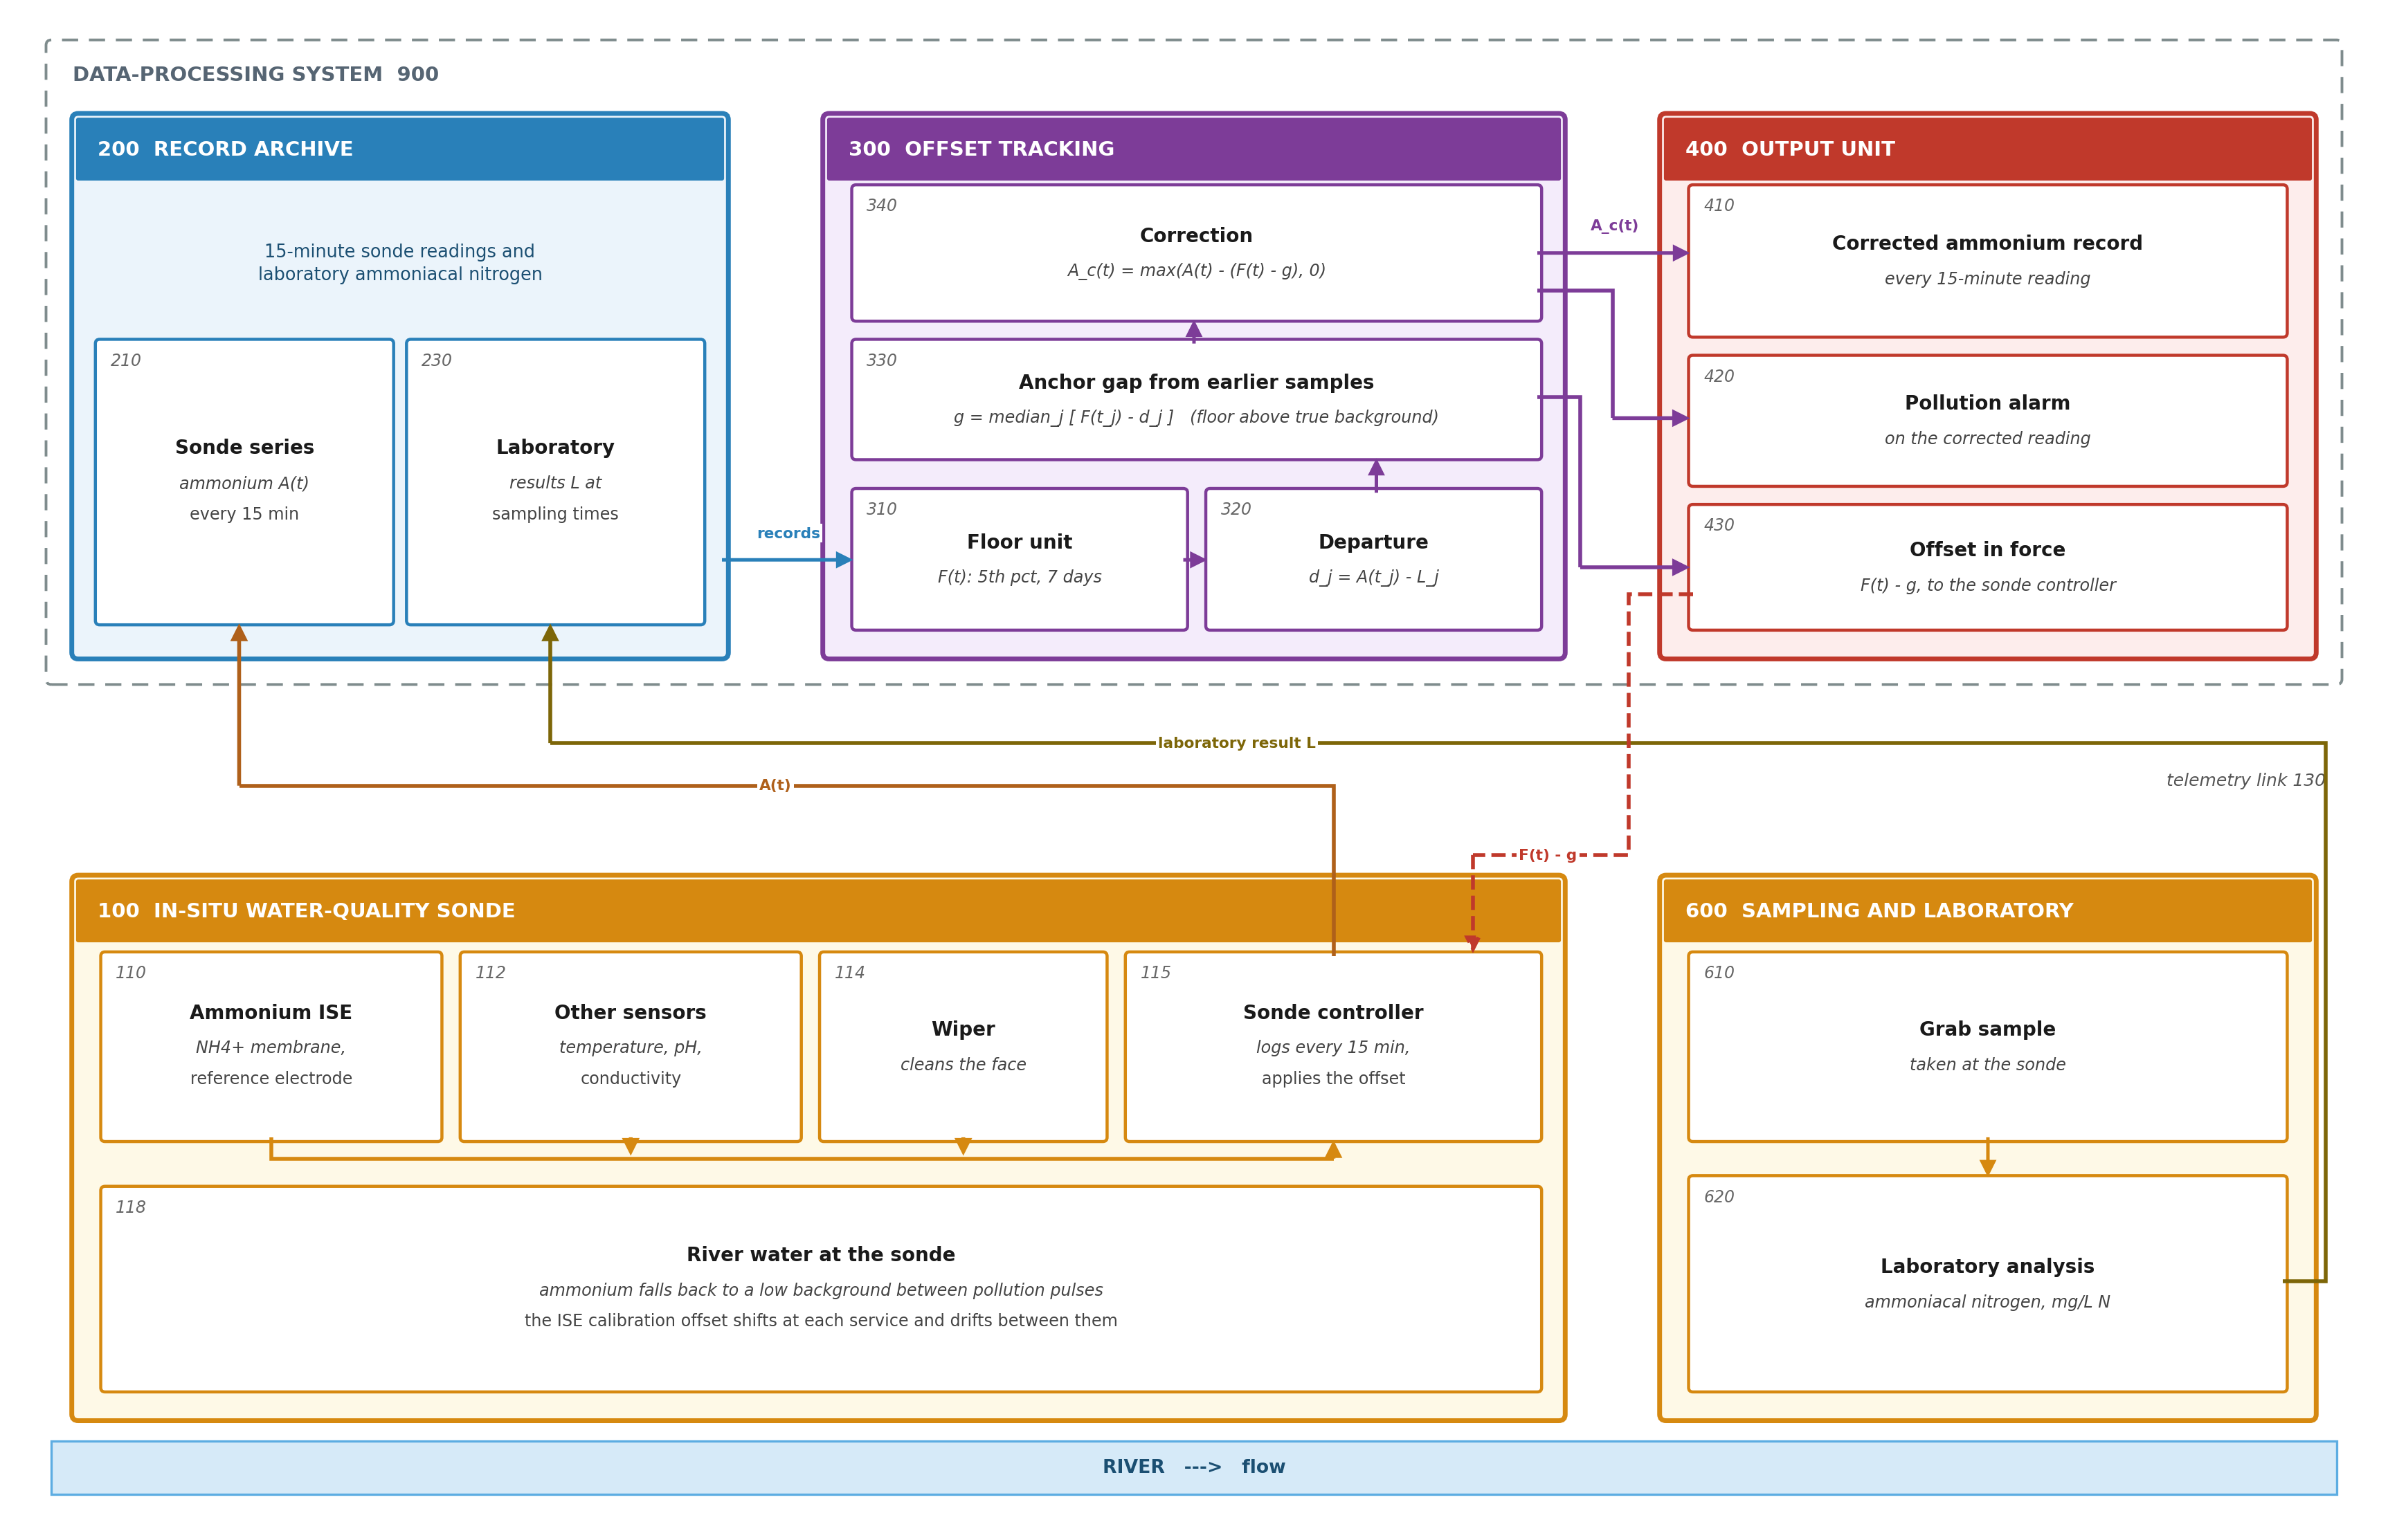
Figure 1. System architecture for ammonium offset tracking at an in-situ sonde. Readings of sonde 100 and laboratory results of grab samples 610 reach the archive (200) over link 130; the offset-tracking units (300) return the corrected record (410), the alarm (420) and the offset in force (430) for controller 115.
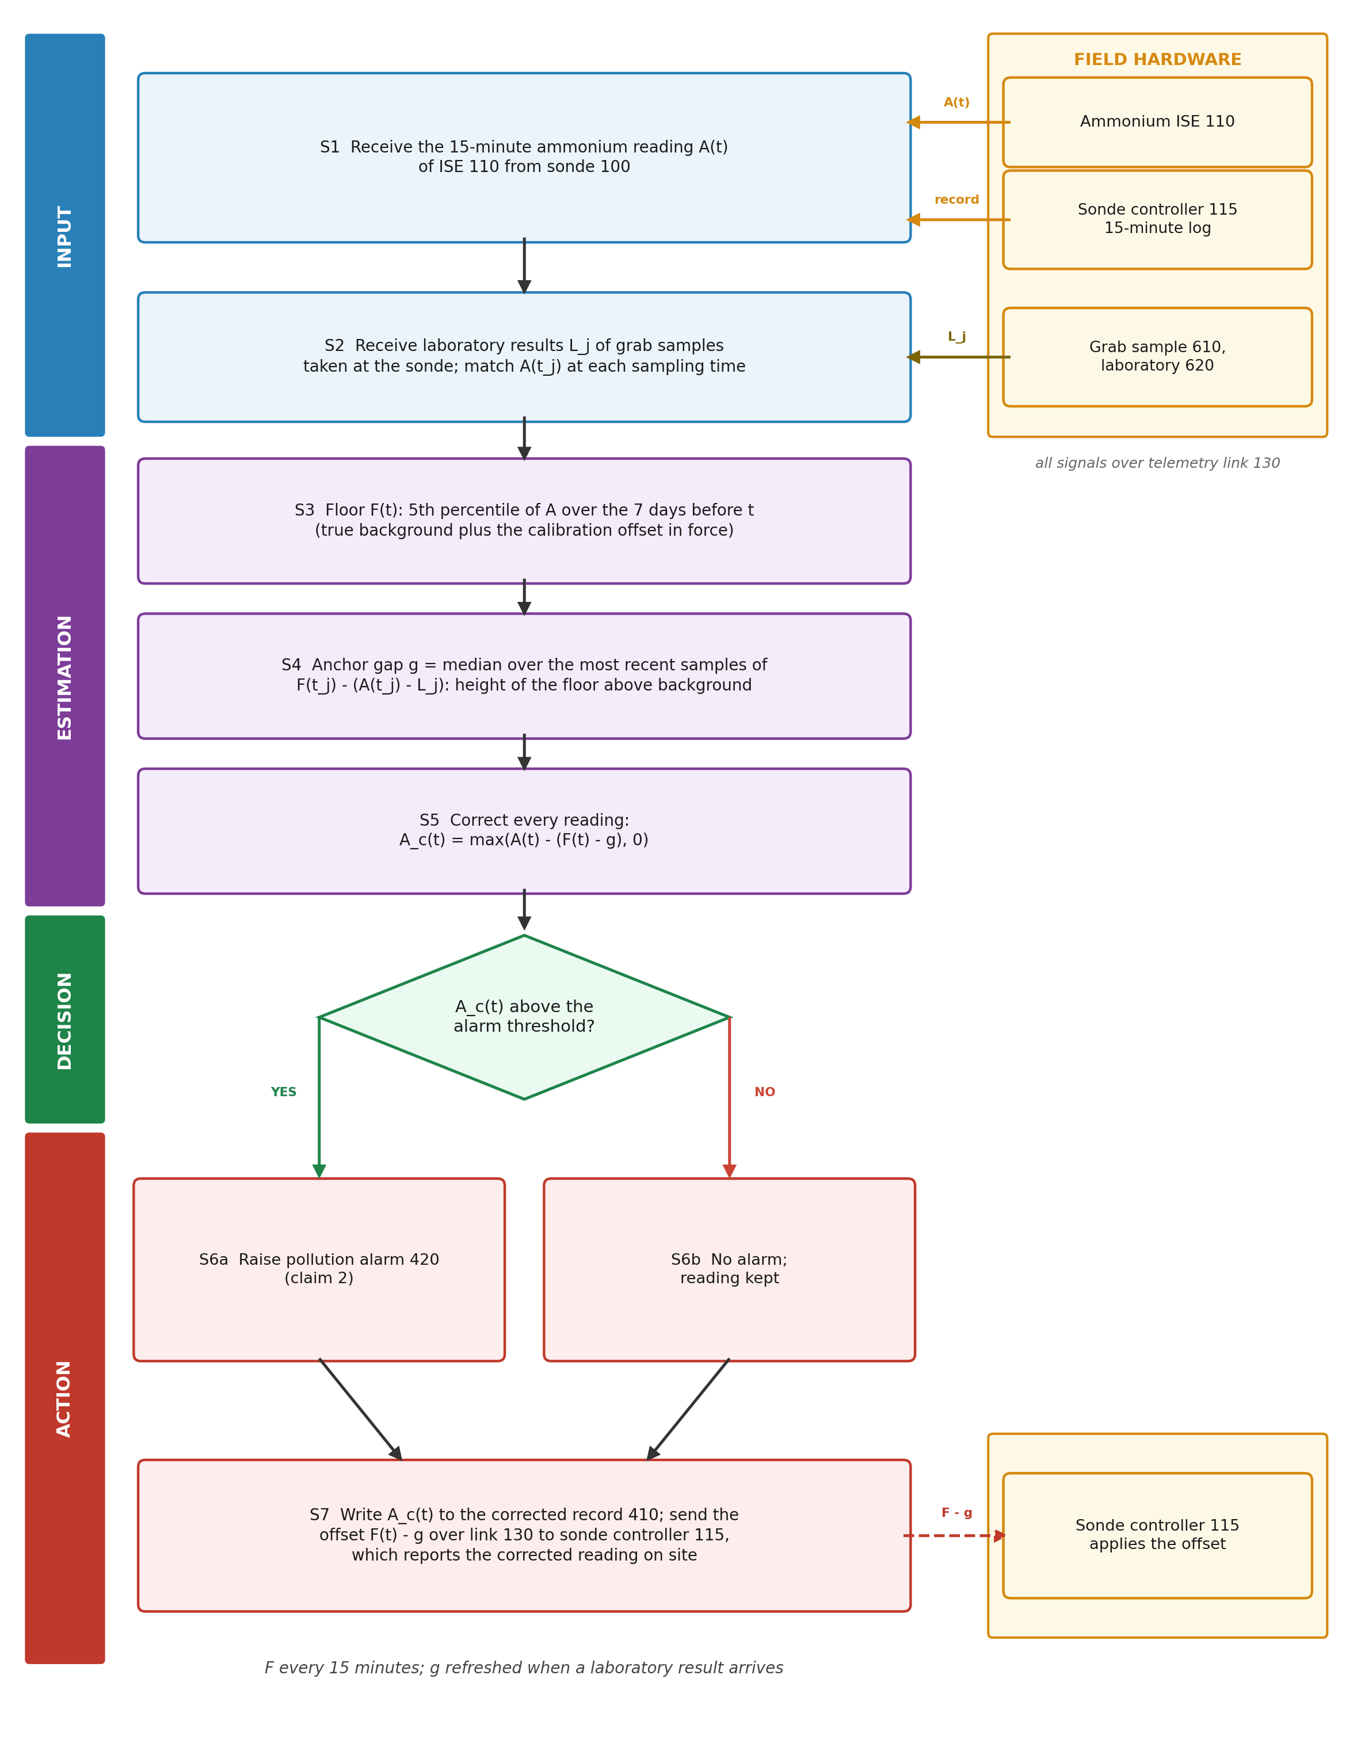
Figure 2. Flowchart of the method. S1-S5 form the floor, the anchor gap and the corrected reading; S6 decides the alarm; S7 writes the record and sends the offset to the sonde controller.

7. Description of the Invention in Detail

7.1 Sonde Hardware
[0006] The sonde (100) holds an ammonium ion-selective electrode (110): a membrane selective to ammonium against a reference electrode with a porous junction. Other sensors (112) of the same sonde report temperature, pH and conductivity, and a wiper (114) cleans the sensor faces. The controller (115) samples the electrode every 15 minutes, converts the potential to ammonium with the calibration line and the offset it stores, and transmits the reading by cellular or satellite link (130).

7.2 Records (200)
[0007] The archive holds the readings A(t) (210) and the laboratory results (230). A result is paired with the reading nearest its sampling time within 30 minutes; a result equal to the reading is a copy of the sonde value, not a laboratory analysis, and is discarded.

7.3 Floor Unit (310)
[0008] For each time t the floor unit takes the readings of the 7 days ending at t and returns their 5th percentile, provided the window holds at least 96 readings. A window of several days is longer than most pollution pulses, so its low part is the background between them; the percentile rather than the minimum ignores single low spikes. A failing electrode that reads far too high for days lifts the floor with it, so the correction removes the fault as an offset.

7.4 Departure and Anchor Gap (320, 330)
[0009] At each earlier laboratory sample j the departure unit (320) forms d_j = A(t_j) - L_j and the gap unit (330) forms F(t_j) - d_j, the height of the floor above the true concentration's background at that time. The anchor gap g is the median of this height over the 12 most recent earlier samples; the median keeps one doubtful sample from moving it.
[0010] Before the first laboratory sample at a sonde, g is taken as the median, over other sondes of the network, of the low decile of their laboratory results: the river background that sondes of the network typically see.

7.5 Correction (340) and Outputs (400)
[0011] The correction unit writes A_c(t) = max(A(t) - (F(t) - g), 0) for every reading to the corrected record (410) in place of the provisional reading. The alarm unit (420) compares A_c(t) with the threshold set for the river and raises the pollution alarm. The offset in force F(t) - g (430) is sent over the link (130) to the controller (115), which subtracts it from each reading it reports. A new laboratory result updates g; a service of the sonde needs no entry, because the floor moves with the new offset.
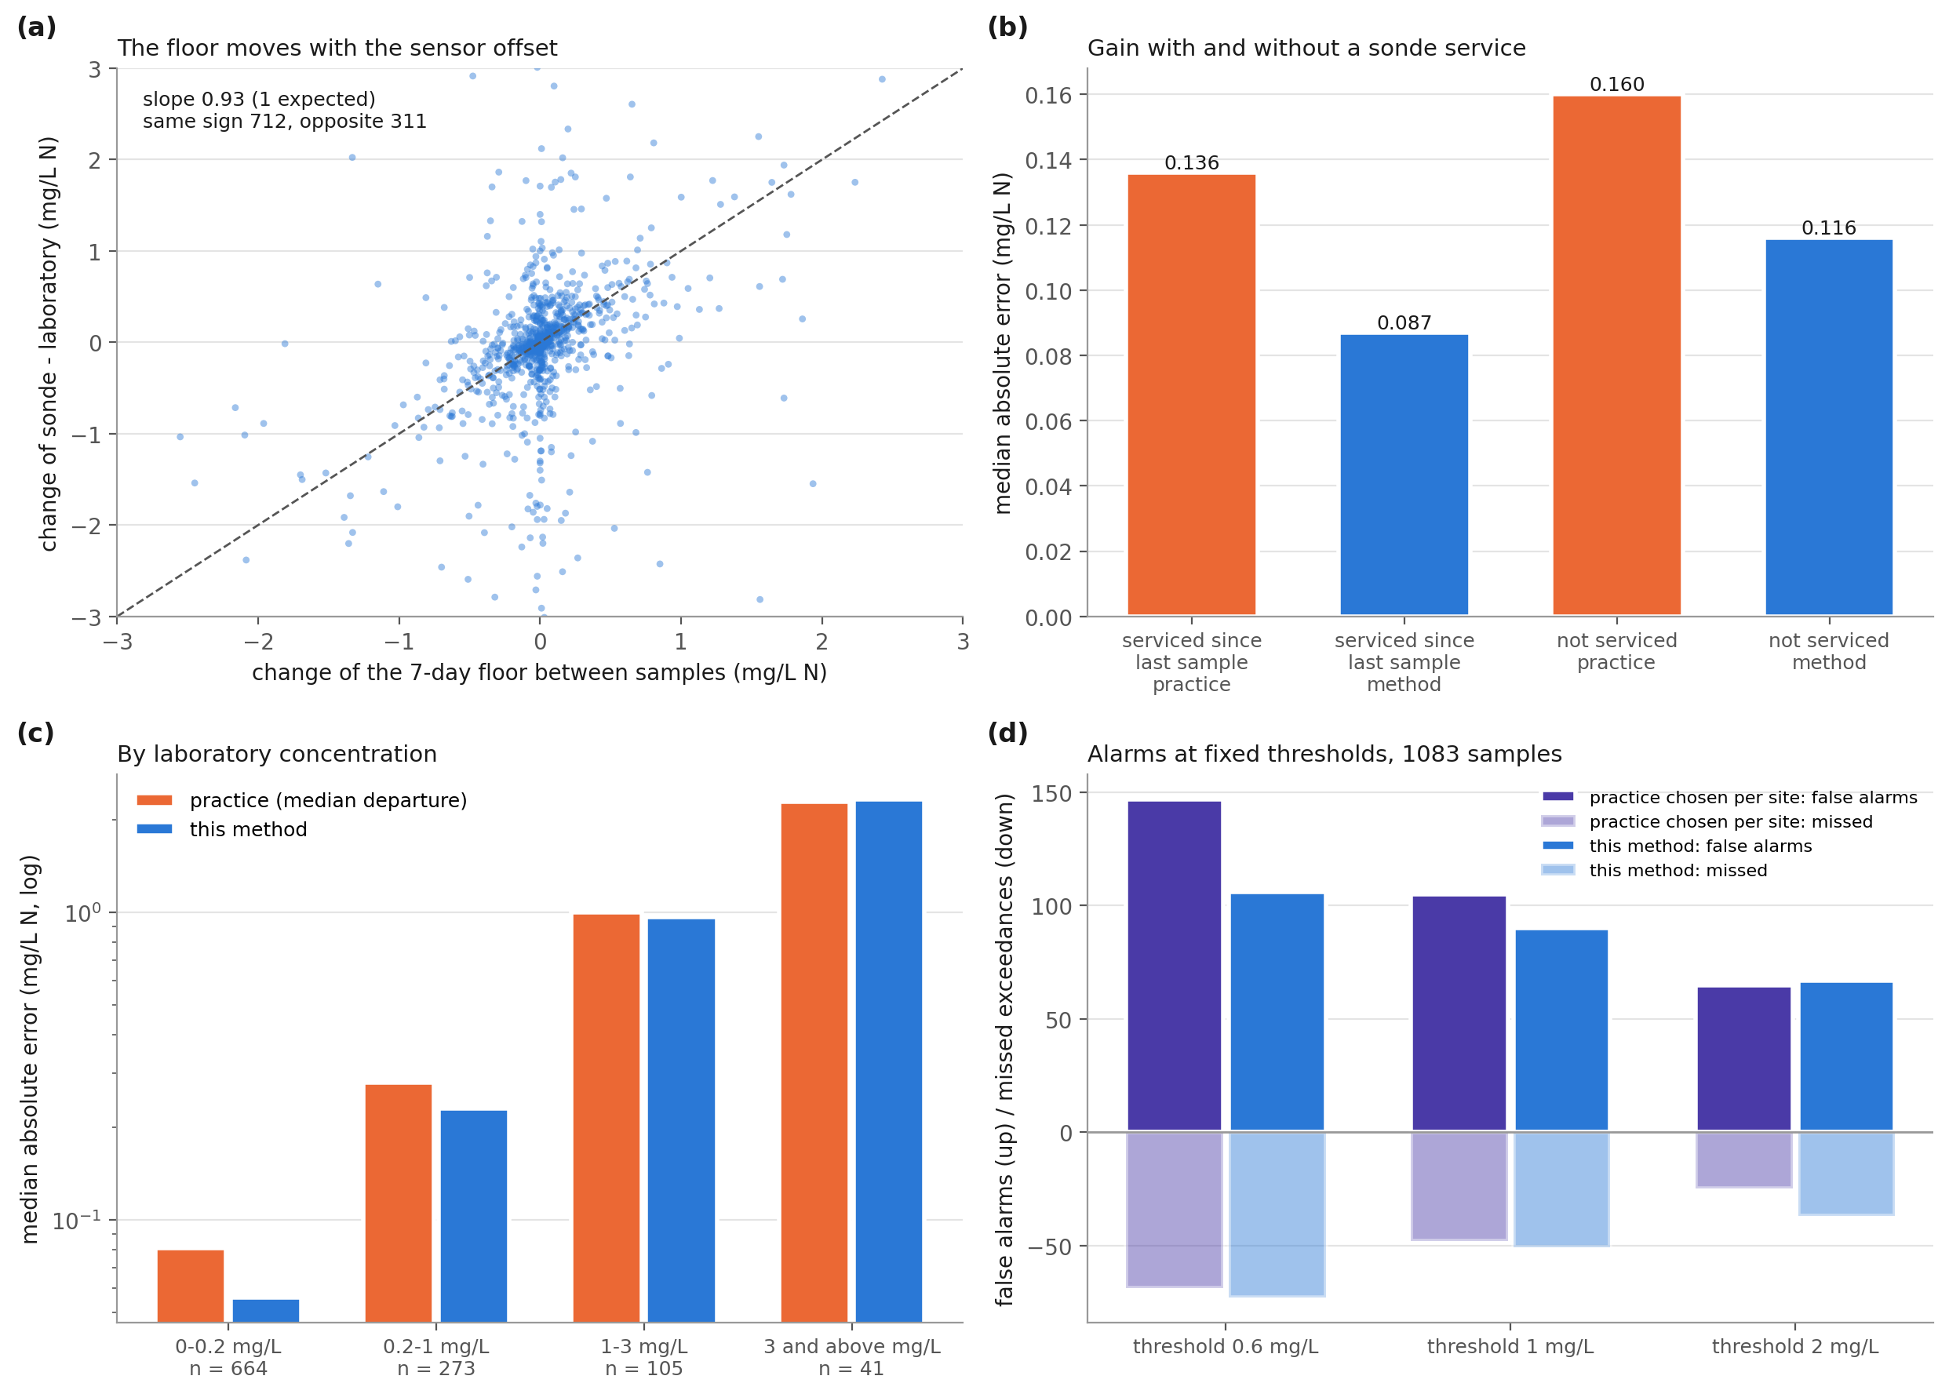
Figure 3. Mechanism and where the gain comes from. (a) change of the floor against change of the departure between consecutive samples; (b) median error with and without a sonde service since the last sample; (c) by laboratory concentration; (d) false alarms and missed exceedances at three thresholds.

7.6 Reference Numerals
Numeral | Element | Numeral | Element
100 | In-situ water-quality sonde | 300 | Offset tracking
110 | Ammonium ion-selective electrode | 310 | Floor unit
112 | Other sensors (temperature, pH, conductivity) | 320 | Departure unit
114 | Wiper | 330 | Gap unit
115 | Sonde controller | 340 | Correction unit
118 | River water at the sonde | 400 | Output unit
130 | Telemetry link | 410 | Corrected ammonium record
200 | Record archive | 420 | Pollution alarm
210 | Sonde readings | 430 | Offset in force
230 | Laboratory results | 600 | Sampling and laboratory
900 | Data-processing system | 610, 620 | Grab sample; laboratory analysis
Table 5: Reference numerals

8. Experimental Validation Results

8.1 Data and Configuration
All inputs are public records of the Environment Agency of England under the Open Government Licence, read without registration: the raw 15-minute sonde readings (quality 'Unchecked') of the Hydrology service, and the laboratory results (ammoniacal nitrogen as N) of the Water Quality Archive. Of 1818 sondes that reported ammonium, those that ran for at least 180 days, also reported conductivity and had a sampling point within 300 m with at least 8 laboratory results during the deployment were kept: 71 sondes, of which 67 had matched samples with a full floor window (1150 samples, 2007-07-11 to 2026-09-21, 3,152,104 readings). Table 6 lists the constants, read from the code that used them; they were fixed before the comparisons with the practice baselines, the station halves and the sensitivity runs, and were not changed for them.
Parameter | Value | Role
Floor window | 7 days, >= 96 readings | floor F(t)
Floor quantile | 5th percentile | floor F(t)
Anchor samples | 12 most recent earlier samples, median | anchor gap g
Pairing | nearest reading within 30 minutes | departure d_j
Alarm thresholds | 0.6, 1 and 2 mg/L N | alarm test
Table 6: Configuration parameters

8.2 Tests
Test | Question | Ground truth
V1 | Is the reading at each laboratory sample closer to the laboratory result after the correction than after the current corrections (median, last and trend of earlier departures, and the one of these that served the sonde best)? | Laboratory result
V2 | Ablation: floor without the laboratory anchor | As V1
V3 | Does the floor move with the offset between consecutive samples? | Change of departure
V4 | Gain with and without a sonde service; by concentration | As V1
V5 | Alarms at fixed thresholds | Laboratory result above the threshold
V6 | First sample of each sonde (no history) | As V1
V7 | Station resampling, two halves of the sondes, changed constants | As V1
Table 7: Validation tests

8.3 Accuracy at Laboratory Samples (V1, V2)
Each sample with at least one earlier sample at its sonde is corrected from the readings up to its own time and the laboratory results before it, so its own result never enters its correction. Table 8 gives the absolute error against the laboratory result.
Correction | Median / p90 / trimmed mean (mg/L N) | Method better at
Raw reading | 0.579 / 4.22 / 2.58 | 933 of 1072 (z = 24.25)
Median of earlier departures | 0.159 / 1.50 / 1.04 | 571 of 881 (z = 8.79)
Last departure | 0.152 / 1.59 / 0.94 | 562 of 936 (z = 6.14)
Trend of earlier departures in time | 0.169 / 2.45 / 1.33 | 621 of 936 (z = 10.00)
Practice chosen per sonde from its earlier samples | 0.152 / 1.49 / 0.97 | 551 of 888 (z = 7.18)
Floor without anchor (ablation) | 0.151 / 3.13 / 1.73 | 692 of 1048 (z = 10.38)
Floor anchored at samples (claim 1) | 0.112 / 1.48 / 0.85 | -
Table 8: Absolute error at 1083 laboratory samples of 67 sondes
The trimmed mean leaves out the largest 1 % of errors, which come from gross electrode faults; with them, the mean error is 104.6 mg/L for the practice chosen per sonde and 7.3 mg/L for the method. Against that practice the method is better at 52 of 67 sondes. Resampling whole sondes (2000 draws), the median error falls by 0.036 (95 % interval 0.017 to 0.060) against the practice chosen per sonde and by 0.034 (95 % interval 0.016 to 0.059) against the last departure; the 90th percentile falls by 0.044 (95 % interval -0.198 to 0.339), an interval that includes zero.
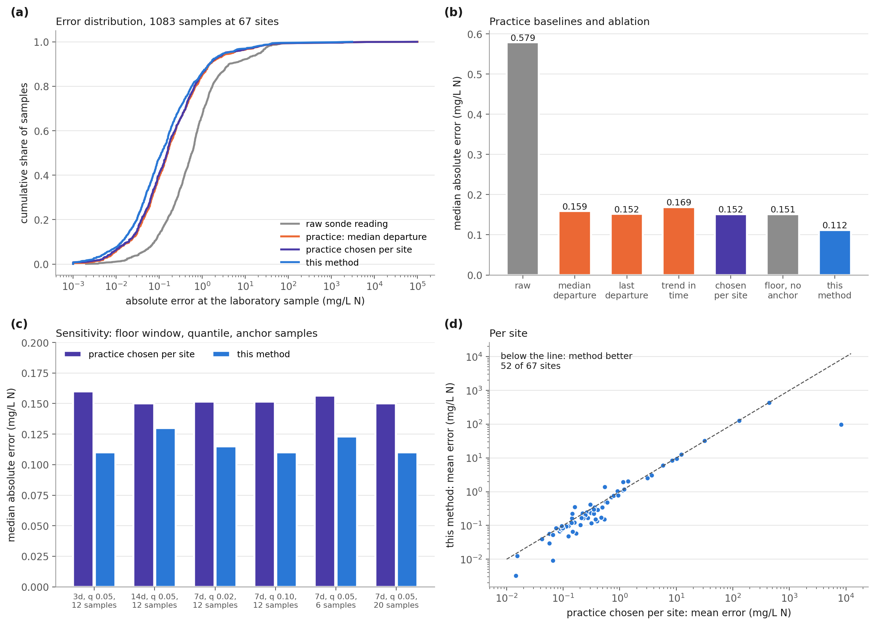
Figure 4. Accuracy at laboratory samples. (a) cumulative error, raw, current practice and this method; (b) practice baselines and ablation; (c) sensitivity of window, quantile and anchor samples; (d) mean error per sonde.

8.4 Mechanism (V3, V4)
Between consecutive samples at a sonde the change of departure follows the change of floor with a slope of 0.93 (1 expected if the floor carries the whole offset), and the two move in the same direction 712 times and in opposite directions 311 times (1083 pairs, largest 1 % of departure changes left out of the slope). Where the sonde was serviced between the last sample and the one corrected, the median error falls from 0.136 to 0.087 mg/L, better at 74 of 120 (z = 2.56); elsewhere from 0.160 to 0.116 mg/L, better at 497 of 761 (z = 8.45): the floor follows offset changes at services and between them.
Laboratory band (mg/L N) | Samples | Practice median error | Method median error | Method better at | Under-read: practice / method
0-0.2 | 664 | 0.081 | 0.056 | 374 of 533 (z = 9.31) | 331 / 315
0.2-1 | 273 | 0.280 | 0.230 | 145 of 232 (z = 3.81) | 151 / 151
1-3 | 105 | 1.000 | 0.965 | 36 of 77 (z = -0.57) | 73 / 70
3 and above | 41 | 2.290 | 2.335 | 16 of 39 (z = -1.12) | 28 / 31
Table 9: By laboratory concentration (practice = median of earlier departures)
The gain lies at low and moderate concentrations, where the offset dominates the error; above 1 mg/L N the method and practice are level and the method under-reads no more often, so a pollution event is not taken for an offset.

8.5 Alarms (V5)
Threshold (mg/L N) | Exceedances in laboratory | Raw: false / missed | Practice chosen per sonde: false / missed | Method: false / missed
0.6 | 217 | 438 / 86 | 147 / 69 | 106 / 73
1 | 140 | 317 / 76 | 105 / 48 | 90 / 51
2 | 71 | 148 / 42 | 65 / 25 | 67 / 37
Table 10: Alarm decisions at 1083 samples
At 0.6 and 1 mg/L the method raises fewer false alarms than every practice baseline; at 2 mg/L false alarms are level (67 against 65) and missed exceedances are higher (37 against 25), because those concentrations lie in the band in which the method has no accuracy gain.

8.6 One Sonde
Figure 5 shows sonde E06152A from 2019-05-21 to 2021-05-04: the raw record moves up and down with services while the laboratory results stay low, and the floor follows those moves. Over the 41 samples shown the median error is 0.100 mg/L with the practice chosen per sonde and 0.083 mg/L with the method.
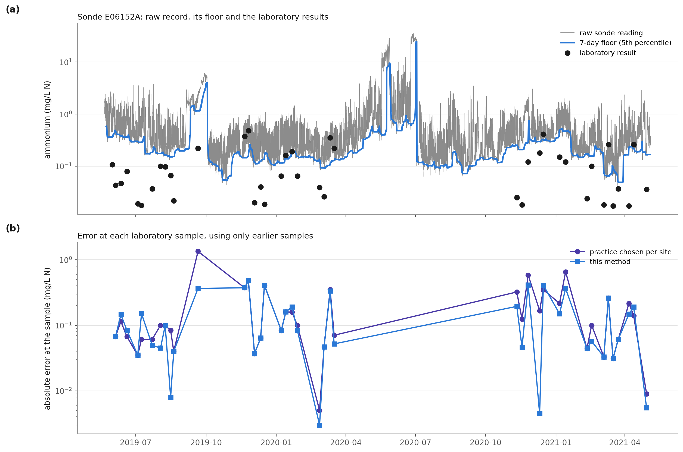
Figure 5. Record, floor and errors at one sonde. (a) raw readings, 7-day floor and laboratory results; (b) error at each laboratory sample, using only earlier samples.

8.7 Sonde without Laboratory History (V6)
At the first laboratory sample of each sonde, with no earlier sample, the gap is taken from the other sondes (claim 4): median error 0.131 mg/L, against 0.172 for one network-wide correction value (mean departure of the other sondes) and 0.648 for the raw reading; better than the network value at 43 of 67 (z = 2.32). Over all samples treated in the same way, the floor with the network background is better than the network value at 697 of 1117 (z = 8.29), with a median error of 0.149 against 0.153.
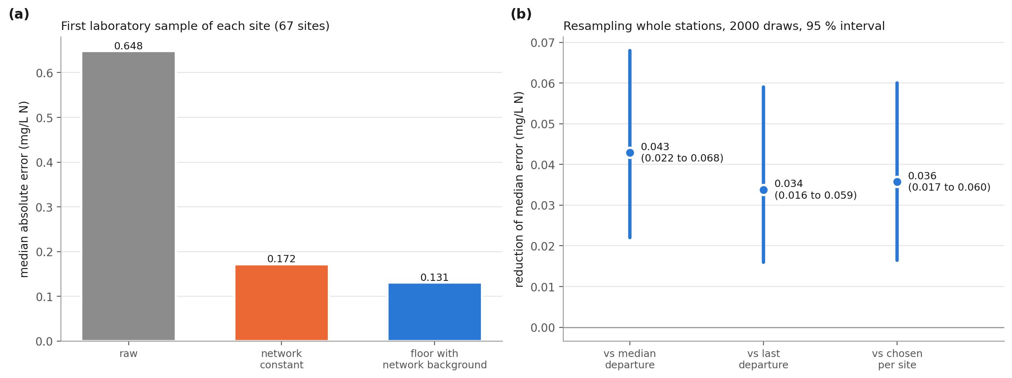
Figure 6. First sample of each sonde and station-level uncertainty. (a) median error at the first laboratory sample of each sonde; (b) reduction of the median error with 95 % intervals from resampling whole sondes.

8.8 Station Halves and Changed Constants (V7)
With every constant frozen, the sondes were sorted by identifier and dealt alternately into two halves. On the first (34 sondes) the method is better than the practice chosen per sonde at 231 of 381 (z = 4.15); on the second (33 sondes) at 320 of 507 (z = 5.91). Changing one constant at a time (Table 11), the method's median error stays between 0.110 and 0.130 mg/L and it is better than the practice chosen per sonde in every run (z from 4.53 to 7.63).
Window (days) | Quantile | Anchor samples | Samples | Practice chosen per sonde | Method | Method better at
3 | 5th | 12 | 656 | 0.160 | 0.110 | 369 of 565 (z = 7.28)
14 | 5th | 12 | 1099 | 0.150 | 0.130 | 497 of 861 (z = 4.53)
7 | 2nd | 12 | 1083 | 0.152 | 0.115 | 556 of 885 (z = 7.63)
7 | 10th | 12 | 1083 | 0.152 | 0.110 | 548 of 888 (z = 6.98)
7 | 5th | 6 | 1083 | 0.156 | 0.123 | 554 of 882 (z = 7.61)
7 | 5th | 20 | 1083 | 0.150 | 0.110 | 551 of 887 (z = 7.22)
Table 11: Sensitivity of the constants (median absolute error, mg/L N)
A window of 3 days keeps fewer samples because some sondes log hourly and do not reach 96 readings in 3 days.

8.9 Processing Time
The floor and the gap for the full records of 10 sondes (all samples, all baselines) take 0.04 s on one processor core; in operation the floor is one percentile over a window of readings per 15-minute reading.

8.10 Technical Effect Summary
Effect | Mechanism | Evidence
Lower error of the ammonium record between samples | Floor follows the offset; gap fixed at samples | Table 8: median 0.152 -> 0.112 mg/L; 551 of 888 (z = 7.18)
Effect holds across sondes | Same constants on every sonde | 52 of 67 sondes; bootstrap 0.036 (95 % interval 0.017 to 0.060)
Gross faults removed | Fault lifts the floor with the reading | mean error 104.6 -> 7.3 mg/L
Fewer false alarms | Corrected reading against the threshold | Table 10, 1 mg/L: 105 -> 90 false, 48 -> 51 missed
Offset followed between samples | Low quantile over days | slope 0.93; same direction 712 of 1023
Table 12: Technical effects, mechanism and evidence

8.11 Insights
Most of the ammonium error of these sondes is an offset that moves, not noise: the raw median error is 0.579 mg/L and a correction from laboratory samples removes most of it.
The floor alone cannot place the river's background; the laboratory samples alone cannot follow the offset between them. Together they beat each.
The gain is in the typical error and in false alarms; the largest errors (90th percentile) are not reduced with certainty.

8.12 Limitations and Acceptance Criteria
Above 1 mg/L N the method has no accuracy gain, and at a 2 mg/L threshold it misses more exceedances than the practice chosen per sonde (Table 10). Acceptance: at each new network the missed exceedances at the alarm threshold in use must not exceed those of the current practice.
Where ammonium stays high for longer than the floor window (a long discharge, a drying river), the floor rises with the river and the correction would remove real ammonium; a window longer than such episodes, or holding the last offset while the floor rises above a set rate, is then needed.
Evaluated on sondes of one agency in England; the laboratory samples are routine and pollution samples taken near the sonde, not always at the same minute. Acceptance: on each new network, V1 must show a lower median error than the current practice chosen per sonde.
The 90th percentile of the error is not reduced with certainty (interval includes zero).

9. Discussion
The invention turns the shape of the sonde's own record into a measurement of the electrode offset. Two facts make this possible: a river's ammonium falls back to a background between pulses, so the floor of a few days of readings is that background plus the offset; and at a laboratory sample the true concentration is known, so the height of the floor above background can be fixed there rather than assumed. The offset is then followed at every reading, through services and drift, without the maintenance logbook and without waiting for the next sample. The results show the gain against every current correction, at most sondes and in both halves, and they show its limits: none at high concentrations, and more misses at the highest alarm threshold.

10. What Aspect(s) of the Invention Need(s) Protection?
Following the offset of an ammonium electrode through a low quantile of the sonde's own readings over a window of several days.
Fixing the height of that floor above the river's background at laboratory samples, from the departure of the reading at each sample.
Correcting every reading by the floor less that height, using only earlier samples.
Writing the corrected record, deciding the pollution alarm on it, and sending the offset in force to the sonde controller.
Taking the height from other sondes of the network before a sonde has its own samples.
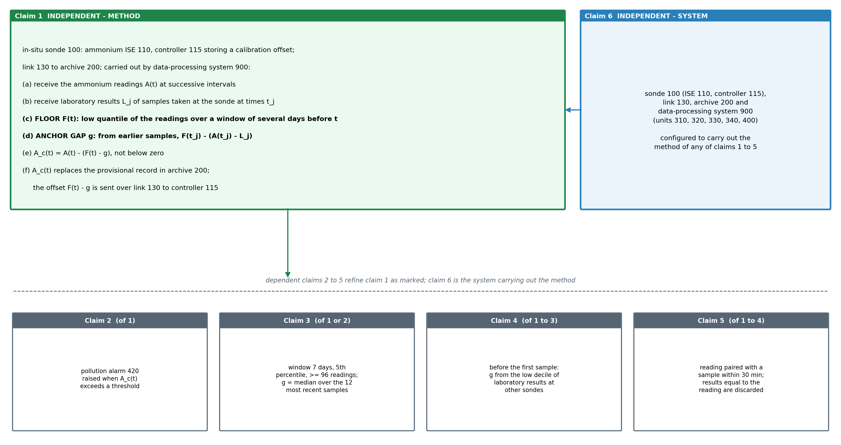
Figure 7. Claim tree. Independent method claim 1, its dependents 2 (alarm), 3 (constants), 4 (no laboratory history) and 5 (pairing), and system claim 6 carrying out the method.

Claims
Claim 1 (independent). A method of correcting the ammonium record of an in-situ water-quality sonde (100) placed in a river and comprising an ammonium ion-selective electrode (110) and a sonde controller (115) that converts the potential of the electrode to an ammonium concentration with a stored calibration offset and reports a reading at successive intervals, the sonde transmitting the readings over a telemetry link (130) to a record archive (200), the method being carried out by a data-processing system (900) and comprising: (a) receiving over the link (130) the readings A(t) of the sonde at the successive intervals; (b) receiving laboratory results L_j of the ammonium concentration of grab samples (610) taken at the sonde at sampling times t_j, and pairing each with the reading of the sonde at that time; (c) computing, for each time t, a floor F(t) as a low quantile of the readings over a window of several days ending at t, the window being longer than a pollution pulse in the river so that the floor follows the river's background ammonium plus the offset carried by the electrode; (d) computing an anchor gap g from laboratory results taken before t, as a combination over those samples of F(t_j) less the departure A(t_j) - L_j, being the height of the floor above the background; (e) computing a corrected reading A_c(t) as A(t) less the offset in force F(t) - g, and not less than zero; and (f) replacing in the record archive (200) the readings with the corrected readings, and transmitting the offset in force over the link (130) to the sonde controller (115), which applies it to the readings it reports.
Claim 2. The method of claim 1, further comprising comparing each corrected reading with an alarm threshold set for the river and raising a pollution alarm (420) when the corrected reading exceeds it.
Claim 3. The method of claim 1 or claim 2, wherein the window spans the 7 days ending at t and holds at least 96 readings, the low quantile is the 5th percentile, and the anchor gap is the median of F(t_j) - (A(t_j) - L_j) over the 12 most recent laboratory samples taken before t.
Claim 4. The method of any of claims 1 to 3, wherein, before a first laboratory sample has been taken at the sonde, the anchor gap is the median, over other sondes of a monitoring network, of a low quantile of their laboratory results.
Claim 5. The method of any of claims 1 to 4, wherein each laboratory result is paired with the reading nearest its sampling time within 30 minutes, and a result equal to the paired reading is discarded as a copy of the sonde value.
Claim 6 (independent). A system for correcting the ammonium record of an in-situ river water-quality sonde, comprising: an in-situ water-quality sonde (100) placed in a river and comprising an ammonium ion-selective electrode (110) and a sonde controller (115) that converts the potential of the electrode to an ammonium concentration with a stored calibration offset and reports a reading at successive intervals; a telemetry link (130); a record archive (200) receiving over the link the readings of the sonde and laboratory results of grab samples taken at the sonde; and a data-processing system (900) comprising a floor unit (310), a departure unit (320), a gap unit (330), a correction unit (340) and an output unit (400), configured to carry out the method of any one of claims 1 to 5.

11. Technology Readiness Level of the Invention
The method runs end to end on public records of operating sondes and is scored against laboratory analysis of grab samples; it has not yet been connected to a sonde controller.
Research |  |  | Development |  |  | Deployment
TRL 1 | TRL 2 | TRL 3 | TRL 4 | TRL 5 | TRL 6 | TRL 7 | TRL 8 | TRL 9
Basic principles observed | Technology concept formulated | Experimental proof of concept | Technology validated in lab | Validated in relevant environment | Demonstrated in relevant environment | Prototype in operational environment | System complete and qualified | Proven in operational environment
✓ | ✓ | ✓ | ✓
Current TRL: Level 4 — Technology Validated in Laboratory.
END OF THE DOCUMENT

