Invention Disclosure Format (IDF)-B
Vellore Institute of Technology – IPR & TT Cell
1. Title of the Invention
A Method and System for Label-Free Detection of Malpractice and Coordinated Collusion at Monitored Assessment Stations Using Self-Supervised Predictive Residual Analysis of Multi-Modal Sensor Signals.
2. Field / Area of Invention
The present invention relates to integrity monitoring of supervised assessment and controlled-access environments, and to the automated detection of prohibited communication, prohibited device use, and coordinated collusion within such environments. More specifically, it pertains to a method by which a sensing system associated with an individual monitored station learns the signal pattern of sanctioned activity and identifies deviations from that pattern, without requiring any labelled examples of malpractice during training. The invention further relates to the correlation of such deviations across two or more spatially proximate stations in order to distinguish coordinated malpractice from an isolated individual anomaly.
The principal embodiment described herein is an examination desk within an examination hall. The invention is not limited to that embodiment: it applies equally to professional certification and testing centres, secure interview and vetting rooms, recruitment and aptitude testing facilities, controlled-access screening areas, and any supervised environment in which unauthorised communication or device use is prohibited and in which sanctioned activity is abundant while violations are rare.
3. Prior Patents and Publications from Literature
The following table summarises the closest known prior art and identifies the gap addressed by the present invention. Entries 7 and 8 concern general-purpose techniques that an examiner may reasonably raise, and are addressed explicitly.
No. | Reference (Patent / Publication) | Key Features & Relevance | Notes / Implications
1 | CCTV-based examination surveillance systems. See e.g. CN 106023516 A (examination monitoring method and system; infrared perimeter and posture sensors with face-recognition camera); US 9,154,748 B2 (online examination proctoring system). | Visual monitoring of examinee behaviour at hall level | Cannot detect concealed electronic devices, low-power signals, or covert audio; blind to what is not visible.
2 | RF signal jammers for examination halls. Category of commercially deployed installations; no single reference relied upon. | Block mobile and wireless communication during exams | Preventive, not detective; may interfere with authorised systems; ineffective against passive or non-RF methods.
3 | AI-based video analytics for cheating detection (supervised). See e.g. CN 111539313 A (cheating-behaviour detection by gaze tracking and video analysis); US 9,881,516 B1 (detecting cheating during online assessment). | Computer vision and behaviour analysis trained on labelled cheating footage | Requires labelled malpractice data, which does not exist at scale; models learn only the specific cheating types staged in training.
4 | Handheld metal detectors and electronic scanners | Detect presence of metallic or electronic objects on individuals | Manual, intrusive, point-in-time; unsuitable for continuous monitoring during an examination.
5 | Acoustic / ultrasonic communication detection. See e.g. CN 200989924 Y (detector for concealed wireless earpieces used in examination cheating). | Detect abnormal sound patterns and ultrasonic signals | Typically single-modality; not fused with other sensing; no per-station deployment; no cross-station analysis.
6 | Multi-sensor exam desk with acoustic + EM signatures (base disclosure) | Desk-embedded acoustic and electromagnetic sensors; decision by "predefined thresholds or learned models" | Does not specify how detection operates without labelled malpractice data; scores each desk independently, so cannot separate collusion from coincidental anomaly.
7 | Time-series anomaly detection by prediction or reconstruction error (autoencoders, recurrent predictors, predictive-coding models). See e.g. Malhotra et al., LSTM-based encoder-decoder for multi-sensor anomaly detection (2016); Hundman et al., detecting spacecraft anomalies using LSTMs and nonparametric dynamic thresholding (KDD 2018); Zong et al., deep autoencoding Gaussian mixture model (ICLR 2018). | General technique in which a model trained on normal data flags inputs it predicts poorly; applied to industrial telemetry, network intrusion, and video surveillance | A general method, not an assessment-integrity system. Does not teach per-venue calibration under non-stationary ambient conditions, does not teach multi-modal residual fusion for this purpose, and critically does not teach correlating residual time-series across spatially proximate stations to separate coordinated from isolated anomaly.
8 | Self-supervised joint-embedding predictive representation learning (JEPA-type architectures, variance-covariance regularised objectives). See e.g. LeCun, A path towards autonomous machine intelligence (2022); Assran et al., I-JEPA (CVPR 2023); Bardes et al., VICReg (ICLR 2022). | Learn representations by predicting the embedding of a future or masked portion of the input, with collapse-preventing regularisation | Representation-learning literature. Concerned with downstream classification quality, not with using the prediction residual itself as a live detection score, and contains no teaching of distributed multi-station deployment or cross-station residual correlation.

The common limitation across the supervised approaches (entries 3 and 6) is a dependence on labelled malpractice data. Genuine cheating is rare, adversarial, and deliberately concealed, so a representative labelled corpus of malpractice cannot be assembled in practice. A detector trained on such data can only recognise the specific cheating methods that were staged and labelled; it does not generalise to novel methods.
The general techniques at entries 7 and 8 supply components but not the invention. Prediction-error anomaly detection is known in the abstract; what is not known, and what is claimed here, is its application as a per-station integrity score under per-venue label-free calibration, fused across heterogeneous physical sensing modalities, and — most importantly — the use of a single normal-only predictive model across many stations so that their residual time-series become mutually comparable and can be correlated to reveal coordination. No prior art known to the inventor performs station-level malpractice detection by learning sanctioned activity alone, nor correlates detection residuals across stations to distinguish collusion from coincidental anomaly.
4. Summary and Background of the Invention (Gap / Novelty)
Examination malpractice has grown more sophisticated with the miniaturisation of electronics. Concealed micro-earpieces, smartwatches, and Bluetooth accessories are difficult to detect by inspection, and supervised detection systems face a fundamental data problem: there is no large, representative, labelled dataset of cheating, and there never will be, because cheating is rare and actively hidden. Any system trained to recognise cheating from labelled examples is therefore limited to the exact behaviours it was shown.
The present invention removes this dependence. The system is trained exclusively on recordings of sanctioned activity, which are abundant and require no labelling. A self-supervised model learns to predict the near-future state of the sensor signals from their recent past. During a monitored session, the error between the model’s prediction and the observed signal — the prediction residual — serves as the integrity-violation score. Because the model has only ever learned what sanctioned activity looks like, any activity unlike it, including methods never anticipated, produces an elevated residual. This inverts the data problem: instead of the impossible task of collecting every kind of violation, the system need only observe ordinary behaviour.
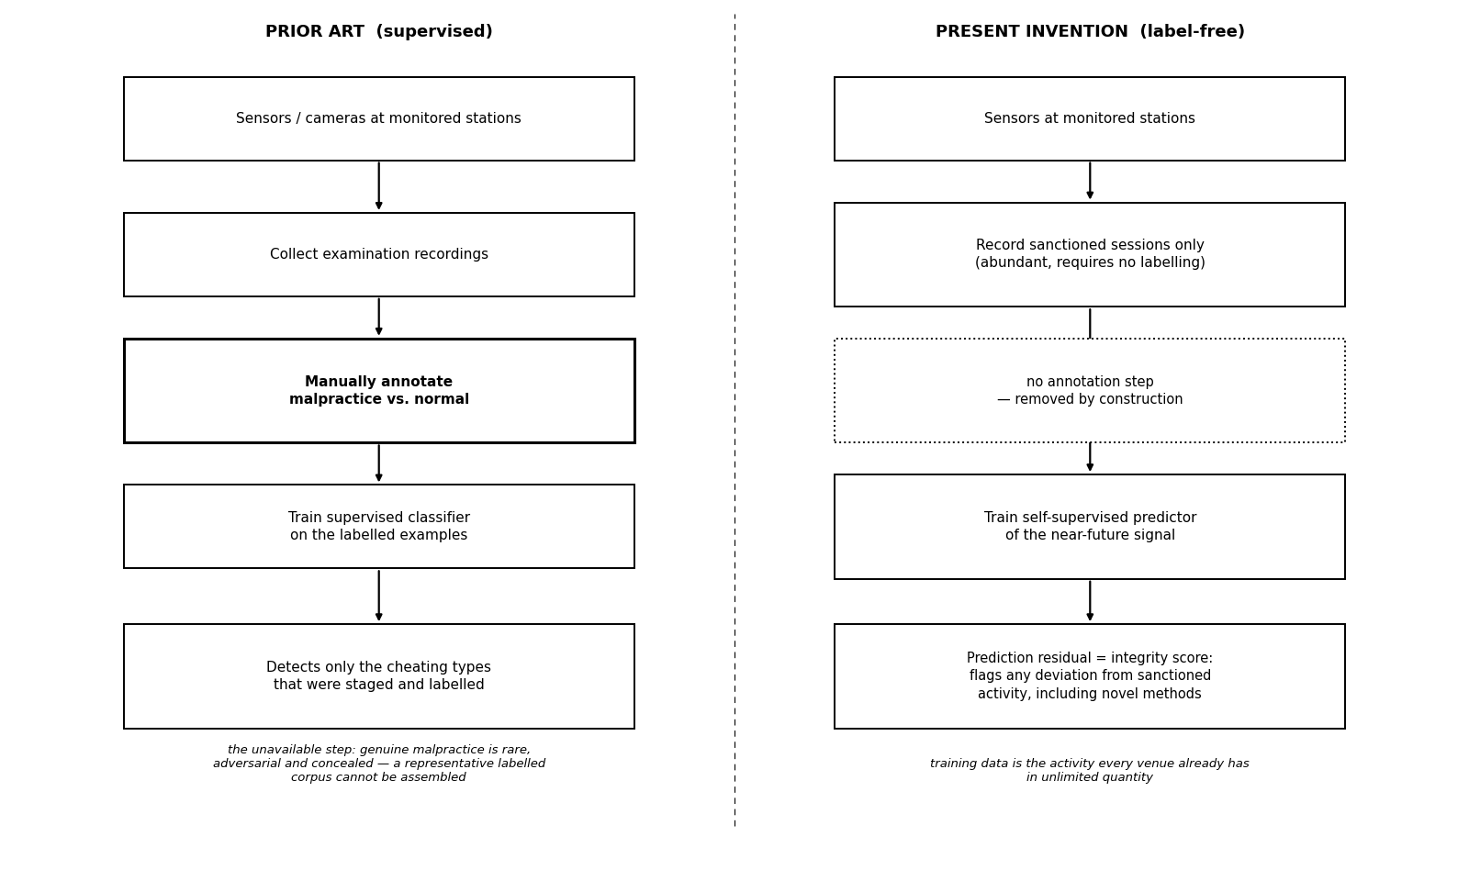
Figure 1. The data problem and its removal. The supervised prior art (left) depends on an annotation step that cannot be performed at scale, because genuine malpractice is rare, adversarial and concealed; the present invention (right) removes that step by construction, training on sanctioned activity alone and scoring deviation from it.
The proposed system comprises: a station-associated sensing assembly employing one or more sensing modalities; a processing unit executing a self-supervised predictive model; a residual-scoring module that converts prediction error into an integrity-violation score; a multi-modal fusion stage; a cross-station correlation module that compares residual patterns between proximate stations; and a communication interface for alert transmission.
4.1 Statement of Inventive Step (Non-Obviousness)
The inventive step does not reside in any single element taken alone. Anomaly detection by prediction error is known in other fields, as is self-supervised predictive representation learning. The invention resides in the specific combination of the following five elements, and in a technical effect that no element produces on its own:
(a) a self-supervised predictive model trained exclusively on sanctioned activity, so that the training corpus is abundant and the detector generalises to violation methods never anticipated at design time;
(b) use of the prediction residual directly as a live integrity score, rather than as an auxiliary training signal for a downstream classifier;
(c) standardisation of that residual against statistics gathered from an initial sanctioned interval at the specific venue, which calibrates the detector to local ambient conditions without any labelled data;
(d) fusion of residuals across heterogeneous physical sensing modalities, so that violation methods manifesting in different channels are covered by one score; and
(e) time-lagged correlation of residual time-series between spatially proximate stations.
(f) suppression of a venue-wide common-mode residual component prior to that correlation, so that the coordination condition responds only to coupling specific to a station pair and not to events shared by the venue as a whole.
The synergy is specifically this. Element (e) is only possible because of elements (a) and (c). A conventional supervised detector produces a station-specific decision whose scale depends on how that station’s classifier was trained and thresholded; such outputs are not commensurable across stations and cannot be meaningfully correlated. Because the present invention scores every station with one common normal-only model and one common label-free calibration procedure, the residual time-series of different stations are numerically comparable by construction. This makes available an entirely new detection channel — temporal coupling between stations — that is provably absent from the analysis of any single station, and that no combination of the prior art would produce. Collusion is a relational phenomenon; every prior system listed in Section 3 scores individuals in isolation and is therefore structurally incapable of observing it. Element (f) is what makes that channel reliable rather than merely available. Stations in a venue share an environment, so the most frequent cause of simultaneous residual elevation at neighbouring stations is not coordination but an event common to the room; a system that correlates raw residuals without first removing the shared component would report such events as collusion. Estimating and subtracting the common-mode component is therefore not an optimisation of the correlation step but a precondition of its validity.
A secondary technical effect follows from the same architecture: because detection depends on residuals rather than on raw recordings, only derived low-dimensional values need leave the venue, which materially reduces the privacy and data-protection burden compared with video- or audio-recording surveillance systems.
5. Objectives of the Invention
1. To detect malpractice at station level without requiring any labelled examples of cheating for training.
2. To detect unauthorised communication devices and covert activity through their physical signatures across one or more sensing modalities, the invention being agnostic to the particular modality employed.
3. To generalise to novel violation methods that were not anticipated when the system was built.
4. To reduce false alarms by fusing multiple sensing modalities and by requiring corroborating evidence.
5. To detect collusion between candidates by correlating detection residuals across proximate stations — a signal that does not exist at any single station.
6. To calibrate automatically to the ambient conditions of each venue without labelled data.
7. To operate without retaining raw audio, video, or radio recordings beyond the point of feature extraction, thereby limiting the privacy burden of continuous monitoring.
8. To provide an honest, quantified operating envelope stating the conditions under which detection is reliable.
6. Working Principle (in Brief)
Each monitored station continuously produces one or more sensor signal streams. In the principal embodiment these are acoustic (including near-ultrasonic energy), electromagnetic (radio-frequency emissions, device-advertisement activity, and signal-strength dynamics), and, where a camera is present, behavioural (blink rate, gaze direction, head pose, and fixation). These signals are divided into short time windows. A self-supervised encoder, trained only on sanctioned sessions, embeds the recent window and predicts the near-future change in the signal. The squared error between predicted and observed change is the per-modality residual. Residuals from all modalities are standardised against sanctioned-only statistics and combined into a single integrity-violation score. When the score exceeds a confidence threshold, the event is logged and an alert is transmitted with station identifier, timestamp, and severity. Separately, the residual time-series of proximate stations are cross-correlated; synchronised elevation on neighbouring stations indicates collusion, whereas an isolated elevation on one station indicates an individual anomaly.
7. Detailed Description of the Invention
Sensing. In the principal embodiment, acoustic sensors capture sound across a wide band, including near-ultrasonic frequencies used by some covert audio links, and electromagnetic sensors monitor bands associated with consumer devices, capturing radio emissions, device-advertisement rates, and received-signal-strength behaviour. An optional behavioural module derives gaze, blink, head-pose, and fixation features from a camera. The invention is not restricted to these modalities; see Section 7.1. In a representative embodiment the signals are sampled at a common low frame rate and grouped into overlapping context windows of approximately seven seconds.
Model. A separate lightweight encoder is provided for each modality. From a context window, the encoder produces a compact embedding, and a predictor estimates the change in the signal over a short future horizon (a pooled prediction several seconds ahead). The model is trained only on sanctioned sessions to minimise the error of this prediction, while a variance-and-covariance regularisation on the embedding prevents the degenerate solution in which the encoder maps every input to the same point. No labelled malpractice is used at any stage of training.
Scoring and fusion. At inference, the prediction error for each modality is the anomaly score. Scores are standardised using statistics gathered from sanctioned calibration data only, then combined across modalities. Fusing modalities is beneficial because different violation methods manifest in different channels; combining them improves detection over any single channel and reduces false positives. Optionally, the residual is aggregated over a longer time span within a session, which raises sensitivity to faint but sustained activity without requiring any labels.
Cross-station correlation. Because a single station cannot distinguish an individual’s brief anomaly from coordinated cheating, the system compares the residual time-series of proximate stations. Collusion couples the two stations in time — one candidate signals, the other responds after a short lag — producing correlated residual elevations. An isolated anomaly on one station correlates with nothing. A lagged cross-correlation of proximate-station residuals, evaluated per modality and combined, therefore separates collusion from coincidental anomaly. As set out in Section 4.1, this comparison is only well posed because all stations are scored by one common normal-only model, which renders their residuals commensurable. This signal is absent from any single-station analysis and constitutes an independent detection channel.
Common-mode rejection. Stations within a venue share an environment, so residual elevations may arise simultaneously at proximate stations for reasons unrelated to coordination: an invigilator passing between desks, a door opening, a dropped object, a public-address announcement, or a venue-wide radio-frequency disturbance. Such common-mode events satisfy a naive coordination condition and constitute the principal source of false coordination alarms. The system therefore estimates, from the residual time-series of a plurality of stations of the venue, a common-mode component representing residual variation shared across those stations, and subtracts that component from each station residual before the correlation statistic is computed. The common-mode estimate may be a robust central statistic across stations, for example the median residual at each time step; or it may be measured directly at one or more instrumented but unoccupied reference stations disposed within the hall; or both may be combined. After subtraction, only coupling specific to a particular station pair survives, which is the quantity the coordination condition is intended to test.
Per-venue calibration. Because ambient acoustic and electromagnetic conditions differ between halls and buildings, the sanctioned-only statistics used for standardisation are established from an initial interval of each session and then held fixed, adapting the detector to the specific room. No labelled data is required for this calibration, which is what makes it deployable at scale.
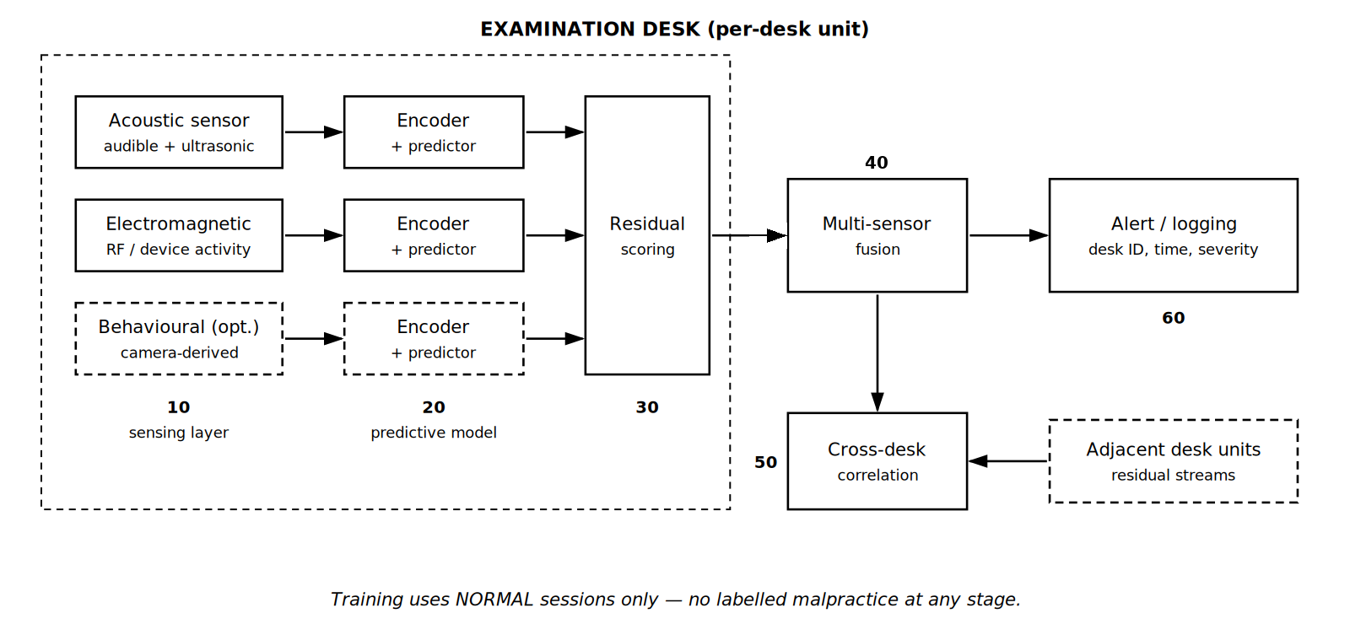
Figure 2. System architecture. Sensing layer (10) feeds per-modality encoders and predictors (20); residual scoring (30) converts prediction error into a score; fusion (40) combines modalities; cross-station correlation (50) compares proximate stations; alerts are issued at (60).
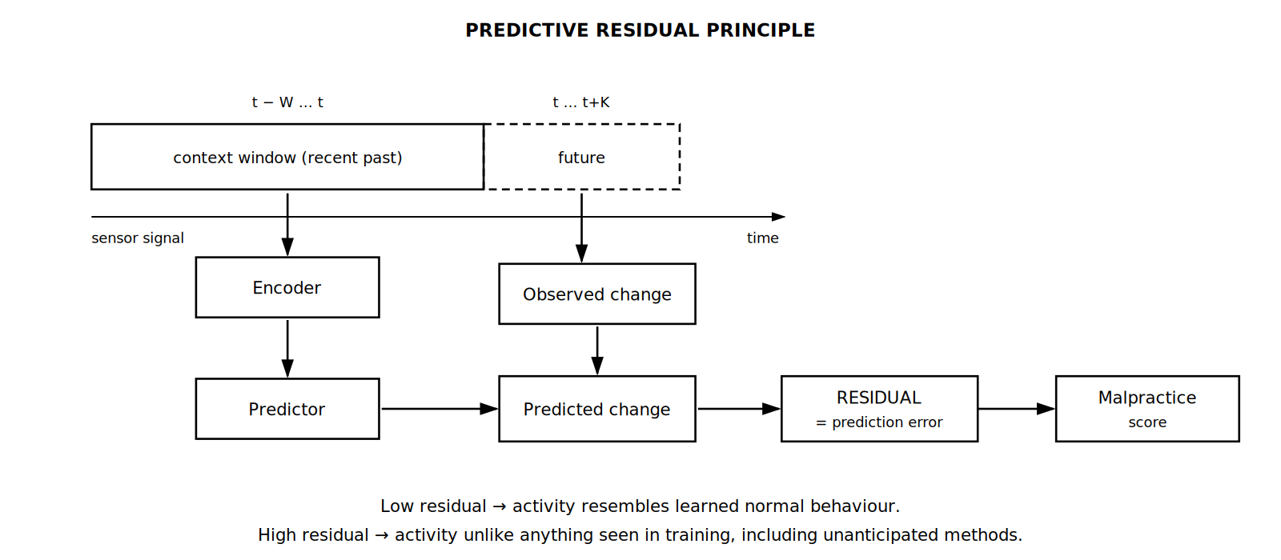
Figure 3. Working principle. The encoder embeds the recent context window and the predictor estimates the near-future change; the discrepancy against the observed change is the residual, which serves as the integrity-violation score.
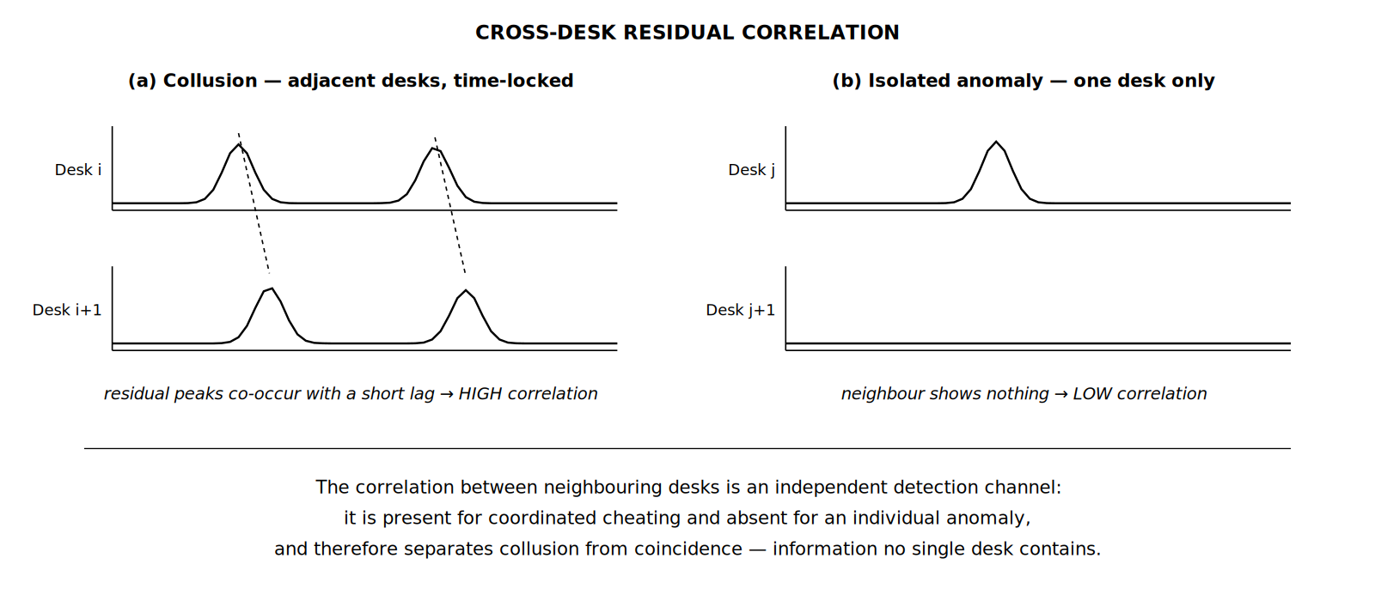
Figure 4. Cross-station correlation. Colluding candidates at proximate stations produce time-locked residual elevations (a); an isolated anomaly leaves the neighbouring station unaffected (b).
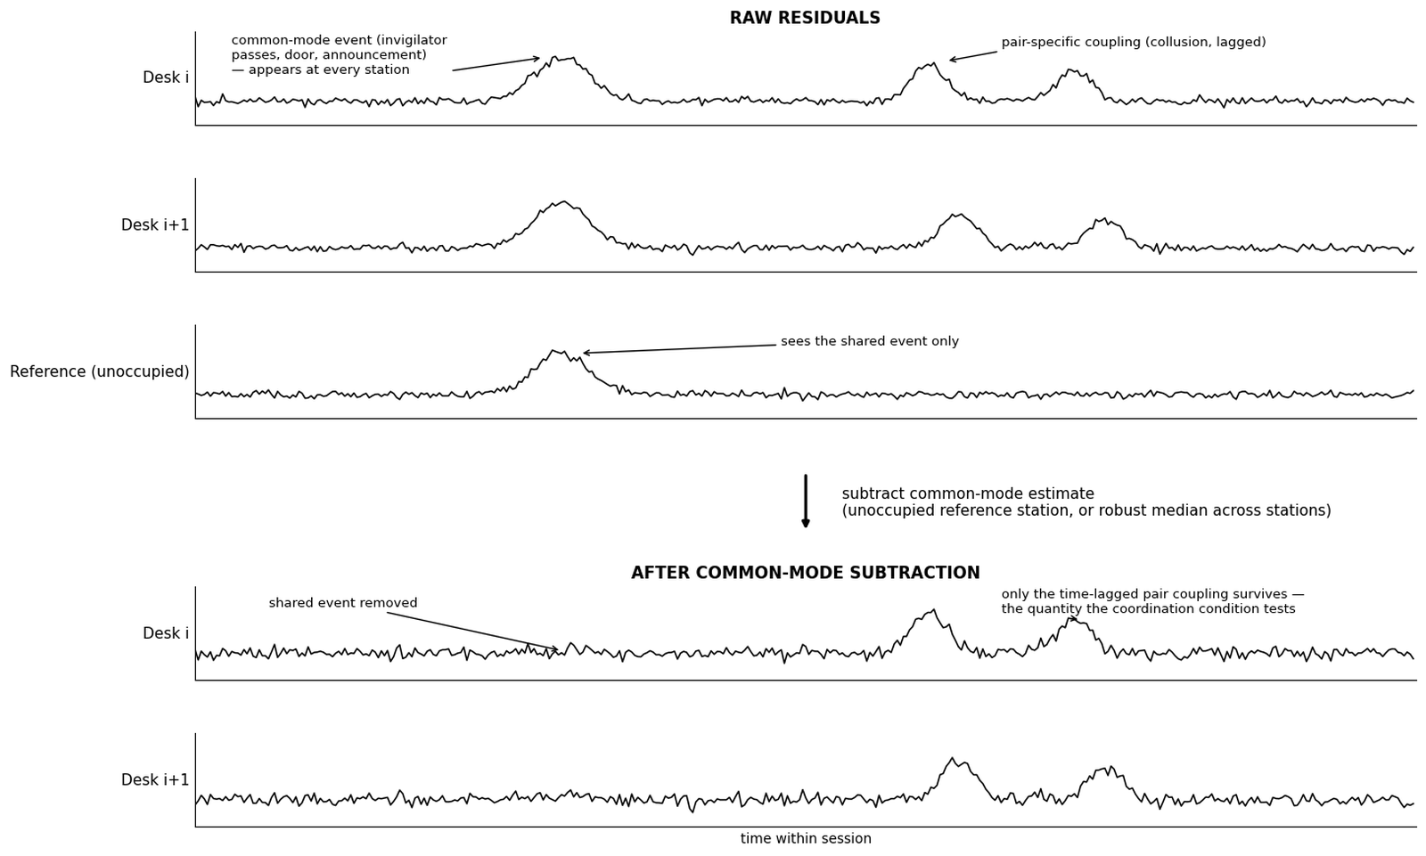
Figure 5. Common-mode rejection. A venue-wide event elevates the residual at every station, including an unoccupied reference (top); subtracting the common-mode estimate removes it, leaving only the time-lagged, pair-specific coupling of collusion (bottom), which alone can satisfy the coordination condition. Claims 11, 12 and 17 recite this step.
7.1 Alternative Embodiments
The following alternatives are contemplated and are to be read as within the scope of the invention. They are recited here so that the disclosure supports claim language broader than the principal embodiment.
(a) Sensing modalities. The sensing assembly may comprise any one or more of: acoustic sensing including near-ultrasonic bands; electromagnetic and radio-frequency sensing including device-advertisement capture and received-signal-strength dynamics; mechanical vibration or accelerometric sensing of the desk or seat surface; magnetic-field sensing; pressure, strain, or load sensing in the seat or writing surface; thermal or infrared sensing; millimetre-wave or radar-based micro-motion sensing; capacitive proximity sensing; and optical sensing of candidate behaviour. The method is indifferent to which physical quantity is sensed, because the detector learns the temporal predictability of whatever stream it is given.
(b) Physical form factor. The sensing assembly may be embedded within a purpose-built desk body; provided as a retrofit sensing pod clamped or adhered to an existing desk; integrated into a partition, seat back, or candidate device holder; or mounted overhead on a per-station basis. Retrofit embodiments are commercially significant because they do not require replacement of existing furniture.
(c) Processing topology. Inference may be performed entirely at an edge processing unit at the station; at a venue-local aggregation server receiving feature streams from many stations and performing scoring, fusion, and cross-station correlation centrally; at a remote or cloud server; or in any hybrid division of these. In privacy-preserving embodiments, raw acoustic, optical, and radio recordings are discarded at the point of feature extraction and only derived features or residual values are transmitted beyond the venue.
(d) Model and residual variants. The predictive model may employ convolutional, recurrent, or attention-based encoders; a single joint encoder across modalities or one encoder per modality; prediction of raw future samples, of future feature statistics, or of the future embedding. The residual may be computed as squared error, absolute error, cosine distance in embedding space, or negative log-likelihood under a predictive distribution. Fusion may be by mean, maximum, weighted sum with weights set from sanctioned-only variance, or a learned combiner trained without malpractice labels.
(e) Correlation variants. Cross-station coupling may be measured by time-lagged cross-correlation, mutual information, coherence, or event-coincidence statistics over sliding windows. Correlation results across a venue may be assembled into a graph in which stations are nodes and supra-threshold proximate pairs are edges; connected components of that graph identify collusion groups involving more than two candidates, and the graph may be presented to an invigilator as a live hall map.
(f) Contemplated further development. In a further contemplated embodiment, the predictive model is additionally trained against corrupted or temporally shuffled future signals as explicit negative examples, such that a plausible future is scored as more probable than an implausible one, sharpening the residual used as the integrity score. This variant is disclosed here to preserve it for possible later claiming; it is deliberately not recited among the claims of Section 10, as it has not yet been reduced to practice.
(g) Application environments. Beyond examination halls, the same system applies to professional certification and licensing test centres, secure interview and vetting rooms, recruitment and aptitude testing facilities, defence and public-service selection examinations, controlled-access screening areas, and remote-proctoring installations at candidate premises. In each case the enabling condition is the same: sanctioned activity is abundant and cheaply recorded, while violations are rare, concealed, and unlabellable.
8. Validation — Part A: Simulation Study
The method was validated on a parametric simulation of station-level signals, in which sanctioned activity and concealed-device activity are generated across a range of signal strengths. All figures in this section are stated as reported by the simulation and should be read as evidence that the method functions, not as measurements from a deployed system. Detection quality is reported as AUROC (area under the receiver-operating curve), where 1.0 is perfect ranking and 0.5 is chance.
Task validity. Before evaluating the method, the simulation was audited to confirm that no single sensor feature trivially separates sanctioned from violation activity; the largest single-feature separation was small (Cohen’s d = 0.16), so any detection must arise from learned temporal structure rather than a single obvious cue. A supervised reference detector, trained from scratch on the same data but permitted to use the labels, establishes the best achievable performance and serves as a ceiling.
The apparent tension between a small single-feature separation (d = 0.16) and a supervised ceiling of 0.946 is expected, and is itself informative. The separating information is multivariate and temporal: it is distributed across features and across time, and is invisible to any test applied to one feature at one instant. This is precisely the regime in which a model of temporal predictability is the appropriate detector, and in which the fixed per-feature thresholds contemplated by prior-art entry 6 would fail.
Scope of the evaluation. The simulation generated twenty-two engineered feature streams per station: eight acoustic features (log band energy in six bands spanning 0-500 Hz, 500 Hz-2 kHz, 2-8 kHz, 8-14 kHz, 14-18 kHz and 18-24 kHz, together with spectral flatness and spectral flux), six electromagnetic features (mean and variance of received signal strength, Bluetooth Low Energy advertisement rate, count of distinct advertising addresses, probe-request rate, and channel utilisation), and eight behavioural features (blink rate, on-paper gaze fraction, saccade rate, head pitch, yaw dispersion, fixation duration, hand-visibility fraction, and pupil-size variance). Streams were segmented into context windows of thirty frames, yielding 17,000 context windows per modality. The predictive model was trained for forty epochs on sanctioned windows only, with embedding spread held between 0.94 and 0.97 by the variance-covariance regularisation, a spread near 1 indicating a healthy, non-collapsed embedding. The supervised reference is a histogram-based gradient-boosted classifier trained from scratch on the same generated data with access to the labels; it is internal to the study and is not a pretrained or external model. The single-station sweep was evaluated at signal strengths of 1.0, 0.6, 0.3 and 0.15; the cross-station evaluation used twenty simulated halls of six stations each at signal strength 0.8, containing ten colluding adjacent pairs against ninety adjacent-but-innocent pairs. All figures are from a single training run per configuration; no across-seed variance estimate is available, and no figure in this section should be read as carrying more precision than that limitation supports.
What the simulation does and does not establish. The sanctioned signals and the violation signals were both produced by a parametric generative model authored by the inventor. The simulation therefore establishes internal consistency: that a model trained on sanctioned activity alone recovers a violation signal which a label-using model also recovers, at a quantified fraction of its performance, and that the cross-station mechanism behaves as the architecture predicts. It does not establish external validity, because the statistical structure of real examination-hall acoustics and radio traffic is not known to match the generative model. The figures in this section are accordingly offered as evidence of mechanism, not as predicted field performance.
Single-station detection. The following table compares the label-using reference detector with the present label-free method across decreasing signal strength (SNR). The second figure for the present method includes within-session temporal aggregation.
Signal strength (SNR) | Reference detector (uses labels) | Present method (uses no labels) | Interpretation
1.0 (overt) | 0.946 | 0.705 / 0.781 | Recovers ~75% of the label-using reference with zero labelled malpractice; temporal aggregation raises the figure to 0.781.
0.6 (moderate) | 0.903 | 0.653 / 0.716 | Detection remains clearly above chance as concealment increases.
0.3 (faint) | 0.843 | 0.613 / 0.657 | Weak but non-trivial detection of subtle activity.
0.15 (near noise floor) | 0.797 | 0.541 / 0.571 | Approaches chance; defines the lower limit of the operating envelope.
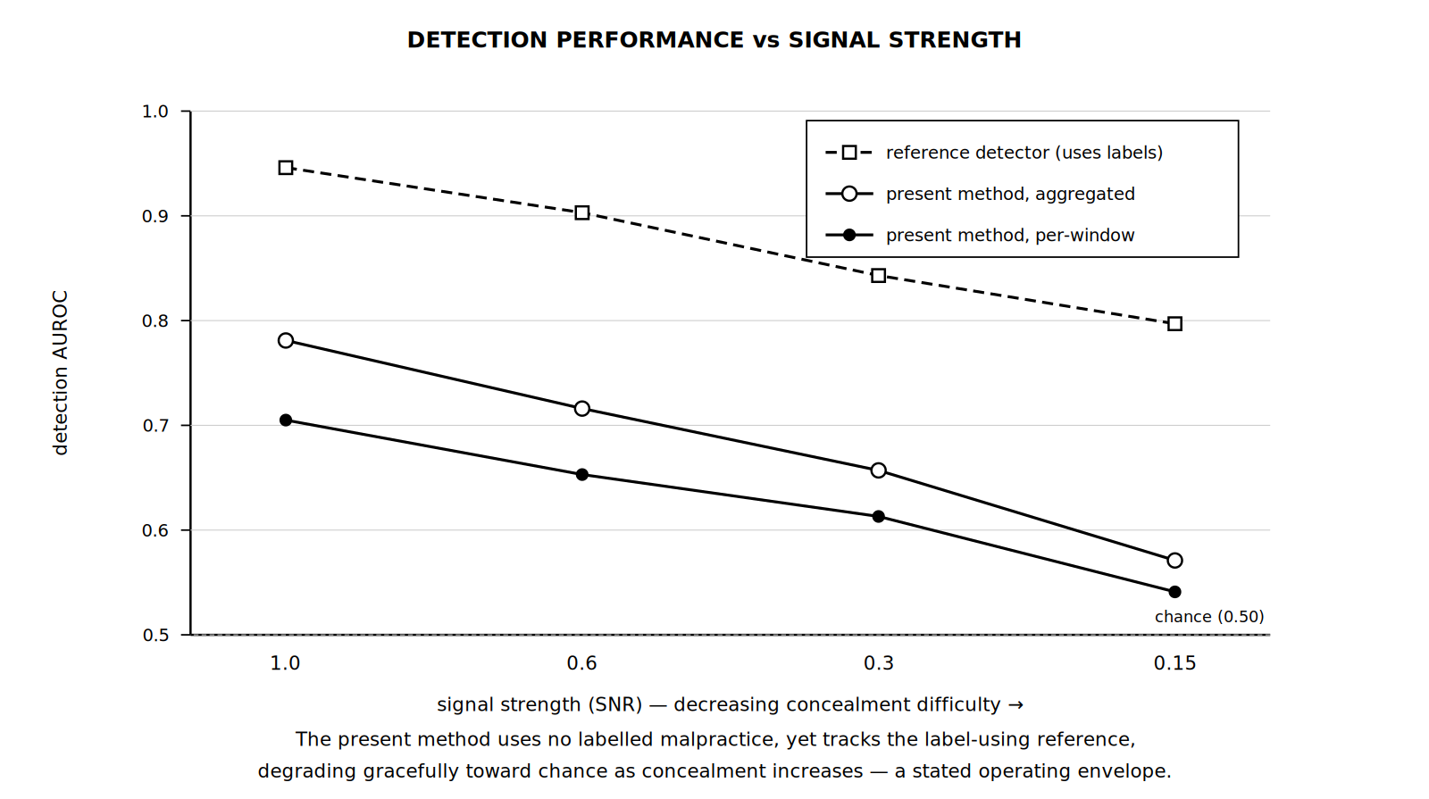
Figure 6. Simulated detection performance across signal strength, compared against a label-using reference detector.
Two observations follow. First, the present method recovers a substantial fraction of the label-using reference’s performance while using no labelled malpractice whatsoever, which is the central claim. Second, detection degrades gracefully and monotonically as concealment increases, approaching chance only near the noise floor. This defines an honest operating envelope: the method is a strong detector of overt malpractice and a progressively weaker detector of increasingly subtle activity. The fusion of modalities was confirmed to exceed the best single modality, supporting the multi-modal claim.
Temporal aggregation in detail. Aggregation is a causal rolling mean of the fused score over a fixed number of preceding windows within the session, so that no future information is used. At signal strength 1.0 the fused figure rises monotonically with the aggregation window, from 0.705 with no aggregation through 0.722 and 0.751 at windows of five and fifteen, to 0.781 at a window of thirty. The lift declines with concealment, from +0.076 at signal strength 1.0 to +0.030 at 0.15. That decline is the expected signature of a genuine but weakening sustained signal: aggregation can only average up a violation signature that persists across windows, so its benefit must shrink as the signature sinks toward the noise floor. An artefactual lift would show no such dependence.
Fusion weighting. The calibration interval yields per-modality fusion weights without any labels; in the reported run these were 0.90 for the acoustic channel, 1.01 for the electromagnetic channel and 1.10 for the behavioural channel. Equal weighting and calibration-derived weighting were evaluated side by side across signal strengths and training lengths and performed equivalently, every difference lying within 0.005 AUROC. The principal figures reported in this section use equal weighting. Claim 6 accordingly recites the calibration-derived weighting as a mechanism available without labels, and no performance advantage over equal weighting is asserted for it in simulation.
Necessity of the collapse-preventing regularisation (ablation). In an ablated run trained without the variance-covariance regularisation (thirty epochs, against forty for the regularised runs), the embedding spread fell from the healthy 0.94-0.97 range to approximately 0.09, the signature of representational collapse, and fused detection fell at every signal strength: 0.633 against 0.705 at signal strength 1.0, 0.618 against 0.653 at 0.6, and 0.571 against 0.613 at 0.3. The collapse is visible in the spread statistic itself, independently of the epoch difference. The regularisation recited in Section 7 is therefore not incidental to the invention: without it the encoder degenerates toward a near-constant embedding, the prediction residual loses discriminative content, and the label-free property on which the disclosure rests cannot be exploited. This ablation directly evidences the contribution of element (a) of Section 4.1 to the claimed combination.
Cross-station collusion detection. The cross-station correlation was evaluated on simulated halls in which colluding adjacent pairs were embedded among innocent stations, so that the score must pick the coordinated pairs out from ordinary adjacent pairs rather than from empty background. The correlation score separates true colluding pairs from adjacent-but-innocent pairs, with the electromagnetic channel carrying the strongest signal — consistent with the physical mechanism of two paired radio devices — and a combination across channels performing best.
Sensing channel | Colluding pairs (mean corr.) | Innocent pairs (mean corr.) | Separation (AUROC)
Acoustic | 0.098 | 0.098 | 0.468
Electromagnetic | 0.232 | 0.099 | 0.739
Behavioural | 0.154 | 0.095 | 0.650
Combined (per-channel max) | 0.293 | 0.177 | 0.810

The combined cross-station score separates collusion from coincidence at an AUROC of approximately 0.81, using a signal that is provably absent from any single station. This directly addresses the false-positive limitation of single-station detection and constitutes the strongest inventive step of the disclosure. (These figures rest on ten colluding pairs against ninety adjacent-but-innocent pairs. At that sample size the ordering across channels is trustworthy, while the combined figure should be read as approximately 0.8 rather than as a third-decimal quantity.)
Note on the acoustic channel. The acoustic cross-station separation of 0.468 lies below chance and is reported unaltered. Two explanations are consistent with it: that the generative model contains no acoustic coupling mechanism between colluding stations, so that no acoustic correlation exists to detect and the figure reflects sampling variation about 0.5; or that the acoustic residual at the sampling configuration used is dominated by station-local variation. The figure is retained rather than removed because it bounds the claim honestly: in this simulation the cross-station mechanism is supported by the electromagnetic and behavioural channels and by their combination, and is not supported by the acoustic channel. Claim 13 is drafted accordingly, weighting modalities by measured calibration statistics rather than asserting a fixed ranking among them.
8.1 Operating Envelope and Alert Burden
Ranking performance (AUROC) does not by itself state how many alerts an invigilator would receive, and Objective 8 undertakes to state the conditions under which detection is reliable. The operating points below are derived from the AUROC figures above under an equal-variance Gaussian assumption on the score distributions, by which the discriminability index is d = sqrt(2) x Phi^-1(AUROC) and the detection rate at a given false-positive rate f is Phi(Phi^-1(f) + d). They are analytic projections from the reported ranking performance rather than separately measured quantities, and are to be replaced by measured values once score distributions are logged. They are stated for the best single-station configuration (AUROC 0.781, with temporal aggregation) at the overt signal strength.
Operating point | Detection rate | False-positive rate | Windows flagged per 300-station hall (180 windows per station)
False-positive rate held at 1% | 11% | 1.0% | approx. 540
False-positive rate held at 5% | 29% | 5.0% | approx. 2,700
Detection rate held at 50% | 50% | 13.6% | approx. 7,300
These figures are stated plainly because they bound the claim. At window level the method is not usable as a per-window accusation device: at any threshold that detects a useful fraction of violation windows, the flagged volume greatly exceeds what an invigilator could act on, and at a base rate of one violation window in a hundred the precision of a window-level alert is of the order of a few per cent.
Session-level triage: the intended operating mode. The system is accordingly intended to operate at session level as a prioritisation aid rather than at window level as an adjudicator. Residuals are aggregated over the whole of a candidate session in accordance with Claim 7, candidates are ranked by aggregated score, and a fixed alert budget consisting of the highest-ranked stations is referred for human attention, per Claims 7, 10 and 19. Under the same assumption as above, the following alert budgets apply.
Alert budget (stations referred per 300-station hall) | Fraction of hall | Expected detection rate at AUROC 0.781 (single station) | Expected detection rate at AUROC 0.810 (cross-station)
1 | 0.3% | approx. 5% | approx. 7%
5 | 1.7% | approx. 15% | approx. 19%
10 | 3.3% | approx. 23% | approx. 28%
20 | 6.7% | approx. 34% | approx. 40%
This is the honest operating envelope the disclosure undertakes to state. Within a realistic invigilation budget the system concentrates finite human attention on the stations most likely to warrant it, at a recovery rate materially above the uniform-random baseline that unaided invigilation approximates, and it does so without any labelled malpractice data. It is not asserted, and no claim should be construed to assert, that an alert generated by the system constitutes proof of malpractice; the output is an ordering of stations for human inspection.
9. Contemplated Prototype and Planned Physical Validation
No physical prototype has been constructed as at the date of this disclosure, and no measurement on real sensor data is reported anywhere in this document. This section is prospective and is included for two purposes: to satisfy the requirement of sufficiency by describing, in terms an ordinarily skilled person could follow, a specific hardware embodiment by which the method may be reduced to practice; and to define in advance the experiment that would move the invention from its present readiness level to TRL 4. Nothing in this section is to be read as a report of results obtained.
Contemplated station hardware. Each instrumented station would carry an acoustic sensor reaching the near-ultrasonic band and an electromagnetic sensor observing consumer-device activity in the 2.4 GHz ISM band; streams from all stations would be time-synchronised and processed at a venue-local aggregator executing the self-supervised predictive model of Section 7. Representative components are set out below. They are recited as one enabling embodiment and are not limitations on the claims, which are drafted to be indifferent to the physical quantity sensed.
Function | Representative component | Rationale
Acoustic sensing, audible and near-ultrasonic | Knowles SPH0641LU4H-1 PDM MEMS microphone (rated 100 Hz to 80 kHz), on a breakout such as the RAK18032 module | Operated in ultrasonic mode with a PDM clock of 3.072 MHz or above, this part reaches the 18 to 45 kHz band in which covert audio links operate. Ordinary I2S voice microphones roll off near 20 kHz and would not capture that band at all.
Electromagnetic sensing, 2.4 GHz ISM band | ESP32-S3 module in IEEE 802.11 promiscuous mode with concurrent BLE scanning | Captures management-frame rate, BLE advertisement rate, and per-frame received-signal-strength without decrypting payloads, which preserves the privacy property recited at Section 7.1(c).
Broadband radio-frequency energy (optional) | RTL-SDR receiver (RTL2832U with R820T2 tuner), or an nRF24L01+ operated as a carrier-detect channel scanner | Extends coverage beyond the ISM band to cellular uplink and to emitters that do not advertise. The nRF24L01+ variant is the low-cost option where only 2.4 GHz occupancy is required.
Behavioural sensing (optional) | Camera module such as a Raspberry Pi Camera Module 3 or an ESP32-CAM, with gaze, blink, head-pose and fixation features extracted at the aggregator | Supplies the optional third modality of Claim 8. Raw frames are discarded after feature extraction.
Inter-station time synchronisation | SNTP discipline over the venue LAN, or a shared one-pulse-per-second line distributed to all stations | Critical to the cross-station claim. The coordination lags to be resolved are of the order of one to three seconds, so inter-station alignment error must be small relative to that, on the order of tens of milliseconds. Uncorrected clock drift both smears genuine coupling and can manufacture spurious coupling.
Common-mode reference | At least one instrumented but unoccupied station per hall or per zone | Supplies a direct measurement of the venue-wide component subtracted before correlation, per the common-mode rejection step of Section 7 and Claims 11, 12 and 17.
Aggregation and inference | Single-board computer such as a Raspberry Pi 5 (8 GB), or a laptop host | Executes the per-modality encoders and predictors, residual scoring, standardisation, fusion, common-mode estimation and cross-station correlation.
Staged-violation instruments (evaluation only) | A spare smartphone operated at reduced transmit power; a Bluetooth earpiece; a paired phone and speaker generating a near-ultrasonic link | Used only to generate ground-truth violation episodes for evaluation. These devices are never used in training, which preserves the label-free property of the method under test.
Minimum viable configuration. Four instrumented stations suffice to exercise every claimed mechanism: two forming a colluding pair, one carrying an isolated individual anomaly as a distractor, and one unoccupied station serving as the common-mode reference, together with a single aggregator. At Indian retail prices current as at the date of this disclosure, the component cost of such a configuration is of the order of eighteen to twenty-five thousand rupees, exclusive of enclosures, cabling and labour. The configuration is deliberately small; it is sufficient to demonstrate mechanism and insufficient to estimate operational performance.
Planned protocol. Sanctioned-session data would first be recorded from consenting volunteers performing written work under ordinary conditions, with that data alone forming the training corpus and the calibration set. Violation episodes would then be staged with independently logged ground-truth timestamps, comprising a concealed mobile device at low transmit power, an active Bluetooth earpiece, a near-ultrasonic audio link between two devices, and a coordinated exchange between two proximate stations. Ground truth would be used for evaluation only and never for training, preserving the label-free property of the method under test. To give the cross-station comparison any statistical weight, not fewer than twenty colluding-pair episodes and twenty adjacent-but-innocent control episodes would be required. Reported quantities would be window-level and session-level AUROC, detection rate at fixed alert budgets in the form of Section 8.1, and cross-station separation, each with a confidence interval. Any trial conducted would be conducted with consenting volunteers and not during a live institutional examination.
Predictions the trial would test. The trial is specified so that it can fail. Three predictions follow from the architecture and each is falsifiable on real sensor data. First, prediction residuals should rise during staged violation episodes and return to baseline during sanctioned activity, without the model having been shown any violation example in training; if residuals do not separate on real signals, the single-station claim is not supported outside simulation. Second, residual elevations at two colluding proximate stations should be time-locked after common-mode subtraction, whereas an isolated staged anomaly at one station should produce no corresponding elevation at its neighbour; if correlation is observed equally for innocent adjacent pairs after common-mode subtraction, the cross-station claim fails. Third, per-venue calibration from an initial sanctioned interval should be sufficient to bring the residual distribution to a usable operating point without labelled data; if the residual distribution drifts materially within a session, the held-fixed variant of Claim 2 is insufficient and its re-established variant is required.
Limits of what such a trial would establish. Even if every prediction above were confirmed, the trial would establish only that the method operates on physically acquired sensor data and that the cross-station mechanism is observable in practice. Three limitations would bound it. The environment would be a controlled room rather than a populated examination hall, and would therefore lack the dense ambient radio population, crowd acoustics, and invigilator movement of operational conditions. The number of stations and participants would be small. Violation episodes would be staged by informed volunteers rather than performed adversarially by candidates with an incentive to evade detection. Performance in an operational hall should be expected to fall below both the simulated figures and any figures such a trial produced, and this disclosure does not assert otherwise.
10. Aspects of the Invention Requiring Protection (Claims)
The following elements are considered novel and inventive and are proposed for protection. Claims 1, 11, 16, 17 and 23 are independent. The set is drafted on two principles. First, the label-free training of the model is a process characteristic, and process characteristics carry their full weight in method claims; the method claims of Part C therefore recite it as an active limitation, while the independent system claims are distinguished in addition by runtime operations of the deployed apparatus — per-session calibration at the venue, common-mode rejection, and cross-station correlation — which are inspectable properties of the running system. Second, the cross-station claims incorporate common-mode rejection as a positive step of the independent claims rather than as an optional refinement, because, for the reasons given at Sections 4.1 and 7, a coordination condition evaluated on raw residuals would be satisfied by ordinary shared-environment events and is not regarded by the inventor as a reliable basis for the claim.
A. System claims — single-station label-free detection
Claim 1 (independent). An integrity-monitoring system for a monitored assessment station, comprising: a sensing assembly associated with the station and comprising one or more sensing modalities configured to monitor activity at said station and to produce corresponding signal streams; a processing unit coupled to the sensing assembly; and a communication module; wherein the processing unit is configured to: execute a self-supervised predictive model trained exclusively on signal streams recorded during sanctioned activity and containing no labelled instance of malpractice; form, from a said signal stream, context windows of predetermined duration; compute, for each context window, a predicted change of the stream over a prediction horizon of predetermined duration, and a prediction residual between the predicted change and the observed change; establish standardisation statistics from at least an initial sanctioned interval of the monitored session at the venue, and standardise the residual against said statistics; derive an integrity-violation score from the standardised residual; and cause the communication module to transmit an alert when said score satisfies a predetermined alert condition.
Claim 2. The system of Claim 1, wherein the standardisation statistics are held fixed for the remainder of the monitored session after the initial interval, or are re-established at predetermined intervals during the session.
Claim 3. The system of Claim 1, wherein the one or more sensing modalities comprise at least an acoustic sensor arranged to capture acoustic energy including a near-ultrasonic band above 15 kHz.
Claim 4. The system of Claim 3, wherein the sensing assembly further comprises an electromagnetic sensor capturing at least device-advertisement activity and received-signal-strength dynamics, the acoustic and electromagnetic sensors being disposed within or upon a desk body constituting the station.
Claim 5. The system of Claim 1, wherein the sensing assembly further comprises one or more of: mechanical vibration or accelerometric sensing; magnetic-field sensing; pressure, strain, or load sensing; thermal or infrared sensing; millimetre-wave or radar-based micro-motion sensing; capacitive proximity sensing; and optical sensing of candidate behaviour.
Claim 6. The system of Claim 1, wherein a plurality of sensing modalities is present, a prediction residual is computed and standardised for each, and the standardised residuals are fused into a combined integrity-violation score by a weighted combination, the weights being determined, without any labelled data, from statistics of the residuals over the sanctioned calibration interval.
Claim 7. The system of Claim 1, wherein the integrity-violation score is additionally aggregated by a causal rolling statistic over an extended interval within the monitored session, the aggregated score being used in place of the instantaneous score for evaluation of the alert condition.
Claim 8. The system of Claim 6, further comprising an optical behavioural sensing module deriving gaze direction, blink rate, head pose, and fixation features, a prediction residual of which is included in the weighted combination.
Claim 9. The system of Claim 1, wherein the self-supervised predictive model comprises, for each sensing modality, an encoder producing an embedding of the context window and a predictor operating upon said embedding, the encoder and predictor having been trained jointly under an objective comprising a prediction-error term and a variance-and-covariance regularisation term applied to the embedding, said regularisation term preventing collapse of the embedding to a constant.
Claim 10. The system of Claim 1, wherein the processing unit aggregates the integrity-violation score over the whole of the monitored session for each of a plurality of stations, ranks the stations by aggregated score, and causes the communication module to identify to an invigilator a predetermined number of highest-ranked stations for human inspection.
B. System claims — cross-station coordination detection
Claim 11 (independent). A system for detecting coordinated malpractice between candidates, comprising: a plurality of monitored stations, each associated with a sensing assembly producing one or more signal streams; and a processing arrangement configured to: generate, for each station, a prediction-residual time-series by means of a single self-supervised predictive model trained exclusively on sanctioned activity, the model and a common calibration procedure being applied identically across said plurality of stations so that the residual time-series of different stations are expressed on a common scale; derive, from the residual time-series of a plurality of stations of the venue, a common-mode component representing residual variation shared across said stations, and subtract said common-mode component from the residual time-series of each station; compute a time-lagged correlation statistic between the common-mode-corrected residual time-series of two or more spatially proximate stations; indicate coordinated malpractice when said statistic satisfies a predetermined coordination condition; and indicate an isolated individual anomaly when an elevated residual at one station is unaccompanied by a correlated elevation at a proximate station.
Claim 12. The system of Claim 11, wherein the common-mode component is derived from a robust central statistic of the residuals of said plurality of stations, from the residual of one or more instrumented but unoccupied reference stations disposed within the venue, or from a combination thereof.
Claim 13. The system of Claim 11, wherein the correlation statistic is computed separately for each of a plurality of sensing modalities and thereafter combined, the contribution of each modality being weighted according to statistics of its residual over the sanctioned calibration interval.
Claim 14. The system of Claim 11, wherein correlation statistics computed across the plurality of stations are assembled into a graph in which stations constitute nodes and proximate station pairs satisfying the coordination condition constitute edges, and wherein connected components of said graph identify collusion groups comprising more than two candidates.
Claim 15. The system of Claim 11, further comprising a time-synchronisation arrangement maintaining alignment between the residual time-series of different stations within a predetermined timing tolerance, the correlation statistic being evaluated over lags exceeding said tolerance.
C. Method claims
Claim 16 (independent). A method for label-free detection of malpractice at a monitored assessment station, comprising: acquiring one or more sensor signal streams from a sensing assembly associated with the station; forming, from a said stream, context windows of predetermined duration; generating, by a self-supervised predictive model trained exclusively on signal streams recorded during sanctioned activity and containing no labelled instance of malpractice, a predicted change of the stream over a prediction horizon of predetermined duration for each context window; computing a prediction residual between the predicted change and the observed change; establishing standardisation statistics from at least an initial sanctioned interval of the monitored session at the venue and standardising the residual against them; deriving an integrity-violation score from the standardised residual; and issuing an alert when said score satisfies a predetermined alert condition; wherein no labelled example of malpractice is employed at any stage of the method, including the training of the model.
Claim 17 (independent). A method for detecting coordinated malpractice within a monitored venue, comprising: acquiring sensor signal streams from each of a plurality of spatially distributed monitored stations; generating, for each station, a prediction-residual time-series by means of a single self-supervised predictive model trained exclusively on sanctioned activity and applied identically, together with a common calibration procedure, across all of said stations; deriving a common-mode residual component from a plurality of stations of the venue and subtracting said component from the residual time-series of each station; computing a time-lagged correlation statistic between the common-mode-corrected residual time-series of two or more spatially proximate stations; classifying an elevated residual as coordinated malpractice when said statistic satisfies a predetermined coordination condition and as an isolated individual anomaly when it does not; and issuing an alert identifying the stations concerned.
Claim 18. The method of Claim 16, wherein the self-supervised predictive model comprises an encoder and a predictor trained jointly under an objective comprising a prediction-error term and a variance-and-covariance regularisation term applied to the embedding.
Claim 19. The method of Claim 16, further comprising aggregating the integrity-violation score over the whole of the monitored session for each of a plurality of stations, ranking the stations by aggregated score, and referring a predetermined number of highest-ranked stations for human inspection.
D. Deployment, privacy, and application claims
Claim 20. The system of Claim 1 or Claim 11, wherein the processing is performed at an edge processing unit located at the station, at a venue-local aggregation server receiving derived features from a plurality of stations, at a remote server, or in any combination thereof; and wherein raw acoustic, optical, and radio recordings are discarded at the point of feature extraction such that only derived features or residual values are transmitted beyond the venue.
Claim 21. The system of Claim 1 or Claim 11, deployed in an examination hall, a professional certification or licensing test centre, a secure interview or vetting room, a recruitment or aptitude testing facility, a defence or public-service selection examination, a controlled-access screening area, or a remote-proctoring installation.
Claim 22. The method of Claim 16 or Claim 17, performed in any environment recited in Claim 21.
Claim 23 (independent). A non-transitory computer-readable medium storing instructions which, when executed by one or more processors, cause the one or more processors to perform the method of Claim 16, the method of Claim 17, or both.
Note on scope. The embodiment described at Section 7.1(f) — training against corrupted or temporally shuffled futures as explicit negative examples — is deliberately excluded from the claim set above, as it has not been reduced to practice. It is nevertheless disclosed in the specification so that priority is preserved should it be claimed in a later continuation or subsequent application.
11. Technology Readiness Level (TRL)
The invention has been formulated as a specific architecture (Sections 6 and 7) and validated as a self-supervised method on a parametric simulation of station-level signals (Section 8). No physical prototype has been constructed and no laboratory trial on real sensor data has been performed; the hardware embodiment and the validation experiment that would constitute such a trial are specified prospectively at Section 9. Readiness is therefore assessed at TRL 3 — experimental proof of concept — as marked below. Successful completion of the trial described at Section 9 would support an assessment of TRL 4, and no higher.
Research |  |  | Development |  |  | Deployment
TRL 1 | TRL 2 | TRL 3 | TRL 4 | TRL 5 | TRL 6 | TRL 7 | TRL 8 | TRL 9
Basic principles observed | Technology concept formulated | Experimental proof of concept | Technology validated in lab | Validated in relevant environment | Demonstrated in relevant environment | Prototype in operational environment | System complete and qualified | Proven in operational environment
✔ | ✔ | ✔

Current TRL: Level 3 — Experimental Proof of Concept.
12. Note on Filing
Four matters are flagged for the IPR & TT Cell.
First: subject-matter eligibility under Section 3(k) — the primary anticipated objection. The invention is a computer-related invention and an objection under Section 3(k) of the Patents Act, 1970, which excludes a mathematical method, a business method, a computer programme per se, and algorithms, should be expected before any objection on novelty or inventive step. The objection is anticipated and the following response is proposed. The claimed subject matter is not a computer programme per se. The independent claims are directed to a system comprising a physical sensing assembly disposed at a monitored station, a processing unit, and a communication module, and to a method of acquiring and processing physical signals from that assembly; the technical effect is not confined to the execution of a program on a general-purpose computer. That effect consists in (i) the detection of a physical condition, namely the emission of acoustic and electromagnetic energy by concealed devices, from sensor measurements; (ii) automatic calibration of the detector to the ambient physical conditions of a specific venue, without labelled data; (iii) suppression of a venue-wide common-mode disturbance so that a spatially specific physical coupling between two stations can be resolved; and (iv) a reduction in the volume of data leaving the venue, because detection operates on derived residual values while raw acoustic, optical and radio recordings are discarded at the point of feature extraction. The fourth of these is a technical effect on the operation of the system itself, independent of the analytical content of the model, and should be pressed first.
The Delhi High Court in Ferid Allani v. Union of India (W.P.(C) 7/2014, decision dated 12 December 2019) held that the exclusion attaches only to a computer programme per se, and that an invention exhibiting a technical effect or a technical contribution falls outside it; the same reasoning has since been applied in Blackberry Limited v. Controller of Patents and Designs and in Microsoft Technology Licensing LLC v. Assistant Controller of Patents and Designs. The Revised Guidelines for Examination of Computer Related Inventions, 2025, issued by the Controller General of Patents, Designs and Trade Marks on 29 July 2025 and superseding the 2017 Guidelines, set out a step-wise assessment methodology for Section 3(k), add a dedicated part addressing inventions in artificial intelligence and machine learning, and confirm that system and method claims are both allowable in independent format where fully supported by the specification. The complete specification should accordingly be drafted so that the hardware limitations of Claim 1 and Claim 11 are substantive rather than nominal, and so that each technical effect listed above appears in the description and not merely in argument at prosecution. A registered patent agent should verify this alignment against the 2025 Guidelines before filing.
Second: claim breadth against the general prior art. The claim language in Section 10 has been drafted by the inventor to be broad at the independent level and progressively narrowed through the dependent claims. A registered patent agent should review the balance between the breadth of Claim 1 and the prior art at entries 7 and 8 of Section 3, since a claim drafted too broadly over known prediction-error anomaly detection risks an obviousness objection that the combination argument at Section 4.1 is intended to answer. The inventor regards Claim 11 and Claim 17, into which the common-mode rejection has been drawn as a positive step, as the strongest position, and would prefer narrowing of Claim 1 to preservation of the cross-station claims. The set numbers twenty-three claims; official fees rise beyond ten claims, and if the agent prunes, the inventor regards Claims 2, 6, 9, 12, 13 and 15 as the dependents most worth keeping.
Third: state of reduction to practice. The invention stands at TRL 3. Section 8 reports simulation results only, and its figures are stated with their sample-size and validity limits. Section 9 is prospective throughout and reports no measurement. No experimental result on physical sensor data is asserted anywhere in this disclosure, and nothing in it should be represented to any external party as such. Section 8 states its sample sizes and its single-run limitation explicitly: the figures there derive from one training run per configuration, and no across-seed variance estimate exists.
Fourth: absence of public disclosure. No part of this work has been publicly disclosed. No preprint, conference submission, demonstration, or public repository exists, and none will be made until a priority date is secured, since public disclosure prior to filing would prejudice novelty in jurisdictions without a grace period. If a prototype is built in accordance with Section 9, any demonstration of it should likewise be deferred or conducted under a written confidentiality undertaking.
--- END OF DOCUMENT ---

