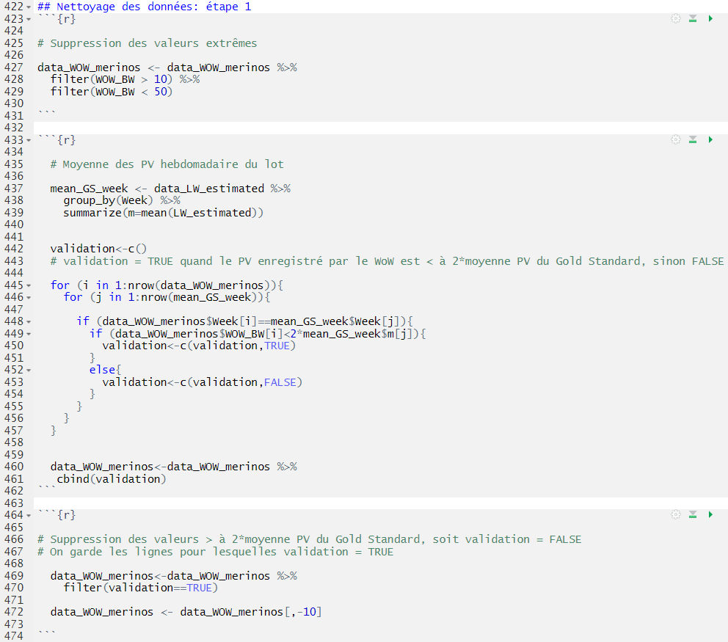
R scripts (R Core Team, 2021) used for the filtering of databases and the analyses of liveweight in the different Steps:
Step 1:

Step 2:

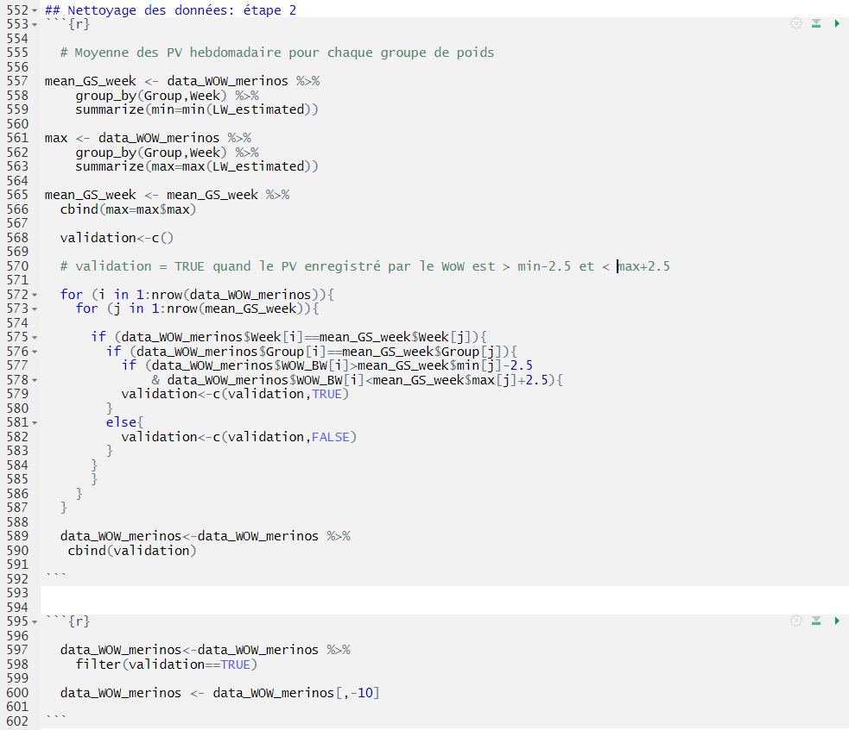

Step 3:

