

**Mini Project Report On**

**“****AgroMart-An Open Bidding System”**

**Submitted By**

Ajay Bohra (4304)

Kunal Khanra (4329)

Deepak Tiwari (4362)

Aditya Suhas Shinde (4363)

Under the guidance of

**Prof. Y N Gholap**

Department of Information Technology

ARMY INSTITUTE OF TECHNOLOGY, PUNE

**SAVITRIBAI PHULE PUNE UNIVERSITY**

**2020-2021**

**CERTIFICATE**

This is to certify that,

Ajay Bohra (4304)

Kunal Khanra (4329)

Deepak Tiwari (4362)

Aditya Suhas Shinde (4363)

of class T.E IT, have successfully completed their mini project work on “**AgroMart-An Open Bidding System**” at Army Institute of Technology in the partial fulfillment of the Graduate Degree course in T.E at the department of **Information Technology**, in the academic Year 2020-2021 Semester – I as prescribed by the Savitribai Phule Pune University.

Prof. Y N Gholap Dr. (Mrs.) Sangeeta Jadhav

Associate Professor Head of the Department

(Guide) (Department of Information Technology)

**ACKNOWLEDGEMENT**

I take this opportunity to express my sincere gratitude to **Prof. Y N Gholap** for his immense support and guidance. Without the help and vision provided by him, this project report would not have achieved its present form. I am indebted to **Prof. (Dr.) Sangeeta Jadhav** (Head of Department, Information Technology) for providing me with all the facilities required for the seminar work.

I would like to thank other staff members of the information technology department who have helped me at various stages in the preparation of this seminar, for which I am thankful to them. Last but not the least I would like to extend my thanks to all my friends for their help, which led to the completion of the report.

Kunal Khanra

Roll No: 4329

**INDEX**

**Sr.No. Content** **Page No.**

1. Abstract 5

2. Introduction 6

3. Feasibility Study 7

4. Proposed System 8

5. Design 10

6. Snapshots 12

7. Coding 17

8. Conclusion 20

9. References 21

**ABSTRACT**

Agromart – An Open Bidding Website for farmers and consumers is an advanced system which provides an online market to deal with crops. Besides all, it safely maintains all records related to buying or selling of crops, users’ data, crops data, Bidding, and all.

India is widely known as the farmers country as its majority of population is still dependent on agricultural sectors and is a global agricultural powerhouse. Our mini project is a web-based application, and this web application provides an online platform for users to buy or sell crops nationwide. The farmers can put up his/her crops for open bidding through this platform ensuring that the farmer receives the best price for it.

User can place bid on crops and can even put up his/her crops on bidding for several days. User has the choice to stop bid at any moment if he/she thinks that the bid received is favorable for him else keep the bid ongoing.

This Web Application is designed in such a way that anyone within the nation can buy or sell crops with surety that the farmer receives the best price for it. It gives the user the option to continue his/her bid or stop it at that moment if the price received is favourable. AgroMart is a platform that connects the farmers and Consumers from different corners of the nation and make them know something new.

**Chapter 1**

**INTRODUCTION**

This chapter gives an overview about the aim, objectives, background and operation environment of the system.

This project aims at objectives that will be achieved at the end of this project and are discussed here below. The aims and objectives are as follows:

* Providing a suitable platform for bidding.
* Making sure that farmer receives a favorable price.
* Maintaining the entire process of bidding.
* Making sure that crops are fresh enough to bid.
* Maintaining the crop status.
* Maintaining records of users, crops and bids.

The various front-end software used in the project are HTML, JavaScript, CSS and ReactJs. NodeJS is used as the backend tool.

All data regarding users, crops and bids are stored in database designed using MySql. Crops maintenance system is also there in this system which would keep track of the detailed description about the crops of a user. With this computerized system there will be no loss of crop or user record which generally happens with a non-computerized system.

**Chapter 2**

**Feasibility Study**

In feasibility study phase we went through various steps which are described as under:

1. Identify the source of information at various levels.
2. Identify the requirements of users from online platform.
3. Analyze the demerits of existing system.
4. Analyze the benefits of existing system.
5. Understand the expectations of users from online bidding

**Working of Present Manual System**

Currently, for selling crops farmers follow this process:

1.Harvesting of Crop

2.Taking all harvested crop to mandi (Crop Market)

3.Wait for Customer to sell the crop

**Drawbacks of Existing System**

Some of the problems faced by the farmers are as follows:

1.Do not get enough Price for their Crop to make some profit

1. Crops Wastage

2. Only limited to local market

**Chapter 3**

**Proposed System**

There will be four major components:

1. Online user registration
2. Farmer Uploading their Crops for sale
3. Users place bid on Uploaded crops
4. After farmer closes bid, the user with the most bid amount can claim the crop

To solve the demerits as mentioned above, AgroMart is proposed. The proposed system contains the following features:

1. User can set the base price as per his convenience.

2. User himself can stop/close the bidding any moment.

3. User can bid on any crop he wants, easily through this platform.

4. User can bid on crop knowing the status regarding its harvesting.

5. Only authenticated users after signing in can access AgroMart.

6. User can connect with us and access the help or FAQs feature to clear his doubts.

7. User can connect to AgroMart on social media (Facebook, Twitter, YouTube) to know about new things.

**Justification and need for the System**

The traditional approach for selling crop is not very friendly approach.

These days there is often more emphasis on Digital India, and without farmers becoming Digital, our country India will never become a Digital India.

It will also increase the use of Cashless transaction through our Platform

More important, the farmer’s crop will not be limited to local market only

**Chapter 4**

**Design**

**Collection/Tables:**

1. Users

Attributes:

1. ID
2. username
3. email
4. password
5. isverified
6. Crops_Detail

Attributes:

1. Crop_ID
2. Crop
3. Baseprice
4. Crop_status
5. farmer_id
6. City
7. Weight
8. Bidtime
9. Bids

Attributes:

1. Crop_id
2. Buyer_id
3. CurrentBid
4. Status
5. EndDate
6. Crop_is_closed

Attribute:

1. Crop_ID
2. Is_closed

**E-R Diagram**

**Chapter 5**

**Snapshots**

**1. Home Page**

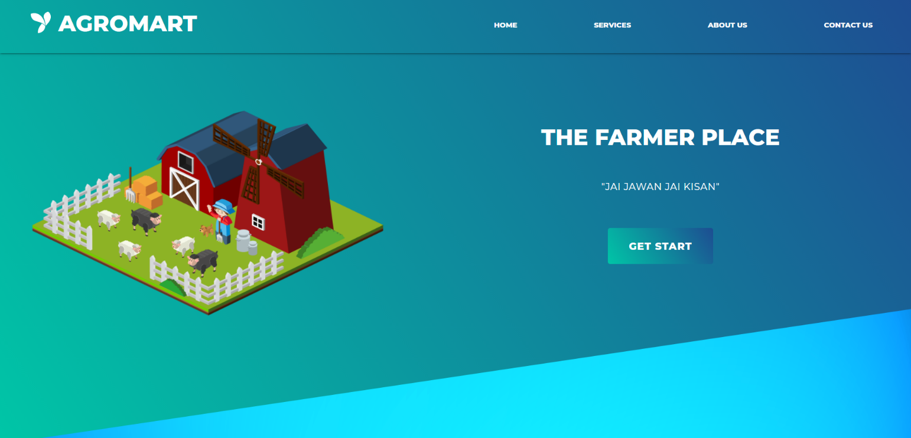

**2. Login/SignUp Page**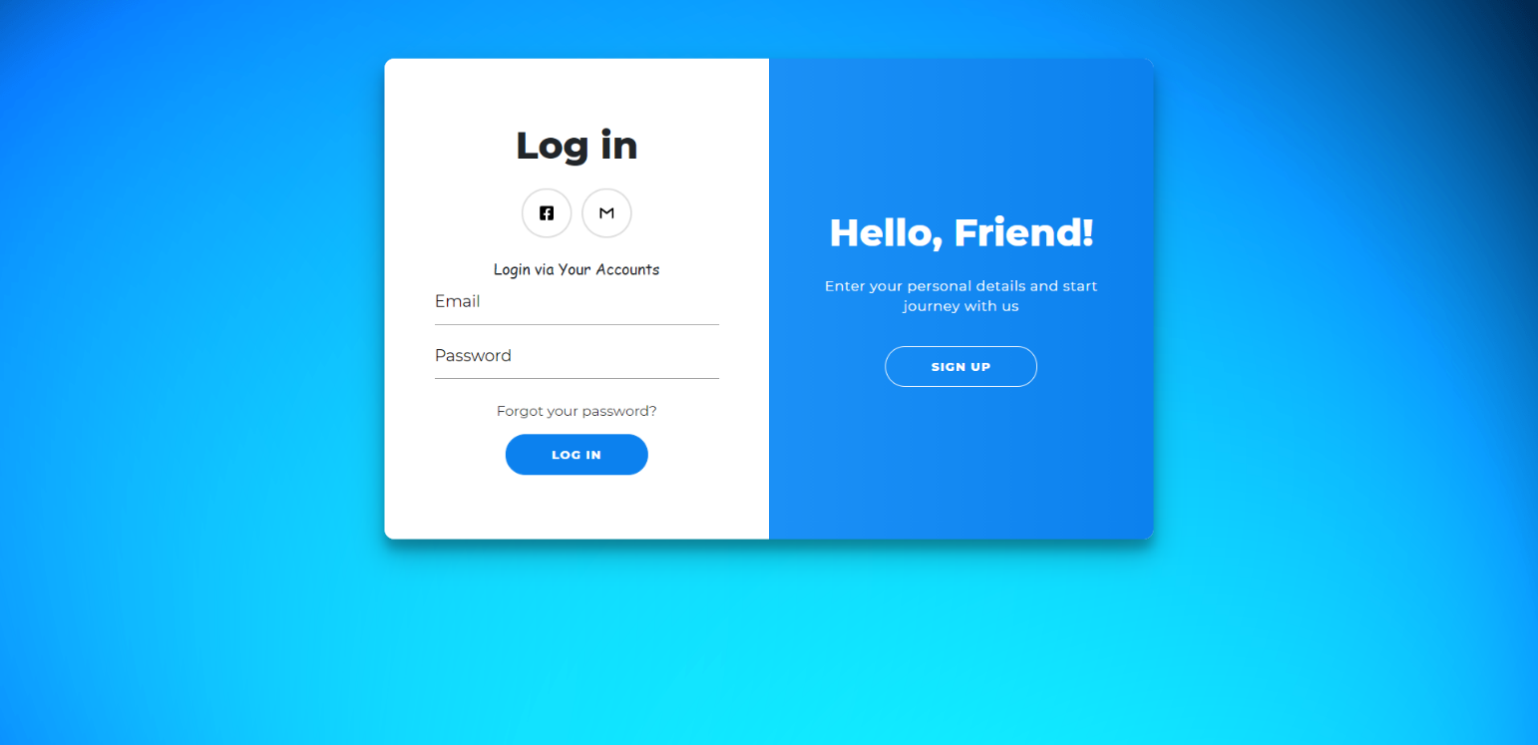

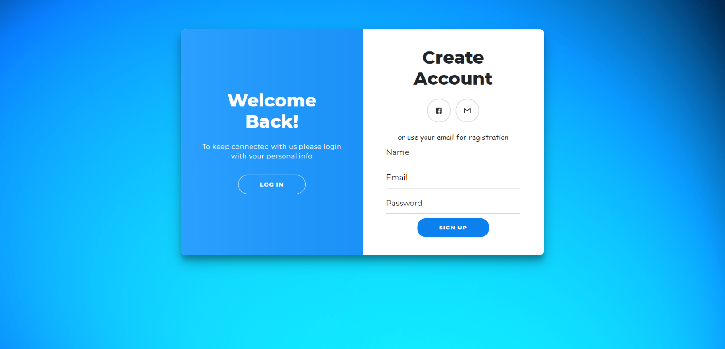

**3. Main Page**

**4. Bid Placing Page**

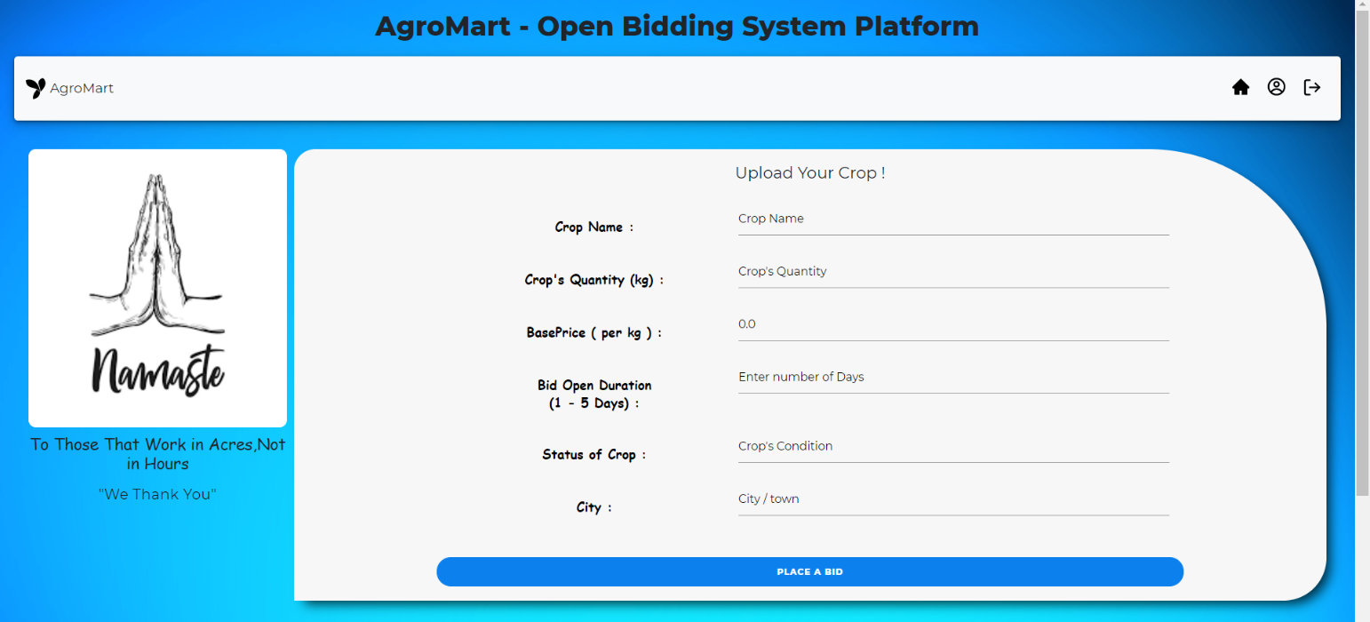

**5. My Profile Page**

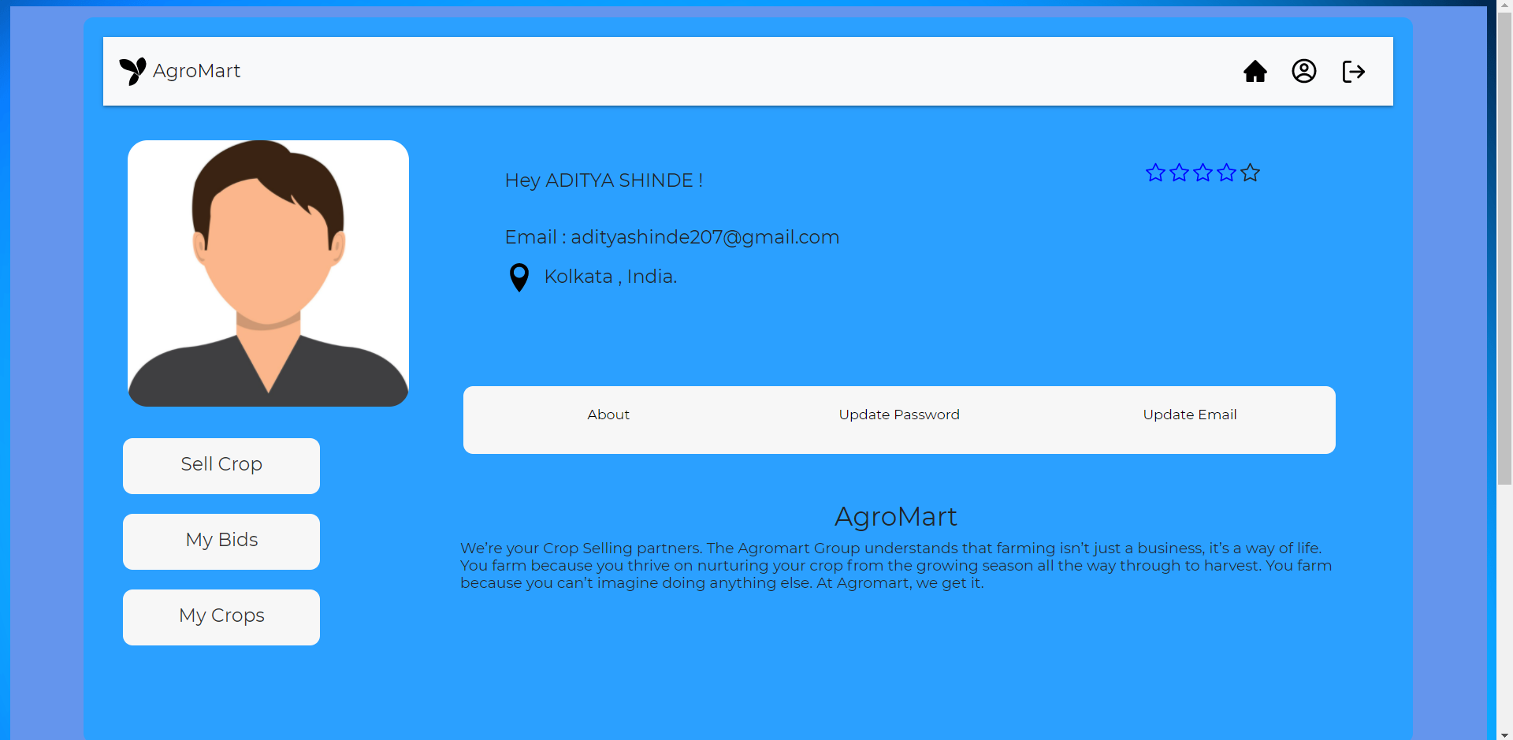

**6.Status of My Crops**

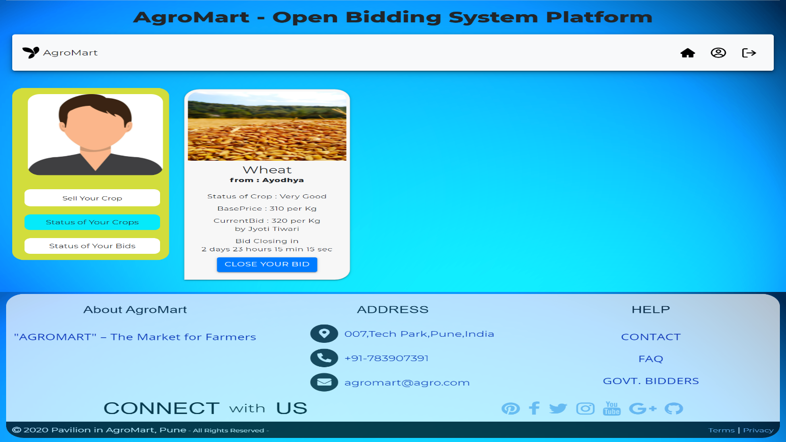

**6.Update Email**

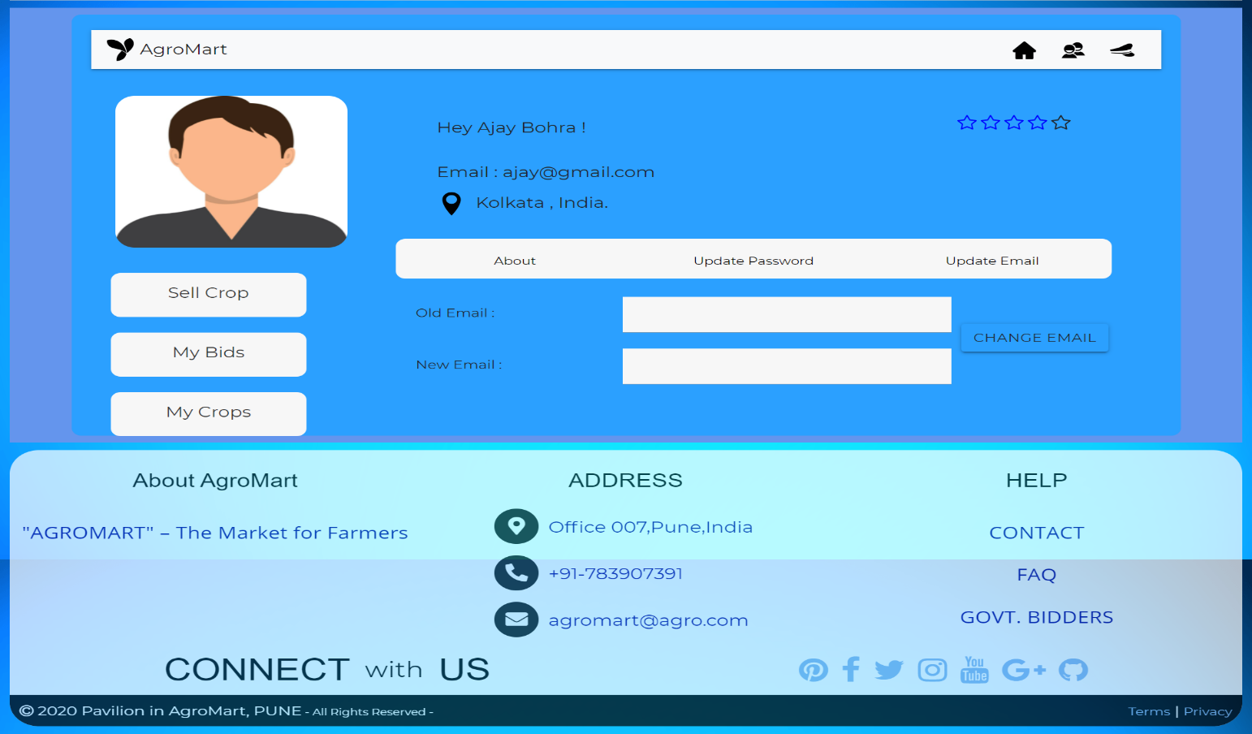

**7.Update Password**

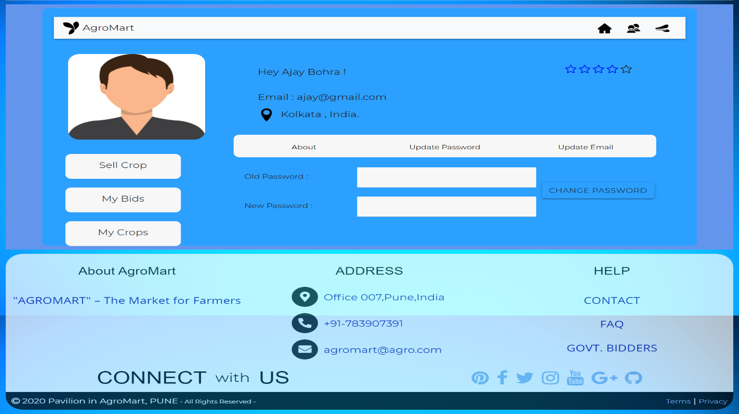

**Chapter 6**

**Coding**

**1.Database Connectivity Code:**

const mysql = require('mysql');

var myConnection = mysql.createConnection({

    user : 'root' ,

    host : 'localhost' ,

    password : '' ,

    database : 'farmer',

    insecureAuth : true

});

myConnection.connect( (err) => {

*if*(!err) console.log('Connected!');

*else* console.log('Failed to Connect..!');

});

module.exports = myConnection;

**2.Navigation Bar Component Code:**

*import* React *from* 'react';

*import* { DiYii } *from* 'react-icons/di';

*import* { AiFillHome } *from* 'react-icons/ai';

*import* { CgProfile } *from* 'react-icons/cg';

*import* { FiLogOut } *from* 'react-icons/fi';

*import* { Link } *from* 'react-router-dom';

*import* '../Css/Navbar.css';

class NavBar extends React.Component {

    state = {

        wobble : 0 ,

        username : ''

    }

    render() {

*return*(

            <div>

                <h1 style = {{textAlign : "center",marginTop:"20px"}}> AgroMart - Open Bidding System Platform </h1>

                <div style = {{margin : "20px", boxShadow: "0 4px 8px 0 rgba(0, 0, 0, 0.2), 0 6px 20px 0 rgba(0, 0, 0, 0.19)"}}>

                    <nav className = "Navbar navbar navbar-expand-lg navbar-light bg-light" style = {{height : "90px" , borderRadius : "5px"}}>

                        <DiYii className = "Icon" onClick = {() => this.setState({wobble : 1})} onAnimationEnd = {() => this.setState({wobble : 0})} wobble = {this.state.wobble}/>

                        <a className = "navbar-brand" href = "#">AgroMart</a>

                        <button className = "navbar-toggler" type = "button" data-toggle = "collapse" data-target = "#navbarTogglerDemo02" aria-controls = "navbarTogglerDemo02" aria-expanded = "false" aria-label = "Toggle navigation">

                            <span className = "navbar-toggler-icon"></span>

                        </button>

                        <div className = "collapse navbar-collapse" id = "navbarTogglerDemo02">

                            {*/\**

*<ul className = "navbar-nav mr-auto mt-2 mt-lg-0">*

*<li className = "nav-item">*

*<a className = "nav-link" href = "#">Home</a>*

*</li>*

*<li className = "nav-item">*

*<a className = "nav-link" href = "#">Contact Us</a>*

*</li>*

*</ul>*/*}

                    <div className = "Main" style = {{cursor : "pointer", color : "black"}}>

                        <a href="/"><AiFillHome className = "MainIcons" title = "Home"/></a>

                        <Link to = {'/profile'}><CgProfile className = "MainIcons" title = "Your Profile" /></Link>

                        <FiLogOut className = "MainIcons" title = "Logout" onClick = {this.props.logout}/>

                    </div>

                </div>

                </nav>

                </div>

            </div>

        )

    }

}

*export* *default* NavBar;

**3.Routing of Website**

const express = require('express');

const Router = express.Router();

const user_controller = require('../Controller/control');

const bid_controller = require('../Controller/controlBid');

Router.post('/' , user_controller.create);

Router.post('/gettoken' , user_controller.gettoken);

Router.get('/getuser' , user_controller.getuser);

Router.post('/newbid' , bid_controller.insertBid);

Router.get('/getallbid',bid_controller.getAllBid);

Router.post('/getmycrop',bid_controller.getMyCrop);

Router.post('/getprice' , bid_controller.getPrice);

Router.post('/placebid' , bid_controller.placeBid);

Router.post('/closebid' , bid_controller.closeBid);

Router.post('/yourstatus' , bid_controller.status);

Router.post('/gDetails' , user_controller.gDetails);

Router.get('/verify',user_controller.verify);

Router.post('/uemail' , user_controller.updateEmail);

Router.post('/upassword' , user_controller.updatePassword);

module.exports = Router;

**4.Server.js**

const express = require('express');

const app = express();

const bodyparser = require('body-parser');

const myConnection = require('./connection')

const Post = require('./Routes/route');

const cors = require('cors');

require('dotenv').config();

app.use(cors());

app.use(bodyparser.urlencoded({extended : true}));

app.use(bodyparser.json());

app.use('/post' , Post);

app.listen(8000

**Chapter 7**

**Conclusion**

This Online Platform provides a convenient version of Online Bidding System which will benefit both the buyer and seller including most of the farmers. It makes the entire process automated hence easier.

Tech Stack Used:-

Front-End: HTML, CSS, JAVASCRIPT

Framework: React.JS

Backend: Node.JS, Express.JS

Database: MySQL

DBMS concepts used: Primary Keys, Foreign Keys, Unique Keys and Database Normalization are also implemented.

**References**

**1.** [**https://agrimp.com/**](https://agrimp.com/)

**2.** [**https://enam.gov.in/web/**](https://enam.gov.in/web/)

**3.** [**http://agricoop.nic.in/**](http://agricoop.nic.in/)

**4.** [**https://www.quora.com/**](https://www.quora.com/)

**5.** [**https://www.wikipedia.org/**](https://www.wikipedia.org/)