Session-11-Assignment-1

Aditya Mulay

July 17, 2018

# Q1. Use the given link and locate the bank marketing dataset. Data Set Link  
# Perform the below operations:  
# a. Create a visual for representing missing values in the dataset.  
bank <- read.csv("C:/Users/Aditya/Downloads/bank-additional/bank-additional/bank-additional.csv", sep=";")  
View(bank)  
dim(bank)

## [1] 4119 21

str(bank)

## 'data.frame': 4119 obs. of 21 variables:  
## $ age : int 30 39 25 38 47 32 32 41 31 35 ...  
## $ job : Factor w/ 12 levels "admin.","blue-collar",..: 2 8 8 8 1 8 1 3 8 2 ...  
## $ marital : Factor w/ 4 levels "divorced","married",..: 2 3 2 2 2 3 3 2 1 2 ...  
## $ education : Factor w/ 8 levels "basic.4y","basic.6y",..: 3 4 4 3 7 7 7 7 6 3 ...  
## $ default : Factor w/ 3 levels "no","unknown",..: 1 1 1 1 1 1 1 2 1 2 ...  
## $ housing : Factor w/ 3 levels "no","unknown",..: 3 1 3 2 3 1 3 3 1 1 ...  
## $ loan : Factor w/ 3 levels "no","unknown",..: 1 1 1 2 1 1 1 1 1 1 ...  
## $ contact : Factor w/ 2 levels "cellular","telephone": 1 2 2 2 1 1 1 1 1 2 ...  
## $ month : Factor w/ 10 levels "apr","aug","dec",..: 7 7 5 5 8 10 10 8 8 7 ...  
## $ day_of_week : Factor w/ 5 levels "fri","mon","thu",..: 1 1 5 1 2 3 2 2 4 3 ...  
## $ duration : int 487 346 227 17 58 128 290 44 68 170 ...  
## $ campaign : int 2 4 1 3 1 3 4 2 1 1 ...  
## $ pdays : int 999 999 999 999 999 999 999 999 999 999 ...  
## $ previous : int 0 0 0 0 0 2 0 0 1 0 ...  
## $ poutcome : Factor w/ 3 levels "failure","nonexistent",..: 2 2 2 2 2 1 2 2 1 2 ...  
## $ emp.var.rate : num -1.8 1.1 1.4 1.4 -0.1 -1.1 -1.1 -0.1 -0.1 1.1 ...  
## $ cons.price.idx: num 92.9 94 94.5 94.5 93.2 ...  
## $ cons.conf.idx : num -46.2 -36.4 -41.8 -41.8 -42 -37.5 -37.5 -42 -42 -36.4 ...  
## $ euribor3m : num 1.31 4.86 4.96 4.96 4.19 ...  
## $ nr.employed : num 5099 5191 5228 5228 5196 ...  
## $ y : Factor w/ 2 levels "no","yes": 1 1 1 1 1 1 1 1 1 1 ...

psych::describe(bank)

## vars n mean sd median trimmed mad min  
## age 1 4119 40.11 10.31 38.00 39.44 10.38 18.00  
## job* 2 4119 4.82 3.61 4.00 4.60 4.45 1.00  
## marital* 3 4119 2.18 0.61 2.00 2.22 0.00 1.00  
## education* 4 4119 4.78 2.15 4.00 4.92 2.97 1.00  
## default* 5 4119 1.20 0.40 1.00 1.12 0.00 1.00  
## housing* 6 4119 2.08 0.98 3.00 2.10 0.00 1.00  
## loan* 7 4119 1.35 0.74 1.00 1.19 0.00 1.00  
## contact* 8 4119 1.36 0.48 1.00 1.32 0.00 1.00  
## month* 9 4119 5.29 2.31 5.00 5.37 2.97 1.00  
## day_of_week* 10 4119 3.01 1.39 3.00 3.01 1.48 1.00  
## duration 11 4119 256.79 254.70 181.00 210.52 136.40 0.00  
## campaign 12 4119 2.54 2.57 2.00 1.99 1.48 1.00  
## pdays 13 4119 960.42 191.92 999.00 999.00 0.00 0.00  
## previous 14 4119 0.19 0.54 0.00 0.06 0.00 0.00  
## poutcome* 15 4119 1.92 0.37 2.00 1.99 0.00 1.00  
## emp.var.rate 16 4119 0.08 1.56 1.10 0.27 0.44 -3.40  
## cons.price.idx 17 4119 93.58 0.58 93.75 93.58 0.56 92.20  
## cons.conf.idx 18 4119 -40.50 4.59 -41.80 -40.59 6.52 -50.80  
## euribor3m 19 4119 3.62 1.73 4.86 3.81 0.16 0.64  
## nr.employed 20 4119 5166.48 73.67 5191.00 5178.54 55.00 4963.60  
## y* 21 4119 1.11 0.31 1.00 1.01 0.00 1.00  
## max range skew kurtosis se  
## age 88.00 70.00 0.72 0.43 0.16  
## job* 12.00 11.00 0.41 -1.42 0.06  
## marital* 4.00 3.00 -0.03 -0.29 0.01  
## education* 8.00 7.00 -0.28 -1.21 0.03  
## default* 3.00 2.00 1.55 0.43 0.01  
## housing* 3.00 2.00 -0.16 -1.95 0.02  
## loan* 3.00 2.00 1.72 1.03 0.01  
## contact* 2.00 1.00 0.60 -1.64 0.01  
## month* 10.00 9.00 -0.31 -1.02 0.04  
## day_of_week* 5.00 4.00 0.00 -1.26 0.02  
## duration 3643.00 3643.00 3.29 20.72 3.97  
## campaign 35.00 34.00 4.00 25.24 0.04  
## pdays 999.00 999.00 -4.77 20.77 2.99  
## previous 6.00 6.00 4.02 22.08 0.01  
## poutcome* 3.00 2.00 -0.84 3.55 0.01  
## emp.var.rate 1.40 4.80 -0.73 -1.04 0.02  
## cons.price.idx 94.77 2.57 -0.22 -0.82 0.01  
## cons.conf.idx -26.90 23.90 0.29 -0.32 0.07  
## euribor3m 5.04 4.41 -0.71 -1.40 0.03  
## nr.employed 5228.10 264.50 -1.08 0.06 1.15  
## y* 2.00 1.00 2.50 4.25 0.00

library(VIM)

## Loading required package: colorspace

## Loading required package: grid

## Loading required package: data.table

## VIM is ready to use.   
## Since version 4.0.0 the GUI is in its own package VIMGUI.  
##   
## Please use the package to use the new (and old) GUI.

## Suggestions and bug-reports can be submitted at: https://github.com/alexkowa/VIM/issues

##   
## Attaching package: 'VIM'

## The following object is masked from 'package:datasets':  
##   
## sleep

missing <- bank  
missing[missing == "unknown"] <- NA  
aggr(missing, col=c('royalblue2', 'lightgreen'), numbers=TRUE, sortvars= TRUE,  
 labels=names(missing), cex.axis=0.5,  
 gap=3, ylab=c("missing data","pattern"))

## Warning in plot.aggr(res, ...): not enough horizontal space to display  
## frequencies

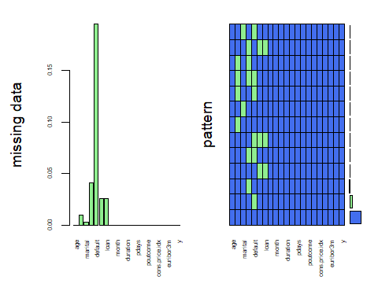

sapply(missing, function(x) sum(is.na(x)))

## age job marital education default   
## 0 39 11 167 803   
## housing loan contact month day_of_week   
## 105 105 0 0 0   
## duration campaign pdays previous poutcome   
## 0 0 0 0 0   
## emp.var.rate cons.price.idx cons.conf.idx euribor3m nr.employed   
## 0 0 0 0 0   
## y   
## 0

# b. Show a distribution of clients based on a Job.  
A <- table(bank$job)  
fig <- barplot(A, xlab = "Job", ylab = "Numbers", main = "Clients based on Job", col = rainbow(12), las=3)

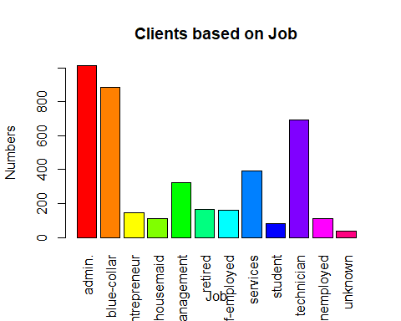

# c. Check whether is there any relation between Job and Marital Status?  
# Ho : There is NO association between Job and Marital Status  
chisq.test(missing$job, missing$marital, simulate.p.value = TRUE)

##   
## Pearson's Chi-squared test with simulated p-value (based on 2000  
## replicates)  
##   
## data: missing$job and missing$marital  
## X-squared = 395.28, df = NA, p-value = 0.0004998

# Since P Value is less than 0.05 ,   
# there is association between Job and Marital status at 95% confidence level

# d. Check whether is there any association between Job and Education?  
# Ho : There is NO association between Job and Education.  
chisq.test(missing$job, missing$education, simulate.p.value = TRUE)

##   
## Pearson's Chi-squared test with simulated p-value (based on 2000  
## replicates)  
##   
## data: missing$job and missing$education  
## X-squared = 3429, df = NA, p-value = 0.0004998

# Since the P value is less than 0.05,  
# there is association between Job and Education at 95% confidence level