Q1.Create an m x n matrix with replicate(m, rnorm(n)) with m=10 column vectors of n=10 elements each,

constructed with rnorm(n), which creates random normal numbers.

Then we transform it into a dataframe (thus 10 observations of 10 variables) and perform an algebraic

operation on each element using a nested for loop: at each iteration, every element referred by the two

indexes is incremented by a sinusoidal function, compare the vectorized and non-vectorized form of creating

the solution and report the system time differences.

Ans-

set.seed(42);

m=10; n=10;

mymat<-replicate(m, rnorm(n)) # create matrix of normal random numbers

mydframe=data.frame(mymat) # transform into data frame

#we can use system.stem() to check how long this takes

system.time(for (i in 1:m) {

for (j in 1:n) {

mydframe[i,j]<-mydframe[i,j] + 15\*sin(0.75\*pi)

}

}

)

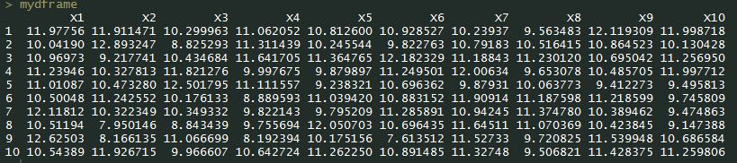Mydframe