1. Import the Titanic Dataset from the link Titanic Data Set.

Perform the following:

a. Is there any difference in fares by different class of tickets?

Note - Show a boxplot displaying the distribution of fares by class

library(ggplot2)

ggplot(titanic3, aes(x = embarked , y = fare, fill = factor(pclass))) +

geom_boxplot() + geom_hline(aes(yintercept=80), colour='red', linetype='dashed', lwd=2)

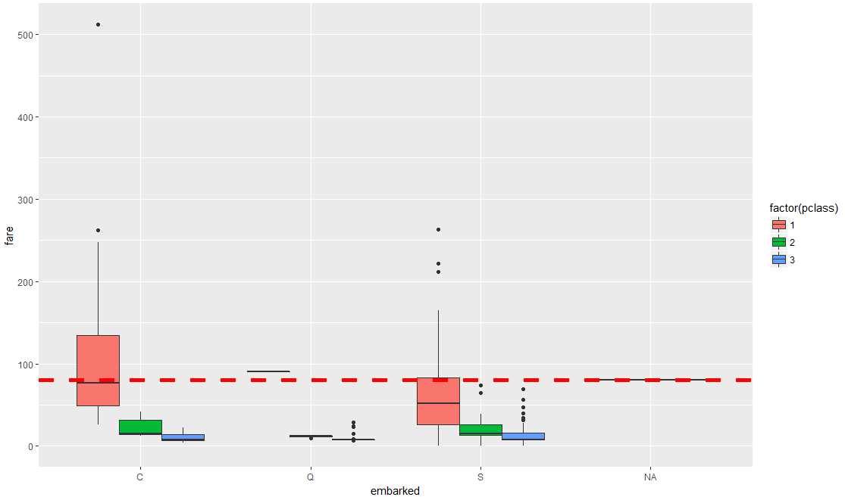

b. Is there any association with Passenger class and gender?

Note – Show a stacked bar chart

ggplot(titanic3, aes(x = embarked , y = fare, fill = factor(sex))) +

geom_boxplot() + geom_hline(aes(yintercept=80), colour='red', linetype='dashed', lwd=2)

