Session-7-Assignment-1

Aditya Mulay

June 27, 2018

#1. Histogram for all variables in a dataset mtcars. Write a program to create histograms for all columns.  
data("mtcars")  
library(ggplot2)  
library(purrr)  
library(tidyr)  
mtcars %>%  
 keep(is.numeric) %>%   
 gather() %>%   
 ggplot(aes(value)) +  
 facet_wrap(~ key, scales = "free") +  
 geom_histogram(bins = 30, col = "red")

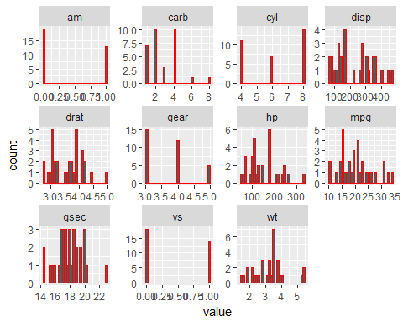

#2 Check the probability distribution of all variables in mtcars  
mtcars %>%  
 keep(is.numeric) %>%   
 gather() %>%   
 ggplot(aes(value)) +  
 facet_wrap(~ key, scales = "free") +  
 geom_density( col = "red")

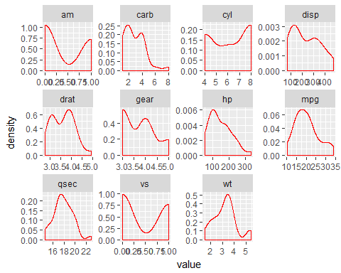

#3. Write a program to create boxplot for all variables.  
boxplot(mtcars[1:11])

