Session-7-Assignment-2

Aditya Mulay

June 27, 2018

#1. Write a program to create barplots for all the categorical columns in mtcars.  
Cyl<- table(mtcars$cyl)  
VS<- table(mtcars$vs)  
AM<- table(mtcars$am)  
Gear <- table(mtcars$gear)  
Carb <- table(mtcars$carb)  
barplot(Cyl, horiz = T , col = c("red","yellow","green"), main = "Types of Cylinder")

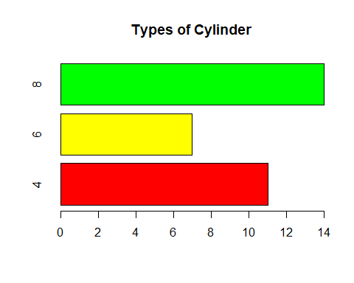

barplot(VS, horiz = T, col = c("lightgreen","lightblue"))

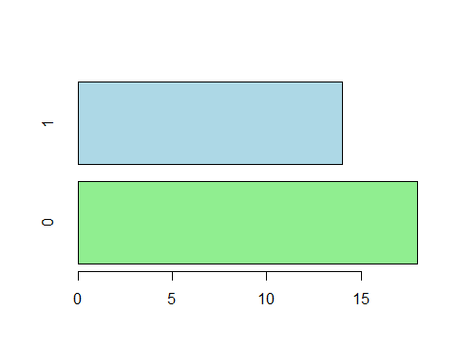

barplot(AM, horiz = T, col = c("beige","brown"), main = "Type of automation")

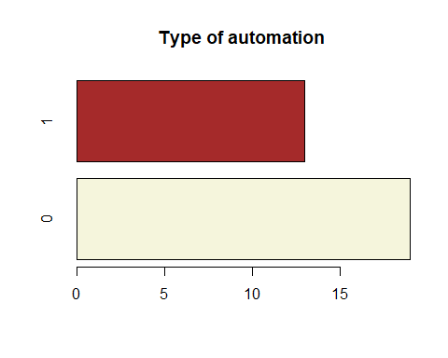

barplot(Gear, horiz = T, col = c("darkgreen","blue","pink"), main = "No. of Gears")

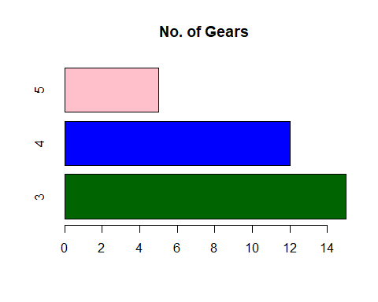

barplot(Carb, horiz = T, main = "Number of Carburators")

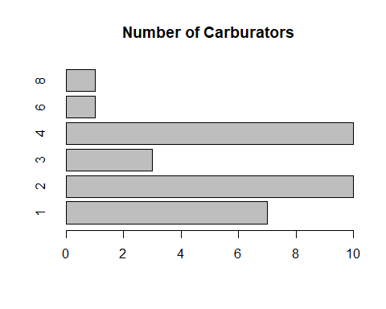

#2. Create a scatterplot matrix by gear types in mtcars dataset.  
library(car)

## Loading required package: carData

library(RColorBrewer)  
data=mtcars  
my_colors <- brewer.pal(nlevels(as.factor(data$gear)), "Set2")  
scatterplotMatrix(~mpg+disp+hp+drat+wt+qsec+gear|gear, data=data , col=my_colors , cex=0.5 , pch=c(15,16,17) , main="Scatter plot with Gear Options")

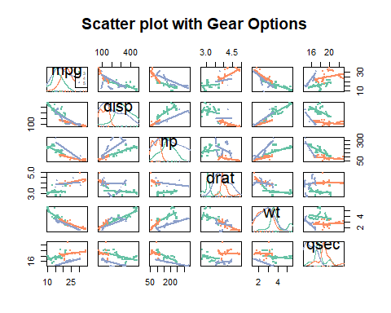

#3. Write a program to create a plot density by class variable.