Session-8-Assignment-2

Aditya Mulay

July 4, 2018

library(RcmdrPlugin.IPSUR)  
data(RcmdrTestDrive)  
#Perform the below operations:

# 1. Compute the measures of central tendency for salary and reduction which variable has highest center?  
sal <- RcmdrTestDrive$salary  
h<- hist(sal,breaks = 10,col = "lightsalmon3",xlab = "Salary",main= "Histogram of salary with normal curve")

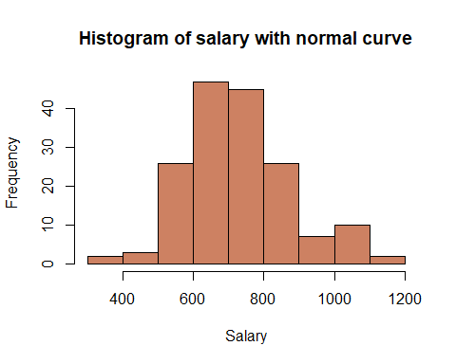

redu<-RcmdrTestDrive$reduction  
h<- hist(redu,breaks = 10,col = "olivedrab3",xlab = "Reduction",main= "Histogram of reduction with normal curve")

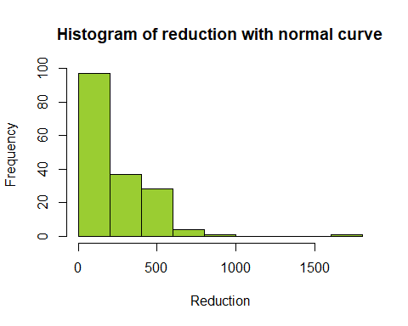

# 2. Which measure of center is more appropriate for before and after?  
boxplot(RcmdrTestDrive$before,horizontal = T,col = "turquoise3",xlab="before",ylab="Boxplot")

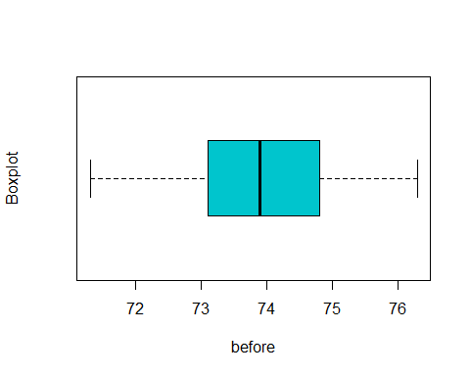

boxplot(RcmdrTestDrive$after,horizontal = T,col = "turquoise3",xlab="after",ylab="Boxplot")

